Experiment 3: Extraction

Dr. Rashmi Venkateswaran
Department of Chemistry
CHM1321

Procedure
Follow procedure as described in the laboratory manual (Experiment 3: Extraction, 2019 pp. 5-6). A modification was made in step 14 during gravity filtration, the content was stirred with a plastic stir stick, being careful not to rip the filter paper, in order to accelerate the filtration time.
Another modification was made in step 16 and 17, due to the filter paper taking too long to air dry, the aqueous phase was transferred onto another dry filter paper with a spatula. The mass was determined by taking the mass of a dry filter paper, taking the mass of the aqueous phase on the filter paper, and subtracting the filter paper.

Observations
-water was a colourless, viscous, odourless liquid.
-ether was a colourless, viscous liquid, less dense than water, strong odour.
-methylene blue was a blue, viscous, odourless liquid.
-methylene red was a red, viscous, odourless liquid.
-NaCl salt was a white crystalline powder.
-aqueous crystal violet was a dark purple, viscous, odourless liquid
-1-butanol was a colourless, viscous liquid, less dense than water, strong odour.
-unknown sample 31 was a colourless, viscous liquid, strong odour.
-dichloromethane was a colourless, viscous liquid, strong odour.
-NaOH was a colourless, viscous liquid, strong odour.
-precipitate was a gel looking consistency, whitish colour.
-biphenyl was a colourless, viscous liquid, strong odour.
-benzophenone was a colourless, viscous liquid, strong odour.
-2:8 ethyl acetate:hexanes was a colourless, viscous liquid, strong odour.

Part A
-The two compounds separated. The dye was at the bottom, but the top was clear. Aqueous layer on the bottom was water.
-The two compounds separated. Pink was seen on the top (organic phase), and yellow on the bottom (water). The dye was in the organic layer.
-The top was yellow ether (organic phase), and the bottom was blue water (aqueous phase).
-The salt resulted in separation to occur in the tube. There was purple dye on the top layer, which was the organic phase butanol, and translucent purple tint on the bottom, which was the aqueous phase water. The control tube had no separation occurring and the content looked homogenous. Undissolved salt seen at bottom of the test tube.

Part B
-Unknown was sample 31. Its dissolution in dichloromethane resulted in a clear solution.
-Bottom was organic layer with dichloromethane. Top was aqueous phase with NaOH and water.
-After shaking, gas was formed and released.
-Oil-looking droplet floating after extraction.
-Acidification resulted in grainy, cloudly, thick precipitate. Warm flask. Was cooled in ice bath.
-Gravity filtration took time. To accelerate, content in the funnel was stirred with a plastic stir stick.

Flow Chart
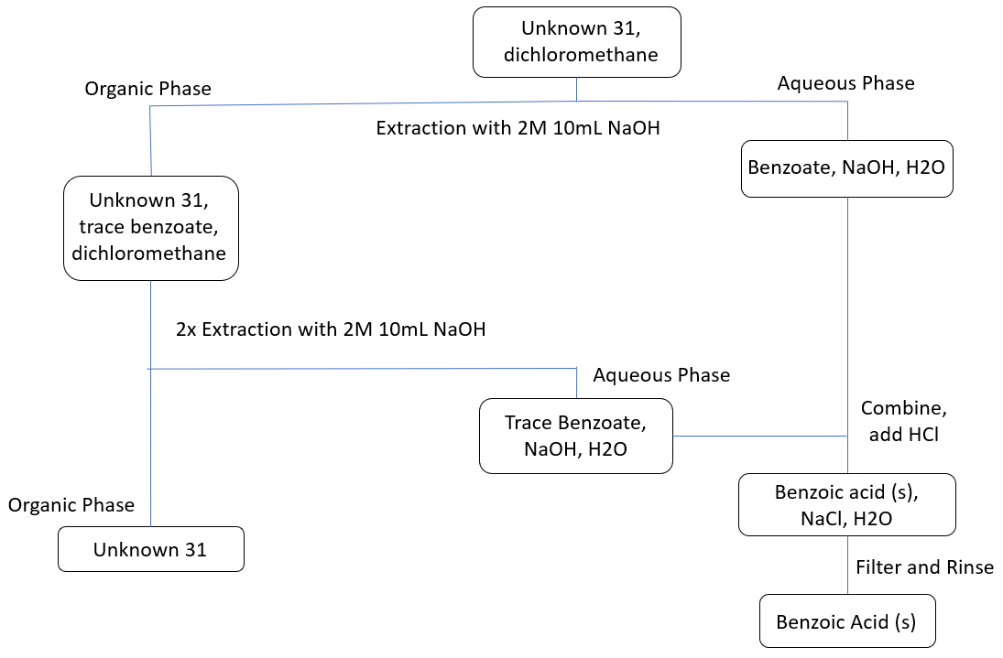

Table 1. Table of Results for Unknown 31.
 | Initial Mass (g) | Final Mass (g) | Composition | Composition by Mass (%)
Unknown #31 | 0.53 | 0.12 | Biphenyl and Benzoic Acid | 23

Figure 1. Developed TLC Plate with Unknown 31 and Organic Layer.
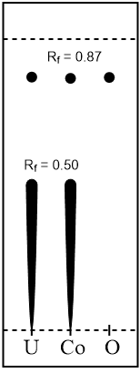
ds= 5.2cm
di= 4.5 cm and 2.6cm
Rf= 0.87 and 0.50
Solvent System: 2:8 ethyl acetate:hexanes
Unknown: sample 31

Figure 2. Developed TLC Plate with Unknown 31 and Aqueous Layer dissolved in Dichloromethane.
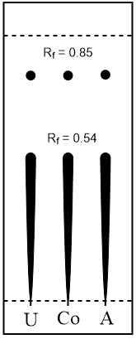
ds= 4.8cm
di= 4.1cm and 2.3cm
Rf= 0.85 and 0.48
Solvent System: 2:8 ethyl acetate:hexanes
Unknown: sample 31

Figure 3. Developed TLC Plate with Biphenol, Benzophenone and Unknown 31.
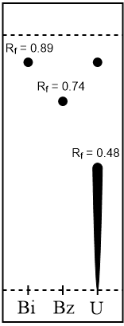
ds= 4.6cm
di= 4.1cm, 3.4cm, and 2.5cm
Rf= 0.89, 0.74, and 0.54
Solvent System: 2:8 ethyl acetate:hexanes
Unknown: sample 31

Calculations
Retention Factor (Rf)
= di / ds
= 4.5cm / 5.2cm
= 0.87

Composition by Mass
= amount obtained / initial mass x 100%
= (0.12g / 0.53g) x 100%
= 0.2264 x 100%
= 23% yield

Discussion
The purpose of this experiment was to extract two solutions based on their polarity, and to identify the composition of an unknown using thin layer chromatography.

Part A
Methylene blue dissolved in water, the aqueous phase, and not the organic layer that sat on top, which was ether. The layers separate due to their density, and their miscibility is dependent on their polarity. The organic layer being on top concludes that it was less dense than water. Having the methylene blue able to dissolve in polar water suggests that methylene blue is a polar compound as well. This can be confirmed by looking at the structure of methylene blue, which is a charged compound. The nonpolar organic layer was immiscible in both water and methylene blue.
With methyl red, the organic phase was dyed yellow, and a pinkish tint was seen with the water. Methyl red was immiscible with polar water, but miscible with the nonpolar organic ether layer. This suggests that methyl red is a nonpolar compound. The compound does not have a charge.
When mixing the two contents together, the water from each test tube combined, sitting at the bottom, and was dyed blue. The organic ether sat on top of the water, and was dyed yellow. An extraction between ether and water would be a good way to separate methyl red and methylene blue due to the difference in polarities of the dyes resulting in their miscibility in particular phases.
Considering the structure of butanol, its polarity and its moderately short carbon chain, it is partly miscible in water. Similar polarity with the 0.003M aqueous crystal violet resulted in it evenly distributing through both layers. With the addition of NaCl, the two separated, with a darker purple seen on the top layer, which was the organic butanol, and a light purple tint of the water. Saturation was confirmed by having the white salt at the bottom of the tube that would no longer mix with the solution. The salting out effect is a method which separates two compounds close in polarity by increasing the ionic strength of the aqueous solution, which was water, and forcing the butanol to separate from the aqueous layer considering its polarity is not exactly that of water. Aqueous crystal violet has a charge, however the compound is so large that the charge does not play a big role, and with the salting out effect, it is not polar enough to stay in the aqueous phase.

Part B
Multiple steps had to be done during the extraction, as seen in the flow chart above. NaOH, a strong base, was added first, followed by an extraction. The addition of the base deprotonated the benzoic acid, resulting in separation from the organic phase, and the benzoic acid became its conjugate base; benzoate. The organic phase contains the unknown. With the addition of HCl, a strong acid, the proton is returned, and the benzoate is reverted back to its conjugate acid; benzoic acid. The colour change of blue litmus paper to pink confirmed the acidity. The benzoic acid then precipitates into a cloudy grainy mass.
In Figure 1, the organic phase only contained the unknown. The organic phase was the dichloromethane, which has a higher density than water and therefore sat at the bottom. Considering this was drained first and the flow was stopped in time made sure that there was no contamination with the aqueous phase. The two lanes contain Rfs of 0.87 for the spot at the top, which indicates that the unknown was present in the organic phase. The Rf of 0.50 was the benzoic acid smudge.
By looking at the right column in Figure 2 marked “A” for aqueous solution, contamination is seen. The aqueous solution should only contain benzoic acid, seen by the smudge with Rf 0.54, and no spot above it. The top spot has a similar Rf of 0.85 as the other columns which suggests the contaminant was the unknown from the organic phase from improper extraction or contamination from capillaries. Benzoic acid has the carboxylic functional group that increases polarity. Considering the polar silica on the plate which attracts the benzoic acid by hydrogen bonds, the benzoic acid would not have been expected to reach around halfway to the solvent front. The reason for this is from its high concentration.
In Figure 3, it is seen that both the unknown as well as biphenyl have Rf values of 0.89, whereas it is 0.74 for benzophenone. Rf values indicate difference in polarity. The proton acceptor on the benzophenone is therefore more polar than the biphenyl composed of solely hydrogens and carbons. This concludes that the unknown was a mixture of biphenyl and benzoic acid. The second mark seen as a “smudge” under the unknown column is the benzoic acid, with Rf of 0.48.

A source of error occurred during the extraction process which resulted in contamination on the TLC plate in Figure 2, seen by the smudge in the right aqueous column “A”. There was oil-looking droplets on the surface of the second layer that was extracted. To prevent the organic phase and the aqueous phase from mixing together during the extraction process, it is important thats some of the top phase is drained into a separate beaker or flask to ensure there is no leftovers of the bottom one. Another error that must be considered is during the addition of HCl dropwise for the formation of precipitate. There was not a quantitative amount to be added. If too much HCl was added, NaCl would have precipitated. If not enough HCl was added, only part of the solution would have precipitated thus decreasing the yield. Referring to Table 1, it can be seen that he percent yield was 23%. A few reasons for this are due to errors occurring during the extraction process. Another factor is when the content was transferred from one filter to another, there was leftover solid on the filter papers. Moreover, leftover chemicals in the capillary tubes could have been a reason for the contamination on the TLC plates.

Questions
- Both acetone and water are polar. The polarity of acetone comes from the presence of oxygen, resulting in partial negativity. Since like dissolves like, the two are miscible in each other and will look like a homogenous mixture, making it difficult to extract. For a successful extraction, polarities must be different.
- Adding NaCl to a test tube containing water, ether, and methylene blue would decrease the amount of dye in the aqueous layer. NaCl has the ability to dissociate into its charges of Na+ and Cl-, and will increase the polarity of the water. It is more miscible in the aqueous phase than methylene blue is. The dye would be pushed into the organic layer.
- KD = (W1 / V1) / (W2 / V2)
= (20.0g / 100mL) / (2.0g / 100mL)
= 10

Let x represent the mass of compound Y in ether. Let y represent the mass of compound Y in water.

1.4g = x + y
1.4g - y = x

Substitute and combine the above equations.

10 = (y / 100mL) / (1.4g - y / 100mL)
y = 0.14g
y = 1.4g - x
x = 1.4g - 0.14g
x = 1.27g

Therefore, 1.27g of compound Y would be removed after a single extraction.
- Using same equation as in question 5;
10 = ( y / 50mL) / (1.4g - y / 100mL)
=1.2g

Remaining is 0.2g.

10 = ( y / 50mL) / (0.2g - y / 100mL)
= 0.2g
= 1.2 + 0.2g
= 1.4g

Therefore, 1.4g of compound Y would be removed after two extractions.
- The student can add a few drops of water to the mixture. The phase that the water mixes with is the aqueous layer. Therefore the organic layer would be the one that the water does not mix with.
- 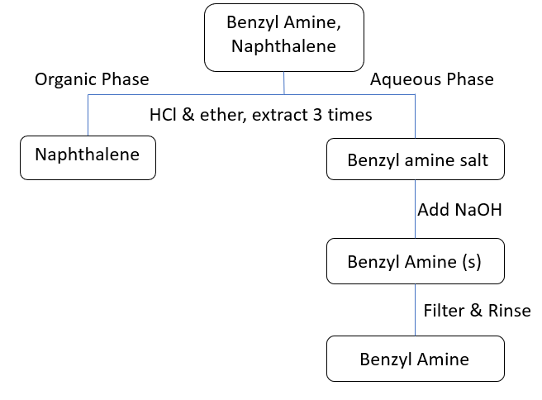
A strong acid should be added to the mixture. It would interact with the organic base, but not with the naphthalene. The amine functional group on the benzyl amine acts as a proton acceptor due to the lone pair on the nitrogen, therefore accepting the proton from the acid. This would result in solubility in water, whereas naphthalene would stay insoluble in ether. The precipitate would be formed by a base being added in order for the ammonium group to deprotonate. Lastly, filtering and rinsing would be performed.

