The standard anatomical position
4 key features
- Body erect
- Feet slightly apart
- Palms facing forward
- Thumbs pointing away from body
Remember!
Left and right is never your own left and right it is left and right with respect to the person you are observing.

Orientation and Directional Terms
Superior: toward the head end or upper end of the body.

Inferior: Away from the head end or toward the lower part of the body.

Anterior: Toward or at the front of the body. In front of.

Posterior: Toward or at the back of the body. Behind.

Medial: Toward or close to the midline of the body. On the inner side of.

Lateral: Away from the midline of the body. On the outer side of.

Intermediate: Between a medial and lateral structure.

Proximal: Closer to the origin of the body part or the point of attachment of a limb to the body trunk.

Distal: Farther from the origin of a body part or the point of attachment of a limb to the body trunk.

Superficial/ external: Toward or at the body surface

Deep/ internal: Away from the body surface. More internal.

Two fundamental divisions of the body:
- Axial: composed of head neck and trunk
- Appendicular: appendages or limbs attached to the axis.
This is used to designate specific areas within the axial or appendicular divisions of the body.
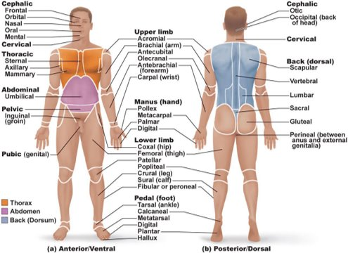
Cephalic
Cervical
Thoracic
Abdominal
Pelvic
Upper limb
Manus
Lower limb
Pedal
Dorsal

Body planes and Sections
Why are they important? They are important in imaging (CTs MRIs etc)
- Midsagittal plane: Vertical plane that divides body into left and right PARTS (we say parts because our organs are asymmetrical) A parasagittal plane would be not exactly down the center line.
- Frontal (coronal) plane: Vertical plane that divides body into anterior and posterior parts.
- Transverse plane: The only horizontal plane. Divides body into superior and inferior parts. A transverse section is a cross section of the body.
What is an oblique section?
Oblique section: a section of the body that is not taken with a 90 degree angle. Does not matter where it is from, if it is not 90 degrees it is oblique. All plane angles are 90 degrees.

Body Cavities
Cavities provide different degrees of protection to organs within them .
- Dorsal Body Cavity: Protects the nervous system. Most protected structures. It is composed of two subdivisions.
- Cranial cavity: enclosed by the skull and houses the brain.
- Vertebral cavity: Vertebral cavity runs within the bony vertebral column, encloses the spinal cord. The spinal cord is essentially a continuation of the brain and the cranial and spinal cavities are continuous with one another.
Both cavities are continuous and well-protected
2. Ventral Body Cavity: Much larger cavity. It houses the viscera. It is composed of two subdivisions.
a. Thoracic cavity: Divided into 2 lateral pleural cavities housing the lungs. Medial mediastinum containing the central pericardial cavity which encloses the heart.
b. Abdominopelvic cavity: Superior abdominal cavity (spleen, liver, stomach, intestines) and Inferior pelvic cavity (bladder, rectum, reproductive organs)

Ventral Body Cavity
Membranes in ventral body cavity​
Serosa: (also called serous membrane)​ It is a thin, double-layered membranes that cover surfaces in ventral body cavity​
Parietal serosa: lines internal body cavity walls​
Visceral serosa: covers internal organs (viscera)​
Double layers are separated by slit-like cavity filled with serous fluid​
Fluid secreted by both layers of membrane
Named for specific cavity and organs that they are associated with​
Pericardium​…..Heart​
Pleurae​…..Lungs​
Peritoneum​….Abdominopelvic cavity
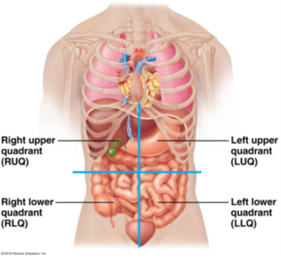

Abdominopelvic Quadrants



