Depressive and Bipolar Disorders
- Two separate categories under DSM 5 but used two be under 1
- Apart from anxiety disorders these disorders are the most common
Depressive Disorders in DSM-5
- Only going to talk about the first two
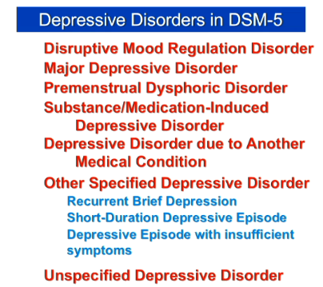

Disruptive Mood Regulation Disorder
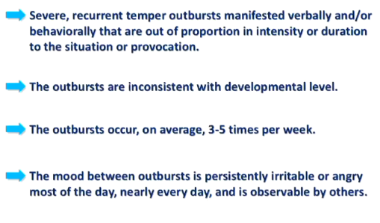

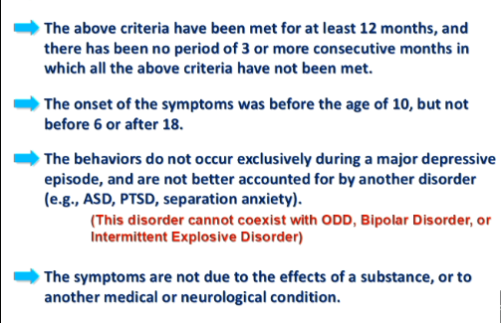
why was this new category created?
- For many years it was believed that children could not have bipolar disorder- then several clinicians began to argue that there were cases of pediatric bipolar disorder- so more and more kids getting bipolar diagnosis
- Concern that diagnosis of bipolar is being over diagnosed in children
- Problematic because drugs used to treat bipolar have side effects and might be dangerous to children
- Developed new definition of DMRD to get pediatricians to use this diagnosis as opposed to bipolar diagnosis
- If you follow the kids who receive the label of bipolar if they developed a mood disorder of any kind it tended not to be bipolar disorder- tended to get unipolar depressive disorders or anxiety disorders when older
  - So diagnosing kids with bipolar was turning out to be wrong- they weren’t bipolar as adults
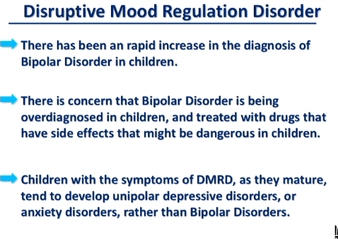

Major Depressive Disorder
- Very common disorder- more common than anything except anxiety disorders
- MDD and BD differ in one very important way from the other disorders we have talked about - most of the disorders we have talked about are chronic – the symptoms are always present for MDD and BD this is not the case- they are episodic disorders- the symptoms are present at some times but then they disappear and then they come back
- So the DSM doesn’t describe characteristics of the disorder but rather describes characteristics of the depressive episode
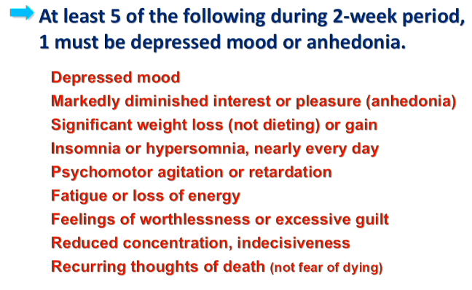

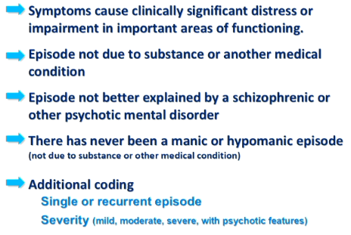

Bipolar Disorders in DSM-5
- Distinction between MDD and BD is presence of manic or hypomanic episodes
- Predominant symptom in BD is depressive episodes just like MDD – the diagnosis shifts from MDD to BD if the person has had a manic or hypomanic episode in their past
- We will talk about Bipolar 1 and Bipolar 2
Bipolar 1 Disorder
- Bipolar 1 and 2 are episodic
- Involve episodes of symptoms
- Most episodes are depressive but for the person to have BP One of those episodes has to be manic or hypomanic
- Criteria for BP 1 is criteria for a manic episode
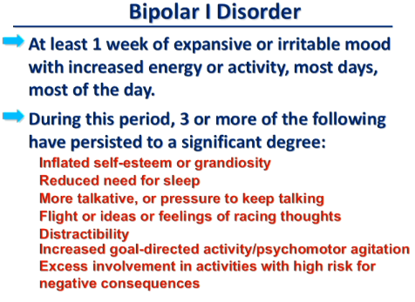

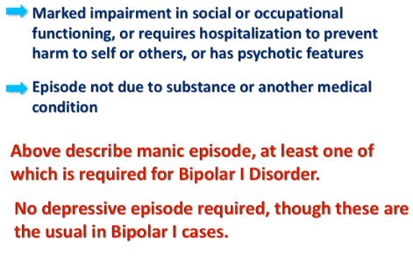

- The most common symptom in BD is depressive episodes – all it takes is one manic episode to shift the diagnosis from MDD to BD
- There are rare cases where the person only shows manic episodes

Bipolar 2 disorder
- Same as bipolar 1 with one difference
- In bipolar 1 the manic episode has to create significant impairment and possibly require hospitalization
- In bipolar 2 the manic episodes are not as intense- they are hypomanic
  - No significant disruption in your life
  - No hospitalization

*majority of drug addicts have comorbid mental disorders

Epidemiology
- Major depression
  - Point prevalence: 5-9% (females) 2-4%(males)
    - How many people have it at any given time
  - Lifetime 10-25% (females) 5-12% (males
  - Age of onset 20’s to 50’s ;mean = late 30’s
  - No race, SES, class bias – non discriminating disorder
- Bipolar disorder
  - Lifetime prevalence: 1-2%
  - no sex bias
  - Age of onset late teens- 20’s
  - No race bias
  - slightly higher in higher SES

- Canadian annual prevalence of depressive and bipolar disorders:
  - Female: 6.3%
  - Males: 4.2%
  - Overall: 5.2%

Depressive Etiology: Freud
- We don’t actually know the causes of any disorders we are just looking at levels of analysis
- Freud argues that depression is anger turned against the self
- Reaction to loss of love object
  - Begins with the loss of a love object- parent etc
- Loss love object introjected
  - In order to preserve attachment to love object the individual introjects that person
  - Form of identification
  - They take on some of the characteristics of that person
  - We then love and value that part of ourselves that represents our dead parent
- The problem in the case of depression is that the interjected love object has been lost and the individual is angry at the love object for having been lost
  - Ex, angry at the person for dying
- That anger is turned against the inward manifestation image of the individual and becomes depression
- Depression then becomes the reaction pattern for any lost love object in the person’s life becomes a pattern
Depressive etiology: Seligman
- Argues for a more cognitive behavioral explanation for where depression comes from
- Begins when individual experiences some sort of failure- loss of job, loss of loved one, disease etc
- They then decide that this loss or defeat is their fault- three different attributions for this particular thought
  - Internal reasons: “something about me” – I am responsible for this loss
  - Global reasons: “something very big and important about me”- something basic to who I am that is responsible
  - Stable reasons: “something unchanging about me”- unchangeable
- Leaves individual with feeling that there is nothing they can do – helplessness- learned helplessness translates into feeling of depression
- Helplessness: “I can do nothing”
Depressive Etiology: Beck
- Cognitive approach
- There are some people who have a tendency to look bleakly on the world- they have ways of looking at and interpreting the world using depressogenic schemata
- Presence of depressogenic schemata depression inducing ways of looking at the world
- They involve unrealistically negative views :
  - Of the self
  - Of the world
  - Of the future
- The cognitive treatment POV says that what we need to do is change the way the individual interprets the things happening to him/her
- The individual who has negative views about themselves, the world, the future, are doing so because of errors in their way of thinking
  - Interpretation is illogical
- System errors in logic:
  - Arbitrary inference- the individual draws negative conclusions without any data to support that negative view – or in the face of contrary information
    - Ex, girl has a talk in lecture hall and it went really well but she thinks it was a disaster – “they were only clapping because they were trying to make me feel better”
  - Selective abstraction- when you have both positive and negative feedback but you focus solely on the negative
    - Ex, you get back an essay and only focus on the bad comments not the good comments
  - Magnification and minimization- overemphasize negative information and minimize the importance of positive information
  - Overgeneralization- seeing the significance of negative information as covering a far wider range in one’s life than you should
    - Ex, you get a bad mark on a test – you don’t think hey its just one bad mark instead you would think I shouldn’t be in university
- Beck argues that individuals who are prone to depression make these systematic errors all the time

Mood disorder Etiology: Amine Hypothesis
- Basic view is that in anxiety there is over activity of neurotransmitters and in depression there is too little activity
- Three candidate neurotransmitters:
  - Dopamine
  - Serotonin
  - norepinephrine
- Depression = low levels of amine neurotransmitter activity
- Mania = high levels of amine neurotransmitter activity
- No way to measure neurotransmitters in the brain have to look at indirect ways of measuring them
- What is typically done is that people will look at what the treatment drug is doing – and assume that the problem must be the opposite of what the drug does
- Ex, many antidepressants increase the amount of activity in certain synapses so if that is what the drug does then the problem must be too little neurotransmitter activity
Treatment Action
- Antidepressants: facilitate transmission
  - Trycyclic antidepressants inhibit reuptake of neurotransmitters into presynaptic neuron
  - MAO inhibiters block the action of MAO MAO which breaks down MAO neurotransmitters – leaving neurotransmitters in the synapse longer
- Antidepressants and ECT (electro convulsive therapy)
  - ECT and some antidepressants reduce B adrenergic receptors – these receptors are responsible for the cardiovascular response to stress
  - Reduce B adrenergic receptors; increase serotonergic response, a-adrenergic receptors (relaxation, inhibition)
- Lithium: stabilizes serotonergic activity
  - Used for people with bipolar diagnosis
  - One of the things its supposedly does is stabilize activity of serotonin- suggesting that stability is responsible for the improvement in the symptoms of bipolar disorder reduced by lithium
  - Mechanism of action unclear
- This is what should happen- what does the data actually say happens
Precursors and Metabolites
- There is no direct way to measure any neurotransmitter of the brain so what we do is take indirect measures
- We look for precursors of neurotransmitters- chemicals that make neurotransmitters
- Or we look for break down products of neurotransmitters
- We can’t look for these chemicals in the brain we have to look for them in :
  - cerebral spinal fluid
  - urine
  - blood

- dopamine:

- the main precursor of dopamine is L-DOPA
- if the problem is too little dopamine in depression than providing additional precursors- giving the person more L-DOA should alleviate symptoms
- giving the person more L-DOPA:
  - enhances the effects of MAO inhibitors- increases amount of inhibition that MAO-I’s produce
  - it also may lead to hypomania in people who are bipolar – again suggesting that depression results from too little dopamine

- the main metabolite of dopamine is HVA (homovanillic acid)
- if the problem is too little activity of dopamine we should see low levels of HVA in the body fluids of ppl who are depress WE DON’T SEE THIS
- HVA is not lower in the Cerebral spinal fluid of depressed patients
- What we do see is that HVA is lower in individuals with motor retardation – which is one of the symptoms of depression
  - One feature of depression is associated with lower levels of HVA

- Norepinephrine:

- The main metabolite of norepinephrine is MHPG
- If the problem is too little norepinephrine then we expect to see lower levels of MHPG in individuals who are depressed – AND WE DO SEE THIS
- Lower levels of urinary MHPG in depression than controls
- See this more pronounced in peoples whose depression is part of bipolar disorder
  - One of the many aspects of etiology that suggests a different etiology for BD than for unipolar MD
  - One of the reasons why PD given own category – more evidence to suggest the causes of BD and MD are different

- Serotonin (5-HT)

- Precursor of serotonin is Tryptophan
- There is some evidence that Tryptophan by itself may be effective in alleviating symptoms in mild depressive cases

- The main metabolite for serotonin is 5-HIAA
- Small majority of studies find lower CSF levels of 5-HIAA in depression- this is what we would expect but it is just a small majority
- Low CSF levels of 5-HIAA in aggression, impulsivity, and suicide
- So low levels of 5-HIAA correlates more strongly with traits of aggression, impulsivity, and suicide than it does with depression as a whole

Permissive serotonin?
- Another view says its not so much the activity of these individual neurotransmitters it’s the damping and raising and modulating of these levels of activity of dopamine and norepinephrine- and what is responsible for this modulating serotonin
- Serotonin regulates neural activity – dopamine and norepinephrine
- Serotonin acts to modulate the level of activity in other neurotransmitter systems
- When we get reduced regulations serotonin activity is not closely controlling the behavior in other neurotransmitter systems- we get elevated mood mania and then a switch to depression
- Reduced regulation = wider activity changes mania or depression
- So one of the things we want to do is damp down the swings and level of serotonin activity- which is what lithium does when treating bipolar disorder
- Serotonin stabilization by lithium in bipolar disorders
- There is some evidence that the precursors of serotonin can serve as an antidepressant function in mild to moderate cases
- Reports of successful treatment with serotonin precursors

Precursors and Metabolites
- All of these measures are indirect- looking at CSF, urine, or blood not at the brain
- Where do CSF metabolites come from?
  - Could come from the brain but could also come from other parts of the nervous system
  - Could come from other organs
  - Brain? Spinal cord? Elsewhere?
- Some drugs relieve depression without amine uptake effects
  - Number of drugs that help depression without having any effect on amine neurotransmitters
- Delay between drug effects and lifting of depression
  - Assumption is that the problem in depression is low levels of neurotransmitter activity
  - So we give a drug that immediately raises levels of that neurotransmitter back to normal within 24 hrs
  - Would expect symptoms of depression to then also be lessened in 24 hrs- but they never are
  - Traditional antidepressants take 4-6 weeks to have their effect even though their chemical effect takes place within 24-48 hrs so why the delay?
- Neurons adapt to changes in activity
  - When we dose the brain with any chemical – the brain adapts- wants things to be just the way they were
  - Homeostasis- if we increase serotonin- the brain will over time reduce the number of serotonin receptors on its own so that it can put things back to the way they were – the brain fights change
  - Maybe what we need to look at is not the first effects that an antidepressant has- but we should look at the downstream effects
- Depression: effect of cause?
  - Every single brain state is a mind state – and every single mind state is a brain state
  - When we see high or low levels of neurotransmitter activity is that the cause or is that the effect
  - Do thoughts and cognitions cause changes in neurotransmitter levels
  - Or do neurotransmitter levels cause changes in thoughts

Etiology: Reverse Amine Hypothesis
- The amine hypothesis says that there is too much neurotransmitter activity for anxiety disorders and too little for depressive disorder
- Alternative hypothesis:
- The problem in depression and anxiety is exactly the same- there is too much neurotransmitter activity in both cases
- Makes sense when we consider that depression and anxiety very often occur together- they are comorbid conditions
- How can this be if they result from opposite neurochemical problems? That makes no sense

- Serotonin levels in brain cannot be measured directly
- Peripheral measures of serotonin, 5-HIAA may be from outside the brain- may come from other places
- There are drugs that have the same effect of SSRI’s – they block reuptake- but even though they do the same thing they do not relieve depression
- There are also drugs that should have the opposite effect – should according to the amine hypothesis increase depression but in fact they could serve as an antidepressant
  - Ex, Reserpine- reduces levels of serotonin and may still serve as an antidepressant
  - Not normally prescribed because of its side effects
- SSRIs increase serotonin quickly- chemical change works within 24 hrs- and yet the antidepressant activity doesn’t occur immediately- it takes 4-6 weeks before we see antidepressant effects doesn’t make sense if we think the cause of the depression is low levels of serotonin activity
- Reducing Tryptophan (and serotonin) does not cause depression id we are reducing serotonin levels shouldn’t we see depression?
- Neonatal exposure to SSRIs causes adult depression in rats SSRIS used to treat depression in humans but causes depression in rats- doesn’t make sense
- Down regulating the 5-HTT transporter protein in rats increases serotonin- so rats should not be prone to depression- but we see depression in rats
- None of this is consistent with the amine hypothesis – so reverse amine hypothesis suggests ts not too little serotonin activity, it is too much

Brain structure, function?
- Some evidence that some parts of the Brian are different in size in individuals who have depression
- Hippocampus (typically thought of as involving memory but can also involve emotional part of memory)
  - In people with multiple sclerosis and depression who do see reduced volume in the hippocampus
  - Suggesting that maybe the same thing might be true in people who don’t have MS
- Also see differences in brain activity
  - Less left frontal EEG activity
  - Relative activity in left and right prefrontal areas of the cortex
    - See lower levels of activation in the left frontal cortex especially in the prefrontal cortex in ppl with depression
    - Significant because pos and neg emotion activate different parts of the brain
    - Activity in the right hemisphere more closely associated with neg emotions
    - Activity in the left hemisphere more closely associated with pos emotions
    - In depression we see a reduction in pos emotions – makes sense
HPA axis?
- Stress response in depression
- Hypothalamus pituitary adrenal gland axis
- Unipolar depression and bipolar depression are both associated with high levels of the stress hormone cortisol produced by the adrenal cortex as a result of the hpa axis
- Originally people said this is not a big surprise these ppl are under more stress and therefore we see an elevated stress response
- yes this is true but the curious thing is that there is a daily rhythm of the release of cortisol in all individuals – tends to increase at 4/5am, continually increases until early afternoon and then it decreases until evening
- Cortisol release pattern different in depression:
  - Starts earlier in depression – instead of 4/5am it will be 2/3am
  - Production reaches a higher level- higher peak in depression
  - Lasts longer before it starts to reduce- longer release period in depression
- So higher levels of cortisol as well as basic difference in the way in which the body produces cortisol in response to hpa axis activity in people with depression – different pattern to the production and release of cortisol in individuals with depression
- One of the hypothesis about why this isthe pituitary gland is releasing higher levels of ACTH- which then effects the adrenal cortex and promotes the release of cortisol

Somatostatin?
- Chemical produced in the gut called Somatostatin- also a neurotransmitter in the brain
- One of the things it does is that it inhibits HPA axis responsiveness – cuts down on stress response
- Affects appetite, motor activity, sleep, pain perception – things to do with the brain not the gut
- Lower levels of somatostatin in CSF of people with depression – suggesting less inhibition of the HPA axis in individuals with depression

Genes and Depression
- Concordance rate in 1st degree relatives range from 6-40%
  - This is higher for BP than for UP depression
  - Suggests stronger genetic tie in BP than in UP
- Concordance rate in first degree relatives higher than the rate of depression in the population at large (only 5% prevalence rate)
- MZ concordance rates higher than DZ
  - Higher for BP than for UP depression
- Genetic basis is Polygenic rather than monogenic

Treatment
- Physical treatments:
  - Antidepressants: about 65% improvement rate – for Major depression
  - SSRIs
  - MAO inhibitors
  - There continues to be ongoing debate about whether antidepressants actually work
    - Compare antidepressant group to placebo group – difference is not that bigin the case of antidepressants a large component of their effect is a placebo response
    - Recent studies suggest that yes antidepressants to have effects that go beyond just the placebo effect- BUT the placebo effect is still very strong
  - Omega- 3 acids: good as antidepressants as long as depression is mild to moderate and when not comorbid anxiety
  - Ketamine: at lower than anesthesia dose, rapid relief of depression (special k)
    - Sold as recreational drug on the street
    - Was used for pediatric anesthetic
    - At lower doses ketamine has antidepressant properties
Ketamine
- Primarily used as pediatric anesthetic, and in pain management
- Depressed people who have not yet responded to other antidepressants will respond to ketamine – they respond very quickly
- At sub-anesthetic doses- about 70% of treatment- resistant depressed patients respond within hours
- Side effects usually mild, but may cause acute psychotic symptoms (hallucinations) in some ppl

How does ketamine work?
- Works almost instantly **
- why does ketamine have this effect?
- We don’t know for sure
- Looks as though chemical activity of ketamine is different from other antidepressants
- Not serotonin, dopamine or norepinephrine being effected by ketamine IT IS GLUTAMATE
- Glutamate is the most common excitatory neurotransmitter in the nervous system
- One effect of ketamine is to operate on the NDMA glutamate receptor as an antagonist- it blocks the receptors activity
  - Sounds consistent with the reverse amine hypothesis
- We have a drug here that helps relieve depressive symptoms and what does it do? It reduced the amount of excitatory neurotransmitters- in this case glutamate

- Zanos et al 2016
- Ketamine has 2 versions: S-katime and R-ketamine
- S ketamine is a better blocker of the NMDA receptor so you would expect it to have more pronounced antidepressant effects BUT NO
- R-ketamine has stronger antidepressant effects
- What about the metabolites of S and R ketamine?
  - Those break down products also have antidepressant properties
  - Again the R-ketamine break down products have higher antidepressant activity

Post ketamine?
- Now that we know the structure of ketamine we can look at drugs with similar structure and see if they also have antidepressant properties
Harraz et al 2016
- Found a new molecule that also has anti-depressant properties and it too works on glutamate receptors
- This new molecule is known to be non toxic to humans and is non addictive – ketamine can be addictive

Treatment
- Physical treatments:
  - Electroshock therapy (EST;ECT): rapid, for severe cases. Memory side effects
    - Works rapidly
    - Shock therapy – old way – patient comes in they are given a tranquilizer and muscle relaxant – electrodes placed on brain- shock is given- they pass out- when they wake up their depression has lessened
    - Problem with this is that major side effect of ECT is memory loss- big concern – people won’t even remember getting the ECT- they will be scared of the room
    - Shock therapy- new way- the patient is anesthetized- not scared of the room- place electrodes across only one hemisphere of the brain- the non dominant hemisphere (for most people this is the right)- this has reduced some of the negative side effects
    - Still a controversial approach for some people because we don’t know how it works- but if we think about it we also don’t know how antidepressants work
    - In some places it is last resort – in other places it might be first resort
  - Transcranial Magnetic Stimulation – was experimental little more expanded now
    - Sort of like ECT but you’re not passing current you are subjecting the brain to an intense magnetic field – does seem to have some therapeutic benefit for depression
    - TMS compared to placebo effect – hook up person to the machine but no magnetic field is actually applied- they found that the placebo groups showed just as much recovery as the TMS group
  - Deep Brain Stimulation
    - In very extreme treatment resistant depression there does seem to be benefit from actually electrically stimulating portions of the brain from within
    - In these cases electrodes are implanted deep in the brain and stimulation of this areas alleviates depression fairly quickly
    - Suggests that it might be working on the dopamine using system
    - Very experimental
  - Hyperthermia:
    - Raising body temp to 38.5 degrees Celsius (101.3F) leads to at least 6 weeks of improvement in depressive symptoms over sham treatment

Treatment
- Psychological treatments:
  - In the last 25-30 years there has been more reliance and use of psychological treatment for depression
  - Psychoanalysis used to be a very long and expensive process- in the last 20-30 years they have shortened in – brief psychoanalysis – still appears to work
  - Psychodynamic psychotherapy
  - Cognitive therapy
    - Changing the way you interpret information from the world around you
Treatment (Mania)
- Almost purely treated with pharmaceuticals
- Pharmacological treatments:
  - Chlorpromazine (antipsychotic, dopamine antagonist)
  - Haloperidol (antipsychotic, dopamine antagonist)
  - Lithium (mechanism of action uncertain)
    - Treatment of choice
    - Very narrow therapeutic window- window within which drug is effective but not toxic
      - Below a certain dose it does nothing
      - Above the certain does the side effects are very bad

