Laboratory 5: Nucleic Acids

By: Sami Aftab Abdul (300018542)

Section Z04 (Monday Afternoon 2nd week)
TEAM #: 14

Lab Partner: Nishwara Tarannum (300019212)
Demonstrator (TA): Nathaline Haidar Ahmad

Due Date: April 01, 2019
Date Lab Performed: March 25, 2019

University of Ottawa
Biochemistry Laboratory BCH 2333
Purpose:

This lab focuses on the understanding of double-stranded deoxyribonucleic acid (DNA) and its properties extracted from calf liver. Experiment one involves understanding the purity of the homogenized calf liver and commercial calf liver based on the purity ratio of spectrophotometry absorbances at different wavelengths (234nm, 260nm, 280nm), used to characterize and measure the purity of the extracted DNA. Experiment two analyzes the effects of high to low salt concentration on DNA, between commercial and commercial + low 0.03M NaClO₄ salt, and high salt concentration of 4.75 M. This was done via a “melting” technique to produce melting curves in order to analyze the denatured DNA in increasing temperatures (heat), which include the melting temperature (T_{m}), hyperchromicity (h%),and temperature range (T), which further compare the homogeneity and integrity of the extracted DNA with that of the commercial DNA. Experiments three and four involved the use of an unknown plasmid #37 mapped with the restriction enzymes (EcoRI, and Hind III) resulting in different migration distances on an agarose electrophoresis gel based on molecular weight (MW) and relative coiling of DNA fragments in relation to the cut locations on base pairs (bp) on the plasmid itself.

Results and Discussion:
R1: UV Absorption Data + Purity of DNA Preparation

Absorbance values: A₂₃₄ = 0.860; A₂₆₀ = 0.607; A₂₈₀ = 0.387

DNA purity is to be analyzed by calculating the relative ratio of ultraviolet radiation (UV) absorbances of the DNA extract via a spectrophotometer a different wavelength to highlight different macromolecule properties from DNA to RNA to protein composition. The proteins will have a maximum absorbance at 280nm, due to the presence of aromatic amino acids (tyrosine and tryptophan) and nucleic acids have a maximum absorbance at 260nm and minimum at 234nm. When a ratio of A₂₆₀ to A₂₈₀ is calculated it determines the relative amounts of different nucleotides in the DNA sample and determines the purity of DNA. Such purity of sole DNA composition is within the 1.8- 1.9. Where if the calculated ratio falls within a higher range than the upper 1.9 limit it is recognized as to have been contaminated by RNA. Again, if said sample is contaminated with protein it will result in a decrease in the A₂₆₀/ A₂₈₀. Protein contamination in DNA sample can be better indicated by the ratio of A₂₃₄/A₂₆₀, which is often a ratio higher than 0.50 as the protein contamination indicator.

Calculation for ratio of A₂₆₀ to A₂₈₀
Variables: A₂₆₀=0.607, A₂₈₀=0.387
A₂₆₀/A₂₈₀ = 0.607/0.387= 1.57

Therefore, the ratio of A₂₆₀ to A₂₈₀ for DNA sample is 1.57. Since the ratio does not fall in the range between 1.8 to 1.9, it means that the DNA in question is not pure. Based on this 1.57 ratio it excludes RNA contamination in the DNA extracted sample as it is set at a higher limit of greater than 1.9. Another reason can be protein contamination. Most proteins have a max absorbance of 280nm often due to the presence of amino acids Tryptophan and Tyrosine being aromatic, the extinction coefficient of proteins at 280 nm (ε280 ~ 1.0 g^{‐1}.L.cm^{‐1}) is much lower than that of nucleic acids, and reasons that contamination by proteins cause a decrease in the A₂₆₀/A₂₈₀ ratio of DNA samples.

Calculation for ratio of A₂₃₄ to A₂₆₀
Variables: A₂₃₄=0.860, A₂₆₀=0.607
A₂₃₄/A₂₆₀ = 0.860/0.607= 1.42

Therefore, the ratio of A₂₃₄ to A₂₆₀ for DNA sample is 1.42. Given that this ration falls above the 0.50 range, it suggests that the DNA sample is contaminated with protein. This contamination could have occurred due to the mistake of collecting denatured protein that was present in the interphase between aqueous phase and organic phase a treatment of spreading the DNA fibrils from RNA + deproteinization via the Marmur procedure of chloroform isoamyl alcohol. Which is known to coagulate the proteins and RNA particles together. When pipetting out the upper aqueous phase containing DNA, some residual proteins may have been included. This would have caused the aqueous phase to contain protein contaminants causing the DNA to precipitate out by addition of alcohol to the aqueous phase to be impure.

R2: Results of Melting Curves:

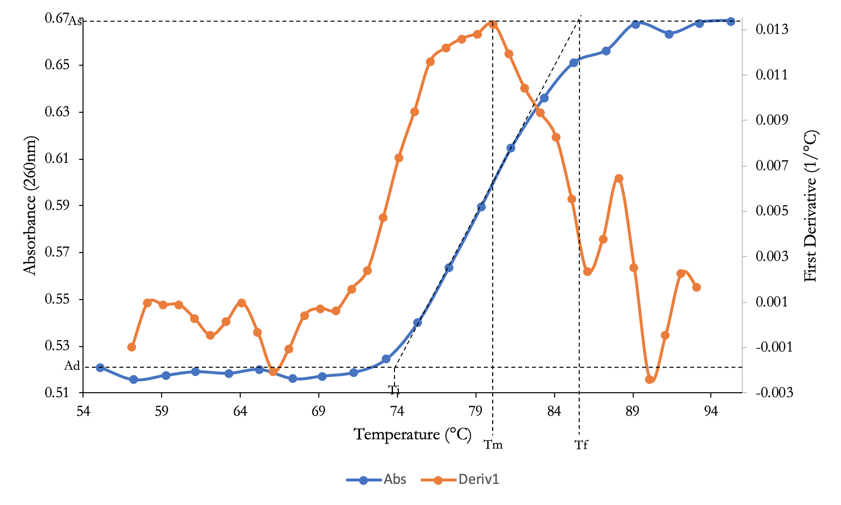
Figure 1. Thermal denaturation curve for commercial calf DNA in 15mM citrate buffer of pH 7 (Solution A). The 1 ml of stock commercial calf DNA (1:20 dilution) contains 50µL of stock commercial calf DNA added to a QURTZ cuvette and diluted in 950µL of 15mM citrate buffer of pH 7 and mixed via inversion. Using the Carry100Bio spectrophotometer this DNA sample is loaded to initiate the melting experiment to observe the effect of an increase in temperature (heat) on DNA via the absorbance values at 260nm. The two curves, blue shows the absorbance of commercial calf DNA at 260nm as a function of increasing temperature (ºC), and the orange curve depicts the slope (dA/dT) of the absorption curve (1st derivative) as a function of increasing temperature where the peak of curve represents, T_{m} , the melting temperature (approx. 80.5ºC), these curves are produced for this commercial DNA (absence of salt) by group 14. The T_{i} (74 ºC) is the initial temperature with T_{f} (85.7 ºC ) being the final temperature, indicating the range (ΔT) where a sudden hyperchromic shift (absorption) can occur. The A_{d} (0.52) value denotes the initial absorbance value of the double stranded denatured DNA in the absences of salt, and the A_{s} (0.67) represents the absorption of the single stranded DNA once denaturation is complete.

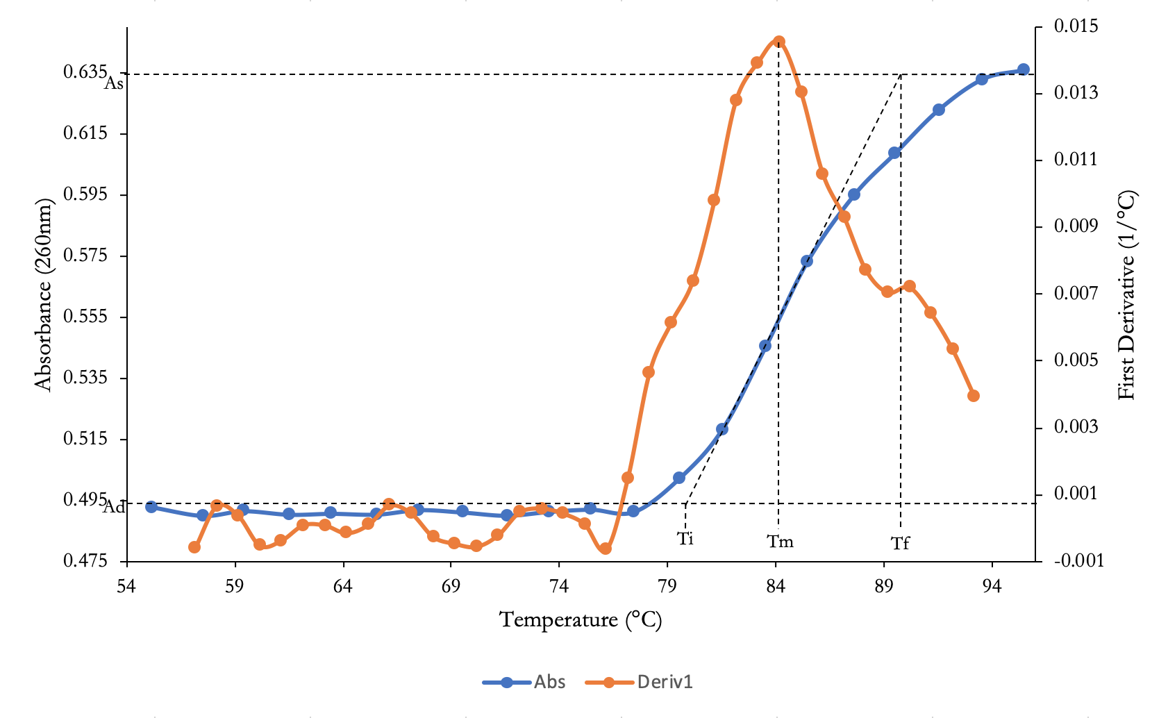Figure 2. Thermal denaturation curve for commercial calf DNA, in the presence of 0.03mM NaCIO₄ salt and 15mM citrate buffer of pH 7 (Solution B). The 1 ml of stock commercial calf DNA (1:20 dilution) contains 50µL of stock commercial calf DNA (with low [0.03mM NaCIO4 salt]) added to a QURTZ cuvette and diluted with 950µL of 15mM citrate buffer of pH 7 and mixed via inversion. Using the Carry100Bio spectrophotometer this DNA sample is loaded to initiate the melting experiment to observe the effect of an increase in temperature (heat) on DNA via the absorbance values at 260nm. The two curves, blue shows the absorbance of commercial calf DNA (with low [0.03mM NaCIO4 salt] at 260nm as a function of increasing temperature (ºC), and the orange curve depicts the slope (dA/dT) of the absorption curve (1st derivative) as a function of increasing temperature where the peak of curve represents, T_{m} , the melting temperature (approx. 84.1ºC), the curves produced for this commercial DNA of low [sat] is by group 11. The T_{i} (79.7ºC) is the initial temperature with T_{f} (90.0 ºC ) being the final temperature, indicating the range (ΔT) where a sudden hyperchromic shift (absorption) can occur. The A_{d} (0.49) value denotes the initial absorbance value of the double stranded denatured DNA in the absences of salt, and the A_{s} (0.64) represents the absorption of the single stranded DNA once denaturation is complete.
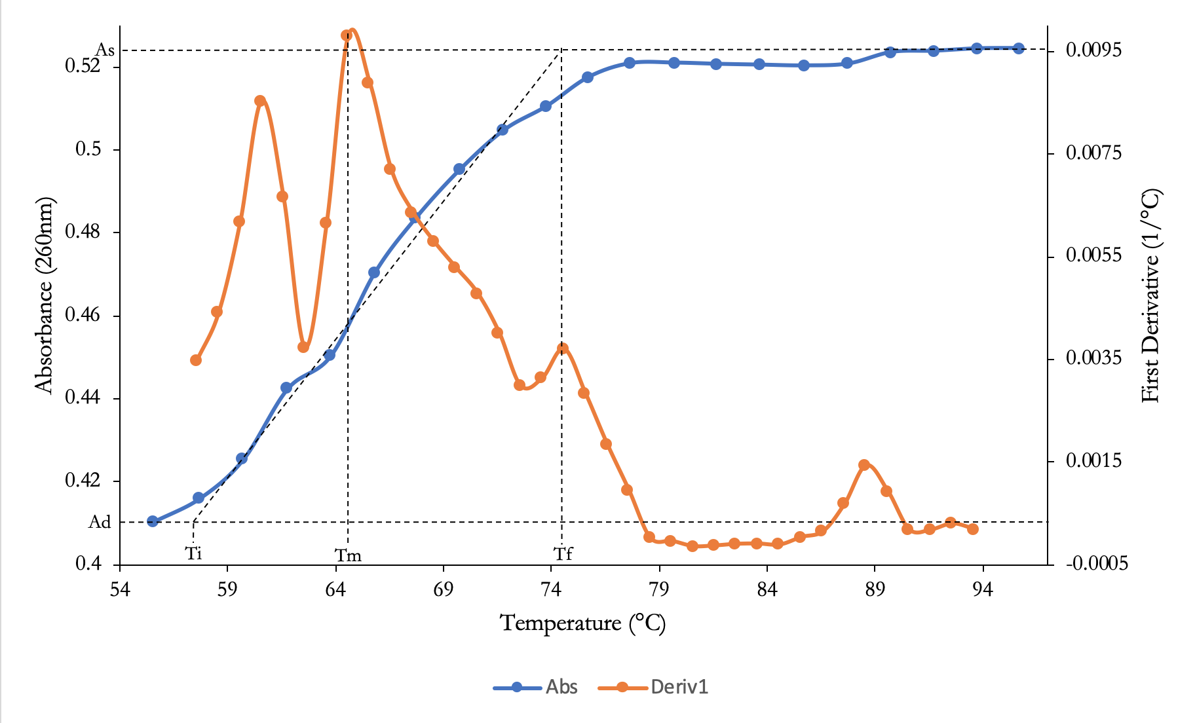

Figure 3. Thermal denaturation curve for commercial calf DNA, in the presence of 4.75mM NaCIO₄ salt and 15mM citrate buffer of pH 7 (Solution C). The 1 ml of stock commercial calf DNA (1:20 dilution) contains 50µL of stock commercial calf DNA (with low [4.75mM NaCIO4 salt]) added to a QURTZ cuvette and diluted with 950µL of 15mM citrate buffer of pH 7 and mixed via inversion. Using the Carry100Bio spectrophotometer this DNA sample is loaded to initiate the melting experiment to observe the effect of an increase in temperature (heat) on DNA via the absorbance values at 260nm. The two curves, blue shows the absorbance of commercial calf DNA (with low [4.75mM NaCIO4 salt] at 260nm as a function of increasing temperature (ºC), and the orange curve depicts the slope (dA/dT) of the absorption curve (1st derivative) as a function of increasing temperature where the peak of curve represents, T_{m} , the melting temperature (approx. 64.5ºC), the curves produced for this commercial DNA of high [sat] is by group 12. The T_{i} (57.5ºC) is the initial temperature with T_{f} (74.3 ºC ) being the final temperature, indicating the range (ΔT) where a sudden hyperchromic shift (absorption) can occur. The A_{d} (0.41) value denotes the initial absorbance value of the double stranded denatured DNA in the absences of salt, and the A_{s} (0.53) represents the absorption of the single stranded DNA once denaturation is complete.
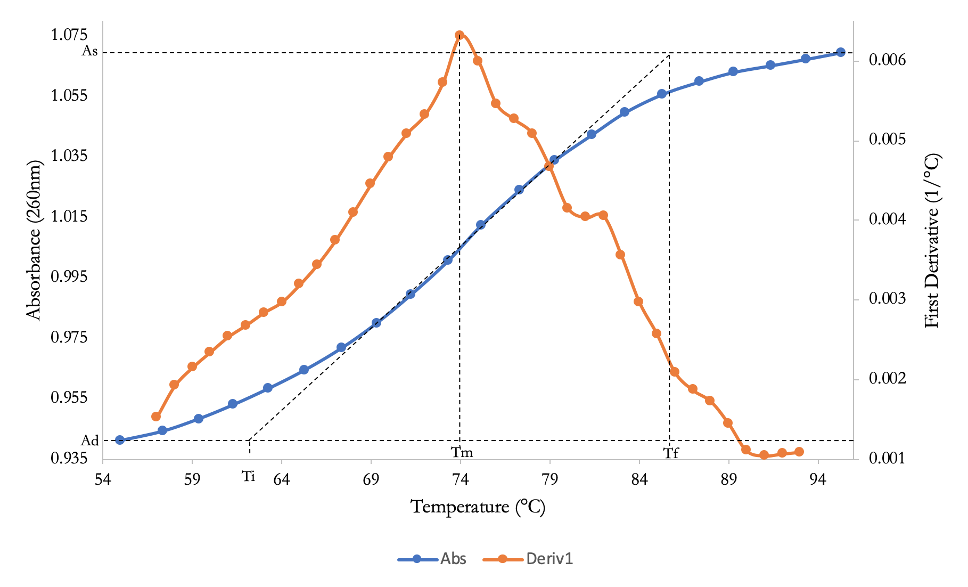
Figure 4. Thermal denaturation curve for extracted calf DNA (Solution D). 600mg of calf liver tissue provided in a 50 mL falcon tub was homogenized (via polytron) in 4mL of cold standard saline- EDTA (0.15 NaCl in 0.1 M EDTA, pH 8 with 100µg/mL RNAseA). The solution is mixed by gentle inversions with 375 µL of 25% sodium dodecyl sulfate (SDS) and incubated in 60⁰C water bath for 10 minutes before cooling to room temperature. Following the addition of 0.725mL of 6 M NaCLO₄ and 5 mL of chloroform: isoamyl alcohol (24:1,v/v) were mixed gently with the solution in a waver for 5 minutes. The resulting solution was centrifuged at 12000xg for 5 minutes having been balanced. Removal of upper 70% of aqueous phase into 15mL falcon tube was layered with 10mL of 95% ethanol, mixed until DNA precipitation. Resulting solution is centrifuged in 15mL tube at 3000g for 2 minutes where supernatant was decanted in sink and 2mL of 70% ethanol was added to the pellet and centrifuged again at 3000g for 2 minutes. Supernatant is decanted once again and EtOH is removed and pelted allowed to air dry for 10 minutes. Resuspended pellet in 2mL of 15mM citrate buffer and placed on a waiver for 5 minutes. Transfer of 1mL of resuspended pellet to 1.5mL microtube was centrifuged for 1 minute at 13,000 rpm. Produced a 1 mL 1:20 dilution containing 50µL of extracted DNA into a QURTZ cuvette and diluted with 950µL of 15mM citrate buffer of pH 7 and mixed via inversion. Using the Carry100Bio spectrophotometer this DNA sample is loaded to initiate the melting experiment to observe the effect of an increase in temperature (heat) on DNA via the absorbance values at 260nm. The two curves, blue shows the absorbance of extracted DNA at 260nm as a function of increasing temperature (ºC), and the orange curve depicts the slope (dA/dT) of the absorption curve (1st derivative) as a function of increasing temperature where the peak of curve represents, T_{m} , the melting temperature (approx. 74.0ºC), the curves produced for this extracted DNA is by group 14. The T_{i} (62.5ºC) is the initial temperature with T_{f} (86.0 ºC ) being the final temperature, indicating the range (ΔT) where a sudden hyperchromic shift (absorption) can occur. The A_{d} (0.94) value denotes the initial absorbance value of the double stranded denatured DNA in the absences of salt, and the A_{s} (1.07) represents the absorption of the single stranded DNA once denaturation is complete.

Table 1: Results of the thermal denaturation curve for both extracted and commercial DNA of varying salt concentrations. Resultant data collected from figures 1-4 is of DNA samples loaded into the Carry100Bio spectrophotometer this DNA sample is loaded to initiate the melting experiment to observe the effect of an increase in temperature (heat) on DNA via the absorbance values at 260nm. The two curves, blue shows the absorbance of extracted DNA at 260nm as a function of increasing temperature (ºC), and the orange curve depicts the slope (dA/dT) of the absorption curve (1st derivative) as a function of increasing temperature where the peak of curve represents, T_{m} , the melting temperature of DNA under different salt concentrations (0.03mM and 4.75 mM of NaClO₄). The temperature range (ΔT) indicates where a sudden hyperchromic shift (absorption) increase can occur at 260nm as the DNA strands are being denatured. This rang is approximated by the initial temperature (T_{i}) and final temperature (T_{f}) from the melting curves. The hyperchromicity (h%) is calculated from the ratio of the initial absorbance of double stranded DNA helix (A_{d}) and the final absorbance of denatured single stranded DNA (A_{s}). The ratio of hyperchromicity as a change in temperature (°C⁻¹) occurs, will be a result of the steepness of the sigmodal absorbance melting curve with a steep curve representing a pure and intact DNA.

DNA sample | T_{m} (°C) | ΔT (°C) | h (%) | h/ΔT (°C⁻¹)
a) Commercial | 80.5 | 11.7 | 28.8 | 2.47
b) Commercial + 0.03M NaClO4 | 84.1 | 10.3 | 29.0 | 2.82
c) Commercial + 4.75M NaClO4 | 64.5 | 16.8 | 28.5 | 1.70
d) Extracted DNA | 74.0 | 23.5 | 13.8 | 0.589
Sample Calculation For Commercial DNA Solution A
- The melting temperature (T_{m )} of commercial calf DNA without any salt , is the peak of the first derivative (dA/dT) plot which equals 80.5 °C.
Determine Change in Temperature $∆$T | Determining Hyperchromicity h (%) | Determining h/ΔT
The change in temperature was estimated from the sigmoidal absorbance curve of the commercial calf DNA at 260nm as a function of increasing temperature to determine to the initial temperature T_{i} where the commercial calf DNA began to denature when the absorbance increase to the final temperature when denaturing process was complete (single stranded DNA).  Variables: T_{i}=74°C , T_{f}= 85.7°C (estimated from absorbance curve from figure 1)  ΔT = T_{f} - T_{i}=85.7°C-74°C= 11.7°C  Therefore, the change in temperature is 11.7°C for the hyperchromic shift of commercial calf DNA without salt. | Hyperchromicity determines the purity of DNA with impure DNA having a hyperchromic shift less than 40%. It can also mean that the DNA is either partially denatured, shortened, or contaminated. The A_{d} represent the absorbance of the double stranded DNA helix before the DNA is denatured and the A_{s} represent the absorbance of the single stranded DNA after denaturation process is complete. The A_{s} was estimated from the absorbance curve shown by the plateau in the start of curve and the A_{d} shown by the plateau at the end of curve.  Variables: A_{d}=0.52, A_{s}=0.67  h= (A_{s}-A_{d})/A_{d} x 100  h= (0.67-0.52)/0.52 x 100  h= 28.846%  Therefore, the hyperchromicity for commercial calf DNA is 28.8%. | Variables: h=28.8% , ΔT= 11.7°C  h/ΔT =(28.2%/13°C)= 2.465°C⁻¹  Therefore, the ratio of hyperchromic shift to temperature change for denatured commercial calf DNA in absence of salt s 2.47°C⁻¹.

R3: Analyzing R2 Results:

The effects of salt (NaClO₄) on commercial DNA structure, which is analyzed by the parameter of the melting curves can vary depending on the concentration of salt present on commercial DNA. The structure of DNA can be analyzed from the absorbance of the denatured DNA over an increasing temperature and the 1st derivative curve showing the slope (dA/dT) of the absorbance curve over increasing temperature. The melting temperature (T_{m} ) of the commercial DNA in the presence of low concentration of salt (0.03M NaCLO₄ ) was estimated from the peak of the 1st derivative graph to be about 84.1°C, which is an increase in T_{m} from the commercial calf DNA (without salt) with a T_{m} of 80.5°C. The increase in melting temperature of the commercial calf DNA in the presence of low concentration of salt means that less energy was required to denature 50% of the DNA double helix in comparison to the commercial DNA in the absence of salt. The increase in T_{m} occurs when the salt has a low concentration in the range of 0.01M to 1M because the positively charged cations in the low concentration of salt shield the negative charges on the phosphate backbone of the double stranded DNA helix, reducing the interchain electrostatic repulsion that destabilizes the double stranded DNA when heated. The increase in stability of double DNA helix makes it more difficult to break the H-bonding that occurs between complementary base pairs holding the two single strands of DNA together. Therefore, the DNA helix need to be heated at a higher temperature (increasing energy) in order to separate 50 % of the strands in the DNA double helix.
The commercial calf DNA in the presence of high concentration of salt (4.75M NaCLO₄) had a T_{m} of 64.5 °C which far lower than the T_{m} of the commercial calf DNA in the absence of salt (80.5°C). It makes sense that the melting temperature of the DNA decreased in the presence of high concentrations of salt (higher than 1M) because at higher concentration of salt the anions in salt destabilize the double DNA structure by breaking the hydrogen bonding between the complementary base pairs in the two strands holding the DNA double helix together. Therefore, less energy/heat was required to separate 50% of the strands in the double helix allowing the DNA to denture at a low temperature. Therefore, the DNA under lower concentrations of salt have a higher melting temperature than the DNA in the presence of high salt concentrations. This means that the concentration of salt has an impact on the stability and therefore the overall structure of double helix DNA.
The hyperchromicity for commercial DNA in the presence of high concentration salt was 28.5% and hyperchromicity in the presence of low concentration of salt is 29.0% and 28.8% in the absence of salt. The hyperchromatic shift of less than 40% indicates that the commercial DNA under different conditions is relatively impure. The hyperchromatic shift results how that there isn’t much difference in the hyperchromicity for the commercial DNA meaning there isn’t much difference in the purity of the DNA when in the presence of different high concentration of salt, low concentrations of salt and in the absence of salt. However, the hyperchromicity of less than 40% can also mean that the DNA is partially denatured, shortened, or contaminated with UV absorbing materials since hyperchromicity is the increase in absorbance of DNA sample. It makes sense that there is a slight decrease in the hyperchromicity for the DNA in the presence of high concentration of salt (h=28.5%) in comparison to DNA in the absence of salt (h=28.8%) since higher salt concentration causes an increase in the amount of commercial calf DNA that is denatured (single stranded), leading to an increase in absorbance of the DNA and a smaller hyperchromicity in comparison to commercialized DNA without salt. The hyperchromicity of the DNA with low concentration of salt (h=29%) is slightly higher than the DNA in the absence of salt (h=28.8%) because low concentration of salt increases the stability of DNA causing a decrease in amount of DNA denatured resulting in a decrease in the absorbance of commercial DNA at low concentrations of salt in comparison to commercial DNA in absence of salt.
The ΔT for commercial calf DNA (11.7°C) is in between the ΔT for the commercial DNA in presence of low concentration of salt (10.3 °C) and the commercial DNA in presence of high concentration of salt (16.8 °C). This means that an increase in absorption of DNA (hyperchromatic shift) occurs over a wider temperature range for commercial DNA in presence of high concentration of salt and occurs over a shorter temperature range for commercial DNA in the presence of low concentration of salt. This makes sense because partially denatured DNA have a wider temperature range and since DNA in presence of high concentration of salt is more easily denatured compared to DNA in absence of salt or at low concentration of salt, it has a broader temperature range during the hyperchromic shift. The ratio of hyperchromicity over range of temperature is higher for the commercial calf DNA with low concentration of salt (2.82 °C⁻¹) in comparison to commercial calf DNA with high salt concentration of salt (1.699°C⁻¹). This means that the commercial DNA is more intact and purer at lower salt concentration since it has a steeper melting curve than that of the commercial DNA in presence of high concentration of salt.

R4: Analyzing Purity and Integrity of extracted DNA.

The T_{m} value of the extracted DNA is 74ºC, which is lower than the commercial DNA in the presence of low concentration of salt (0.03M NaClO₄) with a T_{m} of 84.1 ºC and commercial calf DNA without salt with a T_{m} of 80.5 ºC. However, the T_{m} for the extracted DNA (74 ºC) is higher than the T_{m} for commercial DNA in the presence of high concentration of salt (4.75M NaClO₄) with a T_{m} of 64.5 ºC . This results show that the stability of the extracted calf DNA decreased as a result of possible contaminants such as salt (6.0M NaClO₄), which was used for extraction of calf DNA, which was probably not completely removed causing it to be present in extraction sample. Contaminants of Salt with concentration of more than 1M was probably left in extracted sample, destabilizing the extracted double DNA helix. The high concentration of salt that must have contaminated DNA extract, could have disrupted the H-bonds between complimentary bases with less energy/heat in a similar way to the commercial DNA experimented in the presence of high concentration of salt. For this reason, the Tm values for the extracted DNA is lower than the Tm in the other commercial DNA samples and higher than the commercial DNA in presence of high concentration of salt.
The hyperchromicity for the extracted DNA is 13.8% which is much lower than 40% which proves that there is impurities present in the extracted DNA as was concluded earlier from the absorption ratios, testing for presence of protein contaminants. It is also possible that the extracted DNA is contaminated with EtOH or salt (6M NaClO4), which further lowers the hyperchromicity of the extracted DNA. Hyperchromicity can also be less than 40% if the DNA is partially denatured, shortened, or contaminated with UV materials. Therefore, it is possible that the calf DNA that was extracted was much shorter than the commercial DNA of a certain length causing, a lower hyperchromicity of extracted DNA in comparison to the commercial DNA without salt (28.8%), commercial DNA in high salt concentration (28.5%) and in low salt concentration (29.0%)
The shape of the melting curve for the extracted calf DNA can be used to determine the integrity and homogeneity for extracted DNA. The extracted DNA curve for the absorbance at 260nm at increasing temperature has a hyperchromic shift (increase in absorbance) that occurs over a wide temperature range with ΔT of 23.5ºC which is much higher than the temperature range for the commercial DNA in the absence of salt (11.7 ºC) and in the presence of high concentration of salt(16.8 ºC) and low concentration of salt (10.3 ºC). This means that the extracted DNA is heterogeneous and could have partially shorter DNA than that of the commercial calf DNA or can be contaminated with UV absorbing material such as protein, with aromatic amino acids. The heterogeneous nature of the extracted DNA could be the reason that the melting curve for absorbance of DNA at 260nm vs temperature is shown to be broad. The ΔT is calculated using the T_{i} which is the initial temperature at which the DNA begins to be denatured and the T_{f} which represents the final temperature at which the denaturing process of double DNA helix is complete. The h/ΔT ratio for the DNA extract is very small (0.589 ºC⁻¹) as shown by the less steep of a melting curve in comparison to that of the melting curves for the commercial DNA without and with salt. The small ratio of hyperchromicity to the change in temperature, indicates that the extracted calf DNA was impure and intact.

R5 : Results of Restriction Digestion and Gel Electrophoresis

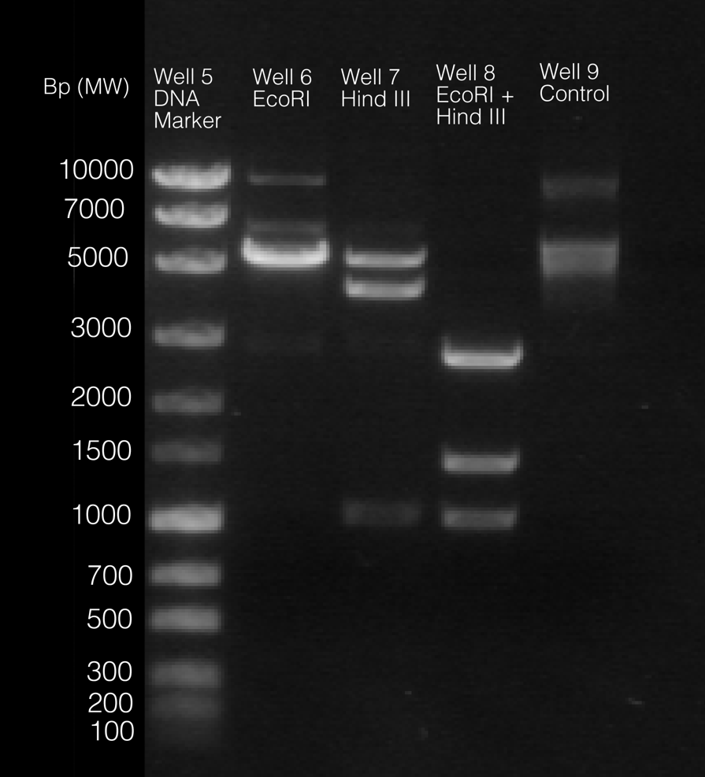

Figure 5: Agarose Gel electrophoresis showing digestion of unknown plasmid #37 with EcoRI and HindIII restrictive enzymes against a DNA ladder. Four microcentrifuge tubes are prepared via the addition of 6µL unknown plasmid #37 (100 ng/µL), 2µL of 10X digestion buffer O, and various amount of water with final 1µL of restriction enzymes EcoRI (10 U/µL) and HindIII(10 U/µL) with and no restriction enzymes added to the control sample tube. The tubes were centrifuged for 15 minutes and incubated in 37⁰C water bath for 1 hour. Once the digestion was completed, 2.2 µL of 10X DNA- electrophoresis loading buffer was added to each sample tube and mixed by shaking. The samples were added to pre-prepared gel #2 composed of composed of 100 ml of a 1% (w/v) agarose solution in TAE (40 mM tris-acetate, 1.0 mM EDTA) buffer and 10 µL of SyBr Safe DNA Stain. 15 µL of prepared samples were added to gel #2 in well 6 (EcoRI), well 7 (HindIII), well 8 (EcoRI + HindIII), well 9(control). 10 µL of Mass Ruler Express Forward DNA ladder marker was added to well 5 by TA and the electrophoresis was run at 100V for 45 minutes . Ta instructed to ignore faded top bands in EcoRI well 6 and to use bottom and middle band in HindIII (well 7). The shorter fragments appear lower on the gel and the larger fragments appear higher on the electrophoresis.

Table 2: The migration distance and the Log(Mw) of the marker DNA fragments to map the unknown plasmid #37.15 µLof the 4 samples containing water, 6µL plasmid 37, 2µL 10X buffer, and lastly 1 µL of EcoRI (10 U/µL) and HindIII(10 U/µL) were loaded in well 6(EcoRI), well 7(HindIII), well 8(EcoRI + HindIII), well 9(control-no enzymes) of pre-prepared gel 1 composed of 100 ml of a 1% (w/v) agarose solution in TAE (40 mM tris-acetate, 1.0 mM EDTA) buffer and 10 µL of SyBr Safe DNA Stain. There was 10 µL of Mass Ruler Express Forward DNA ladder marker added to well 5 by TA. The molecular weights were obtained from the DNA MassRuler Express Forward DNA Ladder which constitutes of 12 DNA fragments varying in size from 100 bp to 10,000 bp. The migration distance of each DNA marker was measured, in cm, using a ruler from the entry point of the well to the center of the DNA markers(C5 of lab manual). The values of the Log (Mw) and the migration distance (cm) of the DNA markers on gel were used to estimate the MW of all DNA fragments in each well to map the unknown plasmid #37 and to identify control sample containing undigested plasmid.

Migration distance (cm) | MW of DNA marker bands (bp) | Log (MW)
1.85 | 10,000 | 4.00
2.15 | 7000 | 3.84
2.45 | 5000 | 3.70
3.00 | 3000 | 3.48
3.45 | 2000 | 3.30
3.85 | 1500 | 3.18
4.30 | 1000 | 3.00
4.65 | 700 | 2.84
4.95 | 500 | 2.70
5.35 | 300 | 2.48
5.55 | 200 | 2.30
5.65 | 100 | 2.00

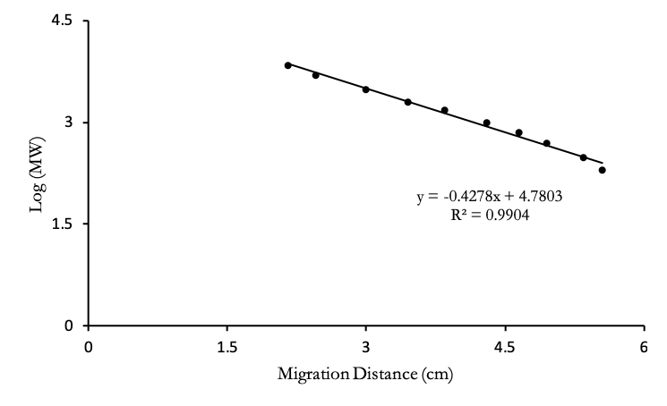
Figure 6: Plot of the Log(MW) vs. migration distance of DNA marker in gel electrophoresis to map out the unknown plasmid #37. Four samples test tubes were prepared by adding various amounts of water, 6µL unknown plasmid #37, 2 µL 10X Buffer, and lastly 1 µL of EcoRI (10 U/µL) and HindIII(10 U/µL) with no enzymes in control sample. Tubes centrifuged (15 min.) and incubated in 37⁰C water bath for 1 hour and 2.2 µL of 10X DNA- electrophoresis loading buffer was added to each sample tube after digestion was complete. Then, 15µL of the 4 samples were loaded in well 6(EcoRI), well 7(HindIII), well 8(EcoRI + HindIII), well 9(control) of pre-prepared gel 1 composed of 100 ml of a 1% (w/v) agarose solution in TAE (40 mM tris-acetate, 1.0 mM EDTA) buffer and 10 µL of SyBr Safe DNA Stain.Also 10 µL of Mass Ruler Express Forward DNA ladder marker was added to well 6 by TA. The migration distance of each DNA marker was measured, in cm, using a ruler from the entry point of the well to the center of the DNA fragments band. Ta instructed to ignore faded top bands in EcoRI well 6 and to use bottom and middle band in HindIII (well 7). The measured migration distance of DNA markers plotted against log (MW) having a linear regression line with equation of y=-0.4278x+4.7803 was used to calculate the MW of the bands in each of the wells. The data points at the ends of regression line for migration distance of 1.85cm and 5.65cm were eliminated to improve the R² value (0.9904) so its closer to 1 (mentioned in appendix C5).

Table 3: The migration distance and the molecular weight of the control plasmid and the fragments digested by restriction enzymes (EcoRI and HindIII). Four samples test tubes were prepared by adding various amounts of water, 6µL unknown plasmid #37, 2 µL 10X Buffer, and lastly 1 µL of EcoRI (10 U/µL) and HindIII(10 U/µL) with no enzymes in control sample. Tubes centrifuged (15 min.) and incubated in 37⁰C water bath for 1 hour and 2.2 µL of 10X DNA- electrophoresis loading buffer was added to each sample tube after digestion was complete. Then, 15µL of the 4 samples were loaded in well 6(EcoRI), well 7(HindIII), well 8(EcoRI + HindIII), well 9(control) of pre-prepared gel 1 composed of 100 ml of a 1% (w/v) agarose solution in TAE (40 mM tris-acetate, 1.0 mM EDTA) buffer and 10 µL of SyBr Safe DNA Stain.Also 10 µL of Mass Ruler Express Forward DNA ladder marker was added to well 6 by TA. The migration distance of each DNA marker was measured, in cm, using a ruler from the entry point of the well to the center of the DNA fragments band. Ta instructed to ignore faded top bands in EcoRI well 6 and to use bottom and middle band in HindIII (well 7). The measured migration distance of DNA markers plotted against log (MW) having a linear regression line with equation of y=-0.4278x+4.7803 was used to calculate the MW of the bands in each of the wells. The data points at the ends of regression line for migration distance of 1.85cm and 5.65cm were eliminated to improve the R² value (0.9904) so its closer to 1 (mentioned in appendix C5).
Well # | Restriction Enzymes | Band Location | Migration  Distance (cm) | Molecular  Weight  (base pairs)
6 | EcoRI | 1st band (top) | 2.35 | 5956
7 | HindIII | 1st band (top) | 2.65 | 4432
7 | HindIII | 2nd band (bottom) | 4.30 | 872
8 | HindIII  +  EcoRI | 1st band (top) | 3.15 | 2709
8 | HindIII  +  EcoRI | 2nd band (middle) | 3.95 | 1232
8 | HindIII  +  EcoRI | 3rd band (bottom) | 4.3 | 872
9 | *Control | 1stband  (Nicked/open circle) | 1.95 | 8833
9 | *Control | 2ndband (supercoiled) | 2.5 | 5138
Calculations for Determining the Molar Weight of the DNA fragments of Unknown Plasmid #37 digested by Restriction Enzymes (HindIII and EcorRI) in Each Sample
Regression Line: y=-0.4278x+4.7803

Well 6 Calculation for MW (bp) of DNA Fragment Digested by Restrictive Enzyme EcorRI | Well 7 Calculation for MW (bp) of DNA Fragment Digested by Restrictive Enzyme HindIII
Migration distance first band (cm): x= 2.35cm (in table 3)  y=-0.4278x+4.7803  y=-0.4278(2.35)+4.7803  y= 3.77497  y= log(MW)  3.77497 =log(MW)  MW= 10^{3.77497}=5956.209981 bp  Therefore, the molar weight of the fragment cut by the restriction enzyme, EcorRI that makes a cut at one site of plasmid #37 is 5956 base pairs. | MW of first Band (HindIII) Migration distance first band (cm): x= 2.65 cm (in table 2)ds  y=-0.4278x+4.7803  y=-0.4278(2.65)+4.7803  y=3.64663  y= log(MW)  3.64663=log(MW)  MW= 10^{3.64663}=4432.308696 bp  2) MW of second Band (HindIII) Migration distance second band (cm): x= 4.30 cm (in table 2)  y=-0.4278x+4.7803  y=-0.4278(4.30)+4.7803  y=2.94076  y= log(MW)  2.94076=log(MW)  MW= 10^{2.94076}=872.4890bp
Therefore, the molar weight of the fragment cut by the restriction enzyme, HindIII that makes a cut at two sites of plasmid #37 with first band (larger fragments) is 4432bp and second band (shorter fragment) is 872bp.

Well 8 Calculation for MW (bp) of DNA Fragment Digested by Restrictive Enzymes HindIII + EcorRI
MW of first Band-Top (HindIII + EcorRI) Migration distance first band (cm): x= 3.15 m (in table 3)  y=-0.4278x+4.7803  y=-0.4278(3.15)+4.7803  y=3.43273  y= log(MW)  3.43273=log(MW)  MW= 10^{3.43273}=2708.507235bp | MW of second Band-middle (HindIII + EcorRI) Migration distance second band (cm): x= 3.95cm (in table 3)  y=-0.4278x+4.7803  y=-0.4278(3.95)+4.7803  y=3.09049  y= log(MW)  3.09049=log(MW)  MW= 10^{3.09049}=1231.657625bp | MW of Third Band-Bottom (HindIII + EcorRI) Migration distance third band (cm): x= 4.3cm (in table 3)  y=-0.4278x+4.7803  y=-0.4278(4.30)+4.7803  y=2.94076  y= log(MW)  2.94076=log(MW)  MW= 10^{2.94076}=872.4890bp
Therefore, the fragment cut by the restriction enzyme, HindIII that makes a cut at two sites of plasmid #37 producing 2 fragments and EcoRI that makes one cut forming 1 fragment therefore producing a total of 3 fragments with MW’s of 2709bp, 1232bp, and 872bp.

Well 9 Calculation for MW (bp) of Undigested DNA plasmid #37
MW of first Band (Nicked/open circle)  Migration distance first band (cm): x= 1.95 m (in table 3)  y=-0.4278x+4.7803  y=-0.4278(1.95)+4.7803  y=3.94609  y= log(MW)  3.94609=log(MW)  MW= 10^{3.94609}=8832.629224bp | MW of second Band (supercoiled) Migration distance second band (cm): x= 2.5cm (in table 3)  y=-0.4278x+4.7803  y=-0.4278(2.5)+4.7803  y=3.7108  y= log(MW)  3.7108=log(MW)  MW= 10^{3.7108}=5138.069802bp
Therefore, the molar weight of the undigested plasmid which seems to have a possible conformation of the nicked form with a MW of 8833 bp and a supercoiled form with a MW of 5138bp.

R6: Three Digested Sample Plasmid Map
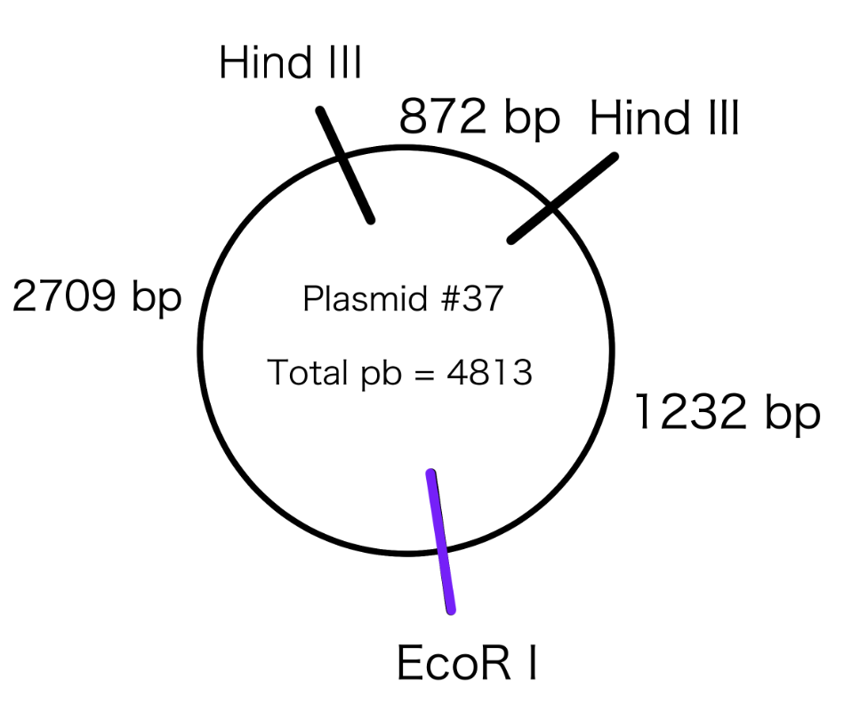
EcoRI + HindIII:
1st band-Top= 2709 bp
2nd band-middle= 1232 bp
3rd band-bottom=872 bp

Figure 7: The Map of Plasmid #37 determined using fragments produced by restriction enzyme EcoRI and HindIII. The plasmid map shows the approximate location of the restriction enzymes EcoRI and HindIII determined from the migration distance of the fragments show in gel electrophoresis, produced by the digestion of plasmid by each enzyme. The restriction enzyme EcoRI made a cut at 1 location on plasmid #37 producing one fragment (well 6) with MW calculated to be 5956bp and two cuts made by restriction enzyme HiiIII producing two fragments(well 7) with MW calculated to be 4432bp (top band) and 872bp (bottom band). The MW of fragments digested by both enzymes produced 3 fragments (well 8) for which the values were used to map out the plasmid #37. The fragments digested by both restrictive enzymes have a MW of 872bp (bottom band), 1232bp (middle band), and 2709bp(top band). The linear equation from migration distance of DNA markers vs log(MW) plot that was used to calculate the MW of fragments is : y=-0.4278x+4.7803. The total size of unknown plasmid #37 is approximately 4813bp (added all fragments). The migration distance of the lower band appearing in the control well 9 undigested plasmid has a nicked conformation. Ta instructed to ignore faded top bands in EcoRI well 6 and to use bottom and middle band in HindIII (well 7).

R7: Analysis of Gel Electrophoresis

Based on the bands appearing in control well of gel electrophoresis (figure 5), the undigested plasmid #37 can be interpreted as having a nicked and or open circle conformation because the bands shown can be interpreted as being nicked due to the thin higher band. Usually, in vivo and or plasmid DNA is often a tightly supercoiled circle, this allows it to during laboratory prep this plasmid will remain supercoiled, although some will sustain single-strand nicks. IF such a nick is present it one of the strands, the DNA will remain circular, but it can now rotate around the phosphodiester backbone and the supercoils will be released but will travel much less due to sustaining far greater friction than small compact supercoiled will. Supercoiled plasmid often experiences less friction against the agarose matrix than does a large nicked/open circle plasmid DNA. Meaning that for the same over-all size a supercoiled DNA will be able to run have a larger migration distance than does open-circular DNA. In comparison to enzyme restriction linear DNA it will run through a gel end first and thus sustains less friction than open-circular/nicked DNA, but more than supercoiled. This then reasons that the undigested plasmid seen in well 9 is in fact nicked and one cannot see the supercoiled as it would have travelled farther than the linear restriction enzymes cut DNA. Thus, in theory an uncut plasmid produces two bands on a gel, representing the oc (open cut/nicked) and ccc (compact -supercoiled) conformations, but once can only see the band of the nicked in this gel.
The digestion of overall plasmid seems to be completely digested by EcoRI and HindIII because there are a total of 3 fragments produced by both restrictive enzymes as shown in well 8, by making a total of 3 cuts on plasmid, with 2 cuts made from HindIII enzymes producing 2 fragments as shown by the two bands in well 7 (told to ignore middle band), and 1 cut from EcoRI producing one fragment as shown in well 6 (ignore upper light band). The nicked undigested plasmid shown by control well 9 appears to be higher on the electrophoresis in comparison to the fragments of the plasmid produced by the HindIII and EcoRI restriction enzymes in well 8 because the nicked form mimics the DNA fragment longer than its linear form and because the linear form of DNA has greater surface area the nicked undigested plasmid (even longer/linear fragment) experiences more resistance and travels slower through gel than the linear fragments completely digested. Therefore, we know that the dark bands (well 8) appearing below the band for undigested nicked plasmids (well 9) represent fully digested shorter linear fragments of plasmid. Overall, the plasmid is assumed to be completed digested in the presence of both enzymes (EcoRI and HindIII).

