Laboratory 2: Amino Acids and Proteins

By: Sami Aftab Abdul (300018542)

Section Z04 (Monday Afternoon 2nd week)
TEAM #: 14

Lab Partner: Nishwara Tarannum (300019212)
Demonstrator (TA): Jonathon Emlaw

Due Date: February 04, 2019
Date Lab Performed: February 11, 2019

University of Ottawa
Biochemistry Laboratory BCH 2333

Purpose:

This lab focuses on understanding the properties of three different amino acids and an unknown protein. The method of ion-exchange chromatography is used to separate the original mixture of amino acids, aspartic acid, glycine and lysine. The mixture is separated based on pKa, ionic, acid/basic properties including charge density amongst functional groups within the column. The charges amongst the amino acids in the ion-exchange chromatography interact with the negatively charged beads. To systematically isolate the mixture into separated solutions, the charge of the amino acid must unbind itself from the ionic interaction with the negatively charged beads. This is done by adding an increasing pH buffer eluent. The amino acid net charge reaches an isoelectric point where the amino acid can pass through the column. This method is useful as different amino acids reach this isoelectric point (no net charge) at different points due to their functional groups and will elute out with the buffer in a systematic process as the pH gradient increase. The corresponding collected fractions have been tested with ninhydrin, an assay that tests for the presence of amino acids by producing a violet color in response to its reactivity with the alpha-amino group. The method of polyacrylamide gel electrophoresis is an approach to determining the molecular weight of an unknown protein and to quantify this by correlating the distance traveled by the protein against a protein ladder. Proteins lager in size travel a shorter distance compared to smaller proteins. By plotting the distance traveled against log(MW) of the ladder protein markers, the molecular weight of the unknown protein can be determined by substituting the distanced travelled by the unknown protein into the linear regressed equation. This lab allows for an application of knowledge surrounding amino acids properties in a setting that uses various techniques to verify composition and structure of amino acids using scientific instruments and procedures.

Results and Discussion:

R1. Chemical Structure at a pH of 3.9 & Calculated pl of each Amino Acid

Note: The value for the pka side chains/functional groups were taken from Maria Musgaard’s Lecture note 5, posted on bright space

Glycine | Aspartic Acid | Lysine
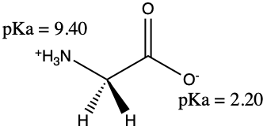 | 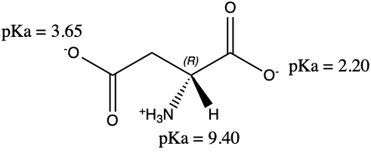 | 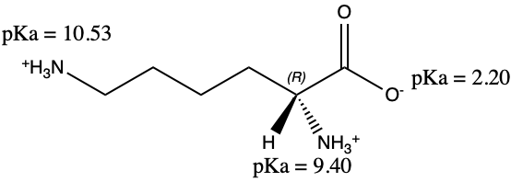
Isoelectric Point (pl):  pKa_{NH3}⁺ = 9.40  pKa_{COOH} = 2.20  pl = ½ (pKa_{COOH} + pKa_{NH3}⁺)  pl = ½ (2.20 + 9.40)  pl = 5.80  Therefore, the isoelectric point for the amino acid glycine is 5.80. | Isoelectric Point (pl):  pKa_{NH3+} = 9.40  pKa_{COOH} = 2.20  pKa_{side chain} = 3.65  pl = ½ (pKa_{COOH} + pKa_{side chain})  pl = ½ (2.20 + 3.65)  pl = 2.93  Therefore, the isoelectric point for the amino acid aspartic acid is 2.93. | Isoelectric Point (pl):  pKa_{NH3+} = 9.40  pKa_{COOH} = 2.20  pKa_{side chain} = 10.53  pl = ½ (pKa_{NH3+} + pKa_{side chain})  pl = ½ (9.40 + 10.53)  pl = 9.97  Therefore, the isoelectric point for the amino acid lysine is 9.97.
To determine the charge on each function group of these amino acids at a pH of 3.9, the pKa of each functional group must be taken into account. When the pKa of a functional group is less than that of the pH, it would be negatively charged or deprotonated. If the pKa is greater than the pH, the resulting functional group will be positively charged or protonated. The net charge of the amino acid is 0 when the pH is equal to the isoelectric point (pl) of the amino acid calculated above.

R2. Ion-Exchange Chromatography Results/Calculations

Table#1: Ion-exchange chromatography column elution results of an amino acid mixture containing aspartic acid, glycine, and lysine. The 4mL amino acid mixture of 2.5mM glycine, 2.5mM lysine and 2.5mM aspartic acid is added to the cation exchange resin DOWEX-50W-X pre-packed with 0.1M NaH₂PO₄ of pH 4.0. that behaves as a strong acid at a pH of 3. The amino acid mixture was eluted with the buffer gradient of 0.1M NaH₂PO₄ of pH 4.0 and 0.1M Na2HPO4 of pH12.5 passing through the resin column to the fraction collector set to 120 drops into 16 test tubes. The average volume per test tube is 4.46mL. Positive control tests were made for each amino acid and a blank, each with 100μL of NaH₂PO₄ of pH 4.0. 100μL of each 16 fractions were added to sperate test tubes recording pH and adding 100μL of ninhydrin, vortex and heated to 100°C for 15 mins to all 20 test tubes. After incubation 2.5mL of ethanol-ether is added to all 20 test tubes, and absorbance values are recorded via a spectrophotometer at 570nm. The absorbance of the positive controls is (a)0.953, (b)0.786, (c)1.100, and (d)0.085, corresponding to 1.0mM glycine, 1.0mM aspartic acid, 1.0mM lysine, and the blank solution respectively. The first fraction had a negative corrected absorption and subsequently a zero concentration.

Fraction # | Elution Volume (mL) | pH | A570 | A570 Corrected | Concentration  (mM) | μmole
1 | 4.46 | 4.10 | 0.053 | -0.032 | 0.00 | 0.00
2 | 8.92 | 4.07 | 0.114 | 0.029 | 0.041 | 0.184
3 | 13.38 | 4.11 | 0.101 | 0.016 | 0.023 | 0.102
4 | 17.84 | 4.28 | 0.880 | 0.795 | 1.13 | 5.04
5 | 22.3 | 4.15 | 0.565 | 0.48 | 0.685 | 3.05
6 | 26.76 | 4.15 | 0.374 | 0.289 | 0.412 | 1.84
7 | 31.22 | 5.42 | 0.509 | 0.424 | 0.605 | 2.70
8 | 35.68 | 6.54 | 0.481 | 0.396 | 0.456 | 2.03
9 | 40.14 | 6.98 | 0.368 | 0.283 | 0.326 | 1.45
10 | 44.6 | 7.44 | 0.252 | 0.167 | 0.192 | 0.858
11 | 49.06 | 9.33 | 0.436 | 0.351 | 0.404 | 1.80
12 | 53.52 | 10.73 | 0.261 | 0.176 | 0.173 | 0.773
13 | 57.98 | 11.25 | 0.586 | 0.501 | 0.494 | 2.20
14 | 62.44 | 11.49 | 0.527 | 0.442 | 0.435 | 1.94
15 | 66.9 | 11.67 | 0.446 | 0.361 | 0.356 | 1.59
16 | 71.36 | 11.84 | 0.443 | 0.358 | 0.353 | 1.57

Sample Calculations:

Fraction Volume Calculation | Elution Volume Calculation | Corrected A570 Calculation
Volumes: 4.49mL, 4.25mL, 4.46mL  $\text{Average Fraction Volume= }\frac{\text{v1+v2+v3}}{\text{3}}$  $$=\frac{\text{4.49mL+4.25mL+4.46mL}}{\text{3}}$$  $$\text{=4.46mL }$$  Therefore, the average fraction volume is 4.46mL. | Fraction #3 via Table 1.  Volume Eluted Fraction 3 = =3(4.46mL)  =13.38 mL  Therefore, the volume eluted up until fraction 3 is 13.38mL. | Fraction #5via Table 1.  A_{blank(d)} = 0.085  A_{fraction 5} =0.565  A_{corrected fraction 5} = A_{fraction 5} - A_{blank(d)}  A_{corrected fraction 5} =0.565 - 0.085  A_{corrected fraction 5} =0.480

The pl calculated for aspartic acid is approximately 2.93, the corresponding fraction values for when this amino acid elutes is fractions 2-7. This is based on the pH range up until 6.42 or fraction 8 which elutes for glycine. Fraction #4 has a peak absorbance within the fractions indicated and it is assumed to have the greatest concentration of aspartic acid. | The pl calculated for glycine is approximately 5.80. The corresponding fraction values for when this amino acid elutes is fraction 8-11. This is based on the pH range up until 10.73 or fraction 12 which elutes for lysine. Fraction 11 has a peak absorbance within the fractions indicated and it is assumed to have the greatest concentration of glycine. | The pl calculated for lysine is approximately 9.97. The corresponding fraction values for when this amino acid elutes is fractions 12-16. This is based on the pH range remaining as it is basic enough to protonate the whole amino acid. Fraction #13 has a peak absorbance within the fraction indicated and it is assumed to have the greatest concentration of lysine.
Conc. of Aspartic Acid in Fraction 4 | Conc. of Glycine in Fraction 11 | Conc. Lysine in Fraction 13
A_{b=corrected aspartic} = A_{Aspartic} - A_{blank(d)}  A_{b}= 0.786-0.085 = 0.701  C_{b}=1.0mM  A₄=0.795  C₄=$\frac{\text{(A}\text{4}\text{)(}\text{C}\text{b}\text{)}}{\text{A}\text{b}}$  C₄=$\frac{\text{(0.}\text{795}\text{)(1.0mM)}}{\text{(0.701)}}$  C₄=1.134094151mM  C₄=1.13mM  Therefore, the conc. of aspartic acid in fraction #4 is 1.13mM. | A_{a=corrected Glycine} = A_{Glycine} - A_{blank(d)}  A_{a}= 0.953-0.085 = 0.868  C_{a}=1.0mM  A₁₁=0.351  C₁₁=$\frac{\text{(A}\text{11}\text{)(}\text{C}\text{a)}}{\text{A}\text{a}}$  C₁₁=$\frac{\text{(0.}\text{351}\text{)(1.0mM)}}{\text{(0.}\text{868}\text{)}}$  C₁₁=0.4043778802mM  C₁₁=0.404mM  Therefore, the conc. of glycine in fraction #11 is 0.404mM. | A_{c=corrected Lysine} = A_{Lysine} - A_{blank(d)}  A_{c}= 1.100-0.085 = 1.015  C_{c}=1.0mM  A₁₃=0.501  C₁₃=$\frac{\text{(A}\text{13}\text{)(}\text{C}\text{c}\text{)}}{\text{A}\text{c}}$  C₁₃=$\frac{\text{(0.}\text{501}\text{)(1.0mM)}}{\text{(}\text{1.015}\text{)}}$  C₁₃=0.4935960591mM  C₁₃=0.494mM  Therefore, the conc. of lysine in fraction #13 is 0.494mM.
µmole of Aspartic Acid in Fraction 4 | µmole of Glycine in Fraction 11 | µmole of Lysine in Fraction 13
C₄=1.13mM  V_{avg}= 4.46mL (1L/1000mL)  V_{avg}= 4.46$×$10⁻³L  n=(V_{avg})(C₄)  n=(4.46$\text{×}$10⁻³L)(1.13mM)  n=5.0398$\text{×}$10⁻³mmole ($\frac{\text{1000µmole}}{\text{1mmole}}$)  n=5.0398µmole  n=5.04µmole  Therefore, the µmole of aspartic acid in fraction 4 is 5.04µmole. | C₁₁=0.404mM  V_{avg}= 4.46mL (1L/1000mL)  V_{avg}= 4.46$×$10⁻³L  n=(V_{avg})(C₁₁)  n=(4.46$\text{×}$10⁻³L)(0.404mM)  n=1.80184$\text{×}$10⁻³mmole ($\frac{\text{1000µmole}}{\text{1mmole}}$)  n=1.80184µmole  n=1.80µmole  Therefore, the µmole of glycine in fraction 11 is 1.80µmole. | C₁₃=0.494mM  V_{avg}= 4.46mL (1L/1000mL)  V_{avg}= 4.46$×$10⁻³L  n=(V_{avg})(C₁₃)  n=(4.46$\text{×}$10⁻³L)(0.494mM)  n=2.20324$\text{×}$10⁻³mmole ($\frac{\text{1000µmole}}{\text{1mmole}}$)  n=2.203224µmole  n=2.20 µmole  Therefore, the µmole of lysine in fraction 13 is 2.20µmole.

R3 Plot of pH and Concentration versus Elution Volume
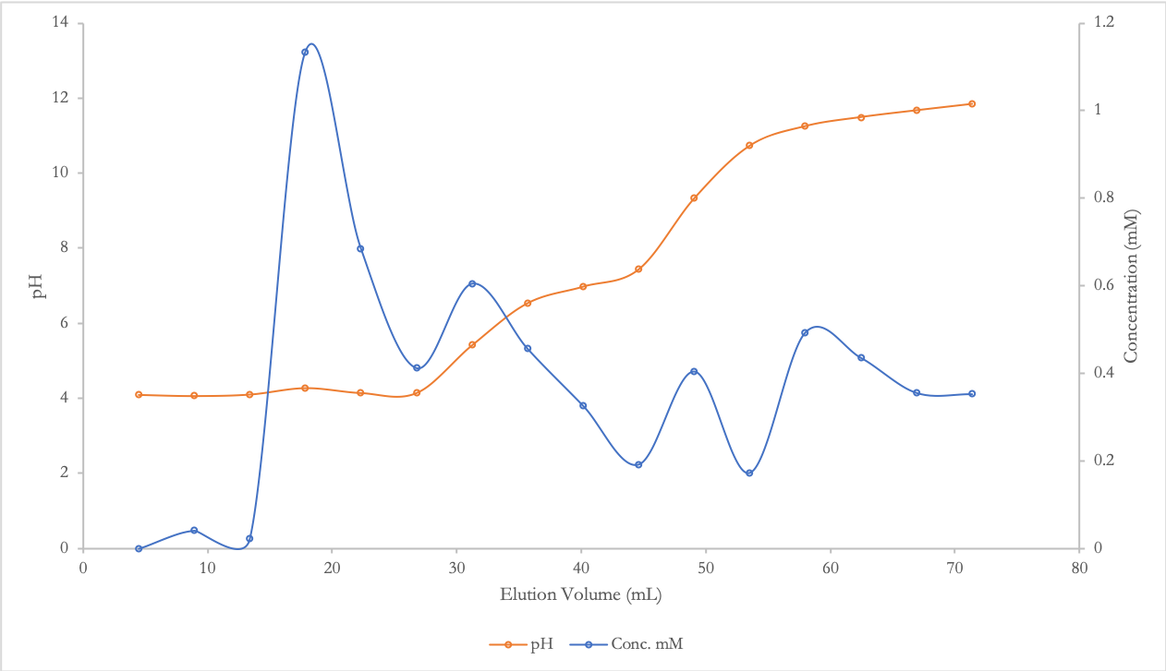Figure 1. The pH and Concentration versus the elution volume of a mixture of aspartic acid, glycine and lysine. The 4mL amino acid mixture of 2.5mM glycine, 2.5mM lysine and 2.5mM aspartic acid is added to the cation exchange resin DOWEX-50W-X pre-packed with 0.1M NaH₂PO₄ of pH 4.0. that behaves as a strong acid at a pH of 3. The amino acid mixture was eluted with the buffer gradient of 0.1M NaH₂PO₄ of pH 4.0 and 0.1M Na2HPO4 of pH12.5 passing through the resin column to the fraction collector set to 120 drops into 16 test tubes. The average volume per test tube is 4.46mL. The average fraction volume is used to determine the subsequent accumulated elution volume for each of the 16 fractions. The pH of each fraction is measured using a pH meter. The standard solutions of 1.0mM glycine, 1.0mM aspartic acid, 1.0mM lysine were utilized in determining the concentration of amino acids in the fraction test tube solutions. The standard solutions made for each amino acid and a blank were each combined with 100μL of NaH₂PO₄ of pH 4.0. 100μL of the 16 fractions were added to sperate test tubes recording pH and adding 100μL of ninhydrin, vortex and heated to 100°C for 15 mins to all 20 test tubes. After incubation 2.5mL of ethanol-ether is added to all 20 test tubes, and absorbance values are recorded via a spectrophotometer at 570nm. The blue curve corresponds to the concentration of each amino acid for which aspartic acid corresponds to fractions 2-7, glycine 8-11, and lysine 12-16. The orange curve showcases the pH of each fraction.

The relative peaks at which each amino acid eluted at greatest concentration is clearly indicated in figure 1. The peak or elution volume at which aspartic acid eluted with greater concentration is 17.84 mL or fraction #4. This peak and the range of 2-7 fractions corresponding to the elution of aspartic acid is due to it having the lowest pl and thus, will have a net change (isoelectric point) of zero when the pH is close to and below 5.80. 5.80 is the upper limit due to a pH of that eluting glycine. Glycine and mentioned has a lower limit of 5.80 and upper limit observational limit of 9.97(Lysine). Glycine’s peak concentration was eluted at a volume of 49.06mL with a fraction range of 8-11. This means that the glycine’s isoelectric point of 5.80 indicates the molecule achieves a net charge of zero to untether the ionic attraction to the negatively charged beads and elute out is correspondent to the fraction’s numbers of 8-11. Lastly the peak for lysine is 57.98mL or a fraction number of 13. This peak is quite close to that of glycine and this can be explained as by the quick pH change between the surrounding three fractions, and as a result the isoelectric point was achieved allowing for the elution of the lysine amino acid. It is also assumed that since ninhydrin is used to assess the concentration of amino acid the presence of continual elution of glycine during the expected range of lysine may contribute to such values, and the assumption for the calculations for each amino acid will stay within their respective pH upper and lower limits to simplify interpretation quantitatively. A possible method in improving the distribution of when each amino acid is eluted, is to control the pH changes in such a way that the buffer changes even more slowly, allowing more time between the amino acids to reach their isoelectric point to pass through the negatively charged resin. Another way is to use stains that target each specific amino acid’s side chain and pKa for better resolution distribution.
R4. Amino Acid Recovery and Percentage Recovery

Experimental Moles of Aspartic Acid | Theoretical Moles of Aspartic Acid | Recovery Yield of Aspartic Acid.
For Fractions 2-7  n₂= 0.184 μmole  n₃= 0.102 μmole  n₄= 5.04 μmole  n₅= 3.05 μmole  n₆= 1.84 μmole  n₇= 2.70 μmole  n_{experimental} =n₁+n₂+n₃+n₄+n₅+n₆+n₇  n_{experimental} = 12.9 μmole (1mole/1000000μmole)  n_{experimental} = 1.29x10⁻⁵ moles  Therefore, the experimental moles of aspartic acid in fractions 2-7 is 12.9346362 μmole. | V_{mixture} = 0.004L  C_{aspartic acid mixture}=2.5mM =2.5x10⁻⁵M  n_{theoretical}= (V_{mixture})(C_{aspartic acid in mixture})  n_{theoretical}= (0.004L)(2.5x10⁻⁵ mol/L)  n_{theoretical}= 1x10⁻⁵ mol  Therefore, the theoretical moles of aspartic acid is 1x10⁻⁵ mol. | Recovery Yield = $\frac{\text{nexperiment}}{\text{n} \text{theroretical}}\text{×100\%}$  RY = $\frac{1.29x10-5 moles}{1x10-5 mol}\text{×100\%}$  RY= 129%  Therefore, the recovery yield of aspartic acid from the 4mL mixture is 129%.
Recovery Yield of Glycine (Fractions 8-11) : Therefore, the recovery yield of glycine from the 4mL mixture is 61.5%.
Recovery Yield of Lysine (Fractions 12-16) : Therefore, the recovery yield of lysine from the 4mL mixture is 80.7%.

Analysis of Recovery Yield:

The recovery yields of glycine and lysine are 61.5%, and 80.7% respectively, both below 100%. This number can indicate experimental error, such as elution from column may not be occurring properly where impurities impact the elution of glycine or lysine at the expected pH. Glycine or lysine could have eluted during an overlap of the expected pH change, where calculations are done strictly by assigning the elution of a pure amino acid for a set fraction range. This overlap may even explain the higher recovery yield of aspartic acid being 129%. Despite reaching the isoelectric point of a previous amino acid, drastic changes in pH may not give enough time for amino acids to untether from ionic interactions with the negatively charged resin in the column and thus, elute with other amino acids. Another source of error may be a result of inaccurate absorption reading of the mixture of amino acids leading to a higher/lower absorption reading from spectrophotometer, which is a value used to calculate concentration of the amino acids assigned to a range of fractions. Since this experiment involves the assumption of choosing a fraction range for an amino acid based on measured pH and the calculations of standard solutions, minute errors in measurement will carry over. A smaller absorbance reading of the standard will result in a larger concentration if the absorbance of the fractions is larger, and thus a larger overall concentration of said amino acid in the 4mL mixture such as that for aspartic acid, vice versa if it were smaller. An inaccurate reading of the initial mixture can also impact the calculation of theoretical moles of lysine, aspartic acid and glycine. Ways to attenuate future results include, increasing fraction number and a slower pH change such as to allow for enough time for amino acids to reach isoelectric point and elute out, resulting in a better resolution of separation. Since all amino acids in the fractions were assayed using ninhydrin it is hard to reflect if more than one type of amino acids has accumulated into a particular test tube, and thus the absorption reading may not agree with our assumption of a strict amino acid range.

R5 : Gel Electrophoresis of Unknown Protein (Sample #47, Well #8)

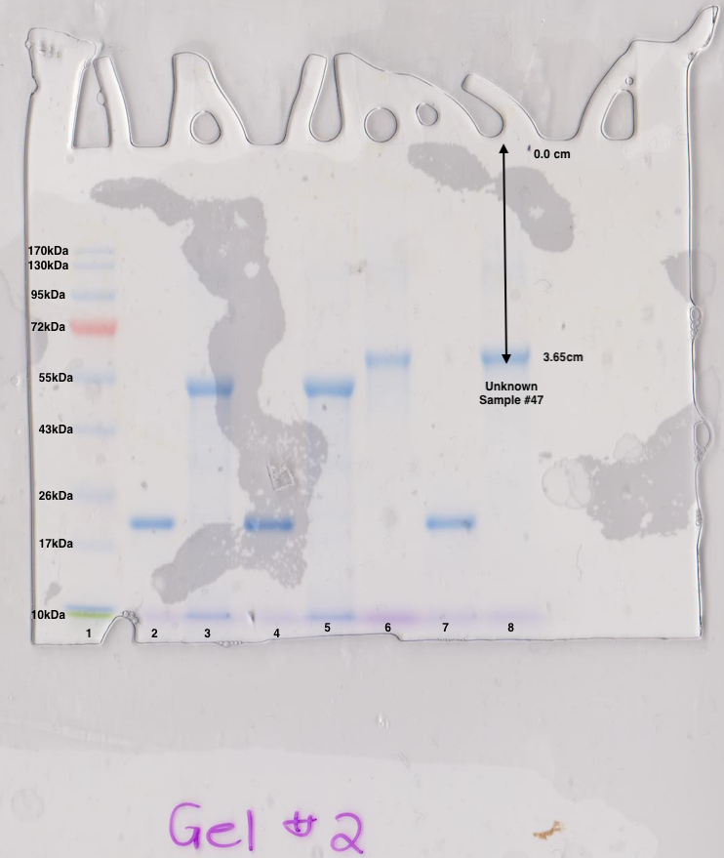
Figure 2. Image of Sodium Dodecyl Sulfate Polyacrylamide Gel electrophoresis (SDS-PAGE) with migration of unknown protein samples. The polyacrylamide has been prepared by a polymerized slab gel with 10% of acrylamide, where the outer chamber of the apparatus is filled with running buffer of pH7.7, 50mM Tris base, 50mM MOPS, 1mM EDTA and 0.1% SDS, and the inner buffer chamber is filled with funning buffer. Addition 5 µL of the mixture of the molecular weight markers EZ-RunTM Rec into well #1 by the TA. Each group and student pipetted 10 µL of their assigned unknown protein sample where were previously dissolved in sample buffer: 62.5 mM Tris-Cl (pH 6.8), 2% SDS, 5% 2-mercaptoethanol (or 0.5% DTT), 10% glycerol, and denatured at 100°C for 3min. The report will focus on sample #47 and well#8 pipetted by group #14. The distance travelled by unknown sample #47 is 3.65cm. The molecular weight measured in kDa have been provided in the lab manual (pg. 40) corresponding to the protein markers. Bromomethyl blue is added to protein samples to track movement of unknown proteins. The higher the molecular weight (MW) of a protein the less distance travelled by said protein. Distance travelled is measured in centimeters from the bottom well to the middle of each protein marker. There are 9 base protein markers but should be 10, the protein marker corresponding to 34kD is not visible on the gel and is most likely missing due to large gap between 26kDa and 43kDa markers as indicated in lab manual appendix C5.

Table #2: Results of distance traveled by protein markers from Sodium Dodecyl Sulfate Polyacrylamide Gel electrophoresis (SDS-PAGE) and the LOG(MW). The polyacrylamide has been prepared by a polymerized slab gel with 10% of acrylamide, where the outer chamber of the apparatus is filled with running buffer of pH7.7, 50mM Tris base, 50mM MOPS, 1mM EDTA and 0.1% SDS, and the inner buffer chamber is filled with funning buffer. Addition 5 µL of the mixture of the molecular weight markers EZ-RunTM Rec into well #1 by the TA. Each group and student pipetted 10 µL of their assigned unknown protein sample where were previously dissolved in sample buffer: 62.5 mM Tris-Cl (pH 6.8), 2% SDS, 5% 2-mercaptoethanol (or 0.5% DTT), 10% glycerol, and denatured at 100°C for 3min. The report will focus on sample #47 and well#8 pipetted by group #14. The distance travelled by unknown sample #47 is 3.65cm. The molecular weight measured in kDa have been provided in the lab manual (pg. 40) corresponding to the protein markers. Distance travelled is measured in centimeters from the bottom well to the middle of each protein marker.

Migration Distance (cm) | MW of marker bands (kDa) | Log (MW)
1.65 | 170 | 2.23
1.91 | 130 | 2.11
2.45 | 95 | 1.98
2.99 | 72 | 1.86
3.71 | 55 | 1.74
4.55 | 43 | 1.63
5.67 | 26 | 1.41
6.49 | 17 | 1.23
7.56 | 10 | 1

Figure 3. Graph of Log(MW) versus migration distance (cm) of protein marks obtained from SDS-PAGE to determine molecular weight of unknown sample#47. The polyacrylamide has been prepared by a polymerized slab gel with 10% of acrylamide, where the outer chamber of the apparatus is filled with running buffer of pH7.7, 50mM Tris base, 50mM MOPS, 1mM EDTA and 0.1% SDS, and the inner buffer chamber is filled with funning buffer. Addition 5 µL of the mixture of the molecular weight markers EZ-RunTM Rec into well #1 by the TA. Each group and student pipetted 10 µL of their assigned unknown protein sample where were previously dissolved in sample buffer: 62.5 mM Tris-Cl (pH 6.8), 2% SDS, 5% 2-mercaptoethanol (or 0.5% DTT), 10% glycerol, and denatured at 100°C for 3min. The report will focus on sample #47 and well#8 pipetted by group #14. The distance travelled by unknown sample #47 is 3.65cm. The molecular weight measured in kDa have been provided in the lab manual (pg. 40) corresponding to the protein markers. A linear regression equation has been determined (y=-0.1839x +2.4381) and linear regression (R² = 0.995) as mentioned in appendix C5 first 170MW and last 10MW data point have been removed to produce an accurate R² closer to 1.

Calculation for the Molecular Weight of Unknown Protein Sample #47.

Givens:
Linear Regression Equation: y=-0.1839x +2.4381; Migration distance x = 3.65 cm

Log(MW) of sample #47:

y=-0.1839x +2.4381
y=-0.1839(3.65) +2.4381
y=1.766865

Antilog of Y:
MW = 10^{(1.766865)}
MW = 58.4608331 kDa.

Therefore, the molecular weight of sample#47 is approximately 58.5 kDa, this is reasonable considering the distance travelled by the unknown sample reached a distanced of 3.65 cm which placed is right above the 55 kDa protein marker.

