Laboratory 4: Lipids and Membranes

$$\frac{83}{100}$$

By: Sami Aftab Abdul (300018542)

Section Z04 (Monday Afternoon 2nd week)
TEAM #: 14

Lab Partner: Nishwara Tarannum (300019212)
Demonstrator (TA): Abdel Rahman LePabic

Due Date: March 18, 2019
Date Lab Performed: March 11, 2019

University of Ottawa
Biochemistry Laboratory BCH 2333
Purpose:

This laboratory focuses on analyzing the various properties of lipids derived from endoplasmic reticulum (microsomal fraction) and mitochondrial enriched fraction, prepared via calf liver tissue. The technique of homogenization is utilized to rupture cells of liver tissue so that based on densities components of the cell can separate using differential centrifuging. This produces a mitochondrial (pellet) and the microsomes (supernatant). In experiment or part 2, mitochondrial membrane is obtained via sonicating which is used in analyzing the relative ratios of protein and lipids through protein and lipid assays. The assay testing allows one to also understand how to analyze the linear plot trends for protein and lipid absorbance against dilution fractions. The method of Bligh and Dyer Lipid extraction separates polar components from non-polar lipid components in the supernatant. 2D thin layer chromatography (TLC) separates the microsomal lipid based on polarity of the functional groups as to discern the chemical interaction between the polar silica gel (stationary phase) and the mobile phase. This is done by analyzing the sample in both acidic and basic solvents, to ensure separation of lipid and clear identification based on their relative polarities to each other.
Results and Discussion:

R1: Figure of TLC Plate

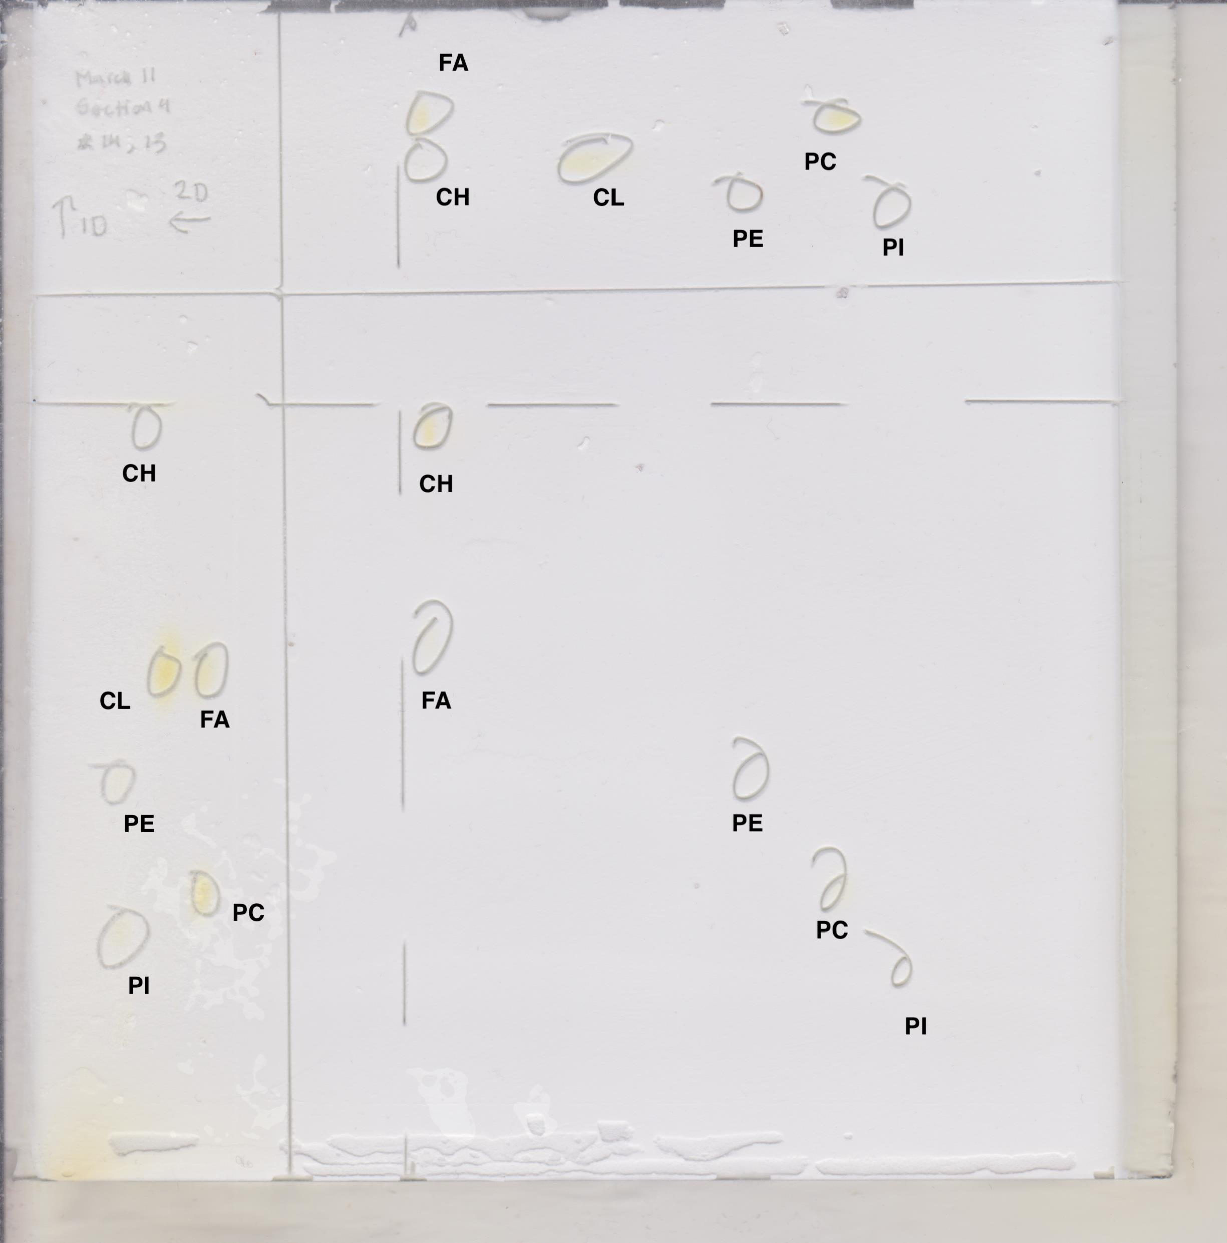
Figure 1. Two-dimensional thin layer chromatography (2D-TLC) of the separation of microsomal lipids from calf liver cells in both acidic and basic solvent systems. This 2D-TLC was performed in teams (groups 13, 14). The TLC was heated to 100ºC for 1-2 hours allowing the 20cm x 20cm silica gel plate to be activated and marked with a border line and indication of travelling direction for the developing solvents using a pencil. Of the microsomal lipid sample 10 µL were pipetted and spotted on the right-hand bottom corner. 5 µL of standards were also pipetted to both dimensions each corresponding either an acidic (2nd dimension) or basic solvent (1st dimension). The first lipid standard contained cardiolipin (CL) and cholesterol (CH), the second standard contained phosphatidylcholine (PC) and fatty acid (FA) and the third lipid stands contained phosphatidylethanolamine (PE) and phosphatidylinositol (PI). Initially the TLC plate is placed in the basic solvent of CHCl₃-MeOH-ammonia (65:35:5 v/v), once the solvent line reach 1 cm from the horizontal line it is removed from the system and solvent front is marked and dried via heat gun for 10 minutes. The plate is then rotated 90 degrees and placed into the acidic solvent system of CHCl₃-acetone-MeOH-acetic acid-H₂O (10:4:2:2:1 v/v), again removed once 1 cm from the horizontal line. The last solvent is the iodine saturated tank where it is placed into for 5 minutes and left in fume hood to dry and circle the visualized spots on the TLC plate.

Table #1: Relative Rf values for standard lipid samples and microsomal lipid sample under basic and acidic solvent systems over a 2D-TLC plate. The 2D-TLC was heated to 100ºC for 1-2 hours allowing the 20cm x 20cm silica gel plate to be activated and marked with a pencil. Of the microsomal lipid sample 10 µL were pipetted and spotted on the right-hand bottom corner. 5 µL of standards were also pipetted to both dimensions each corresponding either an acidic (2nd dimension) or basic solvent (1st dimension). The first lipid standard contained cardiolipin (CL) and cholesterol (CH), the second standard contained phosphatidylcholine (PC) and fatty acid (FA) and the third lipid stands contained phosphatidylethanolamine (PE) and phosphatidylinositol (PI). Initially the TLC plate is placed in the basic solvent of CHCl₃-MeOH-ammonia (65:35:5 v/v), once the solvent line reaches 1 cm from the horizontal line it is removed from the system and solvent front is marked and dried via heat gun for 10 minutes. The plate is then rotated and placed into acidic solvent system of CHCl₃-acetone-MeOH-acetic acid-H₂O (10:4:2:2:1 v/v), again removed once 1 cm from the horizontal line. The last solvent is the iodine saturated tank where it is placed into for 5 minutes and left in fume hood to dry and circle the visualized spots on the TLC plate. The distances of the solvent front, lipids standards and lipid sample were found by measuring the relative distances travelled using a ruler for both dimensions The Rf was calculated by dividing the distance of each of the lipids by its corresponding solvent front distance for either solvent systems.

Lipid Standards | RF Values for Standard |  | Rf values for Sample
Lipid Standards | Basic Solvent System  (1st Dimension) | Acidic Solvent System  (2nd Dimension) | Basic Solvent System  (1st Dimension) | Acidic Solvent System  (2nd Dimension)
Cardiolipin (CL) | 0.575 | 0.673 | - | -
Cholesterol (CH) | 0.976 | 0.945 | 0.962 | 0.935
Fatty Acids (FA) | 0.571 | 0.949 | 0.632 | 0.945
Phosphatidylcholine (PC) | 0.226 | 0.258 | 0.217 | 0.263
Phosphatidylinositol (PI) | 0.160 | 0.166 | 0.0943 | 0.143
Phosphatidylethanolamine (PE) | 0.401 | 0.410 | 0.396 | 0.382

Sample Calculation using data from Table #1:
Rf sample Calculation for cardiolipin (CL)
Basic Solvent System:  D_{solvent} = 10.60 cm  D_{CL} = 6.05 cm  Rf = D_{CL}/D_{solvent}  Rf = 6.05cm/10.60cm  Rf = 0.575  Therefore, the Rf for CL in Basic solvent system is 0.575. | Acidic Solvent System:  D_{solvent} = 10.85 cm  D_{CL} = 7.30 cm  Rf = D_{CL}/D_{solvent}  Rf = 7.30cm/10.85cm  Rf = 0.673  Therefore, the Rf for CL in acidic solvent system is 0.673.

The Rf values are of course not identical which can be attributed to the presence of different solvent systems either acidic (2nd dimension) or basic (1st dimension). These values are quite close between the sample and standards are due to interactions with the charges on the lipid that arise in different pH conditions resulting in varying polarity and distance travelled by the interactions with the polar silica gel plate. Overall polar lipids will interact more tightly the TLC plate that in comparison to non-polar lipids allowing the latter to travel a larger distance. There seems to be a small difference between the Rf values in either acidic or basic solvent, this can be attributed to parallax measurement error except for FA which has a significantly lower Rf under basic conditions than acidic. This is indicative of the acidic carboxylic group on the fatty acid to be deprotonated under acidic basic conditions resulting in a negative charge increasing polarity and tether to the silica gel, making it harder to travel resulting in a lower Rf value.

R2: Ranking of Lipid Standards

Table #2: Relative ranking of microsomal lipid standards in order of polarity observed from 2D-TLC plate in acidic and basic solvent system conditions. The 2D-TLC was heated to 100ºC for 1-2 hours allowing the 20cm x 20cm silica gel plate to be activated and marked with a pencil. Of the microsomal lipid sample 10 µL were pipetted and spotted on the right-hand bottom corner. 5 µL of standards were also pipetted to both dimensions each corresponding either an acidic (2nd dimension) or basic solvent (1st dimension). The first lipid standard contained cardiolipin (CL) and cholesterol (CH), the second standard contained phosphatidylcholine (PC) and fatty acid (FA) and the third lipid stands contained phosphatidylethanolamine (PE) and phosphatidylinositol (PI). Initially the TLC plate is placed in the basic solvent of CHCl₃-MeOH-ammonia (65:35:5 v/v), once the solvent line reaches 1 cm from the horizontal line it is removed from the system and solvent front is marked and dried via heat gun for 10 minutes. The plate is then rotated and placed into acidic solvent system of CHCl₃-acetone-MeOH-acetic acid-H₂O (10:4:2:2:1 v/v), again removed once 1 cm from the horizontal line. The last solvent is the iodine saturated tank where it is placed into for 5 minutes and left in fume hood to dry and circle the visualized spots on the TLC plate. The distances of the solvent front, lipids standards and lipid sample were found by measuring the relative distances travelled using a ruler for both dimensions The Rf was calculated by dividing the distance of each of the lipids by its corresponding solvent front distance for either solvent systems. The following ranks are based on the relative distances travelled that were observed, where polar lipids appeared closer to the starting positions (smaller Rf) compared to less or non-polar lipids travelling higher distance (higher Rf). The ranking is 1 – least polar and 6 – most polar.

Lipid Standards | (1-Least Polar, 6-Most Polar)
Lipid Standards | Basic Solvent System  (1st Dimension) | Acidic Solvent System  (2nd Dimension)
Cardiolipin (CL) | 2 | 3
Cholesterol (CH) | 1 | 1
Fatty Acids (FA) | 3 | 2
Phosphatidylcholine (PC) | 5 | 5
Phosphatidylinositol (PI) | 6 | 6
Phosphatidylethanolamine (PE) | 4 | 4

Table #3: Analyzing the chemical structures and relative polarities of lipids in the microsomal liver cell lipid sample. The 2D-TLC was heated to 100ºC for 1-2 hours allowing the 20cm x 20cm silica gel plate to be activated and marked with a pencil. Of the microsomal lipid sample 10 µL were pipetted and spotted on the right-hand bottom corner. 5 µL of standards were also pipetted to both dimensions each corresponding either an acidic (2nd dimension) or basic solvent (1st dimension). The first lipid standard contained cardiolipin (CL) and cholesterol (CH), the second standard contained phosphatidylcholine (PC) and fatty acid (FA) and the third lipid stands contained phosphatidylethanolamine (PE) and phosphatidylinositol (PI). Initially the TLC plate is placed in the basic solvent of CHCl₃-MeOH-ammonia (65:35:5 v/v), once the solvent line reaches 1 cm from the horizontal line it is removed from the system and solvent front is marked and dried via heat gun for 10 minutes. The plate is then rotated and placed into acidic solvent system of CHCl₃-acetone-MeOH-acetic acid-H₂O (10:4:2:2:1 v/v), again removed once 1 cm from the horizontal line. The last solvent is the iodine saturated tank where it is placed into for 5 minutes and left in fume hood to dry and circle the visualized spots on the TLC plate. The following polar groups have been obtained from the Brightspace TLC animation and are identified based on sample and polarity within each sample.

Sample # | Chemical Structure | Polar Groups | Polarity Ranking
1 | Cardiolipin (CL)  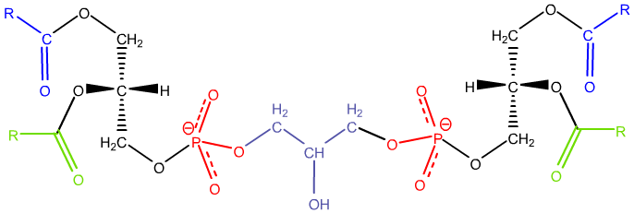 | Negatively charged phosphate group (red)  Ester Groups (green + blue)  OH group (purple) | More Polar
1 | Cholesterol (CH)  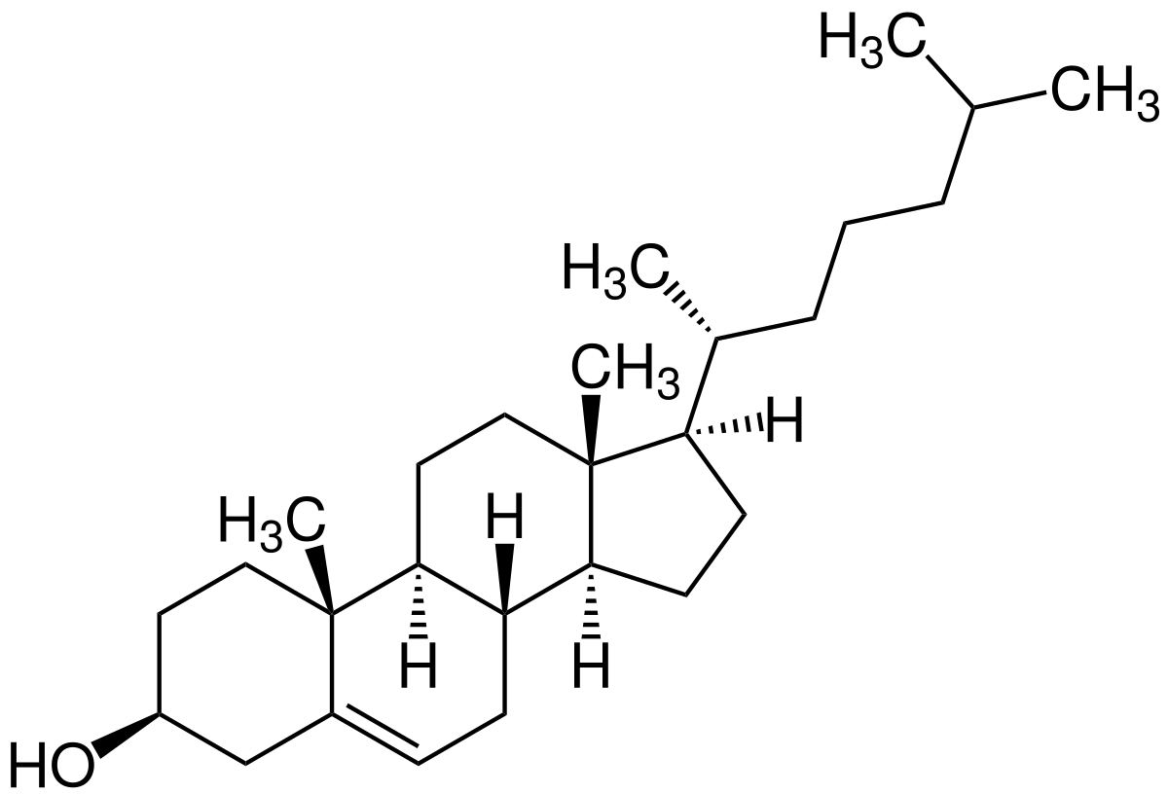 | Oh Group (circled) | Less Polar
2 | Fatty Acid (FA)  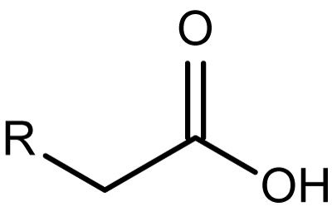 | Carboxylic Group (circled) | Less Polar
2 | Phosphatidylcholine (PC)  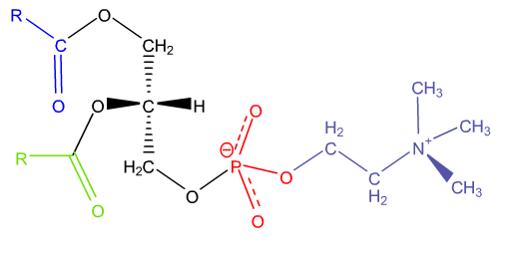 | Carbonyl Group (Blue)  Ester Groups (blue+green)  Negatively charged phosphate group (red)  Positively charged nitrogen group (purple) | More Polar
3 | Phosphatidylinositol (PI) | OH group on cyclohexane ring (purple)  Negatively Charged phosphate group (red)  Ester Groups (blue + Green) | More Polar
3 | Phosphatidylethanolamine (PE)  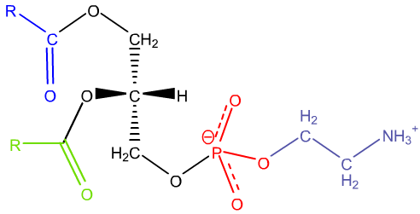 | Negatively charged phosphate group (red)  Ester Groups (blue + green)  Amine Group (purple) | Less Polar

Discussion of each sample and the relative polarity in each sample:

Sample 1: Cardiolipin (CL) + Cholesterol (CH)

The cardiolipin lipid molecule is more polar due to the four ester groups and two negative charged phosphate groups alongside a hydroxy group in the center in terms of polarity this is more polar than the single hydroxyl group on the cholesterol. The cholesterol molecule overall is non-polar due to the many non-polar carbon rings. The TLC results showcase that cardiolipin is more polar than cholesterol as it has travelled a shorter distance than cholesterol, meaning there is a stronger interaction between the polar silica gel and that of the polar cardiolipin. The overall relative polarity of both the lipid molecules does remain the same under either basic or acidic solvent system despite the slight changes made to polar groups of both lipids.

Samples 2 : Fatty Acids (FA) + Phosphatidylcholine(PC)

The Phosphatidylcholine lipid molecule sis more polar due to the many polar functional groups compared to just one carboxyl group on part by the fatty acid’s glycerol head. These polar groups for phosphatidylcholine are two ester groups on the choline head, a positively charged nitrogen group and a negatively charged phosphate group. This results in PC travelling a shorter distance than FA in both acidic and basic conditions. Whereas the fatty acids have a long non-polar chain making it harder to interact with the polar silica stationary phase migrating faster up the TLC plate compared to the of the phosphatidylcholine lipid.

Sample 3: Phosphatidylinositol (PI) + Phosphatidylethanolamine (PE)

The Phosphatidylethanolamine in comparison to the Phosphatidylinositol is less polar despite both having two polar ester groups and phosphate groups. This is due to the positively charged amine group on phosphatidylethanolamine making it less polar than the cyclohexane ring with the five hydroxyl groups on Phosphatidylinositol. The presence of a single hydroxyl group is more polar than an amine group, meaning that the OH groups on Phosphatidylinositol allow it to be more polar than Phosphatidylethanolamine. The TLC results indicate that for both the acidic and basic solvent systems Phosphatidylinositol travels less than that of Phosphatidylethanolamine due to again the tether of the interaction between the more polar molecules of PI with the polar stationary silica gel via hydrogen bonds, than that of PE.

R3: Results of Protein and Lipid Assay
a)
Table #4: Absorbance values for the mitochondrial membrane lipid assay obtained from calf liver. 2.5g of scissor minced calf liver tissue is placed in a 10mL of ice-cold buffer (10mM Tris, 0.25M sucrose, 1mM EDTA, 1 mM DTT, pH 7.5). The glass Teflon is used to homogenize calf liver with a stroke count of 10 times, was then added to a 15mL corex tube and centrifuged at 1000xg for 10 minutes at a temperature of 40ºC. The supernatant formed is filtered into a 25mL cylinder via mira-cloth which is then transferred into a 15mL corex tube where pellet 1 was discarded. The filtered supernatant is centrifuged at 25000xg for 10 min at 40ºC once more and pellet 2 consisting mitochondrial lipids were used for the lipid assay. The new supernatant consisting of microsomes was transferred into a 15mL falcon tube for lipid extraction via the Bligh and Dyer method. The pellet consisting of mitochondrial lipids and other cellular components was suspended in 5-10mL of buffer and sonicated (at 50% power) for 10 second twice. The resulting solution was utilized to form 5 assay dilution fractions of 1/250,1/125,1/50, 1/25 and a control, by adding 1mL of 0.2M of phosphate (pH 11) to each fraction tube followed by addition of different ratios of water and mitochondrial membrane suspension added for a final fraction volume of 2mL. No membrane suspension is added to the control test tube fraction, and 50µL of Brilliant Blue R was added to each fraction and vortexed, the resulting solutions were incubated for 15 minutes, and then the absorbances were read at 559nm via a spectrophotometer zeroed with water.

Sample | Dilution fraction | Phosphate pH 11, 0.2M (mL) | Water (mL) | Membrane suspension (µL) | Brillant blue R 1.0g/L  (µL) | A559*
1) Control | 0 | 1 | 0.95 | 0 | 50 | 0.78
2) 1/250 | 0.0004 | 1 | 0.942 | 8 | 50 | 0.748
3) 1/125 | 0.008 | 1 | 0.934 | 16 | 50 | 0.703
4) 1/50 | 0.02 | 1 | 0.91 | 40 | 50 | 0.564
5) 1/25 | 0.04 | 1 | 0.87 | 80 | 50 | 0.368
*Note Data has been provided for the lipid assay absorbance values.

Table #5: Absorbance values for the mitochondrial membrane protein assay obtained from calf liver. 2.5g of scissor minced calf liver tissue is placed in a 10mL of ice-cold buffer (10mM Tris, 0.25M sucrose, 1mM EDTA, 1 mM DTT, pH 7.5). The glass Teflon is used to homogenize calf liver with a stroke count of 10 times, was then added to a 15mL corex tube and centrifuged at 1000xg for 10 minutes at a temperature of 40ºC. The supernatant formed is filtered into a 25mL cylinder via mira-cloth which is then transferred into a 15mL corex tube where pellet 1 was discarded. The filtered supernatant is centrifuged at 25000xg for 10 min at 40ºC once more and pellet 2 consisting mitochondrial lipids were used for the lipid assay. The new supernatant consisting of microsomes was transferred into a 15mL falcon tube for lipid extraction via the Bligh and Dyer method. The pellet consisting of mitochondrial lipids and other cellular components was suspended in 5-10mL of buffer and sonicated (at 50% power) for 10 second twice. The resulting solution was utilized to form 4 assay dilution fractions of 1/100,1/20 and 1/4 and blank test tube, by adding 1mL of 0.2M of phosphate (pH 11) to each fraction tube followed by addition of different ratios of water and mitochondrial membrane suspension added for a final fraction volume of 2mL and vortexed. The resulting solutions were read for absorbance values at 280nm via a spectrophotometer zeroed with the blank.

Sample | Dilution fraction | Phosphate pH 11, 0.2M (mL) | Water (mL) | Membrane suspension (mL) | A280
1) Blank | 0 | 1 | 1 | 0 | 0
2) 1/100 | 0.01 | 1 | 0.98 | 0.02 | 0.223
3) 1/20 | 0.05 | 1 | 0.90 | 0.1 | 1.007
4) 1/4 | 0.25 | 1 | 0.5 | 0.5 | >2.5

b)

Figure 2. Dilution fraction VS Absorbance (A₅₅₉) plot or the mitochondrial membrane Lipid Assay. 2.5g of scissor minced calf liver tissue is placed in a 10mL of ice-cold buffer (10mM Tris, 0.25M sucrose, 1mM EDTA, 1 mM DTT, pH 7.5). The glass Teflon is used to homogenize calf liver with a stroke count of 10 times, was then added to a 15mL corex tube and centrifuged at 1000xg for 10 minutes at a temperature of 40ºC. The supernatant formed is filtered into a 25mL cylinder via mira-cloth which is then transferred into a 15mL corex tube where pellet 1 was discarded. The filtered supernatant is centrifuged at 25000xg for 10 min at 40ºC once more and pellet 2 consisting mitochondrial lipids were used for the lipid assay. The new supernatant consisting of microsomes was transferred into a 15mL falcon tube for lipid extraction via the Bligh and Dyer method. The pellet consisting of mitochondrial lipids and other cellular components was suspended in 5-10mL of buffer and sonicated (at 50% power) for 10 second twice. The resulting solution was utilized to form 5 assay dilution fractions of 1/250,1/125,1/50, 1/25 and a control, by adding 1mL of 0.2M of phosphate (pH 11) to each fraction tube followed by addition of different ratios of water and mitochondrial membrane suspension added for a final fraction volume of 2mL. No membrane suspension is added to the control test tube fraction, and 50µL of Brilliant Blue R was added to each fraction and vortexed, the resulting solutions were incubated for 15 minutes, and then the absorbances were read at 559nm via a spectrophotometer zeroed with water. The linear regression line showcases that a decrease in absorbance of [lipid] occurs as dilution fraction increases. The assumed expected absorbance of purified lipid is to occur at a dilution fraction value of 1 such that x=1 and the absorbance (y-value) obtained by subbing x=1 into linear regression line equation of y= -8.231x + 0.7759. Meaning the absorbance for undiluted sample is 7.6551 which occurs at a point (1, -7.6551) on the plot. The slope obtained from using the absorbance values of reagent alone at point (0,0) and the undiluted sample at point (1, -7.6551) is used to determine the slope which is equal to (-7.6551-0)/(1-0) where slope is -7.6551, and the regression value is R²= 0.979.

Figure 3: Dilution fraction VS Absorbance (A₅₅₉) plot or the mitochondrial membrane protein Assay. 2.5g of scissor minced calf liver tissue is placed in a 10mL of ice-cold buffer (10mM Tris, 0.25M sucrose, 1mM EDTA, 1 mM DTT, pH 7.5). The glass Teflon is used to homogenize calf liver with a stroke count of 10 times, was then added to a 15mL corex tube and centrifuged at 1000xg for 10 minutes at a temperature of 40ºC. The supernatant formed is filtered into a 25mL cylinder via mira-cloth which is then transferred into a 15mL corex tube where pellet 1 was discarded. The filtered supernatant is centrifuged at 25000xg for 10 min at 40ºC once more and pellet 2 consisting mitochondrial lipids were used for the lipid assay. The new supernatant consisting of microsomes was transferred into a 15mL falcon tube for lipid extraction via the Bligh and Dyer method. The pellet consisting of mitochondrial lipids and other cellular components was suspended in 5-10mL of buffer and sonicated (at 50% power) for 10 second twice. The resulting solution was utilized to form 4 assay dilution fractions of 1/100,1/20 and 1/4 and blank test tube, by adding 1mL of 0.2M of phosphate (pH 11) to each fraction tube followed by addition of different ratios of water and mitochondrial membrane suspension added for a final fraction volume of 2mL and vortexed. The resulting solutions were read for absorbance values at 280nm via a spectrophotometer zeroed with the blank. The point (0,0) will represent the blank (or control) sample absorbance of zero. The assumed expected absorbance of purified lipid is assumed to occur at a dilution fraction value of 1 such that x=1 and the absorbance (y-value) obtained by subbing x=1 into linear regression line equation of y= 11.865x + 0.1909. The undiluted sample occurs at (1, 12.0559). The slope obtained from using the control point of (0,0) and the undiluted sample at point (1, 12.0559) is used to determine the slope which is equal to (12.0559-0)/(1-0) where slope is 12.0559, and the regression value is R²= 0.9571.

R4: Calculation of Theoretical Protein Concentration Within The Mitochondrial Membrane

Calculations of theoretical protein concentration within the mitochondrial membrane:
The undiluted (or purified) protein sample linear graph can be used to determine the expected absorbance of the mitochondrial protein in purified sample where the expected absorbance of this sample occurs when (1,Y) and x=1, subbing this in will give the theoretical absorbance of protein (Y) within the mitochondrial membrane of calf liver tissue cells.
Calculations for Absorbance of Pure (undiluted) Protein in mitochondrial Sample | Calculations for Concentration of Pure (undiluted) Protein in mitochondrial Sample
Linear regression equation: Y= 11.865x + 0.1909  Sub x=1 into equation  Y= 11.865(1) + 0.1909  Y=12.0559  A= slope =(12.0559-0)/(1-0) = 12.0559 (absorbance of undiluted sample)  Therefore, the theoretical absorbance is 9.2785. | A=12.0559, ε=2.0 Lg⁻¹cm⁻¹, l=1cm  A = (ε)(C_{undiluted})(l)  C _{undiluted}= A  ε l  C _{undiluted} = $\frac{12.0559}{ (2.0 {Lg}^{-1}cm^{-1})(1cm)}$  C _{undiluted} = 6.03 g/L  Therefore, the concentration of undiluted purified mitochondrial membrane protein (theoretical) is 6.03g/L. since absorbance increased proportionally the protein concentration will also increase or show that is was larger through calculation.

R5: Calculation of Theoretical Lipid Concentration Within The Mitochondrial Membrane

Calculations of theoretical lipid concentration within the mitochondrial membrane:
The undiluted (or purified) lipid sample linear graph can be used to determine the expected absorbance of the mitochondrial lipid in purified sample where the expected absorbance of this sample occurs when (1,Y) and x=1, subbing this in will give the theoretical absorbance of lipid (Y) within the mitochondrial membrane of calf liver tissue cells.
Calculations for Absorbance of Pure (undiluted) lipid in mitochondrial Sample | Calculations for Absorption of Lipid in mitochondrial Enriched Fraction
Linear regression equation: Y= -8.231x + 0.7759  Sub x=1 into equation  Y= -8.231(1) + 0.7759  Y=-7.6551  A= slope =(7.6551-0)/(1-0) = -7.6551 (absorbance of undiluted sample)  Therefore, the theoretical absorbance is 7.6551. Negative sign means that the absorption of lipids in mitochondrial fraction decrease was dilution fraction increases. | A_{M}= A_{control} – A_{undiluted}= 0.78-(-7.6551)  A_{Unknown} = 8.4351 (absorption of unknown mitochondrial protein concertation)  A_{Known}= 0.013 (absorption of known membrane lipid)  C_{Known}= 1.0µg/mL (Concentration of known membrane lipid)  A_{uknown} = A_{known}  C_{Unknown} C_{known}  C_{unknown}= (A_{uknown)(} C_{known)}  A_{known}  C_{unknown}= (8.4351)( 1.0µg/mL)  0.013  C_{unknown}=648 µg/mL  Therefore the mitochondrial enriched fraction is 648 µg/mL from decrease in in absorption corresponding to the undiluted sample.

R6: Estimation of the Yield of Mitochondrial proteins

Theoretical Mass of Protein in Mitochondrial Membrane in 2.5g of Calf Liver Homogenate
Variables: V= 10mL=0.010L, C _{undiluted} = 6.03 g/L(purified protein membrane concentration)
m _{Experimental}= V (C _{undiluted})
= (0.010L)(6.03g/L )
=0.0603g
=60.3 mg

Mitochondrial Protein yields in 2.5g of Calf Liver Homogenate
Variables: ${ m}_{experimental }=$60.3 mg, ${ m}_{heoretical}=2.5g$ (mass of liver)
Protein Yield =$\frac{{ m }_{experimental }}{m_{theoretical}}$
= $\frac{60.3 mg}{ 2.5g}$
= 24.12mg/g

Therefore, the yield for mitochondrial protein in 2.5g of calf liver homogenate prepared is 24.12mg/g

