1. [10 marks]
In a recent national survey, 30 Canadian adults aged 18-24 reported having used cannabis for the first time since its legalization in 2018 compared to 68 among the 25-44-year-olds. Out of the 1500 survey respondents, 125 were 18-24-year-olds and 400 were in the 25-44 age group. The Public Health Agency has been concerned that the first time use of cannabis among the younger cohort is higher than that among the older cohort.
a) Formulate the appropriate statistical hypotheses to test if the proportion of first-time cannabis users is higher among younger adults.
Let P1 = true users of cannabis among younger adults
P2 = true users among older adults

Hypothesis: Ho: P1=P2
Ha: P1>P2

Therefore, the proportion of first-time cannabis users is higher among younger adults.

b) Perform the appropriate hypothesis test manually using the P-value approach and a 2%
significance level. Make sure you verify that the relevant assumptions and conditions are met for the test.

X1=30, n1=125, p-hat=x1/n1=0.24
X2=68, n2=400, p-hat = x2/p2 =0.17

Hypothesis are:
Ho: P1-P2=0
Ha: P1-P2>0
Level of significance α=0.02
Test is two tailed

The pooled proportion is:
P=(P-hat1)(n1)+(p-hat2)(n2)/n1+n2
=(30+68)/124+400
=98/545
=0.1867

The standard error is:
SE= SQRT(P(1-P)(1/n1+1/n2))
=SQRT(0.1867(1-0.1867)(1/125+1/400)
=SQRT(0.1867(0.8133)(0.008+0.0025))
=SQRT(0.1867(0.8133)(0.0105)
=SQRT(0.001594354)
=0.0399
Therefore, the standard error is 0.0399

Test Statistic:
Z=(P-hat1-P-hat2)-(P1-P2)/SE
=(0.24-0.17)-(0.1867-0.1867)/0.0399
=0.07-0/0.03999
=1.75
Critical value = 2.05
Rejection region if z>2.05, Reject Ho

Decision: since test statistic does not lie in the rejection region so we fail to reject the null
P Value = 0.0401

Since P value is not less than level of significance so we fail to reject the null

c) Using the corresponding confidence level, calculate a one-sided confidence interval for the difference in the proportions of first-time cannabis users among the two age groups.
For one sided confidence interval we need one sided critical value of Z. The critical value for 98% confidence level is -2.054

The standard error:
SE= (P-hat1)(1-P-hat1)/n1+(p-hat2)(1-P-hat2)/n2
=(0.24)(1-0.24)/125+(0.17)(1-0.17)/400
= 0.0426

For 98% confidence bound is:
=(P-hat1-P-hat2)+Zα SE
=(0.24-0.17)-2.054(0.0426)
=-0.0175

Since 0 is not less than -0.0175 we fail to reject the null hypothesis

d) Are the results from b) and c) above consistent and why?
Yes, results are consistent because both are testing right tailed hypothesis and confidence levels are the same.

e) Use Minitab or other appropriate software to perform the calculations in b) and c) and comment on any differences.
The P value output from Minitab is 0.040, my output was 0.0401. The outputs are almost identical, they were different by only .0001.
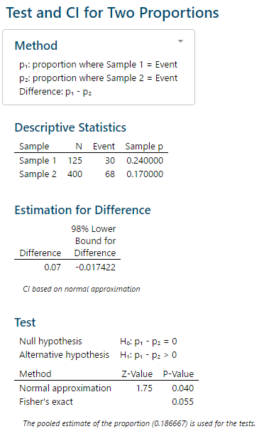

2. [10 marks]
The Office of the Superintendent of Bankruptcy of Canada (OSBC) is developing a new index to measure the vulnerability of firms in the new technology industry. The index is a ratio of current assets to current liabilities adjusted for various factors specific to this industry. The OSBC wants to compare the index among healthy and failed firms for validation purposes. They expect that failed firms should
have a lower index than the healthy ones. Based on a Canadian business registry, they draw a random sample of 68 firms still in operations and another random sample of 33 firms which failed in the last 3 years. Index data for the sampled firms based on their latest financial statements are included in the Minitab file Bankruptcy_Index.mtw and in the Excel file Assign2.xlsx under the
Bankruptcy_Index tab.

a) Use Minitab or other appropriate software to produce boxplots of the index values for the two groups of firms and comment on their distribution.
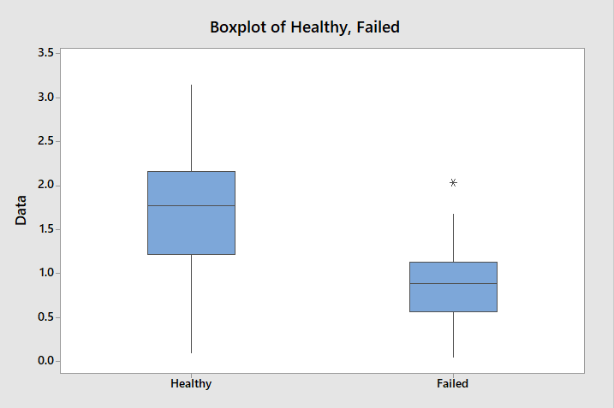

b) Use an appropriate statistical test to determine, at the 1% significance level, whether the data provide evidence of a higher average index for the healthy firms. Make sure you provide your manual calculations using the critical value approach.
Null Hypothesis H₀: µ₁ – µ₂ = 0
Alternative Hypothesis H_{A}: µ₁ – µ₂ >0
Sample Size n₁ = 68, n₂ = 33
d.f. = 68 + 33 – 2 = 99

Level of significance α =0.01
Criterion for rejecting H₀ if t calculated > t 99, 0.01 (t critical) = 2.365
T calculated = (µ₁ – µ₂) / Sp (1/n₁ + 1/n₂)

Where Sp = pooled standard deviation
Sp² = ((n₁ – 1) S₁² + (n₂ – 1) S₂²) / (n₁ + n₂ – 2)

c) Calculate manually a 99% one-sided confidence interval for the difference in the average index of healthy and failed firms and compare your results with b) above.
= (µ₁ – µ₂) – (t 99, 0.01 (t critical)) ∙ Sp ∙ sqrt(1/n₁ + 1/n₂)

= 0.853 – 2.365 ∙ 0.577 ∙ sqrt(0.015+0.030) = 0.853 -0.289 = 0.563 Lower bound

d) Use Minitab or other appropriate software to perform the calculations in b) and c) above and comment on any differences.
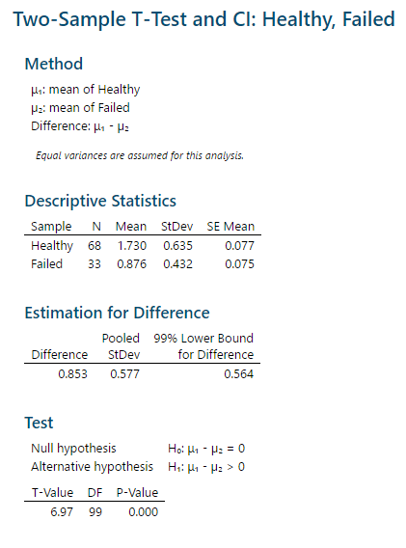

3. [10 marks]
EatWell Inc., a large fast-food chain company of Canada, wants to test two versions of a new product before launching its full production. They select a random sample of individuals among their regular clients and ask them to participate in an experiment to rate the product according to an assessment grid worth 20 points. The 15 individuals who accepted to participate had to come to a specific company location on two occasions during a given week to test the two versions of the product. It was a randomized experiment in which the version assigned to participants during their first visit was selected at random and participants did not know which version they were rating. Scores data of each
participant are included in the Minitab file EatWell_Scores.mtw and in the Excel file Assign2.xlsx
under the EatWell_Scores tab.
a) Examine and comment on the distribution of the ratings for the two versions of the product and decide which statistical test is the most appropriate for this type of data. Justify your selection based on the assumptions and conditions required for the most appropriate test selected.
After examining the data, the distribution of both of these sets is normal. We know this because the data is continuous. The data follows the normal probability distribution. The variances of the two populations are equal, the two samples are independent and there is no relationship between the individuals in one sample as compared to the other. Both samples are simple random samples from their respective population. Which meaning each individual in the population has an equal probability of being selected in the sample. The most appropriate test to use in this case is a Paired T-test.
b) Regardless of your answer in a) above, perform a relevant parametric test using a 10%
significance level to determine if there is a difference between the two versions of the product. Make sure you show your Minitab or other software output along with an interpretation of the results (manual calculations are not required here).
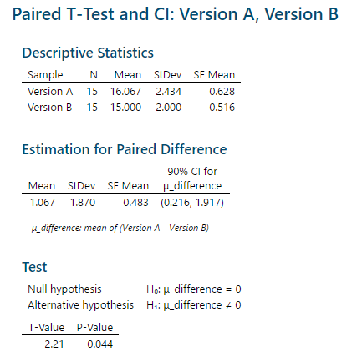

After doing this test, there is not sufficient evidence to say that two population means differ

c) Now, perform a Wilcoxon signed rank test to verify if there is a significant difference at the 10% level between the two versions of the product based on these ratings. Show your manual calculations including the T+ and T- statistics and conclude based on the critical value approach.
T= min(T+, T-) = min(74.5, 16.5) = 20.5
E(T) = n(n+1)/4 = (13*14)/4 = 45.5
V(T) = n(n+1)(2n+1)/24 = (13*14*27/24 = 204.75

2 or more observations may be equal. If so, average the ranks across the tied observations and reduce the variance by (t^ 3−t)/ 48 for each group of t tied ranks.
(6^3-6)/48=4.375, (2^3-2)/48=0.125, (4^3-4)/48=1.25

V(T) = 204.75 – 4.375 – 0.125 – 1.25 = 199
Z = (T – E(T))/√V(T)
= (16.5 – 45.5)/ √199
= -2.055755
Z at 10% level of significance = 1.64
P(Z<-2.055755) = 0.0199
P-value = 2 x 0.0199
= 0.0398
P-value < alpha = 0.1
Therefore, reject H(not)

d) Use Minitab or other software to perform the test in c) above and comment on the computed Pvalue and your conclusion in c).
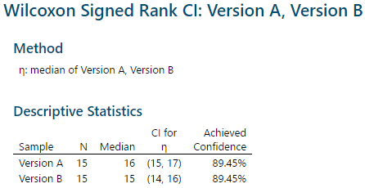

The computed P-value of 0.000 is lower than the conclusion of the P-value that was found in question c). For the computed P-value we would accept H(not).

e) Compare your results from the parametric and non-parametric tests above and state what the final conclusion regarding the two versions of the product should be.

4. [10 marks]
The HR department of a large company needs to assign a newly hired director to either their marketing development or their marketing operations division. To help in their decision, they organize two discussion groups with randomly selected employees from each division. During the talks, the director lays out his marketing vision and employees ask questions relevant to their daily work. At the end, each employee has to rate the director on a scale from 1 to 10 (1=very bad; 10=very good). The HR department wants to know if the distribution of ratings of the marketing development employees is different among the employees of the two divisions. Ratings data for the two groups of employees are
included in the Minitab file HR_Ratings.mtw and in the Excel file Assign2.xlsx under the HR_Ratings
tab.
a) Examine the distributions of the ratings (show histograms) by the two groups of employees and explain why a non-parametric test is justified to perform the analysis.
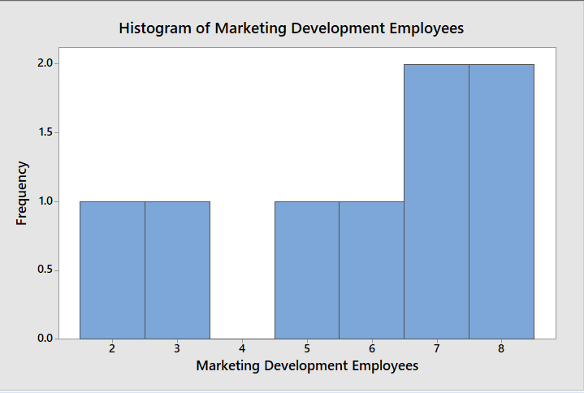
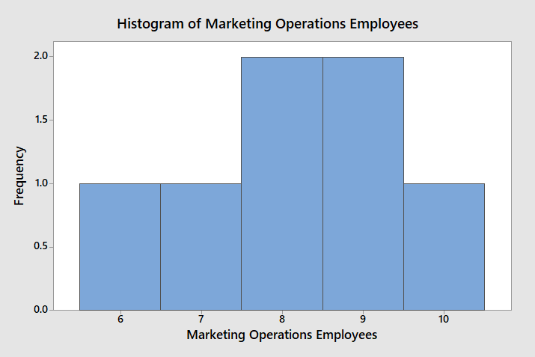

b) Perform an appropriate non-parametric test using a 5% significance level to determine if the distribution of ratings of the marketing development employees is different than that of the marketing operations employees. Specify any assumptions and/or conditions you need to make to apply the test and state your hypothesis clearly. Show your manual calculations.
Let n₁ = Rating by Marketing Development Employees
Let n₂ = Rating by Marketing Operations Employees
Assume (n₁,n₂) are both continuous random variables
Null Hypothesis H₀: n₁ – n₂ = 0
Alternative Hypothesis H_{A}: n₁ – n₂ ≠ 0
W = Two sample Wilcoxon rank sum test = 1 + 2 + 3 + 4.5 + 7 + 7 + 10.5 + 10.5 = 45.5

c) Use Minitab to perform the test in b) above and compare your results.


