CANADA GOOSE: COUNTERFEITS

Presented to Philippe Colas
Department of Marketing

Concordia University John Molson School of Business

Presented by Sejal Patel
Bachelor of Human Resource of Management

November 1, 2017

LETTER OF TRANSMITTAL

November 1, 2018
Philippe Colas, Department of Marketing
Concordia University
7141 Sherbrooke St W,
Montreal, QC H4B 1R6

Dear Philippe Colas,

The attached report; commissioned on September 27, describes the unsustainability of Canada Goose Inc. due to the impact of counterfeit products. I believe you will find the results of this study useful in evaluating the future development of the retail industry.

This study is designed to examine the unsustainability of Canada Goose Inc. in three different aspects:

- Production
- Accessibility
- Awareness
Of counterfeited items.

Primary research consists of interviews with twenty individuals. Secondary research sources include reviews of scholarly articles, statistics, and reviews of news media. Results of this research, are discussed more fully in this report, indicate that the impact of counterfeit products will cause unsustainability for companies in the retail industry such as Canada Goose Inc.

I would be pleased to discuss this report further and as well as the conclusions that can be drawn with you at your request. I would like to thank you for your interest, please do not hesitate to contact me at (514) 659-0559.

Sincerely,

Sejal Patel
Human Resource Management Student

EXECUTIVE SUMMARY

The purpose of this report is to (1) provide an overview of the reason for why retail industries such as Canada Goose Inc. perform unsustainably due to counterfeit products and (2) offer recommendations to help industries remain sustainable.

The research conducted in this report via secondary data sources collected suggests that, the production, accessibility, and awareness of counterfeits has a negative impact on the sustainability of retail industries. With the aide of the primary data source the following conclusion can be drawn; the research conducted is supported and furthermore can be related directly to Canada Goose Inc. Vendors produce counterfeits because of the prices, with high-end products being so costly they possess a competitive advantage selling knock-offs at a low price. Due to the high rise of counterfeits the retail industries have become unsustainable. Last but not least, individuals are aware when they are purchasing a counterfeit product which further fabricates unsustainability in this industry.

With the causes of unsustainability addressed measures need to be taken in order to either improve the situation or even solve the problems for this situation. From the research it can be concluded that industries in the retail sector need to act quickly and efficiently otherwise there will always be a loss when it comes to counterfeit. Especially for companies like Canada Goose Inc. which have a smaller target market. The following recommendations have been made to help deal with the unsustainability for retail industries:

- Retailers should provide consumers with adequate information before they make a purchase, to make sure if they can differentiate the products.
- Report any vendors that are seen selling counterfeits
- Severe consequences including extra penalty fines for vendors who sell counterfeits
- Hire companies to close down stores that sell counterfeit products
- Retail industries should provide samples to consumers to help differentiate
- Individuals shouldn’t be buying counterfeits

Table of Contents
INTRODUCTION 5
Purpose 5
Scope of the Study 5
Sources and Methods 6
LITERATURE FINDINGS AND RESULTS 6
Production 6
Accessibility 7
Awareness 8
SOCIAL SURVEY FINDINGS AND RESULTS 8
Differentiation 9
Accessibility 10
Awareness 10
Final statement on Primary Sources 10
CONCLUSION 12
RECOMMENDATIONS 13
APPENDIX 14
REFERENCES 15

INTRODUCTION

Business sustainability is the management and coordination of environmental, social and demands and concerns to ensure responsible, ethical and ongoing success (Rouse, 2013). Maintaining sustainability can be difficult and come across various barriers such as economic, innovation, political, social, poor monitoring, etc. Take Canada Goose Inc. for example; it strives for success by producing a jacket that can withstand the toughest winters in Canada and the United States. Despite the revenue having almost doubled to $291 million and about $100 million coming from the US and $95 million coming from Canada, the company has its difficulties being sustainable in certain situations.

Purpose

The purpose of the report is to determine the impact on the sustainability of Canada Goose Inc. due to replicated and counterfeit goods. In addition, this report serves to determine whether the recommended solutions can be met. Furthermore, the study will also determine if people are willing buying knock-offs. Would people still buy the knock-off if they knew that it was a fake? The conclusion of this study will not only cover sustainability of Canada Goose Inc. but can also be related to other Canadian companies that have to deal with problems related to counterfeits.

Scope of the Study

The report will be examining the following factors:
- If people buy knock-off products knowingly
- If people buy knock-off products unknowingly
- How easily accessible-are knock off products
- The impacts the above have on Canada Goose Inc.

Sources and Methods

The report relies on the data from primary and secondary sources. The primary data was collected through by conducting a survey on a sample of twenty individuals through the method of simple random sampling. Collecting this sample of data is to provide and determine whether or not the evidence collected is sufficient and if it will defend all the claims and results obtained. The secondary sources will include a review of scholarly articles, statistics, and reviews of news media. These will allow for an understanding of the impacts that unsustainability has on a company, however without the primary data, this information cannot be proved.

LITERATURE FINDINGS AND RESULTS

According to the secondary sources, it has been confirmed that people are willing to buy replicated goods if they are unaware that the item is fake and people are also unwilling to the buy the replicated goods if they are aware that it is fake. The secondary sources will be divided into three sections: production, accessibility, and awareness of counterfeited products.

Production

The main goal for any business is to make as much profit as possible, but when their items are being replicated the businesses aren’t producing the same amount of sales hence there is a slight decrease in profits. The reason why counterfeits exist is that high-end products are expensive and that is when individuals take advantage. People want to own high-end products but aren’t willing the pay huge amounts for just one item, therefore they go to a secondary source. That being said there’s only one reason for which counterfeits are made and that is because of the price of the product. As stated in the article by Dalton “The main reason that there is such a demand for counterfeit goods is the cost”. (Dalton 2013). Often times fake products are sold for a fraction of their true value.
According to the article “Economic impact of counterfeiting and privacy” the main complication caused by counterfeits is that they have a negative impact on (1) sales and licensing, (2) brand value and firm reputation and (3) the ability of firms to benefit from the breakthroughs they make in developing new products. The business of counterfeit is rapidly growing (Sowder, 2013) therefore the production of counterfeits has a negative impact on Canada Goose because as a company they are losing potential sales and therefore are making less profit. In the article published by Athens State University, it states that “businesses and industries lose approximately $200 billion in revenues annually due to counterfeits”. Hence it can be concluded that the loss of revenue can cause unsustainability for any company including Canada Goose.

Accessibility

Counterfeiting is one of the most common scams around, if you could do it without getting caught you would be able to print your own money and buy whatever you want with it (Brian 2017). The main reason why most people will buy fakes is because of how easy it is to obtain them. Individuals can write any product down on Google and every site that sells the products will come up, an example of a website would be EBay. Furthermore, take for example in China there are enormous amounts of markets that are dedicated and known for selling knock-offs and it can be seen how easy it is to obtain a fake. (Biciola, Dutton 2015) According to “Smarter Travel” in New York City one of the fashion capitals of the world, take a walk down Canal Street and you’ll be able to buy any large brand name, however, it will be a fake. The making of fraudulent products is rapidly increasing that it is difficult to say which one is real or fake (Sowder 2013).
The impact would be that Canada Goose will not be able to sell as many jackets and make profits if there are many fabricated counterfeit products available people will not go buy the authentic item. Whether they know that the jacket they are buying is fake or not, for every fake sold Canada Goose is losing a chance to make a profit. The more accessible it is to obtain a counterfeited item the larger the negative impact on the sustainability of large companies as stated in the article by Melik (Melik 2012).

Awareness

Awareness is one major aspect that has not yet been considered. As stated earlier, the production of counterfeited items has been rapidly increasing; therefore it is difficult for consumers to differentiate the real from the fake. According to an article published by “Word Reference” when it comes to purchasing counterfeit goods the consumer is knowledgeable that they are buying the fabricated product (Cristovao 2006). Therefore, it can be said that when it comes to awareness the consumer is well acquainted. The recent trend that has been arising is receiving fakes when ordering attire online, especially in the case for Canada Goose Inc. An article published by the Globe and Mail stated, many have purchased jackets only to receive knock-offs (Wilson 2013). However, this just goes to show that the consumer is aware of the difference between what is real and fake.
The fact that consumers are aware when they buy a fake is absolutely a positive impact on sustainability for a company because, it makes the society feel obliged to purchase the real product, after easily realizing that knock-off do not perform like the original products. “Forty-six percent of the counterfeit-jacket owners bought the authentic products within two and a half years” (Masnick 2009). It can be concluded that the more awareness there is the more jackets will be sold

SOCIAL SURVEY FINDINGS AND RESULTS

Despite the secondary sources, this study also engages in primary data collection. The data collected from the primary research can be found in Appendix A: Survey Questionnaire. The following sections will discuss the major findings and results of the primary data which can be divided into three major categories (1) if people can differentiate between fake and real items (2) how easily counterfeits are accessible and (3) if people are aware of they are buying fake items. Furthermore, the primary data also has subcategories which can be used to better understand the situation of the person conducting the survey, this can help further explain the research that was conducted and either supports or disproves the findings.

Differentiation

Out of the twenty participants who have been consulted in this study, twelve individuals (60%) claim that their income is $5001 and higher. Sixteen individuals (80%) can differentiate between real and fake products this includes the twelve individuals who have an income of $5001 and higher. This can suggest that income plays a role in differentiating between real and fake products. Figure 1 and Figure 2 demonstrates that majority of the people that can tell which items are real or fake have a higher earnings. In terms of the research conducted this demonstrates that the population is aware when they are buying counterfeit products.

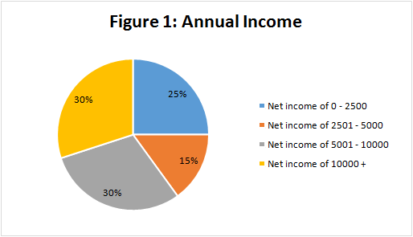

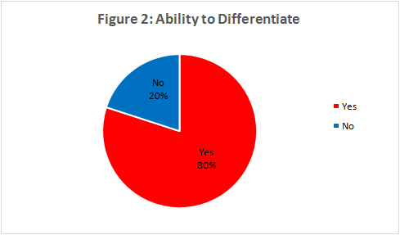

Accessibility

The survey concludes that all twenty individuals (100%) agree that fakes can be easily obtained. According to the survey in Appendix A, the results demonstrated that individuals who use the STM have seen vendors set up selling bootleg clothes and products. Another example would be the shopping malls you can find many stores that sell replicated products. This supports the findings of the report because it demonstrates how easily on daily basis counterfeit products can be purchased.

Awareness

From the survey it can be concluded that 80% of the individuals are aware whether products are authentic, due to the places from which the products are being sold, for example at a metro station, on the streets, etc. When individuals have a higher earning they tend to buy more extravagant products. As stated earlier 60% of individuals have claimed that their income is higher than $5001, the same 60% of individual refuse to buy counterfeited items. 40% of the individuals who earn less than $5000 would buy a fake product knowingly but will buy the authentic in the future knowing that it doesn’t perform the same.

Final statement on Primary Sources

From all the surveys that were completed the following can be concluded, that most of the sample population that was surveyed know the difference between a real and a counterfeit product. Also, it can be stated that more than half the population refuses to buy counterfeit which also the population that earns over 5000$ and refuses to purchase counterfeits. This means that there is a close relationship between income and buying counterfeit products. This information can be used to analyze how it impacts the sustainability of a company. If 40% of the population is buying counterfeit products knowingly that means that there is a loss of 40% of the sales that could be made and therefore it has a major impact on the sustainability of any company. However, generally speaking this is where the fourth part of the survey is used because a direct question about Canada Goose Inc. is being asked. It has been acknowledged that 40% of the population has bought a Canada Goose Inc., 50% have bought imitations or knock-offs, and 10% don’t own a jacket by this company. Figure 4 below demonstrates these findings as a pie chart. This means that for Canada Goose Inc. there is a greater loss in profit if counterfeit products are continuously produced and sold. This being said it is more difficult for the company to remain sustainable.

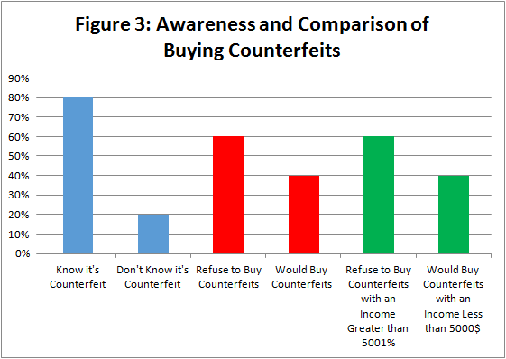

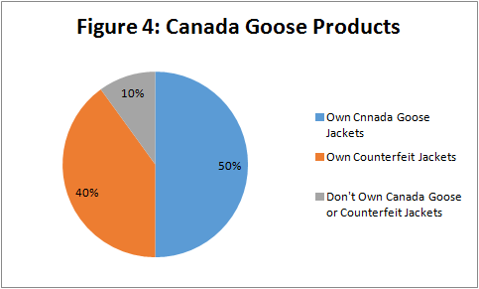

CONCLUSION

In conclusion, this study demonstrates that retail industry can be unsustainable due to counterfeit products through three reasons: production, accessibility, and awareness of counterfeit products. With the help of the secondary sources, possible theories and reasons for which counterfeits can cause unsustainability were found. Conducting a survey which related to Canada Goose Inc. determined whether or not the material that was found was accurate or inaccurate. This report confirms that there is a negative relationship between counterfeit products and the sustainability of retail companies like Canada Goose Inc. which can clearly be demonstrated through the primary research source.
The findings from the research suggested that production, accessibility, and awareness of counterfeit products were the leading cause of unsustainability in the retail industry. The production of counterfeits is a problem because it leads to a loss of sales since now consumers can obtain a similar product for a much cheaper value. Accessibility to counterfeit products is an issue because the easier it is to obtain a counterfeit the more likely consumers will purchase that product and therefore again will lead to a loss in profit. Finally, awareness plays an important role because if the consumer is aware whether or not they are purchasing a knock-off it can make a difference when it comes to actually buying the product. When all three of these issues are considered it is clear how they can cause unsustainability for any business in the retail industry.
The primary source material allows to conclude, whether or not the secondary source materials findings were genuine and also allowed for a more particular link to be drawn between the impacts on the retail industry and Canada Goose. At the end, it was possible to state that the secondary source research was accurate because from the survey very similar results were found, especially about Canada Goose Inc.
In order to prevent these problems from occurring in the future companies in the retail industry need to act together, however, more regulations that helps protect companies from becoming targets of counterfeits. As such, a change in the retail industry is highly recommended.

RECOMMENDATIONS

Backing up the results and conclusion of this study, the following recommendations regarding what can be done to prevent unsustainability for Canada Goose.

- Make sure to provide consumers with access to adequate information before the purchase a product. This will provide them with the knowledge to spot a fake product which is an excellent skill to possess, therefore when buying products, the chances of being exploited are lower.
- Making the sales of counterfeit products is illegal therefore if vendors are seen selling fakes, they should be reported. If vendors were to be caught they should be fined and all of their products should be seized.
- There should be more rigorous policies put into place that punish vendors that sell counterfeit products, which would intimidate other vendors from selling counterfeits.
- Large companies should invest more into companies that specialize in locating and closing counterfeit products producers.
- Others large vendors should not replicate their competitor’s products because it shows incentive for others to do the same.
- Canada Goose Inc. should provide consumers with a sample of the real product versus samples of counterfeits this will help them distinguish between real and fake in future purchases.
- The general public can also help by not buying counterfeit products.

APPENDIX

APPENDIX A: SURVEY QUESTIONNAIRE

This survey is being conducted to obtain a better understanding on the population views and opinions on counterfeit products that are being sold.

PART I
- What is your annual income? $0 – 2500 $2501 – 5000 $5001 – 10000
$10000 +

PART II
- Can you tell the different between fake or real products? Yes No
- Do you think it’s easy to buy a fake product? Yes No
- Where can you find fake products? _____________________________
- Are you aware that the item you are purchasing is fake? Yes No
- Would you buy a product knowing its counterfeit? Yes No
- If you already own a fake counterfeit, would you consider buying the real product in the near future? Yes No

PART III
- Do you own a Canada Goose Inc. product? Yes No
- Have you bought a counterfeit Canada Goose Inc. product? Yes No
- If yes, why? ___________________________________________

REFERENCES

Brain, M. (2004, March 19). How Counterfeiting Works. Retrieved October 28, 2017, from https://money.howstuffworks.com/counterfeit1.htm

Corben, R. (2017, March 27). Economic Report Predicts Rise in Global Counterfeiting, Piracy. Retrieved October 28, 2017, from https://www.voanews.com/a/global-trend-in-counterfeiting-and-piracy/3783360.html

Dalton, J. (2013). Natural Beauty. Retrieved October 28, 2017, from http://www.streetdirectory.com/etoday/the-main-reasons-for-the-demand-of-fake-goods-ujwuee.html

Melik, J. (2012, July 19). Popular trainer brands lose out to fakes. Retrieved October 28, 2017, from http://www.bbc.com/news/business-18508071

New York City Canal Street Shopping and Other Shopping. (2017, February 10). Retrieved from https://www.smartertravel.com/2017/02/10/new-york-city-canal-street-shopping-shopping/

OCED. (2007). The Economic Impact of Counterfeiting and Piracy. Retrieved from https://www.oecd.org/sti/38707619.pdf

Rouse, M. (2013, November). What is business sustainability? - Definition from WhatIs.com. Retrieved from http://whatis.techtarget.com/definition/business-sustainability

Satenstein, L. (2017, June 30). Would You Ever Buy Fake Designer Clothes?Retrieved from https://www.vogue.com/article/rise-of-bootleg-fashion-at-gucci-and-vetements

Sowder, A. (2017). The Harmful Effects of Counterfeit Goods. Retrieved October 28, 2017, from http://www.athens.edu/business-journal/spring-2013/asowder-couterfeit/

Stone, C. (2015, April 15). China Shopping: Your Fake Market Guide. Retrieved October 28, 2017, from http://www.cityweekend.com.cn/shanghai/article/china-shopping-your-fake-market-guide

Zeitlin, M. (2017, February 16). Here are 7 things we learned about Canada Goose from its IPO filing. Retrieved October 28, 2017, from https://www.cnbc.com/2017/02/16/here-are-7-things-we-learned-about-canada-goose-from-its-ipo-filing.html

Unknown. (2006) .Why do consumers buy fake brands? Retrieved from https://forum.wordreference.com/threads/why-do-consumers-buy-fake-brands.116407/

Wilson, T. (2017, March 25). Don't get taken by cheap 'Canada Goose' parkas (like I was). Retrieved October 28, 2017, from https://beta.theglobeandmail.com/report-on-business/small-business/sb-growth/day-to-day/my-christmas-goose-dont-get-scammed-like-i-did/article16088567/

