Reproductive System

What are the purposes of the male and female reproductive systems? To create offspring, to get diversity
What do you need to already understand before approaching the anatomy and physiology of the male and female reproductive systems? Hormones: steroid, testosterone, progesterone & estrogen, gametes: Males produce sperm & females produce ova, depends on meiosis
The female system is cyclical whereas the male system is not. What does this really mean? What important differences will allow one system to be cyclical and the other to maintain fairly steady production of hormones and gametes?

Describe the anatomy of the male reproductive system
Describe the gross & microscopic anatomy of the testes
- testes located in scrotum: sac of skin + superficial fascia outside abdominopelvic cavity at root of penis
sparse hairs, more heavily pigmented
- midline septum provides one compartment/testis
- exterior position provides essential temp 3⁰ C lower than core (Ideal to produce sperm)
2 tunics:
- Tunica vaginalis: outer, 2-layered (derived from an outer pocketing of the peritoneum)
- Tunica albuginea: fibrous capsule of testis (white coat); septal extensions divide each testis into 250-300 wedge-shaped lobules
each lobule = 1 to 4 coiled seminiferous tubules (actual “sperm factories”)
The roles of the dartos & cremaster muscles in testicular temperature regulation can cause testes to come closer to the body for temp regulation
Leydig Cells
interstitial cells that produce androgens (testosterone)
Interstitial means what?? Secrete into the interstitial fluid
Blood Supply
- testicular arteries (branch from abdominal aorta) supply the testes
- testicular veins form pampiniform plexus (surrounds the portion of each testicular artery within the scrotum, absorbs heat from the arterial blood cooling it before it enters the testes)
- spermatic cord: blood & lymph vessels, nerves fibers & vas deferens (passes through inguinal canal
Leydig cells lie in the soft CT surrounding the seminiferous tubules

Describe in detail the pathway followed by sperm from the epididymis to the exterior of the body
A. Epididymis (~3.8 cm)
- where sperm mature
- head (contains efferent ductules that empty into the duct of the epididymis) caps superior part of testis (receives sperm from testes)
- body & tail contain highly coiled duct of epididymis; (uncoiled = ~6 m!)
- sperm that enter epididymis are immature, nonmotile
- ~20 days to traverse epididymis gain ability to swim
During ejaculation, smooth muscle in the ducts contract, expelling sperm into the next segment Ductus deferens
Epithelial cells of the epididymis eventually phagocytize sperm that do not get ejaculated for a long period of time
Sperm be stored in the epididymis for several months
B. Ductus (Vas) Deferens (1/testis)
- Transports sperm during ejaculation
- ~45 cm long
- pathway taken; passes anterior to the pubic bone, then loops medially over the ureter & descends along the posterior bladder wall.
- Its end expands to form the ampulla then joins with the duct of the seminal gland to form the ejaculatory duct
  - ejaculatory duct passes into prostate gland, then into urethra
  - each vas deferens propels sperm out during ejaculation
- Vasectomy is when a physician makes a small incision into scrotum and cuts through and ligates (ties off) or cauterizes each ductus deferens. Sperm are still produced, but they can no longer reach the body exterior. Instead they deteriorate & are phagocytized. Are there any risks associated with this procedure?
C. The Urethra
- terminal portion
- it transports urine & semen so serves both urinary & reproductive functions
- Three regions are:
- The prostatic urethra: portion surrounded by the prostate.
- The membranous urethra: in the urogenital diaphragm
- The spongy (penile) urethra: runs through the penis and opens to the outside at the external urethral orifice, accounts for 75% of urethral length & its mucosa contains urethral glands that secrete mucus into lumen before ejaculation

Localize & describe the structure of the male reproductive accessory glands
- produce secretions that, along with sperm, make up semen
A. Seminal Vesicles (2)
- posterior wall of bladder; about size & shape of little finger
- contribute ~70% of semen volume (yellow, viscous, alkaline; fructose, citric acid, coagulating enzyme, prostaglandins)
- fibrous capsule encloses thick layer of smooth muscle that contacts during ejaculation to empty the gland
- yellow colour due to flavin proteins – fluoresce under UV light
- sperm + seminal fluid mix in ejaculatory duct & enter the prostatic urethra together during ejaculation
B. Prostate Gland (1)
- single gland, size & shape of chestnut; encircles urethra inferior to bladder
- During ejaculation, smooth muscle contracts, squeezing the secretion into the prostatic urethra via several ducts during ejaculation
- milky secretion (close to 1/3 semen volume; contains enzymes; role in activating sperm; also contains PSA)
- Bulbourethral Glands (2)
- pea-sized, inferior to prostate
- Produces a thick, clear mucus which drains to spongy urethra before ejaculation (purpose is to neutralize any traces of acidic urine & lubricate the glans penis when a man is sexually excited)

Describe the structural organization of the penis as a copulatory organ
- delivers sperm into ♀ reproductive tract
- external genitalia = penis + scrotum
- penis = attached root + free shaft or body that ends in an enlarged tip = glans penis
- foreskin or prepuce = cuff of skin around glans (circumcision – not medically necessary but has been shown to decrease the risk of HIV & other infections)
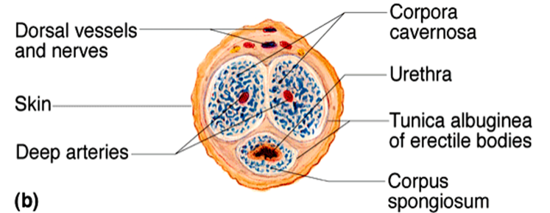
- internally, penis contains:
- spongy urethra
- 3 corpora of erectile tissue
- 2 corpora cavernosa – make up most of penis & are bound by the fibrous tunica albuginea. Their proximal ends form the crura of the penis
- Each crus is surrounded by an ischiocavernosus muscle & anchors to the pubic arch of the bony pelvis
- 1 midventral corpus spongiosum (surrounds urethra)
- (expands distally glans; expands proximally bulb of penis)

Describe the composition of semen
- milky white, somewhat sticky mixture of accessory gland secretions & sperm
- secretions provide:
  - transport medium
  - nutrients (eg: fructose, citrate)
  - chemicals (eg: PGs, ATP, antibiotic chemicals) - protect/activate sperm or support sperm transport
- H 7.2-7.6 neutralizes pH 3.5-4 of vagina
SEMEN: 2-5 ml/ejaculation; [sperm] = 50-100 million/ml

The penis delivers semen to the ♀ reproductive tract.
The testes are the site of sperm & testosterone production.
The ductus (vas) deferens is the passageway for sperm from epididymis to ejaculatory duct.
The urethra conveys both sperm & urine down length of the penis.
The seminal vesicles, prostate gland, bulbourethral glands, & testes contribute to the formation of semen.
The scrotum is the external sac that houses the testes.
The epididymis is the tubular storage site for sperm; hugs lateral aspect of testes.
The prepuce is a cuff of skin encircling the glans penis.
The prostate gland surrounds the urethra at the base of bladder; produces a milky, alkaline secretion.
The seminal vesicles produce over half of the seminal fluid.
The bulbourethral glands empty a lubricating mucus into the urethra
The spermatic cord is a CT sheath enclosing vas deferens, blood vessels & nerves.

Describe the regulation of male reproductive function
Differentiate functionally between Sertoli & Leydig cells
- normal rate of sperm production is 2x10⁸ sperm/day
- testis is a source of both germ cells & hormones
- testis is composed of:
  - seminiferous tubules: = Sertoli cells + spermatogenesis intermediates; 80% of testicular mass
  - Leydig cells: synthesize androgens (testosterone)

Distinguish steroid hormones (both structurally and functionally) from amino acid-based hormones
Cholesterol Progesterone Androstenedione Testosterone
The cell type in testis that synthesizes testosterone are Leydig cells
Actions of testosterone:
gonadal:
- growth/maturation of gonads & accessory organs (puberty)
- essential for spermatogenesis
somatic:
- adolescent growth spurts (start & stop - As testes become active - start and continue to get higher, stimulates closure of epiphyseal plates.)
- growth of larynx & vocal cords
- secretion of sweat
- hair (face, chest, armpits, groin)
metabolic:
- anabolic: hematopoiesis, BMR
CNS:
- maintenance of libido
- aggression
The event that begins first is testis to increase the rate of testosterone
Steroid hormones are lipids – they can easily get in & out of cells

Describe the hypothalamic & pituitary regulation of steroidogenesis in the male
Anterior Pituitary Hormones:
- gonadotropins are glycoproteins
- water-soluble – Not able to get inside target cells, have to activate second messengers
cell surface receptors; 2nd messengers
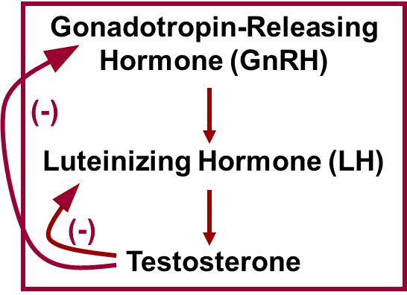
> regulate activity of enzymes
Follicle Stimulating Hormone (FSH)
- stimulates Sertoli cells to support spermatogenesis (T required)
Luteinizing Hormone (LH)
- stimulates Leydig cells to secrete testosterone
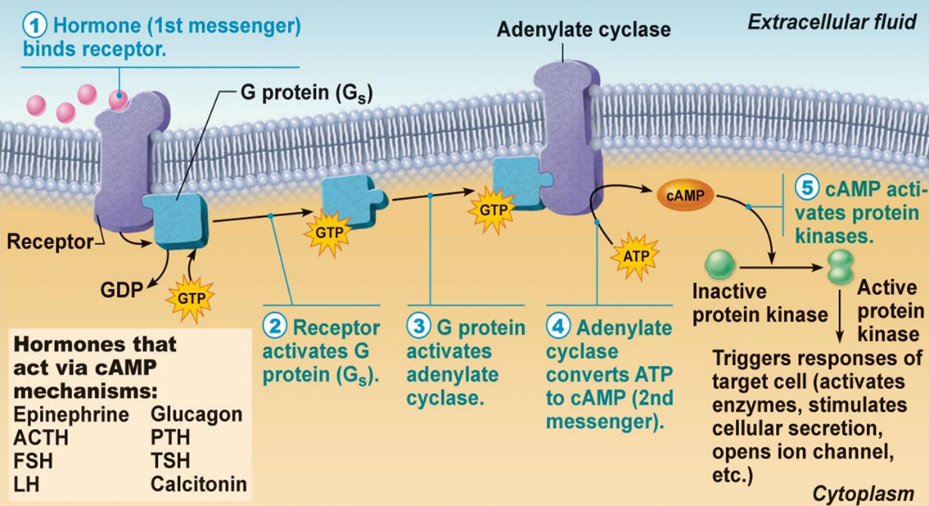
Testosterone synthesis stimulated by LH (luteinizing hormone) from the anterior pituitary.
Cyclic AMP Second Messenger Mechanism of Water-Soluble Hormones

GnRH:
- Gonadotropin Releasing Hormone
- pulsatile secretion by hypothalamic neurons
- stimulates secretion of FSH & of LH
Inhibin:
- released by Sertoli cells
- inhibits secretion of ONLY FSH
Why is this important? Negative feedback, allows for separating effect, otherwise just have GnRH constantly releasing FSH and LH

Outline the main steps in spermatogenesis
- Process of forming male gametes
- Occurs in the seminiferous tubules of the testes & is the hallmark of sexual maturity
- starting point is spermatogonium [diploid] – forming spermatocytes
- at puberty, 6 x 10⁶ spermatogonia per testis; self-perpetuating
What does this mean?? Significant barrier for cells to get through during meiosis, has to cross the tight junction
From Spermatogonium to Spermatozoan
- Spermatogonium: (2N)
- starting point; supply constantly maintained
- first step: spermatogonium B undergoes 2 mitotic divisions 4 1⁰ spermatocytes
- Primary Spermatocyte (2N)
- starting point of meiotic divisions
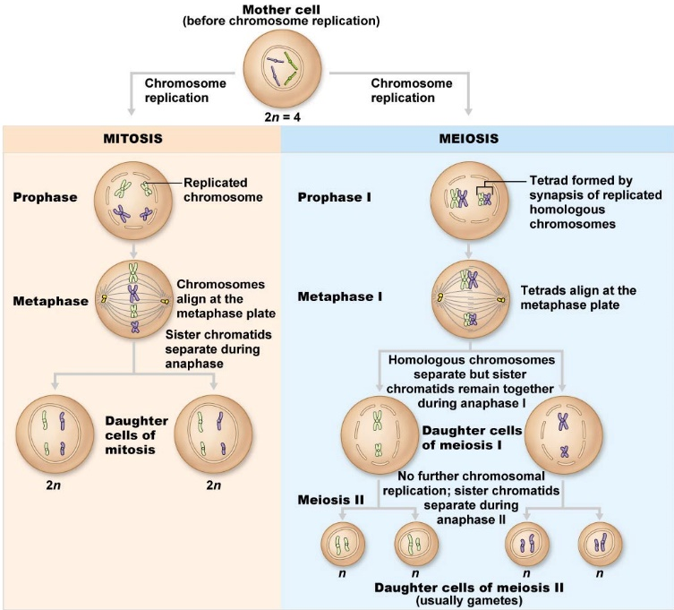
- first round yields 2 secondary spermatocytes/primary spermatocyte
- Secondary Spermatocyte:
- 2 copies of each of 23 chromatids (eg: if ♂, would have 2 Y chromatids)
- 2nd division 2 haploid (N) spermatids
- Spermatid:
- 22 autosomal chromatids + X or Y - still a round cell

Spermiogenesis
from 1⁰ spermatocyte to spermatozoan takes ~70 days
- Spermatozoan:
- conversion of spermatid to spermatozoan requires structural reorganization
- reorganization of nucleus & cytoplasm
- development of a flagellum
- spermatozoa then released into lumen; still not completely mature
- in epididymis will acquire ability:
  - to gain increased motility
  - to gain fertilizing power

Define blood-testis barrier & outline the functions of Sertoli & Leydig cells in supporting spermatogenesis
A. Role of Sertoli Cells
- spermatids & spermatocytes at various stages embedded in Sertoli cells
- Sertoli cells sit on basement membrane; tight junctions create 2 compartments:
>basal compartment:
>adluminal compartment:
tight junctions create blood-testis barrier; all stages after initiation of meiosis occur in avascular environment
Sertoli cells:
- nourish developing spermatozoa
- secrete fluid into seminiferous tubule lumen
- digest cytoplasm discarded by spermatozoa
- bind FSH and testosterone
- produce inhibin

B. Role of Leydig Cells
- located between seminiferous tubules
- vascularized - why important?
- receptors for LH - stimulated by LH to secrete testosterone to:
- support spermatogenesis
- support accessory organs

Describe the functional contributions of the epididymis & the accessory organs to the production of semen
A. Epididymis
- sperm spend ~20 days here
- further maturation – membrane & enzyme changes to permit:
  - sustained motility
  - binding to egg
B. Seminal Vesicles
- secrete viscous, yellow fluid rich in fructose
- Why fructose? Catabolism of fructose provides nearly all fuel needed for sperm ATP synthesis.
- also contains PGs What do they do? cause viscosity of mucus guarding entry of uterus to decrease
C. Prostate Gland
- secrete thin, milky fluid to neutralize acidity of male urethra & female vagina
D. Bulbourethral Glands
- thick, clear mucus
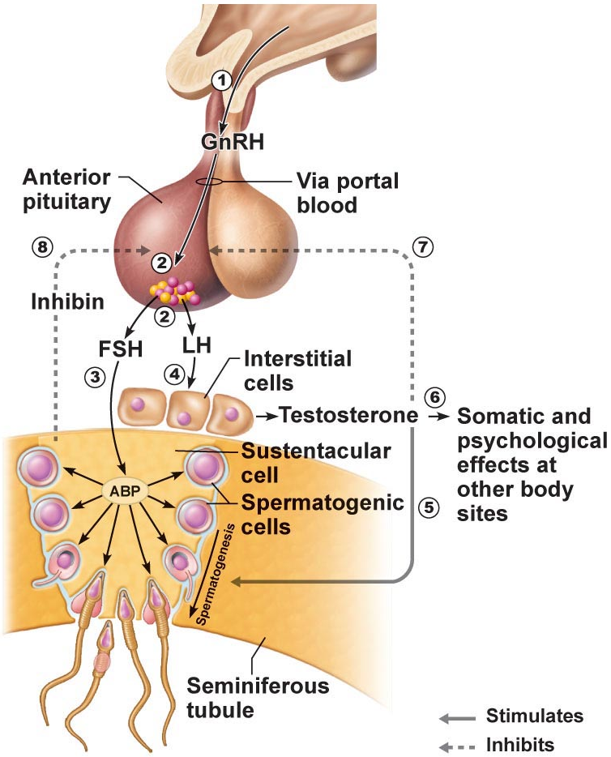
- neutralizes traces of acidic urine in urethra
Know sources & roles of :
GnRH
FSH
LH
testosterone
inhibin
Have an understanding of:
hypothalamus
anterior pituitary
gonadotropin
Sertoli cell
Leydig cell

1. A chromosome count in a spermatogenic cell within the adluminal compartment of the seminiferous tubule shows it to be diploid. The cell could be a:
primary spermatocyte
2. Seminal vesicle secretions have: fructose & prostaglandins
3. Which of the following statements about gonadotropins is FALSE?
a) secreted by the pituitary gland
b) LH and FSH
c) hormones with important functions in both ♂ and ♀
d) the sex hormones secreted by the gonads

Describe the anatomy of the female reproductive system

Describe the gross and microscopic anatomy of the ovaries
- female reproductive system is more complex it must:
  - produce gametes
  - prepare to nurture the developing embryo
    - internal genitalia: ovaries
    - accessory ducts: uterine tubes (oviducts), uterus, vagina
    - external genitalia: vulva
Ovaries
- anchored by ligaments in the peritoneal cavity
ovarian: anchors the ovary medially to the uterus
suspensory: anchors it laterally to the pelvic wall
mesovarium: suspends it in between
NB: suspensory/mesovarium ligaments are part of the broad ligament that supports uterine tubes, uterus, vagina & encloses the ovarian ligaments
- Served by ovarian arteries (branches of abdominal aorta) & ovarian branch of uterine arteries
- external surface covered by tunica albuginea
- final outer covering is germinal epithelium (continuation of the peritoneum)
- ovarian cortex contains follicles at all stages of development
oocyte: immature egg
granulosa cells: surrounding cells when more than one layer is present
theca cells: some secrete steroid hormones in response to LH
corpus luteum: formed from ovulated follicle each month

Describe the gross and microscopic anatomy of the oviducts
- receive egg & provide site for fertilization; ~ 10 cm long
- ampulla: forms half the length of the uterine tube, site where fertilization occurs
- infundibulum: opening of the uterine tube into the peritoneal cavity, margin is surrounded by fimbriae that drape over the ovary
- fimbriae: ciliated, finger like projections
  - oocyte released into peritoneal cavity fimbriae direct it into ampulla of oviduct
- structure of wall of oviduct also helps oocyte move toward uterus:
- It bends to drape over the ovary while the fimbriae stiffen and sweep the ovarian surface.
- The beating cilia on the fimbriae create currents in the peritoneal fluid that carry an oocyte into the uterine tube
- external covering = visceral peritoneum; supported by mesosalpinx
- Isthmus: forms the narrow medial third of the uterine tube, empties into the superolateral region of the uterus.

Describe the gross & microscopic anatomy of the uterus
- lies in the pelvic cavity anterior to the rectum & posterosuperior to bladder
- receives, retains, nourishes a fertilized ovum
- about the size & shape of an inverted pear in nulliparous women (women who have borne children)
- internal os: uterus to cervix
- external os: cervix to vagina
- (os = mouth)
cervical glands: mucus fills cervical canal & covers external os prevents infection; less viscous at midcycle – time of ovulation, allows sperm to pass through
Supports of Uterus:
mesometrium: supports laterally (portion of the broad ligament)
lateral cervical ligaments: supports inferiorly; extend from cervix & superior vagina to lateral walls of pelvis
uterosacral ligaments: secure to sacrum posteriorly
round ligaments: binds to anterior body wall
- supports allow mobility (e.g.: during filling & emptying of the bladder & rectum)
- principal support by muscles of pelvic floor (urogenital & pelvic diaphragms)
Uterine Wall:
- 3 layers:
  - perimetrium: = visceral peritoneum, incomplete outermost serous layer
  - myometrium: middle, interlacing bundles of smooth muscle – become thicker during pregnancy & contracts during childbirth
  - endometrium: simple columnar epithelium + thick lamina propria – blood vessels running through, drawn on through pregnancy
- stratum functionalis: layer closest to lumen, layer that is shed during menstruation
- stratum basalis: form a new functional layer after menstruation ends
vascular supply:
uterine arteries (from internal iliacs) to arcuate arteries (within myometrium) radial arteries (sent into endometrium) straight arteries (stratum basalis) & spiral arteries (stratum functionalis)
- Spiral arteries repeatedly degenerate & regenerate in response to changing hormone levels
- These spasms cause the functional layer to shed during menstruation

Describe the anatomy of the vagina & the external genitalia
- thin-walled tube, 8-10 cm long
- between bladder & rectum
- urethra is anterior and runs parallel
- female organ of copulation
Provides passageway for:
- entry of sperm
- exit of menstrual flow
- delivery of infant
3 layers:
adventitia: outer, fibroelastic
muscularis: smooth muscle
mucosa: inner, marked by transverse rugae; stimulate penis during intercourse, stratified squamous epithelium (To stand up to friction)
- has no glands; lubrication provided by cervical glands & mucosal fluid that seeps from vaginal walls
- epithelial cells store glycogen and are shed metabolized to lactic acid by resident bacteria acidic pH deters infection, but is hostile to sperm
- tends to be alkaline in adolescents, predisposing sexually active teens to STI’s
hymen: incomplete vascular partition of mucosa near vaginal orifice in virgins, may bleed when it stretches or ruptures during first sexual intercourse.

External Genitalia
vulva: external genitalia; mons pubis, labia, clitoris, structures associated with vestibule
mons pubis: fatty, rounded area overlying pubic symphysis; covered with hair
labia majora: 2 elongated, hair-covered fatty skin folds (homologues of scrotum)
labia minora: 2 thin, hair-free skin folds enclosed by labia majora (homologous to spongey urethra)
vestibule: recess between labia minora - contains external opening of urethra & vaginal opening
greater vestibular glands: pea-sized, flanking the vaginal opening (homologous to penis)
clitoris: erectile tissue (homologous to penis); hooded by skin fold (prepuce), formed by the junction of the labia minora folds; richly innervated with nerve endings; corpora cavernosa but no corpus spongiosum

Identify the following female anatomical structures:
1. The uterus is a chamber that houses the developing fetus.
2. The vagina is a canal that receives the penis during sexual intercourse.
3. The ampulla of the uterine tubes is the usual site of fertilization.
4. The clitoris becomes erect during sexual stimulation.
5. The oviduct is a duct through which the ovum travels to reach the uterus.
6. The hymen is a membrane that partially closes vaginal canal.
7. The ovary is the primary female reproductive organ.
8. The fimbriae move to create fluid currents to draw the ovulated egg into the uterine tube.

Describe the regulation of female reproductive function
Describe ovarian steroidogenesis as a compartmentalized process
General Information
- ovaries have two key functions:
  - produce oocytes
  - produce reproductive hormones (eg: estradiol, progesterone)
Remember:
- the hormones a cell can produce depends on the enzymes it has
- steroids are lipids – can easily traverse plasma mbs
CHOLESTEROL progesterone androstenedione testosterone estradiol
3 Types of Steroid Hormones Produced in Ovarian Follicle:
cholesterol
↓
progesterone → 17α-OH-progesterone → androstenedione
↓ ↓ ↓ 17α HSD
↓ ↓ testosterone
↓ ↓ ↓ aromatase
aldosterone cortisol estradiol-17β
(mineralocorticoids) (glucocorticoids) (sex steroids)
C-21 steroids: progestins (eg: progesterone)
C-19 steroids: androgens (eg: testosterone)
C-18 steroids: estrogens (eg: estradiol-17β)
all are derivatives of cholesterol

Describe the hypothalamic & pituitary regulation of steroid hormone production in the female
- there are 3 types of steroid hormones produced in the ovarian follicle
A. Progestins (eg: progesterone - all have 21 carbons)
- produced by all major ovarian cell types: follicular granulosa cells, theca cells, corpus luteum
- most important as a product of the corpus luteum - during luteal phase of menstrual cycle & for maintenance of pregnancy
B. Androgens (eg: testosterone - all have 19 carbons)
- most important as a precursor for synthesis of estradiol in developing follicle
- synthesized by follicular theca cells and by corpus luteum
- too much testosterone is associated with follicular atresia
C. Estrogens (eg: estradiol - all have 18 carbons)
- synthesized by follicular granulosa cells and corpus luteum
- essential for stimulation of follicular development, onset of puberty, etc.
Hypothalamic-Pituitary Axis:
Anterior Pituitary Hormones:
(i) FSH
- stimulates ovarian follicles to grow & produce estradiol
(ii) LH
- stimulates testosterone production by theca cells
- stimulates ovulation, secretion of steroid hormones by corpus luteum
Hypothalamus:
- the secretion of both FSH & LH is stimulated by GnRH

Describe ovarian follicular development & its hormonal regulation
- What is the goal of each menstrual cycle? Ovulation of a single egg, to prepare the lining of the uterus for a possible establishment of a pregnancy
A. Primordial follicle:
starting point = oocyte surrounded by single layer of flattened follicular cells (will become granulosa cells)
- oocyte (primary oocyte) arrested at prophase of meiosis I
- by 6 months postpartum, ovary has full complement of primordial follicles
- ~2 million at birth; gradual loss (degeneration); ~400,000 remain by puberty
Primordial Follicle = oocyte + single layer of flattened granulosa cells
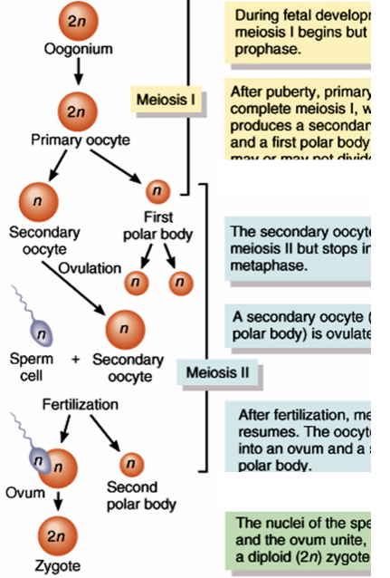
Initiation of development of primordial follicles does NOT require gonadotropic stimulation - some follicles can and do begin developing at any time
- oogonia to primary oocytes accomplished by birth
At what stage are oocytes arrested? Prophase of meiosis I. What would they look like under the microscope? Would be able to see chromosomes condensing & the miotic spindle
What triggers the resumption of meiosis? Surge in LH release necessary for ovulation, second time is ovulation of that egg
What is the fate of most primary oocytes?? To never enter meiosis
What is the fate of most oocytes in which resumption of meiosis was initiated by trigger #1? Not to complete meiosis because most of the time ovulated eggs do not get fertilized
B. Primary Follicle: Developmental Events
- gonadotropin-independent
  - oocyte increases in size & acquires a zona pellucida – slows down sperm
  - granulosa cells start to divide & form several layers outside oocyte
  - outside bm ovarian interstitial cells closest to growing follicle differentiate to form theca cells
- throughout these changes called a primary follicle - continued maturation of this follicle requires FSH and LH
Correction to textbook: “The characteristic feature that distinguishes secondary from primary follicles is the appearance of a follicular antrum within the granulosa layer.”
C. Antral Follicle:
What is an antrum? Fluid filled cavity. Why is it important to have an antrum in a maturing follicle? So we can build up fluid and fluid pressure so ovulation can occur
- basement membrane divides follicle into 2 compartments:
  - inner granulosa cell compartment
    - nonvascularized
    - FSH-responsive:
      - granulosa cell proliferation (Estrogen)
      - granulosa cell estrogen production
      - more FSH receptors
  - outer theca cell compartment
    - vascularized
    - LH-responsive:
      - Testosterone production for use by granulosa cells
Timing is Everything!
- if development coincides with rising FSH levels at beginning of cycle → development will be supported - otherwise: atresia!! (apoptosis of the oocyte & its surrounding cells)
- for one follicle to become dominant, must convert potentially androgenic environment to estrogenic environment - otherwise: atresia!!
D. Emerging dominant follicle becomes the preovulatory follicle
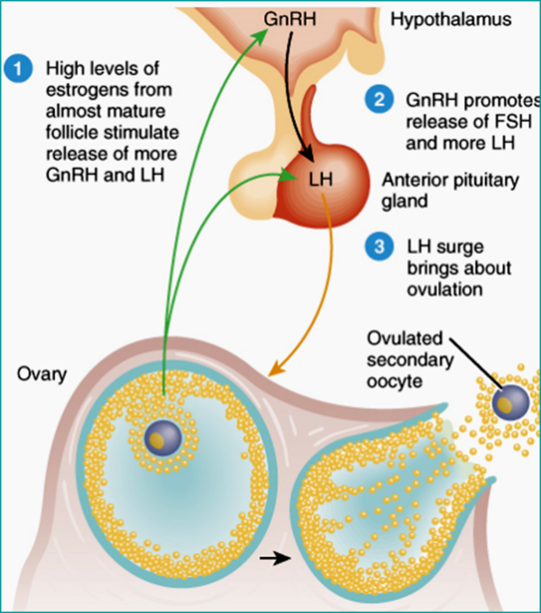
Estrogen levels continue to rise - FSH switches to inducing receptors for LH (Getting ready to become the corpus luteum) LH stimulates further estrogen & progesterone production
- stage is now set for LH surge to trigger ovulation

Describe ovulation & its regulation
LH stimulates:
- resumption of meiosis - extrusion of PB#1
- Progesterone production by granulosa cells
- increase in antral fluid volume
- release of hydrolytic enzymes
minor FSH surge:
- ensures sufficient LH receptors for luteal phase
- stimulates synthesis of hyaluronic acid - important in cumulus expansion
what are cumulus cells? cluster of cells that surround the oocyte in the ovarian follicle & after ovulation, ensure healthy oocyte and embryo development
what is a cumulus-oocyte complex (COC)? an oocyte surrounded cumulus cells ovulated during the ovulatory phase of the menstrual cycle

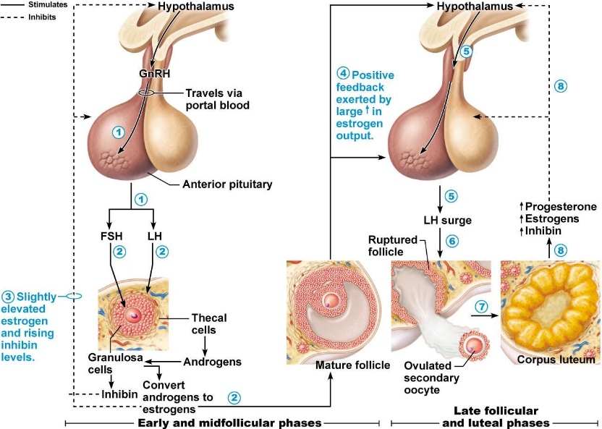
Describe the corpus luteum as a transient endocrine structure
corpus luteum = yellow body
capillaries bring cholesterol to follicle
corpus luteum = luteinized granulosa + theca cells + capillaries
Supplies the high levels of progesterone & estrogens that characterize the luteal phase
unless a pregnancy intervenes, lifespan of CL is <14 days – what is required to maintain CL?? Fertilized oocyte & pregnancy

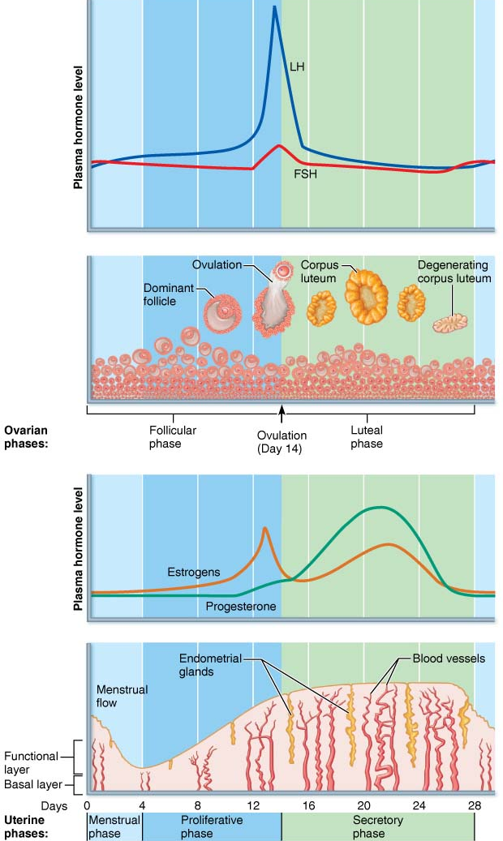
Describe the cyclical regulation of the uterine endometrium
Proliferative Phase:
- The endometrium rebuilds itself
- resurfacing of epithelium
- cell proliferation in response to ovarian E
- development of spiral arteries & uterine glands
- cervical mucus becomes thin; forms channels that facilitate sperm passage
- ovulation occurs at the end in response to LH surge from anterior pituitary
Secretory Phase:
- endometrium prepares for an embryo to implant
- thickening of whole layer due to cell growth & fluid retention
When is endometrium maximally receptive to embryo implantation? When the glands enlarge, coil, & begin secreting nutrients into the uterine cavity
Why is this called the secretory phase? It is when glandular secretion of nutrients occurs
What is the cervical plug? Cervical mucus becomes thick again, helps to block entry of sperm, pathogens, & other foreign materials, Important for sealing off the uterus in the event an embryo has begun to implant
As LH levels decline, CL begins to degenerate (~D24) in absence of P secretion, uterine endometrium is shed & cycle begins again
If oocyte is fertilized: hCG is produced in increasing amounts beginning D9-13 after ovulation; hCG rescues CL until placental P can maintain pregnancy

Outline briefly the hormonal regulation of puberty
- initial hormonal events are the same in males & females
- in females, FSH stimulates E secretion by granulosa cells (LH stimulation provides T precursor from thecal cells)
estradiol responsible for:
- growth & maturation of breasts, reproductive organs
- fat redistribution
- bone maturation (growth closure of epiphyseal plates)
- cycles of proliferation & regression until sufficient growth occurs that withdrawal of steroid support (due to atresia of what??) results in first menstruation (menarche)
- first ovulatory cycle often may not occur until a few months later
- concept of a critical weight to reach before menarche:
- specifically, a critical ratio of fat to lean – Why? (think about aromatase activity in adipose tissue as well as adipose-cell-derived leptin)

Define menopause & summarize its effects on female physiology
DEFINITION: cessation of menses for at least 12 months
- in North America, occurs at mean age of 51.4 years
- primary cause is depletion of ovarian follicles
A. Perimenopause:
- extends from early 40s onward - « transitional years »
- ovarian function begins to wane - deprivation of estrogen (and its effects on FSH/LH secretion) can result in: hot flushes, insomnia, irritability, fatigue, headaches, depression/mood changes, loss of libido, poor mental performance/ nervousness, loss of skin elasticity
Menopause
- median age of 51.4 years; can live 1/3 of life after ovaries have ceased functioning
Loss of ovarian E affects all tissues that have E receptors
- genital tissues: atrophy, vaginal dryness, high incidence of vaginal infections)
- urinary tract: linings of bladder & urethra have E receptors urinary frequency, urgency, even incontinence
- breasts: some atrophy
- CV system: atherosclerosis, stroke
- skeleton: osteoporosis

Describe the process of oocyte fertilization & summarize the main features of early embryonic development up to implantation
For how long after ovulation is an egg capable of being fertilized? 12-24 hours
How long do sperm remain viable in the ♀ reproductive tract? Up to a week
Define sperm capacitation & indicate its relevance to fertility
- a further maturation sperm must undergo to be capable of fertilizing an egg
- occurs following ejaculation once sperm in ♀ tract
- seminal fluid contains capacitation inhibiting factors
- after capacitation, sperm:
  - have increased rate of flagellar beat & accelerated motility pattern ?
  - plasma membranes are more fragile facilitates acrosome reaction
IVF: can induce capacitation by washing sperm or running them through a Percoll gradient what is this process accomplishing?
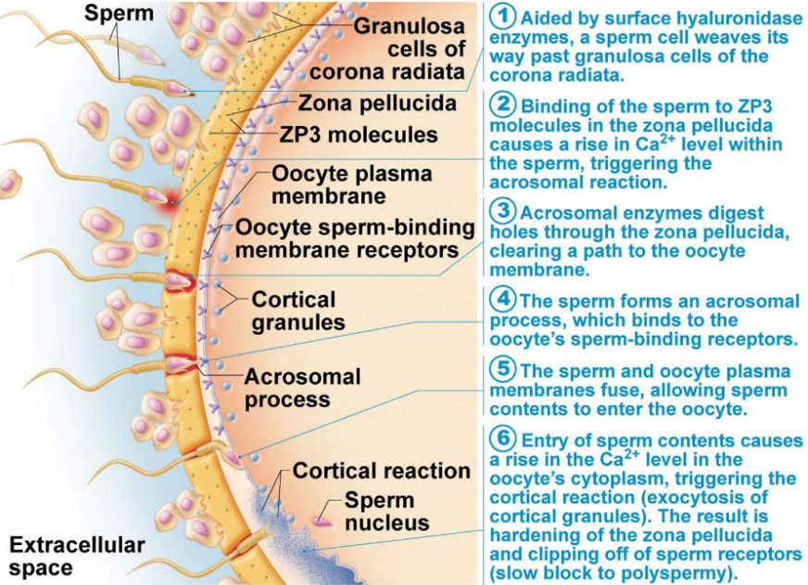
Describe the acrosome reaction
- zona pellucida can bind many sperm but only 1 sperm fertilizes the egg
- of ~300 M sperm in ejaculate, only few hundred get close to oocyte (where is it?)
- binding of sperm to zona pellucida induces acrosome reaction: What happens and why is this important? Ca2+ levels within sperm rise, triggering release of acrosomal enzymes, these enzymes digest holes through the zona pellucida to clear a path to the plasma mb
Why is it important that this happens only after sperm have bound to the zona pellucida??? So a path can be cleared to the plasma mb

Define polyspermy & briefly describe the fast & slow blocks to polyspermy
as soon as first sperm penetrates perivitelline membrane:
- fast block to polyspermy: analogous to the oocyte mb block; oocyte sperm-binding mb receptors are shed
- slow block to polyspermy: equivalent to the cortical & zone reactions; increased Ca2+ levels triggers exocytosis of cortical granules, hardens the zona pellucida & destroys its sperm binding receptors
- resumption of meiosis, extrusion of 2nd PB, formation of ♀ pronucleus
- sperm nuclear material forms ♂ pronucleus; ♂ and ♀ pronuclei fuse to form 2N nucleus of zygote

Define zygote; summarize the developmental steps that occur while the embryo is traversing the oviduct
Define morula, blastocyst, hatching
- Morula: loose collection of cells that form a cluster of 16 or more cells
- blastocyst: fluid-filled hollow sphere composed of a single layer of trophoblast cells & a small cluster of embryoblasts
- implantation begins on ~6th day following fertilization:
- blastocyst burrows into endometrium
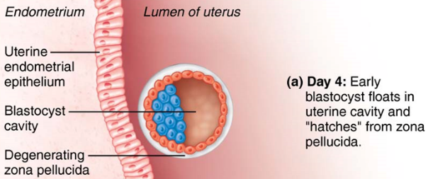
- trophoblast cells grow out toward mat blood vessels
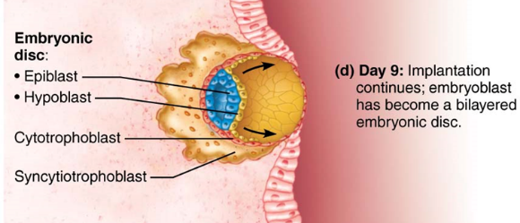

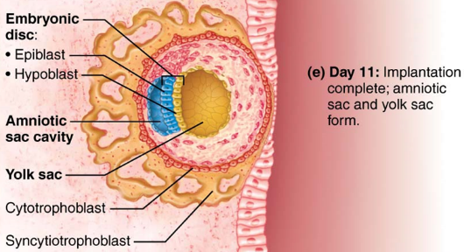
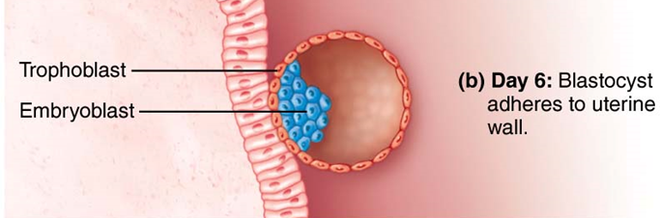

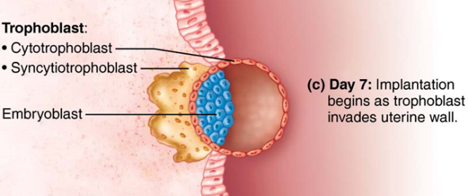
Implantation of the blastocyst

Conception to 2 weeks --- Germinal Period
- not yet aware menstruation has been delayed
3 to 8 weeks --- Embryonic Period
- most critical period in development
- may not know she is pregnant
- fundamental structures of all organ systems developing
9 weeks to term --- Fetal Period
- no longer embryo – fetus

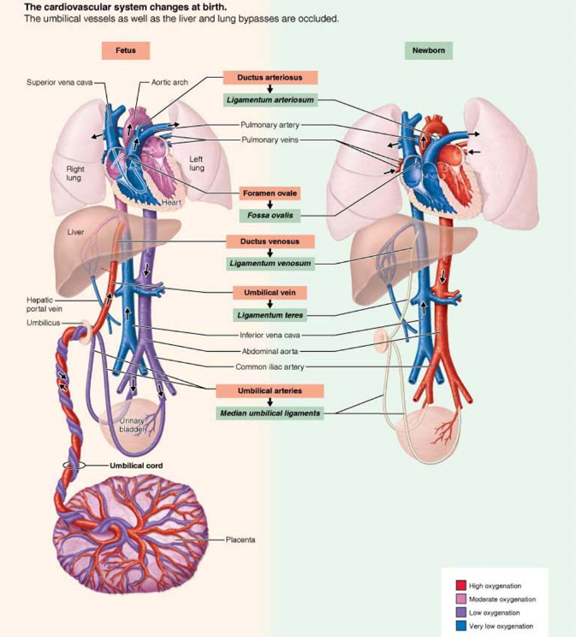
Summarize the hormonal regulation of pregnancy, parturition & lactation
Placentation
maternal and fetal blood supplies NOT in direct contact; nutrients, gases, wastes diffuse through:
- trophoblast
- mesenchyme – embryonic CT
- fetal capillary endothelium – lining fetal capillaries
normal term placenta is ~500g, measures 15-20 cm diam, 2-3 cm thick
umbilical cord usually 50-70 cm in length; contains 2 umbilical arteries, 1 umbilical vein
What is the foramen ovale? A direct communicating pathway between the right and left atria
What is the ductus venosus? A direct pathway that allows the live to be bypassed
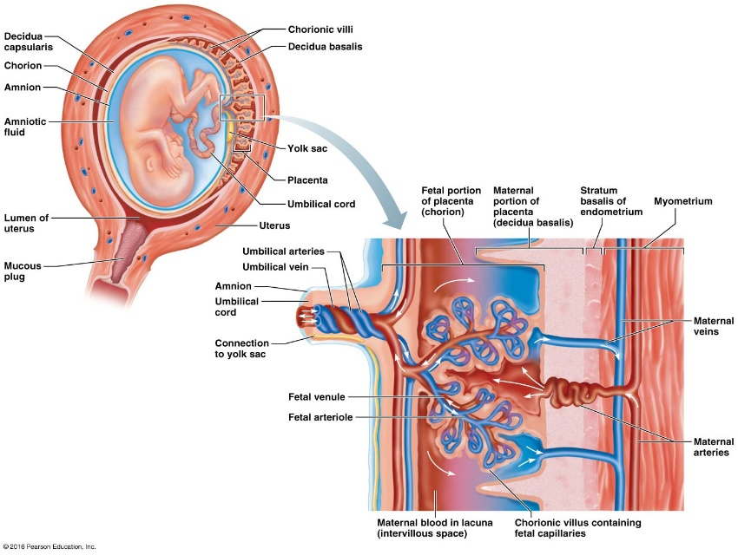
Describe the dual functions of the placenta: endocrine & exchange

13-week fetus

Placental exchange

HORMONES:
a) Human Chorionic Gonadotropin (hCG)
- present in maternal serum by 8th day after fertilization; levels peak by ~60-80 days, then begin to decrease
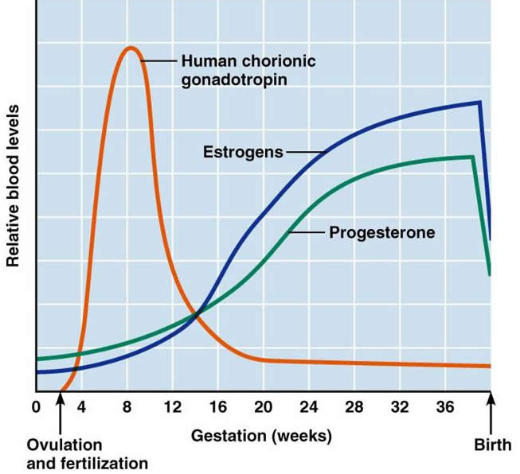
The primary function of hCG is to rescue the corpus luteum. This relates to the timing of its production and secretion by the developing embryo/fetus because levels have to increase quickly enough so that it can take over for LH
- can detect pregnancy by 3 days after missed period
- based on detection of hCG in blood or urine
- Human placental lactogen (hPL)
- structurally similar to GH & prolactin (human chorionic somatomammotropin, hCS)
- placenta begins to secrete hPL during 1st trimester; levels increase until delivery
- stimulates breast development in preparation for postnatal lactation
- supports fetal bone growth
- makes glucose available to fetus = diabetogenic or anti-insulin effect
NB: There is also a placental growth hormone that stimulates lipolysis and gluconeogenesis to support fetal growth
- Estrogens
- initially come from the corpus luteum; function gradually assumed by placenta
- placenta converts circulating androgens (fetal & maternal adrenal glands) to estrogen
- initially estrone & estradiol-17-β, then estriol
- maintains uterine endometrium
- contributes to breast development
- Progesterone
- initially from corpus luteum; function gradually assumed by placenta; levels increase over the course of the pregnancy
- a relaxing effect on smooth muscle:
- uterus: expands, put up with stress and accommodate fetus
- blood vessel walls: need relax to accommodate increased BV
- ureters: slow down flow of urine, relax walls, accommodate glucose in urine
- GE sphincter: heart burn, reflux, accommodate for uterus taking up space
- intestines: constipation, material moves slower, feces more compacted

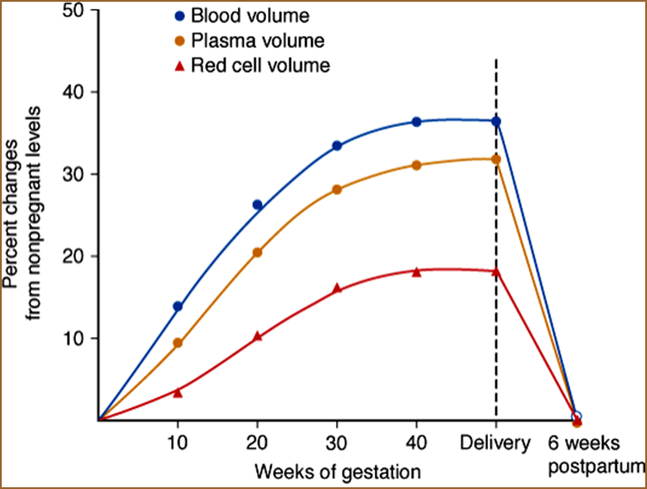
Outline briefly the influences of pregnancy on the CV, digestive, urinary & reproductive systems of the mother
- Cardiovascular:
bp decreases slowly to nadir @ 24 weeks; then slowly back up to NP levels
pulse slowly increases to max of 15-20 beats/min above NP in 3rd trimester
myocardial hypertrophy, increased contractility, increased CO
- overall increase in blood volume (~40%): plasma by ~45% & RBCs by 20-30% ⇒ physiological anemia of pregnancy
- GI tract:
- nausea: increased progesterone, hCG, both? Don’t know a lot yet
- when severe: hyperemesis gravidarum; if untreated can lead to dehydration, ketosis, electrolyte derangements, liver and kidney damage
- heart burn, due to reflux of stomach acid, is common because the esophagus is displaced & the stomach is crowded by the growing uterus
- Constipation occurs as the motility of the DT decreases
- Urinary tract
- kidneys increase in length by 1-1.5 cm (increased renal blood flow)
- bladder tone decreases; bladder capacity nearly doubles
- glomerular filtration rate (GFR) increases by 30-50% in first trimester
- high progesterone promotes renal Na (& water) loss; but increased aldosterone & estrogen promote salt & water retention
- increased risk of urinary tract infections – possible presence of glucose
- Cervix:
- softening & increased vascularity from early in 1st trimester
- increased production of mucus by endocervical glands
- Vagina:
- cervical secretions increase in quantity; decrease in pH (high estrogen)
- increased susceptibility to vaginal candidiasis (fungal infection; high estrogen, high glycogen)
- Uterus:
- enlarges by hypertrophy from 50-70 g (NP) to ~1000 g at term (effects of estrogen & progesterone)
- during 2nd trimester, uterus moves out of pelvis & begins to displace intestines up
- by 36th week, intestines pushed up to just beneath diaphragm discomforts experienced by mother include heart burn & shortness of breath
- blood flow to uterus at term ~500-750 ml/min (10x NP level); = 10-20% total CO
- contracts every 5-20 min during pregnancy; irregular contractions that are not coordinated = Braxton Hicks contractions – tightening in wall of uterus

Reminder of the importance of good nutrition during pregnancy
- balanced diet (protein, carbohydrates, fats, vitamins, minerals, fiber)
- important vitamins include vitamin D (bone growth), folic acid (RBCs), vitamin K (coagulation)
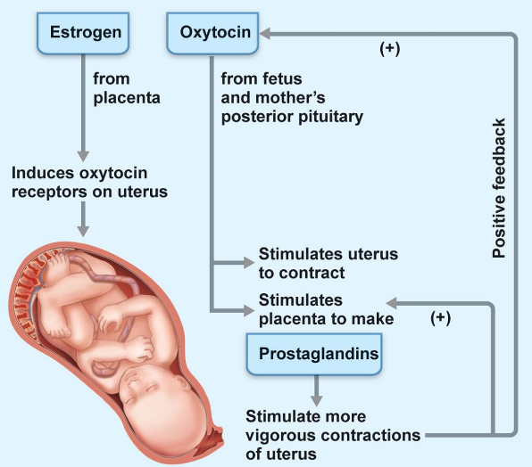
- important minerals include iron (RBCs), calcium (bone growth)

List the 3 stages of parturition
- whole process is not completely understood – esp. what is the signal (fetal cortisol?) to initiate parturition and how can we stop premature labour and delivery??
- estrogen levels highest toward time of parturition:
- lots of oxytocin receptors on myometrial cells
- antagonizes relaxing effect of progesterone
- two hormones important during labour and delivery:
- oxytocin – source is the posterior pituitary
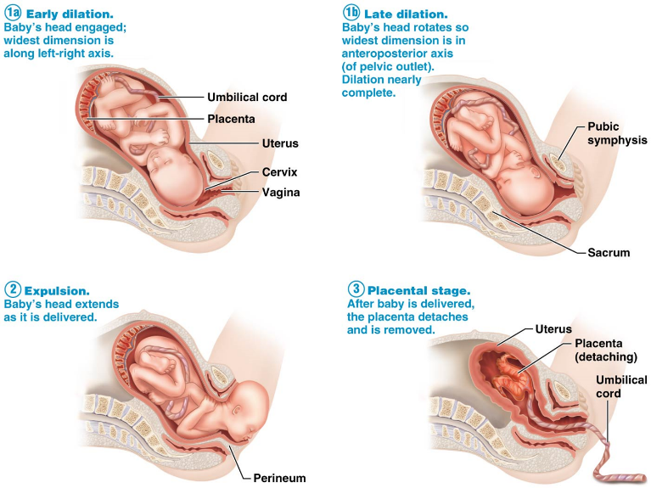
- prostaglandins – source is the wall of the uterus, oxytocin can stimulate production
Stages:
- DILATION: uterine contractions dilate cervix up to 10 cm; variable in duration
- EXPULSION: complete cervical dilation to birth (minutes to few hours)
- PLACENTAL: delivery of placenta;15 min after birth

Summarize the neuroendocrine regulation of the onset & completion of parturition
- Baby moves into birth canal; pressure of head on cervix ⇒ neuroendocrine reflex – cervix softens, effaces (thins), & dilates
- Oxytocin stimulates uterus to synthesize prostaglandins thinning & softening of the cervix just before & during labour
- Oxytocin levels are high during latter part of pregnancy, but labour is not initiated because:
  - progesterone levels are also high
  - myometrial cells have insufficient number of oxytocin receptors

Describe pregnancy-associated preparation for lactation & the roles of prolactin & oxytocin in supporting milk production & milk let-down
- Hormonal Regulation of Breast Development:
During pregnancy:
- alveolus: glandular structure involved in milk production; lined by a single layer of milk-secreting epithelial cells
- each mammary gland divided into 15-20 lobes; subdivided into lobules; basic component of each lobule is the alveolus
estradiol & progesterone levels increased during pregnancy stimulate further growth & development of alveoli & ducts
also, permissive actions of glucocorticoids, prolactin, human chorionic somatomammotropin
- prolactin stimulates milk production; actual secretion during pregnancy inhibited by high levels of estrogen and progesterone
Postpartum:
levels of estradiol and progesterone ⇓⇓, allowing full expression of prolactin
now can have both production and secretion

Explain how lactation is maintained
- Classical Milk Let-down Reflex & Hormonal maintenance of Lactation
- 2 important hormones:
- prolactin secretion of casein, lactose, fatty acids
- oxytocin contraction of myoepithelial cells
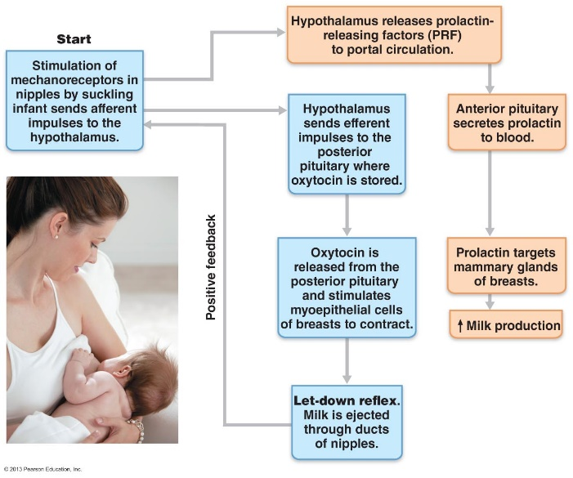
- both of these hormones required for continued lactation
1. Each month, only one: mature follicle undergoes ovulation
2. If the uterine tube is a trumpet (salpinx), what part of it represents the wide, open end of the trumpet? The infundibulum
3. The corpus luteum is formed at the site of: ovulation
Define:
inhibin: Released from gonads of males & females. Exerts negative feedback on & inhibits FSH release from the anterior pituitary. Also inhibits spermatogenesis. Proportional to sperm counts in males – high inhibin=high sperm count. I males releases by sustenocytes & in females by granulosa cells.
diploid: Normal number of chromosomes in most body cells. Consists of two sets of chromosomes, one from each parent, & is symbolized as 2n. In humans the chromosomal number is 46 & diploid cells contain 23 pairs of homologous chromosomes.
corpus albicans: Scar that remains from a degenerated corpus luteum when pregnancy does not occur.
theca cell: CT & epithelial cells that condense around the follicle. Some secrete steroid hormones in response to LH.
Sertoli cell (sustenocytes): Large, columnar cells. Surround, support, & nourish developing sperm. Nourish spermatogenic cells, get rid of their wastes & move them through the tubule wall. Bound laterally by tight junctions which form the blood testis barrier. Divide the seminiferous tubule into the basal compartment & the adluminal compartment. Following mitosis of the spermatogonia, the tight junctions open to allow type B daughter cells to pass into the adluminal compartment.
androgen: Male sex hormones. Produced by Leydig cells. Testosterone & estrogens
ovulation: Occurs when the ballooning ovary wall ruptures & expels the secondary oocyte into the peritoneal cavity.

