Instruction:
- The solution to each question should include detailed calculation steps. No any step means ZERO point.
- Please hand in a paper copy of your solutions at the beginning of the class on Feb. 8, 2019.
- During the year, the Senbet Discount Tire Company had gross sales of $1.2 million. The firm’s cost of goods sold and selling expenses were $450,000 and $225,000, respectively. Senbet also had notes payable of $900,000. These notes carried an interest rate of 9 percent. epreciation was $110,000. Senbet’s tax rate was 35 percent.
  - What was Senbet’s net income?
  - What was Senbet’s operating cash flow?

Description | Amount
Sales | $1,200,000
COGS | 450,000
Selling expenses | 225,000
Depreciation | 110,000
EBIT | 415,000
Interest Paid | 81,000 | (900,000 x 0.09)
EBT | 334,000
Taxes | 116,900 | (334000 X 35%)
Net Income | $217,100

$$Operating Cash Flow = EBIT + Dep – Tax \\ = 415,000 + 110,000 – 116,900 \\ = 408,100$$

- Schwert Corp. shows the following information on its 2015 statement of comprehensive income: sales = $167,000; costs = $91,000; other expenses = $5,400; depreciation expense = $8,000; interest expense = $11,000; taxes = $18,060; dividends = $9,500. In addition, you’re told that the firm issued $7,250 in new equity during 2015 and redeemed $7,100 in outstanding long-term debt.
  - What is the 2015 operating cash flow?
  - What is the 2015 cash flow to creditors?
  - What is the 2015 cash flow to shareholders?
  - If net fixed assets increased by $22,400 during the year, what was the addition to net working capital?

Description | Amount
Sales | $167,000
COGS | 91,000
Other Expense | 5,400
Depreciation | 8,000
EBIT | 62,600
Interest Paid | 11,000
EBT | 51,600
Taxes | 18,060
Net Income | $33,540

$$OCF = EBIT + Dep – Tax \\ = 62,600 + 8,000 – 18060 \\ = 52,540$$

$$Cash flow to creditors=interest paid-net new borrowing \\ = 11,000-\left(-7,100\right) \\ = 18,100$$

$$Cash flow to shareholders = dividends paid – net new equity \\ = 9500 – 7250 \\ = 2250$$
To find addition to new working capital:
Cash flow to asses = cash flow to creditors + cash flow to shareholders

$$CFA = 18,100 + 2250 \\ = 20350$$

CFA = OCF – Net capital Spending – change in net working capital
And Net capital spending = Increase in NFA + Depreciation
Therefore,
$NCS = 22,400 + 8,000$
$$= 30,400$$
And
$$CFA = OCF – Net capital Spending – change in net working capital \\ 20350 = 52,540 – 30,400 – Change in NWC \\ 1790=Change in NWC$$
Therefore, the company increased its net working capital by $1,790

- Given the following information for O’Hara Marine Co., calculate the depreciation expense: sales = $41,000; costs = $26,400; addition to retained earnings = $4,900; dividends paid = $1,570; interest expense = $1,840; tax rate = 35 percent.

$$Net Income = Dividends + addition to retained earnings \\ Net Income = \$1570 + \$4900 \\ Net Income = \$6470$$

Since, EBT – (EBT x Tax rate) = net income

$$EBT =\frac{NI}{1-Tax rate} \\ EBT =\frac{6470}{\left(1-0.35\right)} \\ EBT = 9953.846$$
$$EBIT = EBT + Interest \\ EBIT = 9953.846 +1840 \\ EBIT = 11793.846 \\ EBIT = Sales – costs – depreciation \\ 11793.846 = 41000 – 26400 – Dep. \\ Depreciation = 2806.154$$
___________________________________________________________________
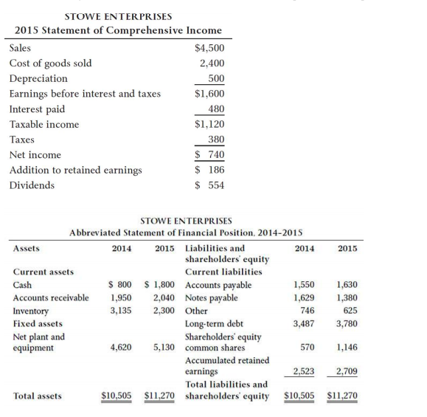

Use the following financial statement information for Stowe Enterprises to solve questions 4-6.

4. Compute the following ratios for Stowe Enterprises for 2014 and 2015:

$$2014/2015 Current Ratio = (current assets)/(current liab.) \\ 2014=5885/3925 \\ = 1.499 \\ 2015 =6140/ 3635 \\ = 1.689 \\ 2014/2015 Quick ratio = ((current assets – inventory))/(current liab. ) \\ 2014=(5885 – 3135)/3925 \\ = 0.701 \\ 2015 =(6140 – 2300)/3635 \\ = 1.056 \\ 2014/2015 Cash ratio = ((cash + cash equivalents))/(current liab.) \\ 2014 = \left(800\right) /3925 \\ = 0.204 \\ 2015 = \left(1800\right)/3635 \\ = 0.495 \\ \sim \\ 2015 Total Asset turnover = sales/(total assets) \\ =4500/11270 \\ = 0.399 \\ 2015 Inventory turnover =( COGS)/(average inventory) \\ =2400/((3135+2300)/2) ) \\ =2400/2717.5 \\ = 0.883 \\ 2015 Receivables Turnover = total operating revenues/average receivables \\ =4500/(((1950+2040))/2) \\ =4500/1995 \\ = 2.256 \\ \sim \\ total Debt ratio =(total assets – total equity)/(total assets) \\ 2014 =((10505 – 3093))/10505 \\ = 0.706 \\ 2015 = (11270 -3855)11270 \\ = 0.658 \\ 2014/2015 debt to equity ratio= total debt/total equity \\ 2014 =7412/3093 \\ = 2.396 \\ 2015 =7415/3855 \\ = 1.923 \\ Equity multiplier= total assets/total equity \\ 2014 = 10505/3093 \\ = 3.396 \\ 2015 = 11270/3855 \\ = 2.923 \\ 15Interest coverage = EBIT/ Interest exp. \\ = 1600/480 \\ = 3.333 \\ 15Cash Coverage Ratio = (EBIT + Dep.)/ interest \\ =1600 + 500 / 480 \\ = 4.375 \\ \sim \\ 15 Profit margin= net income/ sales \\ = 740/4500 \\ = 16.444\% \\ 15 ROA = Net income/ total assets \\ = 740/11270 \\ = 6.566\% \\ 15 ROE = Net income/ total equity \\ = 740/ 3855 \\ = 19.196\%$$

- Prepare a statement of cash flows for Stowe.

Stowe Enterprises
Statement of cash flows
For the year ended December 31,2015
Cash Flows from Operating Activities
Profit before tax | 1,120
Adjustment
Depreciation | 500
Interest | 480
Increase in accounts payable | 80
Decrease in others liability | (121)
Increase in accounts receivable | (90)
Decrease in inventory | 835
Cash flow from operation | 2,804
Less: Tax Paid | (380)
Net cash provided by operating activities | 2,424
Cash Flows from Investing Activities
Investments in property, plant, and equipment | (1,010)
Net cash used for investing activities | (1,010)
Cash Flows from Financing Activities
Common stock issued | 576
Dividend paid | (554)
Interest paid | (480)
Notes payable | (249)
Issuance of debt | 293
Net cash used for financing activities | (414)
Net change in cash | 1,000
Cash at beginning of period | 800
Cash at end of period | 1,800

6. Stowe has 80 shares outstanding in 2015. The price per share is $45. What are the P/E ratio and the M/B ratio?

$$EPS = (Net income -Preference Dividends paid) / shares outstanding \\ = (740 – 0)/ 80 \\ = 9.25 \\ Price earnings ratio = price per share/ earnings per share \\ = 45/9.25 \\ = 4.865 \\ Market to book ratio = market value per share / book value per share$$
$$= 45/48.188$$
$=0.934$

$$Book Value per Share= (total assets – total liabilities)/total \# of shares outstanding \\ =(11270-7415) 80 \\ = 48.188$$

