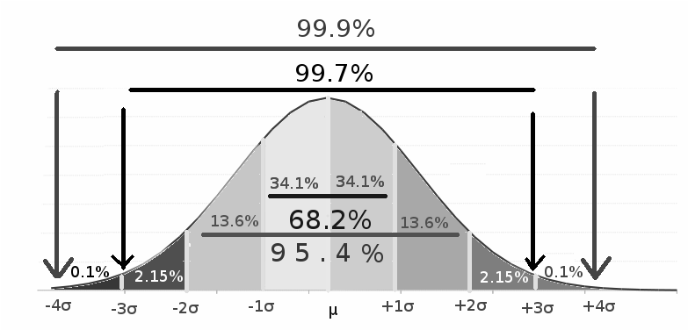
$μ=\frac{ΣX}{N}$ $Q_{i}=\frac{i(N+1)}{4}{}^{th observation}$ $z=\frac{x-μ}{σ}$ $z_{M}= \frac{M-μ}{σ/\sqrt{N}}=\frac{M-μ}{σ{}_{M}}$ $x=μ+zσ$
$population σ{}^{2}=\frac{Σ(X-M)^{2}}{N}=\frac{Σx{}^{2}-(Σx){}^{2}÷N}{N}=\frac{SS}{N}$ $sample σ{}^{2}=\frac{SS}{df}=\frac{SS}{N-1}$ $σ=\sqrt{\frac{Σ(X-M)^{2}}{N}}=\sqrt{\frac{Σx{}^{2}-(Σx){}^{2}÷N}{N}}=\sqrt{\frac{SS}{N}}$
$Standard error: each sample M varies about the mean = \frac{σ}{\sqrt{N}}$
$confidence intervals=M±z_{α}×(σ÷\sqrt{N})$$95\% α=0.05 z=±1.96 99\% α=0.01 z=±2.57$
$z_{M}$$Given σ/μ/N find p(M>) p(M<) p(<M<) 1. calculate z_{M }2. plot distribution 3. find p100$
Hypothesis testing $nondirectional/2tailed:±, directional/1tailed : + OR -, α=.05 corresponds to a z-score of ±1.64$
$1. Determine H0 \& H1 (α=0.05 H0<|1.96| H1>|1.96| \& α=0.01, H0<|2.57| H1>|2.57|)$
$2. Alpha levels (α=0.05, z=±1.96, α=0.01, z=±2.57)$$3. Find zM=\frac{M-μ}{σ/\sqrt{N}}=\frac{M-μ}{σ{}_{M}}$$4. Retain or reject H0$
Type I error $rejecting H0 even though its actually TRUE, lower α = less risk but more evidence$
Type II error $not rejecting H0 even though its FALSE, higher alpha and N (power)$
COHEN'S d$effect size=\frac{M-μ}{σ} N will not affect treatment effect$$small d<0.2 med 0.2<d<0.8 lar d>0.8$
Statistical significance>POWER$A:treatment effect large (X-μ) B: large N C: small σ D: tails, alpha$
$incr power: 1tailed, big alpha, big N$
T-test $t=$$\frac{M-μ}{S_{M}} where S_{M}=\frac{s}{\sqrt{N}} and s^{2}=\frac{Σ(X-M)^{2}}{df}=\frac{Σ(X-M)^{2}}{n-1} so s=\sqrt{\frac{SS}{df}}**Sample Variance**$larger df=closer to NDist
Htesting ttest$1. Determine H0 \& H1 (μ=A, μ≠A)$$2.find tcrit → t(df) ± for alpha used$$3. Find t:first variance then s/\sqrt{N} t=\frac{M-μ}{S_{M}}=\frac{M-μ}{s/\sqrt{N}}$$4. Retain or reject H0$$z_{M}= \frac{M-μ}{σ/\sqrt{N}}=\frac{observed difference}{chance difference}$$cohens d t=$$\frac{M-μ}{s}$$r^{2}=\frac{t^{2}}{t^{2}+df} is a \%$$small0.01-0.09 med.09-.25 larg>0.25$
$indpmeasures:2 sep groups VS repmeasures:same grp comp means$$h0:μ1=μ2$$t=\frac{(M1-M2)-(μ1-μ2)}{S(m1-m2)}, s=\sqrt{\frac{s2}{n}+\frac{s2}{n}}$for indpm df=df1+df2+... df=N-(ngoup) $μ$d=0 no change in mean (h0)now $t=\frac{Md-μd}{Smd} where d=aft3er-b4, Md=\frac{Σd}{N} SS=\frac{Σd^{2}}{N}$repeated measures Economic Issues (Requires fewer n) Changes over time (Allows measurement of change over time) Control issues (The within-group design gives us greater certainty of group equality) Statistical Issues (Related-groups designs can help reduce error variation)
ANOVA for 2+ Samples Factor=IndpV/Level=Condition/H0=all means equal/$f=\frac{MS btwn groups}{MS within grops}=\frac{VIV+Evar}{Evar}$
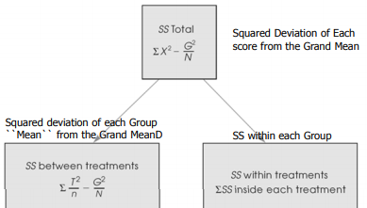
Btwngroups:treatment effect withingroups:errorvar N:The total number of scores in the entire study/n:The number of scores in each group/k :he number of groups (or levels of the factor)/T:the sum of the scores in each group (X)/G:The sum of all scores in the entire study (ΣT) The Grand Total/M:the Mean for each group
SSbtwn grousp $\frac{ΣT^{2}}{n}+\frac{G^{2}}{N}$totalSS=ΣX^2 -G2/N withingrp=SS1+SS2+SS3 F=MSb/MSw
Mean square=SS/df MSbtwn=SSb/k-1 MSwthn=SSwithn/N-k DF btwn:k-1 wthn:N-k tot:N-1 df numerator=k-1 df denom=N-k

