Design Report:
Can Opener

Name: Liam Christo
Student Number: 8284171
Date: April 5th, 2019
Class: MCG 1100-A

Introduction:
I have chosen a rotating wheel can opener for my design report. This is a right handed can open that has the function of opening cans. There have been many different designs for opening cans in the past, from the lever-type can opener to the church key and beyond to the electric can opener and the side can opener. The side can opener is a newer design developed in the 1980s with slight advantages over the can opener chosen here. The side can opener can be used by a person who is both right or left hand dominate and leaves the edge of can with a clean cut instead of a jagged edge. It was the original can opener that I was to use for my design report however there are some moving parts inside the can opener that I could not see and I could not open the side can opener, thus I am basing my report off the right handed rotating can opener with feed wheel. The feed wheel is used to rotate the can and with a set of gears the cutting wheel also rotates.
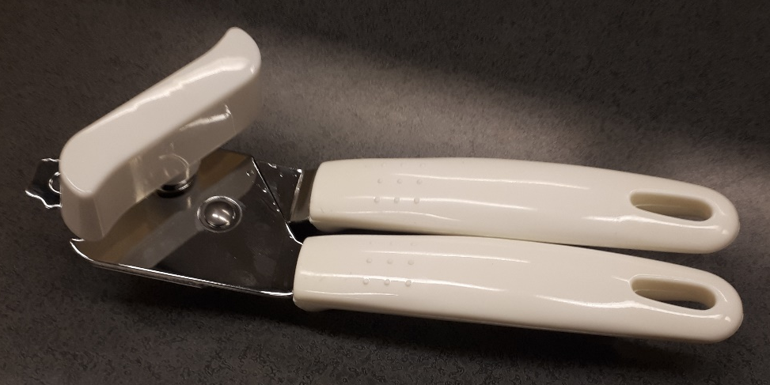 Fig. 1

Mechanics of the Modern Can Opener and How it Works:
The can opener that is shown in Fig 1. has two main components; the handles[5, 6] which act as first-class levers and the actuating key[1] which is on an axis with the feeding wheel[2] and a gear[8] which pairs with another gear[9] on the same axis as the circular blade[3].
By squeezing the handles of the can opener, the circular blade of the can opener is pushed towards the feed wheel teeth which are attached to the actuating key. The blade of the can opener rotates about a pressed grommet. This grommet holds the 2 handles of the can opener together. By squeezing on the handles the feed wheel and cutting wheel are pushed together and the cutting wheel slides about 3 mm past the teeth of the feed wheel, enough space to puncture the lid of a can. The cutting blade is positioned on a 24 degree angle horizontal to the feed wheel. This allows the circular blade to puncture the lid of a can and rotate easily around the edge of the lid. This design will leave jagged marks on the can lid; however this is a necessary draw back with this type of design.
The actuating key when twisted, turns the feed wheel and with a set of gears the circular blade rotates at the same speed.
To operate a can opener the handles must first be opened, then the feeding wheel must be placed parallel against the side of the can, with the blade above the lip of the lid. By squeezing on the handles the force is converted through a first-class lever into the feeding wheel and the circular blade. Albeit with the circular blade being on a 24 degree angle horizontal to the feeding wheel. This force pinches the can lid and the blade pierces the top of the can lid. Next the actuating key is turned about the axis, either clockwise or counter clockwise, and this turns the feeding wheel the same direction. The feeding wheel has teeth that press into the can and these teeth alongside the rotation of the feed wheel rotate the can. The feed wheel axis has a gear which pairs with the circular blade with a 1 to 1 ratio. This causes the blade to rotate about its axis in the opposite direction of the feed wheel. With the feed wheel turning the can and the blade cutting the top of the can lid, the can lid will become fully detached from the rest of the can with enough turning of the actuating wheel.
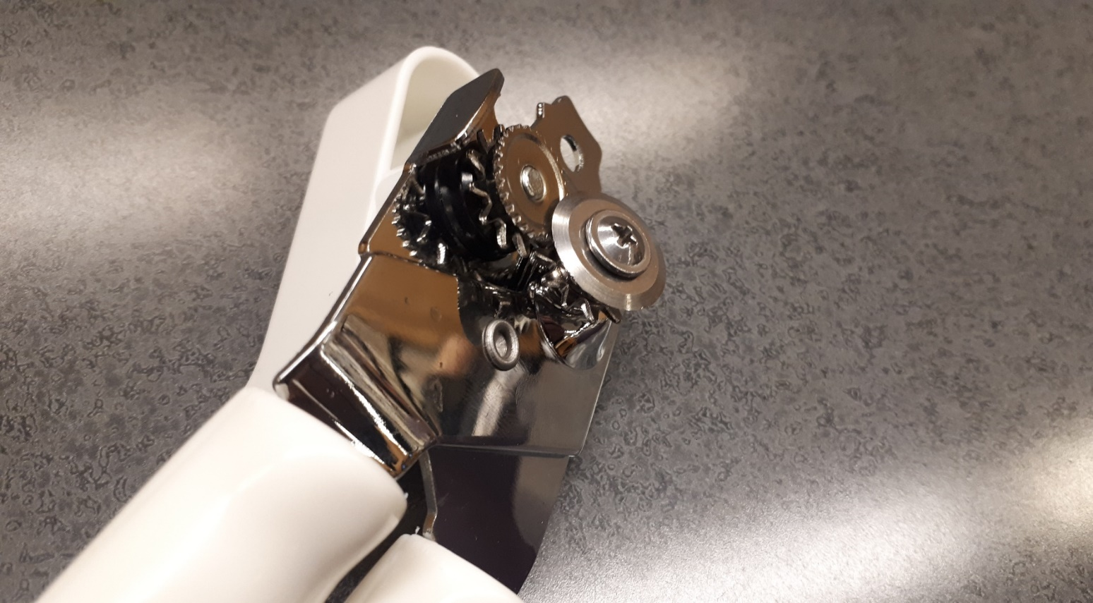
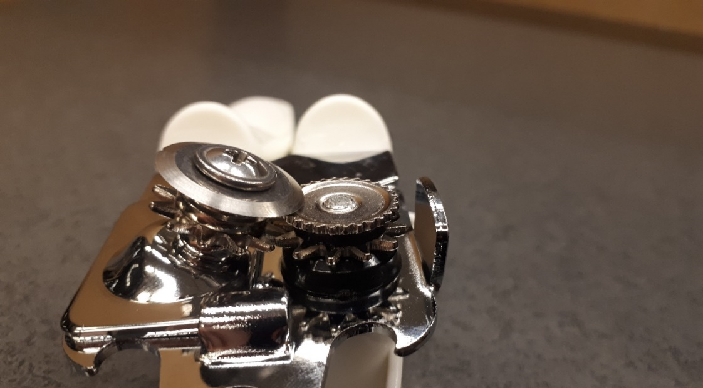
1. Actuating Key
2. Feed Wheel
3. Circular Blade
4. Grommet
5. Handle 1
6. Handle 2
7. Screw
8. Gear 1
9. Gear 2
10. Spacers

Fig 2.

Fig 3.

Materials and Manufacturing Process:
The metal handles appear to be made of brass that has been coated in chrome plating. After scratching the surface of the handle, the metal below was a shiny orange almost gold colour and was not magnetic. These handles are also very easy to bend as I could bend it with just my two hands. The brass was probably forged into sheets, then the desired shape was punched, and the brass was bent into the desired 3-dimensional shape using stamping. Polished then from here it was plated in either chrome or nickel to give its shiny appearance.
The gears appear to be made of aluminum as they have a light silver colour and it is not magnetic. I can easily scratch the gears with a normal knife. These gears where probably produced by first forging the aluminum into sheets, then punching out the desired shape and polished.
The hard-plastic handle covers, actuating key and spacers on the gear axes where made through injection moulding.
The feed wheel, circular blade and screw are made of steel. The metal is a dull grey, magnetic and barely scratches when a knife is used. The circular blade was probable first forged into a sheet of metal, then a circle was punched out of the sheet. From here the edge was sharpened using facing on both sides. The feed wheel was likely also forged into a sheet, then the desired shape including the feed wheel teeth where punched. The middle of both the feed wheel and circular blade have internal screw threads that have been made by a cutting screw attached to a lathe.
The axis from the actuating key and feed wheel is made of aluminum. It is shiny almost like silver and can be easily scratched with a knife. This appears to have been forged and then a lathe with a cutting screw would have made external screw threads.
The last piece is the steel grommet that holds the two handles together. It is dull grey, and barely scratches under a knife. This was forged into a sheet, then a circle was punched out. A grommet press then pressed and secured it to the handles.

Comments on the Design:
The can opener was only $7.95 Canadian dollars before tax and the low quality is apparent. The can opener works as intended, although it is difficult to use and leaves jagged marks in the lid of the can and the lid is often not fully removed, however it is opened. The brass and aluminum for most of the parts as well as the forging and punching for most parts was used to lower the production cost of this can opener. The plastic handles and actuating key are a welcomed inclusion as they are easy to grip and remove the cramps that can come with using a can opener that has handles made of thin metal. If I had the option to purchase this can opener again I would not, as a side can opener is much easier to use and requires less work on the users end. However, the can opener here does the job and for its price I cannot complain.

