Respiratory Viruses
Name of Virus | Diagnosis | Clinical signs | Prevention | Other Info
Influenza  Type A: major epidemic  Type B: milder disease | Throat washing  Naso-pharyngeal aspirate  Inoculated into cell culture  Serology: two blood samples taken at 2-3 week interval in the acute and convalescent stage are investigated for increase in titer antibodies | Fever  Variable respiratory symptoms  - Infants and elderly are most susceptible | Annual vaccination especially for high risk groups  Some anti virals are available but are only active against type A | Produces enzyme haemagglutinin which agglutinates RBCs  Frequent recombination results in high antigenic variability  Can lead to pandemics
Parainfluenza |  | Respiratory infection with potential for serious complications  Croup (barking cough, high pitched sound on inhalation)  Broncholitis  Bronchopneumonia  - Infants and young children most common | No vaccine
Respiratory syncytial virus |  | Major respiratory pathogen for children < 2 years old  Pneumonia  Bronchiolitis  May be fatal | No vaccines  Antiviral Ribavizine available | Can cause epidemics
Rhinovirus | More than 100 serotypes and no cross immunity | Common cold |  | People can have repeated infections due to high number of serotypes and no cross immunity
Adenovirus |  | Pharyngitis  Conjunctivitis  Pneumonia in young children  - Children affected | Vaccines for army personnel | May be asymptomatic
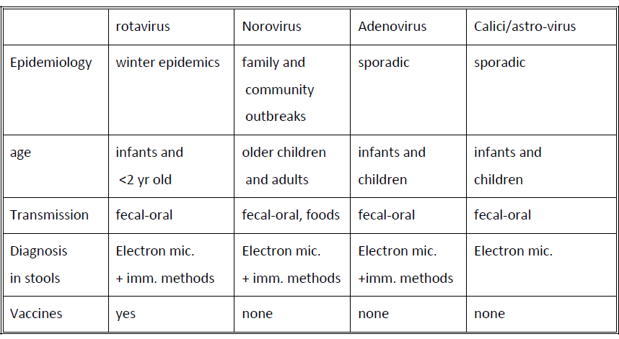
Enteric Viruses
Name of Virus | Diagnosis | Clinical Signs | Prevention | Other
Poliovirus  Types 1, 2,3 | Isolation from stool samples 5-6 weeks after infection  Isolation from CSF and pericardial fluid  Serology: two serum specimens collected (acute and convalescent phase)  Acute collected right after onset, convalescent collected 2-3 weeks later | Causes poliomyelitis  Invades host nervous system and causes total paralysis in as little as a few hours | Global Polio Eradication Initiative  Since 1988 cases have decreased by 99%  Currently polio is only found in parts of Africa and South Asia  Killed (inactivated) polio vaccine, called SALK  Does not produce local immunity IgA in GI tract, virus can still multiply in GI tract and spread.  Killed vaccine still used for immunocompromised individuals  Live attenuated polio vaccine called SABIN  Easy to administer by mouth  Produces IgA and IgG which allows GI tract resistance to infection and spread of wild virus in community  - Should not be administered to immunocompromised or adults who have never been vaccinated before | HUMANS ARE ONLY NATURAL HOST
Coxsackieviruses  Groups A and B | Stool sample and paired serology  Most Group A can only be isolated by mouse inoculation | Group A  Aseptic meningitis  Herpangina and hand-foot- and mouth disease  Group B  Minor respiratory illness  Aseptic meningitis  Pleurodynia, pericarditis, and myocarditis | NO vaccine | Seasonal variation  Prevalent type varies every few years
Echoviruses  Enteric  Cytopathogenic  Human  Orphan  Viruses | Stool sample and paired serology | Minor respiratory illness  Aseptic meningitis | NO vaccine | Several types

Viruses of Diarrhea
Name of Virus | Diagnosis | Clinical Signs | Prevention | Other
Rotavirus | Electron Microscopy or immunological testing of virus from stool samples within 3 days | Epidemics in infants (6 mos-2 years) mainly in winter  Replication in small intestine  Acute gastroenteritis  V/D  Fevere  - Most older children and adults are immune | Rapid diagnosis and isolation  Proper handwashing  Vaccine is available | Highly infectious  Short incubation (2-3 days)  Fecal oral route  Aerosols (explosive diarrhea)  Fomites  Out breaks in daycare centers and children hospitals
Norovirus / Norwalk Virus | Exclude bacterial cause  Differentiated from bacterial gastroenteritis | Outbreaks of gastroenteritis in older children and adults | NO vaccine  Handwashing  Isolation of infected individuals | VERY CONTAGIOUS  Survives on objects and in environment  Fecal oral route  Food borne outbreaks  90% of foodborne outbreaks attributed to Noroviruses
Adenoviruses (also respiratory) | By electron microscopy  Cannot cultivate diarrhea type in cell culture | Some types cause gastroenteritis in children
Calici and Astro viruses | Electron microscopy | Sporadic gastroenteritis in children |  | Fecal oral route of transmission

Viruses Causing Rashes
Name of Virus | Diagnosis | Clinical Signs | Prevention | Other
Measles | Serological  IgM ab in single blood specimen against measles or rising IgG ab titer against measles in paired blood  Detects individuals who are immune by detecting measles specific Ab IgG | Rash first appears behind ears, forehead and nostrils, then spreads to whole body  High fever  Koplik spots  Blotchy appearance  Secondary bacterial infections can occur  Bronchopneumonia  Encephalitis  Exacerbation of TB and Leukemia  Natural disease produces life long immunity | Immunoglobulin: can suppress disease if given within 5 days of contact with virus  Live attenuated vaccine  Effective  Widely use  Administer after 12 months of age  MMR | HIGHEST INFECTIVITY RATES  Lifelong immunity after natural infection
Rubella (German Measles, or 3 day measles) | Suspected cases detected using rubella specific IgM or rising Ab titer in paired serology  Used to determine immune status of individuals by detection of circulating Rubella Ab (IgG) | Very dangerous for non-immune pregnant women  Can lead to birth defects  50% chance of damage to fetus if non-immune mother is infected between 0-4 weeks (first trimester)  Birth defects  Abortion, death of newborn  Cataracts (6th week infection)  Deafness (9th week infection)  Heart defects (5-10 week)  Low birth weight, cleft palate, mental deficiency  Otherwise presents similar to measels but milder, still provides life long immunity | Prevention of congenital rubella  Check immune status of women of childbearing age  Diagnosis in hospital  Rubella serology screening of men and women starting work in hospitals  Vaccination of non immune  Isolation of rubella cases  Vaccination with live attenuated vaccine  - Do not give to pregnant women | Seen during winter and spring  Outbreaks every 7-10 years  - Most cases seen in those 15 and older
Varicella (chickenpox)  Varicella Zoster Virus |  | Childhood febrile illness with characteristic rash  Successive crops of fresh vesicles appear within 3-4 days of onset  In non immune adults occasional pneumonia may be fatal | h
Herpes Zoster (Shingles) | ID of virus particles in pustules by electron microscopy of immune methods  Followed by cell culture | Limited rash along trajectory of one nerve  Later recurrence of latent VZV infection | Vaccine  Detection of susceptible persons by serological methods
Herpes Simplex Virus (HSV) | ID of virus particles by electron microscopy or immune methods  Cell culture  Serology NOT USEFUL | Latent after initial infections  Lesions reappear periodically  High percentage of inapparent infections  HSV 1: cold sore oral and ocular lesions, transmitted via oral and respiratory secretions  HSV 2: herpes genitalis associated with genital tract infected females can transmit to newborn | Antivirals  C section for symptomatic mothers  Vaccine coming soon | Clinical forms other than cold sores  Herpetic encephalitis (rare) CNS viruses  Neonatal herpes: acquired during birth from asymptomatic mother, difficult to prevent, can result in death or severe sequelae (CNS viruses)  Herpetic whitlow: affects fingers, occupational hazard of health care workers, nosocomial infections in neonates  Corneal and conjunctival infection: ulceration of cornea and blindness
Papilloma Viruses | Immune techniques and DNA hybridization techniques  No cell cultures | Cause different types of warts  Common warts: hands and feet in childhood and adolescence  Genital warts: sexual transmission, asymptomatic carriers  Some types associated with cancer of the cervix, vulva, penis | Gardasil Vaccine for certain serotypes

Viruses causing glandular enlargement
Name of Virus | Diagnosis | Clinical Signs | Prevention | Other
Mumps |  | Childhood disease  Bilateral inflammation of parotid gland  Meningitis  Orchitis (lead to sterility)  ovaritis | MMR vaccine  Live attenuated | Incubation 18-21 days  Spread by salivary and respiratory secretions
Infectious mononucleosis (Epstein Barr Virus) | Blood picture (increase in atypical lymphocytes)  Monospot test (detects RBC agglutination)  Presence of EBV antigens | Belongs to herpes virus family  Mild disease in children and young adults can be prolonged and debilitating  Lymphadenopathy  Fever  Sore throat  Atypical lymphocytes  Enlargement of liver and spleen  Latent virus  Chronic disease (rare) or asymptomatic shedding (common) for lifetime of host | NO vaccine | Transmission by saliva (kissing disease)
Cytomegalovirus (CMV) | Isolation of virus from urine, blood, organ biopsies (slow process, but accurate)  CMV antigen detection, DNA hybridization and PCR in leukocytes much faster  Serology screening for donors and recipients before transplant | Herpes family  Infection usually asymptomatic and latent  Dangerous for  Pregnant women  Neonatal infection with jaundice  Enlarged liver and spleen  Mental retardation and motor disorders  Transplant patients  Disseminated infection can cause transplant rejection  Aids and other immunocompromised patients  Frequent infection  GI tract ulceration and retinitis | Antivirals  Prevent in immunocompromised  Match CMV immune status between donor and recipient in transplants  Preventative administration of antivirals  Universal precautions to prevent transmission  NO VACCINE

Hepatitis Virus
Hepatitis is inflammation of the liver
Name of Virus | Diagnosis | Clinical signs | Prevention | Other
Hepatitis A | Serological  Suspected clinical cases  Detection of IgM  Immunity detection of IgG (before travel) | Inflammation of liver  Malaise, fatigue, nausea, loss of appetite, jaundice  Mainly children and young adults  Sporadic cases and small epidemics  Mild of inapparent infections in children  No chronic hepatitis  Life long immunity | Vaccine for high risk populations  Commercial gamma globulin for prevention after exposure | Transmission by fecal-oral route  Incubation 15-50 days  Stools infectious 2-3 weeks before onset  - Outbreak caused by green onion contamination
Hepatitis B | Blood test for HepB surface antigen (HBsAg)  Antibodies are produces several months after onset of symptoms  Used as markers of infection and immunity | Sporadic cases all ages  More severe than HepA  Chronic hepatitis and chronic carrier state | Universal precautions for blood and body fluids  Proper handling of needles  Screening  Vaccination  HepB immunoglobulins after exposure  HepB carriers | Contaminated blood and blood products, saliva, urine, semen  Incubation 90 days  Infective serum 30-60 days before onset of symptoms  Carriers
Hepatitis C | Serological |  | Same as HepB  Treatment or cure  Epclusa | Blood and sexual transmission  Initially mild disease, but can cause chronic hepatitis
Hepatitis Delta Agent - Viroid | Serological |  | Vaccination against HepB | Blood and sexual transmission  Relies on HepB presence for replication in cells  Increases severity of HepB infection
Hepatitis E |  | Symptoms similar to HepA but 20% mortality in pregnant women |  | Transmission via fecal oral route  15-50 days  Endemic in India, Pakistan, Nepal, Burma, North Africa, Mexico
Hepatitis G | Detection of viral DNA by PCR or other molecular methods | Initially mild and no jaundice  Can cause chronic hepatitis | NO vaccine | Blood and sexual transmission  Incubation 14-180 days
Yellow Fever Virus |  | Haemorrhagic fever with hepatitis  Mortality rates as high as 50% |  | Transmitted by mosquito  Endemic in Africa, South America, Caribbean

Viruses Affecting the CNS
CNS VIRUSES WITH HUMAN RESERVOIR
Usually an extension of primary infection in another part of the body
Mumps: aseptic meningitis in children
Enteroviruses: aseptic meningitis in infants and children
HSV1: rare cause of herpetic encephalitis in young adults
HSV1or 2: rare cause of meningo-encephalitis in neonate or young adult
Vaccination for mumps, measles, and polio (entero)

CNS VIRUSES WITH ANIMAL RESERVOIR
Humans are accidental or dead end host

Arbovirus
200 different types
Tropical rainforest areas
Encephalitis- WEST NILE

Rabies virus
Fatal, acute encephalitis
Infections mammals, transmitted via saliva
Long incubation (30-60)
Combined active and passive immunization
Prevention by vaccination of wildlife and pets

HIV AND AIDS
Severe immunsuppressive condition, often fatal, predisposition to opportunistic infection and cancers
HIV causes depletion in helper T cells making the host very susceptible to other infections
Frequent antigenic changes

Inactivation: virus often protected by living inside cells, protect it from disinfecting action

Transmission: sexual, blood/blood products, congenital, organ transplants, sperm donation
Lengthy asymptomatic period ncreaes spread of disease

Pathogenesis: virus is cytocidal to helper T4 cells
AIDS develops from decreasing immune status

Clinical: incubation 6 months to several years
- AIDS related complex disease, progresses to AIDS
- Terminal stage patients develop dementias, other neurological problems, many opportunistic infections

Lab diagnosis: serology based, seropositivity can take months to occur
Isolation of virus from blood, plasma, semen, cervical, vaginal secretions

Prevention
Universal precautions for healthcare personnel
- Screen blood, organ and semen donors
- Heat inactivation of plasma for haemophilia patients
- Sexual education
- Education of drug users
- Testing pregnant women at risk
- NO VACCINE, but is key focus of current research

Treatment:
Many forms of treatment
Most effective is cocktail of treaments
HAART: protease inhibitor (stops viral mutation) reverse transcriptase (stops viral replication)
- Bad side effects
- Expensive

Viruses

General Characteristics
  - Living cells for growth and replication
  - Have DNA or RNA never both
  - Multiply by separate synthesis of nucleic acid and protein, combine to form virus particles
- From 10nm-300nm

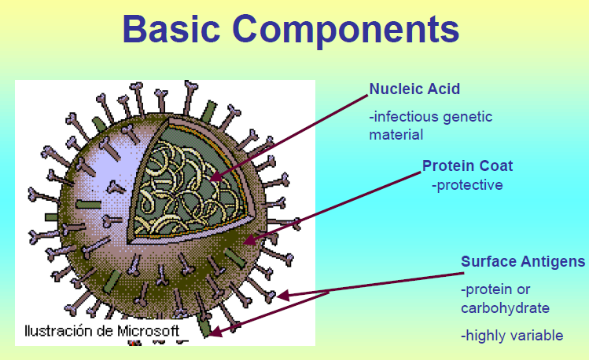

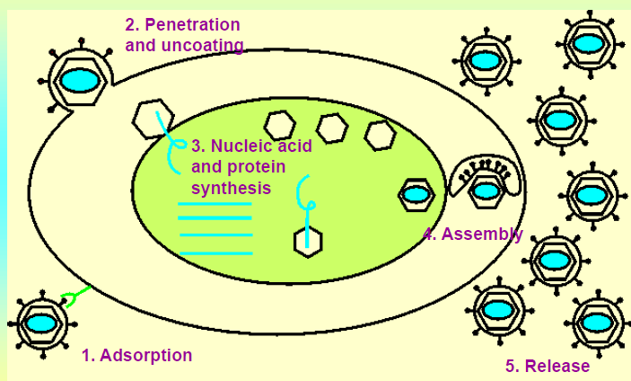
Replication Process
- Adsorption
- Penetration and uncoating
- Nucleic acid and protein synthesis
- Assembly
- Release

Detecting Viral Infections
- Detect the virus itself
- Detect the immune response, or antibodies against the virus

Viral Diagnosis
- Detection in clinical specimens
- Visualization by Electron Microscope
- Cell culture (cytopathic effects, hemagglutination, immunofluorescence)
- Detection of patient’s immune response
- Antibody detection, presence or absence (ELISA) immunity test
- Rise in antibody titre or high antibody titre diagnostic test

