Function of Biological Membranes
- Define cell boundary
- Define enclosed compartments
- Control movement of material into and out of cell
- Allow response to external stimuli
- Enable interactions between cells
- Provide scaffold for biochemical activities
Phospholipids and the Plasma Membrane
- The trilaminar structure is a lipid bilayer
- The plasma membrane is about 6 nm thick, consistent between cell types
- The lipid bilayer is made up of phospholipids
- Lipid molecules, like phospholipids, spontaneously aggregate to bury their hydrophobic tails in the interior and expose their hydrophilic heads to water
- A molecule will always be in a conformation in which it is the most stable. Micelles are usually formed by fatty acids with only one hydrophobic chain
Phospholipid Structure
- Phospholipids consist of two fatty acyl molecules esterified at the stereospecific numbering (sn) sn-1 and sn-2 positions of glycerol, and contain a head group linked by a phosphate residue at the sn-3 position
- They spontaneously organize as stable structures in an aqueous solution
Phospholipid Synthesis
Where do phospholipids making the plasma membrane come from?
Synthesis occurs at the interface of the cytosol and outer endoplasmic reticulum membrane, which has all the molecular machinery (enzymes) for synthesis and distribution.
Phospholipid synthesis is a multistep process, requiring the activity of many specialized effectors.
Eventually a vesicle will come off from the ER containing phospholipids destined for the cytoplasmic cellular membrane on its exterior leaflet and phospholipids destined for the exoplasmic cellular membrane on its inner leaflet
The Fluid Mosaic Model of Biological Membranes
Fluid- individual lipid molecules move
Mosaic- diverse “particles” like proteins, carbohydrates, and cholesterol penetrate the lipid layer
- Proposed by Seymour Jonathan Singer and Garth Nicolson in 1972
- Model is considered the most accurate of the plasma membrane
- Plasma is viewed as a two- dimensional liquid that restricts the diffusion of membrane components
- Different proteins are embedded in the phospholipid bilayer
- Components are mobile
- Components can interact
Dynamics of Plasma Membrane
Lipids move easily, laterally, within leaflet.
Lipids movement to other leaflet is difficult and slow
Membrane proteins diffuse within the bilayer:
- Movement of proteins is restricted
- Rapid movement is spatially limited
- Long range diffusion is slow
- Biochemical modification can alter protein mobility in the membrane- an important feature for signal transduction
Dynamics of Plasma Membrane
The Fre- Edidin experiment (1970)
Elegant experiment that inspired Singer and Nicolson for their Mosaic Fluid model
Just after fusion of the 2 cells the surface proteins are segregated, but after a short period of time, the surface proteins of both cells diffuse around the unified membrane and mingle rather than being locked to their original location
Structure of Biological Membranes
All membranes share common properties
- Approximately 6 nm thick (with water)
- Stable
- Flexible
- Capable of self assembly
Different membranes contain different types of lipids and proteins, giving them different functions
Differences between cells as well as within an individual cell
Biological membrane differences:
The inner membrane of mitochondria contains a very high concentration of protein necessary for electron transport chain and ATP synthesis
The myelin sheath of a neuron contains very low amounts of protein
Myelin sheath simply consists of layers of plasma membrane wrapped around the neuron’s axon. This increases the speed at which electrical impulses propagate along the myelinated fiber.
Membrane Proteins
There are three classes of membrane proteins:
INTEGRAL membrane proteins span the lipid bilayer
PERIPHERAL membrane proteins associate with the surfaces of the lipid bilayer
LIPID-ANCHORED proteins attach to a lipid in the bilayer
Integral Protein Functions: Examples
Different integral (transmembrane) proteins have different functions, for example
- Transport of nutrients and ions
- Cell-cell communication (gap junction)
- Attachment

Symmetry of Biological Membranes
Biological membranes are asymmetrical
Two leaflets have distinct lipid composition in many plasma membranes, the outer leaflet contains glycolipids and glycoproteins (lipids and proteins with carbohydrates attached to them)
Fluidity of Biological Membranes
Temperature is an important variable affecting the fluidity of biological membranes:
- Warming increases fluidity liquid crystal
- Cooling decreases fluidity crystalline gel
Membrane fluidity is crucial to cell function
Membrane fluidity is determined by the nature of lipids in membrane:
- Unsaturated lipids increase fluidity
- Saturated lipids reduce fluidity
In response to changes in temperature, lipid composition of membrane can be changed by:
- Desaturation of lipids
- Exchange of lipid chains
BALANCE between ordered (rigid) structure and disordered structure allows:
- Mechanical support and flexibility
- Membrane assembly and modification
- Dynamic interactions between membrane component (e.g. proteins can come together reversibly)
Cholesterol modulates membrane fluidity
Cholesterol acts as a bidirectional regulator of membrane fluidity because at high temperatures, it stabilizes the membrane and raises its belting point, whereas at low temperatures it intercalates between the phospholipids and prevents them from clustering together and stiffening
Cholesterol modulates membrane fluidity
- Alters packing and flexibility of lipids
- If added to a liquid crystal membrane, fluidity will decrease
- If added to a crystalline gel membrane, fluidity will increase
Transmembrane proteins
A transmembrane protein domain is a peptide sequence that is largely hydrophobic (uncharged) and spans across the protein membrane
This sequence permanently attaches the protein to the protein membrane
The alpha helice is the most common protein structure element crossing biological membranes
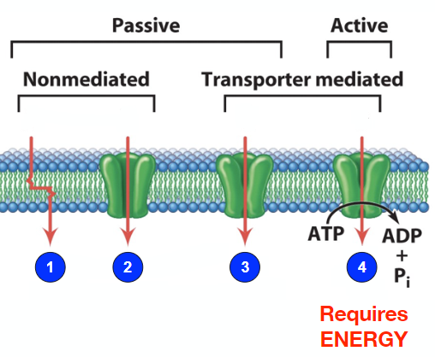
The nine amino acids that have hydrophobic side chains are glycine (Gly), alanine (Ala), valine (Val), leucine (Leu), isoleucine (Ile), proline (Pro), phenylalanine (Phe), methionine (Met), and tryptophan (Trp)
Movement of Substances Across Cell Membranes
Lipid bilayers do not allow many compounds or molecules to pass through them freely
Small, uncharged molecules cross membranes relatively easily (O2, CO2, NO)
Large/polar/charged compounds cannot easily cross lipid bilayers
Specific mechanisms are required for the controlled transport of many substances across membranes
Four basic mechanisms for moving molecules across membranes:
- Simple diffusion
- Diffusion through a channel
- Facilitated diffusion
- Active transport
Passive Mechanisms
Passive movements of substances across cell membranes relies on molecular concentrations
DOES NOT require energy
Simple Diffusion
Down a concentration gradient- flow is downhill
This mode works only for very small and uncharged molecules like O2 and CO2
Water is an uncharged molecule because the bonds between H and O are covalent bond. In a covalent bond, the electrons are equally shared between the atoms forming the bond, therefore no net charge appears on any atom and the molecule as a whole remains neutral.
Simple diffusion plays a central role in maintaining the size/shape of different cell types (red blood cells example)
Channels
Protein channels provide another form of passive transport
This mode is particularly effective for small, charged molecules (ions) like Na+, K+. Ca2+, Cl-
Ions move down concentration gradients- flow is downhill
Channels are selective, allowing only particular types of ions to pass
Ion channels are formed by integral membrane proteins- typically multiple subunits- that line an aqueous pore
Ion Channels
Channels are often gated- can be open or closed
This is an important feature because it provides channels the ability of responding to different stimuli (e.g. neurotransmitters)
In other words, they can be turned ON/OFF in response to different signals

Types of Gated Ion Channels
- Voltage-gated channels (e.g. Na+ and K+ channels)
Channel responds to changes in charge across membrane
- Ligand-gated channels (e.g. acetylcholine receptor)
The channel responds to binding of specific molecule on its surface- a ligand
Binding of a ligand produce conformational change in the structure of the receptor/channel (only a ligand adapted to the binding site can produce an effect)
Toxins Targeting Ion Channels
Tetrodotoxin (TTX) is a very potent neurotoxin
Molecule was discovered in pufferfish but is also found in several other aquatic animals like blue-ringed octopuses and moon snails
TTX is a Na+ channel blocker
It inhibits the firing of action potentials in neurons by binding to the voltage-gated sodium channels in nerve cell membranes and blocking the passage of Na+ ions (rising phase of an action potential) into the neuron. This prevents the nervous system from carrying messages to muscles, including the diaphragm. TTX intoxication consequently causes death via respiratory failure.
Curare is a mixture of organic compounds found in different plants originating from Central and South America, and was used as a paralyzing poison and hunting tool by South American indigenous people
Curare is a competitive antagonist of the nicotinic acetylcholine receptor (nAChR)
It occupies the same position on the receptor as Ach with an equal or greater affinity and elicits no response. It is an example of a non-depolarizing muscle relaxant.

Carriers
Facilitated Diffusion:
Compound binds specifically to integral membrane protein called a facilitative transporter
Change in transporter conformation allows compound to be released on other side of membrane
Compound moves down a concentration gradient
Glucose Transporter
Most animal cells import glucose from the blood into cells down a concentration gradient via this mechanism (facilitator)
- Transporter ready to accept glucose molecule
- Glucose is accepted by transporter
- Intracellular side of transporter opens
- Glucose is released and cycle repeats
Symporter
Under certain circumstances, cells need to move substances from a lower concentration to higher concentrations. An example of this is the reabsorption of glucose in kidney cells after blood filtration to prevent its loss through the urine
In this case, cells can’t rely on a gradient concentration because the kidney cells would stop reabsorbing glucose when an extracellular and intracellular equilibrium is reached
Solution: Rely on the chemical gradient of another molecule that would not reach extracellular and intracellular equilibrium

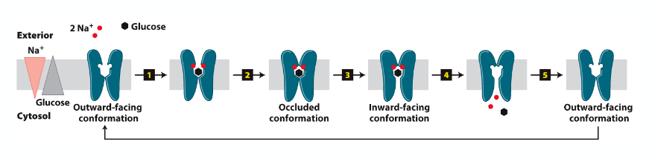
- Simultaneous binding of 2 Na+ and 1 glucose to the transporter with outward-facing binding sites
- This causes a conformational change in the transporter (occluded conformation)
- Eventually the transporter adopts an inward-facing conformation that allows
- The dissociation of the two Na+ molecules in the cytosol. As a result, the glucose molecule gets pushed in as well
- Return to the outward-facing conformation to repeat the cycle

Antiporter
In the case of the antiporter, the concentration gradient of one molecule is used to transfer a second molecule in opposite directions
Active transport:
- Compound binds specifically to integral membrane protein called an ACTIVE TRANSPORTER
- Change in the conformation of the transporter caused by the hydrolysis of an ATP molecule allows molecules to be released on other side of the membrane
- Using this mechanism, compounds can move against a concentration gradient
- Requires input of ENERGY in the form of ATP molecules
- The Na+/K+ ATPase maintains cellular [Na+] and [K+] using ATP

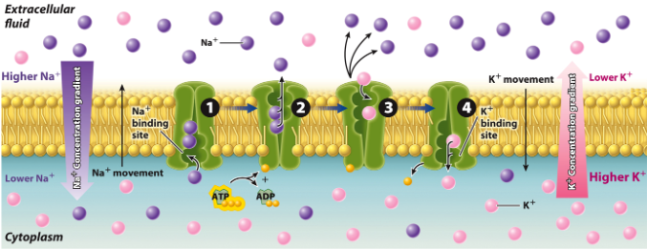

3 Na+ molecules exit the cell and 2 K+ enter for each ATP molecule hydrolyzed

Higher concentration of Na+ outside than inside the cell
Cells spend ENERGY (ATP molecules) to achieve and sustain the Na+ chemical gradient required for required for non-stop activity of the Na+- glucose symporter

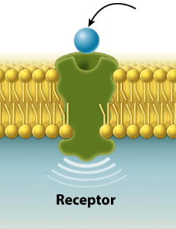
Transmembrane Proteins and Signal Transduction
Membrane proteins play a major role in signal transduction by converting extracellular signal into intracellular signals
Signal transduction allows cells to rapidly respond to events happening in their environment
Ligand- small molecule that binds to a receptor
Ligand binding changes the conformation of the receptor protein
Note that ligand does not enter the cell
Cytosolic side of the receptor protein is affected by the conformation change
These conformational changes then cause other proteins (in the cytosol or membrane bound) to become activated
Signal Transduction
There are three stages to signal transduction:
- Binding of ligand to receptor
- Signal transduction via second messengers like cAMP, calcium, or G-protein
- Cellular response
Glycogenolysis
How epinephrine (adrenaline) activates conversion of glycogen stored in the liver to glucose is a good example of signal transduction
Glycogenin is an enzyme that acts as a primer to polymerize the first glucose molecules- then other enzymes take over
Anchor Porteins and the Extracelllular Matrix (ECM)
Multicellular organisms are composed of tissues and organs consisting of communities of cells. These cells work together to perform a function (e.g., skin, liver, leaves).
Anchor membrane proteins play an important role for interacting with components of the extracellular matrix (ECM)
The ECM is an organized network of material produced and secreted by cells
Functions of the ECM:
- Cell adherence
- Communication between cells
- Cell shape, mechanical support, structural integrity
- Serves as barrier, filters out some particles

Example of ECM: The Skin
ECM and Aging Wrinkles
Development of facial wrinkles is a kind of fibrosis (thickening and scarring) of connective tissues of the skin
Misrepair-accumulation aging theory suggests that wrinkles develop from incorrect repairs of injured elastin (elastic) fibers and collagen fibers
During the repairing process, some of the broken elastic fibers and collagen fibers are not regenerated and restored but replaced by altered fibers
Major components of the ECM are proteins like (e.g collagen) and glycoproteins (e.g. laminin, fibronectin)
Proteoglycans= proteins with chains of polysaccharides
Non-animal cells
Cells of BACTERIA, PLANTS, and FUNGI have WALLS
Plant cell walls= ECM
- Composed of cellulose, hemicellulose, pectin, and proteins
- Provide structural support to cell and to whole organism (equivalent to skeleton)
- Protect cell from mechanical damage and pathogen attack
Mitochondria- ATP synthesis, apoptosis
Chloroplasts- Photosynthesis, ATP synthesis
Endosymbiotic theory (symbiogenesis)- an evolutionary theory of the origin of eukaryotic cells from prokaryotic organisms
First proposed by the Russian botanist Konstanin Mereschowski and later advanced by with microbiological evidence by Lynn Margulis. This theory holds that the organelles distinguishing eukaryote cells evolved through symbiosis of individual single-celled prokaryotes (bacteria and archaea).
Symbiosis (living together): close and long-term biological interaction

Theory holds that organelles from eukaryotic cells with two membranes, like mitochondria and chloroplasts, represent formerly free-living prokaryotes taken one inside the other in endosymbiosis
Support evidence: 1) binary fission of mitochondria and plastids
- circular DNA inside these organelles similar to bacteria

ENERGY SUPPLY
Aerobic respiration: converts in presence of oxygen energy stored in food molecules (e.g. glucose) into chemical energy stored in ATO. This process produces carbon dioxide (CO2) as a by-product (waste).
Photosynthesis: building carbohydrates using energy from sunlight and CO2
Mitochondria: Structure and Function
Mitochondria have a double membrane, consisting of an inner and outer membrane and an aqueous compartment in between
Outer Mitochondrial Membrane (OMM)
Contains many enzymes with diverse metabolic functions. An example is monoamine oxidases that breaks down monoamines ingested from food, as well as monoamine neurotransmitters (dopamine and serotonin).
The OMM also has porins, which are large channels permeable (passive diffusion) to many molecules when opened (e.g. ATP, sucrose).
Inner Mitochondrial Membrane (IMM)
High protein:lipid ratio (3:1)
Double-layered folds are called cristae- increase membrane surface area and contain machinery for aerobic respiration and ATP formation
Rich in a phospholipid called cardiolipin, which is a characteristic of bacterial membranes and needed for optimal function of many enzymes
Mitochondria has two aqueous compartments:
- Intermembrane space
- Matrix: a high protein content, gel-like consistency containing mitochondrial ribosomes and DNA. In mammals, mitochondrial DNA (mtDNA) encodes a total of 37 genes (13 polypeptides like ATP synthase and Cytochrome c oxidase, 22 tRNA, 2 ribosomal RNA)
Cellular respiration uses chemical energy stored in molecules such as carbohydrates (glucose) and lipids to produce ATP
Cellular respiration involves a series of catabolic reactions
Cellular respiration in presence of oxygen= aerobic respiration
Substrate-level phosphorylation: Hydrolysis reaction releases enough energy to drive phosphorylation of ADP to ATP (e.g. glycolysis where a 1 glucose molecule is partially broken down into 2 pyruvate molecules).
Oxidative phosphorylation: Chemical energy of organic molecules is transferred first to electron carriers to create an electrochemical gradient that can power ATP synthesis
Coenzymes acting as electron carriers can exist either as:
- Oxidized – can accept electrons
- Reduced- can donate electrons when returning to their oxidized state
Nicotinamide adenine dinucleotide
Oxidized= NAD+
Reduced= NADH
Flavin adenine dinucleotide
Oxidized= FAD
Reduced- FADH2
Oxidative Phosphorylation
- Generate an electrochemical gradient
Electron transport through complexes I-IV and proton (H+)
High-energy electrons (e-) pass from coenzymes (NADH and FADH2) in the matrix to electron carriers in IMM
Electron transport through Complexes I-IV and proton (H+)
Series of intermediate e- carriers (respiratory enzyme complexes I, II, II, IV)= Electron Transport Chain (ETC)
Energy transfer at each complex used to pump H+ from matrix into intermembrane space
Ultimately, low energy e- is transferred to terminal e- acceptor (O2) resulting in production of H2O
- Proton pavement down electrochemical gradient to power ATP synthesis

Oxidative phosphorylation: ATP synthesis in the mitochondria
Chloroplasts: Structure and Function
Photosynthesis: building carbohydrates (CH2O) using energy from sunlight and CO2. CH2O is then used as a starting point for making other molecules or synthesizing ATP through cellular respiration (mitochondria).
Light-Dependent Reactions
- Occur in thylakoid membrane
- Chlorophyll in light harvesting complex
- e- enters ETC (also in thylakoid membrane)
- H+ pumped into thylakoid lumen
Light-Independent Reactions
- Dark reactions/ Calvin cycle
- Occur in stroma of chloroplasts
- ATP and NADPH made in light reaction used to make CH2O

Mitochondria & Programmed Cell Death
Programmed cell death, or apoptosis, is a normal process that involves the death of cells in a coordinated sequence of events
Part of an organism’s growth or development
Interdigital cell death to regression of soft tissue between embryonic digits in many vertebrate
Bone morphogenetic protein (bmp) is a secreted protein that binds to Bmp receptors (BmpRs)
Expression of non-active BmpRs in chicken embryonic hind limbs greatly reduced interdigital apoptosis and resulted in webbed feet
Apoptosis also plays a role in the growth of plants
The Madagascar Lace Plant, which is a type of submerged aquatic plant, have mature leaves that are fenestrated
This plant uses programmed cell death to generate holes in its leaves
Normal vs Apoptotic Cells
Apoptosis is characterized by:
- Shrinkage of cell
- Blebbing (bulge or protrusion) of the plasma membrane
- Fragmentation of DNA and nucleus
- Loss of attachment to other cells
- Engulfment by phagocytosis
The Intrinsic Pathway of Apoptosis
Initiated by intracellular stimuli like genetic damage, hypoxia, virus.
“Killer” protein like Bax causes change in mitochondria membrane potential and to leak of Cytochrome C.
Release of apoptotic mitochondrial proteins commits the cell to apoptosis

Apoptosis and Diseases
Various diseases are directly associated to apoptosis. In some cases, the problem is due to too little apoptosis. An example of this is cancer where too little apoptosis occurs, resulting in malignant cells that will not die.
In other cases. It is too much apoptosis that is the culprit, such as in the case of degenerative diseases like Alzheimer’ and Parkinson’s disease

Cytosol- protein synthesis, many metabolic pathways
Endoplasmic reticulum (ER)- synthesis of lipids, synthesis of proteins
Golgi apparatus- protein modification, packaging of proteins and lipids
Lysosomes- degradation of cellular material
Endosomes- sorting, recycling

Cytoplasmic Endomembrane System
Early EM focusing on the cytoplasm revealed membrane bound organelles and vesicles as well as extensive network of membranous canals and stacks of “sacs” (cisternae)
Endoplasmic reticulum (ER)
Endosomal transport vesicles
Golgi complex
Lysosomes
Vacuoles
Polarized Structure of a Secretory Cell
Secreted protein (e.g. mucin, a glycoprotein component of mucus):
- Synthesized in the rough ER
- Processed in the ER
- Further processed in Golgi
- Concentrated in vesicles
- Delivered to plasma membrane for secretion

Technique: Using GFP to Track Cell Components
The Green Fluorescent Protein from jellyfish can be fused with other cellular proteins. The fusion protein can then be expressed in cells
The cellular:GFP fusion protein fluoresces and can be visualized under a microscope
Observation of the fusion protein provides information about the endogenous protein (e.g. where it is localized in a cell or organism).
Vesicular Transport/ Trafficking
***look at slides
Utilizes transport vesicles (50-75 nm)
- Small, spherical, membrane-enclosed organelles that bud off donor compartment and fuse with acceptor or recipient compartment
Targeted movement (directed):
- Uses cytoskeleton and motor proteins
- Sorting signals recognized by receptors
Key elements of vesicle trafficking to a compartment:
- Movement of vesicle- uses cytoskeleton and motor proteins
- Tethering vesicle to target compartment- via proteins from the Rab family of protein and other more specialized
- Docking of vesicle to target compartment- uses protein called SNAREs
- Fusion of vesicle and target membrane
Membrane protein fused to GFP protein
Membrane protein fused to GFP starts in the ER, gets concentrated in the Golgi, and finally shows up at the plasma membrane

Transport of transmembrane proteins
Orientation of a transmembrane protein with respect to the cytoplasm and the interior of membrane-bound compartments is maintained during tis travel through the endomembrane system
Exocytosis and Endocytosis
Examples of exocytosis:
Organelle Plasma membrane
Secretion of neurotransmitter
Examples of endocytosis:
Plasma membrane organelle
Activity-dependent internalization of AMPA receptors
Functions of Smooth ER (SER)
Lipid synthesis
Production steroid hormones like glucocorticoids, androgens, and oestrogens-endocrine cells
Detoxification- liver cells contain enzymes that modify foreign compounds
Sequestration (storage) of Ca2+
Intracellular Calcium Handling in Cells
Cells invest a significant amount of their energy to control changes in Ca2+ concentration
Why is Ca2+ so avidly excluded from the cytosol?
Ca2+ does not bind to water well, so it precipitates phosphates and makes proteins insoluble
As a result, calcium in the cytosol is either bound by a range of Ca2+ binding proteins, forced out through pumps and transporters, or sequestered into specific organelles (Ca2+ sinks or pools)
Protein synthesis
In the cytoplasm, ribosomes synthesize polypeptides from mRNA
- Searching for start codon (AUG)
- Begins elongation
- Termination
Functions of Rough ER (RER)
- Synthesis of membrane phospholipids
- Glycosylation of proteins:
- Addition of carbohydrate chains to specific proteins
- Protein folding- quality control
- Involve the activity of molecular chaperones, a specific type of protein that assist in the folding process
- Protein synthesis, modification, and transport:
- Proteins targeted to ER
- Proteins targeted to other endromembrane compartments (soluble and transmembrane)
- Proteins targeted to plasma membrane (secreted and transmembrane)
RER and Protein Translation
All protein translation begins on free ribosomes (not associated with ER)
2 ways for translation; FREE or ER BOUND
- Free ribosomes- cytosolic proteins, peripheral membrane proteins, proteins targeted to nucleus, mitochondria, peroxisomes, chloroplasts
- ER bound- secreted proteins, integral membrane proteins, soluble proteins associated with inside (lumen) of endomembrane system (i.e. proteins that function within the ER, Golgi, lysosomes)

How is the site of translation determined?
Ribosomes are targeted to the ER membrane by a specific signal sequence
Signal sequence is:
- Located in the amino-terminus (N-terminus)
- Contains several consecutive hydrophobic amino acids
- Directs synthesis to the ER compartment
Protein moves through channel into ER for contranslational import
Cotranslational Protein Import
- After translation of a SIGNAL SEQUENCE, a Signal Recognition Particle (SRP) bind to signal sequence and STOPS the translation process
- SRP binds to SRP receptor to target the whole translation complex to ER (SRP+ ribosome+ mRNA+ new polypeptide)
- SRP is released and ribosome binds to translocon. Once this is done. Protein synthesis resumes.
- Polypeptide enters the ER (through the translocon) as it is translated. In the end, the signal peptide is cleaved off and chaperone folds the protein
Proteins Targeted to Mitochondria
???
Endocytic Pathways of Protein Sorting
A protein targeted to the ER lumen, after it is fully synthesized and properly folded, has 1 of 2 options:
- It is retained in the ER lumen, if that is where it functions
- It is transported from the ER to the Golgi complex for further modification and delivered to distal parts of the biosynthetic/ secretory pathway. In some cases, the final destination could be outside the cell (secreted molecules like steroid hormones)
ERGolgi complex
Material moves from the ER to Golgi and then to other compartments and the plasma membrane in a primal to distal direction
Cis Golgi Network (CGN)Medial-GolgiTrans-Golgi Network (TGN)
Structure of Golgi Complex
- Smooth, flattened, disk-like cisterna (0.5-1 micron in diameter)
- 8 or few cisternae/stack- range from a few to several 1000 stacks per cell
- Curved like a shallow bowl
- Shows polarity: cis- medial and trans-cisternae
- Cisternae are biochemically unique
- Membrane supported by protein skeleton (actin, spectrin)
- Scafoold linked to motor proteins that direct movement of vesicles into and out of Golgi
Structural Differences
CGN acts as a sorting station (sorts whether proteins continue on to the next Golgi station or be shipped back to the ER)
TGN sorts protein in to different types of vesicles- vesicles go to plasma membrane or other intracellular destinations (e.g.lysosomes)
Biochemical Diversity of Golgi Complex
Biochemical Diversity of Golgi Complex
Proteins are modified step-wise as they traverse the Golgi
Different cisternae of the Golgi contain different enzymes that modify proteins
- Golgi is the processing plant of the cell, it also synthesizes polysaccharides and specific modification of proteins and lipids (glycosylation and proteolytic modification)
Endocytic Pathways of Protein Sorting
Fully processed proteins are exported to the trans-Golgi network (TGN) and then sorted and delivered to their final destinations
The transfer of vesicles from ER to Golgi, and between Golgi sub-compartments, is achieved by coat proteins

Coat proteins have 2 functions:
- Helps form the vesicle
- Helps select “cargo” (i.e. material inside or on vesicle)
Coatomer: COPI and COPII
COPI and COPII are protein complexes that assemble on the cytosolic surface of donor compartment membrane at sites where budding takes place
Coat protein complex= COP
COPI- coated vesicles move in retrograde direction
COPII-coated vesicles move in anterograde direction
**are a dense coat on vesicles**
Mucin secretion is an example of constitutive secretory pathways. On the other hand, the release of insulin and neurotransmitter is regulated
AP/ Clathrin- coated vesicles also helps form endocytic vesicles to move vesicles from plasma membrane to endosomes or lysosomes

Abnormal Protein Trafficking and Mislocalization in Diseases
Peroxisome- type of organelle known as a microbody. They are found in all eukaryotic cells and are involved in a small number of enzymatic reactions (catabolism of very long chain fatty acids, reduction of reactive oxygen species, biosynthesis plasmalogens- phospholipids critical for the normal function of mammalian brains and lungs)
Zellweger syndrome- proteins affected: peroxisomal proteins, fate of proteins: no peroxisomes made due to mutation in peroxisome assembly factor 1
Cystic fibrosis- caused by mutation in the gene cystic fibrosis transmembrane conductance regulator (CFTR). Proteins affected: CFTR, Fate of proteins: Degraded in ER; fails to reach surface or other sites, missing one codon
How soluble proteins get into the endomembrane system
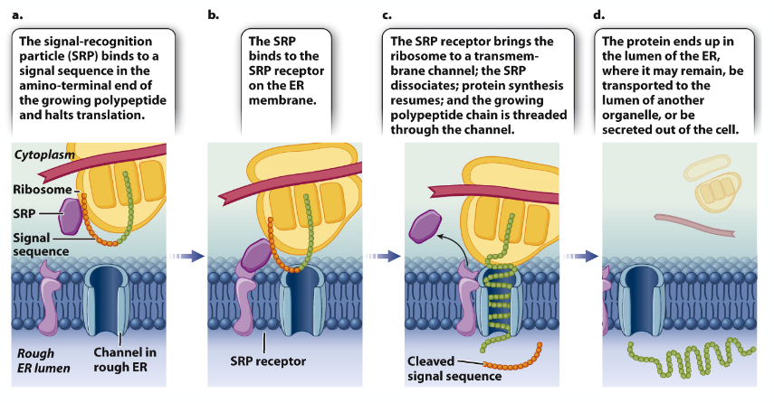

How transmembrane proteins are integrated into a membrane
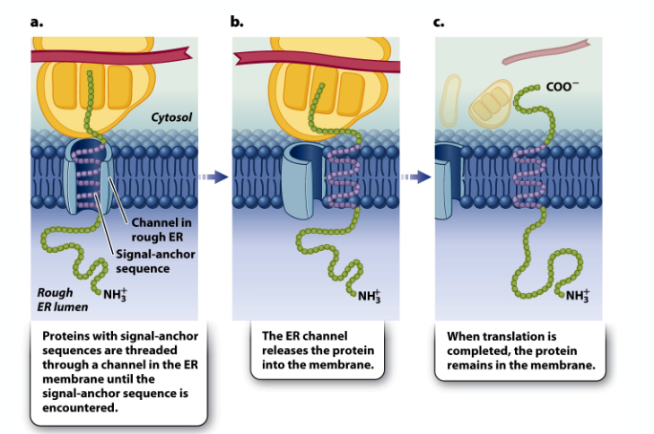
Synthesis of Integral Membrane Proteins
How transmembrane proteins are integrated into a membrane. This i….
Proteins targeted to mitochondria and chloroplasts
N-terminal sequences (signal sequences) direct proteins to their respective organelles. When they arrive at the organelle, other intrinsic sequences within the protein directs it to the correct compartment or membrane
These proteins are synthesized completely in the cytoplasm first
Lysosomes: Key features
- Digestive organelles
- 25 nm to 1 μm
- Internal pH of 4.6
- Contains hydrolytic enzymes: acid hydrolases
- Lysosomal membrane is composed of glycosylated proteins that act as a protective lining next to the acidic lumen

Lysosomes: Function
- Autophagy- Normal disassembly of unnecessary or dysfunctional cellular components- organelle turnover
- Isolation membrane derived from ER engulf target organelles to form an autophagosome (autophagic vesicle)
- Lysosome fuses with ER-derived autophagic vesicle to form an autolysosome
- Content of autolysosome is enzymatically digested and released (exocytosis)
- Degradation of internalized material
- Recycling of plasma membrane components like receptors and extracellular material
- Destroy pathogens like bacteria and viruses- only in phagocytic cells
Plant Vacuoles
Vacuoles are involved in the regulation of cytoplasmic pH, sequestration of toxic ions, regulation of cell turgor (rigidity), storage of amino acids, sugars, and CO2 in the form of malate
Tonoplast: Vacuolar membrane that contain active transport systems that allows ion and molecule transport (NEGATIVE)
Function of Plant Vacuoles
- Intracellular digestion comparable to lysosomes- slightly pH (5.0), acid hydrolases
- Mechanical support, turgor pressure
- Gives rigidity to plant- supports soft tissues
- Stretches cell wall during growth
- Storage
- Solutes and macromolecules
- Chemical storage (toxic compounds as well as pigments like anthocyanin)

Cytoskeleton
Dynamic network of interconnected filaments and tubes that extends throughout the cytosol (and some organelles) of eukaryotes.
Function:
- Structural supports
- Spatial organization within cell
- Intracellular transport
- Contractility and motility
Microtubules (MT)
- Largest cytoskeletal element (25 nm diameter)
- Polymer of two different proteins: alpha and beta tubulin
- Alpha/beta heterodimers form long protofilaments
- 13 protofilaments form longitudinal array creating a hollow cylinder
- + end fast growing
- - end slow growing
2 types:
Axonemal MT
- High organized, stable
- Part of structures (axoneme) involved in cell movement (e.g cilia, flagella)
Cytoplasmic MT
- Loosely organized, very dynamic
- Located in cytosol
Mictrotubules Assembly/Disassembly
- Dynamic instability- rapid turnover of most MTs.
- Shrinkage can occur very rapidly at plus end (catastrophe)
- Formation of MTs is regulated/ controlled
- Microtubules-organizing center (MTOC) is the central site of MT assembly
Microtubule-Associated Proteins (MAPs)
Several different proteins that bind MTs
- Modulate assembly, function
- Mediate interactions with other cellular structures (e.g. vesicles/organelles)
Two classes:
- Non-motor MAPs:
- Control MT organization in cytosol (e.g Tau protein in neurons)
- Defective Tau protein neurofibrillary tangles Alzheimer’s disease
- Non-motor MAPs:
- Two main types: kinesin and dynein
- Use ATP to generate force
- Can move material along MT track
- Can generate sliding force between MTs
Power intracellular transport
Kinesin- plus end- directed
Dynein- minus end-directed
Motor Proteins and Movement
- ATP binding to the leading head induces a conformational change that swings the trailing head by 180 degrees towards the + end of the microtubule. This is the force generating step
- The new leading head quickly binds to a tubulin subunit and releases its ADP. This step moves the kinesin’s cargo forward.
- In the trailing head, ATP is hydrolyzed to ADP, which leads to detachment from the microtubule
- ATP binds to the leading head to repeat the reaction cycle

Microtubule- Organizing Center (MTOC)
- Only found in eukaryotic cells
- The most important types of MTOCs are 1) the basal bodies associated with cilia and flagella and 2) the centrosome associated with spindle formation
- Motor MAPs can generate sliding force between MTs
Intermediate Filaments (IF)
- 10-12 nm in diameter
- Exclusive to multicellular animal cells
- Provide structural support and mechanical strength
- Stable in comparison to MTs or microfilaments
- Arrangement of fibrous alpha-helical proteins
- Not polar (i.e. no ‘plus’ and ‘minus’ ends). For that reason, Ifs are not used for transport
- Examples; Keratins. Neurofilaments, lamins
- Are especially abundant in the axons of neurons
Microfiilaments (MF)
- Thinnest cytoskeletal element
- Polymer of actin protein
- Maintenance of cell shape
- Cell movement
- Vesicle transport
- Muscle contraction
- `Cytokinesis (contractile ring)
Microfilaments (MF) and Actin Molecules
- Actin is the central component of MFs. It exists in cells as a monomer (G-actin or globular) or as a polymer
- Actin is an enzyme that binds and slowly hydrolyzes ATP
- A microfilament is a double helix of actin monomers

Structures of Monomeric G-Actin and F-Actin Filaments
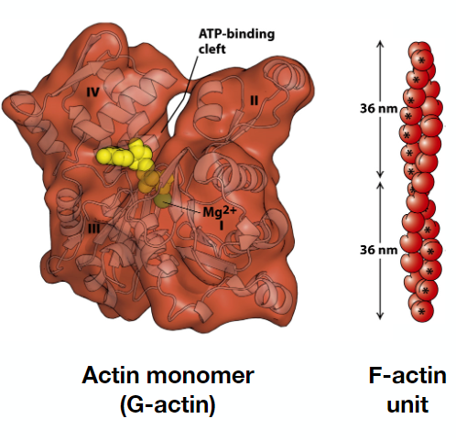
- G-actin has four subdomains and is divided by a central cleft creating two approximately equal-sized lobes
- An actin filament (F-actin) appears as two strands of subunits. One F-actin unit has exactly 28 subunits of G-actin (14 in each strand), covering exactly a distance of 72 nm

MFs are Dynamic like MTs
- Microfilaments have properties similar to microtubules
- F-actin filaments are polar, they have a plus and minus end
- Like microtubules, the plus end assembles/disassembles quickly, while the minus end assembles/ disassembles slowly
F-Actin Microfilament Assembly
Nucleation and polymerization:
The early nucleation steps of G-actin polymerization are slow
ATP binding favours nucleation and stability of filaments
G- Actin dimers trimers short filaments
Monomers can be added at both ends, but its always faster at the plus end
The process is reversible-ATP hydrolysis stimulates the destabilization of the polymer
F-actin microfilaments can be arranged in a loose array network (meshwork) or tight bundles/cables/fibers
The organization of these structures is regulated by actin-binding proteins

Directed Cell Motility
Coordinated activity of actin-binding proteins controls microfilament formation in a lamellipodium to allow directed cell movement
A lamellipodium is an actin projection on the leading edge of a cell
Actin- Associated Motor Protein
Like microtubules, F-actin microfilaments are associated with motor proteins
Myosin- a superfamily of motor proteins associated with microfilaments.
Most myosin molecules move toward the plus end of microfilaments
Divided into 2 broad groups:
- Conventional myosins (TYPE II, primary motors for muscle contraction)
- Unconventional myosins (TYPE I and types III-XVIII)
Unconventional mysosins generate force and contribute to motility in non-muscle cells
Myosin- based contraction pulls the trailing edge forward
Microtubule-based and microfilament – based motors can cooperate in intracellular transport

Nucleus: Function
- Storage, replication, and repair of genetic material
- Expression of genetic material (transcription- mRNA, tRNA, rRNA, RNA splicing)
- Ribosome biosynthesis
DNA is sensitive to chemical. UV light exposure
Nucleus: Structure
Nuclear envelope- membrane, pores, lamina- intermediate filaments
Nuclear content- chromatin, nucleoplasm, nucleolus
Nuclear Envelope
- 2 parallel phospholipid bilayers
- Outer nuclear membrane that binds ribosomes and is continuous with rough endoplasmic reticulum
- Inner nuclear membrane that has integral proteins and connects to nuclear lamina
Importance:
- Separates nuclear content from cytoplasm
- Separates transcription and translation processes
- Selective barrier that allows limited movement of molecules between nucleus and cytoplasm
Nuclear Lamina
- Supports nuclear envelope
- Thin meshwork of filamentous proteins:
- Lamins (intermediate filaments)- found in animal cells only, plants have nuclear lamina, but not made of lamin protein
- Nuclear lamina is bound to inner membrane of the nuclear envelope by integral membrane proteins
- Provides structural support for nuclear envelope
- Attachment sites for chromatin
- Nuclear lamina forms a meshwork next to the nucleoplasmic leaflet of the inner nuclear membrane
Nuclear Pore
- Gateways between cytoplasm and nucleus
- Pores are found where inner and outer membranes fuses
- Complex structure that involve the arrangement of different types of proteins
Nuclear Pore Complex
- Composed of nucleoporins, octagonal
- Very big

Nuclear Import
Regulated movement of proteins into nucleus requires a Nuclear Localization Signal
NLS= several positively charged amino acids within the protein sequence

Nucleolus
Largest structure inside the nucleus of eukaryotic cells
Primary function: biosynthesis of ribosomes
Ribosome Biosynthesis
- Synthesis of ribosomal rRNAs
- rRNA processing
- Assembly of subunits- rRNA+ ribosomal proteins

