PS101

Chapter 1

What is Psychology
- Psychology is the science of studying mental processes and behaviour
- Examining the mind and behavior and determining how each is influenced by internal and external environment
- Mental process is the activity of our brains when we are engaged in thinking, processing information and using language
- Behaviour is the observable activities an organism, often in response to environmental cues
- Culture a set of shared beliefs and practices that are transmitted across generations
4 Goals of studying psychology
- Description
  - Describe very specifically what they observe; what
- Explanation
  - Explain why people do the things; why
- Prediction
  - Predict the circumstances under which a variety of behaviors and mental processes are likely to occur, when
- Control
  - Control situations that we want to limit or increase certain behaviours or mental processes
Levels of Analysis
- Brain
  - How brain structure and brain cell activity differ from person to person or situation to situation
- Person
  - How one’s mental processes form and influence behaviour
- Group
  - How behavior is shaped by the social and cultural environments
History
- Hippocrates
  - a Greek physician
  - Believed that disease had a physical and rational explanation and that it was not caused by evil spirits or as a punishment from the gods
- Herman Von Helmhotls (1821-1894)
  - one of the first experimental examination of human reaction, he suggested that there should be a separation between sensation and perceptions
- Wilhelm Wundt (1832 – 1920)
Perspective and Its Influential Period | Principal Contributors | Subject Matter | Basic Premise
Behavioral (1913- Present) | John B. Watson Ivan Pavlov  B.F, Skinner | Effects of the environment on the overt behavior of humans and animals | Only observable events (stimulus response relationships) can be studied scientifically
- built the first laboratory in psychology, which defined psychology as a modern science, he believed that psychology focused on consciousness. He was the reason psychology separated hi(how the mental works)

Psychoanalytic
(1900-
Present
)
Sigmund Freud
Carl Jung
Alfred Alder
Unconscious
determinants of
behavior
Unconscious
motives and
experiences in
early childhood
govern personality
and mental
disorders
Humanistic
(1950s-
Present
)
Carl Rogers
Abraham Maslow
Unique aspects of
human experience
Humans are free,
rational beings
with the potential
for personal
growth, and they
are fundamentally
different from
animals
Cognitive (1950s-
Present)
Jean Piaget
Noam Chomsky
Herbert Simon
Thought; mental
processes
Human behavior
cannot be fully
understood
without examining
how people
acquire, store, and
process
information
Biological (1950s-
Present)
James Olds
Roger Sperry
David Hubel
Torsten Wiesel
Physiological basis
of behavior in
humans and
animals
An organism’s
functioning can be
explained in terms
of the bodily
structures and
biomedical
processes that
underlie behavior
Evolutionary
(1980s-
Present
)
David Buss
Martin Daly
Margo Wilson
Leda Cosmides
Evolutionary basis
of behavior in
humans and
animals
Behavior patterns
have evolved to
solve adaptive
problems; natural

- structuralism – based on the notion that the task of psychology is to analyze consciousness into its basic elements, and investigate how these elements are related (identify and examine the fundamental components of conscious experience such as sensations, feelings and images)
  - Edward Titchener – helped Structuralism emerge
  - Introspection – the carful, systematic self-observation of one’s own conscious experience, a method used by structuralists to examine the contents of consciousness
- Functionalism – based on the belief that psychology should investigate the function or purpose of consciousness rather than its structure
  - Studies mental testing, patterns of development, effectiveness of educational, and behavioral differences between the sexes

Branches of Psychology

- Academic Psychology
  - Focus on research and instruction in the various areas of psychology
  - Work at schools
- Applied Psychology
  - Applying psychological principles to practice problems in other fields education and marketing
- Clinical and Counselling Psychology
  - The study of abnormal psychological behavior and interventions designed to change that behavior
  - Psychotherapy
Chapter 2
Scientific Principles
- The universe operates according to certain natural laws.
- Such laws are discoverable and testable
The Scientific Method
- Deductive Reasoning
  - reasoning proceeding from broad basic principles applied to specific situations
- Inductive Reasoning
  - reasoning process proceeding from small specific situations to more general truths and not have bias
  - Bias
    - personal beliefs or conventional wisdom that a particular thinker mistakenly accepts as broad, basic truths
  - Empirical
    - able to be tested in objective ways
  - Theories
    - ideas about laws that govern phenomena
- Hypothetico-Deductive Reasoning
  - process of modern science where scientists begin with an educated guess about how the world works, and then set about designing small controlled observations to support or invalidate that hypothesis
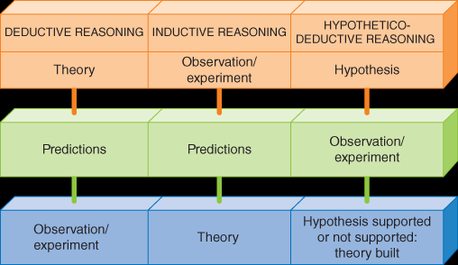
  - Both deductive and inductive

- Make observations
- Develop hypotheses
- Test hypotheses
- Build a theory
How Do Psychologists Conduct Research?
- Observation
- State a Hypothesis
  - generate a prediction
  - Variable
    - condition, event, or situation that is studied in an experiment
  - Independent Variable
    - condition or event that is thought to be a factor in changing another condition or event
  - Dependent Variable
    - condition or event that you expect to change as a result of variations in the independent variable
- Choose Participants
  - Sample
    - a group or set of people or items drawn from a larger population
  - Random Selection
    - identifying a sample in such a way that everyone in the population of interest has an equal chance of being involved in the study
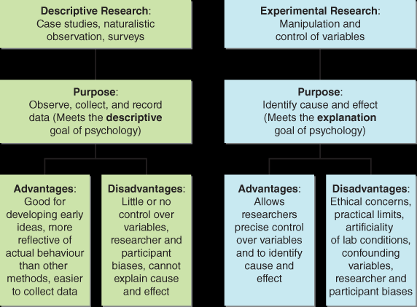
- Pick a Research Method

- Case Study
  - study focusing on a single person
- Naturalistic Observation
  - a study in which researchers directly observe people in a study behaving as they normally do
- Surveys
  - study in which researchers give participants a questionnaire or interview them
- Experiments
  - controlled observation in which researchers manipulate the presence or amount of the independent variable to see what effect it has on the dependent variable
  - Double-Blind Procedure
    - study in which neither the participant nor the researcher knows what treatment or procedure the participant is receiving

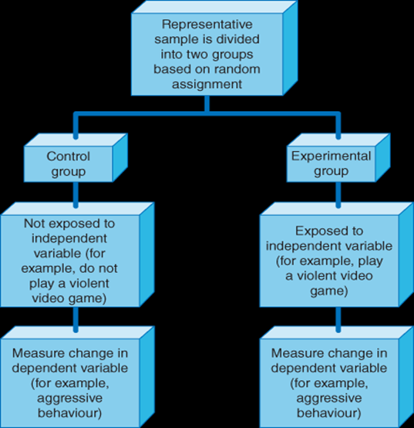
How Do Psychologists Make Sense of Research Results?
- Correlation
  - predictable relationship between two or more variables
- Correlation Coefficient
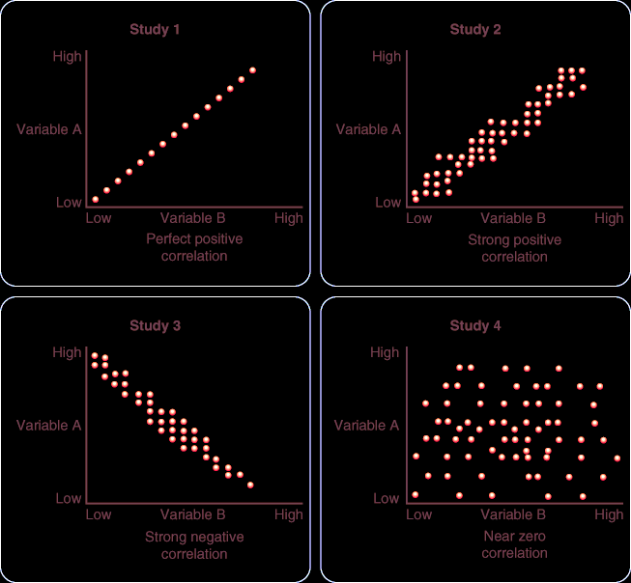
  - statistic expressing the strength and nature of a relationship between two variables

+1.00 | Perfect positive relationship
+.88 | Very strong positive relationship
+.62 | Strong positive relationship
+.38 | Moderate positive relationship
+.12 | Weak positive relationship
0.00 | No relationship
−.12 | Weak negative relationship
−.38 | Moderate negative relationship
−.62 | Strong negative relationship
−.88 | Very strong negative relationship
−1.00 | Perfect negative relationship

- Standard Deviation
  - statistical index of how much scores vary within a group
- Direction
  - Positive or negative
- Strength
  - correlation ranges from -1 to 0 (for negative correlations) and 0 to 1 for positive correlations. So, the closer the correlation is to the absolute value of 1, the stronger the relationship
- Inferential statistics
  - used to test whether our hypotheses are supported or not
- Measures of Central Tendency
  - (mean, median, mode)
- Measures of Variability
  - (standard deviation)
What Ethical Research Guidelines Do Psychologists Follow?
- Obtain informed consent
  - requirement that researchers give as much information as possible about the purpose, procedures, risks, and benefits of the study so that a participant can make an informed decision about whether or not to participate
  - If participants include children, researchers must obtain informed consent from both the parents or caregivers and the child
- Protect participants from harm and discomfort
- Protect confidentiality
- Make participation voluntary
  - Further, participants have the right to end their participation at any point or to decline to answer any particular questions during the study
- Do not use deception or incomplete disclosure
  - Deception, such as providing participants with false feedback on a test to manipulate their moods, is rarely permitted, and then only when no alternative methods are available
  - In addition, supports must be immediately available for negatively-affected participants
- Provide complete debriefing
  - Thus, at the end of a study, researchers are required to offer a debriefing to participants—an information session during which they reveal any information that was withheld earlier
- Pseudopsychology, or pop psychology, is not based on the scientific method, yet it takes on the appearance of science. Pseudopsychologists often have hidden goals, such as promoting certain moral or religious values (Hergenhan, 2005). A fundamental difference between pseudopsychology and psychology is that psychology does not claim to address all human issues, whereas pseudoscientists argue that psychological principles can provide the answers to all of life's major questions
Chapter 3
How Do Scientists Study the Nervous System?
- Examining autopsy tissue
  - This method allows neuroscientists to see what our brains look like, but has the obvious drawback of telling them little about how these systems worked when the person was alive and using them
- Testing the behavior of patients with damage to certain parts of the brain
  - involves researchers making assumptions based on information about the normally functioning brain from the damaged brain
- Recording electrical brain activity through multiple electrodes attached to the surface of the scalp
  - use electroencephalograms, or EEGs, as a non-invasive way to measure or learn about the activity of our brains during certain states (awake and asleep) and during certain behavioral task
  - researchers have refined the electroencephalographic technique through the analysis of event related potentials (ERP) to timelock EEG activity
  - ERP methodology is a useful approach for examining central nervous processing activities, such as audition in nonverbal infants
- Animal studies
  - Studies on animal nervous systems have made it possible to look closely at parts of functioning brains. Animal studies include microscopically examining specific brain regions, electrically recording from specific brain areas or specific neurons, temporarily activating or deactivating parts of the brain and observing the outcome, or targeting specific brain areas for destruction and observing the effects on behaviour
  - Transcranial magnetic stimulation (TMS) delivers an electromagnetic pulse to a targeted brain area, disrupting localized brain activity in a conscious person
- Neuroimaging
  - techniques that allow for studying brain activity and structure by obtaining visual images in awake humans
  - computerized (or computed) axial tomography (CAT or CT)
    - produce clear, detailed, two-dimensional X-ray images of the brain or other organs
  - magnetic resonance imaging (MRI)
    - uses a strong magnetic field to produce images of the anatomy and physiology
  - diffusion tensor imaging (DTI)
    - It measures the orientation and integrity of white matter (described later in the chapter) to assess damage in the brain and produces a DTI colour map
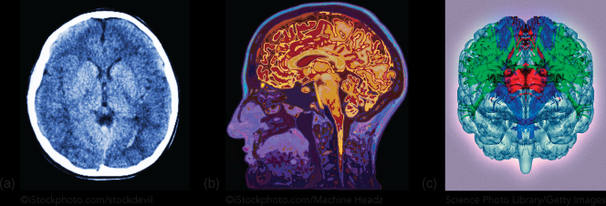
- Computed axial tomography (CAT) scan
- (b) magnetic resonance imaging (MRI)
- (c) diffusion tensor imaging (DTI)

- Positron Emission Tomography
  - a harmless radioactive substance is injected into a person's blood. Radiation detectors are then used to scan the person's brain. Active brain areas have more blood flow and thus display a higher amount of radioactivity
- Functional magnetic resonance imaging (fMRI)
  - allows for the detection of changes in blood flow, a presumed indicator of changes in the activity of neurons
  - detects the amount of oxygenated hemoglobin (the blood molecules responsible for carrying oxygen) after a person is exposed to magnetic pulses

How Does the Nervous System Work?
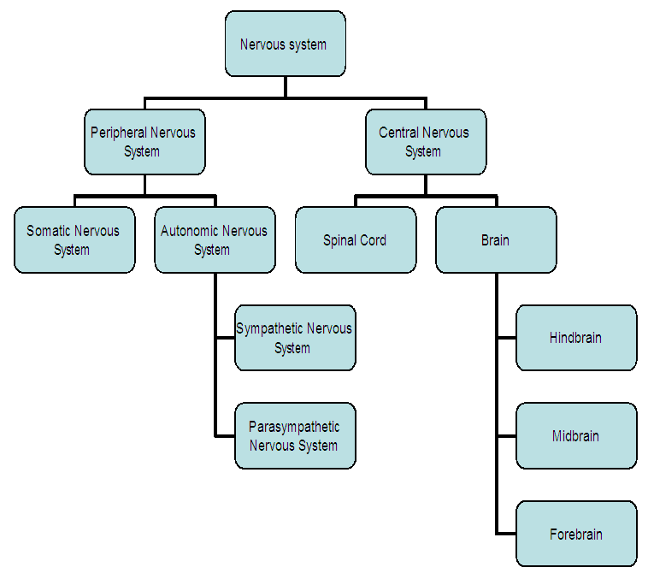
- Neuron
  - Nerve Cell
  - Communication among neurons is necessary for normal functioning of the brain and spinal cord
  - neurons have a cell body filled with cytoplasm that contains a nucleus
  - contain organelles that enable the neuron to make proteins and other molecules, produce energy, and permit the breakdown and elimination of toxic substances
- Dendrites
  - the parts of neurons that receive input from other neurons
- Axon
  - the part of the neuron that carries information away from the cell body toward other neurons
- Axon Terminal
  - the end of a neuron's axon, from which neurotransmitters are released
  - At the end of each axon (a region known as the axon terminal) are many specialized structures (synapses) where information is passed from one neuron to another across a very small fluid-filled space
  - When an electrical impulse (an action potential) reaches the axon terminal, it causes fluid-filled sacs called vesicles (filled with chemicals called neurotransmitters) to migrate to, and fuse with, the neuronal membrane and to then release neurotransmitters into the synapse
- Glia
  - the cells that, in addition to neurons, make up the nervous system
  - Means Glue in Greek
  - Astroglia
    - regulate the flow of blood into different brain regions as those regions increase or decrease in neuronal activity, thus providing more or less nutrition support or oxygenation as required
  - Oligodendroglia
    - central nervous system, including the brain and spinal cord
    - providing a protective fatty sheath, or coating, called myelin that insulates the axons of neurons from nearby neuronal activity
  - Schwann cells (both of which are myelinating glia)
    - peripheral nervous system, the nervous system outside of the brain and spinal cord
    - providing a protective fatty sheath, or coating, called myelin that insulates the axons of neurons from nearby neuronal activity
      - Myelin helps speed neural impulses
  - Ependymal cells
    - specialized neuroglial cells that line the walls of the ventricles, fluid-filled spaces within the brain
  - Glial Cell
    - Buffer neurons from the rest of the body.
    - Control the nutrient supply to neurons.
    - Destroy and remove diseased and dead neurons
  - Microglia
    - so-named because they are very small, are important for cleaning up the debris of degenerating or dead neurons and glia so that brain regions can continue with their normal functioning
The Action Potential
- Ions
  - atoms and molecules that have a relative imbalance of protons and electrons, and are thus either positively or negatively charged
  - The ratio of negative to positive ions in the cytoplasm (intracellular fluid) is different from the ratio in the extracellular fluid that surrounds the neuron
- Polarized
  - when a neuron is at rest, or inactive, the inside of the neuron is negatively charged in comparison to the outside
- Resting Potential
  - the electrical charge of a neuron when it is at rest
- Action Potential
  - a sudden positive change in the electrical charge of a neuron's axon, also known as a spike or firing; action potentials are rapidly transmitted down the axon
  - Either it fires or it doesn’t (all or none)
- Threshold of Excitation
  - the point at which the relative influence of other neurons succeeds in causing a neuron to initiate an action potential
- Concentration Gradient
  - the difference in concentration of sodium ions inside and outside of the neuron
- Electrostatic Pressure
  - force to promote a state of even distribution
  - exists because ions with opposite charges attract one another and ions with the same charge repel one another
- Ions Channels
  - pores in the cell membrane that can open and close to allow certain ions into and out of the cell
- Sodium-Potassium Pump
  - protein molecules in the membrane of cells that push out sodium ions and push in potassium ions
- Depolarization
  - the inside of the neuron membrane becomes less negative relative to the outside
- Hyperpolarization
  - the inside of the neuron membrane becomes more negative relative to the outside
- Excitatory Postsynaptic Potentials (EPSPs)
  - Postsynaptic depolarizations increase the chance the neuron will fire
- Inhibitory Postsynaptic Potentials (IPSPs)
  - hyperpolarize the membrane and thereby decrease the likelihood that the cell will fire
- Summation
  - A given neuron may receive input from hundreds or thousands of other neurons, and whether or not it fires depends on the net effect of the excitatory and inhibitory signals
- Synapses
  - tiny spaces between the axon terminal of one neuron and the neuron through which chemical communication occurs
- Synaptic Vesicles
  - membrane-bound spheres in the axon terminals of neurons in which neurotransmitters are stored before their release
  - Presynaptic terminal
- Absolute Refractory Period
  - very brief period of time after an action potential, during which a neuron is completely unable to fire again
- Relative Refractory Period
  - a brief period just after the absolute refractory period during which a neuron can only fire if it receives a stimulus stronger than its usual threshold level
- The unequal distribution of charges occurs for two reasons. First, the neuron's membrane exhibits selective permeability to ions
Communication Across the Synapse
- Neurotransmitters
  - specialized chemicals that travel across synapses to allow communication between neurons
  - send messages to specific receptors
TABLE3-1Common Neurotransmitters and Drugs Associated with Each
Neurotransmitter | Function | Associated Drugs
Glutamate | Learning, movement | Ketamine
GABA | Learning, anxiety regulation | Valium (diazepam, used to relieve anxiety, muscle spasms); Ambien (Zolpidem, used to treat insomnia)
Acetylcholine (ACh) | Learning, attention | Nicotine
Dopamine | Movement, reward learning | Cocaine; heroin; methamphetamine
Serotonin | Mood regulation | Ecstasy (MDMA); LSD (hallucinogens); monoamine oxidase inhibitors (MAOIs), selective serotonin reuptake inhibitors (SSRIs; antidepressants)
Norepinephrine | Attention, arousal | Adderall (a stimulant made up of dex troamphetamine and amphetamine)

- Neurotransmitter Receptors
  - proteins in the membranes of neurons that bind to neurotransmitters
- Postsynaptic Potentials
  - electrical events in postsynaptic neurons that occur when a neurotransmitter binds to one of its receptors
- Enzymatic degradation (Absorbed)
  - involves the breaking down of the neurotransmitter by enzymes. Often the products of the breakdown are reabsorbed by the cell and are used to synthesize additional neurotransmitter molecules. An example of a neurotransmitter inactivated by a special enzyme is acetylcholine (broken down by an enzyme called acetylcholinesterase).
- Reuptake (Absorbed)
  - in this process, neurotransmitters are drawn back into the presynaptic neuron and recycled for future use
- Acetylcholine
  - stimulating muscles and plays a key role in communicating between motor and sensory neurons. It is also important for attention, arousal, and memory, and plays a part in REM (dream) sleep
- Dopamine
  - associated with mood, control of voluntary movement, and reward mechanisms in the brain
  - An excessive amount of dopamine in the frontal lobes is associated with schizophrenia
  - drugs that block dopamine help to control the symptoms of schizophrenia
  - Parkinson's disease is a neurological condition that involves the death of dopaminergic neurons—those that produce the neurotransmitter dopamine—in the substantia nigra
- Norepinephrine
  - involved in stimulating the sympathetic nervous system, affecting arousal, vigilance, and mood
  - Strong emotions such as fear or anger cause an increase in heart rate and muscle strength, as well as increases in blood carbohydrate metabolism and respiration
  - People with depressive disorders may have low levels of norepinephrine, whereas excessive levels have been linked to anxiety
- Serotonin
  - involved in the regulation of mood, appetite, and sleep as well as in the perception of pain
  - many antidepressant medications block the reuptake of serotonin, increasing the amount available to receptors in the synapse, and resulting in elevation of mood
- GABA (gamma-amino butyric acid)
  - the most common inhibitory neurotransmitter in the brain, reduces the activity of the neurons it binds to
  - associated with reduction of arousal of the nervous system
  - Abnormal levels have been implicated in eating disorders as well as in epilepsy
- Glutamate
  - believed to be the most important transmitter for normal brain function
  - released by up to half of the brain's neurons and is therefore the most common excitatory transmitter in the brain
  - has also been implicated in neurodegenerative disorders such as Huntington's disease
  - Huntington's may be related to excessive glutamate activation
  - People suffering from this disease exhibit awkward movements and often show symptoms of psychosis
  - Huntington's disease is progressive and, as yet, there is no cure
Neural Networks
- Collections of neurons that communicate with one another in a sequential fashion
- Cell assemblies are networks of neurons that begin with essentially random connections, but become organized to work together as an interconnected entity
- synapses that change as a result of input or experience are known as Hebbian synapses
- underlie complex cognitive behaviours
Neuroplasticity
- the brain's ability to create new neural pathways as a result of experience or following an injury.

How Is the Nervous System Organized?
- Peripheral Nervous System
  - made up of the many nerves throughout our bodies that deliver information back and forth between the periphery and the central nervous system
- Afferent Neurons
  - neurons that carry sensory information from the body to the central nervous system
- Effect Neurons
  - neurons that carry information out from the central nervous system to the muscles and glands.
- Interneuron
  - neurons that typically have a short axon and serve as a relay between different classes of neurons; in the spinal cord, interneurons communicate with both sensory and motor neurons
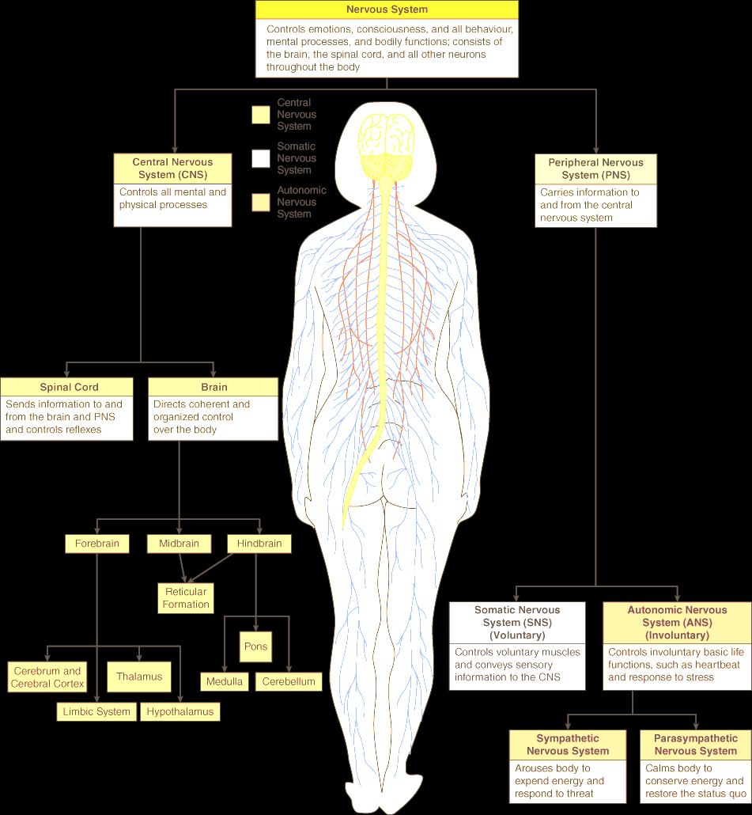
The Peripheral Nervous System (PNS)
- Somatic Nervous System
  - all the peripheral nerves that transmit information about body sensation and movement to and from the central nervous system
  - made up of all of the nerves that gather sensory information (typically about touch and pain) from all over the body, neck, and head and deliver it to the spinal cord and brain, as well as the nerves that send information about movement from the CNS to the muscles of the body, neck, and head

- Autonomic Nervous System
  - portion of the peripheral nervous system that comprises the sympathetic and parasympathetic nervous systems
  - two children on a teeter-totter
  - sympathetic nervous system
    - activated under conditions of stress
    - “fight-or-flight” reaction
  - parasympathetic nervous system
    - inhibited during those times, but is active during more restful times
    - returns the system to its resting state it is sometimes called the “rest and digest” system
The Central Nervous System (CNS)
- Spinal Cord
  - portion of the central nervous system that extends down the base of the brain and mediates sensory and motor information
  - Pain information also travels up to the brain and enables you to vocalize about the pain and carry out other movements, such as hobbling to a chair, sitting down, and pulling the tack out
- Spinal Cord Injuries
  - A spinal cord injury occurs when the nerves that make up the spinal cord itself are damaged
  - It is possible to break your neck and not have a spinal cord injury, though the two often occur together
  - When the spinal cord is damaged such that the flow of information to and from the brain is disrupted, individuals become paralyzed, as well as incapable of perceiving touch or pain sensations on the body
  - The higher up the spinal cord the damage occurs (the closer it occurs to the brain), the larger the proportion of the body that is afflicted
Structures of the Brain
- The human brain weighs about 1,400 grams (about 3 pounds) and is roughly the size of your two fists put together
- Except for a few structures, the brain is almost entirely bilaterally symmetrical
- Your brain uses 20 percent of your body's energy, but it makes up only 2 percent of your body's weight

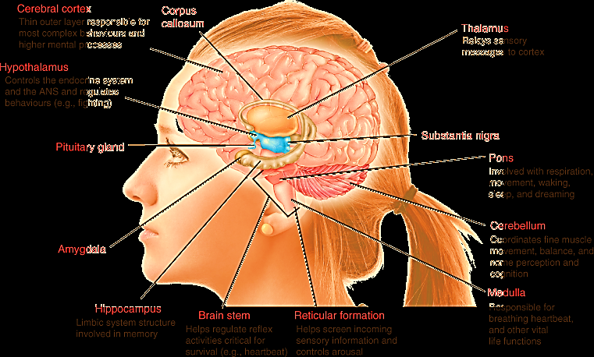
The Hindbrain
- the part of the brain closest to the spinal cord that consists of the medulla, the pons, and the cerebellum; the reticular formation begins here and extends to the midbrain.
- Medulla
  - part of the brain that controls basic bodily processes and regulates certain reflexes
  - regulating reflexes such as sneezing and coughing
- Pons
  - uppermost or anterior (front) part of the brainstem that includes the locus coeruleus
  - involved in sleep, dreaming, breathing, swallowing, eye movements, and facial sensation and expression
  - Bridge to medulla and other brain areas
- Cerebellum
  - part of the brain, near the base of the back of the head, important for motor coordination
  - important for certain types of learning involving movement
  - Once it's completely learned, the cerebellum then stores the learned motor information, ready to be recalled automatically when needed
- Reticular Formation
  - a complex neural network extending from the hindbrain into the midbrain that plays a central role in regulating consciousness and arousal
Midbrain
- Above the pons
- relatively small in humans, contains a number of different nuclei
- contains a number of different nuclei, among them the substantia nigra
- neurons in some other regions of the brain, neurons in the substantia nigra produce the neurotransmitter dopamine
Forebrain
- The largest subdivision of the human brain is the forebrain, which controls complex cognitive, emotional, sensory, and motor functions
- divided into two cerebral hemispheres connected by a band of white matter called the corpus callosum
- Each side of the brain controls the opposite (contralateral) side of the body
- The outermost layer of each hemisphere is composed of grey matter (largely neuron and glia cell bodies) called the cerebral cortex
- Thalamus
  - an area of the brain that serves, in part, as a relay station for incoming sensory information
  - sits in the centre of the brain between the midbrain and higher areas of the forebrain
  - In fact, all of our sensory systems, with the exception of the sense of smell, have a major pathway that synapses in the thalamus
  - An air traffic control center
  - Lateral Geniculate Nucleus
    - important for relaying visual information to the visual area of the cortex
  - Medial Geniculate Nucleus
    - important for relaying auditory information to the auditory area of the cortex
- Hypothalamus
  - brain structure important for motivation and control of the endocrine system
  - important for a number of motivated behaviours necessary for our survival as a species, including eating, drinking, sex, and maternal behaviour
  - Endocrine System
    - the system that controls levels of hormones throughout the body
- Pituitary Gland
  - brain structure that plays a central role in controlling the endocrine system
  - works with the hypothalamus to control a particular class of chemical messengers in the body—hormones—that are important for growth, reproduction, metabolism, and stress reactions
- Limbic System
  - a group of interconnected brain structures that are associated with learning, memory, basic emotions, and drives
  - Amygdala
    - brain area involved in processing information about emotions, particularly fear
    - involved in the development of phobias, or abnormal fears
  - Hippocampus
    - brain region important for certain types of learning and memory.
    - produce entirely new neurons in adulthood
    - The function of these new neurons remains unclear, but their presence suggests that the adult brain is capable of regenerative processes, leading to the hope that the production of new neurons, or neurogenesis, may be harnessed for brain repair
- Basal Ganglia
  - are a group of nuclei that work as a cohesive functional uni
  - Nucleus Accumbens
    - a brain area important for motivation and reward
- Substantia Nigra
  - brain region important in fluidity of movement and inhibiting movements
  - Damage to this brain region produces a collection of debilitating motor symptoms and deterioration of neurons in this area of the brain is associated with Parkinson's disease
  - control of eye movement
- Cerebral Cortex
  - The largest portion of the brain, responsible for complex behaviours including language and thought
  - responsible for many of our most complex functions, including consciousness, language, and thought
  - said to be the only structure that can think about itself
- Primary sensory and/or motor areas.
  - These areas are responsible for processing basic sensory information as well as directions for voluntary movement. As we will see, the primary sensory and motor parts of the cortex process information related to the opposite, or contralateral, side of the body.
- Association cortex.
  - Association cortex is responsible for many complex functions, including higher-order sensory processing, integrating information from different senses (how you know that an object that looks like a violin is producing the music you hear), thinking, planning, and other complex functions.
  - have subdivided the cortex into four major cortical regions or lobes
  - Occipital Lobe
    - lobe of the cortex at the back of the skull, important for processing very visual information
    - information received from each side of the visual world (each visual field) is passed to the opposite side of the brain
    - Information about colour, complex patterns, and motion, is communicated along separate subcortical pathways from the eyes, and is not integrated until it reaches visual cortex
  - Temporal Lobe
    - part of the cortex important in processing sound, in speech comprehension, and in recognizing complex visual stimuli, such as faces
    - located on the side of the brain and wraps around the hippocampus and amygdala
    - primary auditory cortex in the temporal lobe processes sound frequency, and other areas in the temporal lobe create meaning from the sound
    - contains regions important for language comprehension
    - learning and memory as well as in recognition of objects via visual cues
  - Parietal Lobe
    - lobe of the cortex involved in processing information related to touch and complex visual information, particularly about locations
    - located on the top middle region of the brain
    - Somatosensory Strip
      - an area of the parietal cortex that processes tactile information coming from our body parts
    - important role in the higher-order processing of visual stimuli
    - included in a system known as the “where pathway” that enables us to see and respond to visual information in a spatially appropriate way
  - Frontal Lobe
    - lobe of the cortex involved in many functions, including movement and speech production
    - Located at the front of the brain (behind the forehead)
    - important for planning and movement
    - Broca's area
      - a brain region located in the frontal lobe near the motor cortex that is important for speech production
      - the left (in most people) frontal lobe
    - Prefrontal Lobe
      - Portion of the frontal cortex involved in higher-order thinking, such as memory, moral reasoning, and planning
      - part of the frontal lobe closest to the front of the head
      - this area of the brain forms a systematic body map, but one in which some parts of the body are represented to a greater degree than others
      - Some regions are overrepresented, including the mouth and hands
      - When you look up a phone number and “hold” that number in your mind while you dial, you are using your prefrontal cortex
      - when you execute complex plans, such as figuring out how to fit in studying around your work schedule, or determining which public transport systems to take to get to a friend's house, you are using your prefrontal cortex
Differences in Brain Lateralization
- The two hemispheres divide their workload but are team players
- Corpus Callosum
  - bundle of axons that allows communication from one side of the cortex to the other
  - Connects to both hemispheres
  - In most people, cortical areas specialized for language exist only on one side of the brain
  - Some left-handers (about 18 percent) have language areas located on the right side of their brains, or on both sides
- Split-brain Patients
  - individuals who have undergone a surgical procedure to treat severe epilepsy
  - In this surgery, the corpus callosum is severed to stop the spread of seizures from one side of the brain to the other
  - these patients lack the ability to integrate information from the two hemispheres. Studies on these patients highlight the fact that the two hemispheres need the corpus callosum to communicate. Although split-brain patients are largely unaffected by the surgery in their day-to-day lives, the results of split-brain studies clearly show the hemispheric localization of a number of perceptual and cognitive functions
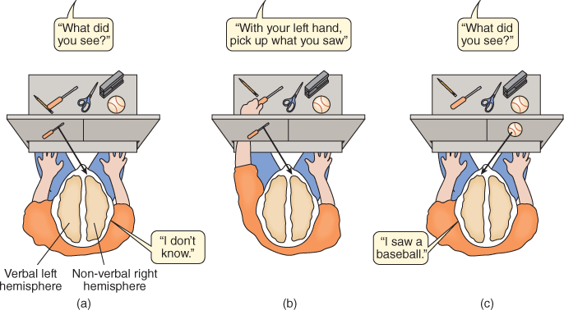
(a) When a picture of a screwdriver is flashed to a split-brain patient's left visual field, the information goes to his non-verbal right hemisphere and he cannot name the object. (b) When instructed to use his left hand (controlled by his right hemisphere) to feel behind a screen among a variety of objects and select the one that matches the picture just seen, the patient correctly selects the screwdriver. (c) When a picture of a baseball is flashed to the patient's right visual field, he easily names it

- the two hemispheres are more similar than they are different. Indeed, even when right-left differences are detected in function, these differences are usually relative. For example, the left brain can accomplish what the right brain can accomplish, it's just less efficient at some tasks and more efficient at others
- What then is the scientific evidence for “right-brain” dominant and “left-brain” dominant thinking?
  - Certainly the work with split-brained patients shows that there is, indeed, some localization of function in one or the other of our hemispheres
Integrated Brain
- To process information, integrate it with previous information, and then formulate and execute a reaction requires neural circuitry undoubtedly not contained within a single brain region
- The fact that no brain region works alone
The Theory of Evolution
- proposes that all life on Earth is interrelated and derives from one common ancestor
- Phylogeny
  - the development of unique species over time
- Fossil evidence of multicellular organisms (of which we are one) suggests that they evolved about 1.8 billion years ago
- Homologous
  - Characteristics that are similar between species and that can be traced back to a common ancestor
- Analogous
  - traits that have evolved independently in different species
- Convergent Evolution
  - he development of similar physical characteristics or behaviours in different species that do not share a common ancestor; occurs because of exposure to similar environmental conditions for different species
  - For example, birds and bees both have wings, but when you trace their ancestral tree they do not have a common ancestor that had wings. Thus, the evolution of wings has happened at least twice in two different species, making it an example of an analogous process leading to similar adaptations in distinct species
- Evolution by Natural Selection
  - the differential likelihood between members of a species in their ability to survive and reproduce, influenced by fitness
  - Darwin began to realize that the process of change in a specific species over generations was likely due to how well a particular animal adapted to the environment it lived in
  - Fitness
    - the ability of an individual to successfully grow to maturity and have offspring that perpetuate the existence of the species that the individual belongs to
  - Darwin made four critical observations to explain the diversity of life on the planet
- As more and more fossil evidence became available, Darwin realized that there were subtle changes in the form of animals that were fossilized. That is, animals were changing over time.
- Aspects of species that seem different on the surface, such as a human hand, a bat's wing, and a cat's paw, had structural similarities underneath. For all three of these animals, the number and arrangement of the bones under the skin, while different sizes, are the same
- Selective breeding of captive animals leads to changes in the appearance of the animal in question
- Not all animals that are born will survive to maturity and reproduce
  - Darwin also made a fundamental inference from his observations: animals of a given species that will survive and reproduce are those that can adapt and therefore survive best in their current environment
  - Darwin did not know about the underlying genetic processes that led to the inheritance of traits between generations
  - It is important to remember that the process of evolution never stops. All living things continue to evolve today in response to changes in the environment (a present-day example is antibiotic-resistant bacteria)

The Evolution of the Brain
- Scientists today do not see humans as the pinnacle of life on Earth, but rather as one species out of many that has adapted to fit a particular (and admittedly very broad) niche
- the evolution of our species has led to some noticeable differences between us and other species on Earth—most notably in the development of our nervous system, of which our brain is a part
The Evolution of Behavior
- Mate Choice
  - All species need to reproduce to survive. The majority of animal species have certain qualities that they find desirable in a mate; quite simply, members of a species that display those qualities have a better chance of mating and reproducing
  - Whether you realize it or not, the person you choose to have children with has been or will be selected based in part on your perception of his or her fitness to reproduce
  - what has been hypothesized is that these differences give us clues about the physiological and reproductive health of a potential mate
- Parental Investment
  - selecting a genetically strong reproductive partner that will provide some level of parental care increases the likelihood that the offspring will reach the age of reproduction
  - When it comes to parental investment of resources, most males want to support infants that carry their genes
  - In order for us to increase the likelihood of the survival and eventual reproduction of our offspring, we need to take care of our young until they can survive independently
  - For females, maternity is generally a certainty—a woman knows that the offspring she is carrying is her own (surrogates are an obvious exception to this).
  - For males, however, paternity is not a certainty; it is possible that a female is carrying a child that she says has been fathered by one individual when in fact another has fathered it
  - They speculated that stepfathers would be more likely to murder stepchildren than fathers would be to murder their biological children
- Heredity
  - One of the important tools to critically evaluate claims that genetics causes behaviour is to understand how the research is conducted. Perhaps the strongest test of whether genetics causes behaviour is identical twin tests, where those twins are raised apart. The rationale is that if twins raised apart still show the same behaviour (e.g., depression) then it can't be environment because they were raised apart and therefore had different environments. The only thing that is the same across them is their genetics (identical twins have 100% of their genetics in common.
  - However, we have to ask ourselves whether it is really the case that twins reared apart will have completely different environments. First, studies show that identical twins often get adopted into similar socio-economic groups and even locations. Second, imagine a set of twins who are 6'8" tall. This is of course a unique characteristic; someone this tall will likely be asked whether they play basketball, they may indeed play basketball, be on a team, and get a sense of self-esteem from sports. That is, if one twin has all these experiences and is treated in a particular way by everyone because he/she is so tall, it is likely that the other twin has a similar experience. So, by virtue of looking similar, they provoke similar reactions by others and likely experience similar things (i.e., similar environmental factors). Similarly, people argue that personality differences in siblings must be genetic given they grew up in the same house and therefore have the same environment. Do they really? In fact, parents parent very differently across child 1 and child 2. They are not the same; they're older, and /or they may live in a different place/location.

Chapter 6
Consciousness
- our immediate awareness of our internal and external states
When We Are Awake: Conscious Awareness
- Attention is a key park of conscious awareness (Aware)
- One possibility is that attention is a prerequisite for consciousness
- At the same time, attention does not equal consciousness; we need something more
- Many networks of neurons must be active simultaneously
The Cerebral Cortex
- are in charge of one's awareness of that attention
- Apparently, the left cerebral cortex is responsible for verbal awareness
- right cerebral cortex can produce tactile awareness, and perhaps other kinds of non-verbal awareness as well
Inattention blindness
- refers to the consistent research finding that people who are not paying attention to a picture, video, or scene are unable to report on the details of what those visual stimuli contain
Thalamus
- For trains to get from place to place on schedule without collision, a train conductor or a system manager (or even a whole group of them) must oversee the process
- Researchers have nominated several brain areas as potential conductors, involved in routing messages along the proper neural network “subway lines” of our brains
- Two of the most prominent candidates are the intralaminar nuclei and midline nuclei of the thalamus
- Research indicates that the intralaminar and midline nuclei receive and project long axons to neurons throughout the cerebral cortex, including areas that are involved in conscious awareness
Blindsight
- involves people with intact retinas but with damage to their primary visual cortex or, in more rare cases, their superior colliculus
- While they claim not to be able to see anything they can often provide correct responses to simple questions when asked to guess
Preconscious and Unconscious States
- Some also believe that consciousness should be distinguished from two alternative states, preconsciousness and unconsciousness
- Preconscious
  - level of awareness in which information can become readily available to consciousness if necessary
  - Many of our most familiar behaviors occur during preconsciousness
  - Preconscious behaviors of this kind are sometimes called automatic behaviors. As we saw at the beginning of the chapter, driving can involve automatic behaviors
- Unconscious State
  - State in which information is not easily accessible to conscious awareness
  - Perhaps you cannot remember the name of someone you saw from a distance, despite being sure you know them
  - Unexpectedly, minutes or days later the name of the person or the song you could not recover earlier jumps right out of your memory
Cognitive Views of the Unconscious
- Explicit memories
  - involve pieces of knowledge that we are fully aware of
  - is the conscious, intentional recovery of a memory.
  - Knowing the date of your birth is an explicit memory
- Implicit memories
  - refer to knowledge that we are not typically aware of
  - information that we cannot recall at will, but that we use in the performance of various tasks in life
  - usually on display in the skills we acquire, such as reading, playing an instrument, driving a car, or speaking a second language
  - may also involve factual information
Freud's Views of the Unconscious
- one of the key functions of the unconsciousness is to house thoughts and memories too painful or disturbing for consciousness
- Indeed, Freud maintained that at some level, we may repress such thoughts and memories (of bullies we have known, for example), pushing them into our unconscious and preventing them from entering our conscious experience
- Freudian Slip
  - Have you ever meant to say one thing, but something very different comes out, often to your embarrassment?
  - Freud identified this slip of the tongue as a moment when the mind inadvertently allows a repressed idea into consciousness
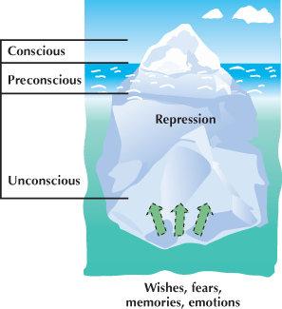
  - Freud also believed that our unconscious can work against us and that people who store too many emotionally

Why Do We Sleep?
- Sleep is so central to our lives—indeed, most people spend 25 years of their lives asleep
- Adaptive Therapy of Sleep
  - theory that organisms sleep for the purpose of self-preservation, to keep away from predators that are more active at night
- Restorative Theory of Sleep
  - theory that we sleep to allow the brain and body to restore certain depleted chemical resources and eliminate chemical wastes that have accumulated during the waking day
  - Sleep deprivation also reduces the functioning of the immune system
Rhythms of Sleep
- Circadian Rhythm
  - pattern of sleep-wake cycles that in human beings roughly corresponds to periods of daylight and night
  - Although we tend to be awake during the day and to sleep at night, our circadian rhythms are not fully dependent on the cycles of daylight
  - biological clock because the pattern repeats itself from one 24-hour period to the next
  - circadian rhythm sleep disorder experience excessive sleepiness or insomnia as a result of a mismatch between their own sleep-wake pattern and the sleep-wake schedule of most other people in their environment
  - This “rule,” however, varies with age. Younger people tend to peak later in the day, while older people peak earlier
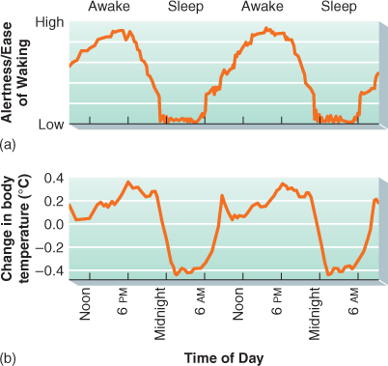
- Two prime examples of circadian rhythms are our cycles of alertness and shifts in body temperature
Owl
- Evening person
Lark
- Morning Person
When We Sleep
- Suprachiasmatic Nucleus (SCN)
  - small group of neurons in the hypothalamus responsible for coordinating the many rhythms of the body
  - As daylight fades into night, the SCN “notices” the change and directs the pineal gland to secrete the hormone melatonin
  - Increased quantities of melatonin, travelling through the blood to various organs, trigger sleepiness
  - Melatonin production peaks between 1:00 and 3:00 A.M
  - During the day, photoreceptors in the retina of the eye communicate the presence of sunlight to the SCN and melatonin secretions remain low
Patterns of Sleep
- Over the latter part of the night, we tend to spend most time in the first two of these five stages and in rapid eye movement or REM sleep
- Electroencephalograph (EEG)
  - examining people's brainwave patterns while they sleep
  - EEG readings indicate that each stage of sleep is characterized by a different brainwave pattern
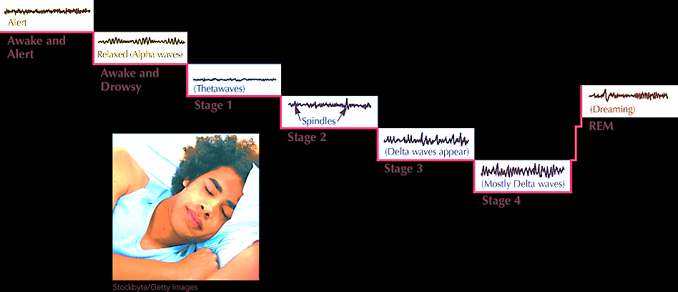
- Hypnagogic State
  - pre-sleep period often characterized by vivid sensory phenomena
  - Hypnagogic Hallucinations
    - We may feel that we are falling
    - floating in space
    - we may “hear” our name called out
    - we may hear a loud crash
  - Myoclonic Jerk
    - a sharp muscular spasm that generally accompanies the hypnagogic hallucination of falling
- Stage 1
  - Brain waves become smaller and irregular
  - Alpha-waves patterns are replaced by slower waves called theta waves
  - Bridge between wakefulness and sleep
  - Our awareness of other noises fade
  - If we are roused from this stage, we might recall having just had ideas that seem nonsensical
- Stage 2
  - Further brain activity occurs
  - Sleep Spindles
    - bursts of brain activity lasting a second or two; occur during Stage 2 sleep
  - Breathing becomes steadily rhythmic
  - Body may twitch
  - Lasts 15 to 20 minutes, we can still be awakened fairly easily
  - Generally, our muscle tension relaxes
- Stage 3/4
  - Delta waves appear in addition to theta waves
  - Delta waves indicate delta sleep or Deep sleep
  - In Stage 3, between 20 and 50 percent of our EEG waves are delta waves
  - Stage 4, the percentage of delta waves increases to more than 50 percent
  - During Stage 4, heart rate, blood pressure, and breathing rates all drop to their lowest levels, and the sleeper seems cut off from the world
  - Muscles are relaxed during stage 4, which leads to sleepwalking and bed wetting
- Passing through all of the first four stages takes a little more than an hour of each of our first two 90-to-100-minute sleep cycles
- Stage 5 (Rapid Eye Movement)
  - Rapid Eye Movement (REM)
    - stage of sleep associated with rapid and jagged brainwave patterns, increased heart rate, rapid and irregular breathing, rapid eye movements, and dreaming
    - Other stages are called Non-REM sleep (NREM)
    - Called paradoxical sleep because, even though the body remains deeply relaxed on the surface—almost paralyzed—we experience considerable activity internally
    - During REM sleep people's brains behave just as they do when they are awake and active
    - Moreover, every 30 seconds or so, our eyes dart around rapidly behind our closed eyelids
    - genitals become aroused during REM sleep
    - men usually experience erections and women vaginal lubrication and clitoral engorgement during REM sleep, even if the content of the dream is not sexual
    - Men often retain their erections beyond the REM stage, explaining the occurrence of morning erections
    - dreams usually occur throughout REM sleep
    - Dreams are less common during NREM sleep, and when they do happen, they do not have the narrative structure of REM dreams and as a result are less vivid or fantastic than REM dreams
    - REMs function is the consolidation of memories of newly learned material
    - every kind of mammal whose sleep patterns have been studied, including birds, experience both NREM and REM sleep
Dreams
- emotional, story-like sensory experiences that usually occur during REM sleep
- large percentage of people recall dreaming about particular events or experiences
TABLE6-1Dream Themes
Item | Total | Women | Men
School, teachers, studying | 89.2 | 89.4 | 88.2
Being chased or pursued | 88.7 | 89.1 | 86.8
Sexual experiences | 86.7 | 85.6 | 92.7
Falling | 74.3 | 74.2 | 75.0
Arriving too late | 68.5 | 70.0 | 60.3
A person now alive being dead | 68.0 | 70.7 | 52.9
Flying or soaring through the air | 63.5 | 63.0 | 66.2
Failing an examination | 60.8 | 63.8 | 44.1
Being on the verge of falling | 56.5 | 57.7 | 50.0
Being frozen with fright | 56.3 | 56.7 | 54.4
A person now dead being alive | 45.0 | 46.3 | 38.2
Being physically attacked | 44.8 | 44.7 | 45.6
Being nude | 43.0 | 43.1 | 42.7
Eating delicious food | 42.1 | 43.6 | 33.8
Swimming | 38.7 | 38.0 | 42.7
Being locked up | 38.7 | 37.2 | 47.1
Insects or spiders | 37.2 | 37.0 | 38.2
Being killed | 36.3 | 34.8 | 44.1
Your teeth falling out/losing your teeth | 35.6 | 35.6 | 35.3
Being tied, unable to move | 34.7 | 33.5 | 41.2
Being inappropriately dressed | 33.1 | 33.2 | 32.3
Being a child again | 32.7 | 32.7 | 32.4
Trying again and again to do something | 30.4 | 29.5 | 35.3
Being unable to find, or embarrassed about using a toilet | 30.0 | 31.1 | 23.5
Discovering a new room at home | 29.1 | 29.0 | 29.4
Having superior knowledge or mental ability | 27.0 | 24.5 | 41.2
Losing control of a vehicle | 26.8 | 28.7 | 16.2
Fire | 26.6 | 26.1 | 29.4
Wild, violent beasts | 26.4 | 26.9 | 23.5

- Information-Processing Theory
  - hypothesis that dreams are the mind's attempt to sort out and organize the day's experiences and to fix them in memory
  - interrupting dreams—impedes a person's ability to remember material learned just before going to sleep
  - periods of REM sleep (during which we dream) tend to extend longer when people's days have been filled with multiple stressful events or marked by extensive learning experiences
- Activation-Synthesis Hypothesis
  - theory that dreams result from the brain's attempts to synthesize or organize random internally generated signals and give them meaning
  - when dreams occur, neurons in the brainstem are activated
  - activate neurons in the cerebral cortex to produce visual and auditory signals
  - Also aroused are the emotion centres of the brain, including the cingulate cortex, amygdala, and hippocampus
  - activated brain combines—or synthesizes—these internally generated signals and tries to give them meaning
- Freudian Dream Theory
  - argued that dreams represent the expression of unconscious wishes or desires
  - believed that dreams allow us to discharge internal energy associated with unacceptable feelings
  - suggested that dream interpretation, in which a psychoanalytic therapist facilitates insight into the possible meaning behind a dream, may help clients appreciate their underlying needs and conflicts with the goal of being less constrained by them during waking life
  - For example, if a lonely and morally upstanding young man is sexually attracted to his brother's wife but is not consciously aware of this desire, he might have a dream in which he goes swimming in a private pool that is marked “No Trespassing.” His therapist might help the man arrive at the conclusion that the dream about swimming in an off-limits pool symbolizes his wish to be with his sister-in-law
  - Freud called the dream images that people are able to recall the manifest content of the dream
- Problem-resolution theory
  - suggests we dream about what we stress about; once the problem is resolved, the dream would stop (this is a good explanation for recurring dreams).
- Activation-synthesis
  - suggests dreams are simply random firings of different parts of your brain; if your emotion centre fires then you dream in emotional content; if your movement centre fires, then you dream about running. Then, to explain this randomness, your cortex tries to put all these pictures together in a story that you'll understand using the memories and experiences you have. In other words, dreams mean nothing, they're just random
- Nightmares, Lucid Dreams, and Daydreams
  - Nightmares
    - Dreams filled with intense anxiety are called nightmares
    - Nightmares generally evoke feelings of helplessness or powerlessness, usually in situations of great danger
    - Tend to be more common among people who are under stress
    - People who experience frequent nightmares and become very distressed by their nightmares are considered to have a nightmare disorder
    - Nightmares are more common among children than adults
    - When children have a nightmare, simple reassurances that they are safe and that the dream does not reflect real danger are usually helpful
    - Important to help the child appreciate the difference between inner and outer reality, a concept they struggle with up to and into their early school years
  - Lucid Dreams
    - Dreams in which sleepers fully recognize that they are dreaming, and occasionally actively guide the outcome of the dream
    - Some lucid dreamers can even willfully guide the outcome of their dreams
    - people who attempt to engage in lucid dreaming often believe that it is a way to open up another phase of human consciousness and perhaps help us to understand the relationships among frontal lobe function, rationality, and psychosis
  - Daydreams
    - Sometimes a daydream can become so strong that we lose track of external reality for a brief while
    - Although we may be embarrassed when caught daydreaming, such experiences may also afford us opportunities for creativity; we are, after all, less constrained during the fantasies than we would be if attending strictly to the outside world
Sleep Pattern Changes Over Development
- Through the first four months of life, babies sleep between 14 and 17 hours each day
- Although babies spend a lot of time asleep overall, the lengths of their sleep periods can last anywhere from minutes to hours before they are awake and crying out for attention
- sleep tends to become more structured at around 6 months of age
- Babies appear to spend a great deal more time than adults in REM sleep
- REM sleep tends to decrease to adult levels somewhere between the ages of 2 and 6 years
- Most children sleep around nine hours each day, although pediatricians recommend between 12 and 15 hours of sleep for anyone between 2 and 5 years of age
- Teenagers average around seven hours of daily sleep, although pediatricians recommend at least eight hours for them
- As adults, our sleep patterns continue to change. As we age, we spend less and less time in deep sleep and REM sleep, our sleep is more readily interrupted, and we take longer to get back to sleep when awakened
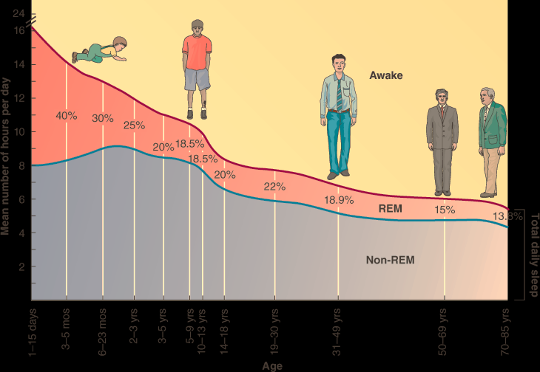
- The body clocks of teenagers also seem to be compromised by the increased social and academic pressures that they encounter
- Many adolescents, for example, stay up late largely because that's what it takes for them to finish their homework or to keep up with their friends
Sleep Deprivation
- When lack of sleep happens, we become generally sleepy and maybe a little cranky
- After a while, we may yearn for sleep
- Without enough sleep, people also experience a general depressed state
- They display lower productivity and are more apt to make mistakes
- Accidents and deaths are more likely to occur when drivers and pilots do not get enough sleep
- Adolescents are particularly likely to be sleep deprived
- Teenagers today get about two hours less sleep per night than teens did 80 years ago
- Ironically, students who pull all-nighters to complete their work actually wind up working less efficiently and effectively than they would if they were to sleep the eight or nine hours that they need
- Studies suggest that, on one hand, sleep deprivation does not necessarily lower one's performance on complex logical tasks
- Many sleep-deprived college and university students, for example, seem able to conduct research or write papers, particularly if those works interest them a lot
Sleep Disorders
- Sleep disorders occur when normal sleep patterns are disturbed, causing impaired daytime functioning and feelings of distress
- Almost everyone suffers from some kind of sleep disorder at one time or another in their lives
- Primary sleep disorders typically arise from abnormalities in people's circadian rhythms and sleep-wake mechanisms
- Insomnia
  - sleep disorder characterized by a regular inability to fall asleep or stay asleep
  - 20 percent of Canadians are dissatisfied with the quality of their sleep
  - many cases of insomnia are triggered by day-to-day stressors
  - Insomnia is more common among older people than younger ones
  - Elderly individuals are particularly prone to this problem because so many of them have medical ailments, experience pain, take medications, or grapple with depression and anxiety—each a known contributor to insomnia
- Sleepwalking
  - Most often takes place during the first three hours of sleep
  - Sleepwalkers will often sit up, get out of bed, and walk around
  - They usually avoid obstacles, climb stairs, and perform complex activities.
  - The disorder appears to be inherited
  - Up to 5 percent of children experience this disorder for a period of time, and up to 17 percent have at least one episode
- Night Terrors
  - Individuals who suffer from this pattern awaken suddenly, sit up in bed, scream in extreme fear and agitation, and experience heightened heart and breathing rates
  - They appear to be in a state of panic and are often incoherent
  - Usually people suffering from night terrors do not remember the episodes the next morning
  - Night terror disorder is not the same thing as a nightmare disorder
  - Sleepwalking and night terrors are more common among children than among adolescents or adults.
  - They tend to occur during Stages 3 and 4, the deepest stages of NREM sleep
  - Because night terrors typically stop after childhood, we do not treat them as sleep disorders but rather as developmental issues
- Sleep Apnea
  - Sleep disorder characterized by repeatedly ceasing to breathe during the night, depriving the brain of oxygen and leading to frequent awakenings
  - the second most common sleep disorder
  - Sleep apnea can result when the brain fails to send a “breathe signal” to the diaphragm and other breathing muscles, or when muscles at the top of the throat become too relaxed, allowing the windpipe to partially close
  - Sufferers stop breathing for up to 30 seconds or more as they sleep
  - Hundreds of episodes may occur each night
  - can eventually lead to cardiac arrest
  - people with sleep apnea are not getting sufficient rest and are at increased risk for fatigue-related problems while driving or working
  - Sleep apnea can usually be stopped completely by using a positive flow ventilator that keeps throat tissue open and stops the snoring and the breathing interruptions associated with this issue
- Narcolepsy
  - sleep disorder marked by uncontrollable urge to fall asleep
  - diagnosed in an estimated 24,000 people
  - People with this disorder may suddenly fall into REM sleep
  - When they wake, they feel refreshed
  - The narcoleptic episode is experienced as a loss of consciousness that can last up to 15 minutes
  - Narcolepsy seems to run in families, and some studies have linked the disorder to a specific gene or combination of genes
Hypnosis
- a seemingly altered state of consciousness during which individuals can be directed to act or experience the world in unusual ways
- During hypnosis, people can be directed to act in unusual ways, experience unusual sensations, remember forgotten events, or forget remembered events
- Spanos argued that hypnosis subjects are actually role-playing—acting as they believe hypnotized people should act
- People typically are guided into this suggestible state by a trained hypnotist or hypnotherapist
- For hypnosis to work, individuals must be open and responsive to suggestions made by the hypnotist
- Approximately 15 percent of adults are very susceptible to hypnosis, while 10 percent are not at all hypnotizable
- People who are especially suggestible are also more likely to do what other people tell them to do even when they are not hypnotized
- Hypnotic Procedures and Effects
  - a person is asked to relax while concentrating on a single small target, such as a watch or an item in a painting on the wall
  - At other times, the hypnotist induces a hyperalert hypnotic trance that actually guides the individual to heightened tension and awareness
  - Posthypnotic responses
    - is a behaviour that was suggested while the person was hypnotized, but which is engaged in later when a specified sign is observe
  - Posthypnotic amnesia
    - the hypnotist directs the person to later forget information learned during hypnosis
  - Hallucinations
    - mental perceptions that do not match the physical stimulations coming from the world around us
    - Positive Hallucinations
      - which people under hypnosis are guided to see objects or hear sounds that are not present
    - Negative Hallucinations
      - often used to control pain
      - The hypnotized person is directed to ignore—basically, to simply not perceive—pain
- Why it Works
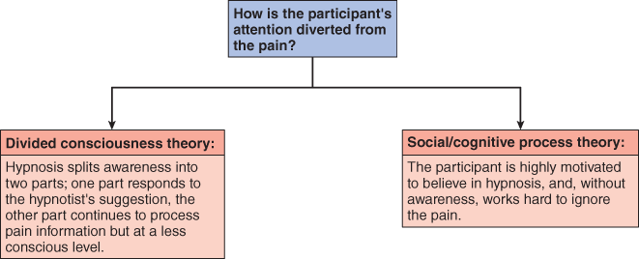
  - Dissociation
    - a splitting of consciousness into two dimensions.
  - Hidden observer
    - operates at a subtler, less conscious level, continuing to process information that is seemingly unavailable to the hypnotized person
    - the hidden observer was the part of the student's mind that was still able to hear while hypnotized
- What Happens in the Brain
  - Mental relaxation
    - neural activity in key areas of the cerebral cortex and thalamus—brain regions that, as we noted earlier, are implicated in conscious awareness—slows down significantly
  - Mental absorption
    - they focus carefully on the hypnotist's voice and instructions and actively block out other sources of stimulation, both internal and environmental
    - Total focus
    - During this state, cerebral blood flow and neural activity actually speed back up in key areas of the cerebral cortex, thalamus, and other parts of the brain's attention and conscious awareness systems
    - anterior cingulate cortex used to reduce pain
Meditation
- technique designed to turn one's consciousness away from the outer world toward one's inner cues and awareness
- The technique typically involves going to a quiet place, assuming either a specific body position or simply a comfortable position, controlling one's breathing, limiting one's outward attention, and forming internal images
- The result of such efforts is an altered state of consciousness, accompanied by deeply relaxing and pleasant feelings
- an ancient practice that can be traced through the history of all the world's major religions
- dating back to between 5,000 and 3,500 years BCE
- Two major meditation techniques
  - Opening-up
    - meditators seek to clear their mind to receive new experiences
    - imagine oneself as another person
  - Concentrative meditation
    - people actively concentrate on an object, word, phrase, or idea, called a mantra
    - Concentrating upon or repeating a mantra serves to calm and focus the mind and, perhaps, clear your mind completely
- people in meditative states experience increases in the same brain waves that are associated with the relaxation phase individuals experience just prior to falling sleep
- meditation also can lower respiration, heart rate, blood pressure, and muscle tension
- Mindfulness meditation
  - meditation that has been applied in particular to patients suffering from severe pain
  - meditators pay attention to the feelings, thoughts, and sensations that are flowing through their minds during meditation, but they do so with detachment and without judgment

Psychoactive drugs
- chemicals that affect awareness, behaviour, sensation, perception, or mood
TABLE6-2Psychoactive Drugs and Their Effects
Drug Class | Action in the Brain | Effects
Depressants |  | Depress activity of central nervous system | Excessive use or overdose effects
Alcohol   | Influences the neurochemical GABA | Slows down brain areas that control judgment, inhibition, behaviour (speech, motor functioning, emotional expression) | Anxiety, nausea, vomiting, constipation, disorientation, impaired reflexes and motor functioning, amnesia, loss of consciousness, shallow respiration, convulsions, coma, death
Sedative-hypnotics (benzodiazepines) | Influences the neurochemical GABA in calming neural activity | Produces relaxation and drowsiness, relieves anxiety
Opioids (opium heroin, morphine, codeine, methadone) | Activates the opioid receptors in the brain, providing their analgesic effect and their related high | Reduces pain and emotional tension, produces pleasurable and calming feelings
Stimulants |  | Increase activity of central nervous system | Excessive use or overdose effects
Caffeine | Blocks access to adenosine receptors, which produce sensations of drowsiness when stimulated | Increases alertness | Insomnia, restlessness, increased pulse rate, mild delirium, ringing in the ears, rapid heartbeat, irritability, stomach pains, vomiting, dizziness, cancer, heart disease, emphysema, anxiety, paranoia, hallucinations, psychosis, elevated blood pressure and body temperature, convulsions, death
Nicotine | Influences dopamine and acetocholene | Increases alertness, reduces stress
Cocaine   | Blocks re-uptake of dopamine, norepinephrine, and serotonin | Increases energy and alertness, produces euphoric feelings of well-being and confidence
Amphetamines | Increase release of dopamine and norepinephrine | Increases energy and alertness, reduces appetite, produces euphoric feelings
Hallucinogens |  | Enhance normal perceptions | Panic, nausea, headaches, longer and more extreme delusions, hallucinations, perceptual distortions (“bad trips”), psychosis, perceptual and sensory distortions, fatigue, lack of motivation, impaired memory
LSD | Stimulates dopamine and serotonin receptors | Dramatically strengthens visual perceptions (including illusions and hallucinations) along with profound psychological and physical changes
Cannabis (marijuana, THC)   | Encourages release of endorphins and dopamine | Produces a mixture of hallucinogenic, depressant, and stimulant effects
MDMA (Ecstasy) | Causes a “dump” of serotonin stores | Enhances sensory perceptions, increases energy and alertness, produces feelings of empathy and emotional well-being
- Addiction
  - psychological or physical compulsion to take a drug, resulting from regular ingestion and leading to maladaptive patterns of behaviour and changes in physical response
- Tolerance
  - mark of physical dependence on a drug, in which the person is required to take incrementally larger doses of the drug to achieve the same effect
- Withdrawal Symptoms
  - unpleasant and sometimes dangerous side effects of reducing intake of a drug after a person has become addicted
  - People in withdrawal may also crave the drug that they had been taking regularly
- In any given year, 2 percent of all teens and adults Canada, around 600,000 people, use cocaine, ecstasy, or hallucinogens, and 194,000 Canadians (0.8 percent) are dependent on illicit drugs
- Depressants
  - class of drugs that slow the activity of the central nervous system
  - Alcohol
    - a depressant that is taken in liquid form, is one of the most commonly used psychoactive drugs
    - More than three-quarters of the people in Canada drink beverages that contain alcohol, at least from time to time
    - Nearly 35 percent of Canadians over age 15 engage in heavy drinking (five or more drinks) at least once a year, and nearly half of those (48 percent) do so at least once a month
    - All alcoholic beverages contain ethyl alcohol, a chemical that is quickly absorbed into the blood through the lining of the stomach and the intestine
    - At first, ethyl alcohol slows down the brain areas that control judgment and inhibition
    - When more alcohol is absorbed, it slows down additional areas in the central nervous system, causing the drinkers to make poorer judgments, become careless, and remember less well
    - As drinking continues, the motor responses of individuals decline and their reaction times slow
TABLE6-3Alcohol's Effects on the Body and Behaviour
Number of Drinks⁽a⁾in Two Hours | Blood Alcohol Content (%)⁽b⁾ | Effect
(2) | 0.06 | Relaxed state; increased sociability
(3) | 0.09 | Everyday stress lessened
(4) | 0.10 | Movements and speech become clumsy
(7) | 0.20 | Very drunk; loud and difficult to understand; emotions unstable
(12)  | 0.40 | Difficult to wake up; incapable of voluntary action
(15)  | 0.55 | Coma and/or death

  - Sedative-Hypnotic Drugs
    - class of drugs that produces feelings of relaxation and drowsiness
    - At higher dosages, they are sleep inducers, or hypnotics
    - Benzodiazepines, Xanax®, Ativan®, and Valium®
  - Opioids
    - class of drugs derived from the sap of the opium poppy
    - heroin, morphine, codeine, and OxyContin
    - Outside of medical settings, opioids are smoked, inhaled, snorted (inhaled through the nose), injected by needle just beneath the skin (“skin popped”), or injected directly into the blood stream (“mainlined”).
    - An injection quickly produces a rush—a spasm of warmth and joy that is sometimes compared with an orgasm
    - Opioids depress the central nervous system, particularly the brain areas that control emotion
- Stimulants
  - substances that increase the activity of the central nervous system
  - Caffeine
    - mild (and legal) stimulant
    - Energy drinks are a relatively new way in which people are getting caffeine.
    - Caffeine intoxication can involve restlessness, fidgetiness, nervousness, excitement, euphoria, insomnia, flushing of the face, increased urination, gastrointestinal disturbance, muscle twitching, a rambling flow of thought and speech, irritability, irregular or rapid heartbeat, and psychomotor agitation
  - Nicotine
    - one of the most highly addictive substances
    - absorbed through the respiratory tract, the mucous membranes of the nasal area, and the gastrointestinal tract
    - proceeds to activate nicotine receptors located throughout the brain and body
  - Cocaine
    - the key active ingredient of South America's coca plant, is the most powerful natural stimulant currently known
    - The drug was first separated from the plant in 1865
    - native people have chewed the leaves of the plant to raise their energy and increase their alertness
    - Processed cocaine—a white, fluffy powder—is snorted and absorbed through the mucous membrane of the nose
    - Around 311,000 Canadians over 14 years of age used cocaine in 2008
    - Cocaine brings on a rush of euphoria and well-being—an orgasmic-like reaction if the dose is high enough
    - Cocaine apparently produces these effects largely by increasing activity of the neurotransmitter dopamine at key neurons throughout the brain
  - Amphetamines
    - manufactured in the laboratory
    - often taken in pill or capsule form
    - Increasing the activity of the neurotransmitter dopamine
    - People who start using the drug to help reduce their appetite, for example, may soon find they are as hungry as ever and increase their dose in response
    - One powerful kind of amphetamine, methamphetamine (nicknamed crank in one impure form or crystal meth in a more pure form), currently is experiencing a major surge in popularity
    - Methylenedioxymethamphetamine, or MDMA (better known as ecstasy), is another “club drug” form of methamphetamine often found at raves
- Hallucinogens
  - substances that dramatically change one's state of awareness, causing powerful changes in sensory perception
  - Lysergic acid diethylamide (LSD)
    - derived by the Swiss chemist Albert Hoffman in 1938
    - During the 1960s, a period of rebellion and experimentation, millions of users turned to the drug in an effort to raise their consciousness and expand their experiences
    - LSD brings on hallucinosis
    - a state marked by a strengthening of visual perceptions and profound psychological and physical changes
    - People may focus on small details
    - Colors may seem brighter or take on a shade of purple
    - Users often experience illusions in which objects seem distorted and seem to move, breathe, or change shape
    - Scientists believe that LSD produces these effects primarily by binding to many of the neurons that normally receive the neurotransmitter serotonin
  - Cannabis
    - The hemp plant Cannabis sativa grows in warm climates
    - The most powerful of them is hashish; the weaker ones include the best-known form of cannabis, marijuana, a mixture derived from the buds, crushed leaves, and flowering tops of hemp plants
    - tetrahydrocannabinol (THC) is the one most responsible for its effects
    - Today's marijuana is at least four times higher in THC content than was the marijuana of the early 1970s
    - producing a mixture of hallucinogenic, depressant, and stimulant effects
    - At low doses, the smoker typically has feelings of happiness and relaxation, although some smokers become anxious or irritated, especially if they have been in a bad mood
    - has been tied to many automobile accidents
    - heavy marijuana smokers may function poorly at school or work
    - regular marijuana smoking may contribute to long-term medical problems, including lung disease, lower sperm counts in men, and abnormal ovulation in women
- The Effect of Psychoactive Drugs on the Brain
  - Reward Learning Pathway
    - brain circuitry that is important for learning about rewarding stimuli
    - This brain reward learning pathway apparently extends from the midbrain to the nucleus accumbens and on to the frontal cortex
    - The key neurotransmitter in this pathway appears to be dopamine
    - Then dopamine is activated there, a person wants—at times, even craves—pleasurable rewards, such as music, a hug, or, for some people, a drug
  - Reward-Deficiency Syndrome
    - Theory that people might abuse drugs because their reward centre is not readily activated by usual life events
    - Abnormal genes have been pointed to as a possible cause of this syndrome
  - According to one explanation, when a person takes a particular drug chronically, the brain eventually makes an adjustment and reduces its own production of the neurotransmitter whose activity is being increased by the ingested drug
  - As drug intake increases, the body's production of the neurotransmitter continues to decrease, and the person needs to take more and more of the drug to feel its positive effects

Chapter 7
Learning
- a lasting change caused by experience
- must be inferred from behaviour—it cannot be directly observed
- Associative learning
  - learning that involves forming associations between stimuli
  - cringing at the whine of a dental drill because you associate the sound with the pain the drill has caused you in the past
  - Classical
  - Operant
    - B. F. Skinner
    - Edward Thorndike
- Non-associative learning
  - learning that does not involve forming associations between stimuli
  - the first time you sleep in a new apartment you may find yourself awakened a number of times by the unfamiliar sounds in the apartment (the furnace coming on) or sounds in the neighbourhood (buses, trains, or trucks going by). However, after a few nights you find you are able to ignore these now familiar sounds and are able to sleep without interruption
  - Habituation
    - the process of habituating, in which individuals pay less attention to a stimulus after it is presented to them over and over again
    - Dishabituation
      - a form of non-associative learning whereby there is a recovery of attention to a novel stimulus following habitation
  - Sensitization
    - a form of non-associative learning whereby a strong stimulus results in an exaggerated response to the subsequent presentation of weaker stimuli
    - Imagine you are home alone at night reading quietly. Without any warning, your cat knocks over a lamp, startling you. You may jump or even shout out in fear before realizing what has happened. And, for some time after you calm down, you are likely to startle again in response to normal auditory stimuli, such as the ring tone from your cell phone.
Classical Conditioning
- a form of associative learning between two previously unrelated stimuli that results in a learned response
- For example, when you first experienced an electrical storm, you initially cringed only to the loud booming of the thunder. However, after experiencing the multiple pairings of thunder with lightning, you now also cringe at the sight of lightning because you have come to associate the sight of lightning with the sound of thunder
- Conditioning
  - the association of events in the environment
- Natural Reflex
  - an automatic involuntary response that typically occurs without learning
  - your pupil contracts—shrinks—in response to bright light; you did not have to be taught this response
How Does Classical Conditioning Work?
- Pavlov's classical conditioning model has only four basic components
- Unconditioned Stimulus (US)
  - a stimulus that on its own elicits a response
- Unconditioned Response (UR)
  - a physical response elicited by an unconditioned stimulus; it does not need to be learned
- Conditioned Stimulus (CS)
  - a neutral stimulus that eventually elicits the same response as an unconditioned stimulus with which it has been paired
- Conditioned Response (CR)
  - a physical response elicited by a conditioned stimulus; it is acquired through experience and is usually the same as the unconditioned response
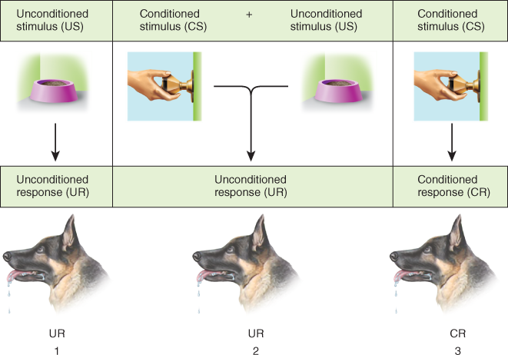

Processes of Classical Conditioning
- Acquisition
  - The most effective presentation schedule would be to pair the US and the CS together, with the CS occurring slightly before the US, so that the CS has predictive value
- Stimulus Generalization
  - what occurs when stimuli similar to the original conditioned stimulus trigger the same conditioned response
  - important because if we rely on past learning to help us decide how to respond to somewhat familiar stimuli and events, we eliminate the need to have to learn how to respond to every single new stimulus we encounter
  - So the person or animal responds to stimuli that are similar but not identical to the conditioned stimulus
  - Therefore any reptile resembling a snake elicits a fear response and any assistant in a lab coat elicits a salivatory response
- Stimulus Discrimination
  - what occurs when an organism learns to emit a specific behaviour in the presence of a conditioned stimulus, but not in the presence of stimuli similar to the conditioned stimulus
  - Similarly, at home your cat may be able to discriminate between the sound of a particular kitchen drawer opening—the one containing her treats—and the sound of any other kitchen drawer being opened
- Higher Order Conditioning
  - what occurs when a previously conditioned stimulus functions as if it were an unconditioned stimulus for further conditioning
  - Advertisers often pair their products (CS) with sexual imagery (US); this type of advertising relies on classical conditioning. However, when a celebrity is paired with a product, advertisers are relying on higher order conditioning. The celebrity (CS) has become associated with sexual imagery (US), and the celebrity, in turn, becomes associated with the product (CS2)
- Extinction
  - reduction of a conditioned response after repeated presentations of the conditioned stimulus alone
- Spontaneous Recovery
  - e-emergence of a conditioned response after extinction has occurred
  - For example, if the assistant hasn't brought food for several visits and the dogs' salivation response has been inhibited by extinction, the dogs might still salivate a week after extinction when the assistant arrives, indicating that the response was not “unlearned.”
Classical Conditioning and Drug Dependency
- Drug dependency involves the psychological and physiological experiences that occur as the individual continues to use the drug; the body adapts to the presence of the drug and the individual experiences withdrawal if the drug is reduced or stopped
- However, Siegel and his argue that a learned compensatory response (US) can trigger drug tolerance (UR) and may be involved in some drug overdoses. They argue that the body seeks to compensate for the effects of a drug by initiating a compensatory response (for example, lowering body temperature in anticipation of a rise in temperature caused by heroin injection) when there are environmental cues that the drug is on its way. The greater the compensatory response, the larger the dose required to offset it
- Exposure to external drug-related cues (CS) causes withdrawal symptoms caused by a compensatory response (CR) in the absence of the drug (US), causing cravings that can lead to relapse
Classical Conditioning and Fears
- Phobias
  - a persistent, irrational, or obsessive fear of a specific object, activity, or situation that may arise as a result of fear conditioning
  - People who suffer from phobias are believed to have learned an association between neutral (CS) and dangerous (US) stimuli, thus being conditioned to fear a relatively harmless cue (i.e., the CS)
Classical Conditioning and Taste Aversions
- Conditioned Taste Aversion
  - a form of classical conditioning whereby a previously neutral stimulus (often an odour or taste) elicits an aversive reaction after it's paired with illness (nausea)
  - For example, you might have had too much alcohol to drink and so now have a hangover, or you may have developed the stomach flu. Either way, whether or not the symptoms are directly related to the food you ate before becoming ill, you will probably develop an aversion to that particular food for some time afterwards. In this case, the US is whatever agent actually made you nauseous, whether bacterial, viral, or chemical. The food you develop an aversion to is the CS. The unconditioned physiological response (UR) is the nausea or other unpleasant gastrointestinal response. Following this initial experience, you will feel ill (experience nausea) simply when exposed to the food.
- Evolutionary Adaption
  - through the process of natural selection, organisms' physical and behavioral features adapt to function better in the face of environmental challenges
Operant Conditioning
- a form of associative learning whereby behaviour is modified depending on its consequences
- The term operant refers to the fact that organisms are learning by operating on the environment
- For example, if you are only a few minutes late for work but your boss docks you an hour's pay, you can alter your behaviour the following day to increase your chances of being on time
- Law of Effect
  - behaviours leading to rewards are more likely to occur again, while behaviours producing unpleasantness are less likely to occur again
How Does Operant Conditioning Work?
- Behaviourism
  - a branch of psychological thought arguing that psychology should study only directly observable behaviours rather than abstract mental processes
- Reinforcement
  - an experience that produces an increase in a certain behaviour
  - Premack Principle
  - Positive Reinforcement
    - presentation of a pleasant consequence following a behaviour to increase the probability that the behaviour will reoccur
    - means that something is present or has been added
    - They like what you’re doing do they give you something
    - E.g. You did well on a test so they gave you Ice Cream
  - Negative Reinforcement
    - removal of an unpleasant stimulus after a response to increase the probability that the behaviour will reoccur
    - means that something is absent
    - We like what you’re doing, and what you to do it more, so they take away something you don’t like
    - E.g. You did well on the test, so you don’t have to do dishes
- Punishment
  - an experience that produces a decrease in a particular behaviour
  - Positive Punishment
    - presentation of an unpleasant consequence following a specific behaviour to decrease the probability of the behaviour being repeated
    - means that something aversive has been presented (added) to weaken a response
    - Don’t like what you’re doing so you add something bad
    - E.g. You did horribly on a test so they beat you, they added pain
  - Negative Punishment
    - removal of a pleasant stimulus as a consequence of a behaviour to decrease the probability of the behaviour being repeated
    - taking away a pleasant stimulus to weaken a response
    - Don’t like what you’re doing so they take away something from you
    - E.g. If you bombed a test, you don’t get to go out anymore
Types of Reinforcers
- Primary Reinforcer
  - a stimulus that has survival value and is therefore intrinsically rewarding
  - many people work for money or for grades rather than for food or for water
  - Biological need
- Secondary Reinforcer
  - a neutral stimulus that becomes rewarding when associated with a primary reinforcer
  - Common secondary reinforcers for human beings include money, grades, praise, approval, acceptance, and so on
Types of Punishments
- Primary Punisher
  - a stimulus that is naturally aversive to an or
  - associated with pain or discomfort
- Secondary Punisher
  - a stimulus that becomes aversive when associated with a primary punisher
  - s include disapproval, indifference, a verbal “no,” criticism, bad grades, demerits, and so on
Schedules of Reinforcement
- Continuous
  - what occurs when behaviour is reinforced every time it occurs
- Intermittent or Partial Reinforcement
  - a schedule of reinforcement where the behaviour is only followed by reinforcement some of the time
- Fixed Ratio Schedule
  - schedule of reinforcement that occurs after a specific number of responses
- Variable Ratio Schedule
  - schedule of reinforcement where the number of responses required for reinforcement is unpredictable
- Fixed Interval Schedule
  - schedule of reinforcement that occurs every time a specific time period has elapsed
- Variable Interval Schedule
  - schedule of reinforcement that occurs after varying amounts of time
Using Operant Conditioning to Teach New Behaviors
- Shaping
  - introducing new behaviour by reinforcing small approximations of the desired behaviour
  - Shaping is a more realistic way to train a new behaviour, rather than waiting for the exact behaviour to happen by chance before providing reinforcement
- Behaviour Modification
  - a systematic approach to change behaviour using principles of operant conditioning
  - For example, imagine a child who is disruptive in a classroom. The child's teacher wants him to sit quietly in his desk. So, the teacher systematically begins to shape the child's behaviour toward the outcome the teacher desires. The teacher has determined that playing video games is rewarding to the child. So the teacher gives the child a sticker whenever he is quiet (even if he is out of his desk). After the child gets a particular number of stickers (say seven), he is allowed to play a video game for 10 minutes. Eventually the child is only rewarded for standing quietly near his desk, then for sitting at his desk talking quietly, and so on. In this way the child's behaviour is shaped toward the desirable outcome.
- Learned Helpfulness
  - a situation in which repeated exposure to inescapable punishment eventually produces a failure to make escape attempts
  - Learned helplessness occurs when organisms are exposed to conditions over which they have no control
Observational Learning
- learning that occurs without overt training in response to watching the behaviour of others, called models
- Modelling
  - what occurs when an observer learns from the behaviour of another
- It is important to note that observational learning is not the same thing as imitation
Observational Learning and Aggression
- Vicarious Learning
  - learning that occurs when an individual observes the consequences to another's actions and then chooses to duplicate the behaviour or refrain from doing so
  - For example, Jagat might manage his time better and get better grades by observing and then imitating Nash's effective study strategies
- Mirror Neurons
  - neurons fired when an animal or human performs an action or when they see another animal perform the same action
  - important for social learning, language, and the development of empathy
Learning and Cognition
- learning without reinforcement
- Spatial Navigation Learning
  - learning that involves forming associations among stimuli relevant to navigating in space
  - involves the presentation of food rewards as rats move in the correct direction. Rats learn mazes very quickly when reinforced
- Latent Learning
  - a form of learning that is not expressed until there is a reward or incentive
- Implicit Learning
  - Learning that occurs without awareness
Insight Learning
- a sudden realization of a solution to a problem or leap in understanding new concepts
- “ah-ha!” or “eureka” moment when the solution suddenly pops into our mind
- more cognitive (involving conscious intellectual activity) approaches to learning
Factors that Facilitate Learning
- Timing
  - You have probably noticed that you learn more information when you study for an exam over an extended period of time, as opposed to cramming for the test by pulling an “all-nighter.”
  - Semantic Learning
    - multiple exposures to the same material, such as reading the textbook, then listening carefully in class, and then reviewing your notes and textbook
    - Learning about facts
  - Episodic Learning
    - Learning about events in our own lives
  - Massed studying, or cramming is ineffective for two reasons.
    - First, it does not allow enough time between learning trials to maximize learning
    - Second, it leads to sleep deprivation, which affects the consolidation of learning
- Context
  - plays an important role in learning and remembering
  - For example, if you take a test in the same location in which you learned the material, you are more likely to do your best
  - Context Effect
    - If you learn information in only one context (for example, in the classroom) you may be less likely to recall it when you are in a different location
  - If you learn the information in multiple locations, then that knowledge may be less tied to the place in which it was acquired, and it may be more readily recalled later
- Awareness and Attention
  - Many forms of associative learning, including semantic and episodic learning, require awareness and are greatly enhanced by attentional processes
  - if one stimulus differs considerably from others, it will immediately grab our attention, a phenomenon referred to as “pop-out”
  - In order for pop-out to work, the stimulus must be singularly different from the surroundings
  - Stroop Effect
    - a psychological test that involves presenting a list of words printed in different colours. Each of the words is a colour word
- Social Networking and Multitasking
  - students who use Facebook while they study and attend lectures get lower grades than those who don't
  - prevents students from focusing their attention on the material
  - Specifically, research has shown that students who had Facebook or other forms of social media running while they studied—even if it was simply running in the background—tended to have lower grade point averages and fewer study hours than students who were not similarly distracted
- Sleep
  - important for learning and memory
  - Sleep deprivation impairs our ability to pay attention and learn
  - sleep deprivation can prevent learned information from moving into more permanent long-term memory storage
Prenatal and Postnatal Learning
- Non-associative learning can occur before infants are even born
- Fetuses show habituation and sensitization to smells and other sensory stimuli
- In one set of studies, for example, infants who had been prenatally exposed to garlic—through their mothers' digestion—showed evidence, after they were born, of recognizing the garlic odour
Specific Learning Disorder
- a disorder that interferes with the acquisition and use of one or more of the basic psychological processes involved in the development of academic skills: oral language, reading, written language, mathematics
- Many children with diagnosed learning disorders are high achievers and go on as adults to have successful lives and careers
- However, many are prevented from realizing their full potential and therefore fail to reach this level of achievement
- The data show that 5 percent of Canadian children between the ages of 6 and 15 have a learning disability, with slightly over 28 percent of those with learning disabilities aged 22 to 29 years of age reporting less than a high school diploma (as compared to about 11 percent in the general population for the same age group)
- Reading Disorder
  - a deficit in reading comprehension, written spelling, and word recognition
  - Most common
  - Dyslexia
  - have reduced blood flow in brain regions associated with acquisition of reading skills, such as the left parietal and temporal cortex
- Mathematics Disorder
  - a deficit in mathematical ability, including the ability to do calculations, as well as the ability to understand mathematical word problems and mathematical concepts
  - Dyscalculia
  - parts of the left parietal and frontal cortex of the brain are less active in individuals with dyscalculia
- Disorder of Written Expressions
  - a disorder experienced as impairment in the ability to create the written word
  - Least understood disorder
  - Dysgraphia
  - Cause of disorder unknown

Chapter 12
Personality
- the unique characteristics that account for enduring patterns of inner experience and outward behavior
- Personality involves a collection of stable states and characteristics and varies from one individual to another
- The study of personality is much more concerned with individual differences than are other areas in psychology
- The Psychodynamic Perspective
  - the psychodynamic (or psychoanalytic) model emphasizes the unconscious, often dark desires that have to be held in check
  - The Structure of Personality
    - The topmost level is the conscious mind
      - composed of the thoughts and feelings that we are aware of at any given moment.
    - 2.The second level, just below the surface is the preconscious,
      - which contains thoughts, memories, and ideas that can be easily brought into the conscious mind if attended to
      - For example, your mother's birthday or your plans for this evening remain in your preconscious until you require the information, at which point the information is transferred into your conscious awareness.
    - 3.The deepest level, the unconscious
      - contains most of the content of our minds.
      - We are unaware of this content and cannot become aware of it except under special circumstances.
      - The unconscious is particularly important to the development of personality

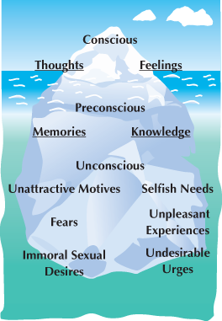

  - Id
    - the personality element representing basic instinctual drives, such as those related to eating, sleeping, sex, and comfort
    - Freud believed that most of these basic impulses have sexual overtones and that sexual energy, which he called libido, fuels the id
    - often described as immature and childlike
    - resides largely in the unconscious and is not readily available to consciousness
  - Ego
    - the personality element that works to help satisfy the drives of the id while complying with the constraints placed on behaviour by the environment
    - assesses what is realistically possible and what the social consequences of gratification might be
    - Freud essentially saw the ego as the rational, problem-solving force that constantly strives to keep id-based impulses from bursting forth in a destructive manner
    - Freud believed that it works both consciously and unconsciously
  - Superego
    - the personality element in charge of determining which impulses are acceptable to express openly and which are unacceptable; develops as we observe and internalize the behaviours of others in our culture
    - also forms during childhood
    - thought of as our conscience
    - an entity that leads us to feel guilt and sometimes even anxiety
    - resides in both the conscious and the unconscious mind
  - Ego acts as a mediator between the id and superego
    - it balances the powerful desires of the id with the moral standards of the superego
  - Psychosexual Stages
    - stages in the development of personality; the stages—labelled oral, anal, phallic, latency, and genital—are primarily influenced by sexuality and aggression
BLE12-1Freud's Psychosexual Stages
Stage | Erogenous Zone | Key Conflict or Experience | Symptoms of Fixation
Oral (0-18 months) | Mouth | Weaning | Dependency on pleasures of the mouth; also general dependence on mother
Anal (18 months-3 years) | Anus | Toilet training | Excessive neatness, orderliness, stubbornness, stingy, controlling
Phallic (3-6 years) | Genitals | Attraction to opposite-sex parent | Sexual role rigidity or confusion
Latency (6 years-puberty) | None | Repression of sexual impulses; identification with same-sex parent | No fixations for this stage
Genital (puberty-adult) | Genitals | Establishing mature sexual relations and emotional intimacy | Sexual dysfunction and unsatisfactory relationships

    - Neuroses
      - an abnormal behaviour pattern caused by unresolved conflicts between the id, ego, and superego
  - Anxiety and Defence Mechanisms
    - unconscious tactics employed by the ego to protect the individual from anxiety
    - Freud described defence mechanisms as unconscious tactics employed by our egos to protect us from anxiety by dealing with id impulses
TABLE12-2Some Common Defence Mechanisms
Mechanism | Description | Example
Repression | Keeping unpleasant memories or thoughts buried in the unconscious | Forgetting the details of a tragic accident
Denial | Refusing to recognize an unpleasant reality | Refusing to admit an addiction: “I don't have a problem”
Rationalization | Creating a socially acceptable excuse to justify unacceptable behaviour | Justifying cheating on taxes because “everyone does it”
Reaction formation | Not acknowledging unacceptable impulses and over-emphasizing their opposite | Overpraising a sibling's accomplishment even though you resent his/her success
Projection | Transferring one's unacceptable qualities or impulses to others | Not trusting a co-worker but believing the co-worker does not trust you
Displacement | Diverting one's impulses to a more acceptable target | Yelling at family members after being yelled at by your boss
Sublimation | Channelling socially unacceptable impulses into acceptable activities | Redirecting aggressive behaviour by becoming a professional fighter
Regression | Reverting to immature ways of responding | Throwing a tantrum when frustrated
Identification | Enhancing self-esteem by imagining or forming alliances with others | Joining groups for their prestige value
Intellectualization | Ignoring troubling emotional aspects by focusing on abstract ideas or thoughts | Discussing various economic theories while ignoring the pain of losing your job

    - Repression
      - he most basic defence mechanism
    - Denial
      - frequently used defence mechanism, and one that has entered into our common vocabulary
  - Evaluating Freud's Theories
    - The popularity of psychoanalytic theory was at its highest in the mid-twentieth century
    - Freud's theories have come under significant criticism in the scientific community.
    - Such criticism is largely due to the fact that the key principles of psychoanalytic theory are based on observations that cannot be directly tested by scientific methods
    - Freud based his theories on the cases of patients he treated in his private practice as a neurologist
    - For example, one of his patients— a 5-year-old boy called Little Hans—had developed an intense fear of horses
    - Freud came to believe that the boy's anxiety was a product of his psychosexual development related to his relationship with his father.
    - In a lengthy summary of his treatment of Hans, Freud described his procedure for helping the father and son learn to address the repressed feelings that were leading to Hans's anxiety
  - Other Psychodynamic Theories
    - Alfred Adler
      - believed that social needs and conscious thoughts are more important to human behaviour than sexual needs and other unconscious motivations
      - interested in how feelings of inferiority motivate behavior
      - In Adler's view, almost everyone has some feelings of inferiority stemming from childhood experiences of helplessness
    - Carl Jung
      - agreed with Freud's views on the importance of the unconscious, but added something else
      - the collective unconscious
        - personal unconscious
          - formed from individual experiences, is similar to the unconscious as seen by Freud
        - collective unconscious
          - however, is not a private entity like the personal unconscious
          - it is a cumulative storehouse of inherited memories shared by all humankind. Jung called these shared memories archetypes. According to Jung, archetypes are reflected in symbols and images that appear in the art, literature, and religions of all cultures
        - argued that the unconscious also includes drives toward joy, creativity, and internal harmony
    - Karen Horney
      - another neo-Freudian, accepted many of the basic principles of psychoanalysis, but went on to develop her own orientation and school of psychoanalytic training
      - she was particularly interested in what she called basic anxiety, which develops in children who experience extreme feelings of isolation and helplessness
      - sets the stage for later neuroses
      - Horney observed distinct differences in personality structure between patients from Europe and those from the United States
      - She came to believe that cultural differences play a more important role in development than traditional psychoanalytic theory acknowledged
- The Humanistic View
  - emphasize people's potential and highlight each person's consciousness, free will, and other special human qualities
  - Abraham Maslow
    - believed humans are basically good
    - an urge to grow and fulfill our potential
    - Personality arises from people's striving to meet their needs
    - these needs are arranged hierarchically, beginning with the need for basic physiological necessities, such as food and shelter
    - Self-Actualization
      - the need of humans to fulfill their full and special potential; the highest level of need in Maslow's hierarchy of needs
      - the full use and exploitation of talents, capacities, [and] potentialities
    - believed that more could be learned from individuals who were healthy and well-adjusted than from those who were experiencing psychological problems
    - The characteristics that define self-actualized people are the ability to recognize the needs and desires of others, the willingness to respond to the uniqueness of people and situations rather than responding in mechanical or fixed ways, an emotionally deep connection with a few people, spontaneity and creativity, and the ability to resist the urge to conform while still responding to reality
    - positive psychology
  - Carl Rogers
    - like Maslow, believed that human nature is fundamentally positive and that people strive for self-actualization
    - based his theory of personality around the concept of the self rather than around a hierarchy of needs
    - Self-Concept
      - a pattern of self-perception that remains consistent over time and can be used to characterize an individual
      - Our self-concept is related both to how we see ourselves and to how others see us
      - unconditional positive regard
        - acceptance without terms or conditions
    - many children form conditions of worth, a perception that they must meet certain standards to gain the love of their parents or other important figures
    - He believed that only in such an atmosphere can individuals begin to put aside the conditions of worth that lie at the root of their personal maladaptive functioning
  - Evaluating Humanistic Theories
    - Many critics fault the humanistic theories for their overly positive focus
    - they are simplistic and that they ignore the role of psychological dysfunction in society
    - it has been difficult for researchers to conduct controlled studies on such abstract concepts as self-actualization and unconditional positive regard
- The Trait Perspective
  - based on the premise that people's personalities are made up of collections of traits
  - personality traits
    - tendencies to behave in certain ways that remain relatively constant across situations
    - describe our general dispositions, and those dispositions lead to our behaviors
  - fundamental attribution error
    - that we are likely to explain our own behaviour in situational terms and others' behaviour in terms of personality traits
    - For example, you didn't finish your paper because you were busy studying for two tests in your other classes, but that guy over there didn't finish his paper because he was lazy or disorganized
    - Central Traits
      - People have innate tendencies to respond to situations in certain ways (traits).
      - These tendencies can be linked together to form broad habits (central traits).
      - Such principles can be used to form the foundation of a scientifically testable theory
    - Gordon Allport
      - believed that psychoanalysis “may plunge too deep, and that psychologists would do well to give full recognition to manifest motives before probing the unconscious”
      - emphasized the unity and uniqueness of the individual, and he believed that the present is more important than the past in understanding personality
      - his ideas have sometimes been criticized by other trait theorists who use empirical investigations to identify the traits that run through large populations
    - Hans Eysenck and Factor Analysis
      - strong proponent of using reliable statistical measures to test psychological principles
      - he strove to develop adequate measures of personality traits and, specifically, measures of their biological foundations
      - Factor Analysis
        - is a statistical method for analyzing correlations among variables
        - marked a significant turning point in the scientific study of personality theory
        - In the past, psychologists such as Freud and Allport had relied on case studies (one person at a time) and on their own intuition to form ideas about personality structure
      - Superfactor
        - a fundamental dimension of personality made up of a related cluster of personality traits
        - Extroversion
          - the degree to which a person is outgoing and enjoys interacting with others. An extrovert has personality traits such as impulsiveness, sociability, and assertiveness. At the other end of the spectrum, an introvert displays traits such as thoughtfulness, reliability, and passivity.
        - •Neuroticism
          - the degree to which a person tends to experience negative emotions, also known as mental instability.
        - •Psychoticism
          - the degree to which a person is vulnerable to developing the serious disorders known as psychoses, in which contact with reality is lost in key ways.
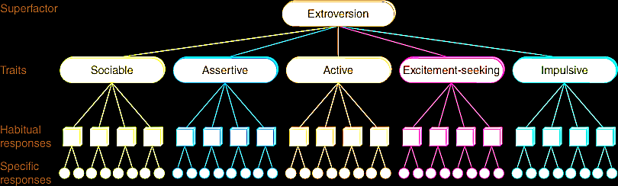

      - saw each of these superfactors—and the individual character traits of which each is composed
      - depended on factor analysis to determine how personality traits cluster together, he needed more basic data to make factor analyses possible
      - Gathered information on the traits themselves through the use of questionnaires on which people were asked to rate themselves on a number of trait-related behaviors
      - He administered his Eysenck Personality Questionnaire to people in hundreds of countries
      - believed that personality traits were biologically based, he also studied the biological basis of personality traits
      - A number of studies of hormones, blood pressure, and brain activity support the notion that biological factors are linked to the superfactors at least to some degree
    - The Five-Factor Model
      - an empirically derived trait theory that proposes five major trait categories: agreeableness/disagreeableness, extroversion/introversion, neuroticism/stability, conscientiousness/irresponsibility, and openness to experience/unimaginativeness
      - Agreeableness (versus disagreeableness)
      - Extroversion (versus introversion)
      - Neuroticism or emotional instability (versus stability)
      - Conscientiousness or dependability (versus irresponsibility)
      - Openness to experience or imaginativeness (versus unimaginativeness)
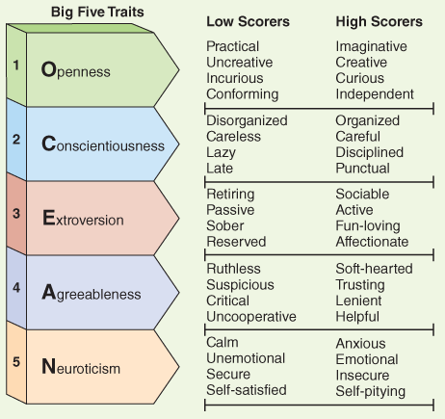
      - OCEAN

      - His third dimension, psychoticism, however, does not appear in the five-factor model
  - Evaluating Trait Theories
    - First, do traits apply to a variety of cultures?
    - Consider an interesting study conducted to determine whether people are “naturally” expressive or inexpressive
    - whether traits, and the behaviours they produce, remain stable across situations
    - whether traits, and the behaviours they dictate, are stable over time
    - traits often show inconsistency across a person's lifespan, especially as individuals travel from childhood to adulthood
    - interested in whether traits are inherited
    - Predict future
- The Situationist Perspective
  - the view that behaviour is governed primarily by the variables in a given situation rather than by internal traits
  - personality factors come into play when people are making choices, reacting to events, or displaying other behaviors
  - situational “pushes” and “pulls” rule in most instances
  - B. F. Skinner
    - Skinner believed that human behaviour was completely shaped by environmental factors
    - saw as simply a certain consistency in what he called response tendencies
    - meant that we approach life in a certain way because some of our behaviours have been rewarding to us in the past while other behaviours have not
    - we tend to favour, or repeat, responses that have previously helped us gain a desired outcome or avoid an undesired one
    - would say that you studied because you found academic achievement to be rewarding or because studying served to keep your parents happy
    - Skinner defined a reinforcer as something that leads you to engage more often in a particular behavior
    - Theorists argue that even in the context of reinforcement principles, it is still people who choose, manipulate, interpret, and react to the situations—or reinforcements—they meet
- The Interactionist Perspective
  - a view emphasizing the relationship between a person's underlying personality traits and the reinforcing aspects of the situations in which they choose to put themselves
  - focuses on interactions between people and situations
  - the choices you make, such as attending your present college or university or being enrolled in your present classes, are functions of underlying personality traits
  - This idea that individual and situational variable interact suggests a way of moving beyond the trait-versus-situation controversy
  - Albert Bandura
    - social-cognitive theory
      - famous for introducing the concepts of modelling and self-efficacy to the study of human behaviour and personality
      - Con
        - show neither whether personality is stable across situations nor how unconscious, emotional, and biological influences apply
    - reciprocal determinism
      - the external environment, internal mental events (such as one's beliefs and expectations), and behavior all interact with one another
  - major advantage of this perspective over other theories of personality is that Bandura's theory, with its special emphasis on observable variables, such as models, behaviours, goals, and outcomes, is readily testable
  - discovered that interactive effects between dispositions (traits) and situations are common, and that disposition-situation relationships often show stability

Personality Assessment
- Personality Inventories
  - a questionnaire designed to assess various aspects of personality
  - These types of assessments are sometimes called self-report inventories because they depend on information that respondents supply about themselves
  - most widely used personality inventories are the Minnesota Multiphasic Personality Inventory 2 (MMPI-2) and the Revised NEO Personality Inventory (Neuroticism, Extraversion, Agreeableness, Conscientiousness, and Openness to Experience) (NEO PI-R)
  - They are favoured by clinicians, employers, and other professionals largely because they are easy to administer and to score, and do not require subjective interpretations by test administrators. Each test requires individuals to respond to hundreds of statements that cover a broad range of feelings, behaviours, and inclinations
  - some significant concerns have been raised about their use as indicators of personality
    - First, the tests rely on self-reports, a source of information that may not always be accurate
    - Another concern is that personality tests may not always be used and applied properly
    - socially desirable responding
      - tailoring answers on personality inventories to try to create a good impression
      - validity items
        - in the questionnaire to assess the likelihood that a respondent would purposely give an answer that was socially desirable rather than accurate
    - United States there were a number of successful lawsuits claiming that hiring decisions based on older personality tests were unfair
- Projective Tests
  - a personality assessment device intended to tap a person's unconscious by presenting the person with an ambiguous stimulus and asking the person to interpret what the stimulus means
  - commonly used by psychoanalytic clinicians and researchers
  - Rorschach Inkblot Test
    - participants are presented with a set of 10 inkblots and asked to explain what they see
    - he ambiguous shapes of the inkblots are intended to force participants to project structure and meaning onto the images, and the participants' responses are thought to reveal underlying psychological themes and personality issues
    - For example, a person who sees images of animals or weapons in the inkblots is often thought to be grappling with underlying aggressive urges
    - Scoring of the tests depends heavily on interpretations by the test administrators—interpretations that may be affected by the assessor's professional biases or level of expertise
    - Studies have shown that individuals who take a Rorschach test today may offer responses that are very different from those they offered when they took the test last week, leading to different personality assessments
  - Thematic Apperception Test (TAT)
    - created in the 1930s by psychologist Henry Murray
    - made up of ambiguous black-and-white drawings of people in various situations
    - Test-takers are asked to describe and make up a story about each drawing
    - most clinicians rely on their own judgments when analyzing an individual's TAT responses
How Much Do Genetic Factors Contribute to Personality?
- Minnesota Study of Twins Reared Apart
  - This investigation focused on 59 pairs of identical twins who had been raised in different families and 47 pairs of fraternal twins raised in the same household
  - Recall that identical twins have exactly the same genetic structure, while fraternal twins are no more genetically similar than non-twin siblings
  - The twins who participated in the study spent six days taking personality and intelligence tests
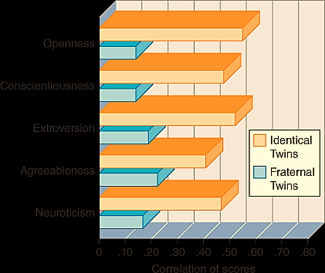
  - The identical twins proved to be substantially more similar on every psychological dimension than the fraternal twins, even though the identical twins had been raised in separate homes and families

- Some researchers have suggested that certain behavioural tendencies, which are expressions of personality, may also have an inherited component
- More likely, multiple genes interact and affect an individual's broad biological systems, and these systems contribute to the traits or behaviours in question
Personality and the Brain
- Twin studies, as we have seen, suggest links between genes and personality
- Franz Joseph Gall (1758-1828)
  - Phrenology
    - a method of assessing a person's mental and moral qualities by studying the shape of the person's skull
    - He believed he could pinpoint specific parts of the brain that were responsible for distinct personality qualities by feeling the bumps they raised on the skull
  - While Gall's techniques were later shown to be inaccurate, his ideas about the localization of brain functions and the role of the brain in personality continue to influence neurological science
- Many studies suggest that certain brain structures help to regulate personality
- Brain imaging studies have shown that people with damage to the amygdala have difficulty becoming conditioned to fear stimuli
- Cerebral hemisphere dominance may also contribute in subtle ways to personality
  - studies have hinted that people whose right hemisphere is dominant experience more negative emotions and traits while those whose left hemisphere is dominant display more positive emotions and traits
  - Psychologists have studied the brains of infants who show high levels of distress when separated from their mothers. Results indicate that such infants tend to display heightened activity in the right-side prefrontal cortex
- Neurotransmitter activity has also been linked to some personality variables
  - Neurochemistry
  - High dopamine activity in the reward centres, for example, has been associated with positive emotions, high energy, and lack of inhibition, while low activity of this neurotransmitter has been linked to anxiety, inhibition, and low energy levels
  - Similarly, low serotonin activity has been associated with depression, violent behaviour, and impulsivity
- Hormonal activity, too, has been tied to personality
  - The important hormone cortisol, secreted by the adrenal cortex to help regulate reactions to threatening experiences, has been tied to personality
  - Jerome Kagan
    - found that the children with inhibited temperaments tended to have higher cortisol stress reactions to unfamiliar situations
    - temperament is a way to describe early-appearing stable tendencies toward particular emotional states (called reactivity) and the ability to manage these states
- Lee Anna Clark and David Watson
  - Three broad categories of temperament

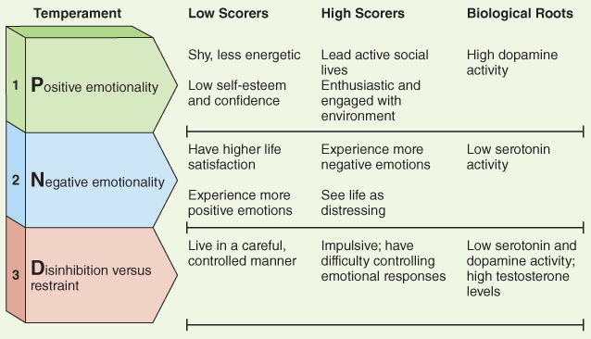

Gender Differences
- A number of studies suggest that the widespread belief in inherent personality differences between men and women may be no more than a myth
- women, on average, tend to be more accurate than men at assessing emotion in other people
- women are more attuned to interpersonal (relational) concerns when making moral decisions, while men are more likely to base such decisions on laws or abstract principles
- she has found that men, on average, score higher on traits that reflect individuality and autonomy, while women score higher on ones that emphasize social connectedness and empathy (Gilligan, 1982). Similarly, some investigations have indicated that women tend to display more nurturing behaviours
- Levels of aggression—particularly physical aggression—were somewhat higher among males
- In addition, males were quite different from females on measures of motor performance and sexuality
- males and females had strikingly different attitudes about sex in casual, uncommitted relationships—men were more open to sex in such instances
- In collectivist societies, contentment is related to harmony in interpersonal relationships, and this emphasis affects behaviour
  - A strong sense of reciprocity and a responsibility to return favours shapes personal styles, behaviours, life goals, and measures of success. In such a culture, a sense of accomplishment comes not from individual achievements but from strong commitment to family, community, or company
- Social Role Theory
  - theory that gender differences occur because girls and boys develop different behaviours and skills based largely on differences in gender role expectations
  - sexual attitudes may be influenced by research participants' awareness that society expects men and women to behave in certain ways sexually
  - Family and social relationships may also contribute to the development of personality differences between boys and girls
  - Broad cultural practices, often a reflection of religious and philosophical beliefs, are also significant in the development of male-female differences
- Biological Factors
  - hemispheric lateralization
Personality Disorders
- an inflexible pattern of inner experience and outward behaviour that causes distress or difficulty with daily functioning
- rigid, extreme and distorted thinking patterns (thoughts)
- problematic emotional response patterns (feelings)
- impulse control problems (behaviour); and
- significant interpersonal problems (behaviour)
- Borderline Personality Disorder
  - a personality disorder characterized by severe instability in emotions and self-concept and high levels of volatility
  - thought of as an emotion dysregulation disturbance
  - high level of instability in relationship
  - form intense, conflict-ridden relationships in which their feelings are not necessarily shared by the other person
  - Thinking in dichotomous (black-and-white) terms, they quickly become furious when their expectations are not met
  - Scared of being alone
  - biosocial theory
    - the disorder actually begins during childhood
    - combination of internal forces (for example, difficulty identifying and controlling one's arousal levels and emotions) and external forces (for example, an environment in which a child's emotions are punished or disregarded)

- Antisocial Personality Disorder
  - a personality disorder characterized by extreme and callous disregard for the feelings and rights of others
  - Dishonesty and deceit are at the root of their relationships
  - Self centered
  - Don’t care about the safety of others
  - often form relationships with the intent of exploiting others for material gain or personal gratification
  - Many are irritable, aggressive, and quick to start fights, and a large number commit criminal acts
  - Sometimes described as “psychopaths” or “sociopaths,”
  - According to a number of behavioural theorists, antisocial symptoms may be learned through modelling
  - studies suggest that biological factors may play an important role in this disorder
    - that people with the disorder display lower serotonin activity than other individuals
TABLE12-3The Major Personality Disorders
Marked by Odd or Eccentric Behaviour
Paranoid: Exaggerated suspicion and distrust of others; assumption that others' motives are hostile; highly guarded and emotionally withdrawn
Schizoid: Detachment from social relationships; flat emotional expression; cold or indifferent to others
Schizotypal: Behaviour that is odd or peculiar; unusual cognitive or perceptual experiences; acute discomfort with close relationships
Involve Dramatic or Emotional Behaviour
Antisocial: Extreme disregard for others; relationships are dishonest, deceitful, and exploitive; typically impulsive and reckless
Borderline: Severe instability in emotion and self-concept; impulsive and self-destructive behaviour
Histrionic: Excessive need to be noticed and be the centre of attention; emotions shallow and changeable; engagement with others superficial
Narcissistic: Characterized by high degree of self-interest and self-importance; callous attitude toward others
Characterized by High Levels of Fear and Anxiety
Avoidant: Extreme feelings of inadequacy; avoidance of social activities; inhibited personal relationships; hypersensitive to criticism
Dependent: Excessive need to be cared for by others; clinging and submissive behaviour; difficulty making decisions
Obsessive-compulsive: Preoccupied with perfectionism and control at the expense of flexibility or enjoyment; excessive devotion to work and productivity
Chapter 15
Abnormal Psychology
- the scientific study of psychological disorders
- In ancient times, there is evidence that “madness” was seen as a sign of demonic possession or of witch or warlock status
- Moral Treatment
  - led to more humane treatment for the mentally ill
- Medical Model
  - encourages a search for patterns in the symptoms people present with the goal of first identifying a syndrome—a collection of symptoms, like general paresis—that is recognized and about which one can make predictions
Defining Psychological Abnormality
- Deviance Behaviour
  - thoughts, and emotions are considered abnormal when they differ from a society's ideas about proper functioning. Judgments of deviance and abnormality vary from society to society. A society that values competition and dominance may embrace aggressive behaviour, whereas one that emphasizes cooperation may consider such behaviour unacceptable and even abnormal (Eller, 2005). Moreover, a society's values may change over time, leading to a new societal view of what is psychologically abnormal. In Western society, for example, a woman's participation in athletics, academia, or business was considered unusual and even inappropriate 100 years ago (Matsumotto, 2001). Today, people in Western cultures value that behaviour.
- •Distress
  - To be considered abnormal, behaviours, ideas, or emotions usually must also cause distress or unhappiness. For example, Diane Markos from the opening case feels upset and burdened most of the time by her negative feelings and thoughts and the impact they are having on her life.
- Dysfunction
  - Abnormal behaviour also tends to interfere with daily functioning, as opposed to behaviour that is simply eccentric but a part of a person's life. When behaviour upsets people so that they cannot take proper care of themselves, interact well with others, or work effectively, then it is referred to as abnormal. For example, Diane's behaviours have contributed to social isolation, problems at work, and conflicts at school.
- Danger
  - Some people with psychological dysfunction become dangerous to themselves or others. If, for example, individuals are consistently hostile or confused, they may put themselves, family members, or friends at risk. Recall that Diane Markos's thoughts of overdosing on pills led her therapist to consider her a serious suicide risk. It is important to note, however, that although danger is often cited as a feature of abnormal psychological functioning, research indicates that it is actually the exception rather than the rule (Hiday & Burns, 2010). Despite popular views, most people who are greatly troubled or even out of touch with reality pose no immediate danger to themselves or anyone else.
Classification System
- International Classification of Diseases (ICD)
  - the system used by most countries to classify psychological disorders; published by the World Health Organization and currently in its 10th edition (ICD-10)
- Diagnostic and Statistical Manual of Mental Disorders (DSM)
  - the leading classification system for psychological disorders in Canada; DSM-5 is the current version
- When people qualify for two or more diagnoses, they are said to display comorbidity. Comorbidity refers to the co-occurrence of two or more diagnoses in one person

TABLE15-1Disorders in DSM-5
Group | Description | Some Disorders Listed in This Group
Neurodevelopmental disorders | Disorders with their onset in the developmental period before the child enters grade school; usually involve impairments in personal, social, or academic functioning | - •intellectual disability  - •language disorder  - •autism spectrum disorder  - •specific learning disorder
Neurocognitive disorders | Disorders where the primary clinical deficit is cognitive function. The deficit is acquired in that it reflects a decrease from a previous state of functioning, as in the case of Alzheimer's disease | - •delirium  - •major and mild neurocognitive disorders  - •major or mild neurocognitive disorder due to traumatic brain injury
Substance-related and addictive disorders | Disorders that involve the activation of reward pathways and reward systems due to substance use or induced by substances; also includes gambling disorder | - •alcohol use disorder  - •caffeine intoxication  - •opioid use disorder  - •stimulant use disorder
Schizophrenia-spectrum and other psychotic disorders | Disorders defined by abnormalities in the form of delusions, disordered thoughts or behaviours, or negative symptoms such as avolition (lack of motivation) or loss of communication ability | - •delusional disorder  - •schizophrenia  - •schizoaffective disorder
Depressive disorders | The presence of sad, empty, or irritable mood that typically goes along with physical or cognitive changes | - •major depressive disorder  - •premenstrual dysphoric disorder  - •disruptive mood dysregulation disorder
Bipolar and related disorders | Alternating bouts of intense positive affect that are followed or preceded by prolonged periods of sadness and other symptoms of depression; seen as a bridge between depressive disorders and disorders representing the schizophrenia spectrum | - •bipolar I disorder  - •bipolar II disorder  - •cyclothymic disorder
Anxiety disorders | Disorders that share features of excessive fear or anxiety and related behavioural disturbances | - •specific phobia  - •social anxiety disorder  - •generalized anxiety disorder  - •panic disorder
Obsessive-compulsive and related disorders | Disorders characterized by repetitive thoughts or behavioural rituals | - •obsessive-compulsive disorder  - •body dysmorphic disorder  - •hoarding disorder
Trauma and stressor-related disorders | Disorders that reflect exposure to a distressing event or events | - •post-traumatic stress disorder  - •acute stress disorder  - •reactive attachment disorder
Somatic symptoms and related disorders | Disorders with prominent somatic symptoms associated with impairment and distress | - •somatic symptom disorder  - •conversion disorder  - •factitious disorder
Dissociative disorders | Disruption or discontinuity in the typical integration of consciousness, perception, memory, emotion, identity, or body representation | - •dissociative amnesia  - •depersonalization/derealization disorder  - •dissociative identity disorder
Feeding and eating disorders | Disturbance in eating or eating-related behaviour that impairs physical health and/or psychosocial functioning | - •avoidant/restrictive food intake disorder  - •anorexia nervosa  - •bulimia nervosa  - •binge-eating disorder
Sexual dysfunctions | Disorders with great heterogeneity that usually involve a clinically significant disturbance in the ability to respond sexually or experience sexual pleasure | - •erectile disorder  - •female sexual interest/arousal disorder  - •male hypoactive sexual desire disorder
Gender dysphoria | Persistent distress due to the discrepancy between one's expressed or experienced gender versus the initially assigned gender | - •gender dysphoria
Paraphilic disorders | Disorders that reflect intense and persistent sexual interest other than the stimulation found in normal physically mature and consenting human partners | - •voyeuristic disorder  - •frotteuristic disorder  - •sexual sadism disorder
Sleep-wake disorders | Disorders involving dissatisfaction in the quality, timing, and/or amount of sleep | - •insomnia disorder  - •hypersomnolence disorder  - •narcolepsy  - •central sleep apnea
Disruptive, impulse control, and conduct disorders | Under-controlled behaviours that violate the rights of others and/or bring the person into serious conflict with societal norms or authority figures | - •intermittent explosive disorder  - •conduct disorder  - •kleptomania
Personality disorders | Pervasive and inflexible behavioural patterns that deviate markedly with societal expectations. These disorders often involve a lack of insight about how personal actions cause distress in others | - •borderline personality disorder  - •narcissistic personality disorder  - •paranoid personality disorder  - •antisocial personality disorder

Models of Abnormality
ABLE15-2Today's Leading Models of Abnormality
Approaches | Causes of Abnormal Functioning
Neuroscience Approaches | Structural or biochemical malfunctions in the brain
Psychodynamic Approaches | Unconscious conflicts often rooted in childhood
Cognitive-Behavioural Approaches | Abnormal behaviours acquired through a tightly interwoven mix of conditioning, modelling, and cognitive principles
Humanistic and Existential Approaches | Distorted views of self prevent personal growth or decision making
Socio-cultural Approaches | Societal, cultural, social, and family pressures or conflicts
Developmental Psychopathology Approach | Early risk factors combined with poor resilience throughout life stages

- The Neuroscience Model
  - illness brought about by a malfunctioning brain
  - Depression, for example, seems to be related to insufficient activity of the neurotransmitters norepinephrine and serotonin
  - neuroscience researchers have learned that mental disorders are sometimes related to abnormal hormonal activity in the body's endocrine system
  - Genetic Infections
    - plays a key role in mood disorders, schizophrenia, intellectual disability, Alzheimer's disease, and other mental disorders
    - no single gene is responsible for a particular disorder
  - Viral Infections
    - that schizophrenia, a disorder marked by hallucinations and other departures from reality, may be related to exposure to certain viruses before birth or during childhood
    - The studies suggest that a damaging virus may enter the brain of a fetus or young child and then remain quiet there until the individual reaches puberty or young adulthood
    - At that time, activated by hormonal changes, by another infection, or by stressful life events, the virus may set in motion the symptoms of schizophrenia
    - linked viruses to mood and anxiety disorders
  - Reductionist Perspective
    - neglect the complex interplay of biological and non-biological factors, including a person's environmental experiences
    - reduce complex phenomenon to a single cause
  - Biopsychosocial Perspective
    - recognizes the links between each of these important areas of human development
    - involves a focus on genetic and epigenetic factors as well as biochemical influences and differences in brain structure and function
    - Biological Component
      - involves a focus on genetic and epigenetic factors as well as biochemical influences and differences in brain structure and function. The psychological component includes interpersonal interactions, personality variables, cognitive and learning histories and development, attitudes, and ability to cope
    - Social Component
      - considers socialization experiences, cultural and social interactions and variables, and life experiences
  - Diathesis-Stress Model
    - disorders arise from an interaction of internal and external causes resulted
    - suggests that a person may inherit a genetic predisposition (a diathesis) for a disorder, but that it will remain undeveloped unless triggered by an external (stressful) life event
- The Cognitive-Behavioural Model
  - propose that psychological disorders result largely from a combination of problematic learned behaviours and dysfunctional cognitive processes
  - such behaviours and thinking processes interact with and mutually influence each other: people use their particular ways of thinking to explain their behaviours and the events in their lives, behaviours may lead to particular thoughts, various cognitions may trigger certain behaviours, and so on
  - The Behavioural Perspective
    - use learning principles to explain human functioning
    - abnormal behaviours are acquired by the same principles of learning as adaptive behaviors
    - suggest that some of the many behaviours we learn through operant conditioning processes of reward and punishment are abnormal ones
    - Modelling, in which we learn by observing others, can also lead to abnormality
    - they can be tested in the laboratory
  - The Cognitive Perspective
    - when people display abnormal patterns of functioning, cognitive problems are to blame
      - Abnormal functioning can result from several such problems, including maladaptive beliefs and illogical thinking processes
    - Albert Ellis (1913-2007) and Aaron Beck
      - proposed that each of us holds broad beliefs about ourselves and our world that help to guide us through life and determine our reactions to the situations we encounter
      - Selective perception —seeing only the negative features of an event.
      - Magnification —exaggerating the importance of undesirable events.
      - Overgeneralization —drawing broad negative conclusions on the basis of a single insignificant event
- The Psychodynamic Model
  - roots in Sigmund Freud's theories
  - Abnormal behaviours or symptoms are viewed as the consequences of conflicts between these forces or as unconscious attempts to resolve conflicts and lessen painful inner turmoil
  - Freud proposed that a child's environment may prevent his id, ego, and superego from maturing properly or interacting effectively
  - experienced during in early years caused an imbalance of power among her id, ego, and superego
  - one group of psychodynamic theorists, called object relations theorists, believes people are motivated primarily by a need to establish relationships with others, known as objects
  - research has often failed to support the effectiveness of psychodynamic therapies
  - Untestable
- The Socio-Cultural Model
  - abnormal behaviour is best understood in light of the social, cultural, and family forces brought to bear on an individual
  - The unique characteristics of a given society may create special stresses that heighten the likelihood of abnormal functioning in its members
  - Social Change
    - When a society undergoes major change, the mental health of its members can be greatly affected
    - Societies undergoing rapid urbanization, for example, usually show a rise in mental disorders
    - societies in the throes of economic depression often display rises in rates of clinical depression and suicide
  - Socio-Economic Class
    - found that rates of psychological abnormality, especially severe abnormality, are much higher among members of the lower socio-economic classes than among members of the higher ones
    - Perhaps the special pressures of lower-class life help explain this relationship
    - Poverty is linked to many stressors, including high rates of crime, unemployment, overcrowding, and even homelessness, as well as inferior medical care and limited educational opportunities
  - Cultural Factors
    - believe that human behaviour, including abnormal behaviour, is understood best by examining an individual's unique cultural context, including the values of that culture and the external pressures faced by members of the culture
    - Cultural groups that have been studied most often are ethnic and racial minority groups, along with economically disadvantaged persons, women, and homosexuals
      - Each of these groups faces special pressures in society that may help produce feelings of stress and, in some cases, abnormal functioning
    - Researchers have learned that women are at least twice as likely as men to be diagnosed with depressive and anxiety disorders, although this may be due partially to women being more likely than men to seek treatment
  - Social Networks and Supports
    - Researchers have often found ties between deficiencies in a person's social networks and that person's functioning
    - They have observed, for example, that people who are isolated and lack social support or intimacy in their lives are more likely to become depressed when under stress and to remain depressed longer than are people with supportive spouses or warm friendships
  - Family Systems
    - Family Systems Theory
      - a theory holding that each family has its own implicit rules, relationship structure, and communication patterns that shape the behaviour of the individual members
      - believe that the structure and communication patterns of certain families actually force individual members to react in ways that otherwise seem abnormal
      - If the members were to behave normally, they would severely strain the family's usual manner of operation and would actually increase their own and their family's turmoil
- The Developmental Psychopathology Model
  - Developmental Psychopathology
    - the study of how problem behaviours evolve as a function of a person's genes and early experiences, and how these early issues affect the person at later life stages
    - interested in this area try to understand how early problematic patterns affect functioning as individuals move through later life stages
    - compare and contrast abnormal behaviour patterns with more typical ones, attempting to identify risk factors—biological and environmental factors that contribute to negative outcomes
  - Equifinality
    - the idea that different children can start from different points and wind up at the same outcome
  - Multifinality
    - the idea that children can start from the same point and wind up at any number of different outcomes
Mood Disorders
- mental disorders characterized by pervasive disturbed mood as the dominant feature
- Depression
  - a persistent sad state in which life seems dark and its challenges overwhelming
- Major Depressive Disorder
  - a disorder characterized by a depressed mood that is significantly disabling and is not caused by such factors as drugs or a general medical condition
  - 8 percent of adults in Canada are diagnosed with major depressive disorder
  - responding to sad events, fatigue, or unhappy thoughts
  - women's greater tendency to seek assistance; men's tendency to deny or pay less attention to their feelings; and women's greater likelihood of carrying the stress of multiple roles as parent, spouse, and employee
TABLE15-3The Diagnostic Criteria for a Major Depressive Episode from the DSM-5
Major Depressive Episode
A. Five (or more) of the following 9 symptoms have been present during the same two-week period and represent a change from previous functioning; at least one of the symptoms is either (1) depressed mood or (2) loss of interest or pleasure.
B. The symptoms cause clinically significant distress or impairment in social, occupational, or other important areas of functioning.
C. The episode is not attributable to the physiological effects of a substance or to another medical condition.
(1) Depressed mood most of the day, nearly every day, as indicated by either subjective report (e.g., feels sad or empty) or observation made by others (e.g., appears tearful) Note: In children and adolescents, can be irritable mood.
(2) Markedly diminished interest or pleasure in all, or almost all, activities most of the day, nearly every day (as indicated by either subjective account or observation made by others)
(3) Significant weight loss when not dieting or weight gain (e.g., a change of more than 5% of body weight in a month), or decrease or increase in appetite nearly every day Note: In children this may be a failure to make expected weight gains.
(4) Insomnia or hypersomnia nearly every day
(5) Psychomotor agitation or retardation nearly every day (observable by others)
(6) Fatigue or loss of energy nearly every day
(7) Feelings of worthlessness or excessive or inappropriate guilt nearly every day
(8) Diminished ability to think or concentrate, or indecisiveness, nearly every day
(9) Recurrent thoughts of death (not just fear of dying), recurrent suicidal ideation without a specific plan, or a suicide attempt or a specific plan for committing suicide
  - Characteristics of Depression
    - depressed feel sad and dejected
    - “miserable” and “empty.”
    - lose the desire to participate in their usual activities
    - lack of drive, initiative, and spontaneity
    - uninterested in life or wish to die; others wish that they could kill themselves, and some actually try
    - spend more time alone and may stay in bed for long periods
    - hold extremely negative views of themselves
    - consider themselves inadequate, undesirable, inferior, and perhaps evil
    - physical ailments such as headaches, indigestion, constipation, dizzy spells, and general pain
    - triggered by stressful events
    - found that depressed people experience a greater number of stressful life events during the month just before the onset of a depressive episode than do other people during the same period of time
  - How Do Neuroscientists Explain Depression?
    - large number of cases among the close relatives of depressed persons
    - discovered that several medications for high blood pressure often caused depression
    - some of these medications lowered norepinephrine activity and others lowered serotonin
    - major depressive disorder is related to low activity of norepinephrine and/or serotonin
  - How Do Cognitive-Behavioural Theorists Explain Depression?
    - believe that people with severe depression acquire distinctly negative behaviours and think in dysfunctional ways that help cause and sustain their disordered symptoms
    - Learned Helplessness
      - that they no longer have control over the rewards and punishments in their lives
      - that they themselves are responsible for this helpless state
      - Attribution-helplessness theory
        - When people view events to be beyond their control, they ask themselves why this is so
    - Negative Thinking
      - pointed to dysfunctional attitudes, errors in thinking, the cognitive triad, and automatic thoughts as the keys to the clinical syndrome
      - steady onslaught of dysfunctional attitudes and illogical thinking eventually triggers extended rounds of negative thinking in these individuals. The thinking typically takes three forms and is therefore termed the cognitive triad:
        - their experiences
        - themselves
        - their futures in negative ways that lead them to feel depressed
      - Automatic Thoughts
        - specific upsetting thoughts that arise unbidden
        - Beck labels these thoughts “automatic” because they seem to just happen, as if by reflex
  - How Do Socio-Cultural Theorists Explain Depression?
    - social forces play an important role in the development of major depressive disorder
    - often triggered by outside stressors
    - he unavailability of social support seems to play a significant role in the onset of depression
    - People who are separated or divorced display three times the depression rate of married or widowed persons, and double the rate of people who have never been married

- Bipolar Disorder
  - a mood disorder in which periods of mania alternate with periods of depression
  - They shift back and forth between extreme moods, experiencing both the lows of depression and the highs of mania
  - symptoms of mania span the same areas of functioning—emotional, motivational, behavioural, cognitive, and physical
  - In mania, people have active, powerful emotions in search of an outlet
  - Their mood of euphoric joy or extreme agitation is out of all proportion to the actual events in the person's life
  - want constant excitement, involvement, and companionship
  - move quickly and talk rapidly and loudly
  - Bad judgement
  - Energetic
  - inflated opinion of themselves, and sometimes their self-esteem approaches grandiosity
  - get little sleep, yet feel and act wide awake
Anxiety Disorders
- disabling levels of fear and anxiety that they cannot lead a normal life
- discomfort is too severe or too frequent; it lasts too long; or it is triggered too easily
- Generalized Anxiety Disorder (GAD)
  - an anxiety disorder in which people feel excessive anxiety and worry under most circumstances
  - accompanied by at least three of the following symptoms: restlessness, keyed-up behaviour, fatigue, difficulty concentrating, muscle tension, and sleep problems
  - worrying causes self-doubt, and the simplest decision represents a risky outcome; for example
  - How Do Cognitive Theorists Explain Generalized Anxiety Disorder?
    - caused in part by dysfunctional assumptions
  - How Do Neuroscientists Explain Generalized Anxiety Disorder?
    - neurotransmitter imbalances
    - malfunction in this feedback system may cause fear or anxiety to go unchecked
    - Malfunction in GABA feedback system
- Social Anxiety Disorder
  - an anxiety disorder in which people feel severe, persistent, and irrational fears of social or performance situations in which embarrassment may occur
  - may be narrow, such as a fear of talking in public or writing in front of others, or it may be broad, such as a general fear of functioning poorly in front of others
  - A person who is unable to interact with others or speak in public may fail to perform important responsibilities
  - It often begins in late childhood or adolescence, and may continue into adulthood.
  - They hold unrealistically high social standards and so believe that they must perform perfectly in social situations. Given such standards, they cannot develop social goals that are reasonable and achievable.
  - They view themselves as unattractive social objects.
  - They view themselves as socially unskilled and inadequate.
  - They believe that they are in danger of behaving incompetently in social situations.
  - They believe that clumsy or inept behaviours in social situations will always lead to terrible consequences.
  - They believe that they have no control over feelings of anxiety that emerge during social situations.
  - Cognitive-behavioural theorists contend that, as a result of this cluster of dysfunctional notions, individuals with social anxiety disorder anticipate that social disasters will occur, and so repeatedly perform “avoidance” and “safety” behaviours to help prevent or minimize such disasters
- Phobias
  - a persistent and unreasonable fear of a particular object, activity, or situation
  - Specific Phobia
    - specific object or situation
- Animals
- Natural Environments
- Situations
- Blood and Injections
- Other
  - According to behaviourists, classical conditioning is one way of acquiring fear reactions to objects or situations that are not really dangerous
    - modelling—that is, through observation and imitation
- Panic Disorder
  - an anxiety disorder characterized by recurrent and unpredictable panic attacks that occur without apparent provocation
  - Panic Attacks
    - periodic, short bouts of panic
    - These attacks occur suddenly, as a wave of intense fear, reach a peak within 10 minutes, and gradually pass
    - Accompanied by agoraphobia
      - a phobia that makes people avoid public places or situations in which escape might be difficult or help unavailable should panic symptoms develop
  - According to cognitive theorists, not only are these individuals hypersensitive to changes in arousal, but once they experience particular bodily sensations, they tend to misinterpret the sensations as signs of a medical catastrophe and fear that the symptoms are signalling that something dire is about to occur
- Obsessive-Compulsive Disorder
  - a mental disorder associated with repeated, abnormal, anxiety-provoking thoughts and/or repeated rigid behaviors
  - compulsions sometimes serve to control obsessions
  - the performance of the compulsive acts reduces the anxiety produced by obsessive thoughts
  - Obsessions often take the form of obsessive wishes (for example, repeated wishes that one's spouse would die), impulses (repeated urges to yell out obscenities at work or at a place of worship), images (fleeting visions of forbidden sexual scenes), or doubts (concerns that one has made or will make a wrong decision)
  - How Do Cognitive-Behavioural Theorists Explain Obsessive-Compulsive Disorder?
    - People stumble upon their compulsions by chance
    - People learn to perform compulsive acts specifically because such acts reduce the anxiety aroused by their obsessions
    - people diagnosed with obsessive-compulsive disorder do indeed experience intrusive thoughts more often than other people, resort to more neutralizing strategies, and experience reductions in anxiety after using neutralizing techniques
  - How Do Neuroscientists Explain Obsessive-Compulsive Disorder?
- abnormally low activity of the neurotransmitter serotonin
- abnormal activity in key brain structures
    - Disorder may be caused by low serotonin activity
    - orbitofrontal cortex, a region in the prefrontal cortex, and the caudate nuclei, structures located within the basal ganglia
    - thalamus, the cingulate cortex, the striatum's caudate nucleus and, once again, the amygdala
- Post-traumatic Stress Disorder (PTSD)
  - an anxiety disorder in which fear and related symptoms continue to be experienced long after a traumatic event
  - Acute Stress Disorder
    - an anxiety disorder in which fear and related symptoms are experienced soon after a traumatic event and last less than a month
    - If persist longer than PTSD
  - stress disorders may be besieged by recurring thoughts, memories, dreams, or nightmares connected to the traumatic event
  - What Causes a Stress Disorder?
    - Biological and Genetic Factors Investigators have learned that traumatic events often trigger physical changes in the brain and body that may lead to severe stress reactions and, in some cases, to stress disorders. They have found, for example, abnormal activity of the hormone cortisol and the neurotransmitter norepinephrine in the urine, blood, and saliva of combat soldiers, rape victims, concentration camp survivors, and survivors of other severe stresses
    - •Evidence from brain studies also shows that once a stress disorder begins, individuals experience further biochemical arousal, and this continuing arousal may eventually damage key brain areas, particularly the hippocampus and the amygdala
    - •Personality Some studies suggest that people with certain personalities, attitudes, and coping styles are particularly likely to develop stress disorders (Burijon, 2007). Research has also found that people who generally view life's negative events as beyond their control tend to develop more severe stress symptoms after sexual or other criminal assaults than people who feel greater control over their lives
    - •Childhood Experiences Investigators have found that certain childhood experiences seem to leave some people at risk for later acute and post-traumatic stress disorders. People whose childhoods have been marked by poverty appear more likely to develop these disorders in the face of later trauma. So do people whose family members suffer from psychological disorders; who experienced assault, abuse, or catastrophe at an early age; or who were younger than 10 when their parents separated or divorced
    - •Social Support It has been found that people whose social and family support systems are weak are also more likely to develop a stress disorder after a traumatic event. Rape victims who feel loved, cared for, valued, and accepted by their friends and relatives recover more successfully than do those without those supports
Schizophrenia
- a mental disorder characterized by disorganized thoughts, lack of contact with reality, and sometimes hallucinations
- Their ability to perceive and respond to the environment becomes so disturbed that they may not be able to function at home, with friends, in school, or at work
- They may have hallucinations (false sensory perceptions) or delusions (false beliefs), or they may withdraw into a private world
- Psychosis
  - loss of contact with reality
- Positive Symptoms of Schizophrenia
  - in the case of schizophrenia, symptoms that seem to represent pathological excesses in behaviour, including delusions, disorganized thinking and speech, hallucinations, and inappropriate affect
  - Delusions
    - false beliefs that are resistant to reason or contradictory evidence, but are maintained in spite of their irrationality
    - Delusions of persecution
      - most common
      - believe they are being plotted or discriminated against, spied on, slandered, threatened, attacked, or deliberately victimized
    - Delusions of Identity
      - the person with schizophrenia believes that he or she is Jesus Christ or Winston Churchill
    - Delusions of Grandeur
      - believe that they have some special talent or that they are privy to secret knowledge
  - they rapidly shift from one topic to another, believing that their incoherent statements make sense
  - The individuals may smile when making a serious statement or on being told terrible news, or they may become upset in situations that should make them happy
  - Shifts of mood
- Negative Symptoms of Schizophrenia
  - in the case of schizophrenia, symptoms that seem to reflect pathological deficits, including poverty of speech, flat affect, loss of volition, and social withdrawal
  - Poverty of Speech
    - refers to a reduction in speech or speech content
  - Flat Effect
    - individuals show very little anger, sadness, joy, or other feelings
  - Avolition
    - They feel drained of energy and interest in normal goals and are unable to start or follow through on a course of action
    - Apathy
  - withdraw from their social environment and attend only to their own ideas and fantasies
- Cognitive Symptoms of Schizophrenia
  - Cognitive impairment is a core feature of schizophrenia and affects most individuals diagnosed with the disorder
  - Affected cognitive functions include memory, executive function, attention, working memory, and intelligence
  - Cognitive deficits are related to brain tissue changes and are consequently permanent, persisting even during symptom remission; it is therefore imperative that patients remain on their antipsychotic medications
- Psychomotor Symptoms of Schizophrenia
  - they may move awkwardly or make odd grimaces and gestures
  - The gestures often seem to have a private, perhaps ritualistic, purpose
  - Catatonia
    - extreme psychomotor symptoms of schizophrenia, including catatonic stupor, catatonic rigidity, and catatonic posturing
    - catatonic stupor
      - stop responding to their environment, remaining motionless and silent for long stretches of time
    - catatonic rigidity
      - maintaining a rigid upright posture for hours and resisting efforts to be moved
    - catatonic posturing
      - assuming awkward, bizarre positions (a squatting position, for example) for long periods of time
    - waxy flexibility
      - maintain indefinitely postures into which they have been placed by someone else
- How Do Neuroscientists Explain Schizophrenia?
  - perhaps people with a biological predisposition develop schizophrenia only if certain kinds of psychological events, personal stress, or societal expectations are also present
  - Genetic Factors
    - people inherit a genetic predisposition to schizophrenia
    - studies have found repeatedly that schizophrenia is more common among relatives of people with the disorder than among other individuals
    - Biochemical Abnormalities
      - antipsychotic drugs
        - medications that help remove the symptoms of schizophrenia
      - dopamine hypothesis
        - proposes a dysregulation or imbalance of dopamine with a hyperactive (overactive) subcortical transmission resulting in positive symptoms, and a hypoactive (underactive) cortical transmission to prefrontal cortex resulting in cognitive impairments and negative symptoms
    - Abnormal Brain Structures
      - they have found that many people with schizophrenia have enlarged ventricles (the brain cavities that contain cerebrospinal fluid), relatively small temporal lobes and frontal lobes, and abnormal blood flow in certain areas of the brain
      - Some studies have linked schizophrenia to structural abnormalities of the hippocampus, amygdala, and thalamus
Somatic (Physical)Symptom and Related Disorders
- excessive thought, feelings, and behaviours related to somatic symptoms (Physical)
- DSM-5 includes somatic symptoms whether they can be medically explained or not
- No medical explanation or cure
- Somatic Symptom Disorder
  - The DSM-5 has three criteria
- the individual has one or more somatic symptoms that cause distress or significant disruption in their daily life
- excessive health-related anxiety and concern, as well as time and energy, are devoted to the somatic complaint
- the concern has lasted for at least six months
  - For some pain is certain
- Illness Anxiety Disorder
  - an individual is preoccupied with having a serious disease in spite of the lack of somatic symptoms
  - The person must engage in excessive care-seeking for at least six months and engage in excessive illness behaviours
- Conversion Disorder: Functional Neurological Symptom Disorder
  - a person develops symptoms suggestive of neurological damage, such as paralysis, seizures, blindness, or loss of feeling
  - Symptoms may also include muscle tensing, arm or leg twitching, shaking or barking, and other odd behaviours
  - The symptoms usually appear suddenly, at times of extreme stress, and last a matter of weeks
  - The disorders are thought to be quite rare, occurring in at most 5 of every 1,000 persons
  - When people are malingering, they intentionally lie about symptoms to avoid an unwanted responsibility
- Psychological Factors Affecting Other Medical Conditions
  - affect a documented medical condition in an adverse manner, creating unique health risks (e.g., chronic overeating creating a lack of adherence to a medical protocol for diabetes)
  - exacerbate (worsen) an existing medical condition (e.g., anxiety triggering asthma attacks)
- Factitious Disorder
  - people deliberately assume physical or psychological symptoms to adopt the patient role
  - Patients may lie about symptoms or they may actually take steps to make themselves ill, impaired, or injured—swallowing or injecting damaging drugs or substances to become genuinely ill or causing themselves bodily harm in some way
  - can also be diagnosed in parents who fabricate illness in their children and then present them as ill, impaired, or injured
- Behaviourists, for example, believe that the fears found in the disorders are acquired through classical conditioning or modelling
- Cognitive theorists suggest that people with one of these types of disorders are extremely sensitive to bodily cues and come to misinterpret them
- How Do Socio-Cultural Theorists Explain Somatic Symptom and Related Disorders
  - Clinicians often use the term somatization when referring to the development of somatic symptoms in response to personal distress, the key feature of somatic symptom and related disorders
    - Somatization of any kind is considered inappropriate in Western countries
Dissociative Disorders
- a psychological disorder characterized by major loss of memory without a clear physical cause; types include dissociative amnesia, dissociative fugue, and dissociative identity disorder
- Dissociative Amnesia
  - unable to recall important information, usually of an upsetting nature, about their lives
  - The loss of memory is much more extensive than normal forgetting and is often triggered by a traumatic event, as in wartime and natural disasters
  - In most cases, the forgotten material or events eventually return, often without the help of treatment
  - The memory loss generally focuses on a particular aspect of a traumatic experience rather than for an entire period of time surrounding the event
  - In a type of amnesia known as fugue, memory loss is extensive
- Depersonalization/Derealization Disorder
  - stress alters perceptions
  - Memory is unaffected, but the person becomes detached from the body and/or the self
  - feeling as if they are observing themselves from a vantage point outside the body, or report feeling robotic or as viewing parts of their bodies as bizarre and unrelated to themselves
  - Once it begins, it is chronic and can last for decades
- Dissociative Identity Disorder
  - Previously known as Multiple Personality Disorder
  - develop two or more distinct personalities—called subpersonalities or alternate personalities—each with a unique set of memories, behaviours, thoughts, and emotions
  - At any given time, one of the subpersonalities takes centre stage and dominates the person's functioning
  - Cases of dissociative identity disorder were first reported almost three centuries ago
  - 3 times more likely in women
- How Do Psychodynamic Theorists Explain Dissociative Disorders?
  - believe that dissociative disorders are caused by repression, the most basic ego defence mechanism
  - believe that people fight off anxiety by unconsciously preventing painful memories, thoughts, or impulses from reaching awareness
  - dissociative amnesia and fugue are single episodes of massive repression. In each of these disorders, a person unconsciously blocks the memory of an extremely upsetting event to avoid the pain of facing it
  - dissociative identity disorder is thought to result from a lifetime of excessive repression
  - failed to receive much research support
- How Does the Neuroscience Approach Explain Dissociative Disorders?
  - biological approach has nothing definitive in this are
  - one study used MRI scans to examine the hippocampus and amygdala of individuals with and without dissociative disorder
  - Both of these brain regions were found to be significantly smaller in those with dissociative disorder
  - these same regions have been found to be smaller in individuals with histories of childhood trauma
Chapter 16
Treatment of Psychological Disorders
- Treatment/Therapy
  - systematic procedures designed to change abnormal behaviour into more normal behaviour
- A sufferer who seeks relief from the healer.
- A trained, socially accepted healer, whose expertise is accepted by the sufferer and his social group.
- A series of contacts between the healer and the sufferer, through which the healer tries to produce certain changes in the sufferer's emotional state, attitudes, and behaviour. The healing process may be brought about primarily by psychotherapy—in Frank's words, “by words, acts, and rituals in which sufferer, healer, and—if there is one—group participate jointly.” Or it may be accomplished through biological therapy, consisting of “physical and chemical procedures”
  - Healers
    - clinicians, clinical practitioners, or therapists
Who Seeks Treatment?
- Until the middle of the twentieth century, therapy was primarily a privilege of the wealthy, largely because of the high fees that out-patients were required to pay
- Freud's fee for one session of therapy was $20 ($160 in today's dollars)
- The hourly rate in Canada typically ranges from $130 to $180.
- Women used to outnumber men in therapy by four to one, partly because they were less reluctant than men to seek help
Entering and Receiving Treatment
- Many decide on their own to consult a therapist.
- Others get advised for others
- Others are forced
- the decision to seek therapy is not easy
- Stigma is a barrier to seeking treatment for many
Conducting Treatment: Who, Where, and How
- psychologists, psychiatrists, counsellors, and psychiatric social workers
- he majority of their clients are people with anxiety, depression, or relationship problems
- psychiatrists see people with schizophrenia, bipolar disorders, and other severe disorders than do psychologists, counsellors, or social workers
- Therapy takes place in all sorts of settings, from public institutions to schools to private offices
- therapist's office or hospital/clinic
- Therapy offered by psychologists in private practice is usually paid for by the people who seek out such mental health services
- clinicians have become increasingly concerned about the negative effects of long-term institutionalization
- deinstitutionalization
  - went on for 40 years
  - the number of psychiatric beds per 1,000 population went from four in 1964 to one in 1975
TABLE16-1Comparison of Treatments for Psychological Disorders
 | Goals of Therapy | Therapy Techniques | Strengths | Weaknesses
Biological Approaches | Improve structural or biochemical functioning; relieve symptoms | Psychotropic drugs; electroconvulsive therapy (ECT); psychosurgery | - •Often effective for people whose problems don't respond to other treatments | - •Side effects  - •Not always effective  - •May neglect non-biological problems of clients
Psychodynamic Approaches | Discover source of conflicts and resolve them | Free association; therapist analysis of resistance, transference, and dreams; catharsis; and working through problems | - •Offered first major alternative to biological treatments  - •Sees abnormal functioning as rooted in same processes as normal functioning  - •Model for many other psychological treatments | - •Research does not support effectiveness of therapies
Behavioural Approaches | Learn more functional behaviours | Desensitization; aversion therapy; operant conditioning, including token economies; therapist modelling, including social-skills training | - •Research often supports effectiveness of treatments | - •Effects of treatment may not always last long after treatment stops  - •May neglect unobservable cognitive processes
Cognitive-Behavioural Approaches | Change harmful thinking patterns to more useful ones | Rational-emotive therapy; cognitive therapy; cognitive-behavioural techniques | - •Considerable research support for its application to several disorders | - •Dysfunctional thinking may result from, not cause, abnormal functioning
Humanistic and Existential Approaches | Provide support for honest self-appraisal, self-acceptance, and self-actualization | Client-centred and Gestalt therapy techniques; existential therapy | - •Recognize positive human goals  - •Recognize distinctly human values and needs | - •Unsupportive and limited research to test effectiveness

Biological Treatments
- Use chemical and physical methods to help people overcome their psychological problems
- psychiatrists
- Drug Therapy
  - act directly on the central nervous system
  - psychotropic drugs
    - medications that act primarily on the brain
    - significantly reduce the symptoms of psychological disorders
    - Antipsychotic drugs
      - psychotropic drugs that help correct grossly confused or distorted thinking
      - Beginning in about 1955, individuals suffering from schizophrenia and other disorders were frequently prescribed antipsychotic drugs
      - reduction of symptoms had the effect of radically reducing the number of mentally ill involuntarily hospitalized and institutionalized patients
      - following the accidental discovery of the antipsychotic drugs, there was rapid closure of beds in psychiatric hospitals across Canada
      - The classic antipsychotic drugs include chlorpromazine (trade name: Thorazine), thioridazine (Mellaril), and haloperidol (Haldol)
      - Help patients experiencing positive symptoms such as hallucinations and paranoia
        - patients experiencing negative symptoms often get little relief from the classic antipsychotic drugs
      - atypical antipsychotics, such as clozapine (Clozaril), resperidone (Risperdal), and olanzapine (Zyprexa), help patients who do not respond to the typical antipsychotics
        - as well as some with negative symptoms such as apathy, diminished affect, and poverty of speech
      - work by blocking dopamine receptors, thereby blocking dopamine activity at the receptor sites
      - dopamine hypothesis does not necessarily argue for more dopamine, but rather for more activity at the receptor sites
      - atypical antipsychotics affect both dopamine and serotonin activity
      - number of researchers have argued that the drug companies have pushed the dopamine hypothesis because they have made billions of dollars on the drugs they sell
      - front line treatment for schizophrenia
      - may also cause serious side effects
      - severe movement abnormalities, including severe shaking, bizarre-looking contractions of the face and body, and extreme restlessness
      - can cause Parkinson-like symptoms such as tremors, posture imbalance, muscle rigidity
      - serious cases can cause a disorder called tardive dyskinesia
      - Tardive dyskinesia is a neurological disorder marked by involuntary repetitive tic-like symptoms affecting the tongue, lips, and face, as well as the trunk and extremities
      - The atypical antipsychotics do not come with these risks, but have side effects of their own
      - atypical antipsychotics in general are associated with obesity and diabetes
      - Due to the unpleasant side effects associated with the drugs, many patients discontinue their medications and relapse within a year
    - Antidepressant drugs
      - psychotropic drugs that lift the mood of depressed people
      - prescribed more than any other class of medications in North America
      - primarily target the serotonin and norepinephrine pathways
      - Tricyclics (Elavil)
        - work by blocking the reuptake of serotonin and norepinephrine
        - result is elevation of synaptic concentrations of these neurotransmitters in the synapse and increasing activity at both receptor sites
      - MAO inhibitors (Nardil)
        - prevent the monoamine oxidase enzymes from breaking down norepinephrine, serotonin, and dopamine, thereby increasing their availability
        - Last line of defense
        - because of dietary restrictions associated with their use to prevent the spiking of blood pressure
      - Fluoxetine (Prozac), sertraline (Zoloft), and paroxetine (Paxil) work by blocking the reabsorption of serotonin from the synapse
        - this group of drugs is called selective serotonin reuptake inhibitors (SSRIs).
        - These drugs exert their effect by keeping serotonin in the synapse for longer, enabling it to exert a stronger effect
        - Fast acting
      - SNRIs or serotonin reuptake inhibitors, including drugs such as venlafaxine (Effexor) and duloxetine (Celexa), act by blocking the reabsorption of serotonin and norepinephrine from the synapse
        - Evidence that this class of drugs is somewhat more effective at treating symptoms of depression than the SSRIs
      - SSRIs are equally effective as tricyclics, but without the side effects, and their use is associated with better rates of compliance
      - Since the side effects of tricyclics can include erectile dysfunction, reduced sex drive, heart arrhythmias, tremors, and confusion, SSRIs are highly desirable as a first line of treatment
      - the Canadian Network for Mood and Anxiety Treatments (CANMAT) partnered with the Canadian Psychiatric Association in 2001 to produce clinical guidelines for the treatment of depression
      - This body has approved the use of second-generation antidepressants (SSRIs and SNRIs) over first generation antidepressants (tricyclics and MAOIs) as a first-line approach
    - Mood stabilizing drugs
      - psychotropic drugs that help stabilize the moods of people suffering from bipolar disorder
      - Lithium, a salt, is the most commonly prescribed drug used to maintain a stable mood and to prevent future relapse or reoccurrence of depression or mania
      - Although lithium can be used to treat acute manic or depressive symptoms, antidepressants and antipsychotics are more commonly used
      - Lithium has a number of serious side effects, including thyroid and kidney disease, renal failure, loss of memory, cardiac arrhythmia, loss of bladder and bowel control, and more
      - The most common alternative to lithium is valproate, an anticonvulsant agent
        - Not really known to be more effective
      - Some patients are treated with a combination of lithium and valproate, or lithium in combination with other drugs
    - Antianxiety drugs
      - psychotropic drugs that reduce tension and anxiety
      - most popular antianxiety drugs are in the benzodiazepine family
        - Common drugs are diazepam (Valium), alprazolam (Xanax), and lorazepam (Ativan)
        - Referred to collectively as tranquilizers
      - antianxiety drugs immediately relieve the symptoms of anxiety
      - Effects wear off easily
      - When a patient takes an antianxiety drug, there is an almost immediate alleviation of anxiety; patients may therefore find themselves reaching for the medication with greater and greater frequency in an effort to seek immediate relief from their unpleasant symptoms, creating psychological dependence
  - most instances a combination of psychotherapy and drugs has a stronger effect than drugs alone
  - drugs do not work for everyone and often come with potential side effects, ranging from annoying to life threatening
  - important to assess whether patients are responding to a particular drug or to the idea of the drug

TABLE16-2Commonly Prescribed Psychotropic Drugs
Symptom | Type of Medication | Examples
Psychosis (loss of touch with reality) | Antipsychotics  Atypical antipsychotics | chlorpromazine (Thorazine)  clozapine (Clozaril)  risperidone (Risperdal)
Depression | Antidepressants | trazodone (Desyrel)  amitriptyline (Elavil)  phenelzine (Nardil)  fluoxetine (Prozac)  paroxetine (Paxil)  sertraline (Zoloft)  venlafaxine (Effexor)
Mania | Mood stabilizers  Antipsychotics | lithium (Lithonate)  carbamazepine (Tegretol)  valproate (Depakote)  olanzapine (Zyprexa)
Anxiety | Anxiolitics  Antidepressants | benzodiazepines (Valium, Xanax)  fluoxetine (Prozac)

- Electroconvulsive Therapy (ECT)
  - use of electric shock to trigger a brain seizure in hopes of relieving abnormal functioning
  - first developed in the 1930s
  - used primarily for people who have severe depression
  - First, a strong muscle relaxant and usually a short-acting anesthetic are administered
  - Next, two electrodes are attached to the patient's forehead, and 65 to 140 volts of electricity are briefly passed through the brain
  - The procedure produces a brain seizure that lasts up to a few minutes
  - After an average of seven to nine ECT sessions, spaced two or three days apart, many patients feel considerably less depressed
  - ECT is administered less often today than it was in the past, and is typically only used in treating severe depression that has not responded to other treatments
  - can negatively affect short-term memory
  - ECT continues to be a viable treatment option when people have a severe depressive episode that does not respond to other forms of treatment or when they are suicidal
  - particularly effective in acute cases because it exerts a much more immediate effect than antidepressant drugs
  - Vagus Nerve Stimulation
    - a procedure in a which an implanted device sends electrical signals to the brain through the vagus nerve; used to treat severe depression
    - The surgeon then guides a wire, which extends from the pulse generator, up to the neck and attaches it to the left vagus nerve
    - Electrical signals travel periodically from the pulse generator through the wire to the vagus nerve
    - In 1997, Health Canada approved this procedure for treating cases of otherwise intractable epilepsy
  - Transcranial Magnetic Stimulation
    - a procedure in which an electromagnetic coil placed on or above a person's head sends a current into the prefrontal cortex; used to treat severe depression
    - was approved as a treatment option by Health Canada in 2001
- Psychosurgery
  - brain surgery often used in hopes of relieving abnormal functioning
  - trephining
    - prehistoric practice of chipping a hole in the skull as a treatment for various brain conditions
    - First use of brain surgery
  - Lobotomy
    - surgical practice of cutting the connections between the frontal lobe and the lower centres of the brain
    - past technique
    - were widely used for a few decades after the procedure was developed in the 1930s
    - who had undergone the surgery later suffered irreversible effects, including seizures, extreme listlessness, stupor, and in some cases, death
    - declined in 60s
  - deep brain stimulation
    - a procedure in which implanted electrodes deliver constant low stimulation to a small area of the brain; used to treat severe depression, Parkinson's disease, and epilepsy
    - he electrodes are connected to a battery, or “pacemaker,” that is implanted in the patient's chest (for men) or stomach (for women)
- They often bring great relief when other approaches have failed
- Moreover, more often than not, biological interventions alone are not a sufficient treatment for psychological disorders
Psychodynamic Therapies
- contend that today's emotional disorder is the result of yesterday's emotional trauma
- psychodynamic therapies are now being practised, ranging from classical Freudian psychoanalysis to modern therapies such as short-term psychodynamic therapy and relational psychoanalytic therapy
- Techniques of Psychodynamic Therapies
  - Free Association
    - psychodynamic therapy technique of allowing clients to freely talk about whatever they want
    - the client is responsible for starting and leading each discussion
    - therapist tells the individual to describe any thoughts or feelings that come to mind, even if they seem unimportant
    - . The therapist then probes the client's associations in the hope that they will eventually reveal the unconscious events that underlie the individual's problem
  - Therapist Interpretation
    - share their interpretations of a client's associations with the client only when they think the individual is ready to hear them
    - Resistance
      - Practice in which clients encounter a block in their free associations or change the subject to avoid a potentially painful discussion
      - The therapist remains on the lookout for resistance, which is usually unconscious, and may point it out to the client and interpret it
    - Transference
      - process through which clients come to act and feel toward the therapist as they did toward important figures in their childhood
      - therapists may help individuals better understand how they unconsciously feel toward a parent or some other key person
    - Dream interpretation
      - Freud (1924) called dreams the “royal road to the unconscious.”
      - Thus, a client's dreams can help reveal the person's unconscious instincts, needs, and wishes
      - distinguished a dream's manifest content (the consciously remembered dream) from its latent content (the symbolic meaning)
  - Catharsis
    - reliving of past repressed feelings as a means of settling internal conflicts and overcoming problems
    - Emotional catharsis must accompany intellectual insight for genuine progress to be achieved
  - Working Through
    - A single session of interpretation and catharsis will not change a person
    - For deep and lasting insight to be gained, the client and therapist must work through, or examine, the same issues over and over, across many sessions, trying on the insights offered through therapy, each time with new and sharper clarity
- Short-Term Psychodynamic Therapies
  - clients focus on a single problem—a dynamic focus—such as excessive dependence on other people
  - The therapist and client centre their discussions on this problem and work only on issues that relate to it
  - A relatively small number of studies have tested the effectiveness of these short-term psychodynamic therapies
- Relational Psychoanalytic Therapy
  - a school of psychodynamic therapy holding that therapists should work to form more equal relationships with clients
  - key principle of relational psychoanalytic therapy is that therapists should also disclose things about themselves, particularly their own reactions to patients, and try to establish more equal relationships with clients as opposed to the distant analytic relationships typical of standard psychoanalysis
- Carefully conducted research, however, has failed to support the effectiveness of most psychodynamic therapies
Behavioural Therapies
- usually part of the cognitive-behavioural model—the perspective that combines behavioural and cognitive principles to explain and treat psychological disorders
- identify the client's specific problem-causing behaviours and to replace them with more adaptive behaviours
- Classical Conditioning Techniques
  - systematic desensitization
    - This step-by-step process is aimed at teaching people with phobias to react with calm instead of fear to the objects or situations they dread
    - Clients first are trained in deep-muscle relaxation, through deep breathing, calming mental imagery, and systematic tensing and releasing of muscles
    - Next, they construct a fear hierarchy in which they list objects or situations associated with their phobia, starting with the least feared and ending with the most feared
    - Research has repeatedly found that systematic desensitization and other classical conditioning techniques reduce phobic reactions more effectively than placebo treatments or no treatment at all
  - aversion therapy
    - therapy designed to help clients to acquire anxiety responses to stimuli that the clients have been finding too attractive
    - In repeated sessions, the clients may be given an electric shock, a nausea-producing drug, or some other noxious stimulus whenever they reach for a drink
    - However, the effects of this approach have typically been short-lived, especially for those individuals who are aware that it is the drugs and not the alcohol, smoking, or other behaviour that is actually causing their nausea
- Operant Conditioning Techniques
  - Therapists consistently provide rewards for appropriate behaviour and withhold rewards for inappropriate behaviour
  - been employed frequently, and often successfully, with hospitalized patients experiencing psychosis
  - Parents, teachers, and therapists have successfully used operant conditioning techniques to change problem behaviours in children (such as repeated tantrums) and to teach skills to individuals with autism or intellectual disabilities
  - Operant conditioning techniques typically work best in institutions or schools, where a person's behaviour can be reinforced systematically throughout the day
  - token economy
    - operant conditioning therapy program in which participants receive tokens (that can be traded for rewards) when they display desired behaviours
  - Behavioural techniques based on operant conditioning have also been useful for depression
  - o deal with these behaviours, therapists may work with depressed individuals to identify activities the clients enjoy and then guide the individuals in adding the activities back into their lives
- Modelling Techniques
  - first developed by the pioneering social learning theorist Albert Bandura
  - therapists demonstrate appropriate behaviours for clients
  - Then the clients, through a process of imitation and rehearsal, acquire the ability to perform the behaviours in their own lives
  - Used to treat phobias
  - used modelling to help people acquire or improve their social skills and assertiveness
  - social skills training
    - behavioural therapy technique in which therapists serve as models and teachers to help clients acquire desired social behaviours
  - Using a combined strategy of modelling, rehearsal, feedback, and practice, therapists have successfully taught social and assertion skills to shy, passive, or socially isolated people
- Certainly, they lend themselves to research more than the psychodynamic approaches do
- The removal of symptoms—the criterion of progress in behavioural therapy—is easier to observe and measure than conflict resolution—the psychodynamic criterion of improvement
- behavioural approaches have been effective for numerous problems, including specific fears, social deficits, and intellectual disabilities
- Behaviour therapy does not get to the root of the problem
Cognitive-Behavioural Therapies
- try to help people recognize and change their faulty thinking processes
- Ellis's Rational-Emotive Behavioural Therapy
  - Ellis's therapy technique designed to help clients discover and change the irrational assumptions that govern their emotions, behaviours, and thinking
  - first help clients identify the irrational assumptions that seem to govern their behavioural and emotional responses
  - Next, they help clients change those assumptions into constructive ways of viewing themselves and the world
  - techniques the therapists may use is cognitive restructuring, in which clients learn to replace negative interpretations with more positive notions
  - Ellis would point out to clients their irrational assumptions in a blunt, confrontational, and often humorous way
- Beck's Cognitive Therapy
  - Beck's cognitive therapy technique designed to help clients recognize and change their dysfunctional thoughts and ways of thinking
  - This approach has been used most often with people who are depressed, although it also has been applied to problems ranging from panic disorder to personality disorders
  - Around two-thirds of depressed people who are treated with Beck's cognitive approach improve
  - Research also indicates the effectiveness of Beck-like cognitive therapy in cases of panic disorder and social anxiety disorder
- Second-Wave Cognitive-Behavioural Therapies
  - These approaches help clients to accept many of their problematic thoughts rather than judge them, act on them, or try fruitlessly to change them
  - The hope is that by recognizing such thoughts for what they are—just thoughts—clients will eventually be able to let them pass through their awareness without being particularly troubled by them
  - One of several disorders to which this kind of approach has been applied is generalized anxiety disorder
  - guide clients with generalized anxiety disorder to recognize and then accept their dysfunctional uses of worrying
  - One of today's leading second-wave cognitive-behavioural approaches is mindfulness based cognitive therapy, developed by psychologist Steven Hayes
    - acceptance and commitment therapy
      - therapists help clients to become mindful of their streams of thoughts—including their worries—at the very moments they are occurring, and to accept such thoughts as mere events of the mind
      - Once again, by accepting their thoughts rather than trying to eliminate them, the clients are expected to be less upset and affected by them
      - The approach borrows heavily from a form of meditation called mindfulness meditation, which teaches individuals to pay attention to the thoughts and feelings that flow through their minds during meditation and to accept such thoughts in a non-judgmental way
  - cognitive-behavioural approaches also have their limitations
- First, although disturbed cognitive functioning is found in many psychological disorders, its precise role has yet to be determined
- It is not always clear that it is at the centre of various disorders
- Correspondingly, it is not clear whether it is the behavioural or the cognitive features of the cognitive-behavioural approaches that most powerfully propel these treatments
Humanistic and Existential Therapies
- humanistic and existential therapists usually emphasize present experiences rather than events from the client's past
- Rogers's Client-Centred Therapy
  - humanistic therapy designed to help clients experience unconditional positive regard and look at themselves honestly and acceptingly
  - three important qualities throughout the therapy
    - Unconditional positive regard
      - full and warm acceptance for the client.
    - Accurate empathy
      - skillful listening, including restatements of the client's own comments.
    - Genuineness
      - realness, sincere communication, no professional front or façade
  - clients will feel accepted by their therapists in this kind of atmosphere
  - They will eventually come to recognize and value their own emotions, thoughts, and behaviours once again
- Gestalt Therapy
  - like client-centred therapists, move clients toward self-recognition and self-acceptance
    - But unlike client-centred therapists, they often try to do this by challenging and frustrating the clients
  - Skillful frustration
    - Gestalt therapists consistently refuse to meet their clients' expectations or demands. The aim here is to help the clients to see how often they try to manipulate others into meeting their needs.
  - Role playing
    - Gestalt therapists often have clients act out various roles. A person may be instructed to be another person, an object, an alternate self, or even a part of the body. Role playing can become very intense, as individuals are encouraged to fully express their feelings. They may cry out, scream, kick, or pound. Eventually they are expected to “own,” or accept, feelings that previously made them uncomfortable.
  - Rules
    - The rules enforced by Gestalt therapists ensure that clients look at themselves closely. In certain versions of this therapy, for example, clients may be required to use “I” language instead of “it” language. They must say, “I am sad” rather than “The situation is depressing.”
  - limited research has been conducted on the approach
- Existential Therapy
  - encourage clients to accept responsibility for their lives and their problems
  - They help clients to recognize their freedom so that they may choose different paths and live more meaningful lives
  - also place great emphasis on the relationship between therapist and client, and try to create an atmosphere of honesty, shared learning, and growth
  - most existential therapists do not believe that experimental methods can properly test the effectiveness of their treatments
  - they hold that research dehumanizes individuals by reducing them to test measures
  - Thus, little controlled research has been done to clarify the effectiveness of this approach
- both humanistic and existential therapists highlight an aspect of psychological life that is typically missing from the other models
- the factors that they say are critical to positive functioning—self-acceptance, personal values, personal meaning, and personal choice—certainly seem to be lacking in many people with psychological disorders
Formats of Therapy
- individual therapy
  - psychotherapy format in which the therapist sees the client alone; the oldest of the modern formats
- Group Therapy
  - psychotherapy format in which a therapist sees several clients at the same time
  - became a popular format for treating people with psychological difficulties after World War II, when growing demand for psychological services forced therapists throughout North America and Europe to look for time-saving alternatives to individual therapy
  - discuss the problems or concerns of one or more of the members
  - created with particular client populations in mind
  - Guidance
    - Group therapy usually provides information and advice for members.
  - Identification
    - Group therapy provides models of appropriate behaviour.
  - Group cohesiveness
    - Group therapy offers an atmosphere of solidarity in which members can learn to take risks and accept criticism.
  - Universality
    - Members discover that other people have similar problems.
  - Altruism
    - Members develop feelings of self-worth by helping others.
  - Catharsis
    - Members develop more understanding of themselves and of others and learn to express their feelings.
  - Skill building
    - Members acquire or improve social skills.
  - self-help groups
    - groups consisting of people who have similar problems and come together to help and support one another without the direct leadership of a professional clinician
    - Still other people are drawn to self-help groups because they find them less threatening and less stigmatizing than therapy groups
    - Examples include alcoholism and other forms of substance abuse, compulsive gambling, bereavement, overeating, phobias, child abuse, medical illnesses, rape victimization, unemployment, and divorce
- Family Therapy
  - a format in which therapists meet with all members of a family to help the whole family to change
  - Started in the 50s
  - Most family therapists meet with family members as a group, but some choose to see them separately
  - Family systems theory
    - holds that each family has its own implicit rules, relationship structure, and communication patterns that shape the behaviour of the individual members, including dysfunctional behaviour
    - For one family member to change, the family system must change
- Couple Therapy/Marital therapy
  - therapy format in which a therapist works with two people who are in a long-term relationship
  - Often this format of therapy involves a husband and wife, but the couple need not be married or even living together
  - there is growing evidence that many adults in our society experience serious marital problems
  - People treated in couple therapy show greater improvements in their relationships than people who fail to receive such treatment, but no one form of couple therapy stands out as more effective than the others
- Community Treatment
  - treatment programs that emphasize community care, including an emphasis on prevention
  - Community-based treatments include community mental health centres, community day programs, and group homes and other residential services
  - Prevention
    - A key feature of community treatment
    - reach out to clients rather than wait for them, an approach that is often very successful
    - Primary prevention
      - consists of efforts to improve community functioning and policies. The goal here is to prevent psychological disorders altogether. Community workers may lobby for better child-care facilities in the community, consult with a district school board to help develop a curriculum, offer mental health fairs or workshops on stress reduction, or provide online information and support sites.
    - Secondary prevention
      - consists of detecting and treating psychological disorders in the early stages, before they reach serious levels. Community workers may teach clergy, teachers, or police how to identify early signs of psychological dysfunction and how to refer people for treatment.
    - Tertiary prevention
      - aims to provide effective treatment immediately so that moderate or severe disorders do not become chronic problems. Unfortunately, although community agencies are able to offer tertiary care for millions of people with moderate problems, low funding often prevents them from providing care for hundreds of thousands with severe disorders
Does Therapy Work?
- therapy outcome studies
  - research that looks at the effects of various treatments
- Is therapy in general effective?
  - Studies reveal that therapy is often more helpful than no treatment or placebo treatments
  - the average person who received treatment was better off than 75 percent of the untreated control clients
    - meta-analysis
- How effective are particular therapies?
  - found that each of the major forms of therapy is of some help to clients—certainly of more help than a placebo treatment
  - found that no one form of therapy generally stands out over all others
  - successful therapists tend to do similar things
    - they provide feedback to clients
    - they help clients focus on their own thoughts and behaviour
    - they pay careful attention to the way they and their clients interact
    - they try to build a sense of self-mastery in their client
- Are particular therapies especially effective for certain problems?
  - Researchers have found that particular therapies are especially effective at treating certain disorders
  - Behavioural therapies, for example, seem to be the most effective of all treatments for phobias
  - Cognitive-behavioural therapies are particularly helpful in cases of social anxiety disorder, generalized anxiety disorder, panic disorder, and depression
  - drug therapy is the single most helpful treatment for schizophrenia and bipolar disorder
  - Drug therapy, for example, is often combined with cognitive-behavioural therapy to treat depression or various anxiety disorders, although the superiority of such combinations over the individual approaches has not been supported consistently by research
  - In fact, it is now common for clients to be seen by two therapists—one of them a psychopharmacologist (a psychiatrist who prescribes medications) and the other a psychologist, social worker, or other therapist who conducts psychotherapy
- Is therapy equally effective across race and gender?
  - found that members of ethnic and racial minority groups typically show less improvement in clinical treatment, make less use of mental health services, and stop therapy sooner than members of majority groups
  - culture-sensitive therapies
    - approaches that seek to address the unique issues faced by members of cultural minority groups
- Be aware of the client's cultural values.
- Be aware of the stress, prejudices, and stereotypes to which minority clients are exposed.
- Be aware of the hardships faced by the children of immigrants.
- Help clients recognize the impact of both their own culture and the dominant culture on their self-views and behaviours.
- Help clients identify and express suppressed anger and pain.
- Help clients achieve a bicultural balance that feels right for them.
- Help clients raise their self-esteem—a sense of self-worth that has often been damaged by generations of negative messages
    - gender-sensitive or feminist therapies
      - approaches that seek to address the unique pressures of being female
    - empirically supported or evidence-based treatment movement
      - movement to help clinicians become more familiar with and apply research findings concerning the effectiveness of particular treatments.

