Lab BCH2333

SECTION: -----

LAB 3: Rate of PNP Formation in the Presence of Enzymic catalyst and Inhibitor

Lab coordinator:
-----

18th/March/2019
TEAM #11
-----
-----

Department of Science
University of Ottawa

Purpose:
All animal cells contain a large portion proteins and lipids within their membranes. The bi-layer membrane of cells consists of a variety of different lipids which act as fluid protective barriers that separate the inside of the cell from the extra cellular space. This in turn allows cells to modify their intercellular cavities to match a desired pH or solute concentration to prevent their vast number of proteins from degradation. In this experiment, students learned the properties of membrane lipids in different environmental pH’s via the use of silica gel TLC analysis. A silica gel is a slightly polar plate which will form hydrogen bonds with any polar compounds that are in contact with it. This property can then be used to measure the distance different molecules travel up the plate in the presence of a solvent system. when the plate is spotted with 2 or more different compounds, it is then submerged in a solvent and as the solvent begins to travel up the plate, it transfers the spotted compounds with it as well. The speed at which these compounds travel is dependant on their degree of polarity, where more polar molecules will form more hydrogen bonds with the plate and therefore be slowed down. This indicates that if two spots are observed on a TLC plate, the spot which has traveled the farthest contains a less polar compound than that of the other spot. Using this technique, the students were able to rank levels of polarity of 6 different membrane proteins obtained from calf liver, which has a high concentration of membrane lipids and proteins.
In the second part of the experiment, spectroscopy is used to measure the concentration of lipids and proteins within a homogenized sample of calf liver. The liver cells require to be broken down and centrifuged prior to spectroscopy. This is achieved via manual homogenization as well as separation of undesired cell organelles via a 1000xg centrifuge. The remaining solution after the initial spin was then placed in a 25000xg centrifuge to separate the membranes and lipids from the other remaining cell parts. The resulting pellet was then dissolved in solution and the absorbance of different concentrations was obtained via spectroscopy. These absorbace values were then used to calculate concentrations of lipids and proteins within the calf liver cells as well as their mass yields.

R1.
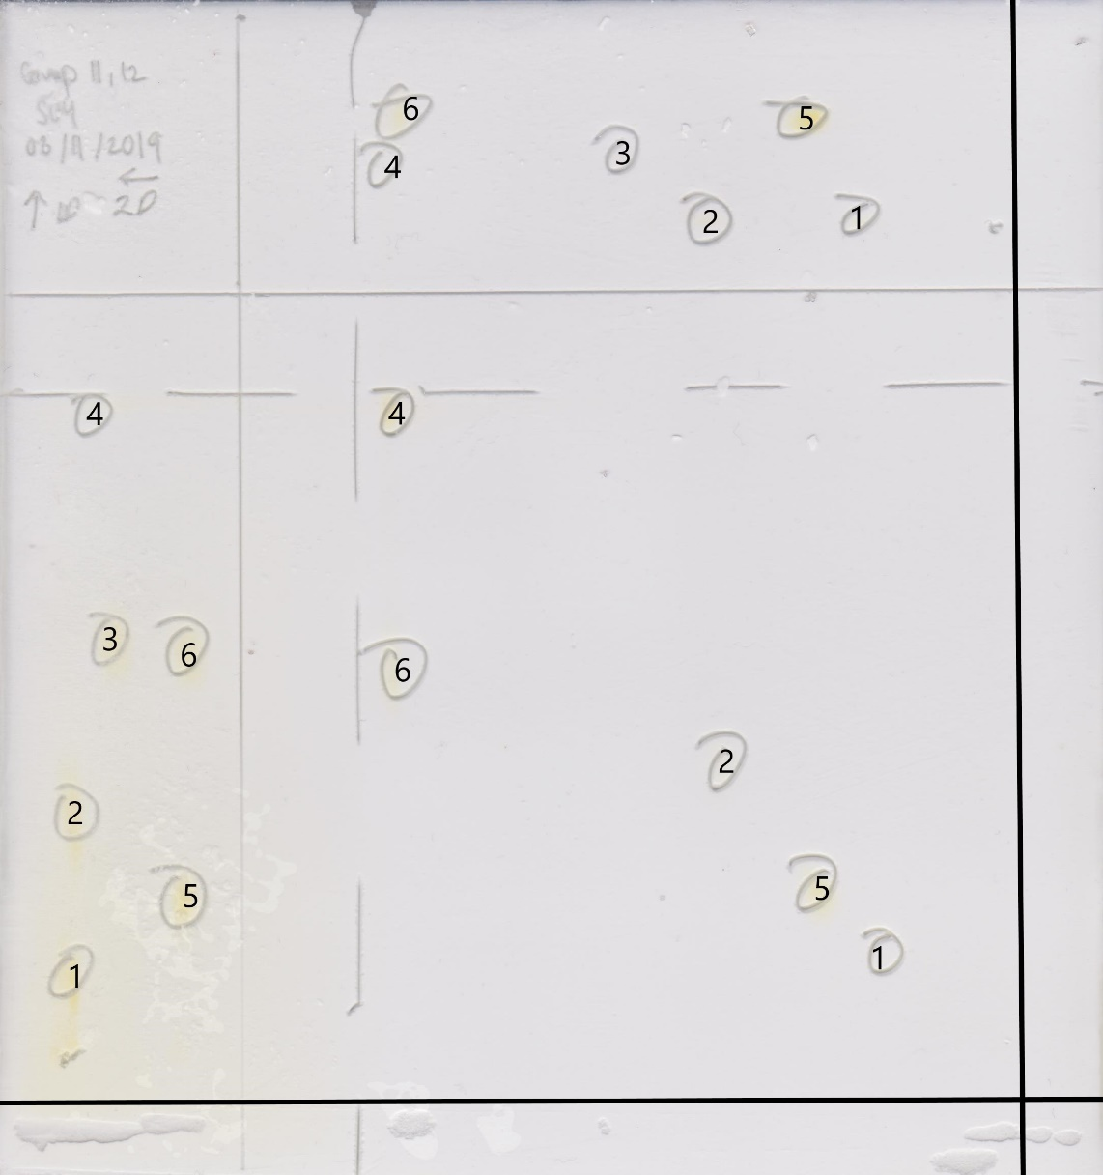
Figure 1. Two-dimensional TLC plate of 6 microsomal lipid samples in the presence of an acidic and a basic solvent system. A 20cm x 20cm TLC plate was heated for one hour before three sets of lipid standard (5µL) obtained from calf liver were used to spot the plate, each containing 2 of the 6 lipids. An additional sample containing 10 microliters was also added to the plate. Spots 1 to 6 correspond to the following 6 lipids respectively; phosphatidylinositol (PI (1)), phosphatidylethanolamine (PE (2)), cardiolipin (CL (3)), cholesterol (CH (4)), phosphatidylcholine (PC (5)), fatty acid (FA (6)). The first TLC dimension was developed in a basic solvent system made up of CHCl3‐MeOH‐ammonia (65:35:5) until the solvent front had reached 1cm from the horizontal line. The plate was then dried, and the observed spots were marked. The TLC was then rotated 90 degrees before being developed similarly in an acidic solvent consisting of CHCl3‐acetone‐MeOH‐acetic acid‐H2O (10:4:2:2:1). The TLC plate was then saturated in an iodine solution so that the marks became visible with the naked eye. It should be noted that TLC plates are slightly polar and will slow down other molecules as they pass through the plate. Consequently, compounds with higher relative polarities will be slowed down more and therefore travel a shorter distance through the plate.

Table 1. Relative Rf values of the 6 lipid samples in the presence of a basic and an acidic solvent. A 20cm x 20cm TLC plate was heated for one hour before three sets of lipid standard (5µL) obtained from calf liver were used to spot the plate. An additional sample containing 10 microliters was also added to the plate. The standards consisted of phosphatidylinositol (PI (1)), phosphatidylethanolamine (PE (2)), cardiolipin (CL (3)), cholesterol (CH (4)), phosphatidylcholine (PC (5)), fatty acid (FA (6)). The first TLC dimension was developed in a basic solvent system made up of CHCl3‐MeOH‐ammonia (65:35:5) until the solvent front had reached 1cm from the horizontal line. The plate was then dried, and the observed spots were marked. The TLC was then rotated 90 degrees before being developed similarly in an acidic solvent consisting of CHCl3‐acetone‐MeOH‐acetic acid‐H2O (10:4:2:2:1). The TLC plate was then saturated in an iodine solution so that the marks became visible with the naked eye. The obtained Rf values are dependant on the type of solvent system used and could differ depending on the polarity and pH of the solution. Lipids with acidic or basic functional groups may lose or gain protons and become charged in the presence of acidic or basic solvents, reducing their Rf values.
Lipid | Rf value (basic solvent) | Rf value (acidic solvent)
PI | 0.17 | 0.23
PE | 0.40 | 0.46
CL | 0.64 | 0.59
CH | 0.96 | 0.94
PC | 0.28 | 0.31
FA | 0.61 | 0.91

Justification:
Although non-of the Rf values obtained for the two solvents match perfectly, it can be assumed that relatively similar values are identical. This is due to possible minor errors during the lab. For example, if the basic solvent is developed slightly longer than the acidic one, it could shift the Rf values slightly and cause a variance in the results. Taking this into account, one can assume that all lipids except the fatty acid (FA) react similarly in both solvents. This is because non-of these lipids contain a strong acid or base. The fatty acid however, contains carboxylic acid, which has a low pKa and can lose its hydrogen easily. Therefore, when FA is developed via a basic solvent, it loses its functional hydrogen and becomes negatively charged and therefore more polar. This increased polarity causes it to travel slower through the TLC plate and in turn result in a much lower Rf value than that of an acidic solution. It can be assumed that in the presence of an abundance of protons (acidic), the carboxylic acid retains its neutral charge and therefore stays relatively non-polar.

R2.
Each of the 6 lipids used has a different relative polarity than others. Ranked from least to most polar the lipids are as follows; PI (1), PE (2), CL (3), CH (4), PC (5), FA (6
Basic developing solvent: PI, PC, PE, FA, CL, CH
Acidic developing solvent: PI, PC, PE, CL, FA, CH
The following are chemical structures of the 6 utilised lipids; all circled atoms are polar groups. Carbon atoms present at the end of ester chains could be substituted with any R groups.
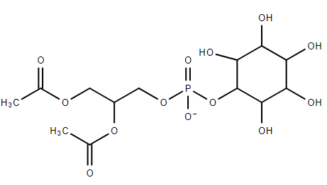
Phosphatidylinositol (PI)

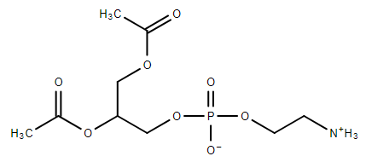
v
Phosphatidylethanolamine (PE)

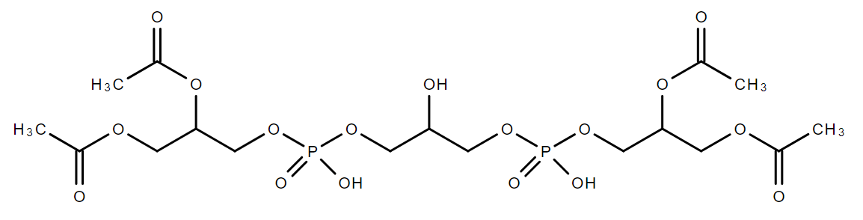
Cardiolipin (CL)

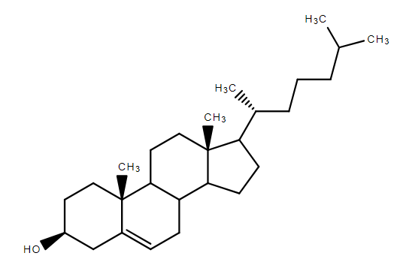
Cholesterol (CH)

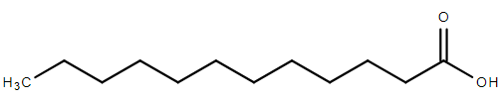
Fatty acid (FA)

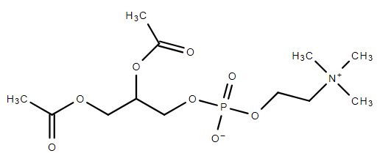
Phosphatidylcholine (PC)

When comparing the polarities of the individual lipid groups (n=3), one can attain the more polar compound via taking the number of polar groups from each individual lipid and comparing them. For example, PE is less polar than PI because it lacks the many OH groups present on the carbon ring of PI. This in turn means that PE will travel higher up the TLC plate during development and will in turn have a higher Rf value. The same tactic may be used to find the relative polarities of the individuals of the other 2 groups. CL has many ester oxygens and 2 phosphate groups which aid in increasing its polarity. CH on the other hand has only one functional OH group and is therefore much less polar than CL. Similarly, PC has ester oxygen and phosphate groups as well as charged groups and is therefore much more polar than FA which only has a carboxylic acid group.

R3.
Table 2. Absorbance ratios of lipid assays of difference concentration. A homogenized mixture containing 2.5g calf liver and 10mL of buffer (10mM Tris, 0.25M sucrose, 1mM EDTA, 1 mM DTT, pH 7.5) was centrifuged at 1000xg for 10 minutes at 4℃. The supernatant of the mixture was then filtered through a mira-cloth and was centrifuged at 25000xg (4℃) for an additional 10 minutes, resulting in a supernatant and a pellet. The pellet was then resuspended in the homogenization buffer. It should be noted that this supernatant contained mitochondrial membranes. The homogenized mixture was then diluted to obtains 4 individual concentrations via the addition of phosphate, water, and brilliant blue. These mixtures were then placed in a spectrometer and their absorbances (559nm) were noted.
Sample | Dilution Fraction | Absorbance ₍₅₅₉₎
Control | 0 | 0.78
1/250 | 0.004 | 0.748
1/125 | 0.008 | 0.703
1/50 | 0.02 | 0.564
1/25 | 0.04 | 0.368

Figure 2. The dilution fraction of the 5 individual lipid assays Vs. absorbance at 559nm. A homogenized mixture containing 2.5g calf liver and 10mL of buffer (10mM Tris, 0.25M sucrose, 1mM EDTA, 1 mM DTT, pH 7.5) was centrifuged at 1000xg for 10 minutes at 4℃. The supernatant of the mixture was then filtered through a mira-cloth and was centrifuged at 25000xg (4℃) for an additional 10 minutes, resulting in a supernatant and a pellet. The pellet was then resuspended in the homogenization buffer. It should be noted that this supernatant contained mitochondrial membranes. The homogenized mixture was then diluted to obtains 4 individual concentrations via the addition of phosphate, water, and brilliant blue. These mixtures were then placed in a spectrometer and their absorbances (559nm) were noted. A scatter plot depicting the relation between absorbance and dilution fraction with the presence of a trend line was presented. The equation slope corresponds to a decrease in absorbance in relation to the dilution factor (control). The negative slope of the trend line equation demonstrates a linier decrease in absorbance as the dilution fraction increases. The R² value of 0.9985 depicts that the linier trend-line is accurate due to its close proximity to a value of 1.

Table 3. Absorbance ratios of protein assays of difference concentration. A homogenized mixture containing 2.5g calf liver and 10mL of buffer (10mM Tris, 0.25M sucrose, 1mM EDTA, 1 mM DTT, pH 7.5) was centrifuged at 1000xg for 10 minutes at 4℃. The supernatant of the mixture was then filtered through a mira-cloth and was centrifuged at 25000xg (4℃) for an additional 10 minutes, resulting in a supernatant and a pellet. The pellet was then resuspended in the homogenization buffer. It should be noted that this supernatant contained mitochondrial membranes. The homogenized mixture was then diluted to obtains 4 individual concentrations via the addition of phosphate, water, and brilliant blue. The test tubes were then incubated for 15 minutes at room temperature. These mixtures were then placed in a spectrometer at 280nm and their absorbances (559nm) were noted.

Sample | Dilution fraction | Absorbance ₍₂₈₀₎
Blank | 0 | 0
1/100 | 0.01 | 0.092
1/20 | 0.05 | 0.415
1/4 | 0.25 | 2.102

Figure 3. The dilution fraction of the 5 individual protein assays Vs. absorbance at 559nm. A homogenized mixture containing 2.5g calf liver and 10mL of buffer (10mM Tris, 0.25M sucrose, 1mM EDTA, 1 mM DTT, pH 7.5) was centrifuged at 1000xg for 10 minutes at 4℃. The supernatant of the mixture was then filtered through a mira-cloth and was centrifuged at 25000xg (4℃) for an additional 10 minutes, resulting in a supernatant and a pellet. The pellet was then resuspended in the homogenization buffer. It should be noted that this supernatant contained mitochondrial membranes. The homogenized mixture was then diluted to obtains 4 individual concentrations via the addition of phosphate, water, and brilliant blue. These mixtures were then placed in a spectrometer and their absorbances (280nm) were noted. A scatter plot depicting the relation between absorbance and dilution fraction with the presence of a trend line was presented. The equation slope corresponds to an increase in absorbance in relation to the dilution factor (blank). The positive slope of the trend line equation demonstrates a linier increase in absorbance as the dilution fraction increases. The R² value of 1 depicts that the linier trend-line is 100% accurate.

R4.
Calculating the protein concentration of the assay.
ε = 2.0 L/g.cm
A = 8.3986
L = 1cm
A = εCL
C = A/εL
C= 8.3986 / (2.0L/g.cm x 1cm)
C= 4.1993g/L
; Therefore, the calculated concentration of the membrane proteins is 4.1993g/L

R5.
Calculation the Lipid concentration of the assay.
A₁ = 0.013
A₂ = 10.479
C₁ = 1ug/ml
C₂ =?
A1 / C1 = A2 / C2
0.013 / 1ug/mL = 10.479 / C2
C2 = (10.479)(1ug/mL) / 0.013
C2 = 315.75ug/mL
C2 = 0.3158 g/L
; Therefore, the calculated concentration of lipids in the calf liver membrane preparation was 0.3158g/L

R6.
Mass yield calculations for the protein assay.
C = 41993g/L
m (liver) = 2.5g
V = 10mL or 0.010L
m (protein) = C x V
m (protein) = 4.1993g/L x 0.010L
m (protein) = 0.04199g or 41.99mg
Mass yield = mass of protein / mass of liver
= 41.99mg/2.5g
= 16.80mg/g
; therefore, the mass protein yield of the mitochondrial preparation is 16.80mg/g

