GNG 1103 final review
Lecture 1
Design thinking: An approach to solving design problems by understanding user needs and developing the design tools required to solve those problems
Design thinking process:
- Empathize
- Define
- Ideate
- Prototype
- Test

- Empathize:
Step 1: Interview ask open ended questions
Step 2: Dig deeper ask why?
- Define
Step 3: capture findings create a list of needs
Step 4: create a problem statement (should be short and concise)
- Ideate
Step 5: sketch
Step 6: share solution and get feedback
Step 7: iterate based on feedback
- Prototype:
Step 8: build solution
- Test
Step 9: share solution and get feedback
Lecture 2
EMPATHIZE STEP:
What is customer need identification?
Process of determining what and how a user interacts with a product. User needs are non-technical, and they reflect the users’ perception of the product, NOT the actual design specifications.
Customers vs user?
- A user is a person who uses the product.
- Customer is the person who pays for the product.
Goals of costumer needs identification:
- Focuses product development on costumer needs
- Identifies explicit needs but also latent needs
How to identify costumer needs?
- Gather raw data from costumer
- Interpret data in terms of costumer needs
- Organize needs
- Establish relative importance of needs
- Reflect on results
Before solving a problem…
- Determine who the costumers are
- Determine what information should be gathered from costumer
- Determine how the information should be gathered
How to gather raw data?
- Observation
- Passive: watch a user in natural environment
- Active: work side-by-side with user and gain their experience.
- Interviews: takes place in the user’s environment
- Focus groups: involve 8 to 12 costumers. This group is lead in a discussion by an interviewer.
Lead users:
Users that experience needs ahead of the market. They help develop new products.
There are three types:
- Lead users of target application and market
- Lead users of similar applications in advanced markets
- Lead users with respect to important attributes of problems faced by users in target markets
To rank the importance of the need use a 1-5 ranking system where 5 is the most important.
Do not use must or should in the interpreted need statement
Turning costumer needs into problem definition:
A problem definition is a claim of one or two sentences in length that outlines the problem that will be addressed by the design process based on the customer needs.
What does it include?
1. What is the problem? This should explain what needs are being addressed
2. Who has the problem or who is the client/customer/end-user? This should explain who needs the solution and who will decide if the problem has been solved (solved really well)
3. What form can the solution be? What is the scope and limitations (e.g. in time, money, resources, technologies) that can be used to solve the problem?
Example: “A need exists for skill patrollers to safely and easily transport injured persons down a ski-hill with a portable device that is easy to control, compact and cost effective for owners”
Lecture 3
What are design criteria?
A precise description of what the product has to be based on interpreted needs, also called: – “Requirements” – “Characteristics”
- Functional Requirements: Are design criteria that affect the solutions “function” (if measurable, then also a metric)
- Non-Functional Requirements: Are design criteria that do not affect the “function” of the solution
- Constraints: Set of important considerations that must be taken into account in your design
What is a metric?
- Metrics are a list of measurable attributes you want your solution to have (i.e., weight, size, speed, impact resistance, etc.)
- Metrics have readily identifiable units of measure
- Metrics can be used to measure solution performance
- Metrics are obtained from
– Functional design criteria (“Musts” i.e., mandatory and “Wants” i.e., would be nice)
– Benchmarking (what is the competition doing?)
Engineering design specifications:
Target Specifications are numerical values based on defined metrics that are desired of potential solutions
• Create a list of Design Criteria based on interpreted customer needs
• Do product Benchmarking – Look at other products that satisfy some/all needs – Gather data about those products
• Set Target Specifications: – Set values considered to be ideal – Set values considered to be acceptable
Benchmarking:
Two kinds of benchmarking data:
– Benchmarking competitive products in terms of customers’ perceptions
– Benchmarking competitive products in terms of technical performance
• To create a competitively superior product, the team must know what the competition can do
• There are opportunities to learn specific design approaches by observing competitors’ products
The best specs:
3- great, 2- ok, 1- bad
- Better specs will depend on customer needs and priorities
- Multiply weight ( importance) of each spec with its value
- Add them together for each product, and compare them
Example: o
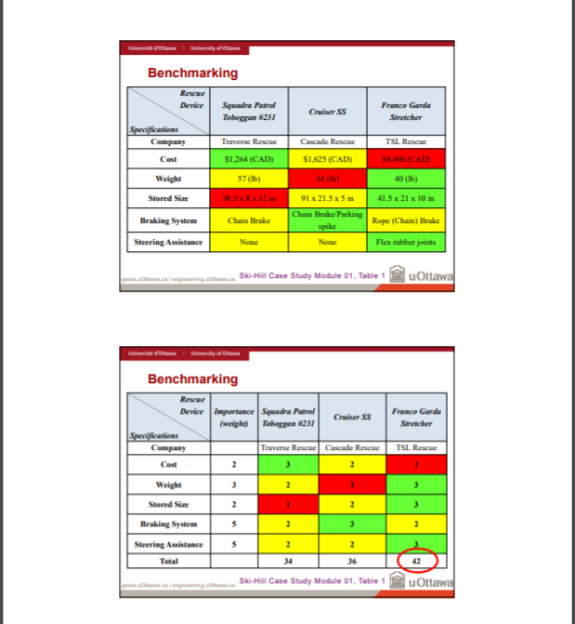
Setting Target Specifications
• From the list of design criteria and based on benchmarking, set target specifications by defining ideal and acceptable values
Examples (ideal “perfect world” values or range of values):
  - Exactly X
  - A list of discrete values
  - The “sweet spot” in a range of values
Examples (marginally-acceptable “on the edge” values):
  - At least X
  - At most X
  - Between X and Y
  - No worse than…

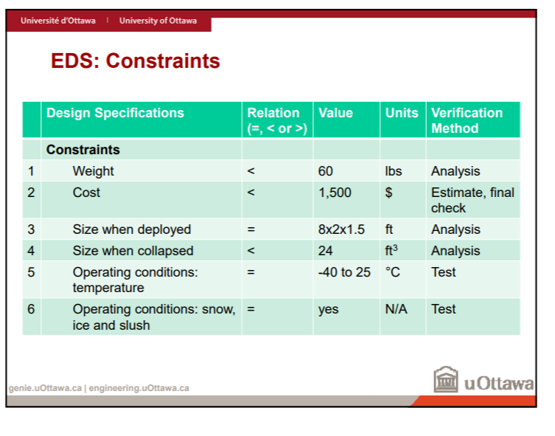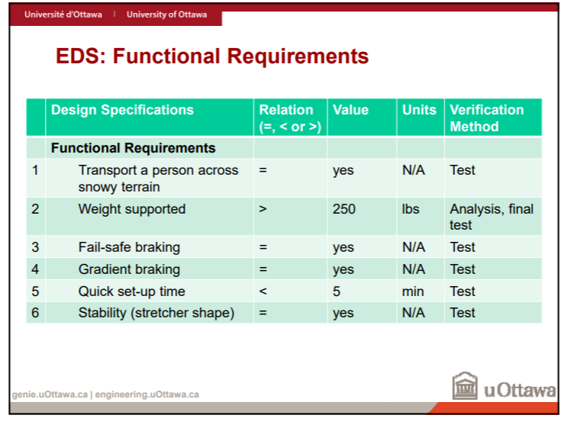

Lecture 7: Conflict resolution process
Step 1: prepare for resolution
- Acknowledge the conflict
– Cannot be managed and resolved otherwise
– Tendency is to ignore (which makes the situation worst)
- Discuss the impact it has on team dynamics and performance
- Agree to a cooperative process
– Everyone involved must agree
– Opinions and pride must be temporarily set aside
- Agree to communicate
– People involved must talk about the issue
– Active listening is essential!
Step 2: understand the situation
- Clarify positions
– Get through the emotions and reveal the true issue
– Everyone’s position must be identified and articulated
- List facts, assumptions and beliefs underlying each position
- Analyze in smaller groups (separate alliances)
– Which facts and assumptions are true? Need more info?
– Helps gain a better understanding and may reveal new ideas
– Remain open and listen, rather than criticize and judge
- Convene back as a team
Step 3: reach an agreement
The team must decide what decision or course of action to take
• Understanding the facts and assumptions makes reaching an agreement easier
• If further analysis and evaluation is required, create a plan:
– Agree on what needs to be done
– By when
– By whom
• Make sure the team is committed to work with the outcome of the analysis or evaluation
Conflict management styles:
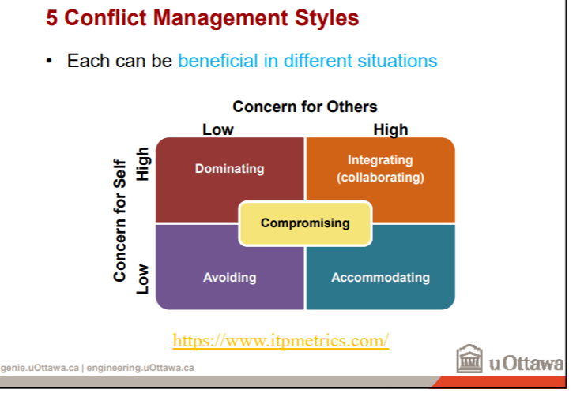
Matching Conflict Styles to Situations
• Time pressure: if there was never time pressure, integration (collaboration) might always be the best approach to use
• Issue importance: extent to which the conflict involves important priorities, principles or values
• Relationship importance: how important is it that you maintain a close, mutually supportive relationship with your team members
• Relative power: how much power you have compared to other team members
There Is No One Right Answer…
• But there are better styles to achieve positive conflict outcomes depending on the specific situation and circumstances
• As long as everyone is happy enough and no one is willing to actively resist, then the conflict can be considered resolved
• Following the three-step process and being aware of the different conflict management styles which can be used in different situations will help

Lecture 8: Ideate
Concept Generation
• This is the creative phase of the design process
  - Many ideas and concepts are generated
• It is a divergent phase where many possibilities are considered without judgment
• For a typical design project:
  - At least three conceptual design alternatives should be generated
  - These concepts should be well documented using sketches and descriptions
• There is no formula or set of rules to generate ideas! Rather, a set of practical strategies to:
  - Help designers enhance their inherent creativity
  - Facilitate the generation of new ideas
Freehand Sketching
• Ideation
  - Integral to the design process
  - Generation of design concepts to solve the design problem
• Usually, freehand sketching is used to explore, study and communicate these design concepts
• The “BEST” design engineers can immediately communicate an idea via a freehand sketch
• Simple: all you need is a paper and pencil.
Don’t use templates and compasses. They will slow you down!
Freehand Sketching
• Although quick, sketches are planned
• Visualize the sketch
– Size of paper & scale
– Orientation of the object
– Minimum detail to communicate the idea
• Type of sketch
– Isometric
– Oblique
– Orthographic
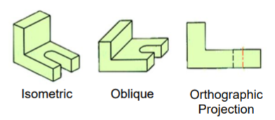

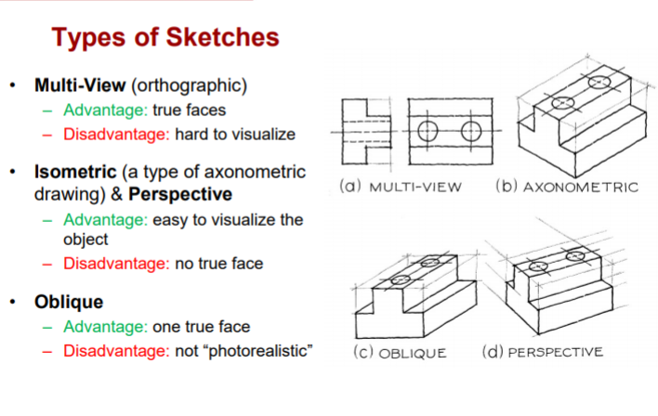
Freehand Sketching
• Fundamental rule of sketching: maintain proportions
• Hint: use standard techniques to draw lines and arcs
• Lines
– Locate a start “dot”
– Locate an end “dot”
– Put pencil on start dot, keep eyes on end dot and smoothly move pencil toward the end dot (always pull, never push)
• Circles (arcs)
– Draw light horizontal and vertical lines that intersect at the center
– Lightly mark the radius on the lines
– Connect the radius marks with arcs to complete the circle (adapt the natural radius of your wrist and hand)
Construction Lines
• Light and thin lines (barely visible)
• Serve as paths for final straight lines
• Intersection of construction lines specify the length of the final lines
• Points marked by the intersection of construction lines serve as guides for sketching of arcs and circles
• Guide the proportions of the sketch
Block Diagrams
• System components (software code, electrical systems, etc.) can be represented by “blocks” in block diagrams:
• Many systems are hierarchical (i.e. composed of multiple subsystems)
• Systems must have at least one input variable and at least one output variable
The objectives of a block diagram are:
• To provide an understanding of signal flows in the system (i.e. inputs and outputs of subsystems)
• To enable modelling of complex systems from simple building blocks
• To allow us to generate the overall system transfer function (i.e. how do we get from the input to the output)
Lecture 10- engineering design analysis
Engineering analysis: application of principles and scientific analytical processes to study the properties, state of system, apparatus, or mechanics.
ENGINEERING ANALYSIS IS DONE IN STAGES:
- Separate the system into parts (modules or components)
- Analyze each part
- Recombine the analyzed subcomponents using physics.
Importance of engineering analysis
- Allows us to guarantee our work
- Allows us to predict the result of our design and prevent possible system failures.
Engineering design process:
- Determine initial list of components and materials that best meet the target specifications
- Calculate the specific values of the design defined by metrics and the properties and materials of each component
- Compare o target specifications and change the choice of components and materials.
- Repeat steps 2 and 3 until satisfies.
How is it done?
- Engineering analysis uses mathematical calculations, models, simulations, and experimental prototyping
1.List of components and materials
1) Start with concepts chosen and target specifications
- Create a list of components and materials needed for design concepts
- Make sure that list of components can meet the list of metric and non metric specifications.
2.Calculations based on properties
1) Research to find the properties of components and materials:
- Create a table of properties
2) Calculate the specification values for your design concepts to allow comparison with the target specifications
- Assume reasonable values if the concept is still not well-developed
- Overestimate assumed values
3) Compare with target specifications
- Compare the values that you have calculated with the target specifications( if not within the target specifications, modify list of calculations ad materials)
REPEAT STEPS 2 AND 3 AS NEEDED.
Lecture 11: Giving/ receiving feedback and prototype test planning
Personal feedback- The human factor
Difference between feedback control systems and personal feedback is that people are involved,
- People aren’t always logical
- Observations aren’t always accurate
- People’s emotions cloud their ability to give feedback
Feedback is needed to correct poor behaviour and enhance or re-enforce good behaviour
How to give productive personal feedback?
- Use neutral terms (don’t use emotionally loaded descriptions…ex atrocious)
- Describe its effect on you
Why give feedback this way?
- Neutral descriptions of a specific behaviour is hard to dispute, provided its accurate.
- Describing the effects of a behaviour on yourself is not contestable.
Elements of a productive feedback
- Specific and actionable
- Timely (details of events fade fast in memory)
- Not be given for other people
- Given at the right time (when the receiver is receptive)
Receiving feedback
- You don’t have to agree with the feedback, but it should be acknowledged.
What is a prototype?
A prototype is a physical representation of a part or all of a design concept to learn something useful
Why are prototypes useful?
- Understanding a problem better
- Communication/ getting feedback from users
- Reducing the risk associated with a particular aspect of a design
- Measuring performance often of the overall functionality of the design
What makes a good prototype?
Fidelity (“trueness”): Degree to which the prototype testing represents the final product.
Cost: Total cost of designing, building, testing.
Iteration times: Time from designing, building, testing..
Signal to noise ratio (SNR): Extent to which the variable of interest is obscured by experimental noise.
Prototyping objectives:
- Reduce uncertainty.
- Different types of prototypes (have different objectives)
- Early, simple models can be used to validate initial concepts
Different types of prototypes:
- Physical
- Focused
- Analytical
- Comprehensive

Analytical vs physical
Physical:
- Tangible approximation of the product
- Best for communication
Analytical
- Mathematical model of the product
- Allows more experimental freedom than physical models
- Cheaper and easier to modify
Comprehensive vs focused
Focused:
- Implementation of one or a few attributes of the product
- Answers specific questions about the product design
- Several are required
Comprehensive
- Implementation of many or all product attributes
- Offers opportunities for rigorous testing
- Best for milestones and integration
Prototype fidelity
Value of a model for testing:
- Reduces the investment in time and money
- Allows control of a specific design aspects
- Simplifies analysis task
Simulations can also be used to complement physical prototypes being tested. .
Benefits of testing
- Avoid critical problems down the line (design issues, ease of issues)
- Helps ensure proper functionality
- Save time and money
Test planning steps
- Define the purpose of the test
- Choose a specific design concept
- Choose a testing method
- Perform the test
- Measure important attributes, observe and record.
- Interpret the result
How much testing is enough?
Continue until…
- Run out of money, time, energy
- Satisfied with the result
Lecture 12: User experience
Designing for task efficiency
Factory based production (efficiency)
- Henry ford task specialization
- Fredrick TaylorScientific management
- Frank and Lilliam Gilberth time and motion studies
Organizational behaviour (OB)
- Micro-level: individual behaviour in organizations
- Meso-level: Work groups
- Macrolevel: organizational behaviour
Modern OB theories emphasize cultural effects and the effects of change as well as the role that social and psychological factors play in organizations
Designing for users
Importance of Psychology and Sociology now recognized for the design of objects and processes (Lillian Gilberth first recognized this)
- Design starts with the user
Ergonomics (“Human factor design”) : design of products, systems, or processes to take proper account of the interaction between them and the people who use them*
User experience
User Experience: "User experience" encompasses all aspects of the end-user's interaction with the company, its services, and its products
- Emotions and attitude towards a product
- Create an experience through a device
- Elicits an emotional response
- Perceptions about efficiency and easy of use
Jakob Nielsen’s Usability heuristic
- Visibility of System Status (what’s happening now?)
- Match between system and the real world
- User Control and Freedom (“Undo”; What’s next?)
- Error Prevention (confirmation options)
- Error recognition, diagnosis and recovery
- Consistency and standards (of words and images)
- Recognition vs recall (users not forced to remember much/anything)
- Flexibility and efficiency (tailoring, response time)
- Aesthetic and minimalist design
- Help and documentation (user-appropriate)
Basic concepts of usability
Can be understood in the context of human behavioural and cognitive processes:
- Attention: Ability of a person to concentrate on information, while ignoring other information
- Memory: Process used to encode, store, and retrieve information.
Attention DISTRACTION
Structure information so that it is easy to find and easy to browse
- Don’t have too many items
- Don’t have too few items
- Group items logically
Attention COMPEXITY
• People multitask
Make the usage 'state' clear enough so that users can jump either backwards and forwards from ‘where’ they are
• Some mental processes are automatic
- These processes are then very hard to “unlearn”
Avoid conflicting or changing aspects of the user interface.
Memory- recognition vs remembering
The more meaningful, the more easily remembered
  - Use effective names and icons (even animated ones!)
  - Combine icons with words
  - Icons can be analogies, examples or abstract, but should not arbitrary
  - Watch out for cultural differences and “norms” (e.g. washroom symbols!)
• People can more easily recognize than recall
  - Use menus, icons, quick lookup shortcuts
Studying usability- experiments
• Experiment Requirements:
    - Establish a hypothesis
    - Compare 2 User Interfaces (ideally, one is a control)
    - Measure some aspect of usability
    - Perform statistical analysis of the results
• Conducting an experiment:
- Users perform the tasks
- Measure various factors and compare various conditions
- Record usability ‘problems’
Process for usability analysis
- Understand users
    - Think about each class of users
2. Understand tasks the users will need to perform
3. Pick representative sets of tasks
    - Prioritize tasks that are more frequent and/or important
4. Pick a representative set of users – Cover a suitable set of the different classes
5. Determine exactly what questions need to be answered about usability

Understanding Users
- Experience
• Job function – Different tasks, knowledge for different jobs (e.g. manager, salesperson, shipper, client all have different skillsets)
• Domain-specific experience:
    - Low experience (any difficulties with these kinds of users may not be directly related to the application)
    - High experience (problems with these kinds of users are probably the system designers' fault)
• Background experience level
    - Familiarity with different things (e.g. with computers or repairing automobiles or with social activities or with working with small children or ….)
Understanding Users – Personality
Personality traits can be hard to know in advance, so some thought or research may be required
Understanding Users – Attributes
• Physical disability – Innovative I/O may be
• Dyslexia or other cognitive glitches – Confusion between left and right
• Illiteracy / young children / foreign language speakers – Culturally-appropriate icons needed instead of words
Understanding Users – Interests
• Different kinds of users can have different interests in a product or service, and this may be determined by experience, personality or other attributes
• Different users can require trade-offs in the functional or non-functional criteria for the design.
Creating User Personas I
- Compile everything you know about your customers and group your findings into a spreadsheet or table
- Use relevant headings for the particular design problem (e.g. based on specific industry, devices, time, or goals)
- Organize your findings on Post-it™ notes or something that can be changed relatively easily (Wipebook?)
- Look for patterns (e.g. industries in which your customers work, what devices they use, when/ where they use the devices, etc.)
- Form questions about customers and determine what they have in common and how they differ (give them names as convenient handles when reviewing them)
- Find people who form these clusters (either in your existing customer database or by actively going out and recruiting them)
- Talk to and interact with these people (ideally in person)
- Tag and analyze your findings – If personas share many characteristics, combine them – If there’s enough differences, split them up into multiple personas
- Creating personas is an iterative process
Problems with Personas
• Personas must be based on real people or real data and need to be defined so that they aren’t just vague things with specific names
- Keep simple and focused: Focus the persona on design task at hand
- Just include the specific facts to help make good decisions (i.e. only if the user information affects design decisions that you’re making)
- Use them when making decisions. Actively use your personas when making design decisions. If missing stuff, don’t just make assertions or guesses, but re-validate
- Use a simple process.
Lecture 13- Prototyping II
Modeling
• Modeling can be used to estimate the quantitative behaviour of a system
  - Analysis of metric performance
• Modeling can be used to understand the qualitative behaviour of a system
  - Customer perceptions, user experience
• Multiple different modeling techniques can be and should be used to validate the results and identify modeling strengths and weaknesses
• Each modeling technique has an optimal time and place for its use
Analytical Modeling
• Analytical models are mathematical representations which have closed form solutions (i.e. the solution to the model’s equations can be expressed as a symbolic function or can be calculated exactly)
When to Use Analytical Modeling
• Analytical models are best used when a closed form solution exists and the solution procedure is straightforward
• Often quicker to set up for simple calculations
• May be used to extrapolate insight of un-modeled cases due to the nature of the equations involved and their derivation from basic scientific principles
Numerical Modeling
• Numerical models are mathematical representations that use discretization or time-stepping methods to approximate a solution or describe a behaviour over time (i.e. the solution to the model’s equations can be expressed as discrete values in a table or a graph)
When to Use Numerical Modeling
• Numerical models are best used when no closed form solutions exist or the solution procedure is very complicated and computationally demanding
• Often quicker to setup for complex calculations
• May be used to extrapolate a large number of results quickly by varying the parameters and recalculating the results
FEA Modules
• Many things can be evaluated under structural analysis:
– Displacement
– Stress-strain
– Thermal
– Vibration-acoustics
Advantages of Using FEA
• The most prominent advantages of using FEA are:
– Accurate representation of complex geometries
– Inclusion of dissimilar material properties
– Relatively easy representation of the total solution
– Capture of local effects
• Dynamic solutions are possible with moving boundaries!
Assumptions – Be Careful!
• All numerical tools involve assumptions! We must make sure we know what those assumptions are
• Classical equations usually have clearly defined assumptions •
Numerical tools often provide false confidence:
– Solutions are provided regardless of faulty inputs – Existence of “hidden assumptions” similar to classical equations
– We often assume that solutions are more exact then they actually are
– Limitations are not well understood
Experimental Modeling
• Experimental models are physical representations which can be used to measure outputs or behaviour to given inputs or stimuli (i.e. the output or behaviour of a model can be measured using specialized measurement tools)
When to Use Experimental Modeling
• Experimental models are best used when no mathematical solutions exist or the solution procedure is extremely complicated and requires too much time to solve computationally
• Often more expensive than analytical or numerical models, but may be the only representation possible
Modeling Fidelity
• Modeling is used on simplified versions of the actual intended design
• The value of the model is to:
– Reduce financial investments
– Control out aspects of the real situation to simplify analysis
As a result of an incomplete designs, two types of errors are possible:
– Designing for failure modes that will not occur (over-design)
– Failure to detect true problem
Modeling Noise
• Noise occurs when:
– Certain variables cannot be controlled
– When too many variables are being manipulated
– Independent variables have too high a variability
• Noise makes it difficult to discern what is happening during testing
• In any case, noise prevents effective learning from occurring
Lecture 14- Presentation skills
Qualities of an Effective Presenter
• Confident
• Knowledgeable
• Relaxed
• Clear, concise and organized
• Believe in what they are saying
Nonverbal Communication
A form of communication without using any words
– Eye contact
– Hand gestures
– Movement
– Posture
– Facial expression
Eye Contact and Facial Expressions
• Establish eye contact with your audience
• Avoid talking to your notes
• Don’t scan faces, focus on one face per thought
• Seek out friendly faces
• Develop appropriate facial expressions
Hand Gestures
• Show what you are saying
• Enhance your message
• Avoid closed hand position
• Novice speakers may have issues with (and should try to avoid):
– Stuffing their hands in their pockets
– Fidgeting
– Tugging at their hair
Posture and Movement
• Posture: Stand up straight
• Movement:
– Move with purpose
– Stop when delivering key messages
– Avoid pacing, swaying from side to side, etc…
Verbal Communication
• Speak clearly and expressively
• Raise your volume
• Avoid filler words (ah, umm, like, etc…..)
• Practice pausing for extra effect
Pitch Content
• Pitch: a speech or act that attempts to persuade someone to buy or do something
• Before you put your pitch together you need to understand people’s buying drivers
• Buying driver: those things that motivate people to buy (what people “takeaway” from buying)!
TIRES- TIME, INCOME, RISK, EXPENSE, STATE
General Structure of a Presentation
• Introduction
– Introduces you and the team
– States the problem and provides background info
– Grabs attention (example, story, etc…)
• Body
– Presents main points in an organized manner
– Provides “enough” supporting material
• Summary
– Reviews main points
– Tell the listeners what you want from them
Lecture 15- Faliure and iterative testing
Failures and Criticality
• System Failure is normal and expected
• Failure*: Omission of occurrence or performance; a state of inability to perform a normal function; a fracturing or giving way under stress
• Critical **: Turning point or specially important juncture; crucial, decisive; indispensable, vital
Handling Critical Failures
• Detection: Critical failures must be identified, if and when they occur, as having occurred
• Prevention: Using different strategies, failures are stopped from occurring …
– Since we have accepted that this assumption is often not realistic, system recovery is an alternative, usually achieved by adding component redundancy to cope with those failures
Predicting Failures
• To predict system failures, we can:
– Model and measure component reliability
– Analyze system structure and the interconnection dependencies for these components to determine the effects of component failures on the system
– Analyze the root cause for failures that already happened
– Build prototypes of part (focussed) or all (comprehensive) of the system in question
Testing with prototypes
• Prototypes can also be used to test designs for the three defined kinds of potential failure:
– Inadequate or Missing Performance Level
– Improper or Incorrect Function
– Giving way (under stress)
Testing Process
– Performance Level Failures
• Determine the required and desired level of performance for the design (comprehensive) or portion of the design (focussed)
• Define a test to measure what level of performance the design can achieve (e.g. case study toboggan braking mechanism use of stopping distance)
– It may only be necessary to determine whether the design can achieve the required level of performance or not, depending on the type of performance specification
Testing process- function failures
• Determine required performance attributes or features and desired functions to be verified
• Verify functionality
– Verify that specific “critical” features can actually be realized at all (i.e. that success is actually achievable)
– Measure the specific test conditions where correct functional operation stops. If these test conditions are outside of the required operating conditions, then functional failures may be acceptable
– Verify specific functionality at the boundary cases or the extremes of the operating conditions. Highly-Accelerated Lifetime (HALT) tests use these conditions or even more severe ones to predict reliability and failure modes
Testing Process
– Stress-Induced Failures
• Determine the specific extreme test conditions where failures occur
– “Testing to failure” methods can be used, where the test condition parameters required for failure are recorded
– Sometimes, historical data can be used to help determine the kinds of parameters to vary or else an understanding of failure mechanisms can help to determine the parameters to vary
Testing Steps With Prototypes (Planning)
• Scientific method attempts to prove or disprove a hypothesis with some level of confidence
1. Define the testing objectives and the type of prototype to be used (e.g. focussed or comprehensive, analytical or physical)
2. Define the level of fidelity for the model or prototype
3. Make the required assumptions and simplifications
4. Define and plan the execution of the tests, making the required trade-offs between the usefulness of the results and the time and money required for the testing
5. Execute the tests
• Observe and record all results carefully
• Watch out for systematic errors and experimenter bias! •
Investigate all “surprise” results and determine the cause and whether this is a modeling artifact or not 6. Analyze and interpret all recorded results
• Watch out for numerical round-off errors, faulty assumptions or improper extrapolation or interpolation
• Consider the use of data analytics and determine if it is possible to access other sources of test data for comparison purposes
Iterative Prototype Testing
• When testing iteratively, the following can be varied:
– Prototype (type, level of detail, etc.)
– Tests (test cases, the number of test cases, …)
– Test conditions (normal or extreme operating conditions, specific environmental conditions kept constant or varied systematically)
• Different combinations of variations are possible, such as:
– Same prototype under different test conditions
– Same prototype under same conditions multiple times (e.g. repetitive chair seating pressure test at IKEA)
– Same conditions and same tests with different instances of the same prototype to measure or compare performance variation (e.g. “A/B test mode” used with two identical New Zealand boats)
• The following needs to be determined:
– How many different prototypes are required? A sequence of prototypes could be used, each building on the results of previous ones or using increasing levels of detail or complexity
– What different test cases are required? Planning ahead and prioritizing helps ensure that test cases are not missed or duplicated unnecessarily
– How many instances of each prototype are required?
– What test conditions are varied or kept constant with each iteration and how representative are these test conditions?
Uncertainty and Risk
• Not all failures can be determined and not all failures are understood or are predictable
– Initial prototypes or an initial prototype testing strategy can be redefined, adapted or evolved, but still may not cover all cases
• “What if” types of analysis can help cover cases when things do not turn out exactly as expected or when things are not understood well enough yet (i.e. users exist with different usability requirements)? • We need a way to handle uncertainties and/or a way to quantify risks that we must take, if we can’t reduce or eliminate risk by testing with prototypes
Adding Design Margin
• One solution is to improve the design significantly so that failures in the level of performance or failures in functionality or even stress-related failures are less likely
– Design is changed so that it more than meets or goes well beyond the basic required performance levels
– Such performance improvement usually comes at a cost and it is not possible to have enough design margin to eliminate all uncertainties and risks
– A “thought experiment” analysis technique called Failure Mode and Effects Analysis (FMEA) is another way of managing risk and uncertainty in a design project
FMEA Analysis (failure modes and effects analysis)
• For each design component:
1. Identify failure modes
2. Determine the possible effects or consequences of the failure
3. Assess potential severity of the effect
4. Identify failure causes (and take action!)
5. Estimate probability of occurrence
6. Assess likelihood of failure detection
FMEA Analysis – Effects
• For each failure mode, identify the potential downstream consequences (the Effects)
• Brainstorm or use other methods to identify failure modes and effects
FMEA Analysis – Severity
• To analyze risk, first quantify the severity of the Effects
– Assume that all Effects happen if the Failure Mode actually happens
– Design and process changes can reduce these severity ratings
FMEA Analysis – Causes
• After Effects and Severity addressed, identify the Causes of the Failure Modes
• Causes of failure that result in a Failure Mode are design deficiencies
FMEA Analysis – Occurrence
• Estimate failure occurrence factor (scale of 1-10)
– Consider any fail-safe controls intended to prevent cause of failure
– Consider the following two probabilities:
1. probability that potential cause of failure will occur
2. probability that once cause of failure occurs, it results in the indicated failure mode
FMEA method identifies three types of control, grouped according to purpose
– Type 1 Controls: prevent Failure Mode from occurring, or reduce rate of occurrence (e.g. shear pin designed to fail to keep system from failing)
– Type 2 Controls: detect Cause of Failure Mode and lead to corrective action(e.g. LED light to indicate when battery is low)
– Type 3 Controls: detect Failure Mode before product reaches “customer” (e.g. 100% inspection)
FMEA Analysis – Detection
• Detection values associated with Control types
• Detection is a measure of:
– Type 2 Controls to detect Causes of Failure
– Type 3 Controls to detect subsequent Failure Modes
• High values indicate Lack of Detection
• Value of 1 does not imply 100% detection
FMEA – Results
• Risk Priority Number (RPN)
RPN=SxOxD
S=Severity, O=(Probability of) Occurrence, D=Detection 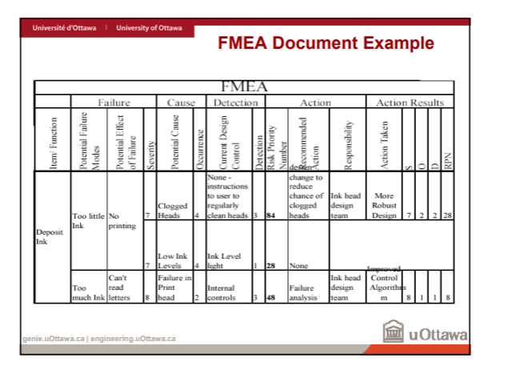
• Once the RPN has been calculated for all failure modes, take action to reduce the RPN of the highest-risk item – Repeat the process until the highest RPN value is “satisfactory”

