Introduction
- A hospital-acquired infection is an infection which was not present (or incubating) at the time of admission
- Common in up to 25% of patients administered to hospital
- Most common infections?
  - Urinary tract
  - Respiratory
  - Wound
    - These 3 most common, these patients require more invasive treatment
  - Skin
  - Soft tissue
  - Septicaemia

Preventable vs. Non-preventable?
- Preventable = medical or nursing or surgical mishaps
  - Bad hand washing, leaving stuff inside patients, coughing all over etc.
  - Could be bc of non-compliable staff or carelessness
- Non-preventable = stuff you can’t control
  - Immunodeficient patient, surgeries where organs are seriously damaged, gunshot/stabbing to GI-tract
  - Certain areas of the hospital are at higher risk for infection (ex. emergency room)

Where do these things come from?
- Sources for hospital-acquired infections include
  - Environment (biggest problem)
    - Could be the air, water, people in hospital
  - Person-2-person (endogenous vs. exogenous?)
    - This is the highest transmission rate
    - Endogenous vs. exogenous
      - Endogenous****
        - Someone needs surgery which requires him to stay a couple days after to recover
        - Day going into procedure was exposed to flu virus from family member – feels perfectly healthy
        - By the next day the patient is showing flu symptoms
        - Picked up the pathogen from outside the hospital
        - Sharing room with other patient
        - Virus was endogenous and inside the patient before he came to the hospital
        - Is there anything the hospital could’ve done to prevent this infection from happening? No
      - Exogenous****
        - The other patient in the shared room comes down with the flu virus, this is an exogenous infection
        - You can argue that the hospital could’ve done something to prevent the second case from happening
  - Food supply
  - Air supply
  - Fomites – agent that potentially carry pathogen from source to host (is the transmitter so nonliving objects)
  - Vector – living things that transfer pathogen to the host
  - Water supply
Obvious problems…
- While a hospital is supposed to help, medical activities can cause problems
  - Intravenous access
  - Urinary catheters
  - Surgeries
- 3 factors play a role in the transmission of a nosocomial infection

Nosocomial infections: THE CHAIN OF INFECTION
- Source
  - Location where microorganisms replicate and disseminate (where the virus is hiding)
- Route of infection
  - Way by which microorganisms leave source to get to host (us) (this is what links the source to the host)
- Host
  - How susceptible are you? Age? Immune status? Etc.
  - There’s not much you can do here

Control over nosocomials
- Chain of infection (source to host) must be prevented or avoided
- Hospital infection control plans are in place to
  - Render source non-infectious
  - Prevent microorganisms from leaving source
  - Interfere with dissemination routes
  - Prevent microorganisms from entering host
- The most efficient step is the identification and detection of the source of infection
- Source
  - What can we do?
- Route
  - What can be done?
- Host
  - What should you do?

Hospital infection control team
- Everyone involved
- Activities include, but are not limited to
  - Good clinical practices (separation of infected/non-infected patients)
  - Wound and enteric isolation (toilet facilities, basins)
  - Respiratory isolation (facemasks, SARS)
  - Strict isolation (enclosed isolation units, air systems)
  - Protective isolation (patients highly susceptible to infection)
  - Typing (serology, phage, molecular)

Universal Precaution
- Infection control techniques recommended following the AIDS outbreak in the 1980’s
- Every patient is treated as if they are infected and therefore precautions are taken to minimize risk
- Universal precautions are good hygiene habits, such as hand washing and the use of gloves and other barriers, correct sharps handling, and aseptic techniques
  - EX: no recapping of needles, use disposable bins to ensure you don’t poke yourself with a used needle
- Additional precautions are used in addition to universal precautions:
  - Prion disease (e.g., Creutzfeldt-Jakob disease)
  - Diseases with air-borne transmission (e.g., tuberculosis)
  - Diseases with droplet transmission (e.g., mumps, rubella, influenza, pertussis)
  - Transmission by direct or indirect contact with dried skin (e.g., colonization with MRSA) or contaminated surfaces
- Universal precautions are recommended not only for doctors, nurses and patients, but for healthcare support workers. Some support workers, most notably laundry and housekeeping staff, may be required to come into contact with patients or bodily fluids

Did you notice that, universal precaution ≠ isolation of patient

Infection control in communities
- Social and environmental factors
- Health education
- Food safety
- Vector control
- Immunization (immunoglobulins, vaccination)
- Chemoprophylaxis (e.g., rifampicin/ciprofloxacin for meningococcal contacts)
- Outbreak investigations
- National and international agencies (EX: WHO)

Cleaning, sterilization and disinfection
- What do we mean by clean?
  - Your room?
    - Everyone has different definition of clean but in order to work in hospital everyone must follow same definition of cleaning
  - Wash your hands?
    - Proper handwashing between patients and procedures is critical
  - Apply some ethanol-based liquid and rub hands until dry?
    - Useful but should never replace handwashing
    - Good for if you don’t have time to wash hands for 30 seconds or more
- How clean is clean?
  - Removal of soil and dirt visible to the naked eye?
    - If you clean it first as best as possible then it is easier to sterilize

- There are physical and chemical exist to achieve our objectives (both important and work together)
- Physical (3 approaches currently used):
  - Heat (most common and best way)
    - Dry (150-200°C) > this should usually do the job
      - Takes longer and is less effective
    - Moist (pasteurization, boiling, autoclaving, microwaves)
      - Way more effective and take way less time > sterilized most effectively
      - Spore forming bacteria are the hardest bacteria to kill in the hospital > temperature must be MUCH higher to sterilize it
        - Require temperatures much higher than boiling point
      - Pasteurization: is not sterilization it is food treatment – removes some of bacteria but not all
      - Autoclaving: apply pressure inside the chamber, the more pressure applied then the higher the temperature of water that goes up
        - Most reliable way to sterilize instruments and dressing
        - This will kill spore-forming bacteria
      - Microwaves: sometimes reliable, wouldn’t use in a clinical setting but may be able to use it in a research lab
    - Incineration (1000°C)
      - EXTREMELY effective, nothing would survive including material to sterilize
      - Used to get rid of potentially infected materials
  - Radiation (for cases where material is too sensitive to high heat or moisture – doesn’t damage material)
    - Gamma
      - AKA ionizing radiation
      - Very powerful and penetrative
      - Can sterilize the inside AND outside of container guaranteeing that contents are sterile until box is opened
      - Very expensive
    - Ultraviolet
      - Not as expensive so more commonly used
      - Not penetrative
      - This what you get from sunlight
      - Increases mutation rate of viral or bacterial cells so that they multiply too quickly and eventually die from mistakes
      - Main use is in hospital environments
        - During unused period of surgical room a UV light will be turned on and mutate any remaining organisms so that they cant contaminate anything
  - Filtration
- Chemical
  - Using chemical disinfectants in lab environment

What affects a particular disinfectant?****
- In order for a disinfectant to be effective, the following must be thought about
  - Concentration of germicide?
    - This is key, they are usually sold in a concentrated form and you will have to dilute it before use
    - If you don’t read the instructions how to properly you could dilute it too much or not enough
      - If dilute it too little and the disinfectant is too strong > it could be corrosive and destroy instruments trying to be cleaned our yourself
        - Adding unnecessary cost to your program
  - What is the target?
    - Do you know what you are trying to disinfect against?
  - What is the contact time?
    - Key, cannot shortcut contact time
    - If you don’t treat it enough time you don’t penetrate
  - What is the temperature that I should use project at?
    - In general chemicals work better when temperature is higher
    - Don’t want it to heat up so much that its giving off fume
  - Load? Organic? Inorganic?
    - If instrument contaminated with a lot of tissue, it would cut down effectiveness of disinfectant
      - Cleaning off as much organic material as possible will allow you to disinfect much better
      - Competing priority – cleaning and universal precaution
        - Cleaning sharp surgical instruments should not be cleaned
        - Universal precautions always win over cleaning or sterilization because you cannot risk hurting yourself
      - Just sterilize as is, then clean properly, sterilize again
  - Miscellaneous factors
    - Instrument shape and texture determines how long it should be sterilized
    - Humidity has effect
    - No shortcuts

What is the strongest against disinfectants?****
- Interestingly, the resistance against a disinfectant is not necessarily related to how dangerous a microorganism is
- Goes from highest resistance to lowest in sterilization

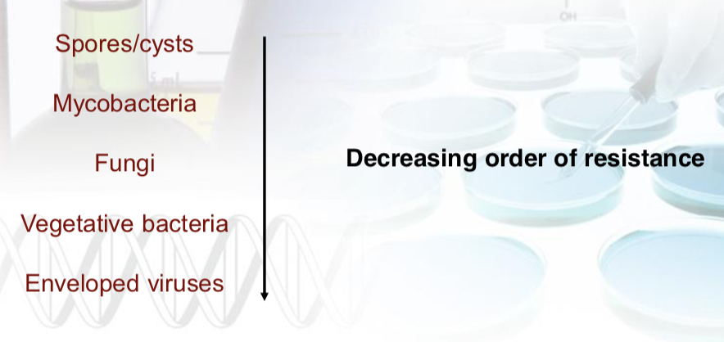
To rub or not to rub... that is the question!
- Antiseptics
  - What you apply to skin or patients’ skin at site of surgical procedure
  - Used to inactivate and remove flora (transient. Resident) from hands prior to surgical procedures
  - Used to inactivate transient and resident flora from site of operation
  - Used for treatment and/or prevention of infection on skin surfaces or mucous membranes
- Hand rubs
  - Removes transient flora only
  - Usually contains 60-70% ethanol, plus emollient(s)

Do you know how to wash your hands?
- Soak and warm water for at least 30 seconds to remove dirt and any left-over flora

