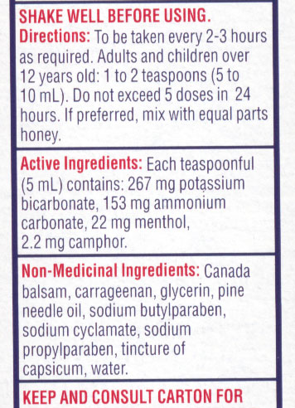
Cold Medications on the Market
- We spend about $8 billion on cold medication each year (north America)
- We spend more money on cold medications than pain medications because they’re more expensive (even though we use pain medications more often)
- Cold medications are misleading so it’s important to read the back of the box not the front
  - The list of ingredients on the back of the box will tell you what the product does, NOT the front
  - For example: Buckley’s cough and congestion
    - These ingredients listed will do nothing
    - Menthol and camphor are the only ingredients
      - They are artificial flavours that have to do with peppermint
      - This product will do nothing for colds

Cold Remedy Ingredients
- 5 different ingredients found for cold medications
  - Pain reliver or fever reducer
  - Decongestant
  - Antihistamine
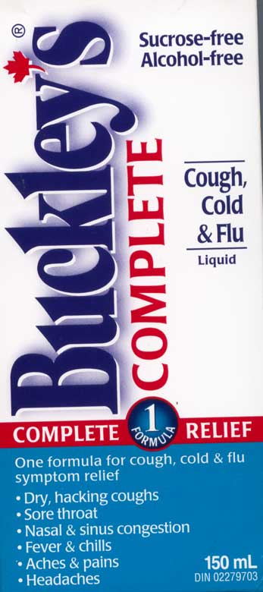
  - Antitussive
  - Expectorant
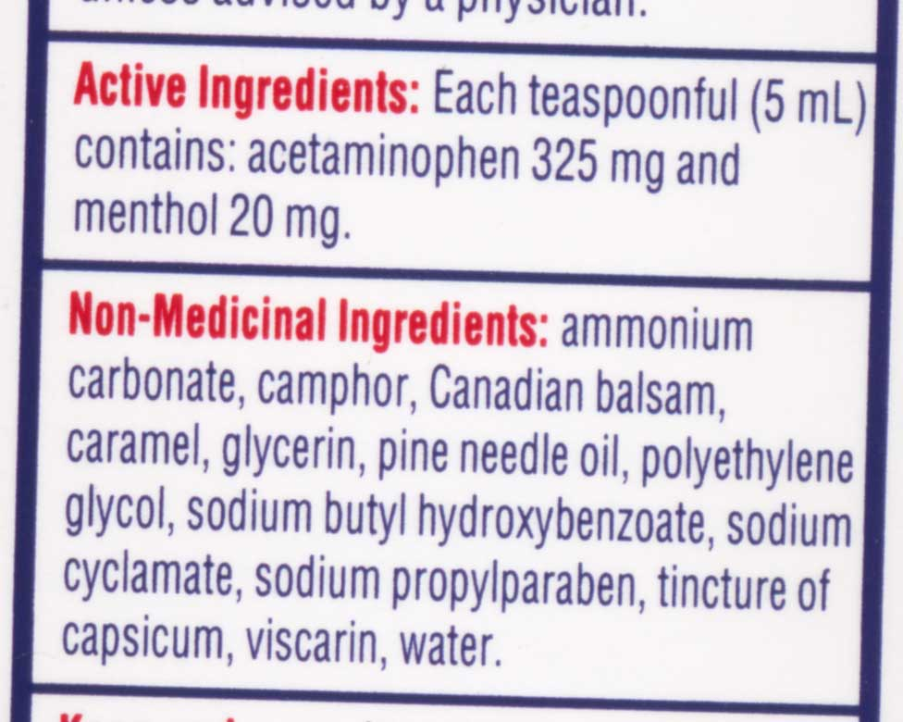
Antihistamine for pain relief and fever
- Acetaminophen is a pain reliver
- The most common pain reliver found is acetaminophen
- EX: this box claims that it is a complete cough, cold, and flu reliever but the only thing in it that will really do anything is acetaminophen (which really only reduces your fever)
- Menthol is also involved with pain relief

Ibuprofen is becoming a common replacement
- Acetaminophen is a popular pain reliver for cold medicine
- Now they add ibuprofen as a pain reliever in different cold medications to give you a choice in the active ingredient that you want
- There is no such thing as a sinus cold, every time you get a cold you will have an infection in your sinuses
- When medications say sinus on them, this is a good indication to help you find pseudoephedrine which is the most effective ingredient used to fight cold symptoms

Menthol for Sore Throat?
- Menthol is flavouring in peppermint
- It gives the cooling effect and causes the mouth to feel cold
- Menthol stimulates nerve endings in the mouth and this is was stimulates the feeling of being cold
- Menthol is a weak topical analgesic
  - It was designed to give sensation of cold in the mouth to mask the symptoms of burning and pain experienced from a cold

Menthol is a weak topical analgesic EXAMPLE
- Buckley’s cough and congestion
  - Contains 22 mg of menthol and this is a very large amount
  - In order for menthol to work it must make PHYSICAL CONTACT with the tissues
  - Tastes very bad so you’ll want to swallow it as quickly as possible to get it out of your mouth
    - Because of this, the entire 22 mg will end up in your stomach and do nothing to relieve your pain
    - The physical contact needs to be in the throat in order to reduce pain and unfortunately it is only here for seconds
- Menthol drops for sore throat
  - If we want relief from menthol the best way to get it is by taking a cough drop
  - Cough drops contain 2.5 mg of menthol
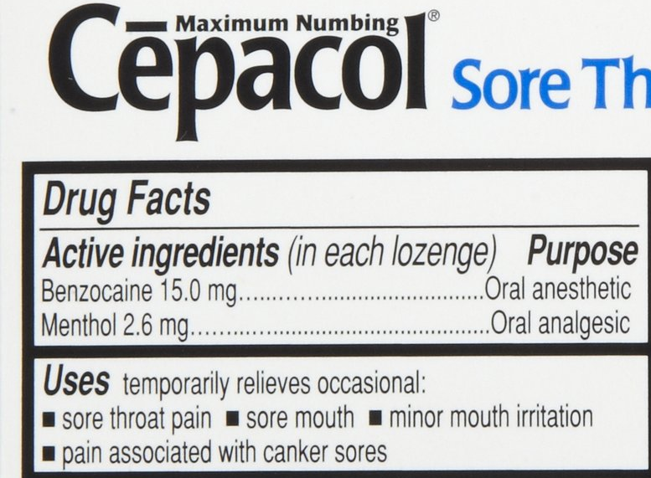
    - 10X less ingredients in the cough drop BUT since you’re holding it in your mouth the entire time it WILL actually reduce the pain for a short amount of time (longer than Buckley’s)

Cēpacol contains topical anesthetic
- Cēpacol contains 15 mg of benzocaine which is a topical anesthetic
- Anesthetics reduce sensation and this is an effective way to reduce a sore throat
- You don’t want to use this product a lot, it will numb your entire mouth

Decongestants dry a runny nose
- (these can also be used if you have watery eye)
- There are 2 ingredients is most effective
  - Pseudoephedrine
    - Most effective
  - Phenylephrine
    - Don’t work

Snot is mostly water with a little mucin
- Reduce production mucous in nose
- The stuff in the nose is made of mucin (protein) and water
- 95% of snot is water
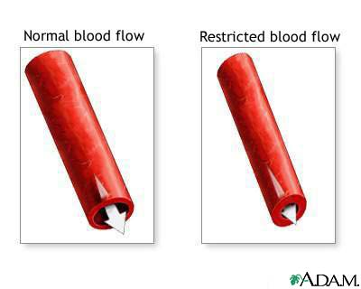
Water in snot is supplied by the blood
- The source of water is from the blood supply
- Decongestants are vasoconstrictors
  - Blood vessels in the nose dilate (get bigger) and as this happens it pulls the cells apart (stretches) and the space between the cells gets thinner and they leak
- The leakiness in the blood vessels supply water and allows for the mixture of mucin
- Medications will work to bind the cells together which will make them less leaky, reducing the production of mucus

Amphetamine for cold symptoms
- Amphetamine is one of the best decongestants
- Problems with it:
  - Used as a recreational drug

Problems with Phenylpropanolamine (PPA)
- We manufactured related molecules that allow your vessels to vasoconstrict
- Phenylpropanolamine (PPA) is one of these, the only difference between PPA and amphetamine is the OH group added which reduces some effects
  - Side effect of PPA:
    - Acts as an appetite suppressor
  - Some companies use the side effects to sell a drug
  - Side effects aren’t necessarily harmful, they are just an unplanned effect that accompanies a drug
  - Depending on what you want from a drug will determine whether something is the primary effect or side effect
- Diet pills used PPA
  - The side effect being decongestion

Over-use of diet pills caused hallucinations
- Amphetamines were removed from cold medications because of their use in diet pills
- Amphetamine psychosis
  - Some users experienced psychotic events when taking amphetamine pills
    - This was because of the consumer not the drug
  - Cold medications are taken over a short period of time
  - Diet pills that contain amphetamines suppress appetite, they don’t do anything that the pills advertise – they only suppress appetite
    - Since the pills don’t work the way that people intend them to they start to abuse them
      - Take diet pills > lose weight > body recognizes weight loss and changes metabolism > stop losing weight > get frustrated and abuse pill (start taking more than you’re supposed to > results in overdose > overdose creates the problem > psychotic event
      - Over use of diet pills caused strokes
        - Because of the overdosing events they removed the pills from the market
        - Overdose caused psychotic events and strokes
  - When you go on a diet you have the same kind of problem when it comes to them working how you would like them to – it’s a pattern
    - Lose 10 lbs easy and then you stop losing weight because your body has recognized that it is losing weight and changes its metabolism to ensure that you don’t lose weight
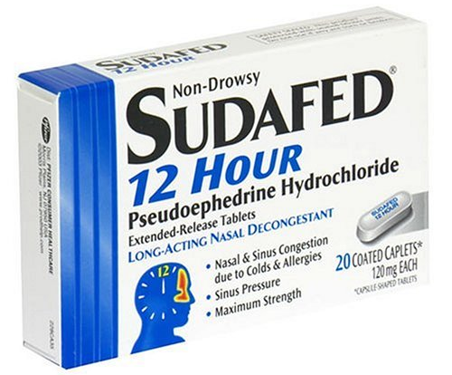
Sudafed (decongestion product) contains Pseudoephedrine
- The active ingredient used today is called pseudoephedrine
- You can’t buy this product in Canada because there is a problem with one of the ingredients
  - Its molecular structure is very similar to methamphetamine
  - People who wanted to make meth would just by Sudafed and burn off the OH accessory and make crystal meth

Drug dealers used to buy direct
- Up to 50% of pseudoephedrine was used to make methamphetamine
  - There was no restriction to pseudoephedrine so people were able to make a lot of meth
- The DEA realized that this was the source of meth so they made restrictions so that you must have a special licence to have large amounts delivered to you
- Dealers turned to “smerfing”
  - They would pay junkies to go into the drug store and buy every single box of Sudafed and then they would extract it that way
- Once the DEA realized that the drug was being accessed through smerfing, they made it so that you cannot buy Sudafed OTC
- Pseudoephedrine is now only accessible by prescription and in the USA you must go through a lot of paperwork to get it
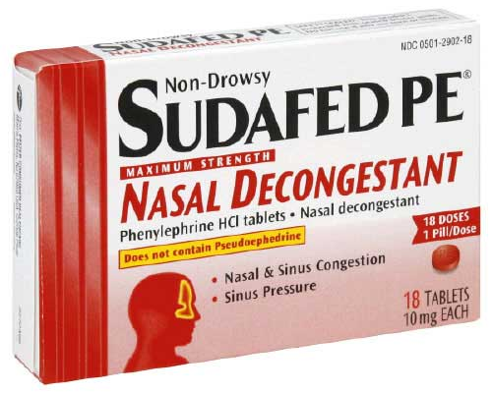
- Pseudoephedrine is still widely available OTC in Canada but it is always bundled with a pain reliever, this makes it harder for dealers to isolate the pseudoephedrine

They replaced pseudoephedrine with phenylephrine
- Pseudoephedrine was replaced with phenylephrine
- You can find phenylephrine in Sudafed PE
  - They put PE on the box to make it easy to find
- Phenylephrine is not effective
  - It is very easily metabolized by the liver
  - It never makes it into the blood stream because the liver has already broken it down

Generic versions are available for all cold medications
- If you’re looking for products for cold and sinus medications, look for ones that contain pseudoephedrine
- Pseudoephedrine will never be available on its own, it will always be available attached to a pain reliever
- The product will typically have 2 names
  - 1st name = active ingredient
  - 2nd name = chemical stabilizer that is added to the drug
    - Used to prevent oxygen from interfering with the drug
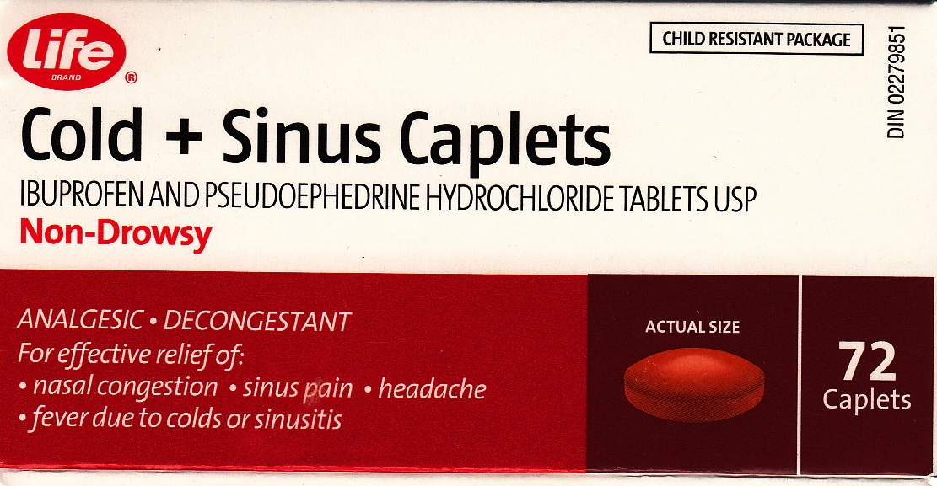
- EXAMPLE: Pseudoephedrine hydrochloride

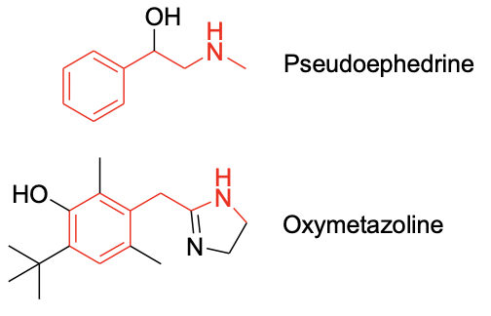
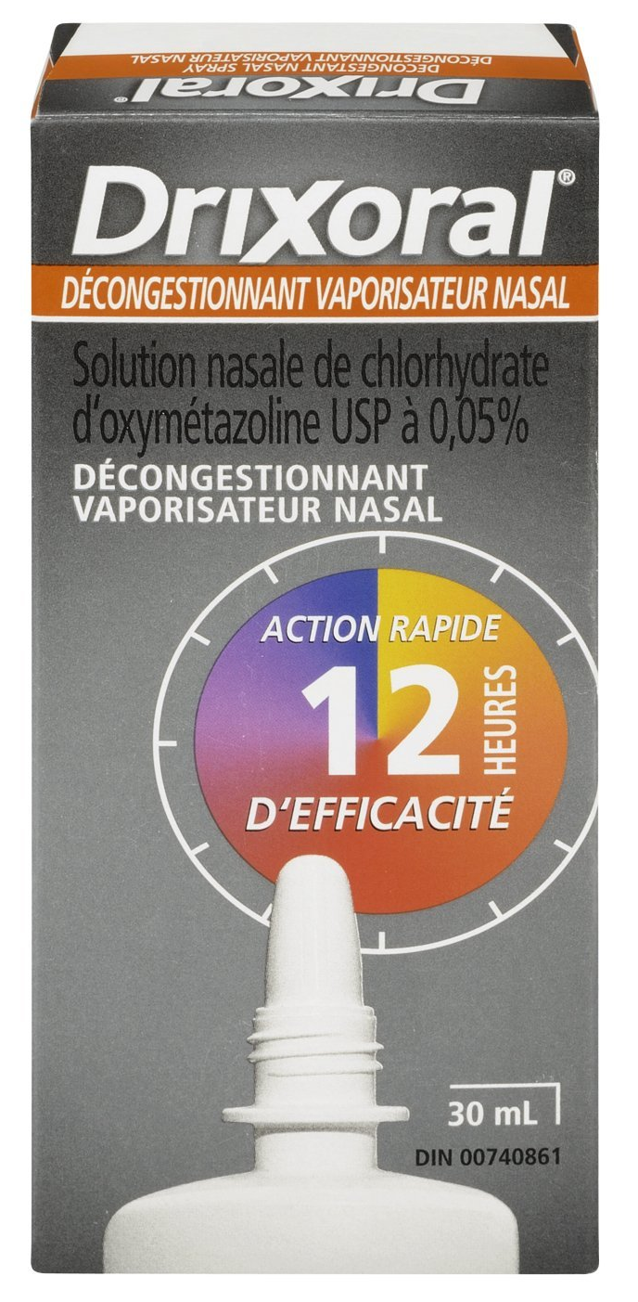
Nasal sprays contain decongestants
- Oxymetazoline is related to pseudoephedrine
- Both pseudoephedrine and oxymetazoline are members of the amphetamine family

Antihistamines for sneezing, runny nose, watery eyes
- People take them for generic cold symptoms
- They are also useful for cough
- Antihistamine side effect is drowsiness
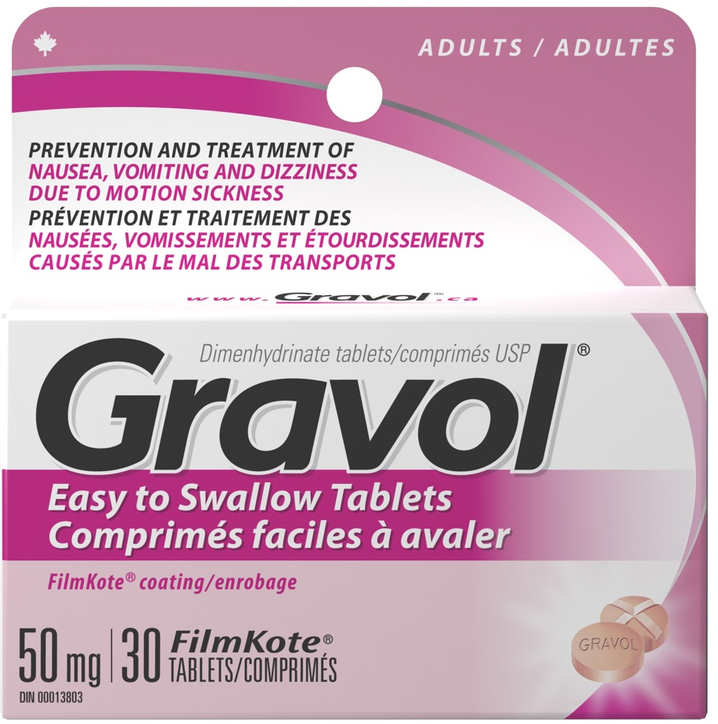
  - All antihistamines make you sleepy which lead to their use in sleeping pills
- You can utilize side effects and put them in different products for different kinds of problems
  - A side effect is simply something unintended it is not necessarily bad
- Antihistamines also have the property to reduce nausea
  - Contains the same active ingredient as Gravol
  - EXAMPLE: GRAVOL
    - Dimenhydrinate tablet
      - A combination of diphenhydramine (antihistamine) and 8-chlorotheophyliine (stimulant – has the same effect as caffeine)
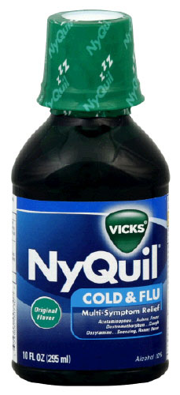
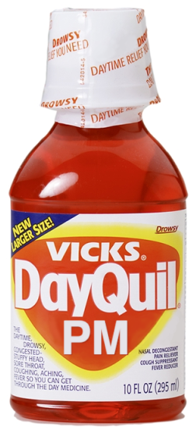
Chlorpheniramine is the most common antihistamine for colds
- If you buy cold medications there are 3 possible different antihistamines that could be used (they all do the same thing)
- Side effect of chlorpheniramine:
  - Drowsiness
  - It makes you sleepy when you have a cold, it will make you more comfortable which will make it easier to sleep
- Dayquil does not contain antihistamines
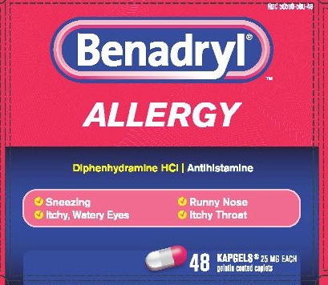
  - Leave antihistamine out of daytime version to prevent drowsiness

Diphenhydramine is the most common antihistamine for allergies
- 3 possible different antihistamines that all do the same thing
- Side effect of diphenhydramine:
  - Drowsiness
- Can also use this for anti-nausea (same active ingredient as gravol

Dry cough and productive cough
- There are 2 different drugs used to treat cough
- Treat in 2 different ways and target 2 DIFFERENT TYPES of cough
  - It is important to know what kind of cough you have so that you can treat it appropriately
- Dry cough – no mucus
- Productive cough – substantial amount of mucus present in the throat (happens during a cold)
  - If you cough enough you will dislodge the mucus

Cough syrup is a marketing trick
- You can purchase as a pill or liquid
- Cough syrup dates back to the days of patented medications
  - Heroin used to be the best cough suppressant – for dry cough
    - When it worked people thought it was because of the liquid

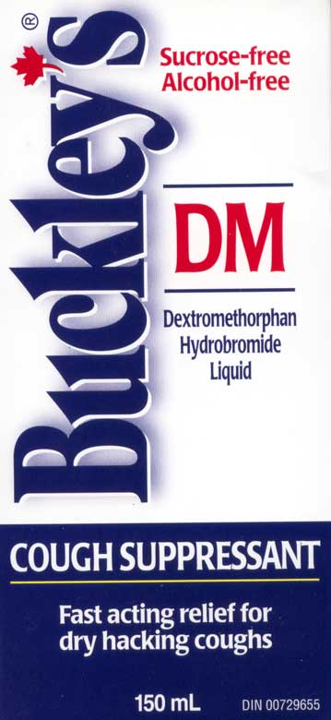
Dextromethorphan is used today for dry cough
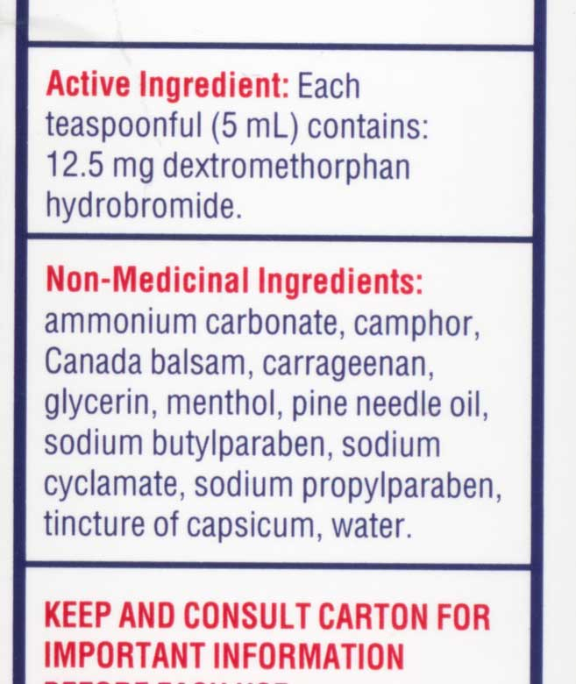
- Suppresses your cough reflex
- Dextromethorphan is the active ingredient
- Anything that says DM on the label is for dry cough

Dextromethorphan and heroin
- Dextromethorphan has a molecular structure vary similar to heroin
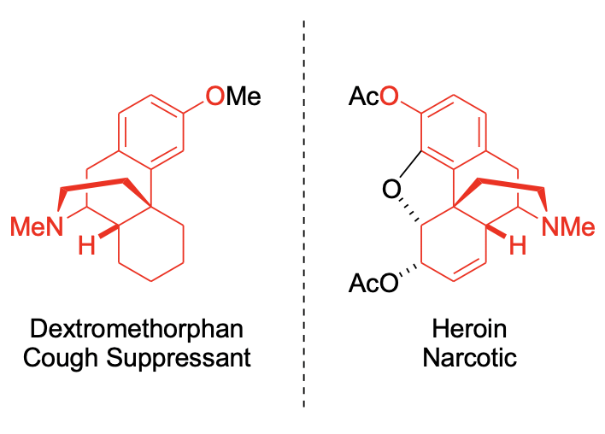
  - Almost a mirror image

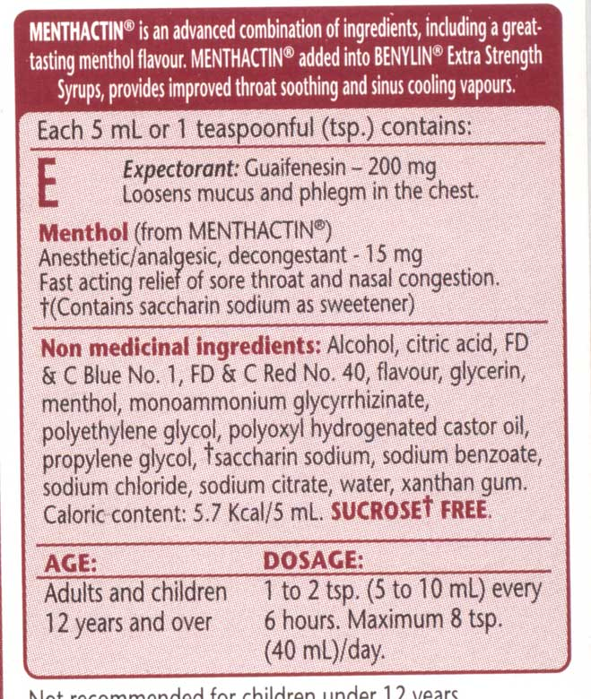
Expectorant for productive cough
- You can find this product marketed for mucous and phlegm
- It is very important that you cough to make the drug more effective
- It is designed to removed mucous that it is thick
  - Thick mucus is difficult to remove
- The drug supposedly adds water to your mucus – watery mucus is easily coughed up
  - So, when you cough it is supposed to make it more easy to bring the mucus up, giving you relief for a little while longer
  - This is why it is so important that you cough because it will make it easier to dislodge
- Guaifenesin makes mucus watery
  - Supposed to make the body produce a waterier mucus
  - But it has never been clinically proven to work
    - There is no evidence proving that it actually works
- Drink liquids with expectorants
  - The more liquid that is present in the body, the easier it will be to provide liquid to the mucus
  - If you have a productive cough, you will probably get more relief by consuming liquids than by taking these medications

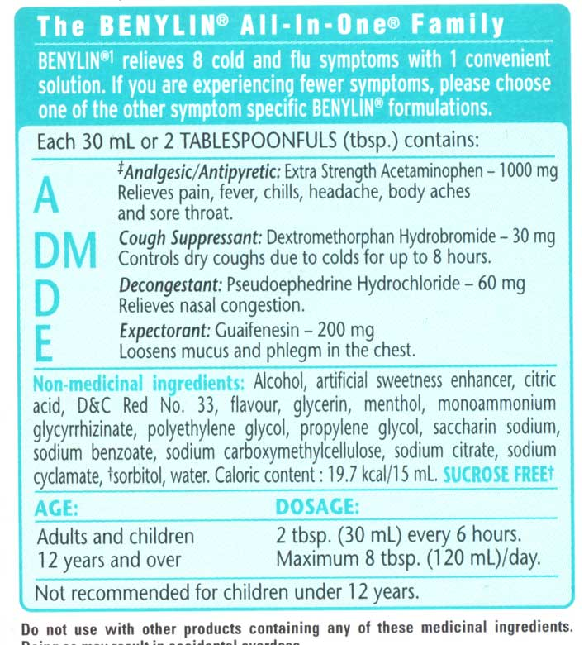
Beware of multi-symptom medications
- Multi-symptom products are a rip off
- We like to buy these products thinking that they will be very successful but they are actually really bad for you
- EXAMPLE: BENYLIN ALL-IN-ONE
  - Contains dextromethorphan – cough suppressant
    - Need to have cough in order to dislodge mucus
  - Contains expectorant – adds water and makes more mucus
    - Need to cough mucus out
  - These ingredients can be harmful
    - More mucus is produced that needs to be removed but the cough suppressant suppresses the need to cough and the mucus will go down the throat
- Expectorant – make watery mucus
- Decongestant – dries mucus up
  - These ingredients are designed in opposite directions
  - Might make coughing much more difficult than it was originally
- EXAMPLE: BUCKLEY’S COMPLETE COUGH, COLD AND FLU
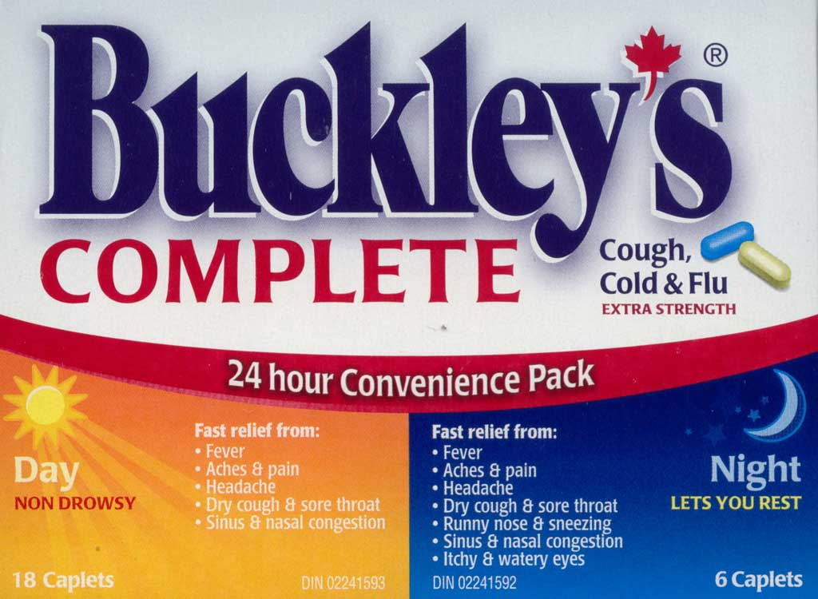
  - Day and night version
    - In the night tablets they add antihistamine which makes you sleepy
    - However, in the night tablet it also includes a decongestant which will keep you awake because it is a stimulant
      - This will keep you wide awake, whereas if the decongestant had been removed from the night tablet you would be able to sleep
        - They won’t remove the decongestant because then people will complain that it doesn’t contain what they’re paying for
    - Day version has no antihistamine

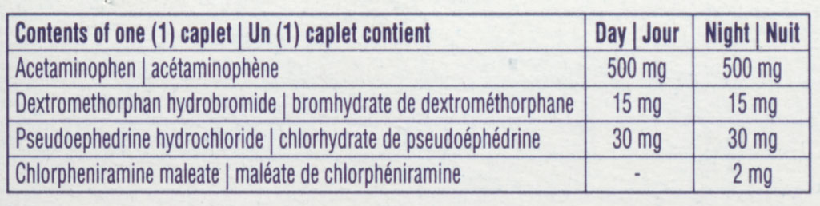
No cold medications for children under 6
- It is recommended that cold medications should NOT be given to children under the age of 6 and this is because of multi-symptom products
- You can overdose the child on acetaminophen because of the potential for mixing Tylenol (for fever) with cold medications and this is why it is no longer sold

Vitamin C and preventing colds
- Some people take vitamin C to prevent colds – vitamin C will NOT prevent a cold, make it go away, or relieve symptoms
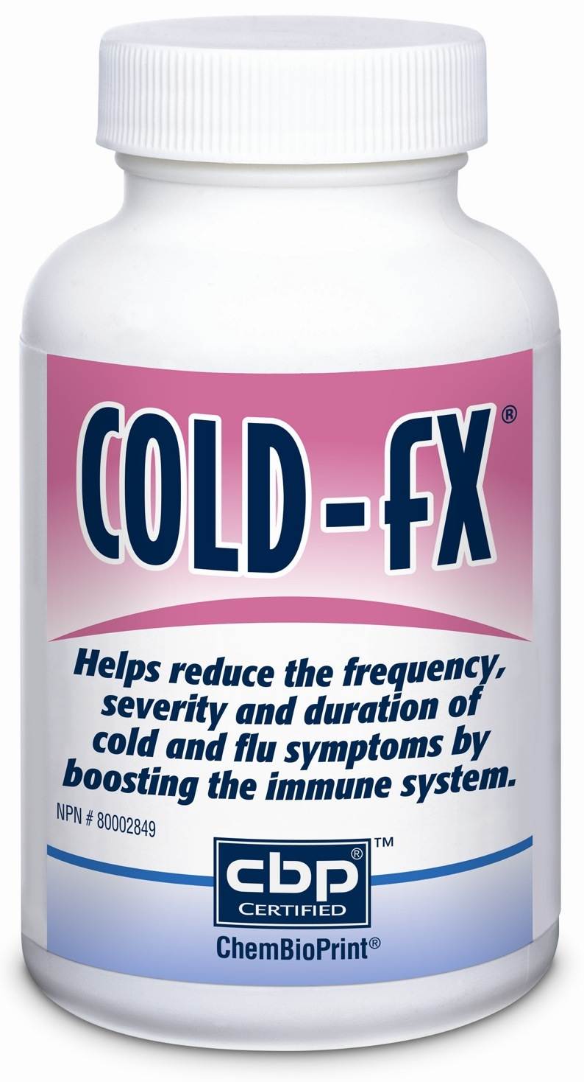
Colf-fX, a #1 seller in Canada
- Contains poly-furanosyl-pyranosyl-saccharides – this is a starch made from the root of ginseng
  - Ginseng is used for everything
    - It looks like a little person so it must have magical properties
- Cold-fX claims are highly questionable
  - The trials are highly debatable
    - Data from 2 studies was combined which is a big no no
    - The studies were very low quality and each clinical trial showed no benefits, there was only benefits when the data was combined to make it look like there was
      - They picked and chose which results to include
      - BAD EVIDENCE

Buyer beware
- Gravol multi-symptom was originally sold for nausea then disappeared from the market, it later reappeared to be sold as a cold symptom relief product
- It had a very weak antiviral effect (no animal data)
  - Very weak antiviral effect
  - No animal data, only data of a petri disc
  - Fresh ginger at 300 μg/mL gave 80% plaque reduction in vitro
    - 80% plaque reduction means it killed about 80% of viruses on the petri dish
- What’s in the box?
200 mg willow bark (15% salicin)  -30 mg salicin | Minimum effective dose of salicin is more than 300 mg
20 mg ginger (25% gingerols)  -5 mg gingerols | In a perfect world, minimum dose is 1500 mg  -based on 300 μg/m and assuming 100% of the gingerols reach the bloodstream  -this dose gives 80% viral reduction in the lab
  - The dosage here is about 10X too small in order for there to be a benefit
  - There is no real science to back it up
  - They put so small amounts that they have no chance in helping you in any way – 0 effect

15% of colds are due to the flu virus
- Companies use the word “flu” as a way of selling a product
- Influenza causes seasonal colds
  - Normally infects 5-15% of the population
    - You get the flu about once every 3 years on average
  - New virus formed every year
    - Every year the flu virus mutates so there is a new version every year
  - Most forms are not dangerous
    - It’s only a problem for very young (and below) and very old (70+), they are at risk
  - You can’t tell the difference between a cold and the flu
  - If you are infected by a particular flu virus, you will never be infected by that virus again

Occasional severe influenza pandemics
- Very virulent strain occasionally arises
  - 1918 – 20 000 000 deaths
  - 1957 – 1 000 000 deaths
  - 1968 – 700 000 deaths
- We must pay attention in these situations because they have been very serious

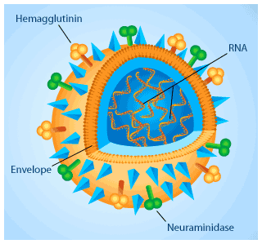
Virus contains an outer envelope
- Hemagglutinin (viral entry into the cell)
- Neuraminidase (viral exit from the cell)
- The flu virus is classified using envelope proteins
  - Hemagglutinin (H)
    - 16 types
    - Human flu
      - H1 through H5
  - Neuraminidase (N)
    - 9 types
    - Human flu
      - N1 or N2
  - H1N1 refers to the 2 proteins on the flu structure
  - How different they are is described by the number
- Because the proteins are on the outside, they make it easy to track the difference from this year’s flu from last years

Disease and Virus Type
Antibody response | Virus
H1N1 | Spanish flue (1918)
H2N2 | Asian flu (1957)
H3N2 | Hong Kong (1968)
H1N2, H3N2, H1N1 | “normal” flu (seasonal)
H5N1 | Avian flu (2007)
H1N1 | Swine flu (2009)
- Results from an overall change of the structure of the virus

Mortality rates and pandemics (world)
 | Infection rate | Deaths | Fatality rate
Spanish flu (1918) | 30% | 20 million | 2.5 %
Asain flu (1957) |  | 1 million | <0.1 %
Hong Kong (1968) |  | 700 000 | <0.1 %
“normal” (seasonal) | 5 – 15% | 250 000 – 500 000 | <0.1 %
H1N1 (2009) |  | 12 000 | <0.05 %
- Normal season – typically these people who are dying are elderly people who are succumbing to the flu

Name brands vs. generic
- There is no difference between name brand and generic brand cold medications
- They all use the same ingredients and the same doses
  - Pain and fever
    - Acetaminophen 500 mg
    - Ibuprofen 200 mg
  - Decongestant
    - Pseudoephedrine 30 mg
    - Phenylephrine 10 mg
  - Antihistamine
    - Chlorpheniramine 2 mg
  - Antitussive
    - Dextromethorphan 15 mg
  - Expectorant
    - Guaifenesin 200 mg

Price per 100 tablets
Advil cold and sinus (pain and congestion) | $35.93
Generic cold and sinus (pain and congestion | $9.99
Buckley’s DM (dry cough) (250 mL) | $13.99
Generic DM (dry cough) (250 mL) | $5.99
Benylen congestion (productive cough) (250 mL) | $15.35
Generic Guaifenesin (productive cough) (250 mL) | $7.99
Nyquil (antihistamine) | $56.63
Generic antihistamine | $18.59
- We use more pain medications but we spend more on cold medications

Medications for colds and flu
- You will get colds
- Nothing will cure it
- Primarily spread on surfaces
  - There’s nothing you can do to prevent the cold besides avoiding touching surfaces and reduce touching your face
- Some medications may reduce symptoms
  - You cannot treat all symptoms
  - Choose which symptoms you want to treat
- Read the back not the front
  - Choose the right medication
- Avoid multi-symptom products
- Compare before you buy

