Colds are the most common infection
- Typically, when you get an infection it is a cold
- Colds outnumber all others by 25 to 1
- There is no cure and there probably never will be and this is because there are 100s of different cold viruses
  - Each virus is different and must have its own drug to treat
    - We don’t know which drug to take so we won’t really make a difference by prescribing different antibiotics blindly
- It is hard to get effective antiviral drugs

More than 200 viruses cause colds (we know this)
Rhinovirus | 30-50 %
Unknown | 20-30 %
Cornavirus | 10-15 %
Influenza virus | 5-15 %
Respiratory scincitial virus | 5 %
Parainfluenza virus | 5 %
Adenovirus | <5 %
Enterovirus | <5 %
HMPV | 1 %
Bocavirus | 1 %
- Influenza (flu) virus
  - There is no way to tell if you have a cold or the flu
  - They both have the exact same symptoms, it is even difficult for HCPs to tell the difference
  - You can get a fever with any of the viruses so it doesn’t offer any way to tell which one you have
  - On average, you get the flu every 3 years

Virus destroys tissue, immune system makes symptoms
- Symptoms experienced when you have a cold are caused by an immune reaction
  - The tissue gets destroyed by the virus
  - The virus destroys the cells and in response the immune system provides your body with flu symptoms

There is no cure for the common cold
- There is no way to prevent a cold
- The average cold lasts about a week
- Some cold medications relieve symptoms
- Many remedies do nothing
  - Doing something makes you feel better
    - A lot of remedies that we do have no effect (EX: eating chicken noodle soup)
  - There is no difference in whether you do anything or not to shorten the duration
- No medication will prevent colds
  - Medications will just alleviate symptoms

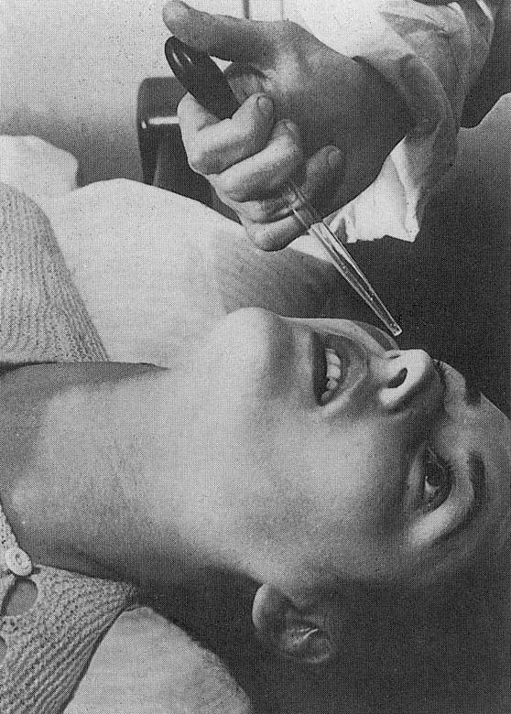
Common cold research unit Salisbury, England
- A lot of what we know about colds comes from this institute after WWII
- They tested on humans and in exchange offered people a free vacation
- The test subjects lived in extreme comfort but the vacation was not exactly free, they had agreed to be experimented on
- They concluded that sneezing does not spread colds very well
  - Discovered this through a sneeze collector
    - The sneeze collector was connected to a vacuum
    - The person would sneeze and it would vacuum up the aerosol of air in front of the individual
      - They would then put the collected mucous into a healthy person and see if they got a cold
    - Typically, a sneeze didn’t transmit a cold very well
      - This is because the liquid in a sneeze doesn’t contain a lot of viruses
  - Discovered that being cold does not cause colds
    - Cold temperatures have nothing to do with getting sick
    - You get the same results if you expose people in both cold and warm environments
  - Discovered that wet hair does not cause colds
  - Discovered that direct exposure to the virus does not always cause a cold
    - Only about 50% of the time will this occur

The cold virus in nasal secretions
- They discovered that a runny nose is full of virus
- Humans are subconscious face touchers, they touch their face often and then proceed to touch various surfaces
  - When they do this, this means that they have spread mucous onto that surface so the next person to touch that surface has the potential to spread the virus to themselves if they touch their face after coming into contact with the virus
- Nasal secretions are spread easily
  - Put fluorescent dye in the nasal secretion liquid and found that it was everywhere
  - It was also confirmed by mythtbusters
    - We unconsciously touch things all the time and if it happens to be our faces then we spread the cold around
- Cold viruses are transferred by touching
- Colds are more common in crowds
  - They have nothing to do with temperatures, they have to do with crowding
    - During the cold season we are in more crowded situations


School season is cold season
- Cold season is when children are in school
- When children are in school they are brought into close contact with others
- When in school you are going through different classrooms where you are exposed to different viruses
- Stop touching face = less colds
- Proved this through a study conducted on Tristan ca Cunha in the middle of nowhere (very remote island)
  - Incidence of colds and contact with the outside

    - White marks = ship arrival
    - Black spots = cold outbreak
    - Colds started to appear about 2 weeks after the ship had docked
    - Their cold season was the same as in Canada and it was not because of weather (they are located in the southern hemisphere so our winter = their summer)
      - In June, July, august it was their winter so there were no colds during this time because of the bad weather – ships won’t dock
      - The period of cold season in Canada is when people are back in school
      - Cold viruses spread through crowds

Washing hands may reduce colds
- Hand sanitizer works for some viruses but not all – it may also reduce colds
  - Don’t overdo it – avoid skin damage
  - If you use hand sanitizer too much you can wipe off the protective layer of oil on your skin that protects it from drying out

Incidence of colds decrease with age
- This is because young children are more social, they do not have a sense of personal space – adults do
- As you age and go through life you acquire immunity by being infected
  - Exposure to viruses cause illness
    - Immune response is too slow and weak to prevent
  - Body makes large amounts of antibodies only during infection
  - After each infection you build up “memory” cells
    - After being infected by a virus, you will never be infected by that same virus again
  - Later exposure to the same virus does not make you sick
    - Rapid and strong immune response

