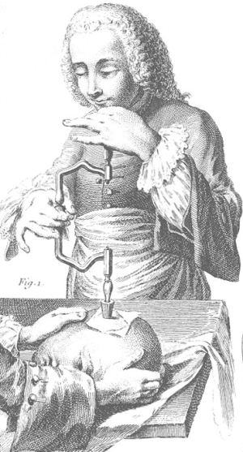
Cephalalgia
- Cephalalgia is enjoyed by 90% of the world’s population
- It was once believed that headaches by demons
  - It used to be treated in funny ways – they were not successful and this is because they didn’t know what actually causes headaches
  - They thought that to lose the demon was to lose the headache
    - They would stick your head in an oven to get rid of the demons
  - Sometimes they would use a metallic tractor to pull out the pain
    - EX: a magnetic headache to pull out the headache
  - Surgical cures were also used for headaches
    - Similar to bloodletting, they have specialty tools for trepanation
      - There was a variety of different techniques and devices used to make different kinds of holes
      - Trepanation is for life
        - If you did undergo a trepanation treatment, you had to live with it for the rest of your life (you would have a permanent hole in your skull)
      - Modern practitioners of trepanation
        - People still practice this unfortunately
        - Unfortunately, these people manage to persuade others into following them

The brain and pain
- Some believe that the brain feels pain and that this is where headaches come from
- This is incorrect, the headache is not the brain
- The brain is incapable of feeling pain
- The pain that is felt occurs in the thin tissue surrounding the skull

Headaches
- You need to understand the headache before treating it, you can get effective treatment if you treat the underlying cause instead of just the pain
- There are 12 types of headaches
  - 60 sub-types
- Headaches are grouped into 2 classes
  - Muscular
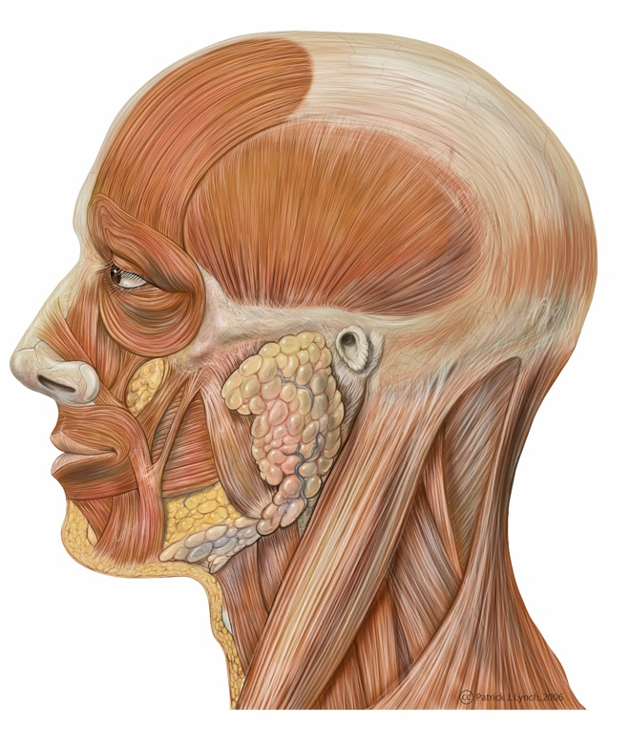
  - Vascular

Muscular headache – muscle band around the skull
- The muscle band surrounding the skull helps to make facial expressions and move the head around
- Muscles compress or contract involuntary and squeeze the tissues surrounding the skull which creates pain
- Muscular headaches are typically caused by stress (this is the most common cause)
  - Causes the contracting of muscles that are surrounding the skull
- Treat a muscular headache with: (probably get more relief from the ones that use prostaglandins (1,3,4))
  - A.S.A.*
  - Acetaminophen
  - Ibuprofen*
  - Naproxen
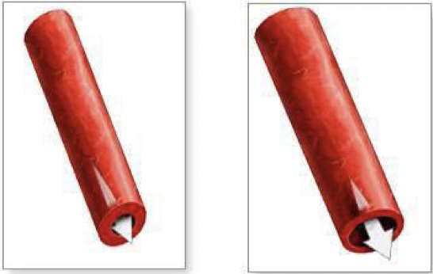
Vascular headaches – involves blood circulation
- 3 major types
  - Toxic
  - Migraine
  - Cluster (we won’t be talking about this one)
- Toxic headache is caused by the ingestion of some kind of poison
  - It generates the headache as a response to blood vessel dilation of the tissue surrounding the skull (called vasodilation)
  - Pain is caused by vasodilation – squished tissue surrounding the skull
  - The most common type of toxic headache is from the consumption of alcohol

Metabolism of alcohol contributes or helps
- Alcohol on its own does not cause hangover pain
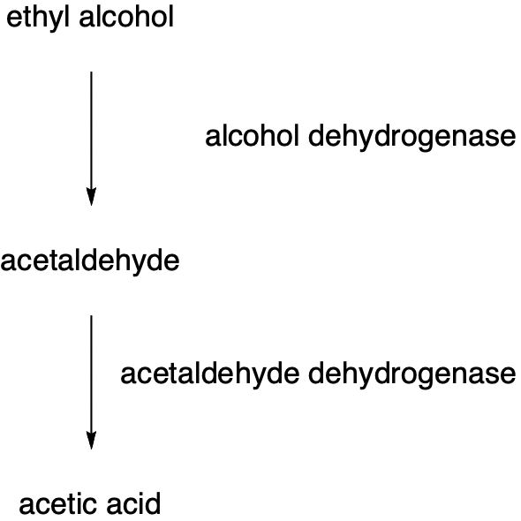
- It is recognized in the body as a poison and the liver will remove this poison by chemically changing it
- There are 2 possible chemical reactions to detoxify which result in either acetaldehyde or acetic acid
  - Acetaldehyde causes hangovers
  - Acetic acid is safe – NO HANGOVER
  - There are 2 different chemical reactions that occur, some people are different and this makes them more susceptible to hangovers
    - Some have a large amount of alcohol dehydrogenase but some people only have a small amount of acetaldehyde dehydrogenase so they build up acetaldehyde quicker (consuming alcohol for these people is not very comfortable)
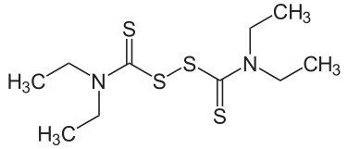
      - This tends to me more common in people of Asian descent
- Disulfiram (Antabuse) to treat alcoholics
  - Blocks aldehyde dehydrogenase
  - Generates rapid and severe hangover after alcohol consumption

Aging adds to the pain
- We enhance the flavor through storage in wooden containers
- Over time the alcohol extracts flavor from the wood
- Wood containers also release congeners which increase the severity of the hangover

Presence of congeners increases severity
Vodka | 1
Gin | 1
White wine | 4
Beer | 4.5
Whiskey | 4.5
Sherry | 4.5
Rum | 7.5
Red wine | 9
Whisky | 10
Cognac | 10
- The longer the beverage is aged, the darker it gets
- As it is stored longer in the wood, it will add more ingredients and increase the severity of the hangover
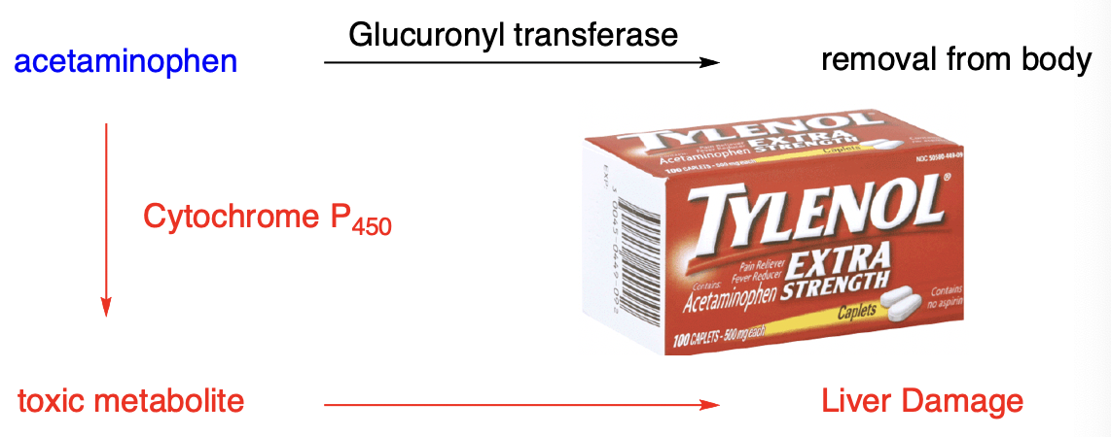
Alcohol increases liver function
- Alcohol activates CYP450 making acetaminophen toxic
- The liver makes acetaminophen toxic
  - Don’t take acetaminophen for hangovers
- The enzymes used to process alcohol come from the same family so it increases liver toxicity

Histamine and foods
- Some red wines contain histamine
  - The difference between red and white wine is the skin presence on the grapes
  - Red wine produces histamine which can give you a headache
- Some fermented foods contain histamine
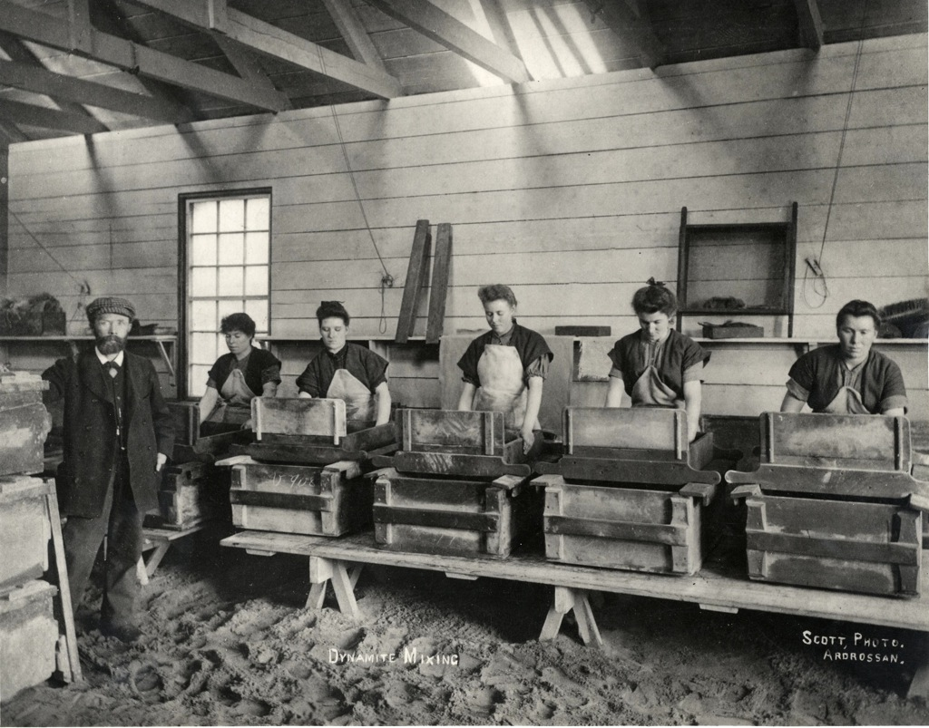
- Some aged cheeses contain tyramine
- Chocolate triggers some headaches
- Hotdogs and other kinds of smoked meats contain nitrites
  - These are very potent vasodilators

Nitroglycerin is a potent vasodilator
- It is a potent vasodilator as it releases related kinds of materials and releasing nitric oxide into the blood
- Nitroglycerin causes headaches
- People who used to make bombs during the war would have extremely bad headaches

Monosodium glutamate – MSG
- Discovered by Kikunae Ikeda in 1907
- MSG is associated with headaches and foods that you eat
- It was identified that monosodium glutamate can enhance the flavours of food (this was discovered because of seaweed)
  - This became very popular as a cooking additive, especially in oriental cooking

Kwok syndrome and MSG
- Kwok syndrome is when you get a headache from eating at a Chinese restaurant
- Kwok syndrome was named after the guy who made this observation
- He claimed that after he ate at certain restaurants he would get a headache and at other restaurants he wouldn’t
  - The headaches were from restaurants that used MSG
  - The only evidence was in his own observation, there was no research on the study
- This is the origin of the association between MSG and headaches in oriental cooking
- Some people avoided MSG
  - This created a problem for the people in this industry because they were losing business (people would avoid and stop eating there)
    - Over the years they have spent 10-100s of millions on research on the potential effects
      - MSG does NOT cause headaches
      - Even people who claim to be sensitive to headaches from consuming MSG will not get headaches if they are not aware that they are consuming MSG

MSG is in virtually all prepared food
- MSG is not unique to oriental cooking
- The majority of products contain MSG, we consume it and don’t know about it
- When cooking food on a large scale the food tends to be tasteless and this is because of the way heat gets transferred as you make more and more
  - The food industry must put flavor back into the product and one of the ways that they do this is by adding MSG
  - It is cost effective because it enhances the existing flavours
- MSG is disguised as hydrolyzed vegetable protein
  - People won’t buy products that say that they contain MSG on the label so industries disguise the presence of MSG by using euphemisms for it (change the name)
    - Hydrolyzed protein or hydrolyzed vegetable protein = MSG

MSG is a normal human metabolite
- Constitutes approximately 5% of our protein
- It is produced constantly in the body
- It’s a normal thing to find in basically anything you eat

Caffeine gives rebound vasodilation
- Caffeine causes vasoconstriction
- Body compensates for heavy caffeine use by trying to initiate vasodilation
- Reducing caffeine intake results in vasodilation
  - If you don’t drink coffee that morning you will get a headache because the vessels in the head will get larger expecting to get coffee but since you don’t get it, it results in a headache (this is for heavy coffee drinkers)

Brain freeze
- Brain freeze has nothing to do with the stomach; it has to do with the palate
- When we swallow, our tongue pushes up on the palate which squeezes food and forces it down
  - If this food it cold, the body senses that the head is cold and dilates the blood vessels in the head as a way of guarding up your brain – this causes the strong head pain

Treat a toxic headache
- It is recommended to choose from pain relivers that deal with prostaglandins
  - A.S.A
  - Ibuprofen
  - Naproxen

Acetaminophen and toxic headaches
- Increased liver function causes acetaminophen toxicity
  - Liver damage
    - (changes the drug that is harmful to the liver so it is best to avoid it)
- Don’t take acetaminophen for a hangover

Caffeine may help to reduce the pain
- Best to use caffeine to reduce the pain
- Caffeine will constrict blood vessels which will address the pain and the source of pain
- If you know that you’re suffering from a toxic headache, caffeine will help

Migraine is an overused term
- We interchange the term migraine and headache
- Migraines affects a small % of the population – it is unusual for a person to suffer from migraines
  - 18% of women get migraines
  - 6% of men get migraines

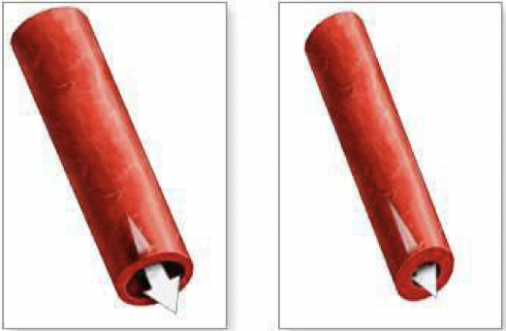
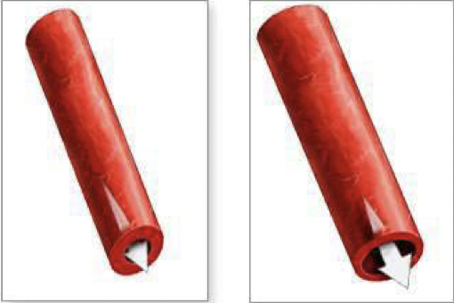
Migraine headache is a two-stage process – a vascular event
- Phase one: Vasoconstriction
  - Blood vessels in the head undergo vasoconstriction
- Phase 2: Vasodilation
  - In this phase you experience the pain of the migraine

Migraines are initiated by a trigger
- Migraines are not just headaches, they usually occur from being triggered – a behaviour can act as a trigger
- If you can figure out what sets off your migraines then you can avoid them (or at least try to) and you can work to protect yourself and treat
- EXAMPLES:
  - Tension
  - Lack of sleep
  - Menstruation
  - Foods
  - Relaxation
  - Too much sleep
  - Pregnancy
  - Drugs
  - Strong smells

Migraine headaches follow a progression
- There are 4 phases:
  - Podrome phase
  - Aura
  - Pain
  - Postdrome

Podrome Phase gives a warning
- Not everyone gets podrome, only about 30 to 40% of sufferers
- Typically happens 1-2 days before you get the headache and constitutes as a warning
- You can use this as a way to manage yourself
- It is often characterized by mood swings

Aura phase in 20 to 30% of sufferers
- Occurs about 1-2 hours before the pain phase
- This phase is valuable because it tells you that the migraine is coming and you can use this as an indication to take your medication
- It will be unique to each individual, you might not experience all things (listed below)
  - Scotomas
    - Visual disturbances, flashes of light
  - Olfactory hallucinations
  - Auditory hallucinations
  - Vertigo
  - Reduced sensation
  - Hypersensitivity

Pain involves half of the head
- The pain is only felt in one half of the head and you typically feel like someone stabbed you straight through ONE eye
  - Hemicrania (Latin)
  - Hemigrania (French)
- Pain can last 1-72 hours and vary on the individual
- Nausea is common – people often vomit
- GI disturbances
  - Some people get constipated or diarrhea
- Movement makes it worse
  - Even if it is slight, such as moving your toe
- Sensitivity to light, sound, smell
  - People become hypersensitive
    - These people often close themselves away from the world

Postdrome phase may take hours or days
- Can occur after the pain goes away
- For most people it only lasts for a few hours
  - “hungover”
  - Exhaustion
  - Poor concentration
  - Depression or euphoria

Treatment – pain medications and ride it out
- A.S.A.
- Acetaminophen
- Ibuprofen
- Naproxen
- Prescription pain medications
  - People who get migraines commonly can get a prescription to help manage the pain
- Triptans can abort a migraine
  - You can prevent migraines from starting if you get to them early enough and take a triptan, if you are a little too late you will at least prevent the symptoms from getting too severe

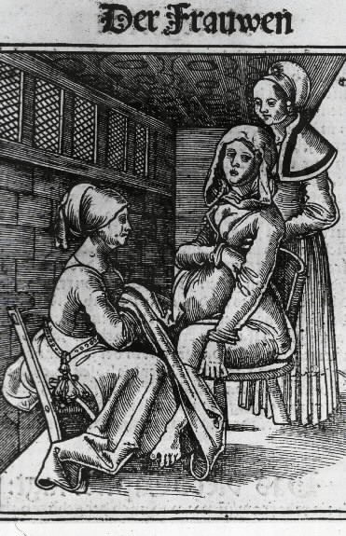
Rye bread was common in medieval Europe
- Rye has a fungus that grows in its grain
  - If stored improperly you will get this growth which will secrete a chemical substance that is an extremely powerful poison
    - Causes extreme vasoconstriction
- St. Anthony’s fire from vasoconstriction
  - It is extremely painful
  - If it becomes too severe you can lose your limbs
- Gangrene – St. Anthony’s fire in humans – require amputation
  - It can also happen to people and when this occurs it results in amputation
- Midwives used ergot to induce labour
  - Similar to all poisons, the dose determines the effect
  - It would sometimes cause people to have involuntary muscular contractions and movements, which are very important for labour
    - Often times midwives would take advantage of the effects of ergot and use it to induce labour

Ergot is a powerful hallucinogen
- You can get severely intoxicated if you take the appropriate dose
- The poison makes you hallucinate and in medieval times, it would lead officials to think you were possessed by demons
  - Because of the involuntary muscular contractions and hallucinations that would cause you to speak weirdly, ergot poisoning was seen as demonic possession

Inquisition in Europe
- If you managed to survive the ergot poisoning you would find yourself in trouble with the authorities as they would believe that you were a witch or a Satan worshipper
- A normal law was suspended for witches
  - Witchcraft was to be eliminated
  - To be accused of being a witch was very bad
  - There were a number of procedures for the accused to undergo
    - EX: torcher them even if they confess
- No win for witches
  - They invented situations to test for the presence of the devil
    - Would throw you into deep water (most could not swim)
      - If you float, you are in leagues with the devil
      - If you sink you are innocent (but this meant you were dead)

Witchcraft in Salem 1692
- Over 100 people were accused and a lot of people were killed
- Theory behind what happened:
  - Rye bread was a common staple at the time
  - 1692 was a very wet year for the harvest – when rye gets wet, the fungus grows very easily
  - When they looked at the records of the trials, the events described were very similar to what happens to an individual who has rye poisoning

Witch hunt in Canada
- A woman defrauded a Toronto layer of 10s of thousands of dollars by telling him that she was the embodiment of the spirit of his deceased sister, come back to help him in business
  - She faced charges under a rarely used section of the criminal code for pretending to practice witchcraft
Witch hunts and exorcisms around the world
- Kira Canhoto killed during exorcism 1995
  - Happened in Kitchener, Ontario
  - The child’s parents and grandparents tortured the child during an exorcism and the child died
- Witchcraft killing in London
  - Exorcisms often lead to death

Extracts of ergot for migraine 1862
- Downside: they had no way of accurately measuring the active ingredient
  - This was dangerous due to poor control of dosage
  - Extracts tend to give variable amounts
- In lower doses ergot has the effects of counteracting certain kinds of headaches

Arthur Stoll isolates ergotamine in 1918
- He isolated the active ingredient – poisonous substance
- It is easy to control dose and accurately measure the amounts from purified substances

Cafergot is still available today
- We still use it today, it is still extracted from the fungus and is in cafergot
  - (prescription for migraine)

Ergotamine is not drug-like
- It is not the ideal drug
- It is not very drug-like (user friendly)
  - It has some serious side effects if you’re not careful in taking the proper dose – can lead to death
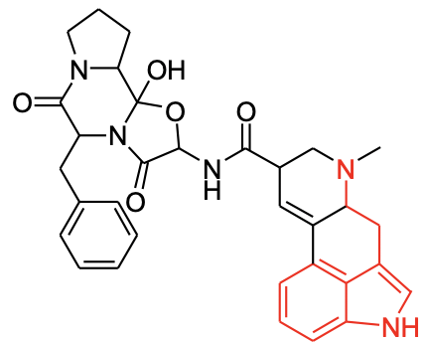
- Ergotamine:
  - Prevents migraine
  - Poison in high doses
    - Hallucinations
    - Muscular contractions
    - Vasoconstriction
    - Gangrene
    - Death

A drug-like substance – something which is user friendly or convenient for the consumer to use
- Provides beneficial effects
  - Specific
- Limited side effects
  - Low incidence
  - Low severity
- Cheap to manufacture
- Patentable

Albert Hoffman discovers LSD by accident
- Is like the other kinds of drugs
- He accidently discovered that ergotamine can be converted into a hallucinogenic substance – LSD
  - He tasted it and liked the effects so he took it again
    - The bicycle day
      - He colleagues found him and took him home on the front of his bike because he was so high off LSD

LSD was used by the CIA at McGill in the 1950’s
- The CIA tested it on students without their knowledge
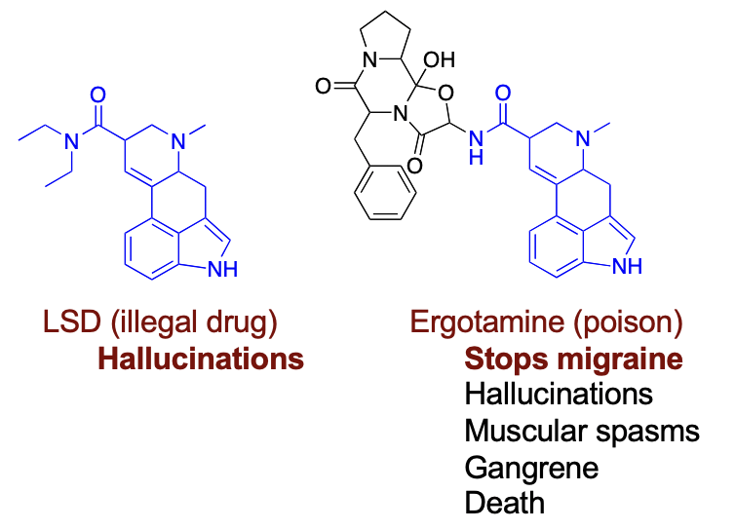
- Some of these people who were in the study experienced flash back experiences that were so bad they killed themselves

Hallucinations from part of ergotamine
- You can use the chemical structure of the material to tease the effects that are coming out
- We do this to study how drugs operate on the brain and to help us figure out the generation of the migraine

Order of the Migraine
- Migraines start with serotonin
  - Serotonin – neurotransmitter which is used to carry information to different parts of the brain
  - Serotonin levels change during a migraine
    - Amounts drop during aura
      - Noticed that drugs interact with serotonin in the brain and you can prevent migraine by replacing missing serotonin with a drug
        - If you can get the drug to build up the same amount to replace the serotonin in the brain, maybe it can prevent migraines from even occurring
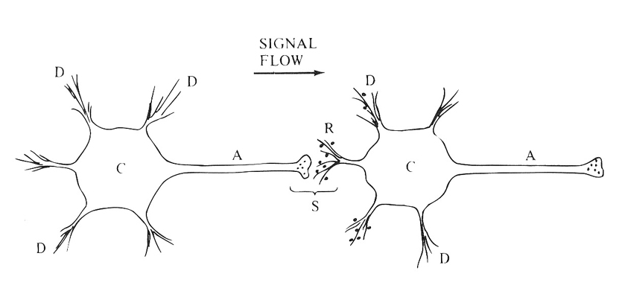
Nerve signals
- They are chemical
- Nerve signals are cascading chemical reaction
  - Set up a cascading series of chemical reactions to send information from one place to another
- Nerve cells do not touch each other
  - There is a gap called a synapse which occurs between the two cells
  - We transmit information along a membrane
  - The cell sending the information sprays chemicals at the other cell and this chemical is what transmits the information
- Messages are carried by neurotransmitters
  - When we get the end of the synapse, we send neurotransmitters from one cell to another as the molecules stick to the receptors
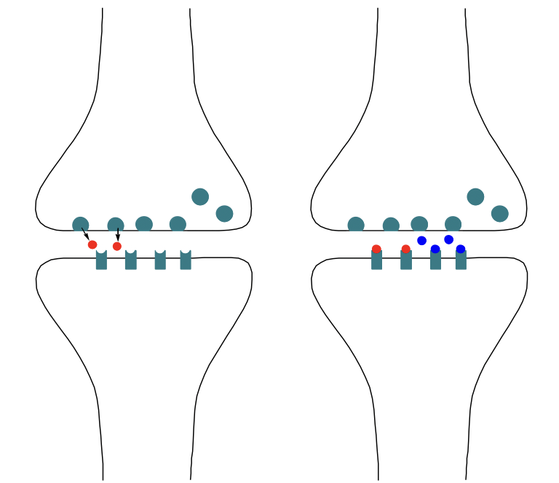
    - When they make physical contact, it causes the receptors to continue to carry the information further
  - The synapse is a nice place for drugs because it is a space between the cell
- Use a drug that works like serotonin
  - When you start to get a migraine, you start to produce small amounts of serotonin so to prevent a migraine we simply amplify signals to replace serotonin or take a drug to do a similar thing

Serotonin is a poor drug
- Used in many parts of the brain
  - Serotonin does a lot of different things to a lot of different parts of the brain
  - Drug must only effect migraine
    - If you give it as a pill it will go everywhere, not to where we want it to go
- Does not easily pass from blood to brain
  - Drug must travel from stomach to brain in the blood
  - If we were to use it as a drug, we would have to inject it into the brain at the location of the migraine – we aren’t going to do this

Basis for serotonin drug selectivity
- Must make sure that the drug has the ability to know where it needs to go
- We only want it to effect stuff associated with the drug
  - We can get selectivity of the drug by changing the shape of the molecule
- Serotonin fits into receptors
  - Molecule fits into a pocket of another molecule and its receptor is shaped to fit only the receiving molecule
- Serotonin fits other receptors
  - We can get further selectivity by changing the shape of the receptor
  - Serotonin can change shape a little bit to fit into different receptors
  - We can redesign the shape of the molecules that that it fits into the different receptors

Engineer for the effect you want
- Use information from a variety of different molecules that we know fit into a variety of different pockets
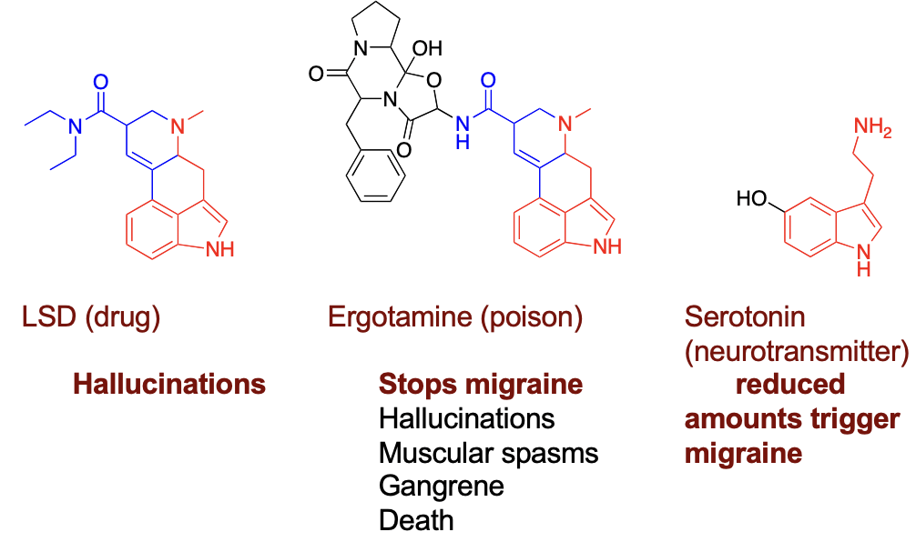
- Molecules highlighted in rid have part of molecules that are identical

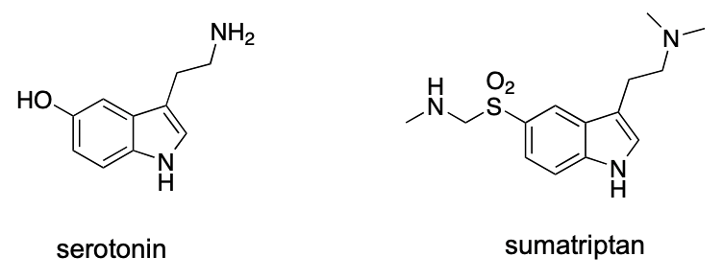
Sumatriptan selectively targets migraines
- Shape changes ensure that it only fits into the pockets that we want it to go into
- First triptan drug for migraine
  - Must be taken at the beginning of the migraine
  - Has the ability to prevent the migraine from even happening
  - Triptan is used for migraines
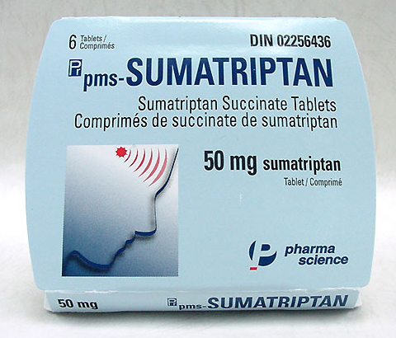
    - There are name tricks to help HCPs to remember uses of drugs
- Magic potion for migraine
  - Drug derived something with association from witchcraft which now creates a lot of options for people with migraine headaches
  - There are a number of drugs and options available now:
    - Sumatriptan
    - Rizatriptan
    - Naratriptan
    - Zolmitriptan
    - Eletriptan
    - Almotriptan
  - It is important to have choices of drugs to treat certain conditions because not all drugs work equally as well in all people
  - Variety allows for doctors to have choice of a different one that could be more beneficial and work better for different patients

There are lots of causes of headaches
- If you know what is the cause of your headaches there are more things that you can do to get rid of them as opposed to taking ibuprofen or Tylenol
  - Treat with painkiller
  - Gain and added benefit from understanding the cause

