Pain Medication
- The development of pain medication is one of the most important classes to be developed
- There are 2 general classifications:
  - Prescription drugs
  - Over the counter

Prescription Drugs
- $300 billion/year (US)
- Requires doctor’s prescription

Over the Counter – OTC
- $25 billion/year (US)
  - OTC drug market is 10X smaller than the prescription drug market; however, they are taken a lot more frequently
- Younger individuals take – OTC
- Older individuals take – prescription (they have more wear and tear on their bodies so they require more prescriptions
- No prescription is required
- Some “behind the counter” drugs
  - Must ask the pharmacist for them in order to get them as they are kept behind the counter as they require more management and supervision
- Top OTC medications (North America 2016)
  - We spend the most money on cough and cold medication – they charge more for cold medication than pain medication so we end up spending more money on them even though we get less product overall
    - Cough and cold - $8.2 billion
    - Pain reliever - $4.1 billion
    - Antacid - $2.7 billion
    - Toothpaste - $1.5 billion
    - Laxative - $1.3 billion

Important considerations when buying
- 3 things to consider
  - Safety
    - Companies won’t let you use something dangerous unless it is prescribed by a doctor
    - Dose makes the drug
      - Dose is the amount taken in order to feel the effects of the drugs
      - Some believe that the number of capsules has to do with pain or speed of effect, but it is based on body size (the larger the individual the more capsules needed)
    - Dose makes the poison
      - They also tell you the dose for poison effect that you should avoid taking (on the bottle)
      - Just be aware that there is a big safety gap; however, if you were to go over so there is no worry
    - Side effects
      - ALL drugs have side effects
        - It is 100% impossible to make a drug with no side effects
        - A drug that claims that it has 0 effects WILL NOT WORK
      - Effect – what is it?
        - Information is easy to find – on the box, bottle, or information sheet
        - Label or box
        - There are 2 questions to ask and effects to take into consideration before deciding to use a drug
          - How common is it that the side effect occurs?
          - Does it happen when I take all the time or is it dependent on the timing or individual?
        - Google
          - The FDA is the best website to find information on how often the side effects occur
      - Incidence – how common is it? (this is something you should consider)
        - This information is difficult to find
        - The doctor will tell you about the most common or serious side effects
        - It is useful to ask how common it is for the side effects to occur and how likely is it that you will experience the side effects (what are your chance?)
      - Need both effect and incidence to evaluate the risks
  - Indications
    - What to use it for?
      - You want to make sure that you’re using the proper product for your problem
      - Certain products are more effective than others and if you know the causes of your issue, this can help you to properly decide the right product for you
    - Many people take the wrong drug (very common)
    - Many people take drugs unnecessarily
  - Counter-indications
    - When should you NOT use (more common to find this in prescription medications than OTC drugs)
      - Conditions
        - When you have a condition or when you’re in a particular situation where it is BAD to take the drug
          - EX: if you are pregnant
          - EX: if you have pre-existing conditions or problem with your liver, digestive system, etc.
      - Drug combinations
        - Certain drugs can interact with other drugs
          - EX: antibiotics and birth control
      - Foods
        - EX: certain foods can interact with different medications (Usually prescription medications)
      - “natural” remedies
        - “natural” remedy products can affect prescription medications
        - Often times when taking supplements, we don’t consider them as drugs, so when doctors ask what medications we are on we won’t identify the supplements being taken
          - ALWAYS tell your doctor about the supplements that you take because they could potentially affect and/or interact with prescription OR OTC medication

Pain Relievers are the most common OTC drug
- $4.1 billion/year (North America)
- 50 billion tablets (North America)
- 16 000 tonnes/year
- 500 dump trucks

Aspirin – one of the World’s most popular drugs
- Alcohol
- Caffeine
- Aspirin
  - There are very popular substances both in aspirin and related substances
- Nicotine (should probably be on this list)

Salix
- Aspirin is associated with a family of plants – the Salix family (or Salix genus)
- Genus (family)
  - Willow
  - Poplar
  - Beech
  - Wintergreens
- All of these plants produce poisonous substances to protect themselves called salicylates
- These products have been used medicinally for a very long time

History of Salix usage
- Sumerians used willow leaves for pain in 2 200 BC
- Egyptians used willow for inflammation
  - This was correctly identified for the use of these plants (both above points)


The Evolution of Willow in Europe
- People knew that herbs could be used for pain but the knowledge of herbs was lost in the dark ages
- The church was the only official source of medicinal information and they would tell you how to treat yourself
  - If the church didn’t like or agree with a method – it would disappear
- The church did not agree with the use of plants for medicine so they ended the information

Reverend Edward Stone 1702-1768
- Rector in the Church of England
- Described treatment for ague (fever) in 1763
  - The use of willow was rediscovered in the 1700s
- He walked into a swamp where the willow trees were
  - He tasted the bark and noticed that willow bark has a bitter taste
- He was familiar with the use of quinine and knew that quinine had a bitter taste as well and identified that willow is similar to quinine

Doctrine of Signatures
- Association between disease and cure
  - People who live near swamps get malaria
  - People with malaria have fever
  - Treat malaria with quinine
  - Quinine is bitter
  - Willow bark is bitter
  - Willows grow in swamps
- Willow bark will cure fever!

Willow Bark for Fever
- Willow bark does in fact work to cure fever
- If you take enough willow bark and dry it out and consume it, it will work; the treatment will be effective and you can use it to treat fever and pain
- Ground to a powder
- Given for fever
- Downsides to using willow bark for fever:
  - Expensive
    - Not everyone lived by the willow trees so if you didn’t, you would have to buy it
    - Only rich people could buy and use this product because of its expense
  - Extremely limited supply
  - Variable effectiveness
    - The effect of the drug was highly variable on how much bark was there; how it was extracted; how much active ingredient is actually present in what is consumed
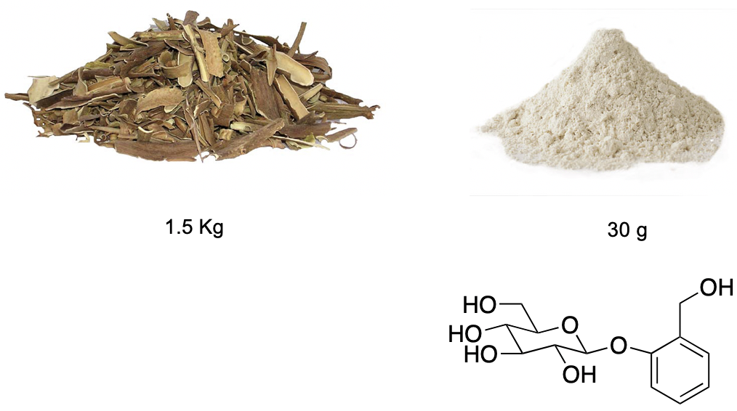
      - The active ingredient in willow is salicin
        - In 1829 salicin was isolated (someone was able to do this successfully)
        - They discovered that if you take 1.5 kg of bark the you can isolate approximately 30 g of active ingredient

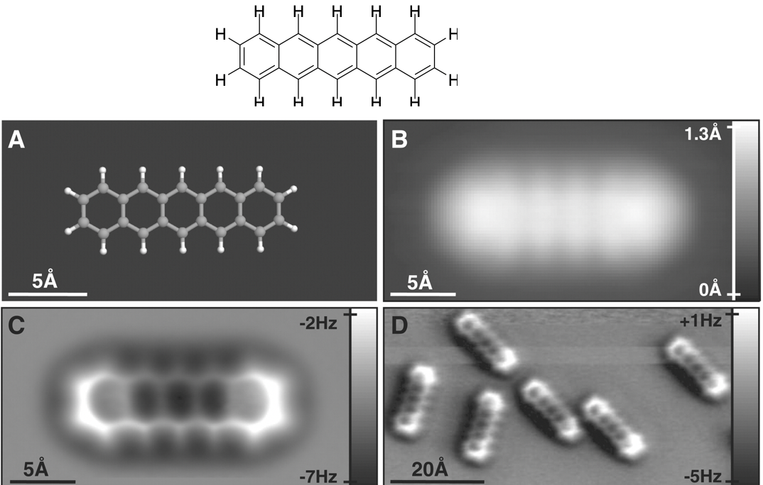
Chemical Structures
- Represent the shape and function of molecules
- Match shapes to match function
  - (The shape of molecules dictate how they function within the body)
- The molecules actually look like the drawings
  - We use a style that reflects the overall shape of how the molecule presents itself
  - We use scanning tunneling microscopes to see single molecules on the microscope
  - We also use the shape of representations often because they are very close to the actual shape of the molecules

Salicin
- We only get a little salicin from a lot of bark
- 1.5 kg (1500 g) of bark produces 30 g of salicin
- Only 1-2% of bark is active ingredient, so we must consume a large quantity of bark and this is why it was so expensive

Salicin converted to salicylic acid in 1838
- Better drug than salicin (lower dosages)
- Occurs in meadowsweet flowers (very small amounts)
- Someone discovered that you can process salicin into salicylic acid
- The original molecule gets cut in half and the stuff on the left (refer to molecule drawing) gets thrown away and the stuff on the right (again drawing) is what gets converted into salicylic acid; this becomes the active ingredient that reduces our pain
  - Analgesic – reduces pain
  - Antipyretic – reduces fever
  - Antinflammatory – good to reduce swelling
- Salicylic acid is effective in lower dosages and is more effective in reducing pain and fever than salicin

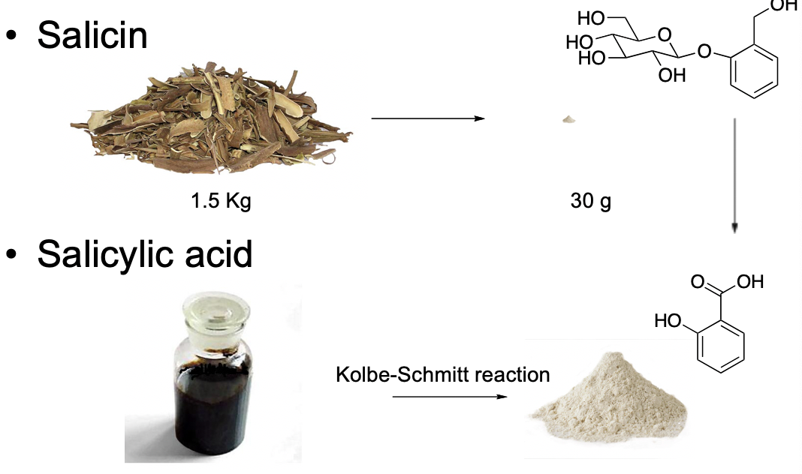
Salicylic acid manufactured from coal tar
- The identification was a significant breakthrough because it made it possible for pain reduction to the general public
- You can manufacture salicylic acid from coal tar which means that you can produce it in much larger quantities
- Coal tar was a waste product in the 1800s
  - Someone discovered that you can convert coal into a gas called coal gas and then you can convert that into coal tar
  - They used coal gas for lamps which created a waste (coal tar)

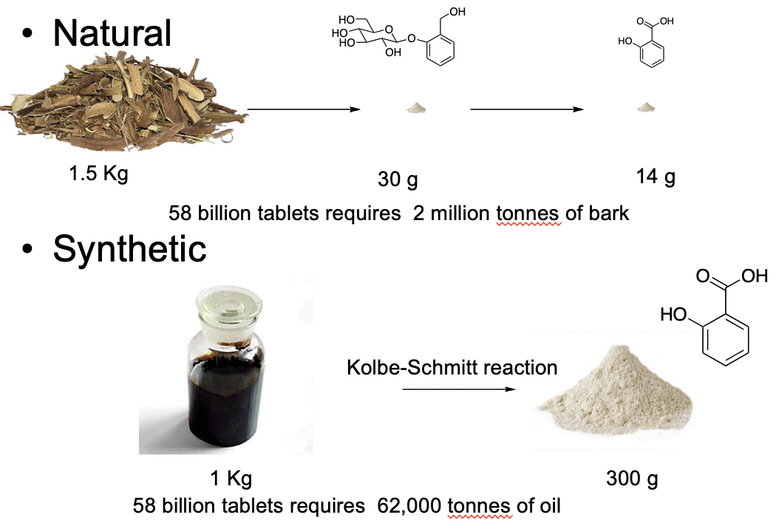
Synthetic vs. “Natural”
- Coal tar became a very important source in manufacturing drugs
- Natural – from natural materials
- Synthetic – from coal tar and carrying out chemical reactions to make the exact same substance as natural
- When dealing with chemical materials, the substance that you get at the end of the day is identical – the ingredients you get from both natural and synthetic are IDENTICAL
- There is an advantage to synthetic materials – manufacture in much larger quantities at cheaper prices as the materials are cheaper
  - Material is manufactured from oil
- Natural material issue – supply
  - Need a massive amount of bark to supple the product
  - It is impossible to supply the needs of the medication that we need today
- The only difference between natural and synthetic is that the source where the original materials came from is different

Dye companies specialized in coal tar chemistry
- Manufacturing from coal made pain medications basically available to everyone
- Coal allowed for large quantities to be sold at the lowest price as possible
- They dye companies exploited the coal tar waste product and rapidly branched into making dyes because the chemistry to make dyes was the same as the chemistry required to make drugs
- Salicylic acid was made and sold by dye companies

Salicylic acid was a drug with problems
- Beneficial effects:
  - Analgesic
  - Antipyretic
  - Antinflammatory
- Side effects which created a problem:
  - Bitter taste
    - It used to be taken as a powder which meant it was difficult to make children take it – especially with the taste
  - Stomach irritation
    - It caused upset stomachs and in certain cases it could become a life-threatening situation that could potentially kill you
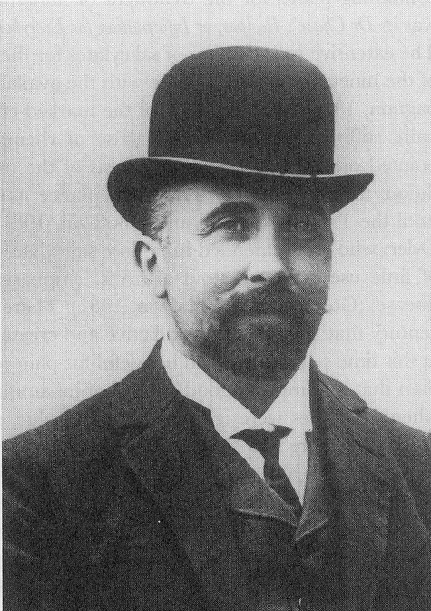
Felix Hoffmann 1868 – 1946
- His father had arthritis
  - Took salicylic acid for the pain
  - Suffered from stomach problem
- Hoffman realized that they were using different chemical products to manufacture this naturally made product
- He looked at the chemical structure and realized since doing a chemical reaction to make it, maybe he could use a chemical reaction to modify it

Process of drug optimization
- Hoffmann basically invented the modern drug industry
  - He artificially made drugs to make them better for us
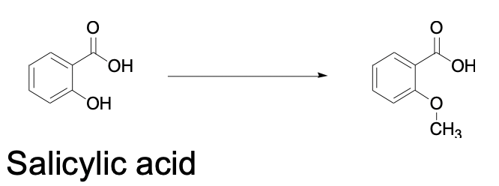
  - He made small changes to the molecular structure to find out what made it better or worse
  - He found that he had gotten rid of the harmful side effects when he replaced the OH with CH3 but unfortunately also got rid of the beneficial effects
    - Tasted less bitter, no stomach irritation, but not effective for pain
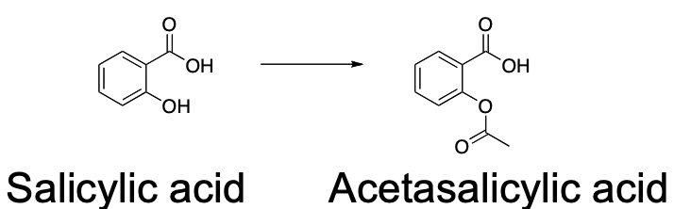
    - He realized that he just didn’t pick the right spot to modify
- On August 10, 1897
  - He realized that if he changed OH into something else it will produce less stomach irritation and it better at reducing pain and fever – he made the first artificial drug
  - Natural drug – from a natural object
  - Artificial drug – substance that doesn’t occur outside of the construction of humans (doesn’t exist in nature) > must be purely synthetic
  - Synthetic – refers to how we make a drug, it can be natural or artificial

Aspirin
- Aspirin was the world’s first artificial drug
- It was initially sold as a powder
- Bayer changed it into a tablet
  - The aspirin tablets become more popular
  - Standardized the dosage – by putting in tablet you ensure that each tablet has the same does
    - Easier to consume

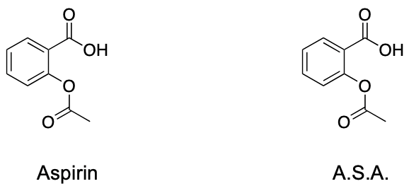
Aspirin and A.S.A.
- Acetasalicylic acid (A.S.A)
- 2 names associate with it:
  - Aspirin = trade name
  - A.S.A = generic name – scientific name
- Companies that invent new drugs git it a trade name – it is short and easy to remember that doesn’t sound scary and they use this. Name when selling their product
  - Only the company that originally discovered the drug can use the same name – the generic name is the name that everyone else can use
    - For other companies, it doesn’t matter about the name that they come up with and use, they just have to have the exact same makeup
  - The scientific name is the most important name to remember when in the drug store, you will have a wider selection to choose from if you look for the scientific name

A.S.A.
- Is very specific for the type of pain that you have
  - It is very good for muscle pain
  - Not good for visceral (organ) pain
  - Typically, good for reducing pain on the outer part of your body
- Benefits
  - Pain
  - Fever
  - Inflammation
  - Reduce heart attack risk
- Side effects
  - Tinnitus
  - Stomach irritation
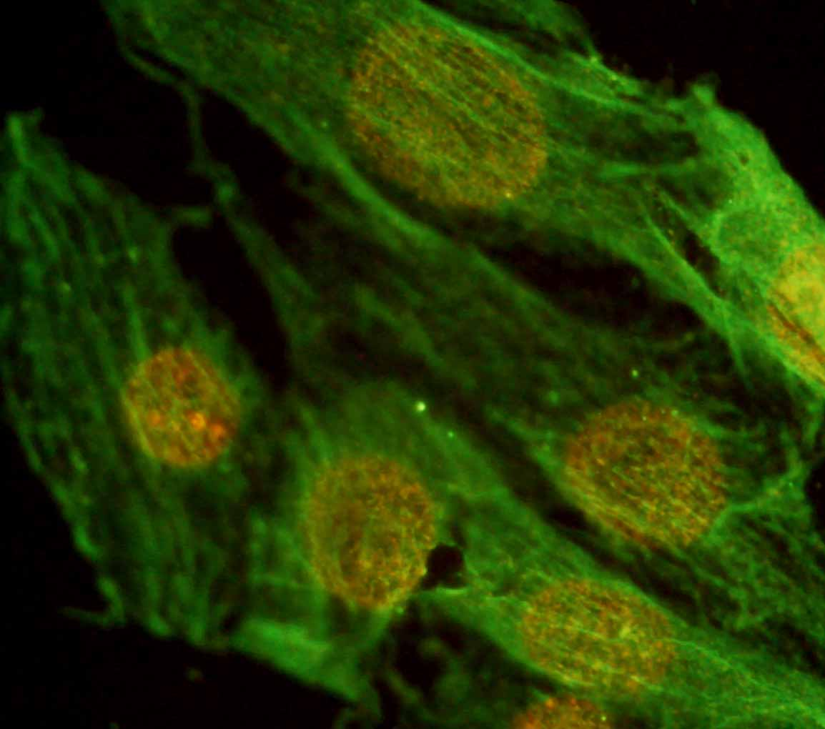
  - Blood clotting

A.S.A. interferes with the production of prostaglandins
- Prostaglandins are local hormones
  - Produced and “used” in the same cell
  - Exist for short times
  - They communicate over short distances and short periods of time within the body – the production is linked to the processed pain in the body
  - When produced they result in the feeling of pain, fever, etc.

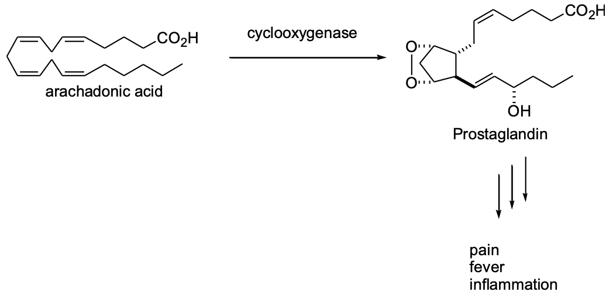
Prostaglandin biosynthesis
- Regulated when the body decides it needs to feel pain, it manufactures prostaglandins
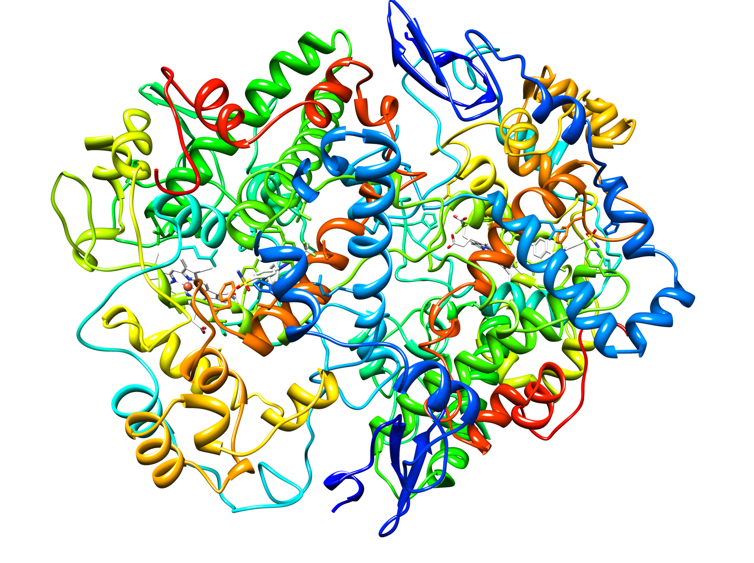
- Arachidonic acid in the body, through the special enzyme cyclooxygenase, undergoes a chemical reaction into prostaglandins
- “-ase” = an enzyme in the body
- We screw up the operations of the machine by using drugs
- Aspirin deactivates the machine
  - It chemically changes the structure of the machine into something else so if the machine doesn’t work, we can’t produce prostaglandins which means we can’t produce pain

Cyclooxygenase
- The shape of the enzyme is important, it gives us the function that it does and causes it to have the chemical reaction that it does
- Enzymes are machines
  - There’s a physical movement that carries out the enzyme reactions

Drugs block machine action
- Antibiotics prevent the machine from operating by blocking the action of the machine
- The drug must make physical contact with the biological molecule, when it does this it prevents the machine from operating which creates the drug effect in the body
- Every drug that we take work in the same way

Aspirin blocks the cyclooxygenase machine
- Aspirin is composed 2 identical proteins that stick together in the same way
- In the middle of the machine there are specific atoms that do everything – when looking at atoms, most of the enzyme functions to hold things in place
- Aspirin interacts with the two specialized units and chemically changes them into something else
  - aspirin has exactly the right shape that allow themselves to fit into the place of the 2 atoms
  - it will transform the enzyme into a particular substance – changes the key part into something else
- The drug physically touches other components in the body that are doing the reaction and prevents the component from doing this function by chemically altering it

A.S.A. for pain, inflammation, and fever
- Aspirin and heart disease
  - There is a link between aspirin and heart disease – people who take aspirin over a long period of time have reduced risk of heart attack
- One aspirin tablet every 2 days for 5 years
Myocardial infarction | Aspirin | Placebo
Fatal | 10 | 26
Non-fatal | 129 | 213

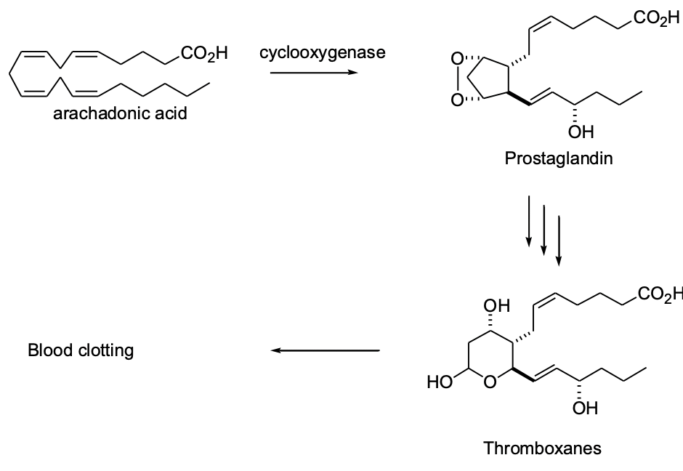
Prostaglandins and blood clotting
- Aspirin to prevent heart attack
  - This is something you do under a doctor’s prescription but typically they only do this if the individual has a high risk for heart attack
  - There are side effects with taking aspirin everyday which are more dangerous than the preventative ability

A.S.A. and cancer?
- The reduction in cancer risk is relatively small and you only get the reduction after taking aspirin for 10 years
- This works but it is impractical

A.S.A. in the news
- A crazy man used A.S.A. to kill a lot of individuals
- His name was Anders Breivik
- He made homemade explosives through aspirin and then proceeded to kill a bunch of children on an island through homemade explosives and guns
- He changed A.S.A. to picric acid
  - It’s an efficient way to make picric acid through aspirin tablets

Side effects of A.S.A.
- Death
  - More than 60 tablets at once
  - This is not accidental
  - When someone dies from aspirin poisoning, it is suicide
- Ringing in the ears
  - Tinnitus – a ringing sound in your ears
    - This occurred when more than 10 tablets have been consumed – it’s a warning sign
    - Warning of salicylism (aspirin poisoning)
      - If you stop taking the pills the ringing sound will go away
      - The ringing is a warning to call poison control or go to the ER
- Stomach irritation – excess HCl
  - HCl is produced in the stomach and the aspirin has the effect that causes damage to the stomach through the excess HCl produced
  - The stomach produces a specialized form of mucous that creates a barrier and protects the stomach from HCl
  - Mucous protects the stomach
  - Producing prostaglandins in the stomach is good
  - Prostaglandins help to protect the stomach
    - Decrease acid productions
    - Increase mucous production

  - Aspirin causes acid damage in the stomach
    - Taking aspirin blocks the function of the enzyme and prostaglandins are not manufactured in the stomach which results in the increase of HCl production in the stomach and decrease in mucous production which makes the individual more likely for corrosion of the stomach lining
    - Increase acid production
    - Decrease mucous production
  - Long-term aspirin use causes stomach damage (LONG-TERM)
  - Tablets can cause stomach irritation
    - Irritation typically happens on an empty stomach when the pill gets caught on the fold of the stomach and it dissolves in one spot (this is what causes the irritation)

Bufferin
- Contains an antacid
  - MgSO₄ (gypsum)
- Pills dissolve quickly
- (counteracts the effect of the acid in the stomach)

Plastic coating on A.S.A. tablets
- Typically for people who have arthritis
- The coating prevents it from dissolving in the stomach

Avoid irritation of the stomach
- Swallow pills with a lot of water
- Do this to ensure that the water fills the stomach and lessens the wrinkles in the stomach walls
  - This will prevent the fill from getting caught in the folds of the stomach

Rye syndrome and influenza
- There was a situation where children had a high fever which lead to brain swelling
- This increased during a period of time in the 1970s where they found that people who had this problem had also consumed children’s aspirin
- Children’s aspirin was no longer available
  - The condition was serious enough that they found that it was NOT worth it to test on children so the solution was to remove it from the shelves and replace it with Tylenol
  - No causative link between A.S.A. and Rye syndrome
  - Children’s aspirin was removed as a precaution

Cause vs. association
- An association between 2 things does not mean that one thing influenced (caused) the other
- Should not be concerned
- Association shows statistic link
- Association
  - Notice statistically that things are connected, this is often meaningless
- Cause – happens when we know that things are definitely connected and that the drug definitely causes a symptom (there will be a whole series of information that has been used to establish a cause)
  - Requires a body of evidence
    - Associated between 2 things
    - Control experiments
      - Eliminate other possibilities
    - Experiments with animals
    - Biochemical explanation of the effect
    - Deliberately change one factor to look for changes in the other
Cause (Aspirin and stomach irritation)
- Aspirin and stomach irritation
  - Ulcers are common in people who take aspirin (long-term)
  - Ulcers are less common in people who don’t use aspirin (control)
  - Aspirin dosing in rats results in more ulcers (animal)
  - Prostaglandin production in the stomach lowers stomach acid and increases mucous production (biochemical)
  - Aspirin use raises stomach acid and decreases mucous production
    - Aspirin inhibits prostaglandin production
  - Stomach irritation will reduce if you stop taking aspirin (change, animals)
- We know all of this above information because there is a lot of data to support this

Strength and Form and caffeine
- There’s a variety of strengths that are available
  - EX: regular strength vs. extra strength
- There’s a variety of forms that you can get, the form doesn’t matter – they all work the same
  - You’ll likely be unable to see the difference between taking tablets, capsules, or gelcaps
  - Some may claim that they’ll be faster but only scientists will be able to notice this, you cannot tell the difference it is very minuscule
    - From the POV of the scientist it works faster but from the POV of the consumer it is not noticeable
- There’s generic vs. name brand
- Some forms of pills add caffeine for headaches
  - A.S.A. 325 mg
  - Contain caffeine 32 mg

Name brand vs. Generic brand
- Quality often costs more
- People often associate name brands and quality, this is true for physical things but not for pharmaceuticals
- Generic drugs are the same quality as name brands
  - Same chemical substance
    - The chemical substances do not differ from company to company
  - Same dosage
    - It is the exact same chemical substances, brand does not matter
  - Equivalent bioavailability
    - Same amount of drug enters the body
    - Test must make the same outcome
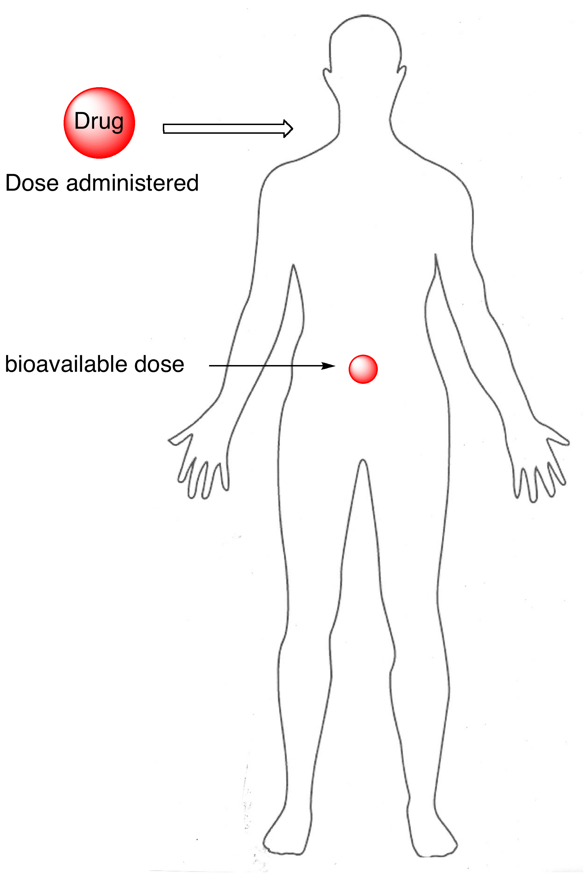
Bioavailability – how much drug gets in
- A small amount of the drug will never make it into the body
- By law, a company must prove that the amount of drug that enters the body is comparable and equivalent to the name brand drug (must be very similar)
- Generic drugs are equal to name brand drugs
  - Same chemical substance
  - Same dosage
  - Must have equivalent bioavailability
    - Same amount of drug enters the body

Use name brand to find the generic brand
- Brand does not matter – they are literally all the same
- Find the name brand in the store and then find the generic name and dose, then just compare and match the name and dose to a generic product
- If you know the generic name and the amount in the product you can use it to find the scientific name in order to buy the cheaper version

A.S.A Summary
Benefit |  | Side effect
Pain | Yes | Reducing blood clotting | Yes
Fever | Yes | Stomach irritation | Yes
Inflammation | Yes | Rye syndrome | Maybe
Prevent heart attack | yes
- Big side effect – stomach irritation
- Don’t stress over blood clotting
- Rye syndrome is possible but we aren’t sure if there’s truly a link or not

Price per 100 tablets
Bayer aspirin | $ 9.49
Bayer aspirin (extra strength) | $ 9.99
Bufferin | $ 12.49
Bayer coated aspirin | $ 15.82
Anacin | $ 11.49
Bayer Aspirin Low Dose | $ 17.99
Generic A.S.A. | $ 2.50
Generic A.S.A. | $ 7.99
- Extra strength just means that they put more active ingredient into the tablet
- They sell a lot less of the regular strength tablets so they bring up the price to compensate
  - It is more cost effective to buy the extra strength stuff
- Bayer low dose is very expensive (this is what you take to compare or take to protect against heart attack) – it is 8X more expensive than regular dose aspirin
- All of these products are identical but the Bayer Low Dose will be more expensive because it is what is taken when recommended under prescription by a doctor and companies figure insurance will cover the costs
  - If you don’t have insurance – buy regular strength and just cut the pill into 4 pieces
- Often times now in 2019 the generic brand is more expensive than brand name

A. Cahn and P. Hepp 1886
- Experimenting to find a vermifuge
- Noticed a fever reduction in person who was given acetanilide
- Antikamnia (antifebrin)
  - Made from coal tar
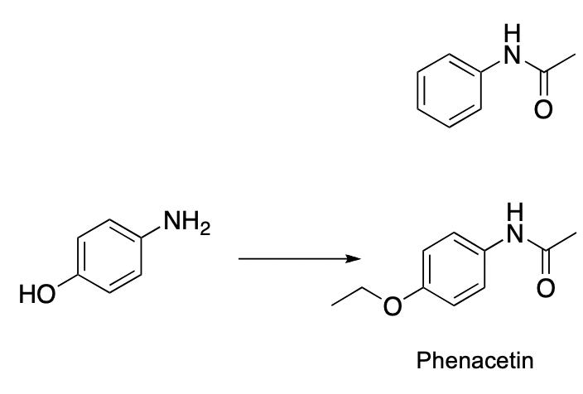
Carl Duisberg
- Chemist at Bayer
- Needed to dispose of 50 tons of aminophenol
- He realized that if he could modify aminophenol then he could make it effective for reducing pain
- He didn’t test it because he thought that the OH compound was potentially toxic
- (bottom left – aminophenol)
- (top right – the one that reduces pain)
Phenacetin
- APC tablet – sold for a long time as a pain reliever (you can still find this product in Australia)
  - (combines aspirin and caffeine which can be used to treat certain kinds of headaches and can be more effective than some other types of pain reliever)
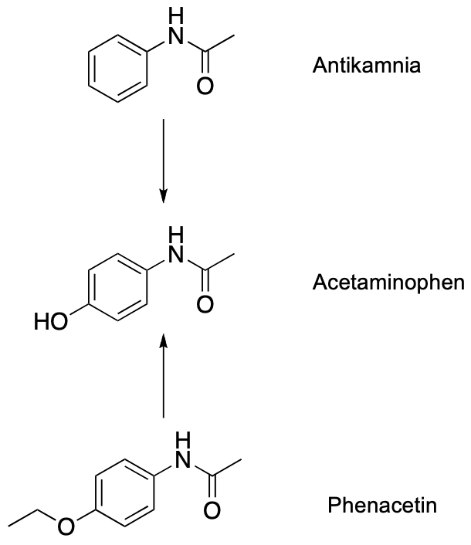
  - Aspirin
  - Phenacetin
  - Caffeine

Both drugs converted to acetaminophen in the body – 1947
- Both Antikamnia and Phenacetin compounds were metabolized into the same substance within the body
  - Acetaminophen is the REAL pain reliever in the body
- Acetaminophen offers pain relief through increasing our pain threshold
  - Tylenol does this

Acetaminophen raises pain threshold
- Reduces the body’s ability to feel pain and is very effective for:
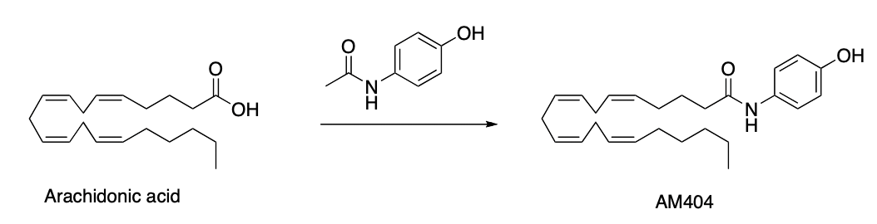
  - For muscle pain
  - For visceral pain
- It is an antipyretic (has the ability to reduce fever)
- It is not for inflammation or swelling
  - It will relieve the pain but it will not reduce the swelling
  - It does not inhibit prostaglandin synthesis
    - It has nothing to do with prostaglandins and this is why it does not help with swelling – does not have the same function as aspirin
- Arthritis use – variable effectiveness
  - Reduces the pain of arthritis and will reduce ALL arthritis pain, but some are more effective for certain kinds
  - Osteoarthritis
    - Works well
  - Rheumatoid arthritis
    - Works ok
    - Better to use pain relief that targets prostaglandins
- Stomach irritation
  - A.S.A.
    - Strong irritation (chronic)
  - Acetaminophen
    - Weak irritation (?) (if you create a new drug to go into the same class as others, you still have to list all the possible side effects of the others – even if the side effect has been eliminated in the new one – done as a precaution)
- Death
  - More than 60 tablets
    - If someone dies from acetaminophen you know it is suicide because it is impossible to accidently swallow 60 pills
  - #1 suicide drug in England

Acetaminophen liver toxicity
- The liver is there to reduce toxic substances from our food
- The liver metabolizes the food
  - It chemically changes it so that it can remove it from our body
- (top of diagram) this is the safe pathway to reduce toxicity – if followed there should be no problems
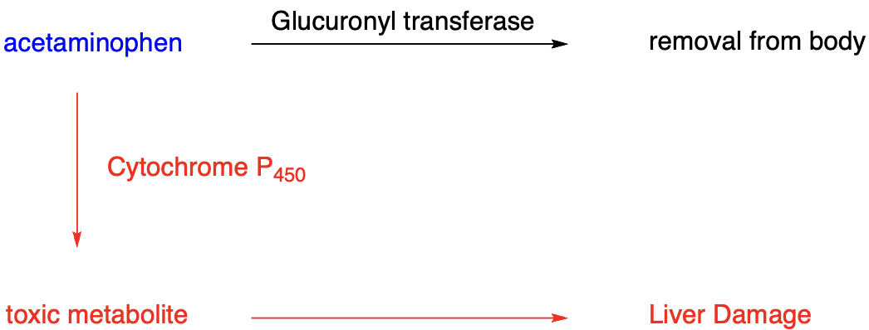
- (bottom of diagram) if you take too much acetaminophen then the liver changes it into a toxin created in the liver and it damages the liver

Never take acetaminophen for a hangover
- Alcohol stimulates liver function
- If you consume acetaminophen at the same time that your liver and detoxifying the effects of alcohol, it can damage your liver because the liver is already removing the toxicity from the alcohol
- Acetaminophen poisoning is very common
  - They warn people now because acetaminophen has been recognized as safe, so it gets put into a lot of different products

Acetaminophen as a common ingredient
- Acetaminophen is in many prescription medications
  - If both medications that you take contain acetaminophen, then you will overdose as it becomes toxic for your liver
- It is in many OTC medications
  - A lot of people accidently take too much and end up poisoning ourselves (overdose)
  - Now, as a result, they are starting to change the labels and ingredients in medications

There is no risk for Rye syndrome
- No association with acetaminophen
- Since there is no link between Rye syndrome and acetaminophen, it can be used to reduce fever or pain from teething

Children’s Tylenol in small bottles
- Child’s Tylenol is only available in small bottles and it is very expensive
  - This is a safety procedure
    - Children’s medications are made as a liquid and taste good and children cannot tell the difference between candy and medicine
  - The bottles are child proof but children are still able to get through it
    - Because of this they only keep a small amount of liquid inside the bottle to make sure that there is not enough medication in there to harm a child if they were to drink the entire bottle

Tylenol regular and extra strength
- Regular: Acetaminophen 325 mg
- Tylenol is available in regular and extra strength; the difference is the amount of drug put in (~50% more active ingredient is put into extra strength)
- Extra strength: acetaminophen 500 mg
  - Bought more often

Tylenol arthritis or muscle and body
- Acetaminophen 650 mg > this pill is equivalent to approximately 2 regular strength tablets
  - Contains the same ingredients
- The arthritis pills are more expensive because you often require a prescription to use them and there is usually insurance coverage for prescriptions
  - They are identical products

Tylenol Migraine
- Used for people who suffer from migraines
- Acetaminophen 500 mg
  - Caffeine 65 mg
- Caffeine is good for certain kinds of headaches, the amount of caffeine in the pill is approximately half a cup of coffee

Tylenol and Cyanide incident – 1982
- Tylenol is associated with multiple poisoning cases in 1982
- Involved the Tylenol capsules
  - Capsules: hollow plastic tubes with powdered medication inside
- A crazy man bought a bunch of Tylenol capsules and removed the Tylenol medication and replaced it with cyanide
- He resealed the capsules and boxes and then went back into various pharmacies across the city and put the resealed boxes back onto the shelf
- A lot of people died from the consumption of cyanide laced Tylenol products
- Tylenol capsules were recalled by J & J across the entire world
  - They did this until they could solve the problem
- Because of this incident there are now safety features built into OTC drugs
  - You can only buy capsules through prescription drugs and there are now non-tamper proof pills now to prevent forgery from occurring
    - The caplets replaced the capsules
    - The safety seal was added to all OTC medication – tamper-proof
      - This is done at a factory and is very difficult to forge
      - If you find one of the 2 safety features damaged – do NOT consume

Acetaminophen Summary
Benefit |  | Side effect
Pain | Yes | Reduced blood clotting | No
Fever | Yes | Stomach irritation | No
Inflammation | No | Rye syndrome | No
Prevent heart attack | No | Liver toxicity | yes
- A lot of companies manufacture or include acetaminophen into their products
- Big side effect to worry about: liver toxicity

Price for 100 Tablets
Tylenol | $ 10.49
Tylenol extra strength | $ 9.00
Tylenol migraine | $ 13.88
Tylenol muscle and body | $ 18.74
Tylenol arthritis | $ 22.98
Tylenol PM | $ 17.98
Children’s Tylenol | $ 32.99
Generic acetaminophen (brand X) | $ 3.20
Generic acetaminophen (brand Y) | $ 7.99
- When you buy Tylenol, you are paying for things in the pill other than the medications
- Muscle and body and arthritis Tylenol are identical products
- Children’s Tylenol is much more expensive than regular strength but it is very important to only keep it in small amounts to ensure a child’s safety
- Generic brand prices have been raised

Ibuprofen
- Developed in 1961
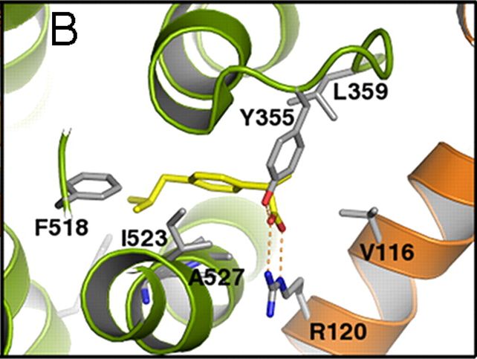
- It was originally only given by prescription
- It was approved as it was found to be safe enough to be given OTC in 1984

Ibuprofen inhibits cyclooxygenase
- Similar to how aspirin works
- There's a pocket on the enzyme where cyclooxygenase is supposed to attach and do its job but ibuprofen fits into the site and blocks it – inhibiting cyclooxygenase

Ibuprofen Summary
Benefit |  | Side effect
Pain | Yes | Reduced blood clotting | Yes
Fever | Yes | Stomach irritation | Yes
Inflammation | Yes | Rye syndrome | No
Prevent heart attack | No | Liver toxicity | No
- Pain relief lasts longer > these last 8 hours the other medications last about 4 hours
- Big one: stomach irritation
  - Typically happens when you have a condition like arthritis where you’re taking these pills very often over a long period of time

Advil
- Ibuprofen 200 mg
- Ibuprofen is the active ingredient in Advil

Motrin and Advil are the same stuff
- The active ingredient in Motrin is also in Advil
- Motrin regular strength 200 mg
- Motrin extra strength 300 mg
- Motrin super strength 400 mg

Read the back of the box NOT the front
- Advil migraine vs. Advil regular
- When it comes to migraines, people have the impression that the pain is worse than headache pain. People also have the impression that migraine medications (because of the previous impression) are stronger so they should also work on regular headaches
- Read the back of the box:
  - Regular Advil – 200 mg of ibuprofen
  - Migraine Advil – 200 mg of ibuprofen
- You end up paying more for migraine medication even though they contain the same amount of active ingredient and work the same
- Generic ibuprofen contains 200 mg

Price for 100 tablets
Advil | $ 23.60
Extra strength Advil | $ 24.29
Advil Migraine | $ 32.40
Motrin | $ 12.49
Extra strength Motrin | $ 14.69
Super Strength Motrin | $ 24.98
Children’s Motrin | $ 45.79
Generic ibuprofen Brand X | $ 4.59
Generic Ibuprofen Brand Y | $ 17.68
- Double the product in extra strength but they’re basically the same price
- Advil regular and Advil migraine are identical products but you will pay more for migraine Advil
- Motrin and Advil are the same product but Motrin is half the price of Advil

Naproxen
- This is a newer drug
- Aleve
- Very good for inflammation
- Generic now available
- Relatively expensive

Top pain relievers (North America)
- Acetaminophen – 43%
  - Tylenol has taken over due to the Rye syndrome so people moved away from A.S.A. and Tylenol
- A.S.A. – 28%
- Ibuprofen – 26%
- Naproxen – 3 %
  - Because this product is so expensive it represents a small percentage of the market

Benefits and side effects
Effect | A.S.A. | Acetaminophen | Ibuprofen | Naproxen
Pain | Yes | Yes | Yes | Yes
Fever | Yes | Yes | Yes | Yes
Inflammation | Yes | No | Yes | Yes
Prevent heart attack | Yes | No | No | No
Reduced blood clotting | Yes | No | Yes | Yes
Stomach irritation | Yes | No | Yes | Yes
Rye syndrome | Maybe | No | No | No
Liver toxicity | No | Yes | No | no

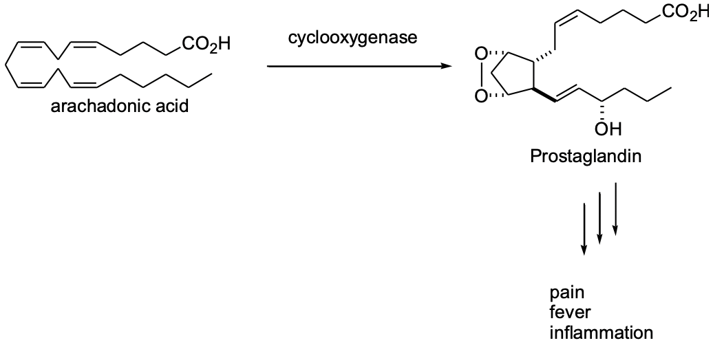
COX-1 and COX-2
- Comes in two different forms within the body that carry out the same interaction
- Reduces pain, fever, and inflammation
- COX is short for cyclooxygenase, 1 and 2 are the different forms

Effect of COX-1 inhibition
- Consumption of aspirin inhibits the production of COX-1
  - Don’t want this to happen because it produces harmful effects that leads to stomach problems
- Primarily located in the stomach
  - HCl production increases
  - Mucous production decreases
- Platelets
  - Clotting inhibition
- Long-term COX-1 inhibition
  - In the long-term it produces life threatening ulcers in the stomach that bleed severely
    - The ulcers won’t stop bleeding because you have stopped the clotting factors (platelets, clotting inhibition)
    - You can BLEED OUT INSIDE of your body – kills you
- Harmful effects

The effect of COX-2 inhibition
- It is distributed around the muscles
  - Reduces pain
  - Reduces inflammation
  - Reduces fever
- These are the beneficial effects to why we would take aspirin or ibuprofen, etc.

Current arthritis treatments
- Inhibit both COX-1 and COX-2
- COX-2 is beneficial
  - Reduces pain
  - Reduces inflammation
- COX-1 is harmful
  - Stomach irritation
  - Blood clotting inhibited
  - Bleeding ulcer in chronic users – occurs in period over a long period of time
Selective COX-2 inhibitor for arthritis
- You can engineer a drug that can block only COX-2
- This is safe because it skips the dangerous stomach effects
- Vioxx – a Canadian drug developed in Montreal (no longer available)

VIOXX Clinical Trials
- Approximately 60 studies were done
  - More than 5000 patients
  - No serious side effects
  - No difference in cardiovascular disease vs. placebo
- Drug approved in 1999
  - Sales averaged $ 2.5 billion/year
- When it came out it was a safe alternative, a very clean drug in terms of side effects
  - Very advantageous to people with arthritis

VIGOR – VIOXX GI Outcomes Research
- The drug company got themselves into trouble
- They carried out the clinical trial after the drug was on the market
  - Companies do this to advertise their drug to the doctors

VIGOR was done for marketing
- Illustrated reduced risk of ulcer
  - 18-month study
    - They were trying to advertise to doctors to switch their patients from ibuprofen to vioxx
    - (designed to show risk of ulcer)
  - Used naproxen as a placebo
    - Used VIOXX at twice the normal dose* and compared it to one of the existing drugs that produced stomach products
    - Naproxen was given at the normal amount
    - When they submitted their data for the full 18 months to the FDA, when they published the information it was a slightly different data set
      - Only published the first 10 months of data
  - Study showed 54% reduction in serious GI side effects with VIOXX
    - 56 out of 4047 for VIOXX
    - 121 out of 4029 for naproxen
- Full VIGOR data released to FDA
  - The data included everything but within the first 10 months there was not an increased risk for heart attack
    - It turns out that people who were taking VIOXX had a 4x risk of having a heart attack as opposed to taking the original medication
  - Increase risk of heart attack
    - 0.4 % for VIOXX (45 out of 4047)
    - 0.1 % for naproxen (19 out of 4029 patients)
    - No difference in mortality
  - Paper in NEJM reported no adverse effects
    - Only data from first 10 months was included
      - This made them look sneaky because they only published the first 10 months – it made them look like there were trying to cover up the information
        - The media went crazy on Vioxx, they made them look like they were trying to cover-up

FDA Analysis of 1.4 million patients
- The FDA went back and found that the heart attack risk was real
  - Estimated that VIOXX caused 88 000 – 139 000 heart attacks during 1999-2004
- The FDA didn’t tell them to take it off the market, they did it themselves because the drug was not cost effective
  - (they were being sued so much)
- In 2004, Merck voluntarily removed the drug from the market
  - Cut 7000 jobs
  - >10 000 jobs

2005 Advisory Panel Conclusions
- The FDA looked at the data and asked the advisory panel to make a recommendation of what should happen
  - The panel recommended that the drug be put back on the market because “Patients benefit from having a variety of drugs to choose from”
  - The panel was heavily criticized because of this
- The benefits outweigh the risks
  - Current arthritis treatment
    - FDA estimates 10 000 to 20 000 deaths/year from gastrointestinal bleeding
  - VIOXX as an arthritis treatment
    - FDA estimates 18 000 – 28 000 heart attacks/year
    - Risk of heart attack was similar to ibuprofen
    - Just needed to improve the labeling and MD education
  - Merck refused to re-introduce the drug
    - Risks outweigh the benefits
    - >10 000 lawsuits
  - It was deaths vs. heart attacks
    - Because of the different units, it was part of the recommendation the other was the improved labelling and MD education
      - Now that they knew the problem, all they had to do is change the label and teach doctors not to give it to high risk heart attack patients OR monitor them closely
    - It was not cost-effective for the company so they wouldn’t put it back onto the market in North America

Know what the numbers mean
- It is worth it to find out the base of the data
- Raw data is informative
  - If you look at the raw data you will be able to notice for example that a surgery will offer benefits 3 weeks in but a couple months down the road there may no longer be no benefits so if knowing the raw data you can make education decisions

