Science issues a big part of your life – make informed decisions
- Science vs. Magic
  - Science
    - Collect facts
    - Draw conclusions based on those facts
    - Test your conclusions in several ways
  - Magic, superstition
    - Draw the conclusions you want
    - Find some facts to fit those conclusions
    - Avoid testing or challenging your conclusions
- Human brain’s default mode is “magic”
  - Draw conclusions you want
  - Find some facts to fit those conclusions
  - Avoid testing or challenging your conclusions
  - Ignore or explain away contradictory evidence
- Concept of science is new
  - Developed in last 150 years
    - Collect facts
    - Draw conclusions based on those facts
    - Test your conclusions in several ways
    - Include all evidence

Life Expectancy (2009)
Rank | Country | Years of Life
1 | Macau | 84.4
2 | Andorra | 82.5
3 | Japan | 82.1
4 | Singapore | 82.0
5 | San Marino | 82.0
6 | Hong Kong | 81.9
7 | Australia | 81.6
8 | Canada | 81.2
9 | France | 81.0
159 | World Average | 66.6
224 | Swaziland | 31.9
- We live in a unique time and place
- Our current life expectancy is higher than any other time in history
- Know the ballpark numbers not necessarily the exact number
- Swaziland life expectancy is like prehistoric expectancy

Life Expectancy Through History
- Life span is an educated guess made based on written records and archaeology
- It is important to remember that only “important” people make it into historical records, life expectancy is mostly “ordinary” people
- ~30 to 35 years for most of recorded history
  - Last 6000 years
- ~30 to 35 years through the stone age
  - 500 000 to 6000 years ago
- 82 years in 2009 (Canada)
  - Most improvements over the last 150 years
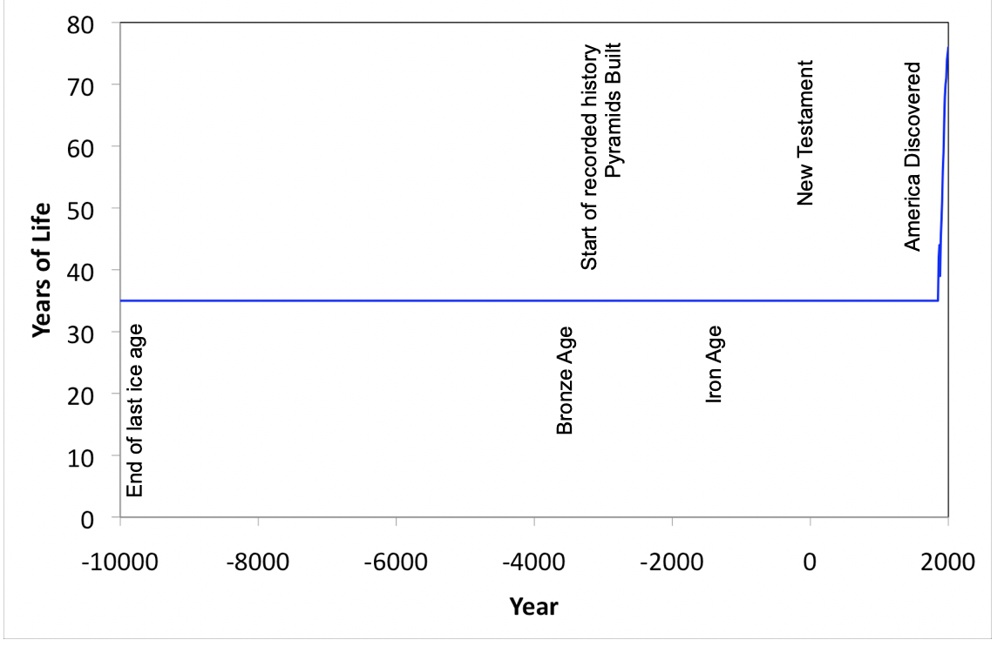
- Variations smoothed out (as records are not precise)
- Number of 35 years is an estimate made by combining data from various sources
- Numbers may vary depending on source used
- Range is more appropriate

Increase was only in the last 150 years (data for USA)
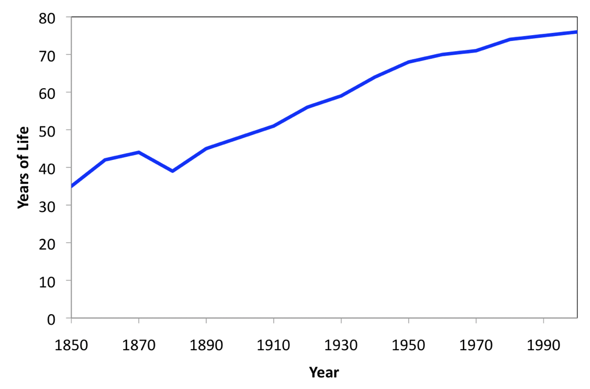
- 150 years ago, life expectancy was same as that of the stone age

Life in the “good old days”
- Harsh
  - People were constantly sick
- Cruel
- Short
  - 200 years ago, you would only expect to live to be maybe 30-35
- Disease was common and dangerous
  - Our quality of life now is much better
  - If we catch something now we don’t worry about dying, but if you were to get sick 200 years ago you had the potential to die
- Lice and fleas on humans
  - People were common to carry parasites such as lice all the time, now it is very uncommon

Life with worms
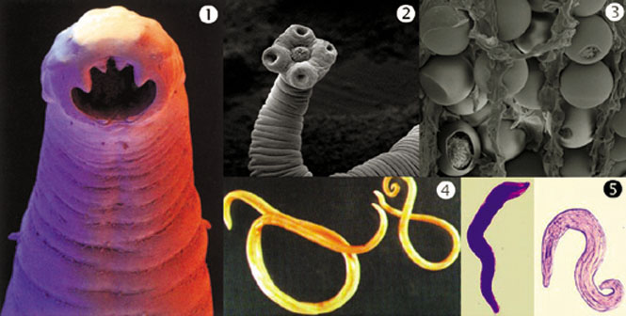
- Many people 100s of years ago commonly had worms
  - Hookworm
  - Tapeworm – can lay 1 million eggs/day
  - Tapeworm eggs
  - Roundworm max size 50 cm lay 200,000 eggs/day
  - Pinworms – migrates out of the colon and lays eggs in the anus - itching

Improved quality of life in Canada
1900 | 2004
- Life expectancy: 44 years  - Main causes of death  - Pneumonia  - Tuberculosis  - Influenza  - Lasted until 1950s | - Life expectancy: 82 years  - Main causes of death  - Heart disease  - Cancer  - Stroke  - Lower respiratory infection  - Traffic accidents  - Diabetes
    - Life expectancy has doubled in the last 100 years
    - There has also been changes in the quality of life
    - The main causes of death have shifted from infectious diseases to “wear-and-tear”
      - Infections are still part of the deaths in Canada but are still very small percentage
      - You are more likely to have your body die out or get hit by a car than die from an infectious disease
    - Historically people lived their entire lives in an unhealthy state, they were constantly sick (with parasites)
      - This condition still exists in many developing countries

Main Reasons for Improved Health
- (more or less in order of importance)
- (today vs. 100s of years ago)
- Improved sanitation
  - We now separate our waste from us
  - Plumbing is new
  - 100s of years ago we did not physically separate ourselves from our waste
    - (outhouse)
    - A chamber put was used when cesspits were available
      - If you lived in a city where the population was too high for you to have an outhouse, then you would have a chamber pot in your bedroom
      - You would relieve yourself in your bedroom and empty it every day – it would be picked up by a cart
  - Open vs. closed sewers
    - If there were no carts available to pick up your waste, you would’ve brought your waste to an open sewer
    - Once you put things into a separated plumbing system, you reduce the risk for disease
  - Populations exposed to dead and dying
    - Dead people would be put into a cart that came around to pick them up every day
    - A dead body can transmit disease to you
      - For example, if you’re relative were to die from infection it would happen at home and you would have to handle their dead body and bring it to the cart – in this situation you have been exposed to their disease
    - Nowadays the majority of deaths occur in the hospital and not at home

- Clean drinking water
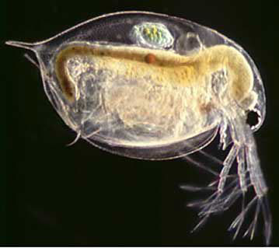
  - We have a safe water supply
    - Our water is now treated both physically and chemically in order to make it safe for consumption
  - Nature does not make pure water, outdoor water directly from nature is not safe to drink
    - You must first boil and treat it before consumption
    - Things live in the water even when It looks clean
      - For example: Guinea worm – dracucculiasis
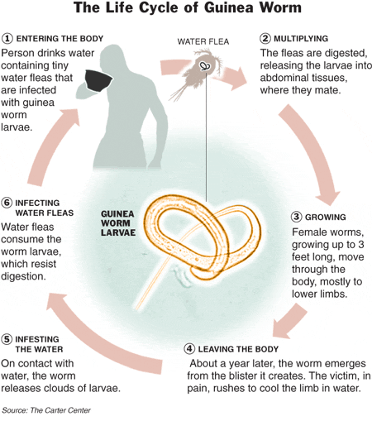
        - Exists in tropical areas and has a microscopic larval phase that occurs in the water
        - Once this animal gets into the digestive system, it starts to develop and become a worm and lives in your muscles and eats you
        - When the worm is ready to leave the body, it bursts from your skin – it does this by secreting a substance that causes an extreme burning sensation that causes the host to rush to water and this is when the worm will complete its lifecycle
    - Simple water treatment makes the difference
      - Treating our water from plants is similar to the communities that use cloth as a filter
      - Filtering and removing things in it and then treating it makes a large difference in water quality
  - A major improvement in water quality is the addition of chlorination
    - We now add chlorine to our water and this is very important for our safety
      - It kills anything that gets through the filtering process and acts as a preservative to keep water in a pure and safe state when being transported to us from the plant through the pipes
        - If the pipes leak this allows for something to get into the water, but the chlorine will kill anything that gets in and continue to keep the water clean and safe

- Refrigeration
  - Food spoilage was common before refrigeration
  - Refrigeration is really important for our health
  - Back 100s of years ago, spoilage was common – you either ate the spoiled food or you didn’t eat at all > today we throw out spoiled food
    - When you ate spoiled food, you exposed yourself to risk for infection and disease
  - Seasonal availability
    - There is now availability to all kinds of foods at all times
    - Before, certain foods were only available at certain times of the year due to the lack of refrigeration
  - Modern food storage year round
    - You can now get and eat whatever you want at any time because of refrigeration (food storage)
- Pharmaceuticals improve and contribute to health – there are 2 classes:
  - Vaccination (immunization) – the greatest achievement in medicine
    - Prevents you from getting sick in the first place, very successful for viral diseases
    - EX: smallpox
      - Eliminated in 1977
      - People who survived become permanently disfigured
      - Only exist in labs and biological weapons in Russia (hopefully the weapons have been destroyed)
    - EX: Polio
      - It used to kill people worldwide
      - Was eradicated from North America 1991
      - There are currently less than 30 cases world-wide
        - 2 countries
        - >300 000 cases in 1998
        - Major eradication barrier is politics
        - Almost eradicated completely and this is possible because of the development vaccines
  - Antibiotics
    - Works against bacterial infections
    - Back then if you cut yourself you could die such as a paper cut
    - Antibiotics have allowed us to live from cuts or breaks in skin such as paper cuts
    - EX: Penicillin reduced maternal mortality
      - It was very common to die during or after childbirth
      - If you got an infection after you delivered your baby you would likely die
      - What happened to change this was the introduction of penicillin around 1940
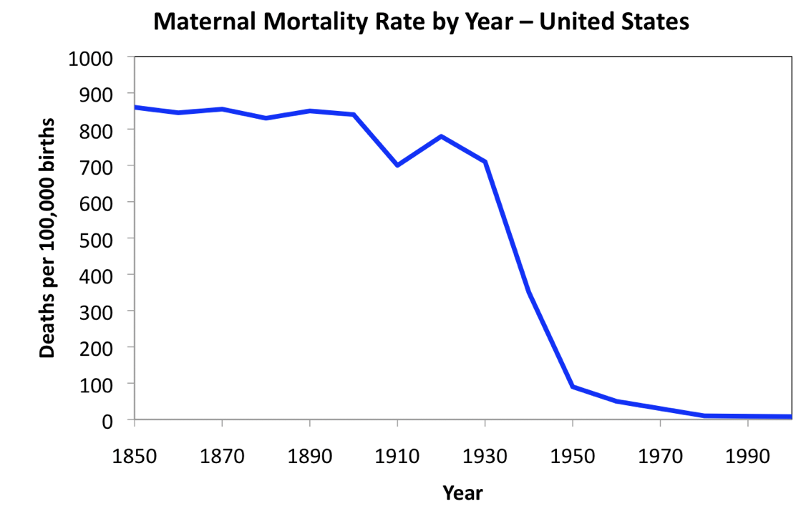

Modern Drugs
- Modern drugs work and this is because they are made based on ideas, tested, and then followed up to make sure that they are still working for what they were tested for
  - Each starts with a scientific idea
  - Each is optimized using scientific methods
  - Each is tested scientifically
- North America drug market (2009)
  - Prescription drugs
    - $300 billion
  - Over-the-counter (OTC) drugs
    - $25 billion
- World drug markets
  - Half of the drugs that are sold today are sold within the USA
  - The world follows the FDA regulations, the rules that the FDA have in place are pretty much followed by the rest of the world
  - From the table below, you should remember that 50% comes from the USA and that the world number will usually be twice the USA number (applies to pretty much all pharmaceutical information)
United States | 49.1%
Japan | 14.1%
Germany | 7.7%
France | 7.1%
United Kingdom | 4.2%
Canada | 3.8%
Italy | 3.8%
All Others | 10.3%
- The modern pharmaceutical industry is young
  - Started in 1856
  - Uses scientific methods
    - Chemistry
    - Biology
    - Molecular biology
    - Epidemiology
  - Works hard to remove bias
  - Very heavily regulated by the government and this is essential

Most Ancient Medications were Useless
- “made-up” cures
  - People believe in magic
  - If you got sick 200 years ago, it was very likely that the cures wouldn’t work
- Feel better just by getting treatment
- Only a very small number of treatments actually worked
  - A few of these are still used today but these are very rare
- Many treatments are actually harmful
- The most ancient drugs came from plants (most common source)
  - Why plants?
    - When seeking out treatment, you look for poisons from the plant
    - Since plants produce a lot of poisons, they give use a large source for drugs

Drugs are Poisons
- All drugs are poisons
  - Drugs produce the desired (beneficial) biological effect
- Poisons
  - Produce undesired (harmful) biological effect
- The only difference between the two (drug and poison) is the dosage (the amount you take)
- The Greek word for both harmful and beneficial and amount is pharmakon
- Sola dosis facit veneum
- Poison – kill
- Potion – cure
- Only the dose makes the poison (the amount is what makes the difference, not the substance itself)

Dosages
- Normally we assume
  - Low doses produce beneficial effects (drug)
  - High doses produce harmful effects (poison)
    - The harmful amount is typically in the higher dosages, but not always
      - EX: insulin
        - Insulin is administered as a drug in higher amounts and it now acts as a drug
      - EX: salt
        - If you don’t get enough salt in your body it acts as a poison
- Sometimes
  - Low doses produce harmful effects (poison)
  - Higher doses produce beneficial effects (drug)
- Only the dose makes the poison
  - EX: if you drink too much water without relieving yourself you will die
- Dose makes the poison
  - Ask “how much”? (remember this)
  - Works for lots of things
    - Drugs
    - Pollution
      - EX: which is worse? Dumping sewage in the river vs. child peeing in the river
    - Finances
    - Everyday issues

How were drugs discovered before 1900?
- Observation (rare)
  - People observed the effect of the drug
  - Strong poisons
  - EX: someone eats a plant and watch what happens then base the drug off of it (usually strong poisons in low quantity so that you can see an effect)
- Philosophy (very common) (make it up)
  - Based on belief
  - Cure arrived at by reasoning – make it up
  - Healing often connected with superstition, magic, religion

Drugs from observation
- Strong poisons (common)
  - Easily identified
  - Low dose makes it into a drug (strong poison with a very clear effect)
    - Opium, digitalis, nicotine, cocaine
- Weak poisons (uncommon)
  - Large quantity for effect (must consume a large amount to get a harmful and beneficial reaction)
    - Caffeine, salicin

Papyrus Ebers
- Egyptian medical document 1500 BC
- Scroll about 20 meters long
- Thousands of medical treatments
  - Most useless
  - A few are still used today
    - Such as opium

Identification of opium for pain
- Opium (extracted from poppy seeds)
  - Narcotic painkiller
    - Used for heavy duty painkillers
  - Sedative
- Toxic in high doses
- Drug in low doses
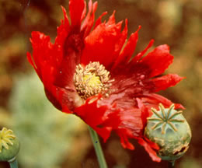
- Very clear effect and strong poison – easy to see
- Opium is the basis of modern painkillers
  - All artificial drugs that don’t exist in nature are all structurally based off opium
  - Analgesics
    - Reduce pain
  - Codeine
  - Oxycodone
  - Fentanyl
  - Methadone
  - Demerol
- Identification of cocaine as a stimulant
  - Observation
    - Extracted from coca leaves
      - Topical painkiller
      - Stimulant
- Modern anesthetics designed from cocaine – has now become the foundation for a lot of our painkillers
  - Anesthetics
    - Reduces sensation
    - EX: dental anesthetics
  - Novocaine
  - Procaine
  - Lidocaine
  - Benzocaine

Problems with observation
- There are problems if you go out and observe the world if you don’t study the human brain and psychology
- Human brain searches for patterns
  - We see patterns even when they are not there – you will find false things if you’re not careful to control the patterns searching behaviour
- Ancients did not use experiments or statistics
  - Anecdotal evidence (stories)
    - EX: eat this plant and if you get better you will think it was because of the plant – even if it wasn’t
  - Drug and effect may be coincidence
  - Perceptions subject to placebo effects
  - People lie
- Once “evidence” is available, it is hard to contradict
  - Many harmful remedies retained because of this
  - Parent’s cold remedies

The Human Brain Searches for Patterns
- Apophenia – seeing patterns or connections in random or meaningless data
  - Even when they are not there
  - EX: cancer or magnetic waves
- Pareidolia – perceiving sounds or images as something else
  - EX: you spill coffee and the spill looks like Jesus

Anecdotal evidence is misleading
- It is a way of observing the world and taking out of the information that, that is how the world works (even if it isn’t)
  - EX: if someone jumps off a 42-story building and survives, if you do not know that this is impossible – you will believe that if you were to jump off a 42 story building, you will also live
- Anecdotal evidence relies on chance
  - Medication and a cure may not be connected
    - May eat a plant at the same time that you were getting better anyway
  - Poison and harm may not be connected
  - Science fights anecdotal evidence by removing bias especially because our brain searches for patterns and we will make stuff up to go along with the patterns that we see and convince ourselves that the experiment does work (when it doesn’t)

Only experimental evidence is reliable
- The best way to find out how reliable a method or treatment is, is to look at how they came up with those treatments:
  - Make a measurement
  - Measure properly
  - Measure accurately
- How you made the measurement is the most important, not the statistics
- Must rely on statistical significance
  - Collect data from a large number of experiments and use statistical analysis to get ride of the outlying numbers
  - Good stats doesn’t mean good science
    - Science tends to put an emphasis on stats
    - Stats are a guideline, not the end all be all

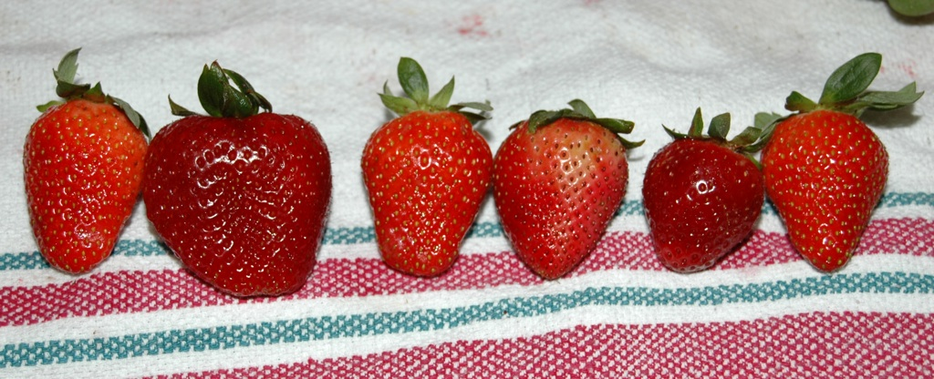
Problems with traditional remedies
- There are several problems with traditional remedies
- Poor control over dose (lack of standardization
  - Plants produce variable amounts of active ingredients which leads to different amounts being present in a drug
  - The state of ripeness or health of the plant will dictate the amount of flavor molecules that you will get
  - In North America, we pick bigger foods because we figure that were are getting more bang for your buck
- Preparation changes chemical composition
  - If you must produce something medicinal, you may destroy the compounds depending on how you prepare them in the process
- No standardization
  - Back in the day people could not read, there were no written instructions
    - Information passed verbally as people could not read
    - Imprecise as when you verbally transfer the information, it can be interpreted differently by different individials
    - Poor reproducibility

Difficult to correct Information
- False information often spreads faster than true information
- Because of this it is very difficult to get information out to the public once you discover that something is actually harmful
- Once someone accepts an idea, they are unwilling to change – it is very hard to change their belief
  - EX: Tomatoes were once thought to be poisonous – in Europe people wouldn’t eat tomatoes because they thought they were poisonous and this was due to misinformation
  - EX: In North America we have the idea that there is a problem with eating bugs even though there isn’t as they are nutritional
    - There is nothing wrong with eating insects
    - In North America bugs are not knowingly eaten

Philosophy to identify Cures
- Cure arrived at by reasoning (make it up)
- Search for “proof” afterward
- Healing often connected with superstition, magic, religion
- They look for information that supports their information and just stick with it – don’t look for opposing information

Hippocrates develops doctrine of humors
- This was the standard treatment thousands of years go
- Hippocrates believed that the universe is made out of 4 elements
  - Earth
  - Air
  - Fire
  - Water
- He believed that if the universe is made out of 4 elements, that means that humans must be made out of 4 elements too
- The body is made of 4 humors:
  - Blood
  - Phlegm
  - Yellow bile
  - Black bile

Doctrine of humors
- The 4 humors are normally in balance
  - If the 4 humors are not in balance – you become ill
  - Too much or too little of a humor causes disease
- He would try and figure out which humor was out of balance and then try to restore it in some way that was based on the humor
  - Cured the individual by re-balancing the humors
    - Diagnose using the properties of the humors
  - EX: A fever is associated with hot and dry (look for the opposing properties)
    - Cured individual using cold and wet (come from the elements)

Too Much thinking
- Properties of the 4 elements
  - Earth p dry
  - Air – cold
  - Fire – hot
  - Water – wet
- Properties of 4 humors
  - Blood – cold
  - Phlegm – wet
  - Yellow bile – hot
  - Black bile – dry

Bloodletting and the doctrine of humors
- To rebalance the blood humor – bloodletting
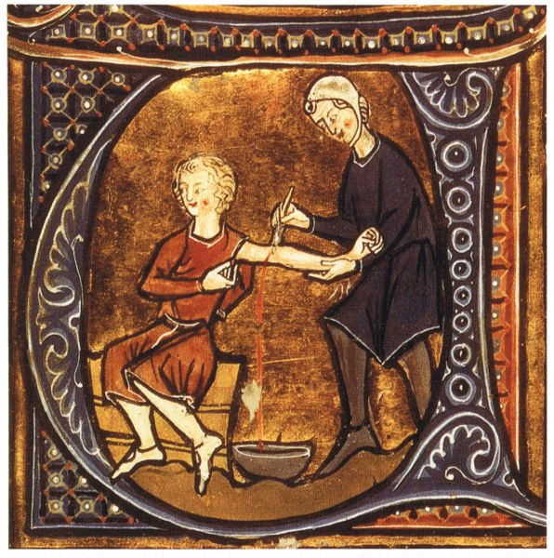
  - They would remove blood to put you back into balance so by removing blood, this would restore your balance
- They used creative methods to remove blood
  - They would use astrological symbols to figure out where to cut you and remove your blood
  - Would cut in different designs
  - Would use leaches
- Bloodletting often killed the patient
  - It was very painful and harmful to the patient
  - As soon as you cut the individuals skin, you opened them up to infection and people would often die either from too much blood loss or from infection to the wound or secondary infection
    - EX: George Washington died from bloodletting
Rebalance with Emetics and Purges
- Emetic – make you vomit
- Purges – empty bowel
- If you do this in a violent manner – it is very unpleasant and not guaranteed to work (EX: through substances)
  - They would remove stuff but also put stuff in, such as feces

Doctrine of humors was stupid
- The doctrine of humors was considered state of the art for thousands of years but it is based on incorrect idea
  - The universe is not made of 4 elements
  - Humans are not made of 4 humors
- Treatments developed that they were using were harmful and painful
  - Bloodletting
  - Purges
  - Fasting
  - Special foods
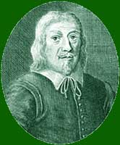
Doctrine of Signatures
- Jakob Bohme, shoemaker and philosopher (1575-1624)
  - The idea was that there was a secret code on the objects on the plant left by God (that he left clues to tell us how to use things) and if we can decode the secrets we can figure out how things are supposed to be used
  - Disease and cure were linked
  - This approach is/was used by almost all cultures - this idea existed thousands of years before he existed – he just put a name to it
- Doctrine of signatures is the imagination of the person that’s seen

- Doctrine of Signatures: walnuts look like brains
  - Eating walnuts is goof for brain health
    - They look like brains, so they are good for your brain health
    - There are no special ingredients in walnuts that benefit brain health
- Doctrine of Signatures: Boneset stems grow “through” the leaves
  - Boneset plants are goof for our bones
    - Boneset plant leaves are aligned with each other which creates the illusion that the stem is going through the middle of the leaves > since our skeleton goes through the middle of the body just like the plant (not true), this must mean that boneset plants are good for our bones
- Doctrine of Signatures: “Sharks don’t get cancer”
  - Sharks don’t get cancer because people noticed that our body structure is bone and shark’s body structure is cartilage so that must have something to do with cancer
    - Instead of investigating the biochemistry of a shark they just assumed that they don’t get cancer because of their cartilaginous body structure when in fact their cartilage is basically the same as our cartilage and consuming it will not benefit you in anyway
    - Sharks DO in fact get cancer, all animals do
    - Sharks are now hunted for this doctrine – they are harvested for nothing

- Doctrine of Signatures: Breath mints have chlorophyll
  - Clorets have chlorophyll which help with bad breath
    - There is no way that chlorophyll can treat bad breath, chlorophyll is just a green pigment
    - 100s of years ago farmers would chew stems of parsley and it would make their breath smell better
    - Parsley colour > green > the green is because of chlorophyll > this must cause the freshness of breath (NOT AT ALL)
  - The packaging on Clorets gum claims that it is “not just candy”
    - The stuff listed in the ingredients first are in the largest amount
    - Glucose syrup, corn starch, mono and diglycerides, and potassium sorbate – SUGAR
    - Wax is the outer layer of the gum which makes it shiny
    - Chlorophyll is last on the list
      - So if you compare the miniscule amount of wax on gum and the fact that chlorophyll is listed last, this should be a pretty good indicator of the amount of chlorophyll present within the gum
    - It is literally just candy
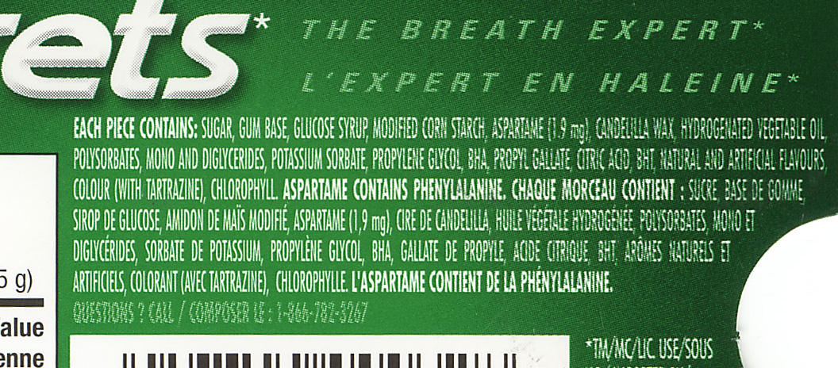
      - It freshens your breath for a short period of time and this is due to the natural and artificial flavoring

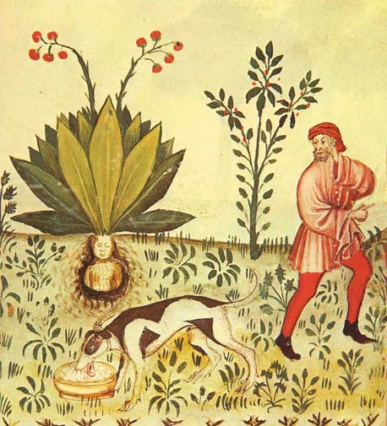
- Doctrine of Signatures: Mandrake roots look like people
  - Mandrake roots are used for many medicinal and magical purposes
    - The primary use was a cure for demonic possession
    - It was used for almost everything
    - The shape of the root looks like a little person
  - Screaming mandrake root
    - It was believed that the plant would scream when harvested
  - They would use a dog to harvest the mandrake to protect themselves against the screaming
    - They would tie a rope around it and have a dog pull on the rope and this way ensured that you wouldn’t hear the screams as well as preserve the magic

- Doctrine of Signatures: Rhino horn is a phallic symbol
  - Powdered rhino horn used in Chinese medicine as an aphrodisiac
  - The location of the horn is a phallic system and people will kill the rhino so that they can harvest the horn – grind it up and use it as a sexual enhancement
    - Rhino horns have the same makeup as your finger nails
    - Rhinos are being driven to extinction because of this
- Doctrine of Signatures: Mercury is a heavy liquid
  - People drink mercury as a purgative
  - The idea that it is a heavy liquid and can push out all the toxins and bad things out of his body
- Doctrine of Signatures: only by your imagination
  - Avocados, eggplant and pears target the health and function of the womb and cervix of the female
  - This is believed because of the shape of the fruit – it is FALSE

Doctrine of Signatures is Crap
- Most remedies developed this way were harmful
- At best were harmless
  - Denied the patient proper treatment
- Lack of rationality of evidence
  - Based on appearance or location
  - Required imagination to see connections

Life expectancy through history
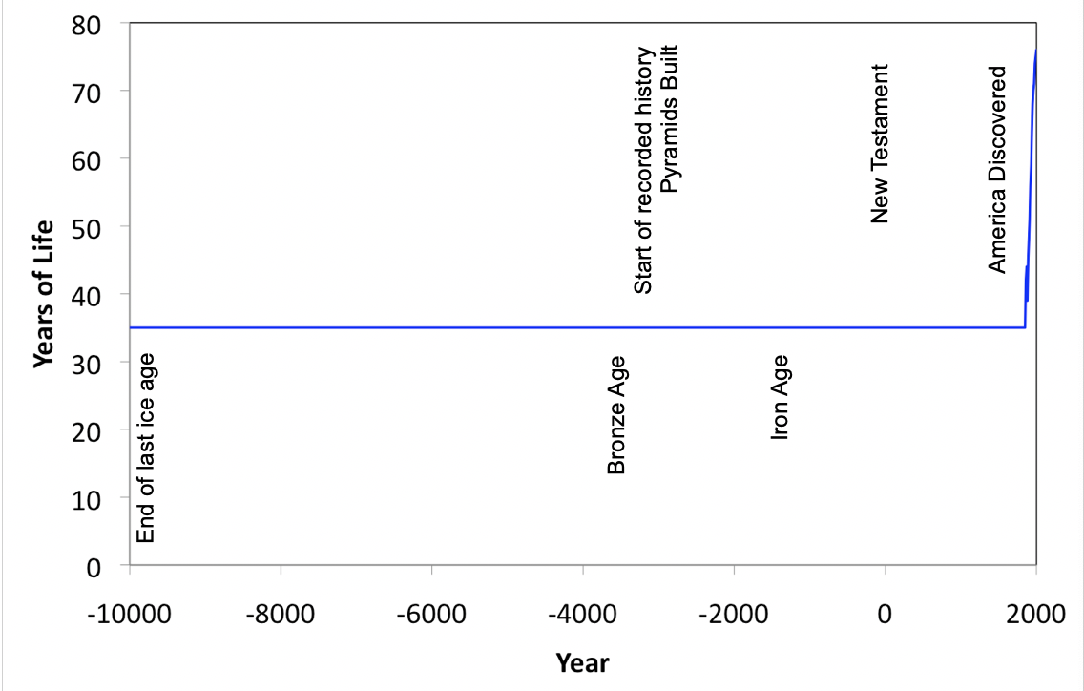

- Variations smoothed out as records are not precise
- Number of 35 years is an estimate made by combining data from various sources
- Numbers may vary depending on source used
- Range is more appropriate

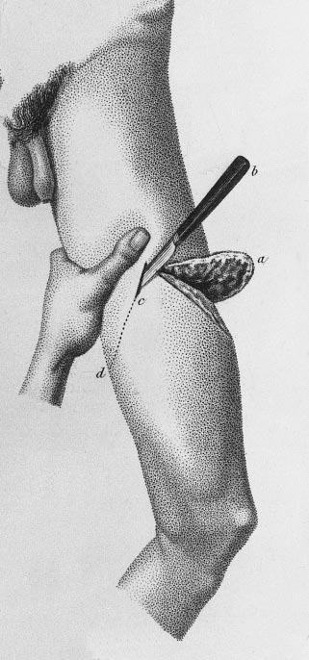
Some Problems Require Surgery
- Amputation without anesthetic
  - There was no anesthetic that existed at the time, people would just hold you down and you would often lose consciousness from the pain and loss of blood
- Back in the day, there was no certification needed to become a surgeon – anyone could amputate
- Amputation had to be done quickly
- The art of amputation – if you amputate and cut into the shape of a V, you can properly connect the tissues and ligaments back together
- Amputation learned by trial and error

Sir Humphry Davy discovers nitrous oxide
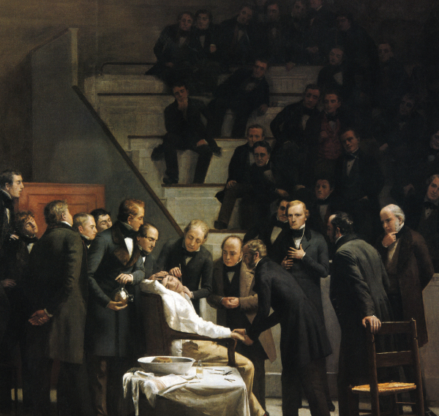
- Nitrous oxide is laughing gas which allows you to forget what happened to you and later you don’t remember the pain that you endured
- Nitrous oxide is still used recreationally as a propellant
  - Source: cool whip canister

William T.G. Morton and either 1846
- William T.G. Morton discovered ether
- This was a huge break through because either renders the person unconscious and this allows surgeons to operate on you properly
- First surgery was on a tumor on someone’s neck and it took place in a theatre

Anesthetics make modern surgery possible
- They changed medicine, they made the surgeries that we do today possible
- Anesthetics indirectly gave us a vast improvement in our treatment abilities

Less than 30% survived surgical treatment
- Preforming surgery was very dangerous
- When you did surgery, only 30% of the time people died
  - Bled out or went into shock during surgery
  - Or died after due to the development of infection as they didn’t know what actually caused illness and they couldn’t take the proper steps to protect themselves
    - There was not attempt for cleanliness because they didn’t know it was important

Joseph Lister uses phenol as an antiseptic
- In 1867 he developed the concept of antisepsis
- They discovered that bacteria are what are causing disease
- Lister thought that maybe they can prevent infection by killing bacteria (which are microscopic and eating us) and decided to use phenol
  - Phenol was used to deodorize sewers
- They would use a carbolic acid sprayer to spay a mist of phenol over the patient during surgery and doing this would kill the bacteria in an open would
  - Allowed the person to have a chance to live
- Phenol offered an increased survival rate but the downside was that it is a highly toxic material
- Toxic effects of phenol on doctors
  - The dosage that a patient would receive was low so they wouldn’t experience toxic side effects, for the doctors who is doing surgery all day long and is constantly exposed to the vapor started to have problems
- They realized that an easier way to get rid of bacteria is to keep the space clean and this was the birth of the surgical – clean room, utensils, hands, and clothes
The age of the surgical room
- Washing and glove use was safer
- Antisepsis was brought to Canada by Thomas Roddick in 1877
- The only way for them to have come up with antisepsis was to know what was causing the problem
- When you don’t know the causes of infection, you will have a low survival rate

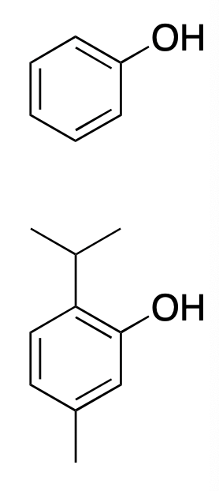
Listerine
- Lister invented Listerine and it became a common household product
- Listerine for dandruff
- Listerine no longer contains phenol – it was a little too toxic
  - It now contains thymol
  - By containing thymol, they have maintained the beneficial effects and added some branches that lower the toxicity

William Perkin first synthetic dye – 1856
- He developed mauve (purple colour) and he derived this from coal
- Before dye, you could not have coloured materials unless you were really rich
- Dye companies became pharmaceutical companies
  - The chemistry used to make dye materials are the same chemistry used to make drugs
  - These companies became the major pharmaceutical companies developed

Artificial Drugs
- Bayer developed the first artificial drug – 1897
- Artificial drugs were better and cheaper
  - If we restrict ourselves to natural materials we are left with what nature is making
  - When making artificial materials, you can engineer them to do what you want
- Most modern drugs are artificial
  - Designed for optimal activity, safety
    - We have designed them to work inside the human body better than natural drugs do
  - Provide convenience
  - Manufactured in large quantities
    - Lower cost – cheaper because the raw materials used to manufacture artificial drugs is oil, which is relatively cheap material
- Most pharmaceuticals are made from oil
  - 40-50% of oil is used to manufacture stuff – not used as energy source

Genetically engineered drugs
- Genetically engineered drugs are a way of manufacturing things
- They have become a very safe source of the drug rather than trying to get it naturally from the environment

Rules are important
- Regulation of drugs
- Regulation of medical devices and procedures
- Is an important way of ensuring that things stay safe and work properly
- Before 1907 there were no rules
  - ANYBODY could make and sell drugs
    - No proof that anything worked
    - No safety testing
    - No testing of any kind
  - Most drugs were “made-up”
    - Put some leaves in a bottle with water or alcohol
    - Start selling it
Rise of patent medicine late 1800’s
- Included the word “Patented” on the label
  - Public thinks patented = quality
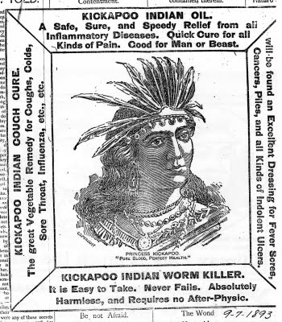
  - Some of the drugs released were actually very harmful and these were often “patented”
- You could sell ANYTHING
  - Mrs. Winslow sooths with opium
    - Cough syrup to stop your child from coughing
  - Kickapoo Indian Oil cures all with alcohol
    - Most of their products were a concentration of alcohol products with some leaves
    - Drugs that say there are no side effects or are harmless are a scam and will not work
      - ALL DRUGS HAVE SIDE EFFECTS
    - Alcohol was the most common “active ingredient”
      - Alcohol
      - Opium
      - Cocaine
      - The materials most often used were just materials that made you “feel good” and get the illusion that you were feeling better
  - Great Radium Spring water, it’s radioactive!
    - William J.A. Bailey makes Radithor and sold it as a cure all
    - Someone published a paper saying radioactivity kills cancer cells and this guy sold it as a way to improve your mental activity/intelligence
      - How did they go from cancer to intelligence?????
      - Twisted science – from cancer to morons
    - Eben M. Byers was a believer
      - He drank Radithor everyday
      - The radioactivity in his teeth after his death was enough to expose film
      - His body was highly radioactive
    - It was a medicine from deaths laboratory – a lot of people started dying

The Board of Food and Drug Inspection
- After Radithor began killing people, people started to pressure the government to get involved
- Formed in 1907
  - First government regulations for medicines
  - Labeling only
  - No regulation of therapeutic claims
  - No safety testing
- Patent medicine – fake medicine

Massengill company and drug safety
- Sold one of the first antibiotics – sold sulfanilamide (antibiotic) as a powder
  - Scoop some of the packet and put it into your mouth and swallow
  - It tasted bad and children refused to consume it so it didn’t do very well on the market
- Massengill sells sulfanilamide elixir
  - They invented a liquid formula for children
  - In order to do this, they had to add ethaline glycol to get it to dissolve into the solution and it had a sweet taste
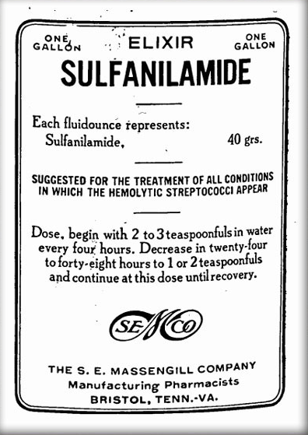
Message to the AMA
- “Please wire collect by Western Union suggestion for an antidote”
- Ethaline glycol has the same effect as antifreeze and it ruins your kidneys
- The government noticed that people were dying due to the ingestion of this drug and suggested that the company stopped selling the drug

Labelling forced the drug off the market
- There were no rules against selling toxic drugs, luckily the government found out that the company had done something wrong in their labelling
  - They used the word elixir – legal definition of elixir is a substance dissolved in ethanol – NOT THE PRODUCT THAT THEY USED

Government inspectors track down drug
- Recovered 234 of 240 gallons that were sold
- 107 dead
- 260 permanently disabled

Food and Drug Administration (FDA) created
- Food, drug and cosmetic act of 1938
- Ensure the safety of drugs
- Animal testing was now required (safety only)
- Clinical trials were done to follow safety in humans
- Directions for proper use were required on the label
- This was the first time that they were required to measure safety
  - Problems still occur – must enforce the rules and carefully police them
    - Without proper policing and enforcement, it’s not enough to have rules

Thalidomide
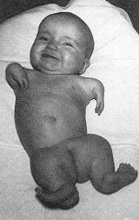
- Developed as a sedative – 1957
  - What you would call “clean” – very few side effects
- By 1962, thalidomide recognized as a teratogen
  - Babies born to the women who had consumed this drug were born without limbs called phocomelia (comes from the Latin word for seal)
  - Attenuated limbs

Teratogen causes birth defects
- From Greek word “teratos” for “monster”
- Thalidomide comes from the teratogen family – causes birth defects
- Thalidomide was tested on rats (poor choice)
  - Rats do not often give birth to deformed pups as their body can detect the problematic pup
  - In humans, problems with a fetus result in miscarriage stillbirth or birth defects

Modern safety standards
- Safety testing is done in at least 2 species
- At least one must be a primate (other is typically a rat or dog)
- Must show that the drug is bioavailable (if it actually get into the bloodstream)
  - Gets into body
  - If it doesn’t get into the bloodstream, it won’t cause nasty effects so companies would do this to get drugs approved
- Must use relevant doses – now the dose must be the same in the animal as it would be in humans in order to see the proper effects
Industry regulation is important
- Ensures safe products
- Ensures products work
- Ensures good manufacturing quality
- Downside: regulation increases costs
  - A significant amount of the money you for a drug goes towards paying lawyers for the company

Modern Drugs Work
- Each starts with a scientific idea
- Each is optimized using scientific methods
- Each is tested scientifically
- Manufacturing is standardized
- Drug industry is tightly regulated _ it is the most highly regulated industry on the planet
  - Must provide scientific proof

