INTRODUCTION
• major function of the respiratory system is to supply O₂ and dispose of CO₂
• 4 distinct processes:
- Pulmonary ventilation: movement of air in and out of lungs
- External respiration: exchange of gases between air of alveoli & blood
- Transport of respiratory gases: role of blood in transport of gases between lungs & tissues of body
- Internal respiration: at the level of the tissues, exchange of gases between blood in systemic capillaries and tissue cells
• first 2 functions handled by respiratory system; other two by CV system

Inspirational pathway
- Conduction zone: nose, nasal cavity, pharynx, larynx, trachea, bronchi. These structures form a continuous passageway for air to move in and out of the lungs.
- Also warms, moistens and traps infectious agents in the incoming air
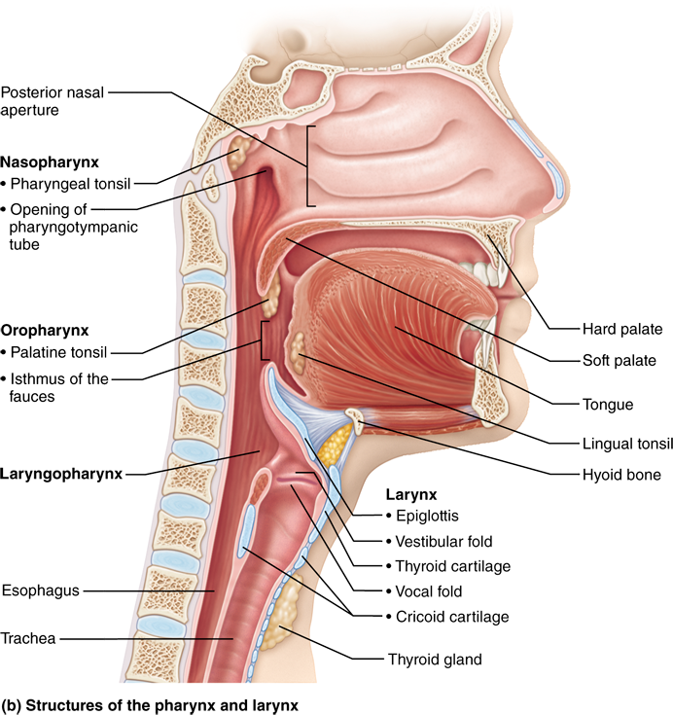

Respiratory terms
- nasal cavity, nasal conchae (turbinates), uvula, soft palate, hard palate
- conchae mix the inspired air for smell, warmth, moistening and trapping of infectious agents

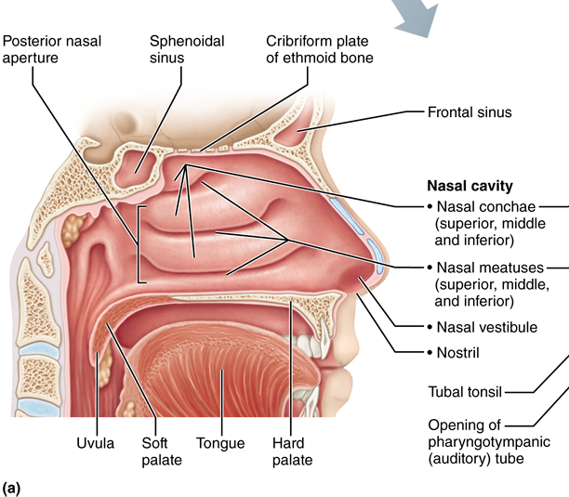
6.1 Describe the structure of each one of the components of the conduction and respiratory zones
• conducting zone: (passageways) »»»» 1 nose, 2 nasal cavity, 3 pharynx, 4 larynx, 5 trachea, 6 bronchi, bronchioles, terminal bronchioles / as well as providing a passageway, conducting zone organs also cleanse, humidify (moistening) & warm incoming air
• respiratory zone: (= site of gas exchange) »» composed of respiratory bronchioles, alveolar ducts & alveoli (microscopic)

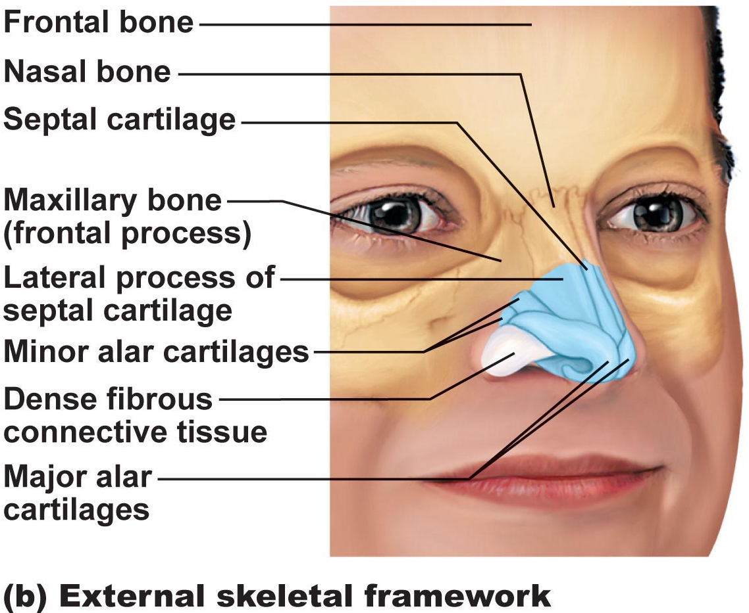
1. Nose
• functions:
a) airway for respiration
b) moistens & warms incoming air
c) filters & cleans inspired air
d) resonating chamber for speech
e) olfactory (smell) receptors
•structure of external nose: differences in nose size/shape due to differences in nasal cartilages
- skin covering dorsal/lateral aspects of nose is thin; contains many sebaceous glands
- air enters nasal cavity via external nares (nostrils) - divided by midline nasal septum (cartilage » bone); air then goes via internal nares to nasopharynx
• roof of nasal cavity formed by ethmoid & sphenoid bones of skull
• floor of nasal cavity formed by palate (anterior is hard; posterior is soft)
• vibrissae: what are these? hairs in your nostrils keep foreign particles from entering your body
• nasal cavity lined by 2 types of mucosa
a) olfactory mucosa: contains receptors for sense of smell
b) respiratory mucosa: pseudostratified ciliated columnar epithelium with goblet cells; lamina propria has mucous & serous glands (1 L/day sticky mucus containing lysozyme -bacteriocide)
• resp mucosa cilia move contaminated mucus posteriorly to pharynx
• cold air slows cilia → runny nose
• thin-walled veins under nasal epithelium role? cold air & nosebleeds?
• What are nasal conchae? *
• nasal mucosa richly supplied with sensory nerves irritants trigger sneeze reflex
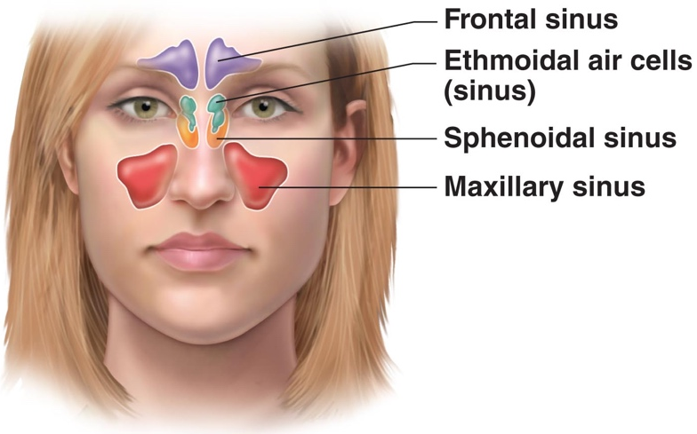
- Paranasal Sinuses
- surround nasal cavity
- frontal, sphenoid, ethmoid, maxillary bones
- lighten skull, produce mucus, also warm & moisten air
- sinus mucosa continuous with nasal mucosa »» spread of infections
- sinus headache: passageways connecting sinuses to nasal cavity blocked » air in sinus absorbed » partial vacuum

- Pharynx • common pathway for food and air, wall composed of skeletal muscle throughout ~13 cm length; mucosal lining varies
3a) Nasopharynx ------------
• below sphenoid bone, above soft palate
• only an air passageway
• what happens when swallowing? closes
• pseudostratified ciliated epithelium
• pharyngeal tonsils
• pharyngotympanic (auditory) tubes drain from middle ear,
3b) Oropharynx --------
• connects oral cavity with oropharynx
• from soft palate to epiglottis (air and food)
• epithelium becomes stratified squamous
• paired palatine tonsils + single lingual tonsil
3c) Laryngopharynx -------------
• also both food and air
• stratified squamous
• from epiglottis to larynx – then respiratory
& GI pathways diverge, during swallowing, food has “right-of-way”

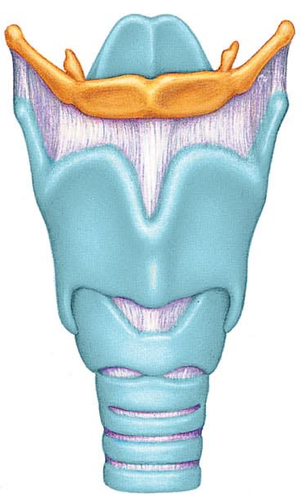
- Larynx
• ~5 cm (4th-6th cervical vertebrae)
• attached to hyoid bone (above); continuous with trachea (below)
• 3 functions:
(i) open, 2-directional airway
(ii) switching: food vs air
(iii) voice production
• 9 cartilages in total
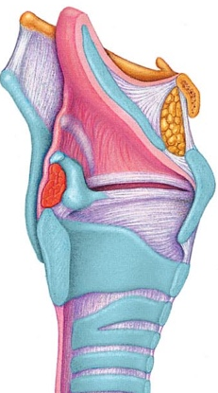
thyroid cartilage: large, shield-shaped cartilage in front (puberty in males?)
arytenoid cartilages (2): lateral, pyramid-shaped, anchor vocal cords
9th cartilage is epiglottis: elastic cartilage, anchored to anterior rim of thyroid cartilage & extends up to base of tongue
true vocal cords: white (avascular); vibrate in response to air movement up from lungs (what is the glottis?) the opening between the vocal folds
false vocal cords: above true vocal cords
• epithelial lining of upper versus lower larynx?

Voice Production:
• speech = intermittent release of expired air + opening & closing of glottis
• length of vocal cords & size of glottis altered by action of laryngeal muscles that move arytenoid cartilages
• male voice at puberty: vocal cords vibrate more slowly – why?
• loudness of voice: force of air across vocal cords
• laryngitis: inflammation of vocal cords ⇒ vibration impaired
• sphincter functions of vocal cords:
(i) epiglottis closes respiratory tract during swallowing
(ii) Valsalva’s maneuver: What is this? exhaling when your airways are blocked
What is the Heimlich maneuver??

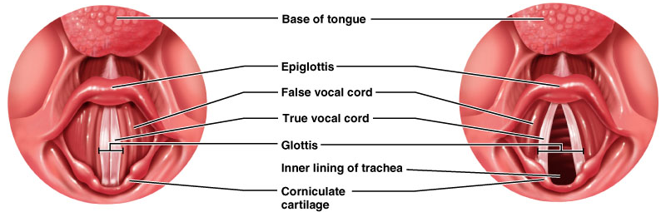
- Trachea
• 10-12 cm long; ~2.5 cm diameter; flexible, mobile
• pseudostratified ciliated columnar; cilia move mucus up to pharynx
smoking inhibits & then destroys cilia; only coughing to clear mucus
• submucosa is CT with seromucous glands
• outer adventitia reinforced internally by 16-20 C-shaped cartilaginous rings; keep airway open during pressure changes associated with breathing
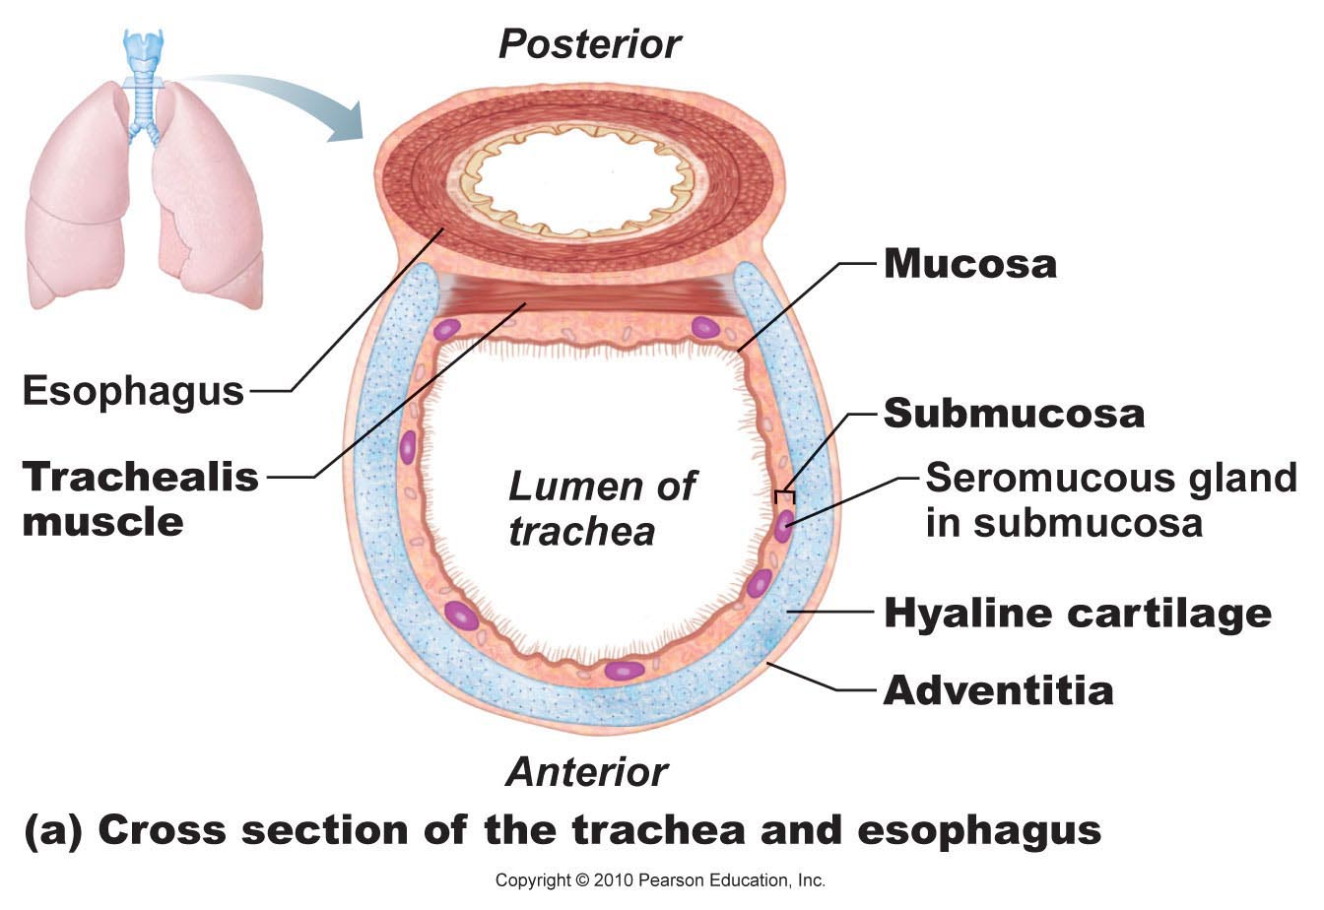
The Bronchial Tree
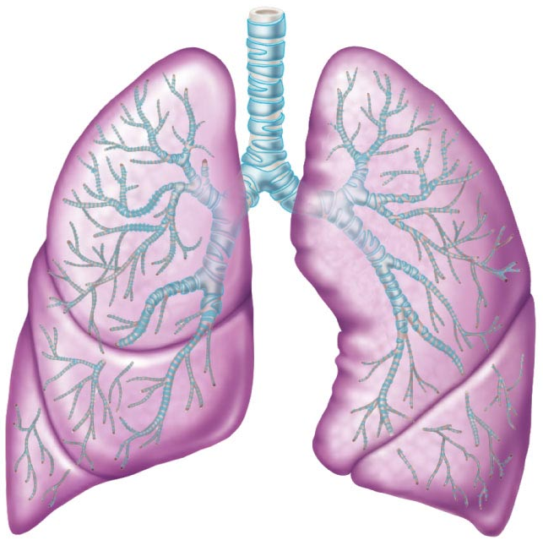
Conducting zone structures:
• right primary bronchus is wider, shorter, more vertical than left
• air in bronchi is warm, cleansed of most impurities & humidified
• ~23 orders of branching air passages in lungs = bronchial or respiratory tree
bronchi (1⁰, 2⁰, . . )

bronchioles (< 1 mm diam)

terminal bronchioles (< 0.5 mm diam)
• changes in wall composition as one moves through tree:
a) cartilage: rings to plates to none
b) epithelium: pseudostratified columnar to columnar to cuboidal; no cilia or mucous cells in bronchioles
c) smooth muscle: relative amount increases as passages become smaller

2. Respiratory Zone
terminal bronchioles branch into respiratory bronchioles
~300 million alveoli = huge surface for gas exchange
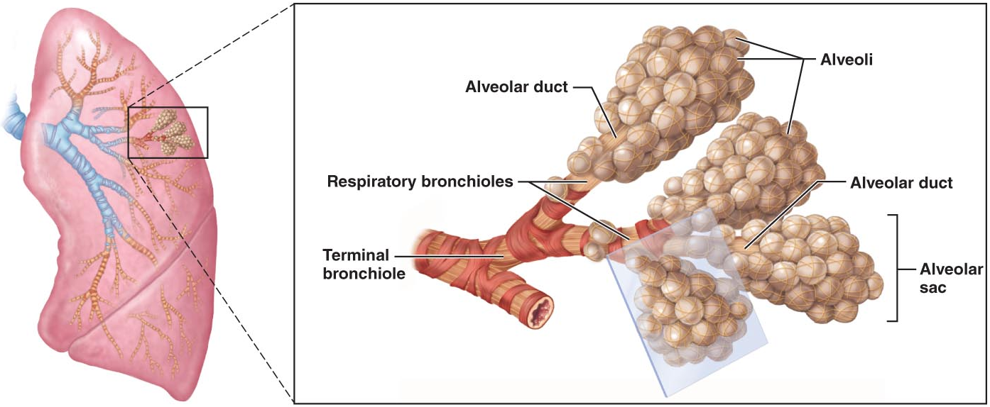

respiratory membrane = alveolar wall + capillary wall + basal laminae
• respiratory membrane is an air-blood barrier; gas exchange by simple diffusion
• type II cells: scattered among type I cells; secrete surfactant
• other characteristics of lung alveoli:
(i) surrounded by fine elastic fibers
(ii) alveolar pores: allow equalization of air pressure throughout lung; alternate air routes if bronchi collapsed
(iii) alveolar macrophages = dust cells; inner alveolar surface; clear & swallow > 2 million dust cells/hour!
6.2 Describe the gross structure of the lungs and the pleural coverings
• paired lungs occupy entire thoracic cavity except mediastinum
• each lung suspended in own pleural cavity; connected to mediastinum by vascular & bronchial attachments (= root)
• costal surface = anterior, lateral & posterior lung surfaces in close contact with ribs
apex, base; also hilus »» blood vessels enter & leave lungs
1⁰ bronchus enters lungs
fissures: oblique, horizontal » septa subdivide each lung into 10 bronchopulmonary segments (CT divisions; own artery & vein)
pulmonary disease often segmental & can be treated that way
• lobule: smallest subdivision seen with naked eye; hexagon ~ size of pencil eraser; served by large bronchiole
• lung : primarily air spaces; rest is elastic CT
Blood Supply & Innervation
• pulmonary arteries bring blood to be oxygenated
• pulmonary veins return oxygenated blood
• bronchial arteries provide systemic blood to lungs ⇒ bronchial veins
• innervation primarily parasymp (effect?) + some symp (effect?)

Pleura
• thin, double-layered (parietal & visceral) serosa
• pleural fluid: serous secretion that fills pleural cavity »» lungs slide easily during breathing; surface tension keeps pleurae from separating
• 3 chambers: central mediastinum + 2 lateral pleural compartments
• pleurisy: inflammation of pleurae

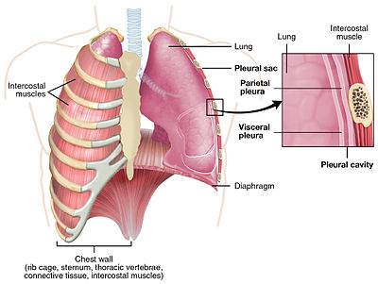
- intrapulmonary pressure : the pressure within the alveoli
- intrapleural pressure : the pressure within the pleural cavity is slightly less than the atmospheric pressure, in what is known as negative pressure
- transpleural pressure : the difference between intrapulmonary pressure and intrapleural pressure – keeps the lung inflated
- Boyle’s law – gases always fill their container – increase the volume of the chest cavity and you will decrease the gas pressure creating a vacuum the leads to inhalation of air

- Hering Breuer reflex - a reflex triggered to prevent over-inflation of the lung. Pulmonary stretch receptors present in the smooth muscle of the airways respond to excessive stretching of the lung during large inspirations.
- Bohr effect - a decrease in the amount of oxygen associated with hemoglobin and other respiratory compounds in response to a lowered blood pH resulting from an increased concentration of carbon dioxide in the blood
- Haldane effect - oxygenation of blood in the lungs displaces carbon dioxide from hemoglobin which increases the removal of carbon dioxide
- Dalton’s Law - the total pressure exerted is equal to the sum of the partial pressures of the individual gases.
- Boyle’s Law - the pressure of a gas tends to increase as the volume of the container decreases
- Henry’s Law - the amount of a given gas dissolved in a liquid is directly proportional to the partial pressure of that gas in equilibrium with that liquid.
- Valsalva’s maneuver - exhaling when your airways are blocked

