CHAPTER 1. Overview of Marketing
Term: marketing Def: A set of business practices designed to plan for and present an organization’s products or services in ways that build effective customer relationships.
Term: marketing plan Def: A written document analyzing the current marketing situation (SWOT), marketing objectives and strategy for the four Ps, action programs, and projected financial statements.
EXHIBIT 1.1
Core Aspects of Marketing
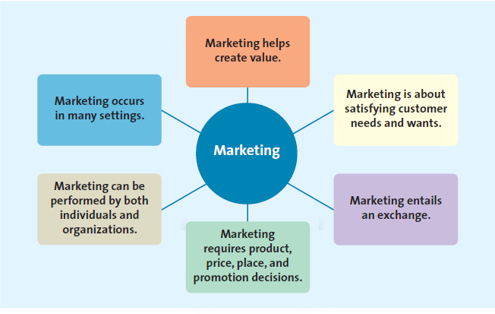
Term: need Def: Basic necessities, such as food, clothing, shelter, and safety.
Term: want Def: The particular way in which a person chooses to satisfy a need, which is shaped by a person’s knowledge, culture, and personality.
Term: market Def: Refers to the groups of people who need or want a company’s products or services and have the ability and willingness to buy them.
Term: target market Def: The customer segment or group to whom the firm is interested in selling its products and services.

EXHIBIT 1.2
Exchange: The Underpinning of Seller—Buyer Relationships
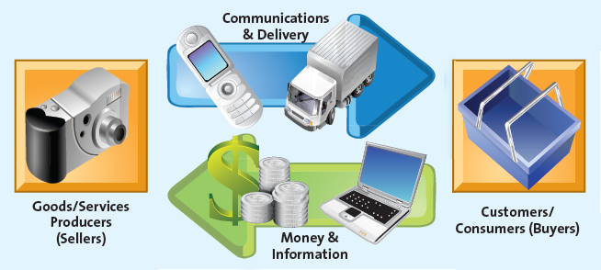
Term: exchange Def: The trade of things of value between the buyer and the seller so that each is better off as a result.

EXHIBIT 1.3
Marketing Mix Decisions
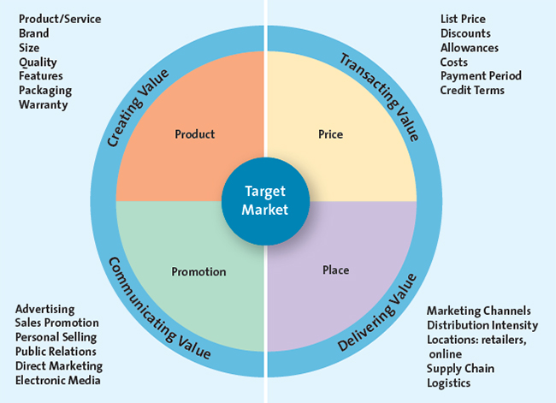
Term: marketing mix (four Ps) Def: Product, price, place, and promotion—the controllable set of activities that a firm uses to respond to the wants of its target markets
- Product
Term: Goods Def: Items that can be physically touched.
Term: services Def: Intangible customer benefits that are produced by people or machines and cannot be separated from the producer.
Term: ideas Def: Thoughts, opinions, philosophies, and intellectual concepts.
- Price
Term: price Def: The overall sacrifice a consumer is willing to make—money, time, energy—to acquire a specific product or service.
- Promotion
- Place

Term: B2C (business-to-consumer) Def: The process in which businesses sell to consumers.
Term: B2B (business-to-business) Def: The process of selling merchandise or services from one business to another.
Term: C2C (consumer-to-consumer) Def: The process in which consumers sell to other consumers.
Term: social media Def: The use of digital tools to easily and quickly create and share content to foster dialogue, social relationships, and personal identities.

EXHIBIT 1.4
Marketing Evolution: Product, Sales, Market, and Value
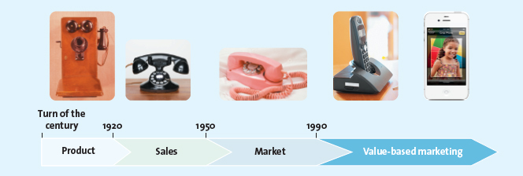
Term: value Def: Reflects the relationship of benefits to costs, or what the consumer gets for what he or she gives.
Term: relational orientation Def: A method of building a relationship with customers based on the philosophy that buyers and sellers should develop a long-term relationship.
Term: customer relationship management (CRM) Def: A business philosophy and set of strategies, programs, and systems that focus on identifying and building loyalty among the firm’s most valued customers.

EXHIBIT 1.5
Importance of Marketing
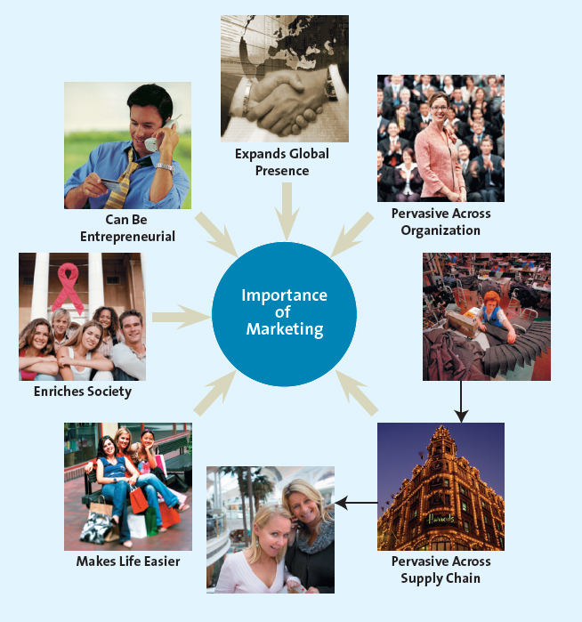

EXHIBIT 1.6
Supply Chain
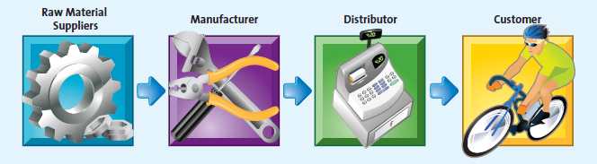
Term: supply chain Def: The group of firms and set of techniques and approaches firms use to make and deliver a given set of goods and services.

