Communication
- Interactive exchange of information
- A message 2) sender (expresses) 3) receiver (responds)

Speech
- Vocal production of language (easy/fastest way of communicating)

Language
- Formal method of communication (signs & symbols) and represents ideas + thoughts

5 components:

phonology: individual and combined sounds (“p” “i” = “pie”)

morphology: the structure of words (“possible” “im”=”impossible”)

syntax: order of words and phrases to create sentences (“the boy hit the ball”)

semantics: content, intent and meanings (“bank” can mean more than one thing in different sentences)

pragmatics: the use of language and the contexts in which it is used (texting, conversing with an adult)

Communication Disorders

Speech Disorder: impairments of voice, articulation and fluency

Articulation: cannot correctly pronounce one or more sounds (“r”)

Phonological: errors of many sounds that form patterns (“nake” “snake”)

Motor Speech: articulation problems due to neuro damage (head injury)

Voice: problems with pitch, loudness, sound quality (vocal abuse or tumors)

Fluency: problems with smoothness/rapidity in language skills (stuttering, repetition)
  - Causes = personality or environment

OVERALL CAUSES:

Organic: hearing loss, cleft palate, thick tongue

Functional: student’s learning opportunities, type of speech models

Language Disorder: impairments of comprehension / use of language (form/content)

Form of language (phonology, morphology, syntax)

Content of language (semantics)

Function of language (pragmatics)

These affect:

Receptive language: it is received, decoded or interpreted

Expressive language: it is spoken, written, visually communicated (sign language)

Teaching Strategies

-provide good speech model

-improve child’s self-esteem

-make interaction feel natural and interesting

-active listening

- The Basic Concepts of ADHD are:
- - short attention problems / excessive motor movements
- - concern in public education
- - developmental disability with mental or physical development
- - apparent before age 7
- -continues to be problematic even during adulthood
- -negative impact on academics/social success
- -affects children/adults in all levels of intelligence
- School Years
- - Negative impact on academic/social success
- - Affects all cultural, racial, socio economic groups
- 4 TYPES of Diagnoses:
- 1) predominantly inattentive
- 2) hyperactive-impulsive
- 3) combined
- 4) not otherwise specified (NOS)
- Causes
- Neuroanatomical: brain structure
- Neurochemical: chemical imbalance in brain
- Neurophysiological: brain function
- Neuropsychological: frontal lobes dysfunction = executive functioning deficits (attention deficit, self-regulation and impulsivity)

- Frontal Lobe: Executive Functions
- Perception of Time: gained by regulating feelings of time with actual time (cannot feel passage of time >> 3min=3hrs)
- Inhibiting Responses: think before you act (problem solve)
  - fight or flight through logical thinking
  - ADHD candidates find it difficult to inhibit their responses and/or use their experiences to guide present or future decisions - impulsive
- Working Memory: difficulty of short term (RAM) and long term (ROM) memory causing slow processing. Cannot remember past experiences in the moment, trouble absorbing info all at once.
- Internalizing Speech: self-directed, age 4-10,
- - hyper-verbalism (talks without thinking) and delayed speech (poor self-regulation)
- Self-Regulation: all of the above factors combined (impairment of frontal lobe and executive functions along a spectrum).

- Common characteristics of children and youth with ADHD:
- 3 areas of difficulty:
  - limited capacity for sustained attention or persistence with attention to the tasks at hand (lose concentration during long periods)
  - lower impulse control or delay of gratification (difficulty waiting/ turn taking)
  - large amount of task-irrelevant activity or engagement in an activity that does not align or match with situational demands (fidgety and restless)
- Adulthood + ADHD
- Changing jobs frequently, divorce rate higher, criminality.

- Assessment
- Checklists (Conner’s Rating Scale, BASC 3, BRIEF 3)
- Psychological Assessment (depends on checklist feedback) (Intellectual Cognitive, Academic learning, Visual/Auditory Testing)
- Teacher Assessment/portfolios

- Functional Behavior Assessment (FBA) STEPS:
- -establish a team
- -identify behavior
- -collect data
- -hypothesis
- -develop intervention
- -implement intervention
- -continuously review progress

- Medication(psycho-stimulants)
- Adderall, Ritalin, Concerta, Dexedrine, Vyvanse. Antidepressants and antipsychotics.

Adaptations & Accommodations

Group Management: classroom rules, time management, self-regulation

Individual Behavioral Support: positive reinforce, cueing student when on the verge of bad behavior, proximity control (walking near or over to student when bad behavior occurs)

Student-Regulated Strategies: self-regulation, study and organizational tactics(note taking)

Premark Principle: preferred activity should follow a non-preferred activity. It will motivate and reinforce student to complete non-preferred.

- ADHD Myths:
- They are stupid and lazy
- Children on meds will abuse drugs as teens
- It is caused by bad parenting

Reasons ADHD Students Misbehave
- Classroom=distraction
- Frustration due to different perception
- Overwhelmed with tasks

Executive Functions

-neuropsychological concept that contain skills that allow us to organize our behavior overtime and manage our emotions/thoughts.

1.Response inhibition: think before you act (act on impulse)
- eliminate trouble situations, supervision, reinforce skill

2. Working Memory: hold information while completing tasks (forget homework at school)
- use checklists, enforce use of textbooks/homework, cue devices (alarm)

3. Self-Regulation: manage emotions in order to achieve goals or control behavior (unable to control emotions, upset quickly, outbursts)
- provide coping strategies, teach I-statements, provide situational script
- Sustained attention: keeping focused in a situation/task (trouble starting work and focus on everything else except work)
- Reward with fun at end, break down tasks, write start/stop time
- Task Initiation: completing a task without stalling (putting off work)
- Verbal cues, visual cues(note), walk through first part
- Goal Directed Persistence: to have a goal (not able to achieve goal and cannot complete steps to reach goal)
- Help keep track of progress, goals that interest student, reasonable goals
- Flexibility: changing plans and introduced to new information (trouble with new things and changes “daily schedules”)
- Advance warning of changes, provide rubrics, practice new schedule

Classroom Setup
- Seat away from distractions (front and next to good role model)
- Cool down area
- Quiet music

Other solutions:
- Clear lessons
- A lot of visuals
- Cooperative learning
- More test time
- Provide additional materials (highlighter/headphones)

Variety of labels:
- Behavioral Difficulties (BD)
- Emotionally and Behaviorally Disturbed (EBD)
- Conduct Disorder (cd)
- Oppositional Defiant (od)

Measures of Behavior:
- Extreme (intensity)
- Chronic (frequency)
- Does not quickly disappear (frequency)

Unacceptable due to social/cultural norms (ODD/CD)

disorder/disability= affects student’s academic performance and cannot be explained by health, sensory, or social difficulties

Classification (educational)
- Conduct disorder (ODD)

The individual behaves physical/aggressively towards others and lacks empathy. Difficulty in following rules and behaving in a socially accepting way.
- Socialized aggression (CD)

The individual is likely to join a group of peers who are openly disrespectful and commonly see delinquency, truancy and other gang behaviors.
- Attention problems-immaturity (ADHD)

The individual has attention deficit, poor concentration and are easily distracted. They may also be impulsive and difficulty acting before thinking.
- Anxiety/withdrawal

The individual is self-conscious and unsure of themselves. Their self-concepts are generally low causing them to retreat from activities. The individual is often anxious and depressed.
- Oppositional Defiant Disorder

The individual seeks attention, is disruptive and often acts out. They can lose their temper easily and demonstrate negative behavior towards authoritative figures.
- Psychotic behavior

Hallucinate, fantasy world, gibberish talk, bizarre behavior

less important when school programs use a functional assessment/intervention

CAUSES
- •Biological (e.g., genetic inheritance)
- •Behavioral (e.g., environmental events)
- - family Interactions; academic failures; peer pressure or rejection
- •Psychoanalytical (e.g., traumatic early childhood experiences)
- •Phenomenological (e.g., feelings coming from self)
- •Sociological/ecological (e.g., labelling)

- Characteristics
- •Aggressive/acting-out behaviors
- •Social deficits
- •Anxiety and/or depression
- •Inadequate peer relationships
- •Hyperactivity/distractibility
- •Lying, cheating, and stealing
- •Lower level of moral reasoning

- Externalizing are acting out behaviors and are more apparent (temper tantrums; hitting; yelling)
- Internalizing are acting-in behaviors (fearful, anxious, depressed)

Other disorders that exist with EBD

Depression: inability to concentrate, achieve, suicide

Language Deficits: impairments in one or more areas of language

Academic problems: below average, school skills, lack of motivation

- –EBD students are more likely to drop out of school

- –Students with EBD had greater success in adult education programs or programs designed to complete high school in a smaller setting

Assessment

Strength-based assesses:

1) self-esteem

2) social skills

3) coping skills

4) self-confidence

Intervention planning should take these factors into account

Risk factors: increased chances of negative life outcomes (family conflicts)

Protective factors: child will be resilient and avoid negative life outcomes

(attachment to teacher)

Strategies

Effective Instruction Practices:
- •Provide appropriate structure
- •Predictable routines
- •Establish a consistent schedule with set rules and consequences, and clear expectations
- •Foster positive teacher-student interaction

•Incorporate independent seat work
- •Use of centers and stages
- •Allot time for positive social interaction

- Social Skills Instruction
- •Teaching EBD to work cooperatively, following directions, taking turns
- •Teaching generalization across settings – one teacher or subject or setting to another
- •Instruction using relevancy and authenticity
- •Teaching social behaviors in the context of the classroom

- Behavior Modification
- treatment approach, based on the principles of operant conditioning (Skinner), that either replaces undesirable behaviors with more desirable ones or rewards newly established desirable behaviors through reinforcements.

- Positive Reinforcement: praise, teacher attention, rewards to desirable behavior
- Negative Reinforcement: avoid the loss of privileges, removal of aversive stimulus
- (remove or avoid of negative condition in order to strengthen behaviour)
- EX: Timmy must clean room first then go outside to play (avoidance of staying home)

- Punishment: decrease or supress undesirable behaviour (punishing if something was not done).
- EX: Timmy did not clean his room and went outside to play. So his dad assigned him a bunch of chores around the house.

- External Motivational strategy: reinforcing desirable behaviour with positive/negative contingencies
- Intrinsic: autonomous self-regulation

- Kindergarten (Positive strategies)
- •Paint + Draw
- •Use model clay
- •Use colored chalk
- •Walk around in the back of the room
- •Watch a video
- •Listen to music
- •Anchor Activities

- Mid
- •Pick a game to play
- •Listen to a story with earphones
- •Work in the art corner
- •Read and record a favorite story with expression and clarity
- •Work on scrapbook for history project using magazines in the room
- •Be line captain
- •Be in charge of taking attendance
- •Get a drink at any time without asking permission
- •Be in charge of passing out papers and other class materials
- •Anchor Activities

- Later
- •Use the computer
- •Do extra credit problems to raise grade
- •Make up a quiz and give it to the class
- •Start homework earlier
- •Less homework
- •Prepare the bulletin board using display of student's choice
- •Write a letter
- •Read
- •Play charades
- •Anchor Activities

- General Interventions: For Positive Behaviour
- Positive Teacher attention
- Premark Principle= a preferred activity followed by less preferred activity.
- Shaping= allows you to build this desired behavior in steps and reward those behaviors that come progressively closer to the one you have selected as the final goal.

- For Undesirable Behaviors:
- Negative reinforcement = “no __ until ___”
- Punishment= no recess! Detention!
- Response cost = positive punishment “you will have to pay…”
- Social Isolation = time out

- Functional Behavioral Analysis (FBA)
- -understand the what in problematic behavior
- 1.What are students getting out of their problem behavior?
- 2.What function does this misbehavior serve to the student ?
- 3.What are you doing that is or is not working?
- 4.What choices are you using or giving?

WHAT is contributing to the problem? PEERS? HOME LIFE?

Behavioral Management Strategies
- 1.ABA individual
- •Specify target behavior (operational terms)
- •Identify baseline behavior
- - frequency (how often/tally)
- - duration (how long it lasts)
- - intensity (how severe is it)
- •Classroom application:
- - Plan a specific intervention
- -Keep track of the results (assess/data)
- -modify plan (if necessary)

- 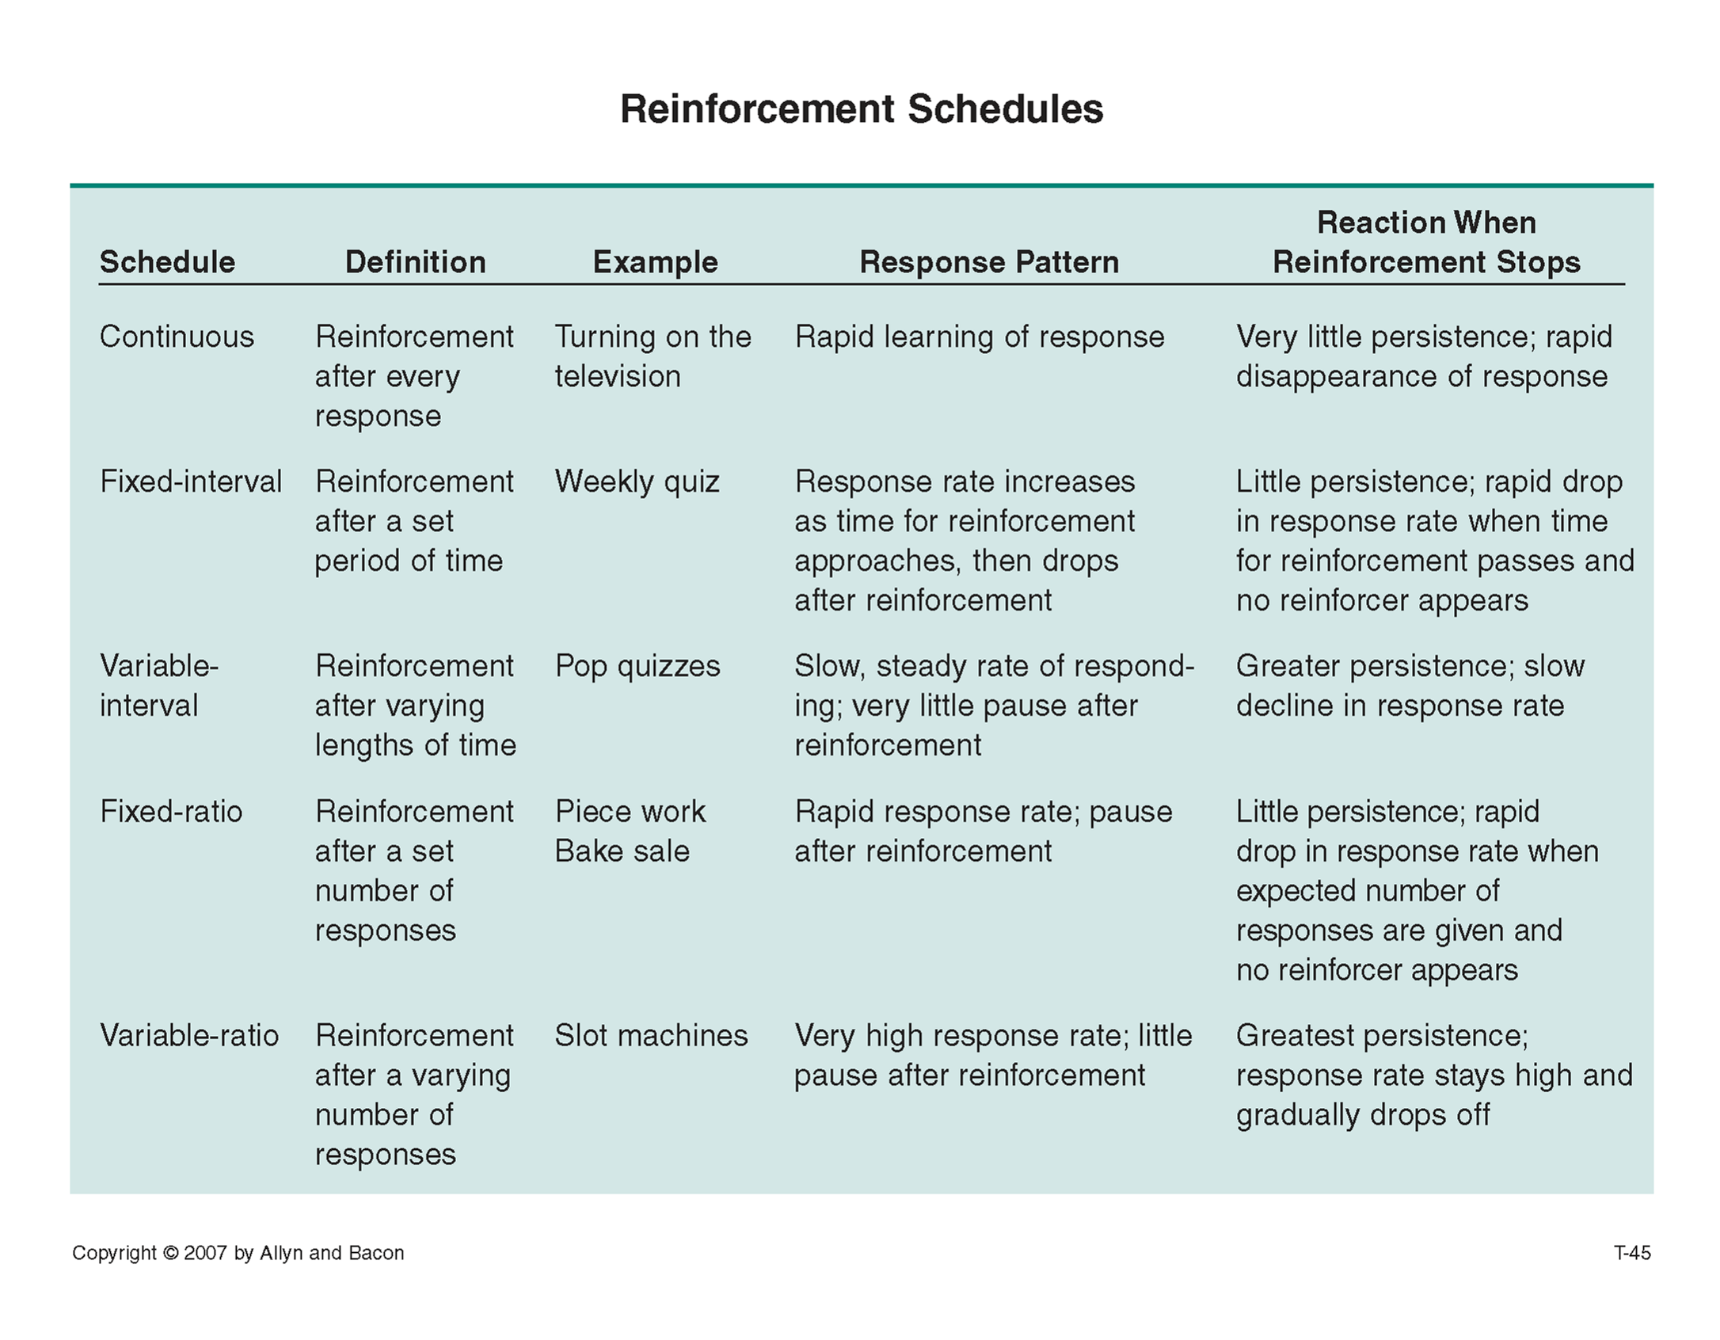

Best schedule?
- •Variable-Ratio or Variable-Interval
- *By not being ‘fixed’ the reinforcements are less predictable; behavior is more stable; less chance of extinction. Behavioral reinforcements can be manipulated easier over larger ratios or amounts of time without the student noticing.

- 2.Group Consequences
  - Positive or negative reinforcers (and punishers) given to the entire class as a whole
- 3.Token Economy
  - “tokens” are earned for academic work and positive behavior which can be exchanged for some desired reward
- 4.Contingency Contracts
  - contract between the teacher and individual student to increase a desired behavior or decrease an undesired behavior. The contract clearly states what the student is expected to do and what are positive consequences for accomplishing the set goals.

