CP216 – Introduction to Microprocessors
Department of Physics and Computer Science
Midterm Exam
Thursday, March 1, 2018
- Answer the following questions: (10 marks)
- What is an ALU – Arithmetic and Logic Unit
- What is a CPU – Central Processing Unit
- What is RISC – Reduce Instruction Set Computer
- What is CISC – Complex Instruction Set Computer
- What is RAM – Radom Access Memory
- Describe static RAM – RAM built using Transistors, no refresh required
- Describe dynamic RAM – RAM build using capacitors, requires refreshing
- What is ASCII -- American Standard Code for Information Interchange
- A memory component spans the address range 0x00400000 to 0x007FFFFF, what is its capacity?
2²²MB = 4MB

- Do the following Digital Logic and Arithmetic Operations: (10marks)
- Bitwise X-OR of 1100 and 0011 --- 1111
- Find the 2`s complement of 11110000 ---- 00010000
- Multiple the binary number of 11100011 and 00011100 ---- 01100011010100

- Convert 1234.125 into 32-bit IEEE floating-point format (10 marks)
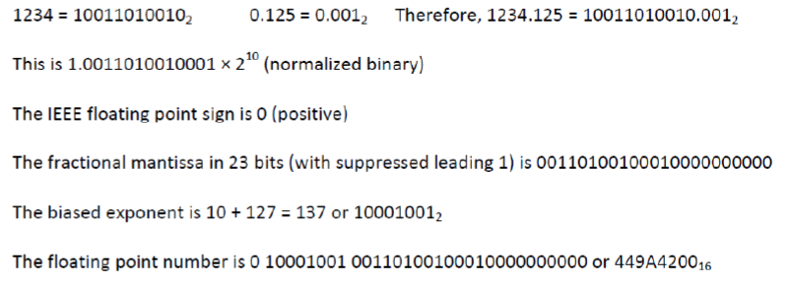
- What is the decimal equivalent of the 32-bit IEEE floating-point value CC4C0000₁₆ (10marks)

- Consider the following circuit that takes a 4-bit binary input and encodes it. Construct a truth table for the 16 inputs 0000 to 1111 and examine the outputs code. What is the characteristic feature of this code. Note that input b4 is always 0. (10marks)

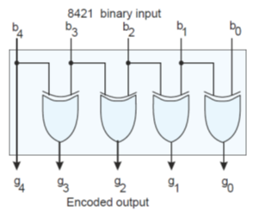

- In the ARM processor, if r1 = 11110000111000101010000011111101 and
r2 = 00000000111111110000111100001111, what is the value of r3 after executing BIC r3, r1, r2
(10marks)
- If r1 = 00FF_{16 ,} and r2 = 4, what is the value of r0 after each of the following instructions has been executed? (assume that each instruction uses the same data)
- ADD r0, r1, r1, LSL #2
- ADD r0, r1, r1, LSL #4 (10 marks)

- What does the following code do?

Label_1 ADD r0, r1, r2 ;Add register r1 and register r2, put the result into register r0
SUBS r7, #1 ;Subtract r7 by 1 (decrease r7 by 1)
BEQ Label_1 ;Branch to (go to) Label_1, if r7 is not Zero (Branch to Label_1 is Z is 0)
(10 marks)

- Write an ARM assembly code to do:
IF (X == Y)
THEN Y = Y +1;
ELSE Y = Y + 2
(20 marks)

