HSS1101 MIDTERM 1 REVIEW.
THE SCIENCE OF HEALTH. (3 QUESTIONS)
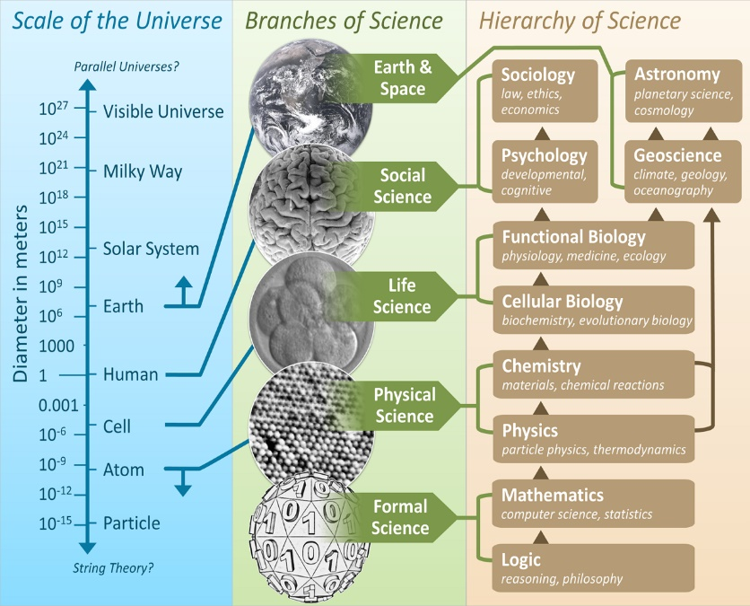
Top of diagram represents the fields in which it is increasingly difficult to make causal statements i.e Sociology, Astronomy, Psychology, Geoscience.

Reductionist health approach: the human body is divided into systems (neurology, immunology, etc) that are to be treated individually.
- =micro scale
Goal: treatment of disease and illness. i.e identify symptoms, and intervention is typically invasive such as cancer radiation, diabetes.
Limiting factor: human motivation to maintain health. Ie low autonomy and self-empowerment to prevent illness; ailments now at a younger age
Integrative health approach: the human body in one unit and is to be treated as one (environment included in this unit)
- =macro sacle
- Ie Complementary-Alternative Medecines (CAM)
Goal: prevention of disease and illness; an expression of well-being. Intervention typically non-invasive i.e lifestyle habits such as stress management, nutrition, etc.
Limiting factor: research methodology has high variance and low reliability.

THE DETERMINANTS OF HEALTH. (4 QUESTIONS)
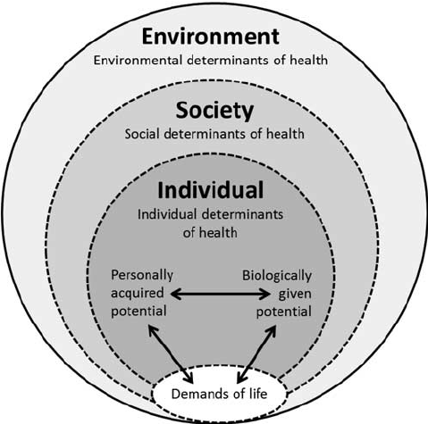
The Meikirch Model of Health: health occurs when people use biological and personal potential to manage demands of life; promotes own well-being.
- Embedded into social and environmental factors
- Thus, 3 dimensions of health = individual, social, environmental.

Population health= mix of public health and medical care.
Public health: implementation of improvement based on stats
Population health: theoretical statistics at end of every year

SOCIAL DETERMINANTS. (4 QUESTIONS)
Conventional approach = risk factor approach
- =interaction between genetic susceptibility/resilience and behaviour
- Context must always be factored in i.e smoking and drinking in Ottawa vs predominantly Aboriginal areas
- Socioeconomic influence: lower income homes are more at risk for disease
  - Higher income, education = longer life
  - Most Canadian health inequalities are attributed to education levels
  - Positive effects from lifestyle change are greatest for those in favoured circumstances (economic, social)
  - Health promotion broaden gap between richest/ most educated to the poorest/least educated.
    - Ie access to information greater, more resources, etc
Health care = fair access to good quality health will not close health gap between rich and poor BECAUSE need to improve conditions for entire population
- Social epidemiologist’s state: our health problems arise as a result of poor public policies from democratic deficit
- Large scale reform leading to just institutions is not a near-term probability.
  - Our only path to improving population health:
    - Greater gender equity (mothers, children)
    - Less sociocultural exclusion
    - Accountable government and corporations
    - Fairer employment practices
    - More supportive communities
    - Better environmental stewardship
- Support for goals other than economic exploitation of natural and human resources have grown, especially since global economic crisis of 2008.
  - Governments promising broader outlooks
  - Aboriginal people and youth are more engaged in Canadian politics and policy

HEALTH AND SOCIETY.
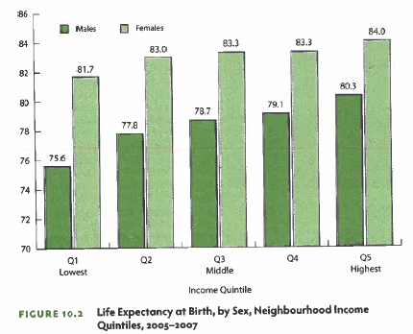
Key Determinants of Health:
- Income and inequality
- Political regimes
    - Social networks, social capital, mortality
- Neighbourhoods
- Lifestyle (i.e. food, transportation)

POPULATION HEALTH MODELS. (3 QUESTIONS)
- Health: Health is a state of complete physical, mental, and social well-being [and not merely the absence of disease or infirmity (WHO)].
- Health Inequity: are avoidable inequalities in health between groups of people within countries and between countries (WHO).
  - Equality: same opportunities vs Equity: more opportunities given to those who are starting lower than the rest (ie end game is equal by giving more to those that have less)
- Population Health: is an approach to health that aims to improve the health of the entire population and to reduce health inequities among population groups (PHAC).
- Social Determinants of Health: birth, growth, live, work, and age [and the systems put in place to deal with illness (WHO)].
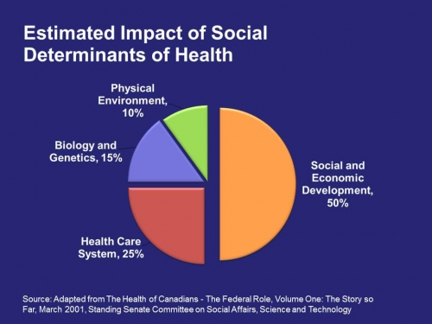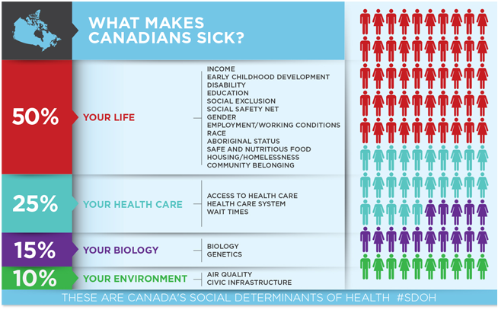

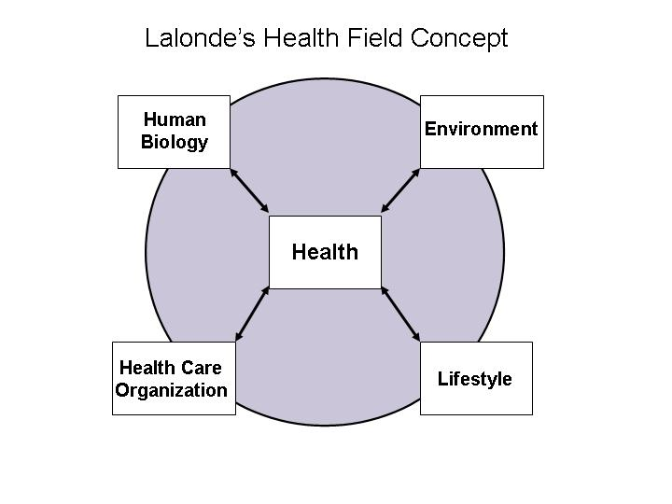
Lalonde Model (1974): first model in Canada to look at bigger picture.

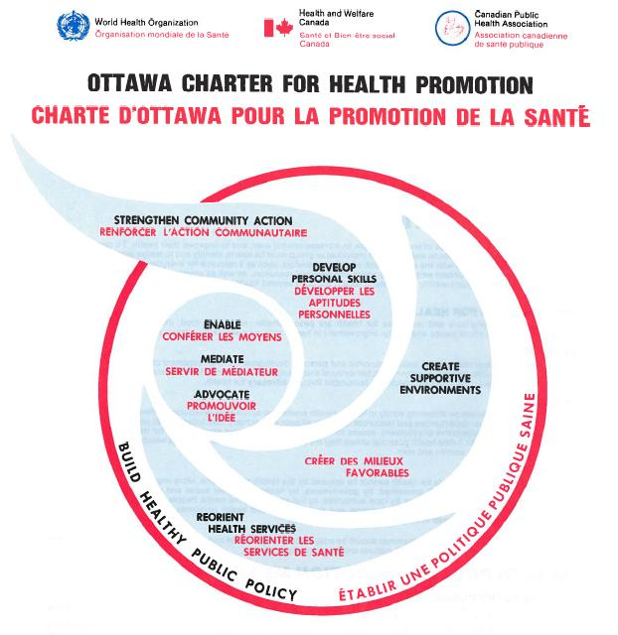
Ottawa Charter (1986): conference geared towards building healthy public policy ie create supportive environments, develop personal skills, reoriente health.

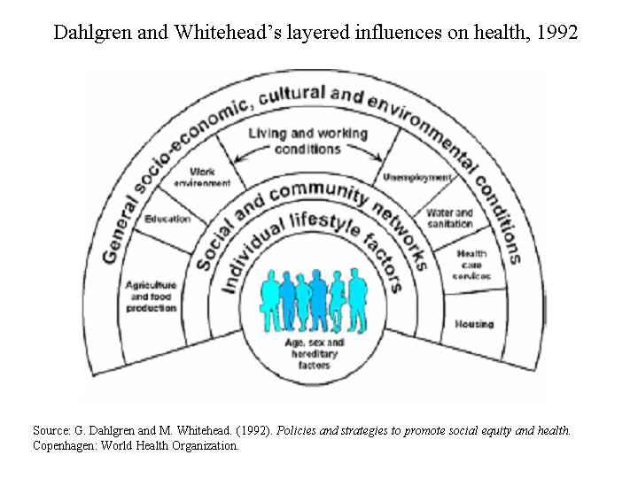
Dahlgren and Whitehead’s (1992) layered influences on health: more dynamic, adds in aspect about living and working conditions (water, sanitation, housing, etc)
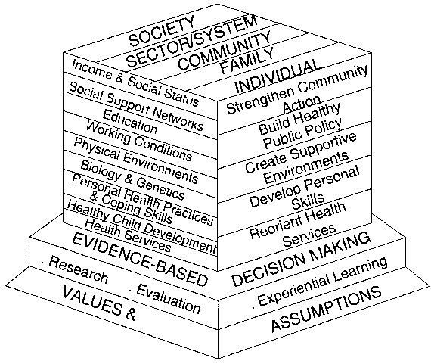
Hamilton and Bhatti (1996) Integrate Framework for Population and Health Promotion: brings in evidence -based research with a complex building block/foundation of values and assumptions.

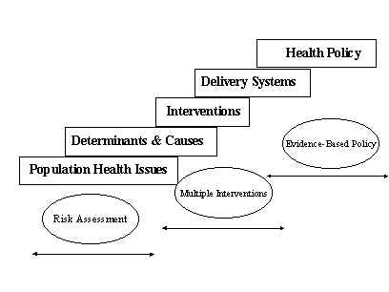
UOttawa Population Health Institute Model (1998)

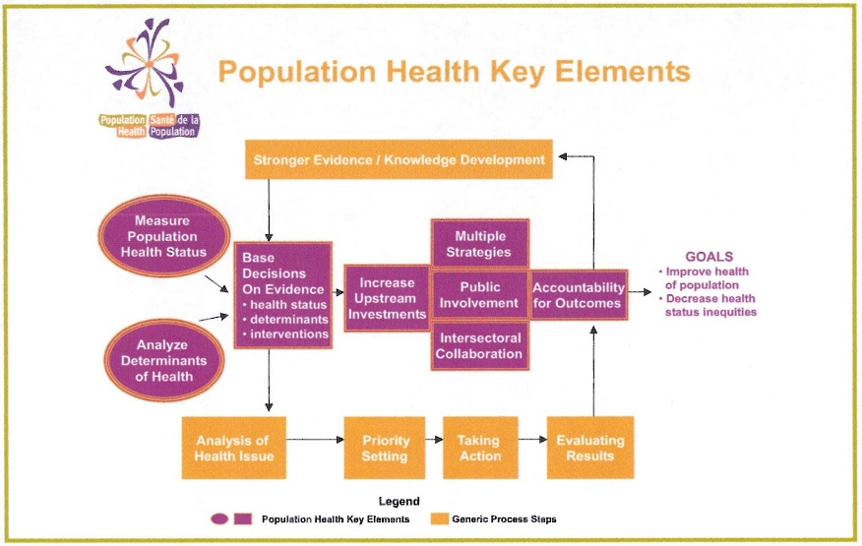
Population Health Template Tool (2001):

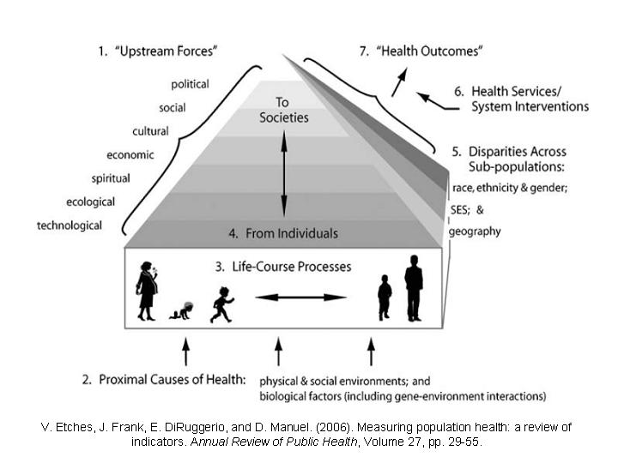
Etches Model (2006):
First model to account for life course

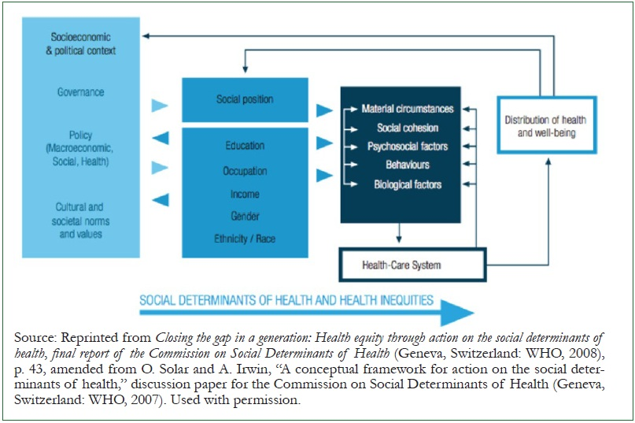
WHO Commission on Social Determinants of Health (2017): conceptual framework for social determinants of health. WHO= “gold standard” for population health, stats, etc.

CHAPTER 1: DISCOVERING YOUR PERSONAL RHYTHM FOR HEALTHY LIVING (6 QUESTIONS)
- Health and Sickness: Defined by Extremes
  - Changing views of health:
    - Classic model: absence of disease and good hygiene; not ideology anymore. Quality of life important (enjoying not just trying to avoid disease) ie attainment of complete physical, mental, social well being
    - Wellness: process of living a healthy lifestyle; asymptomatic (ie finances, sleep…)
    - Health: symptomatic/disease/state of being
  - Death due to disease: infectious and chronic in past
  - Mortality: death rates show lives now longer, morbidity: illness rates show less frequent illness
  - Life expectancy: femlaes: 81; males: 78 (higher childhood obesity rates are concern)

- Health Promotion: Helping You Stay Healthy
  - Optimal conditions (supports) for successful behaviour change: educational (promote learning), organizational (programs, services), environmental policy (decisions to change), financial (incentives/disincentives)
    - Factors reflecting sex biases in medical research
  - Androcentricity: viewing the world from a male perspective
    - Sex insensitivity: overlooking sex as an important variable
    - Double standards ie if product is likely geared towards women then conduct studies on women
    - Overgeneralization: study explores medical issues in one sex but reports that the findings span across both sexes (applies to age bias as well)
Prevention.
  - Primary prevention (intervention):
    - Stop health problems before they start. Ex: advocacy, wearing condoms, vaccines, physical activity
  - Secondary prevention (intervention):
    - Early intervention; reduce symptoms, halt progression. Ex: OTC drugs, prescription, modifying diet/physical activity
  - Tertiary prevention (intervention): Most funding
    - Treatment, rehabilitation: limit effects of disease. Ex: radiation, treatment after illness has already set in.
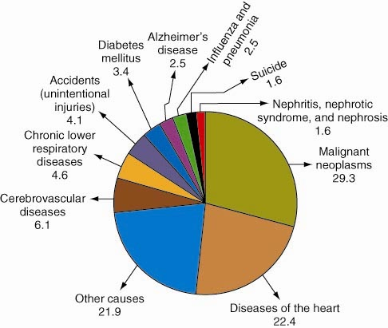
Leading cause of death by both sexes; in Canada (2009): cancer then heart disease then “other”.

BY AGE GROUP:
1-24 YRS: Accidents
25-44 YRS: Other
45-64 YRS: Cancer
65+: Other, Cancer

Benefits of Achieving Optimal Health
- Quality of life
- Greater ability to manage stress (stronger immunity)
- Enhanced self-confidence (healthy relationships)
- Environmental awareness and sensitivity
- Reduced reliance on healthcare system
- Meaning and purpose (outlook on life)

CHAPTER 5: EATING FOR OPTIMAL HEALTH AND PERFORMANCE. (30 QUESTIONS)
Essential food: nutrients only obtained via diet, nonessential: bodily production
- Hunger: physiological need to eat (hyperglycemic)
- V.S Appetite: psychological desire to eat (smell, cultural/social meanings of food, comfort)
Caloric control: weight management, body composition; calories measure the amount of energy gained from a substance
Adequacy: sufficiency in terms of intake ie are you getting enough based on statistics of healthy populations
Moderation: middle ground on intake
Balance: proportional intake/distribution of all nutrients
Variety: food obtained from many different sources
Canada’s Food Guide.
=change to emphasize less heavy carbohydrates like pasta, rice, bread and more emphasis on getting carbohydrates from other sources like vegetables
- Debate on whether milk products should be so heavily featured as most people are lactose intolerant and calcium is readily available through other sources
- New: age and sex related specifications, includes new small portion of unsaturated fats
Food Guide (most recent) created to:
- Promote a pattern of eating to meet nutritional needs
- Promote health
- Minimize risk of nutrition-related chronic diseases
The Digestive Process.
=body aims to break foods into a usable form of energy.
- Mouth: mechanical breakdown (saliva, enzymes)
- Esophagus: movement via peristalsis
- Stomach: chemical breakdown (gastric acid)
- Small intestine: absorption (duodenum, jejunum, ileum; receives enzymes from liver and pancreas)
  - Absorption i.e nutrients travel into the bloodstream
    - Liver purifies the blood, distributes nutrients (lipids go into lympathic system, carbs/proteins in vascular system)
- Large intestine/Colon (ascending, transerve, descending)
  - Processes digestive waste (some absorption of nutrients)
Digestive process takes approx. 24 hours
Age group | Percent calories from  ENERGY:  4 CAL/G 4 CAL/G 9 CAL/G
Age group | Carbohydrates | Protein (too much= uric acid buildup) | Fat (too much= ketone as source of energy; fatigue, low blood sugar symptoms)
1-3 yrs | 45-65 % | 5-20% | 30-40%
4-18 yrs | 45-65 % | 10-30% | 25-35%
19 yrs + | 45-65 % | 10-35% | 20-35%
Acceptable Macronutrient Distribution Ranges (AMDR’s):

no atp is generated from micronutrients**
CARBOHYDRATES – Simple. /refined sugars
=best source of energy for athletes.
- All simple sugars are converted to glucose (=blood sugar)
  - =sharp energy level (and glucose level) spikes
- Monosaccharides: have one molecule of sugar ie glucose, fructose, galactose. Disaccharides: 2 molecules/monosaccharides combined ie sucrose, lactose
- Sources: fruits, vegetables, table sugar, syrup
- WHO recommendation: less than 10% of daily calories allocated here
Complex
- Starch: bread, potatoes, pasta, beans, grains, cereals
  - = plant source
- Glycogen: storage form in humans in the muscles and liver
  - Athletes aim to increase endurance through carbohydrate loading techniques
    - Very low carb diet days before then the last day before spike carbohydrate intake in order to dramatically increase glycogen storage and thus be able to use in competition (not reported to be effective in women – menstrual cycle role?)
- Low carb diets: more negative implications than positive ie Atkins, Zone, 40/30/30

FIBER. (non-digestible portion of plants ie cellulose)
- Aids digestion (promotes gastrointestinal regularity; insoluble fibres attract water = easier passage through GI tract)
  - Decreases risk of cancer, heart disease, diabetes, obesity
- Dietary Reference Intake (DRI): 25 g/day for women; 38g/day for men
  - Via whole grains, fruits and vegetables (skin on), legumes

PROTEIN.
- Composition = amino acids, “building blocks” for body, tissue development
- Only broken down for energy if fats and carbohydrates are not available (worst case),
- Complete proteins = contain all essential amino acids v.s incomplete where 1-2 are missing
- Plant sources: incomplete ie need to combine sources
  - Legumes
  - Nuts and seeds
  - Grain products
  - Vegetables
- Most Canadians consume more than needed
  - DRI: 0.8g/kg of body weight
  - Food groups: meat and alternatives, milk and alternatives
FATS.
- Triglycerides (most), cholesterol, phospholipids
  - “Fats” and “oils”: saturated (“bad”) vs unsaturated (“good”)
    - Monounsaturated: peanuts, olive oil. Polyunsaturated: corn, sunflower oil ie - MUFAs, PUFAs
  - Unsaturated: (Essential Fatty Acids - EFAs)
- Excess consumption increases risk of heart disease
  - Eat less saturated and trans-fat (more likely to clog arteries)
  - Animal sources (red meats; visible fat) and processed foods
  - Eat adequate unsaturated fats (plant-based foods)
WATER.
- Typically 50-60% of body weight (average healthy person)
  - % values increase, as health and fitness levels increase.
- Dietary Reference Intake (DRI): recommendations
  - Females (ages 19-50): 2.2 litres; males (ages 19-50): 3 litres
  - Can be any “liquid” (ideally, pure water)
VITAMINS.
- Fat soluble: A, D, E, K
- Water soluble: B-complex, C
- Needs can be met with food (supplements not required)
- Antioxidants: protect against tissue damage (ie free radicals)
- Beta-carotene vitamins found abundantly in foods with orange pigment to them
  - Also = antioxidants
- Vitamin D: increased bone matrix and immunity
  - Canadians at risk of insufficient Vitamin D
  - Greater skin pigmentation = greater risk for a deficiency
- A, C, E: essential; anti-oxidants

MINERALS.
- Macrominerals are needed in large amounts; 5+ grams exist in skeletal system
  - Calcium,magnesium,phosphate,sodium,chloride,potassium
  - Need at least 100mg/day
- Trace minerals (micro)are needed in small amounts; -5 grams
  - Iron,iodine,zinc
~~
- Sodium: most Canadians consume too much
- Calcium: Vitamin D increases absorption of calcium, muscle contractions
    - v.s magnesium: muscle relaxation
    - Carbonated drinks may cause excretion of calcium
    - Good sources: green vegetables (milk products)
- Iron: deficiency (anemia) causes fatigue
VEGETARIANISM.
- Vegans (no foods of animal origin)
- Lacto-vegetarians (dairy)
- Ovo-vegetarians (eggs)
- Lacto-ovo-vegetarians (dairy and eggs)
- Pesco-vegetarians (seafood, dairy, eggs)
- Semi-vegetarians (poultry, seafood, dairy, eggs)
  - Omit red meat
When Funds Are… Short
- Avoid shopping when hungry
- Take advantage of discounts, coupons, and specials
- Plan ahead, take time to be prepared
- cook large meals and store portions
Fast Foods: Eating on the Run…
- Limit deep fried and heavily processed foods
- Order veggies, salad (limit sauces)
  - I.e mayo, dressings, and other add-ons
- Choose water instead of sugary beverages
- alcohol in moderation
Understanding Nutrition and Health Claims
What do the words in nutrient content claims mean?
- Reduced: at least 25 percent less
- Light: reduced in fat and/or calories
- Source: source, high (good), very high (excellent)
  - Ex. fibre, vitamins and minerals
FOOD-BORNE ILLNESS.
- 10,000 reported cases per year in Canada. Rise may be due to increase consumption of plant-based foods that are not in season ie greater imports = greater exogenous disease rates
- Minimizing food-borne illness
  - Keep appropriate temperatures of food . 4-60 degrees = optimal for microbe invasion.
  - Avoid cross contamination ie wash hands, surfaces, etc
  - Thaw food in the refrigerator (only for 1 or 2 days)
  - Eat leftovers within 1-3 days
- Symptoms vary, may include: cramping, nausea, vomiting, diarrhea
FOOD ADDITIVES.
=Added to food to
- Reduce risk of food-borne illness
- Prevent spoilage
- Enhance look and taste
- Enhance nutrient value

FOOD ALLERGIES.
- Body overreacts to normally harmless proteins; elicits an antibody response to the food consumed
  - Hives or rash, itchiness, diarrhea, nausea
- Common allergens:
  - Nuts, fish, shellfish, eggs, wheat, milk, beans; non-dose specific
- Food Intolerances: when one lacks the digestive enzymes; imitate allergy symptoms
  - Does not involve the immune system; dose specific
  - Gluten, lactose, reaction to food additives very common
Organic Foods
- Foods that are pesticide and chemical-free
- Usually more expensive; health impacts unclear because almost impossible to eliminate chemicals in study ie untestable
  - Purchase of locally grown products benefits environment
- Genetically Modified Food Crops
  - Genetic modification (GM): genetic cutting and pasting to enhance production
  - Improve colour or appearance
  - Adverse health impacts: liver/kidney toxicity, increasing Ax resistance
FOOD FACTORS.
Frequency: 6 smaller feedings better than 3 larger feedings
Quantity: ex. 2 egg white omelette and water vs. 5 strips of bacon, 2 sausage links, and 2 slices of buttered white toast
Quality: ex. grilled slices of zucchini vs. deep-fried zucchini sticks dipped in sour crème
- After meals, blood sugar rises and thus insulin is released to tell organs to absorb it.
CHAPTER 10: USING ALCOHOL AND CAFFEINE RESPONSIBLY AND REFRIANING FROM TOBACCO USE. (34 QUESTIONS)
Overview.
~78% of adult Canadians consume alcohol
Most popular (2011): beer, wine, spirits
Revenue from sales: ~$20+ billion (2011)
Average Canadian spends $700+, annually
Alcohol and the Post-Secondary Student
~90% of students consume alcohol
“Binge” drinking (during single “sitting”): 4* drinks: women; 5* drinks: men (* doesn’t account for alcohol tolerance, individual/cultural differences)
Three major recreational drugs: tobacco, alcohol and caffeine.
- half-more than half had negative consequences associate with their alcohol use
- Men are more likely to abstain
- Women are less likely to binge drink
- Occasional and frequent binge drinking rate are constant with both men and women
Drinking Guidelines (per week): **if not followed, one is classified as a heavy drinker**
    - Women: maximum 9 standard-sized drinks
    - Men: maximum 14 standard-sized drinks
    - Maximum 2-3 drinks per day (both women and men)
- One can be a heavy drinker without being a binge drinker and vice versa.
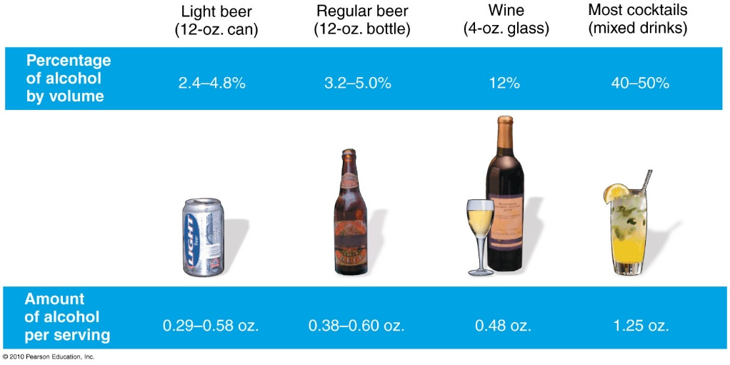

Behavioural effects.
- Blood Alcohol Concentration (BAC): alcohol to total blood volume (g/100ml blood)
  - Canada: 0.08 BAC = legal limit
0.02 – relaxed, mood enhanced
0.05 – motor impairment, more talkative
0.08 – elated, more impairment
0.10 – depressant feature of alcohol becomes apparent, drowsiness, more impairment
Learned behavioural tolerance: physiological/psychological tolerance to the effects of alcohol with repeated drinking, people may learn to modify their behaviour to appear sober even with a very high BAC.
Factors that influence absorption:
- Amount consumed (time being fixed)
  - Type of alcohol
- Amount of food in stomach
  - More = less effects
- Sex (male vs female)
  - Body mass/composition/metabolism (more BMI = more capacity for alcohol)
- Mood (/emotional state)
  - i.e because emotional state can influence the rate at which food is emptied (more stressed = faster = alcohol absorbed more rapidly)
- Women and Alcohol
  - Less of alcohol enzyme (alcohol dehydrogenase) = same drinks for man and women leads to woman with 30% higher BAC levels
- Breathalyzer and other tests
  - Breathalyzer based on amount of alcohol in breathe
  - Urinalysis based on concentration of unmetabolized alcohol in urine
  - Blood tests most accurate
Immediate Effects
- Central nervous system depressant and diuretic
  - Reduces nerve transmission frequency ie lowers CNS functions, respiratory rate, pulse, blood pressure
- Water loss from cerebrospinal fluid (dehydration)
  - Hangover” symptoms / headaches due to mitochondrial dehydration
Long-Term Effects
- Liver disease
  - Cirrhosis: results if drinking doesn’t stop after fibrosis occurs; liver cells die permanently
  - Fibrosis: liver deterioration causing fibrous scar tissue
  - Alcohol hepatitis
- Effects on cardiovascular and nervous systems
  - Moderate drinkers: decrease in brain size/weight, intellectual ability (less likely with moderation as opposed to binge drinking)
  - High blood pressure, heart rate, cardiac output
  - Holiday heart syndrome: drinking atypically large amount of alcohol (drinking sprees) may experience atypical heart rates/loss of rhythm
- Fetal Alcohol Spectrum Disorders (FASD)
  - Alcohol during pregnancy (1st trimester is worst): developmental and cognitive delay/disabilities
    - Fetal Alcohol Syndrome: neurological and developmental disorders
    - Fetal Alcohol Effects: less severe developmental issues
- Cancer and other effects
  - Inflammation of pancreas, decreased nutrient absorption (including calcium ie osteoporosis for women is now significantly higher)
  - Gastrointestinal cancers
  - Immune system deficiencies

Alcohol Abuse: interferes with work, school, relationships
  - Binge drinking 1+ times/ week
  - Most common in men ages 20-35
ALCOHOLISM.
Causes
- Biological/ Family Factors
  - Type 1 alcoholics: both men and women, guilty when binge-drinking but well adjusted when not drinking (75%, 25 years+)
  - Type 2 alcoholics: more men, no guilt, more high risk behaviour (25 years or under)
  - Those who grew up with alcoholics are more likely to become one ie drinking reinforced
- Social/ Cultural Factors
  - Peer pressure, to dull pain of emotional loss, stress (students), drinking seen as involved in religious passage = less likely to abuse than when its seen as a passage into adulthood
- Recognizing own risk – Yes to 2+ = warning sign
- Need to significantly reduce drinking?
- Feel annoyed by criticism of drinking?
- Feel guilty about drinking?
- Feel the need to drink in the morning?
Effects of Alcoholism on the Family
- Children‘s roles (1+ role):
  - family hero: divert attention from problem by always being good
  - scapegoat: diverts attention through misbehavior
  - lost child: withdrawn
  - mascot: provides comic relief through tense situations
Costs to Society: $14.6 billion (2002)
- Loss productivity, healthcare costs, traffic accident damage
Women and Alcoholism
  - More cases of women alcoholics compared to previous decades
  - Alcoholism: starts later, progresses more quickly = telescoping
- Receive less support for treatment and recovery
  - More-likely prescribed mood-altering drugs
  - Usually onset drinking due to a traumatic event
Treatment.
Withdrawal symptoms: convulsions, agitation, depression, seizures, delirium tremens (= a state of confusion brought on by alcohol withdrawal; hallucinations, anxiety)
- Family, Individual, Group therapy – person diagnosed will learn positive coping mechanisms for situations that usually lead to their drinking
- Other treatments
  - Drug therapy: disulfiram (Anatbuse) can create unpleasant effects when alcohol is consumed
  - Aversion therapy: create aversive reaction to the properties of alcohol
  - Alcoholics Anonymous
**Relapse rate within the first 3 months = ~60%**
SMOKING.
Tobacco = Number one preventable cause of death
- Cigarettes, cigars, pipes, chewing tobacco
- Smoking: most common form of tobacco consumption
  - Nicotine plus 5,000 chemicals (tar, carbon monoxide, and 50 carcinogens)
  - smoking inhibits the works of hair-like cilia so chemicals are able to irritate sensitive lung tissue
  - carbon monoxide reduces oxygen-carrying capacity of RBC’s by binding to the iron
Physiological Effects of Nicotine
  - Stimulates central nervous system and adrenal glands
  - Increases heart rate and respiratory rate
  - Constricts blood vessels (increased blood pressure)
  - Reduces appetite
  - Makes blood “stickier”/ viscous
  - Nicotine poisoning: new smokers feel lightheadedness, erratic pulse, clammy skin, nausea, vomiting, diarrhea (significantly worse in children)
Learned Behaviour
- ~85% start before 16 years
  - Social/cultural influences: peer pressure, growing up with a smoker, perceptions of smoking that surround you
  - Takes roughly 2-3 years for transition from experimentation to daily smoker
- Tobacco promotions target
  - Youth; especially young women
  - Aim to make smoking look desirable, sexy, cool, glamorous
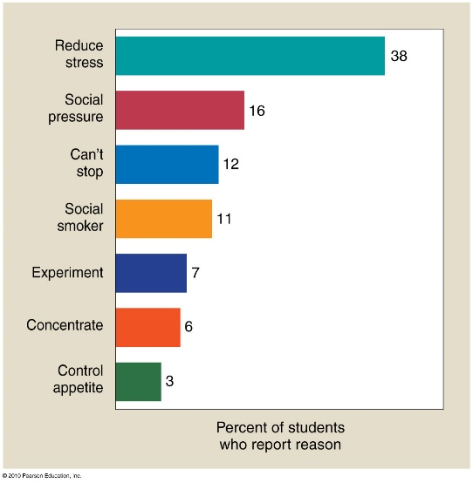
Smokeless/chewing tobacco
- As addictive as nicotine content is MORE
- Leukoplakia: leathery white patches inside the mouth
  - Taste and smell impairment = added salt/sugar to food = high blood pressure risks
- Dental Problems such as receding gums, tooth decay, discoloured teeth

Environmental Tobacco Smoke
2 types: mainstream and second-hand smoke
- Mainstream: smoke drawn from a cigarette while inhaling
- Second-hand: smoke released into air then inhaled by others
- Passive smokers: those who breathe smoke as a result from someone else’s cigarette (or other nicotine tool)
  - More carcinogenic properties in second-hand smoke than actual voluntarily inhaled smoke
  - Lung cancer, heart disease risk
  - Children have greater risk for respiratory problems
Quitting
- One of the hardest addictions
- Irritability, restlessness, intense craving for tobacco = nicotine withdrawal
- Nicotine replacement products
  - Chewing gum: same nicotine dose but dissolves in mucous membrane ie the same rush not achieved; usage is geared to be gradually stopped
  - Patch: nicotine dissolved into skin on upper body; helps with withdrawal symptoms as well
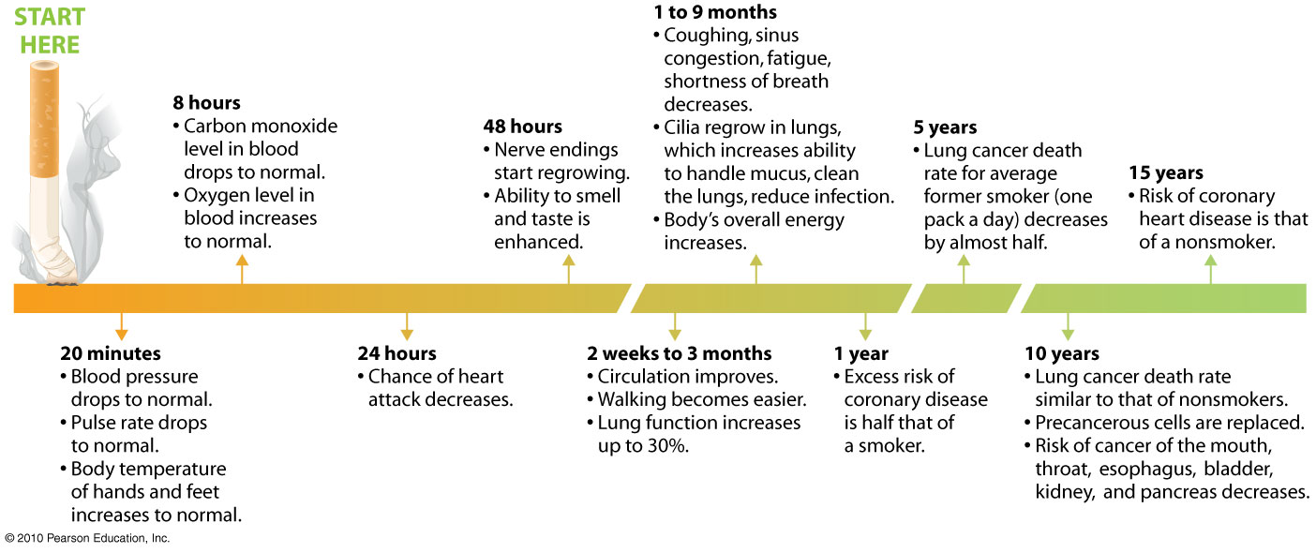
CAFFEINE.
=most widely consumed recreational drug in Canada
- Avg: 210-238mg/day
Effects: insomnia, irregular heartbeat, dizziness, nausea, indigestion
- From chemical family xanthines ie mild CNS stimulants that enhance mental alertness, reduce fatigue
  - Increases also in: oxygen consumption, metabolism, urinary output, heart muscle contractions
Caffeine Addiction
- To maintain effects due to tolerance, we drink more
  - May develop dependency = caffeinism
  - Withdrawal: severe headaches
Energy Drinks
- Potent stimulant effects
- Available in a variety of sizes
- Various levels of caffeine, sugar, calories, nutrients
Health consequences of long-term caffeine use
- Linked to heart disease, cancer, mental dysfunction (high consumption of 6+ cups/day)
  - Birth defects, high LDL
- Less than three cups per day = moderation & little to no health consequences
- Those with pre-existing health conditions should be careful
  - Ie those with irregular heart beats may experience fatal increases in heart rate

