1
Introduction to Sports Medicine
Sports medicine
- Broad and Complex
- Prevent, recognize, assess, manage & rehab injuries related to sport, exercise, or recreational activity
- Enhance fitness & performance
- Branch of medicine that applies medical & scientific knowledge to improve sport performance
Sport Medicine Team
- Sports medicine Team: group of specialized medical professionals; provide immediate on-site health
- Primary Care Team – Pg.6
  - Team physician
    - Supervise healthcare of team, determine mental & physical fitness of athletes, CASEM qualifications
    - Final authority to the development of mental & physical fitness of athletes
  - Athletic Therapist
    - Prevention, Health & welfare of athletes
    - Immediate care, injury assessment, management, rehab, reconditioning, education, counselling, organization, administration, liaison b/w team members
    - #1 skill = communication
    - Everything links back to the certified athletic therapist
  - Coach/ sport supervisor
    - Teach skills & strategies of a sport, team leader, administration, injury prevention (minute restriction; scheduling, competition, training, time-off, not rushing the player)
  - Sport participant
    - Performance & injury prevention
- Secondary care team
  - 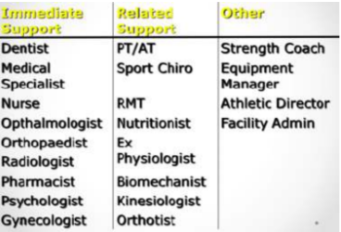

Professional Organizations in Sport
- CATA: Candian Athletic Therapist Association
  - Therapists from diff teams collaborated, picking each other’s brains, eventually led to an organization
  - Board of directors
  - Several committees
  - Associated with the OATA (Ontario athletic therapist association)
- NATA: National Athletic Trainers Association
  - Represents more than 35,000 members in athletic training profession
  - Similar history to CATA
  - Responsible for the growth & development of athletic training profession
  - Establishing standards for professionalism, education, research, and practice settings
  - Reciprocity rule (Canada- US)
- Board of Certification
  - Resposible for awarding the ATC credential (separate from NATA)
  - Published the Role delineation study: defines the current entry-level knowledge, skills & abilities required for practice in the profession of athletic training:
  - Injury/illness prevention & wellness protection, Clinical evaluation & diagnosis, Immediate & emergency care, Treatment & rehabilitation, Organizational & professional health & well-being
- SPC: Sport Physiotherapy Canada
  - Same skill as Athletic therapist, more opportunity in clinic
  - Need a diploma to become a physiotherapist
    - 10 Years
- CASEM: Canada Academy of Sports & Exercise Medicine
Who makes up the medical team?
- CMO (medical officer)
  - Must be a member of CASEM
- CT
  - Must be either a CT or diploma SPC
- Health care team
  - Sport medicine physician
  - Certified AT
  - Sport physiotherapist with diploma
  - Sport massage therapist
  - Sport chiropractor
  - Sport Psychologist

2
Ethical and Legal Aspects of Injury Care *13-20, 53-54*
- Ethical Standards (professions)
  - Coaches
  - Medical professionals
  - Rights of athletes (warren fraleigh)
- Ethics: the science or study of moral values or principles including ideals of autonomy, beneficence, and justice. Guidelines, not laws.
- Sport Ethics: Avoid acts or the encouragement of acts that are known to increase the possibility of physical injury
- Scope of practice: outlines the role and responsibilities of an individual in that profession and delineates what should be learned in the professional preparation of that individual
- Standard care: measure by what another competent individual who is educated and practicing in that profession would have done to protect an individual
Ethical and Moral Dilemmas in Sport
- Providing treatment to mask the pain
- Position of authority
- Baseball pitcher
- Playing an athlete when he or she shouldn’t
  - Medical staff is the voice of reasoning
  - An impaired decision with athlete and coach
  - Therapist (voice of reason) will give both athlete and coach their opinion but the athlete has the final say. In some instances the coach can just refuse to play the player
Legal Considerations
- Practice of athletic therapy is tried under tort law
- Tort Law
  - A civil wrong done to an individual, whereby the injured party seeks a remedy for damages suffered
  - Act of omission
    - An individual fails to perform a legal duty of care resulting in injury or harm
    - Athlete tells AT that they’re doing weed and not to say anything
      - Civil wrong done by therapist where an individual has a remedy for damages suffered
      - Individual fails to perform a legal duty
  - Act of Commission
    - An individual commits an act that is not one’s act to perform or an act that is
    - One’s duty to perform that is carried out w/ the wrong procedure, leading to injury or harm
    - i.e. Injecting someone

  - Why people sue
    - People are more aware of their legal rights & less willing to accept incompetence/negligence
    - Publicity about large financial awards in lawsuits
    - Public is less hesitant to take complaints to court
    - People assume insurance companies have an unending capacity to pay
NATA Code of Ethics (5)
- Members shall respect the rights, welfare, and dignity of all individuals
- Comply w/ the laws & regulations governing the practice of athletic training
- Accept responsibility for the exercise of sound judgement
- Maintain & promote high standards in the provision of services
- Not engage in any form of conduct that constitutes a conflict of interest or reflects adversely on the profession
Negligence
- Individual does not assume the risk that a professional will breach the duty of care
- Contributory negligence: injured person was involved
  - Malfeasance
    - Individual commits an act that is not one’s responsibility to perform
    - Not within scope of practice
    - Injection (commission)
  - Misfeasance
    - Individual commits an act that is one’s responsibility to perform but it is done wrong
    - Doing incorrectly
    - Commission
  - Nonfeasance
    - Individual fails to perform the legal duty of care
    - Omission
    - AT fails to stabilize athlete when suspected spinal injury
  - Malpractice
    - Individual commits a negligent act while providing care. (umbrella of the others)
    - AT committing negligence act
    - Covered by insurance
  - Gross Negligence
    - Individual has total disregard for the safety of others
    - Everything wrong
  - Vicarious negligence
    - Negligence done by someone working under you
    - Situation where employer has AT and athlete sues therapist and employer
    - Responsibility

- To prove negligence all 4 must be present:
  - 1 Duty of care was owed to the athlete
  - 2 A breach of the standard of care was committed
  - 3 An injury resulted
  - 4 The injury was a direct result of the breach of standard of care
- Defense against negligence (PROVE 1)
  - 5 Proper standards of care was taken thus no breach of duty
  - 6 Injury was an unavoidable accident
  - 7 Injured party Involved in contributory negligence
  - 8 Athlete was aware of the assumption of risk
Legal Liability
- Liability: the condition of affairs that gives rise to an obligation to do a particular thing to be enforced by the action
- Potential litigious factors:
  - Ignorance of the law
  - Ignoring the law
  - Failure to act
  - Failure to warn
  - Time & Exposure
- Failure to warn
  - Participants must be informed of risk & understand its nature
- Foreseeability of harm
  - Recognizing a potential danger & removing the danger before an injury occurs (i.e. checking the field)
- Informed consent
  - Injured party can be reasonably informed of needed treatment, possible alternative treatment, and advantages/disadvantages of each course of action
  - Exclusionary clause – identify conditions not treated by CATC
  - Obtain before any treatment (potential for battery w/o)
  - Battery: unpermitted or intentional contact with another individual without consent (assault)
- Refusing Help
  - Individuals have the right to refuse treatment
  - Exception = increased risk for further injury
- Product Liability (NOCSAE or CSA)
  - Implied warranty: duty of care to design, manufacture, and package safe equipment that will not cause injury to an individual when used as intended
  - Expressed warranty: written guarantee that the product is safe for use
  - Strict liability: manufacturer liable for any and all defective equipment that unduly threatens an individual’s personal safety
  - NOCSAE = National Operating Committee on Standards for Athletic Equipment
  - CSA = Canadian Standards Association
- Confidentiality
  - Right to privacy
  - Breach = disclosure of medical/health condition w/o consent
  - Able to disclose when you think there’s an issue
  - Pregnancy, HIV, HBV
    - Can get arrested if you don’t tell people about HIV
Legal Defenses
- Assumption of risk
  - Athlete acknowledges the understanding of the risks of their participation in activity
  - Assuming all risks of injury or even death due to participation
- Exculpatory waiver
  - Release of liability
- Good Samaritan Laws
  - Immunity applied to emergency first aider
  - Varies from province to province
    - Emergency
    - Good faith
    - Without paid
    - Not guilty of misconduct
- Contributory negligence
  - Relative degree of negligence
  - Damages awarded on a proportionate basis
Common Areas of Negligence
- Poor selection of activities
- Failure to take protective measures
- Hazardous conditions of buildings or grounds
- Faulty equipment
- Inadequate supervision
- Poor selection of play area
Preventing Litigation
- Understand & complete duty of care, act in an ethical manner, steps to reduce risk of litigation, be nice
- Pre-participation medical exam, acceptance of risk, planning & supervision, equipment, facilities, emergency care, records kept (10 yrs or 10 yrs after age 18 for kids)
LEGAL AVOIDANCE CHECKLIST
- Preparticipation medical examination
- Health insurance
- Preseason preparation
- Acceptance of risk
- Planning and supervision
- Equipment (NOCSAE or CSA)
- Facilities
- Emergency care preparation
- Records kept
3
Evidence Informed Practice *chapter 5*
- Evidence Based practice: practice based on evidence suggested
- Evidence Informed Practice: takes into account clinician’s clinical expertise, patient’s values & health status, risks & benefits of the treatment, and empirical research
  - A person may react differently to the evidence-based treatment so you have to act accordingly
5 steps of EIP
- Formulating an answerable clinical question
- Searching the literature
- Appraising the literature
- Integrating the evidence into clinical practice
- Evaluating the EBP process & patient’s outcomes
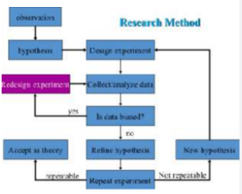
Formulating a Clinical Question
- PICO - Answerable Question
- Patient or clinical problem
- Intervention of interest
- Comparison
  - Not always included
- Outcome of interest
- ACL injury
  - P: female soccer athlete with ACL injury
  - I: certain type of exercise
  - C: incidence of injury (flexibility and quad strengthening)
  - O: will it help
Epidemiologist
- Epidemiology: study of the distribution and determinants of varying rates of diseases, injuries or other health states in human populations
  - Studies and attains data
  - Uses research methods to investigate the rates and determinants of injury and disease
  - Believe in the causes and not bad luck
- Factors
  - Rates of injury and Illness
  - Person
    - Age
    - Sex
    - Type of activity performed
    - Risk taking behavior
  - Place
    - Environment
    - Concrete
    - Outdoor
  - Time
    - Before or after workout
    - Preseason, postseason
    - Weather seasons
Types of Studies
- Retrospective
  - Look to past exposure for risk factors
  - Not controllable
  - Cheaper
  - Unreliable
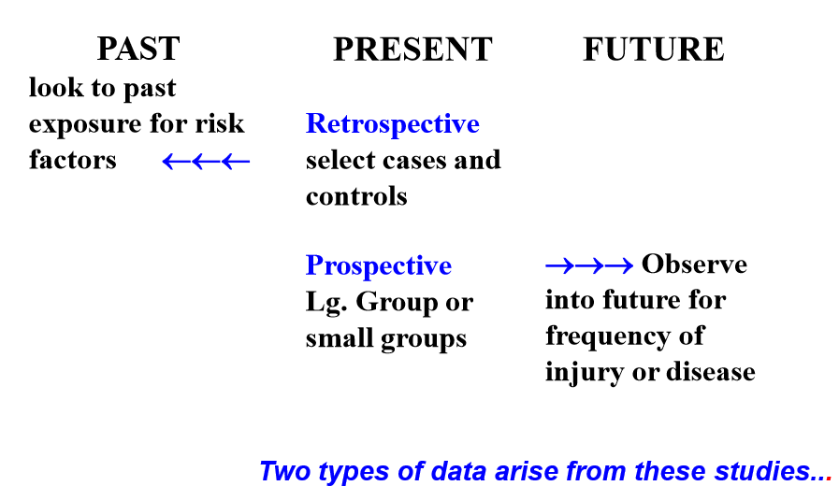
- Prospective
  - Observe into future for frequency of injury or disease
  - Controllable
  - Costs money
  - Reliable
  - There is still bias
    - Hawthorne effect
    - Can’t control because participants know they’re being studied
- 2 types of data arise
  - Quantitative
    - 16 torn ACL injuries
  - Qualitative
    - Feelings of anxiety after ACL injury
Rates of Injury and Disease
- Incidence Rates
  - Measure of the rate at which new injuries/ events occur in a population
  - # of new cases in a fixed time period/ population at risk
- Prevalence Rates
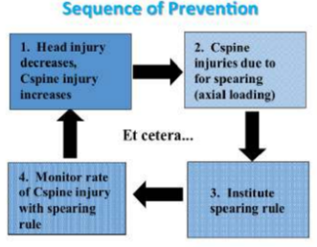
  - A measure of the proportion of the population experiencing an event at a designated time/given time period
  - Total # of events in the population at risk per 1000 at a given time
- Statistics used for
  - Injury prevention
  - Proper conditioning & technique
  - Proper equipment
  - Safe scheduling
  - Medical screening
  - And rule changes
Epidemiology use
- Identify causes of disease/injury
- Completes clinical picture (causes, symptoms)
- Identify syndromes (Osgood Schlatter)
- Determine efficacy of a treatment
- Monitor health of a community
- Identify risk groups (children and fx)
- Study trends over time (overuse injuries)
4
Classification of Injury *190-198, 231-262*
- Injury
  - Any occurrence, caused by various types of trauma that impairs tissue structure or function & thereby alters the cell’s ability to carry out its normal homeostatic mechanism
  - Any injury will cause the inflammatory response
  - Strain
    - Amount of deformation with respect to original dimension
    - Muscular
  - Sprain
    - Ligament injury
  - Ice has a physiological response
    - Reduces temp, homeostasis and slows down blood
    - If accumulate too much blood then it impairs brain function
- Inflammation
    - Positive thing
    - Part of healing
    - Inflammatory (1-72h), repair (1-3 weeks), remodel (3+ week)
- Factors that affect injury
  - Size and magnitude
  - Direction of force
  - Area of which force is applied
  - Properties of tissues
  - Magnitude of stress
Classification
- Contact vs non-contact
- Direct vs indirect
- Acute vs chronic
- Macrotrauma (acute) vs microtrauma (chronic)
Macrotrauma
- Spike in pain happens right away past the threshold of pain which differs from person to person
- As inflammation reduces & healing occurs pain will drop
- 3-6wks in = no pain but period of re-injury because you will feel no pain and think everything is alright but in actuality the tissue is still healing
- Nutrition & lifestyle habits affect healing rate
- Traumatic
- Single event or force which pushes tissue beyond its capabilities
- Player may not be injured because of equipment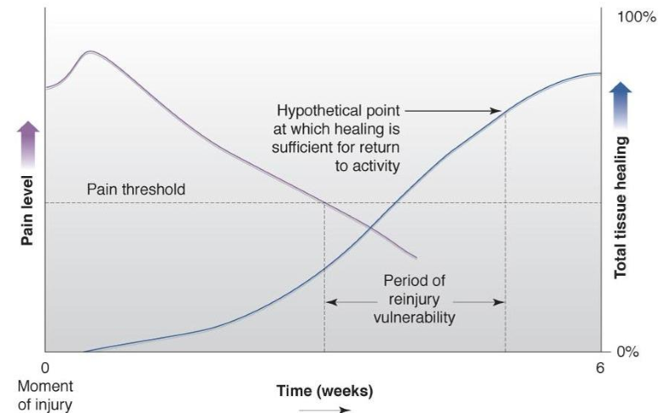

Microtrauma
- Overuse
- Repetitive stress causing minor tearing and inflammation of tendons
  - Unable to withstand force
- Harder to identify when it started to become damaged
- If you don’t have adequate rest & recovery you start to get pain
- Often times people take time off, they come back and the pain will come back because they are not allowing enough time for the tissue to heal
- This can become permanent if you cycle between pain & no pain
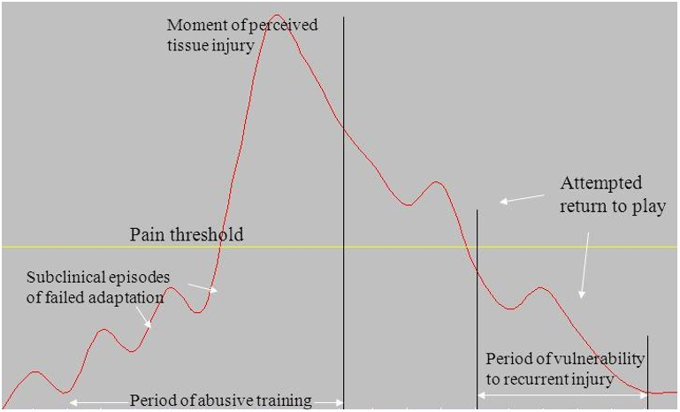
- Tough injury to deal w/ as a physio b/c you are recommended the client to stop what they are doing entirely.
- Failed adaption
  - Muscle is not responding to strain
- Antecedent pain
  - Beginning of pain
  - Constant pain
  - Pain goes down because you stop working out a think, you’re okay
5
Injury Mechanisms
- Force: a push or pull acting on the body which results in acceleration or deformation
  - Compression, tensile, frictional, torsional
- Force factors
  - Size of force
  - Tissues involved
- Deformation of tissue
  - Changing shape
  - Sitting on glutes = flattened
  - Elastin and collagen
  - Elastin
    - Stretch and recoil
  - Collagen
    - Resist Load

Force
- Compressive
  - Pressure and squeezing
  - Directed through body to increase density
  - Football player sandwiched
- Axial
  - Loading
  - Directed along the axis of the body
  - Fencing
  - Opponent touches with foil
- Tensile
  - Pulling and stretching
  - Directed axially through the body or body part
  - Muscle contraction puts force attached to bone
  - Inversion of foot
- Shear
  - Directed parallel to surface
  - Object slides or displaces
Force and Effects
- Changing shape
  - Depends on certain % of elastin
  - As long as you don’t apply a lot of force muscle will go back to normal
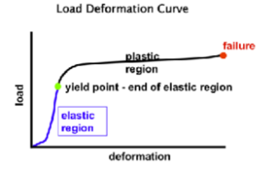
- Plastic region
  - Can go on for a long time before tissue fails
  - A tear
  - Depends on load and tissue type
- Permanent deformation
  - Pass elastic region
  - More elastin causes it to be longer
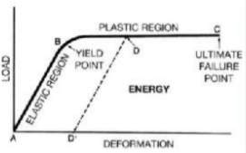
  - Sometimes it can be beneficial (ear piercing)
Response to Force
- Small load
  - Elastic response-load is removed, material returns to its original shape
- Load reaching yield point
  - Plastic response
  - Load is removed, some amount of deformation remaining
- Yield load
  - Max load a material can handle without permanent deformation
- Failure
  - Force such as loss of continuity, rupturing soft tissue or fracturing bone
Direction of Force
- Many tissues are anisotropic
  - Stronger in resisting a force from certain directions than from others
  - Anisotropic
    - Having different strength response for loads in different directions
    - Need to move in the night to prevent bed sores
  - Anatomic make-up of joint
    - Susceptibility from a given direction
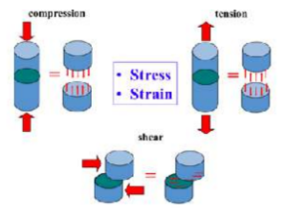
Effects of body movement speed
- Rapid, jerky lift
  - ↑ compression & shear on spine
  - ↑ tension paraspinal muscle
- Effects of impact forces
  - High speed & collision ↑ risk
  - Cervical flexion (large bending moment) + axial compression
  - Load = danger
Magnitude of stress
- Force divided by the area over which the force acts
- Less stress to tissue if the force is over a large area compared to a small area
- A high magnitude of stress rather than a high magnitude of force determines injury
- Large vs small area has different effects
  - Less stress/ large area
    - LESS STRAIN
  - Greater stress/ small area
    - MORE STRAIN
Strain vs Force
- Strain: the amount of deformation relative to the original size of the structure
- Ultimate strength of biological tissues determines the amount of strain that a structure can withstand without fracturing or rupturing
- Results in…
  - Compression: shortening and widening
  - Tension: lengthening and narrowing
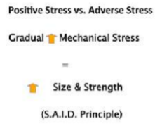
  - Shear: internal deformation
- Repetitive stress injury
  - Results from repeated loading
  - Causative factor microtrauma
  - Characterized by becoming more problematic over time
- S.A.I.D
  - Specific Adaption to Imposed Demands
  - Do this during exercise no matter the tissue
  - Osteoporotic women need weight training walking to strengthen bone
  - Load bearing exercises
  - GRADUAL
Torque
- Rotary force
- Torque produces rotation of a body segment about a joint
- When the muscle develops tension, it produces torque at the joint it crosses
  - For example: the torque produced by the biceps brachii is the product of the tension developed by the muscle and the distance between its attachment on the radius and the center of rotation at the elbow.
- Excessive torque can cause injuries. 2 types: Bending and Torsion
  - Bending:
    - The simultaneous application of forces from opposite directions at different points along a structure
    - E.g. tibia, generates torque known as a bending moment, which causes bending and ultimately leads to a fracture
    - For example: a football players leg being anchored to the ground while being tackled on that leg from the front while being pushed into the tackle from behind, a bending moment is created on the leg
    - Due to bone being stronger in resisting compression forces, if bending should occur, the side which produces tension will fracture if the bending moment is large enough
  - Torsion:
    - The application of torque along the long axis of a structure i.e. long bone, can cause torsion – twisting of the structure
    - Torsion results in the creation of shear stress throughout the structure
    - For example: in skiing a lot of times one boot and ski are firmly planted as the skier rotates during a fall – this results in torsion load that can cause a spiral fracture of the tibia
- Moment arm
  - Perpendicular distance from line of action to the axis of rotation
  - Moment arm: door
  - Axial rotation: hinges
  - The greater the moment arm will give a mechanical advantage
    - Why the doorknob is further from hinges
    - If closer, more torque will be generated
Anatomical Properties of soft tissue
- Skin
  - Mostly elastin
- Tendons, ligaments, aponeurosis
- Muscles
  - Elastin
- Nerves
  - Least elastin
Soft tissue
- Collagen
  - Primary constituent of skin, tendon, ligaments
  - Protein substance strong in resisting tensile forces
  - Wavy configuration, which allows for an elastic-type deformation or stretch but otherwise is inelastic
  - As long as the load isn’t too heavy it won’t deform
- Elastin
  - Protein substance
  - Adds elasticity
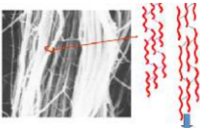
Collagen
- Each fiber is made up of fibrils that are arranged in a helix
- They have a wavy configuration when unloaded and straightened configuration when under tension
- Example
  - Ropes hanging from a ceiling
    - Tightly bound
    - Serrand wrapped (sheath)
    - In the ropes there are small ropes that are intertwined (collagen fibers)
    - Held together by collagen cross linkages
  - Put heavy load
    - Breaks
    - Micro tear of tendons
  - Cross linkages help to make tissues less mobile but stronger
- Tissue tear
  - Get it to med back by immobilization
  - Prevent movement
  - Sitting, sleeping, ankle brace helps to BUILD UP CROSS LINKAGES
    - Why you stretch
    - Morning
Elastin
- Ability to recoil (curl shaped)
- Not as much strength as collagen
- Ligaments have more elastin
  - Bone to bone
- Tendons have more collagen
  - Muscle to bone
The Skin
- Epidermis
  - Outer region
  - Multiple layers containing the pigment melanin
  - Hair, nails, sweat glands
  - Made up dead epithelial cells which are replaced every 4 weeks
- Dermis
  - Collagen in different direction
    - Allows compression, tension and shear
  - Largest portion of the skin
  - Provides strength and structure
Tendons
- Muscle to bone
- Dense connective tissue
  - Unidirectional bundles of collagen and some elastin
- Collagen
  - Parallel arrangement
  - Helps to resist high unidirectional tension
- 5-8% stretch ability
- Stronger than muscle
- Takes a lot to damage
  - Continued stress
Ligament
- Bone to bone
- Collagen is parallel and interwoven
  - Resists large tensile loads along the long axis of the ligament and smaller loads from other directions
- Collagen and elastin intermixed (more elastic than tendons)
Aponeurosis
- Muscle to other muscle or bone
- Dense connective tissue
- Strong, flat, sheet like
Muscle
- Viscoelastic (stretch/recoil)
  - Extensibility – ability to be
  - Elasticity – ability to return to normal length
- Viscoelasticity allows muscle to stretch to greater lengths over time in a response to a sustained tensile force
- Irritability
  - Respond to stimulus
  - Electrochemical: nerve
  - Mechanical: external blow
- Contractility: ALL MUSCLES CAN DO THIS
  - Develop tension
    - Isometric SAME
    - Concentric SHORTEN
    - Eccentric LENGTHEN
6
Disposing Factors of biomechanics
- What are the risk factors and predisposing factors that make some athletes more athletes more likely to sustain an injury when exposed to these factors than others?
  - Muscle strength, weakness, imbalance
  - Flexibility
  - Lifestyle factors
  - Hydration
    - Fatigue
    - Poor performance
- Intrinsic factors related to sport injuries
  - Age
  - Sex
  - Neuromuscular, structural, and performance aspects
    - Agility
    - Speed
    - Steadiness
    - Timing
    - Strength
    - Balance
    - Muscular tightness
  - Mental and psychological aspects
    - Intelligence
    - Creativity
    - Motivation
    - Discipline
    - Skill level
- Extrinsic factors related to injury
  - Exposure to situation
    - Position played
    - Playing time
    - Competitive level
  - Amount of practice and training
Posture
- One factor which can dramatically affect the load on the spinal cord is the body position
- When the body is in the upright position – the line of gravity passes anterior to the spinal column
  - As a result, the spine is under constant forward bending moment
- As the trunk is flexed, the line of gravity shifts further away from the spine – the further the line of gravity is from the spines, the larger the moment arm for body weight and the greater the bending moment generated.
- To maintain that position, this moment is counteracted by tension in the back muscles
- The more tension required to maintain body position, the greater the compression load on the spine.
  - Thus, lifting with the trunk erect minimizes that tension requirement for the lumber muscles
  - This also means that carrying a load to your trunk as close as possible results in minimal load on the back
- JOM and muscle strength play a role in achieving optimal posture
- Poor posture can cause flexibility and muscular imbalance
Causes of Poor Posture
- 1. Postural Habits
  - Adaption to culture – Environment/Sport
  - Attitude
  - Physical strength
- 2. Bony Anomaly
- 3. Pain
- 4. Respiratory Conditions
- 5. Age
Postural Assessment and Biomechanics
- Lordosis
  - Abnormal exaggeration of the lumbar curve
  - Associated with weakened abdominal muscles
- Sway Back
  - An individual with sway back presents with an increased lordotic curve and kyphosis (abnormal curve of spine)
  - Results due to weakened lower abdominal and thoracic extensors and many more
  - The deformity makes the spine bend backwards sharply at the lumbosacral angle
  - Entire pelvis shifted anteriorly and to maintain line of gravity, it causes the thoracic portion to flex onto the lumbar spine increasing the lumbar and thoracic curves
- Flat Back Syndrome
  - Refers to the relative decrease in lumbar lordosis (20deg) which shifts the center of gravity anterior to the lumbar spine and hips
  - Most notable trait is the tendency to lean forward when standing or walking
- When you deviate from normal posture you have imbalances throughout the body
7
Pain
- Pain: a subjective and multidimensional, unpleasant experience which accompanies injuries and often persists for a longer period of time than is useful
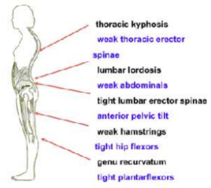
  - Purpose
    - Acts as a protective mechanism
  - Types
    - Chronic
    - Acute
- We need to experience pain to…
  - Build up tolerance
  - Appreciate health
  - Best motivator
Categories of Pain
- Somatic
  - Musculoskeletal pain
  - Twist finger a certain way
  - Arises from the skin, ligaments, muscles, bones, and joints and is the most common type of pain encountered in musculoskeletal injuries
  - It is classified further into 2 sub-categories: Deep and Superficial
  - Deep Somatic Pain
    - Is described as nagging, as if intense pressure is being exerted on the structures – may be complicated by a stabbing pain. Deep pain is longer lasting and usually indicates tissue damage to bone, internal joint structures or muscles.
  - Superficial Somatic pain
    - Results from injury to the epidermis or dermis and usually is sharp, prickly type of pain that tends to be brief
- Visceral
  - Organs
  - Results from disease or injury to an organ in the thoracic or abdominal cavity
  - E.g. compression of the viscera
  - Similar to deep somatic pain, it is described as deeply located, nagging, and pressing, and it often is accompanied by nausea and vomiting
- Psychological
  - No physical injury
  - Referred Pain:
    - Is a type of visceral pain that travels along the same nerve pathways as somatic pain
    - It is perceived by the brain as being somatic in origin
    - i.e. the injury is in one location, but the brain considers it in another
  - Radiating Pain:
    - Is a type of pain which is felt at both the source of the pain and along a nerve
    - E.g. pinching of a sciatic nerve at its root may cause pain that radiates long the nerve down to the posterior aspect of the leg
Words used to describe Pain
- Aching
  - Chronic inflammatory response
- Stabbing
  - Acute tear
- Throbbing
  - Vascular
  - Buildup of tissue
- Burning
  - Nerve related
- Tingling
  - Nerve related
Pain characteristics
- AM pain/stiffness/better with activity
  - Chronic inflammation with swelling
- Sharp, stabbing pain during activity
  - Acute ligament sprain or muscular strain
- Dull, ache aggravated by muscle contraction
  - Chronic mm strain
- Night Pain
  - Compression of a nerve or bursa
- Sharp/burning/numbing
  - Nerve pain
Coping with Pain
- Gaining a sense of control over pain is the most important factor in learning how to cope with pain
- Distraction mechanism
  - Gate control
  - Control the situation by altering it
    - Creating afferent information to the brain so it perceives mechanical stress
  - As long as you control afferent pain you can alter it
- Active copers
  - Can cope with pain
- Passive copers
  - Can’t cope with pain
  - Avoiding activity
  - Waiting for something to happen
  - Believe someone else will have a treatment
Pain Perceptions
- Psychological factors
  - Previous pain experience
    - Different ethnic populations express pain different
      - Crying swearing
  - Pain expectations
  - Pain tolerance levels
    - If they believe they have a low tolerance etc
  - Effect of modalities
    - Shape of pills
  - Body part/What the injury looks like
    - Males perceive more pain when struck in the ground
  - Situation/ Time of season/winning/losing
    - Winning or losing
    - Winning a game, lightly side tackled you won’t care VISE VERSA
  - Status of player
    - Goalie who won’t perceive pain till after the game
Acute situation
- Need to get control of situation
- Making the athlete pay attention to you
- Important functions
  - Protects from further harm
- Language chosen affects person’s pain
- Handling pain
  - Establish CONTROL
  - Establish helping/ collaborative relationship between you and the athlete
  - Establish cooperation with the athlete
  - Alter the concentration (Distraction/Attention)
  - Provide information
  - Caveat – adrenaline may mask pain
- Adrenaline may mask pain
  - Release hormone and endorphins that mask ability to feel pain
Coping
- Psychologically
  - Maintaining a sense of humor
    - Raise endorphins levels
  - Patient/Pain Education
    - Easing a person’s pain
  - Distraction/Attention
    - Delay with kid crying because they look up at the parent and see their reaction
  - Visualizations (pain modalities)
    - See something associated with reducing pain
  - Goal setting (reduce swelling to reduce pain)
    - Give small attainable goals
    - Rehab
  - Relaxation skills
    - Breathing exercise
    - Meditation
- Fear of the unknown often makes pain seem to be worse
  - Increases anxiety level
- Providing knowledge can help provide a sense of control
- Athletes often are “in tune” with their bodies – they want to understand how their bodies work
  - Learning the physiology of pain can reduce the threat value
  - Reducing threat value can reduce the sympathetic system
  - It can have an affect on our immune system
- Distraction and attention
  - Taking the focus on something else
Coping in Chronic situation
- Long-term pain (chronic situations
  - Long term problems
  - Depression
- Dependency on pain medication
  - People become depressed that they’re not getting better
- Caution – Depression can result from long-term use of pain medication and chronic pain
  - Can become addicted
  - Oxycontin
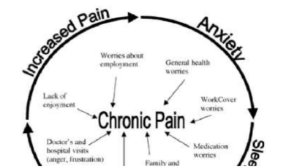
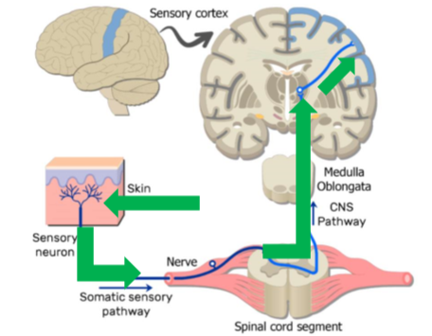
- Pain stimulated at nerve ending
  - Spinal cord
  - Brain
  - Thalamus
  - Sent to other parts to get perceived
  - There are synapses to travel to next neuron
- Synapse
  - Sites where we have impact on pain itself
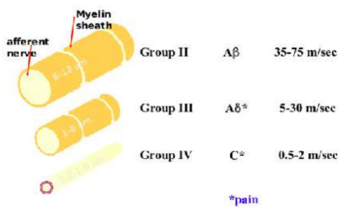
- Three pathways of transition of pain
- Afferent nerves
  - AB (A beta)
    - Large in diameter
    - Myelination
      - Protect but increases nerve conduction of impulse
    - Has low stimulus threshold
    - Fast
  - A Delta
    - Large diameter
    - Thin myelination
    - Slower
    - Caries pain fibers
      - Activated first
      - Start message
      - Sharp pain
  - C
    - Unmyelinated
    - Smallest fiber
    - Low level pain
      - Dull
      - Aching
    - Travels to spinal cord
  - ALL ARTICULATE TO SPINAL CORD
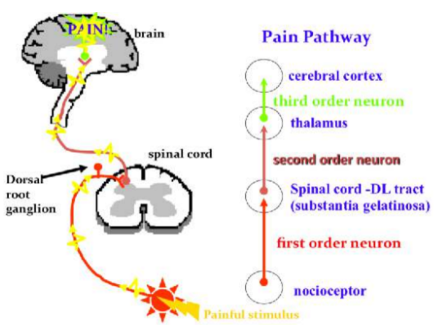
- Painful stimulus
  - Starts at site of tissue area
  - Information accompanies tissue damage
    - Causes it to bind to nociceptors
  - Travels down afferent nerve
    - Continues to synapse till it hits dorsolateral tract with second order neuron where it synapses
    - Gets carried across by subsequence P
    - Delivered to T cells
      - Send message up spinal cord
  - Epidural doesn’t allow message of pain to hit thalamus or brain
Neurological basis of pain
- The stimulation of specialized afferent nerve endings, called nociceptors produce the pain sensation
- Nociceptors are prevalent in the skin, meninges, periosteum, teeth, and some internal organs
- In acute injuries, pain is initiated by mechanosensitive nociceptors responding to the traumatic force that caused the injury
  - In chronic injuries and during early stages of healing of acute injuries, pain persists because of the activation of chemosensitive nociceptors
  - Serotonin, histamine, etc. are all chemicals transported to the injury site during inflammation, which activate the chemosensitive nociceptors
  - Thermal extremes can also stimulate other specialized nociceptors to produce pain
- 2 types of afferent nerves transmit the sensation of pain to the spinal cord
- Small diameter, slow transmission, unmyelinated C fibers transmit low level pain that might be described as dull or aching
- Sharp, piercing pain are transmitted by larger, faster and more thinly myelinated A fibers
- Pain can be transmitted along both types of afferent nerves from somatic and visceral sources
  - Activity involving A and C fibers from the visceral organs can also provoke autonomic responses, such as change in blood pressure, HR, and respiration
- Afferent nerves carrying pain impulses, along with those transporting sensations such as touch, temperature, and proprioception, articulates with the spinal cord through the substantia gelatinosa of the cord dorsal horn
- Specialized T cells then transmit impulses from all the afferent fibers up the spinal cord to the brain, where each T cell is carrying a single impulse. Within the brain, the pain impulses are transmitted to the thalamus and the somatosensory cortex, where pain is finally perceived
There are three neurophysiological explanations of pain control:
- Ascending pain control aspect of Melzack and Wall’s Gate Control Theory (A Beta stimulation blocks Alpha gamma and C fiber pain signals )
  - Gate control theory
    - Stimulating Large A beta to block A delta and C
    - Mental state can affect pain tolerance
- “Central biasing” or descending pain control (neurological and hormonal aspects)
  - Placebo effect
    - Something is working to help pain
- Beta endorphin theory (A gamma and C fiber pain signals cause release of endogenous opiates into CNS)
  - Body’s ability to produce natural narcotics
  - Endorphins
- Melzack & Wall Gate Control Theory:
  - All the pain messages coming in through the substantia gelatinosa, thus first come first serve
  - Theory that touching a stubbed toe or putting ice on the injury, because those two reactions are faster
  - i.e. touch and temperature messages, they essentially hog all signals going to the brain, thus, the reason why putting ice or grabbing a wound makes it feel less painful for a small duration
  - When you touch or heat or cool something it is stimulating large aB fibers
    - They travel fast to get to the brain
    - Whoever gets to the brain first
    - First come first serve basis
  - Gate control only lasts so long
    - Help to control pain
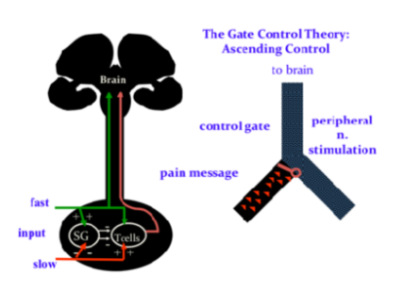
    - ICE

Neurochemical Modulation of Pain
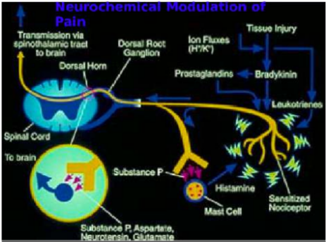
- Any time there is a tissue injury there is a release of chemicals
- Another way we module pain
- Sunburn
  - Instinctive not to take a hot shower
    - It would cause more pain
  - Sensitizing nerve endings
    - Histamine
    - Lupitines
    - Tissue that injured has chemical response
  - All the messages are getting through the first and second order neuron
    - PAIN PAIN PAIN
  - Brain at the spinal cord level says to substance P to check out what is going
    - Marches down first order neuron
    - Fire going on
    - Substance p tells mast cell to release more histamine
      - Throw more fuel to fire
    - Brain makes you more sensitized
      - Adds protection
Descending control
- Descending mechanism

