CHAPTER 2: ORGANIZATIONAL STRATEGY, COMPETITIVE ADVANTAGE AND INFORMATION SYSTEMS

2.1 Business Pressures, Organizational Responses, and IT Support
- Business pressures
- Organizational responses
- Competitive Advantage: an asset that provide an organization with edge against its competitors in some measure such as cost, quality, or speed. It also helps an organization to control a market and to accrue larger-than-average profits.
- Business Environments: the combination of social, legal, economic, physical, and political factors in which businesses conduct their operations. Significant changes in any of these factors are likely to create BUSINESS PRESSURES on organizations
- Organizations Responses: organizations respond to the various pressures by implementing IT such as strategic systems, customer focus, make-to-order and mass customization, and e-business.

Business Pressure
- Market Pressures: business pressure generated by the global economy, intense competition, changing nature of the workforce, and powerful customers
- Technology Pressures: business pressures caused by technological innovation and information overload
- Societal/Political/Legal Pressures: business pressures related to social responsibility, government regulations/deregulations, spending for social programs, spending to protect against terrorism, and ethics.

Market Pressures
- Globalization: the integration and interdependence of economic, social, cultural and ecological facets of life, made possible by rapid advances in IT
- Changing Nature of the Workforce: the workforce, particularly in developed countries, is becoming more diversified. Increasing number of women, single parents, minorities, and persons with disabilities are now employed in many different positions
- Powerful Customers: customer sophistication and expectation increase as customers become more knowledgeable about the products and services they acquire. Customers can use the internet to find detailed information about products and service, to compare prices, and to purchase items at electronic auctions

Technology Pressures
- Technological Innovation and Obsolescence: few and improved technologies rapidly create or support substitues for products, alternative options, and superb quality. As a result, today’s state-of-the-art products may be obsolete tomorrow.
- Information Overload: internet and other telecommunication networks are bringing a flood of information to managers. To make decisions effectively and efficiently, managers must be able to access, navigate, and utilize these vast stores of data, information, and knowledge.

Societal/Political/Legal Pressures
- Social Responsibility: social issues that affect businesses and individuals range from the state of the physical environment, to company and individual philanthropy, to education. Some corporations and individuals are willing to spend time and/or money to address various social problems. These efforts are known as organizational social responsibility or individual social responsibility.
- Compliance with Government Regulations: government regulations regarding health, safety, environmental protection, and equal opportunity. Businesses tend to view government regulations as expensive constraints on their activities. In general, government deregulation intensifies competition.
- Protection Against Terrorist Attacks: IT can help protect businesses by providing security systems and possibly identifying patterns of behavior associated with terrorist activities, including cyberattacks.
- Ethical Issues: ethics relates to general standards of right and wrong. Information ethics relates specifically to standards of right and wrong in information processing practices. Ethical issues are very important because, if handled poorly, they can damage and organization’s image and destroy its employees’ morale.

Social Responsibility
- IT is instrumental in organizational efforts to “go green” in 3 areas:
  - 1. Facilities design and management
  - carbon management
  - international and U.S. environmental laws
- Digital Divide: refers to the wide gap between those individuals who have access to information and communications technology and those who do not.

Organizational Responses
- Strategic Systems: provide organizations with advantages that enable them to increase their market share and/or profits, to better negotiate with suppliers, and to prevent competitors from entering their markets
- Customer Focus: Organizational attempts to provide superb customer service can make the difference between attracting and retaining customers versus losing them to competitors. Numerous IT tools and business processes have been designed to keep customers happy
- Make-to-Order: a strategy of producing customized (made to individual specifications) products and services
- Mass Customization: a company produces a large quantity of items, but it customizes them to match the needs and preferences of individual customers. Mass customization is essentially an attempt to perform make-to-order on a large scale.
- E-Business and E-Commerce: conducting business electronically is an essential strategy for companies that are competing in todays business environment. E-commerce describes the process of buying, selling, transferring, or exchanging products, services, or information via computer networks, including the internet
- E-Business: a somewhat broader concept the EC that includes servicing customers, collaborating with business partners, and performing electronic transactions within an organization.

2.2 Competitive Advantage and Strategic IS’s
- Strategic Information Systems (SISs): provide a competitive advantage by helping an organization implement its strategic goals and improve it performance and productivity
- Porter’s Competitive Forces Model
- Porter’s Value Chain Model
- Strategies for Competitive Advantage
- Business- Information Technology Alignment

Porter’s 5 Forces Model
- Threat of entry of new competitors: the threat that new competitors will enter your market is high when entry is easy and low when there are significant barriers to entry
- Bargaining power of suppliers: suppliers power is high when buyers have few choices from whom to buy and low when buyers have many choices
- Bargaining power of customers (buyers): buyer power is high when buyers have many choices from who to buy and low when buyers have few choices.
- Threat of substitute products or services: if there are many alternatives to an organizations product or services, then the threat of substitutes is high. If there are few alternatives, then the threat is low.
- Rivalry among existing firms: the threat from rivalry is high when there is intense competition among many firms in an industry. The threat is low when the competitions is among fewer firms and is not as intense.

Barriers to entry: a product or service feature that customers have learned to expect from organizations in a certain industry. A competing organization must offer this feature in order to survive in the market place (e.g., legal requirements such as admission to the bar to practice law)
Switching costs: the costs, in money and time, imposed by a decision to buy elsewhere (e.g., contracts with smartphone providers)

Porter’s Value Chain Model
- Value chain: a sequence of activities through which the organization’s inputs, whatever they are, are transformed into more valuable output, whatever they are
- Value system: includes the suppliers that provide the inputs necessary to the firm along with their value chains. After the firm creates products, these products pass through the value chains of distributors (which also have their own value chains), all the way to the customers. All parts of these chains are included in the value system.
two categories of organization activities in the value chain:
1-Primary Activities: relate to the production and distribution of the firm’s products and services. These activities create value for which customers are willing to pay.
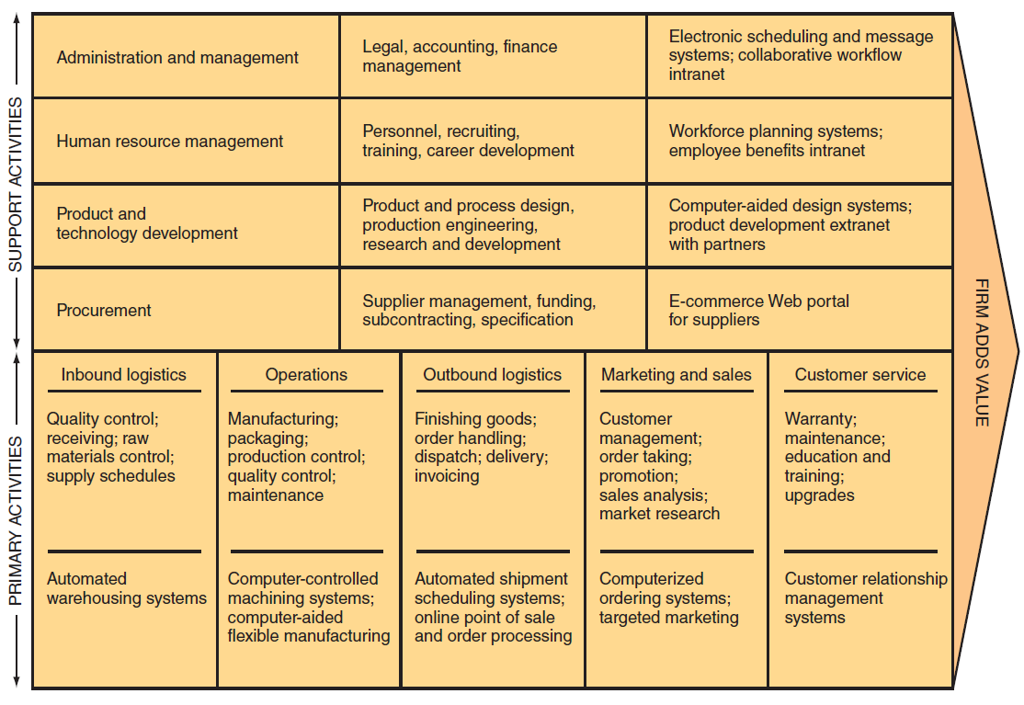
2-Support Activities: contribute to the firm’s competitive advantage by supporting the primary activities, but do not add value directly to the firms products or services

Primary Activities
Five sequences primary activites of typical manufacturing companies:
- Inbound logistics (inputs)
- Operations (manufacturing and testing)
- Outbound logistics (storage and distribution)
- Marketing and sales
- Services

Support Activities
Value chain support activities typically include:
- The firm’s infrastructure (accounting, finance, management)
- Human resources management
- Product and technology development (R&D)
- Procurement

Strategies for Competitive Advantage
- Cost leadership strategy: produce products and/or services at the lowest cost in the industry
- Differentiation strategy: offering different products, services, or product features than your competitors
- Innovation strategy: introduces new products and services, add new features to existing products and services, or develop new ways to produce them
- Operational effectiveness strategy: improve the manner in which a firm executes its internal business processes so that it performs these activities more effectively that its rivals. Such improvements increase quality, productivity, and employees and customer satisfaction while decreasing time to market.
- Customer orientation strategy: concentrate on making customers happy, web-based systems are particularly effective in this are because they can create a personalized, one-to-one relationship with each customer.

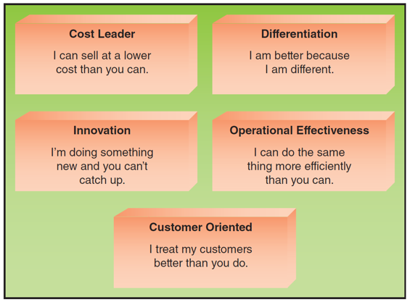

Business-Information Technology Alignment
- Business-Information Technology Alignment: IT function directly supports the business objectives of the organization through the tight integration of the IT function with the organization’s strategy, mission, and goals.

Six Characteristics of Excellent Business-IT Alignment
- Organizations view IT as an engine of innovation that continually transforms the business, often creating new revenue streams
- Organizations view their internal & external customer and their customer service function as supremely important
- Organizations rotate business and IT professionals across departments and job functions
- Organizations provide overarching goals that are completely clear to each IT and business employee
- Organizations ensure that IT employees understand how the company makes (or loses) money.
- Organizations create a vibrant and inclusive company culture.

