Kin 343 – Review questions

Lung capacity does not change with training where PO2 is decreased to reduce ventilation requirements (homeostasis) – this is exempted from athletes whose saturation goes down = we have unusually low o2 concentration in blood – this messes with performance (if prevented, we increase VO2max)

Dr. Bill Sheel – Breathing lecture

- What path does oxygen follow when breathing in? Start at your upper airway all the way to metabolically active (target) tissue.

- What is the main function of the lungs?

Allows for gas exchange that separated blood from gaseous environment

- Why are alveoli important in respect to structure? Consider surface area in your
response.

Alveoli allows for gas exchange – more surface area = more possibility of gas exchange thus respiration

- Does the diaphragm contract during inhalation or exhalation? How does the diaphragm contracting facilitate air flow in/out of the lungs?

Diaphragm ascends and descends during inhalation (moves up when exhale, moves down in inhale

- Is breathing a passive or active process?

It is passive

- Name and define the following terms. Draw a spirometry graph and label these terms on it.
- TV = tidal volume – what you normally inhale
- IRV = inspiratory reserve volume -- what you can maximally inhale
- ERV = expiratory reserve volume -- what you can maximally exhale
- FRC = functional residual capacity – amount of air left after exhalation +exhalation volume
- FVC = forced vital capacity – amount you can maximally inhale and exhale
- TLC = total lung capacity
- RLV = residual lung volume – amount of air that remains after full exhalation
- Why is the partial pressure of oxygen in the trachea less than that of oxygen in room air?

Because of water vapor – air is humidified in the airway, reducing partial pressure

- What happens to the partial pressure of oxygen once it gets to the lungs and why?

Once in the lungs, the partial pressure goes down due to capillary o2 uptake and gas mixing (o2 and co2)

- Is there a difference between arterial partial pressure of oxygen and alveolar partial pressure of oxygen? If yes, why is this important?

There is a difference to allow for gas transfer between the alveoli and arteries so o2 can be delivered to muscles. You want efficient diffusion, so this difference allows that.

- What happens to the partial pressure of carbon dioxide in blood as it travels through circulation and why? Consider the value of PCO2 when it is leaving the lungs and again when it is entering the lungs after completing a full loop in systemic circulation.

It increases as it is a waster product of cellular respiration, and with the gradient formed, we can get good exchange allowing it to leave quickly out of the blood. (lower concentration in the alveolus compared to blood).

- How is oxygen transported in blood?

Oxygen transported as oxyhemoglobin (O2+hemoglobin)

- Draw the oxygen dissociation curve and explain it what it means

More O2 = More Hb binding to it at a certain point (50% Hb saturation)

- In your own words, describe the 3 pulmonary system challenges discussed in class

- Increased muscle metabolism = raised PCO2 venous
- Ventilation must increase to regulate PACO2 and PAO2 at exercise
- Cardiovascular and pulmonary system must respond to exercise with the increase in metabolic requirements.

- How do a trained and untrained person differ in their breathing patterns during exercise?

Trained people = better ventilation (L/min)

- What are the components of ventilatory control and why are each of them important?

- Central Controller: creates respiratory rhythm and pattern
- Sensory Inputs: afferent inputs
- Motor Output: effectors that distribute and synchronise respiratory motor output to specific muscles

- Graph the three phases of ventilation during exercise and describe what is happening in each phase

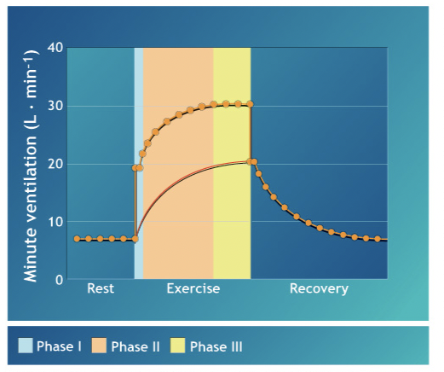

- Phase 1: We have stimulus from cerebral cortex to ventrolateral medulla to increase ventilation quickly
- Phase 2: We have a rise in minute ventilation to reach a level that meets gas exchange demands
- Phase 3: We have fine tuning to get steady state ventilation through sensory feedback

