Chapter 7 Notes

- What is consumer surplus? How is it related to the demand curve?
  - CS – amount a buyer is willing to pay, minus what the buyer actually pays
    - CS = WTP – P
  - Total CS = area under demand curve, above the Price, from 0 to Q

- What is producer surplus? How is it related to the supply curve?
  - PS – amount a seller is paid for the good, minus the seller’s cost
    - PS = P – cost
  - Total PS = area above the supply curve, below the Price, from 0 to Q

- Do markets produce a desirable allocation of resources? Or could the market outcome be improved upon?
  - Total Surplus = CS + PS = (value to buyers) – (cost to sellers)
  - An allocation of resources is efficient if it maximizes total surplus, efficiency means:
    - Raising or lowering the quantity of a good would not increase total surplus (total surplus is maximized)
    - The goods are being produced by the producers with the lowest cost
    - The goods are being consumed by the buyers who value them most highly
  - Efficiency means making pie as large as possible, equity refers to whether the pie is divided evenly
  - Efficiency is goal, as equity is subjective and harder to evaluate

- Welfare Economics: the study of how the allocation of resources affect the economic well-being

- Willingness to Pay (WTP): maximum amount a buyer will pay for a good, measures how much the buyer values the good.

- At any Q, the height of the D curve is the WTP of the marginal buyer, (the buyer who would leave the market if P were any higher).

- Consumer Surplus (CS): area between P and the D curve, from 0 to Q
  - If P rises, CS falls – buyers leave market and remaining buyers pay higher P

- Cost: is the value of everything the seller must give up to produce a good
  - Includes cost of all resources used to produce good, including value of seller’s time

- At each Q, the height of the S curve is the cost of the marginal seller, (the seller that would leave the market if P were any lower).

- Producer Surplus (PS): area between P and the S curve, from 0 to Q
  - If P falls, PS falls – sellers leave market, remaining sellers receive lower P

- CS measures benefit buyers receive by participating in the market
- PS measures benefit sellers receive by participating in the market
- Total Surplus = CS + PS: measures the total gains from trade in a market

- Evaluating the Market Equilibrium (Free markets achieve these)
  - The equilibrium Q maximizes total surplus
  - The goods are produced by the producers with lowest costs
  - The goods are consumed by the buyers who value them most highly
- Thus economic well-being cannot be increased, the equilibrium supply and demand maximize total surplus, gov’t cannot improve on the market outcome.
- Centrally planned economies are never very efficient (i.e. Communism)

Chapter 8 Notes

- How does a tax affect consumer surplus, producer surplus, and total surplus?
  - Taxes lower CS, PS and TS

- What is the deadweight loss of a tax?
  - DWL is the fall in total surplus due to a market distortion, i.e. a tax

- What factors determine the size of this deadweight loss?
  - The more elastic the S and D curves are, the larger the DWL
  - When a tax increases, DWL increases exponentially

- How does tax revenue depend on the size of the tax?
  - When the tax is small, increasing it causes tax revenue to rise
  - When the tax is larger, increasing it causes tax revenue to fall
  - The Laffer Curve shows the relationship between the size of tax and tax revenue

- Tax revenue is included in total surplus, because tax revenue can be used to provide services such as roads, police, public education, etc.

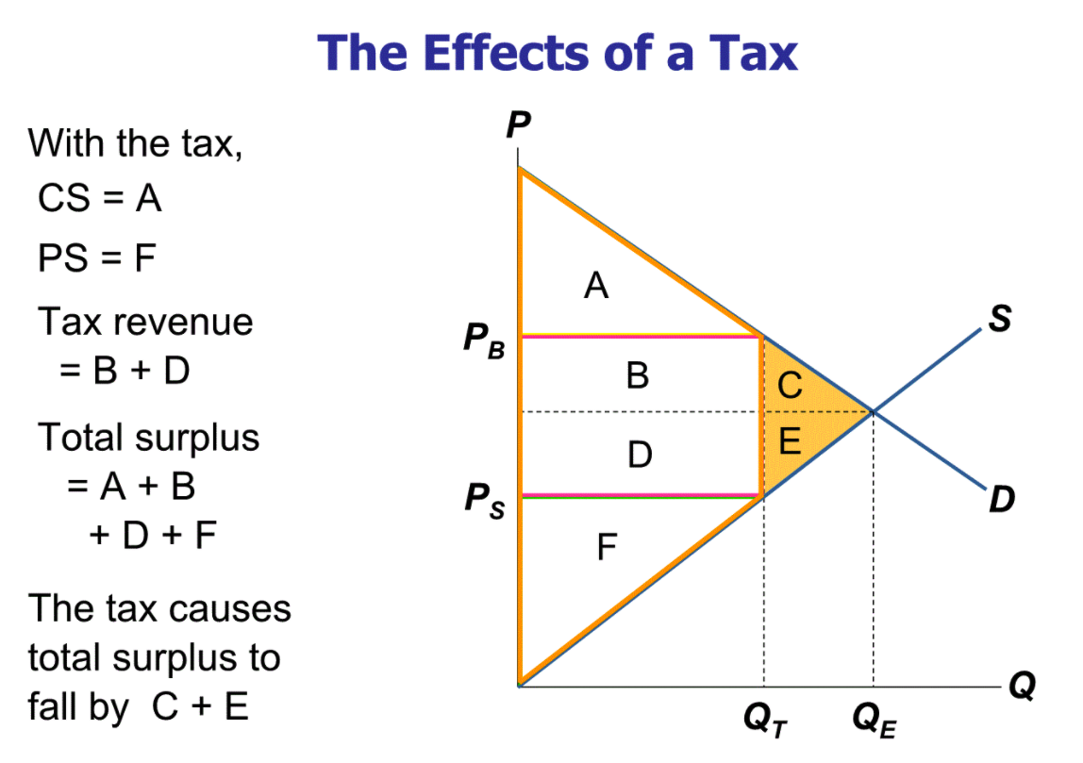
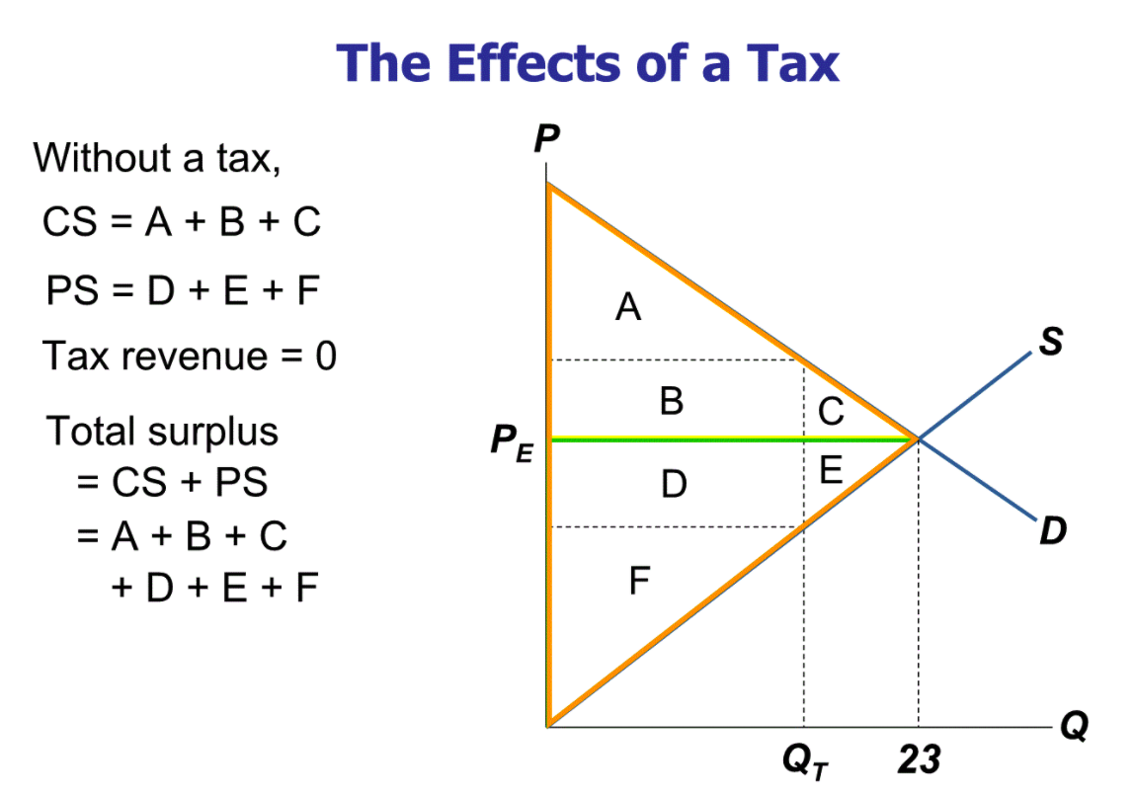

- C + E is called the deadweight loss (DWL) of the tax, the fall in total surplus
  - The losses to buyers and sellers exceed the revenue raised by the government
- Because of the tax, the units between Q_{T} and Q_{E} are not sold

- What determines the size of the DWL?
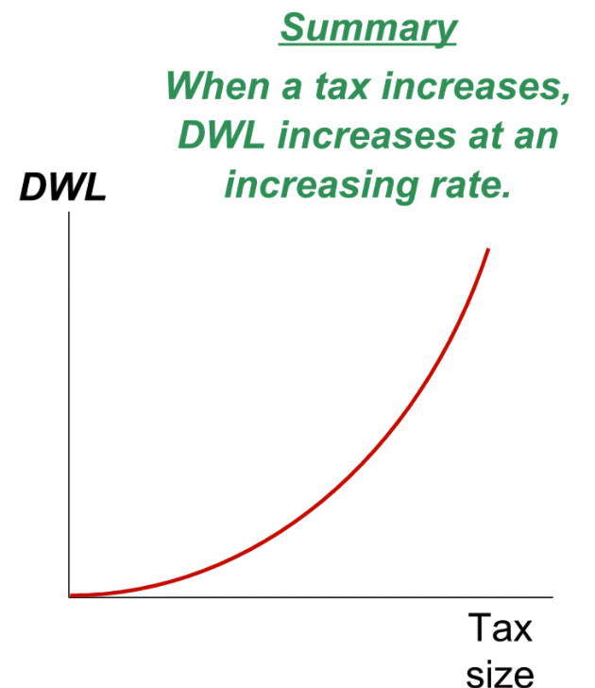
  - Governments should tax goods/services with the smallest DWL, i.e. the markets with inelastic supply/demand curves

Chapter 9 Notes – Application: International Trade

- What determines how much of a good a country will import or export?
  - A country will export a good if the world price of the good is higher than the domestic price without trade. Trade raises PS, reduces CS, raises total surplus
  - A country will import a good if the world price is lower than the domestic price without trade. Trade lowers PS, raises CS, raises total surplus.

- Who benefits from trade? Who does trade harm? Do the gains outweigh the losses?

- If policymakers restrict imports, who benefits? Who is harmed? Do the gains from the policy outweigh the losses?

- What are some common arguments for restricting trade? Do they have merit?
- Protecting jobs, defending national security, helping infant industries, preventing unfair competition, responding to foreign trade restrictions
- Some of these arguments have merit in some cases, but economists believe free trade is usually the better policy

P_{W} = the world price of a good
P_{D} = the domestic price of a good
- If P_{D} < P_{W}
  - Country has a comparative advantage in the good
  - Under free trade, country exports the good
- If P_{D} > P_{W}
  - Country does not have comparative advantage
  - Under free trade, country imports the good
- A small economy is a price taker in world markets: its actions have no effect on P_{W}
  - Ex. Spain, Canada, …
- When a small economy engages in free trade, P_{W} is the only relevant price
  - No seller would accept less than P_{W}, because they could sell the good for P_{W} in world markets
  - No buyer would pay more than P_{W}, because they could buy the good for P_{W} in world markets
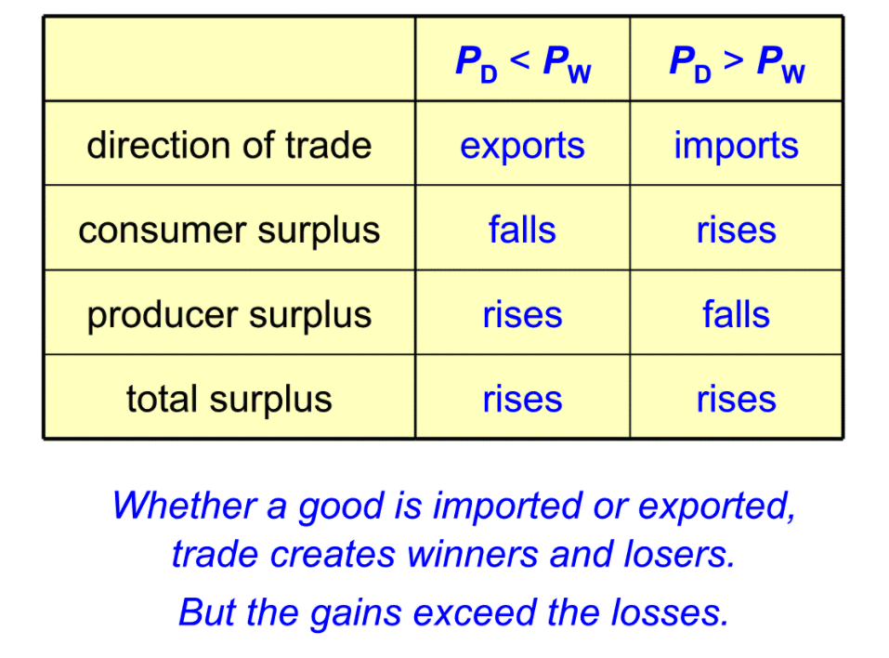
  - As a result, once free trade is allowed, the domestic price will equal the world price

Benefits of International Trade
- Consumers enjoy increased variety of goods
- Producers sell to a larger market and may achieve lower costs through economies of scale
- Competition from abroad may reduce market power of some first, which would increase total welfare
- Trade enhances the flow of ideas, facilitates the spread of technology around the world

Losers from trade have more incentive to organize and lobby for restrictions on trade, since they feel the negative effects more acutely then the gains that are felt.

Tariff - a tax on imports
- In general, price facing domestic buyers and sellers = (P_{W} + T)
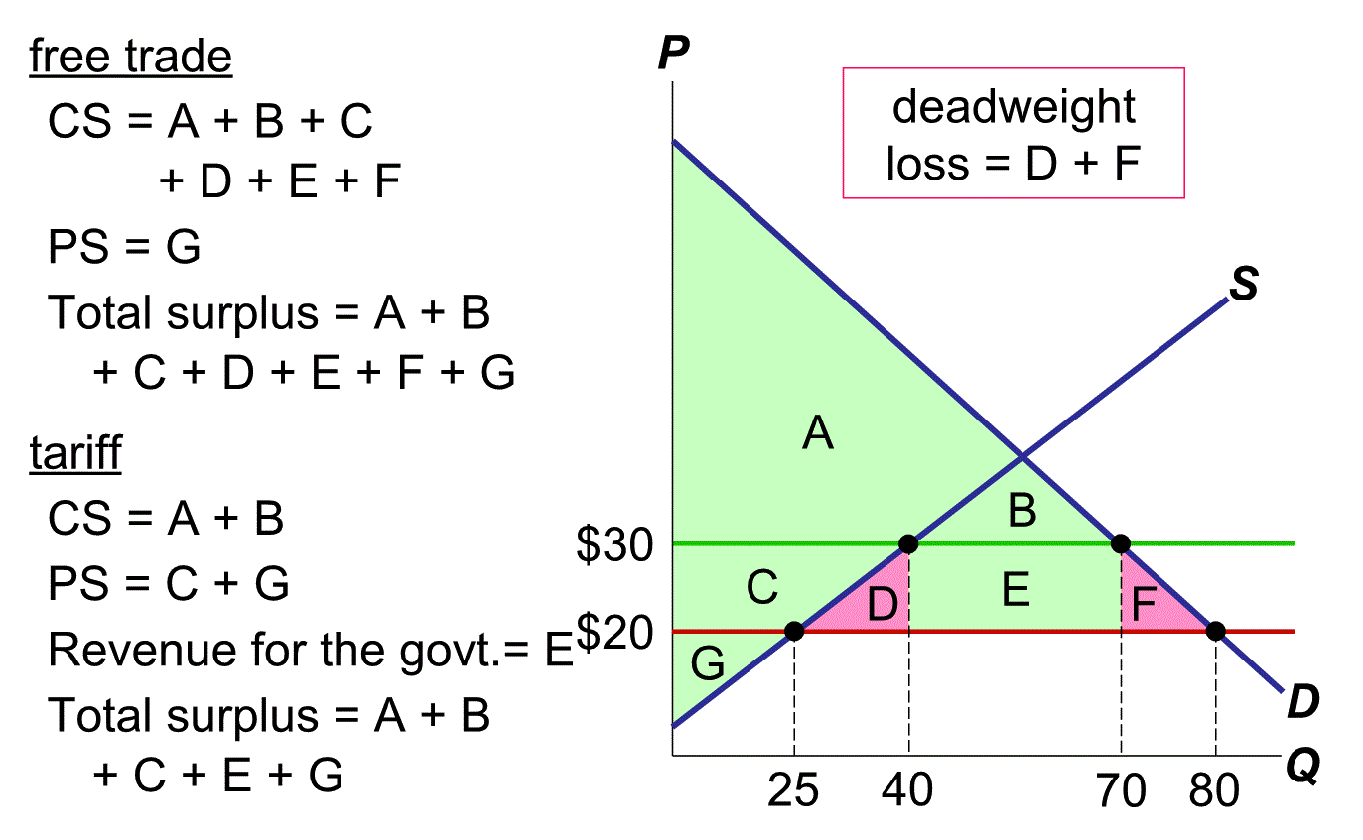
- D = DWL from overproduction
- F = DWL from under-consumption

Import Quota – a quantitative limit on imports of a good
- Mostly, has same effects as tariff:
  - Raises the domestic price of good
  - Reduce quantity of imports
  - Reduces buyers’ welfare
  - Reduces sellers’ welfare
  - Causes a DWL
- A tariff creates revenue for the government, a quota creates profits for the holder of the import license who sells the good at P_{D} which is higher than P_{W}
  - Or gov’t could charge fee for import license, i.e. quota works like a tariff

Trade Agreements
- A country can liberalize trade with:
  - Unilateral reductions in trade restrictions on its own
  - Multilateral agreements with other nations, reduce its trade restrictions while other countries do the same
- i.e. NAFTA (1993), General Agreement on Tariffs and Trade (GATT), World Trade Organization (WTO, 1995)
- Pros: multilateral approach has the potential to result in freer trade than a unilateral approach because it can reduce trade restrictions abroad as well as at home
- Cons: if international negotiations fail, the result could be more restricted than under a unilateral approach

Ch. 10 – Externalities

One type of market failure – externalities
  - Negative Externality: effect on bystanders is adverse
    - Ex. Pollution, neighbor’s barking dog, noise pollution from construction, …
  - Positive Externality: effect on bystanders is beneficial
    - Ex. vaccinations, R&D, renovating house improves neighboring property value
- Self-interested buyers/sellers neglect external effects of their actions, thus the market outcome is not efficient
- Governments can sometimes improve market outcomes
  - Ex. impose a tax on a firm equal to the external cost of the firm’s negative externalities
- Positive Externalities from Education
  - A more educated population benefits society
    - Lower crime rates, better gov’t, lower unemployment, better international competitiveness, improved economic efficiency and productivity
  - Often people do not consider these external benefits when deciding how much education to purchase, resulting in eq’m consumption being too low
  - So governments can improve market outcome by subsidizing education
- Internalizing the Externality
  - altering incentives so that people take account of the external effects of their actions
  - taxes that internalize negative externalities are called Pigovian Taxes
- Positive Externalities
  - Social Value of a good includes
    - Private Value – the direct value to buyers
    - External Benefit – the value of the positive impact on bystanders
  - The socially optimal Q maximizes welfare
    - If Q is lower, the social value of additional units exceeds their cost
    - If Q is higher, the cost of the last unit exceeds its social value

- Effects of Externalities
  - Negative – market produces a larger quantity than is socially desirable
  - Positive – market produces a smaller quantity than is socially desirable
  - To fix the problem – “internalize the externality”
    - Tax goods with negative externalities
    - Subsidize goods with positive externalities
- Private Solutions to Externalities
  - Moral codes and social sanctions
  - Charities, ex. Greenpeace
  - Relies on self-interest of relevant parties
  - Contracts between market participants and the affected bystanders
  - The Coase Theorem
    - If private parties can bargain, without cost, over the allocation of resources, they can solve the externalities problem on their own
    - The private market will reach the efficient outcome on its own
- Why Private Solutions Do Not Always Work
  - Transaction Costs – costs that parties incur in the process of agreeing to and following through on a bargain
  - Coordination problems and higher costs when number of parties is very large
- Public Policy Toward Externalities
  - Command-and-Control policies (regulation) – regulates behavior directly
  - Market-Based policies – provide incentives for private parties to solve their own problems
    - Pigovian Taxes & Subsidies
    - Tradeable Permits
- Pigovian Taxes & Substitutes
  - PT – a tax designed to induce private decision makers to take account for the social costs that arise from negative externalities, gives incentive to reduce externalities
  - Ideal corrective tax = external cost
  - Ideal corrective subsidy = external benefit
  - PT’s raise government revenue and enhance economic efficiency (unlike other taxes)
  - Ex. Gas Tax – half of what drivers pay for gasoline goes to gas tax
    - Reduces: congestion, accidents, pollution
- Tradeable Permits
  - Permits for negative externalities (like pollution), firms are free to trade these permits
  - Market reaches efficient outcome, whatever the initial allocation

- Pigovian Tax vs. Tradeable Pollution Permits
  - Like most demand curves, the firms’ demand to pollute is downward sloping function of the price of polluting
    - A PT raises this price, thus reducing quantity of pollution
    - A tradeable permit system restricts supply of pollution rights, same effect as tax
    - Environment Canada can achieve any point on the demand curve by either setting a price with a PT or by setting a quantity of permits
    - Permit system usually achieves pollution reduction target more precisely
- Objections to Economic Analysis of Pollution
  - No one should be able to “buy” the right to pollute, cannot put price on environment
  - However, people face tradeoffs, clean air & water obey law of demand
  - Market-based approach reduces cost of environmental production, so it should increase public demand for clean environment

Ch. 11 – Public Goods and Common Resources

We consume many goods without paying – parks, national defense, clean air & water, ….
  - When goods are free, the market forces that normally allocate resources are absent
  - Private market may fail to provide social efficient quantity of such goods, so governments work to improve market outcomes
- A good is excludable if a person can be prevented from using it
  - excludable – fish tacos, dial-up internet service
  - non-excludable – FM radio signals, national defense
- A good is rival in consumption if one person’s use of it diminishes others’ use
  - rival – fish tacos
  - non-rival – an MP3 file of music
- Private goods – both excludable and rival goods
  - ex. Ice Cream Cone, Clothing, Congested toll roads
- Public goods – neither excludable nor rival goods
  - ex. National Defense, Tornado siren, Uncongested non-toll roads
- Common resources – rival, but not excludable goods
  - ex. Fish in the Ocean, Environment, Congested non-toll roads, Spam email
- Club goods – excludable, but not rival goods
  - ex. Fire Protection, Cable TV, Uncongested toll roads
- Free Rider – a person who receives the benefit of a good, without paying for it
  - If a good is not excludable, there is incentive for free-riders
  - Result: the good is not produced, even if buyers collectively value the good higher than the cost of providing it
- Public Goods
  - If the benefit of a public good exceeds the cost of providing it, the government should provide the good and pay for it with a tax on people who benefit
  - Problem: measuring the benefit is usually difficult
  - Cost-Benefit Analysis – a study that compares the costs & benefits of providing a public good
    - Imprecise, efficient provision of public goods is more difficult than private goods
  - Important public goods include
    - National Defense
    - Knowledge created through basic research
    - Fighting poverty

- Common Resources
  - Not excludable
    - Cannot prevent free-riders, little incentive for firms to provide
    - Role for gov’t – see that these goods are provided
  - Rival in consumption
    - each person’s use reduces others’ ability to use
    - Role for gov’t – ensure these goods are not overused
- Tragedy of the Commons – illustrates why common resources get used more than is socially desirable
  - No one individual has incentive to reduce negative externalities
  - Negative externalities can become out of control
  - Important common resources include
    - Clean Air & Water
    - Congested non-toll roads
    - Fish, whales and other wildlife
- Importance of Property Rights
  - Public goods tend to be under-provided
  - Common resources tend to be over-consumed
  - Market fails to allocate resources efficiently b/c property rights are not well established
    - Nobody owns air, so no one can charge polluters too much pollution
    - Nobody can charge people who benefit from national defense too little defense
  - When absence of property rights causes a market failure, gov’t can intervene
    - Pollution permits
    - Restricted hunting seasons
    - National defense
  - A well planned and implemented policy can improve the allocation of resources and raise economic well-being
- Markets work best for private goods, which are excludable and rival in consumption
- Markets do not work well for other types of goods

