Problem 1
- The .40 in the objective function represents the dollar value gained by producing 1 box of regular chips.

  - The .30 of the objective function represents the dollar value gained by producing 1 box of crinkle chips
  - X2 represent the number of boxes of crinkle chips
- The 144 minutes in the cutting constraints is the maximum number of minutes spent on cutting both types of chips
- 4.8 in the packing constraint is the amount of second spend to pack 1 box of regular chips
- X2 must be greater than 20

  - 3.2 is the number of minutes spent to fry 1 box of regular chips
  - X1 represents the number of boxes of regular chips

  - What is the break-even point?
  - Is it worth it for the company to produce more of one type of chips over another?
- x1= 15, x2 =70 (15,70)
  - Cutting: 3.6x1+.8x2 ≤ 144
Cutting: 3.6(15)+.8(70) = 110
110 minutes will be assignment to cutting both types of chips
  - Frying: 3.2x1+1.6x2 ≤ 160
Frying: 3.2(15)+1.6(70) = 160
160 minutes will be allocated to fry both types of chips
  - Packing: 4.8x1+7.2x2 ≤ 576
Packing: 4.8(15)+7.2(70)=576
576 seconds will be allocated to pack both types of chips
- Slack
  - Cutting: 3.6x1+.8x2 ≤ 144 (Original constraint)
3.6x1+0.8x2+S1= 144
Adding the point X1=15 and X2=70
3.6(15)+.8(70)+S1=144
S1= 34
Slack value for the cutting constraint is 34
  - No slack for frying and packing
Problem 2

Constraint 1 - Protein
3x1+5x2 >= 30
Points for constraints:
3(0)+5x2 = 30  5x2 = 30  x2 = 6  (0,6) | 3x1+5(0) = 30  3x1 = 30  x1 = 10  (10,0)

Constraint 2 – Carbohydrates
6x1+4x2 >= 48
Points for constraints:
6(0)+4x2 = 48  4x2 = 48  x2 = 12  (0,12) | 6x1+4(0) = 48  6x1 = 48  x1 = 8  (8,0)

Testing to determine the feasible area
Constraint 1 | Constraint 2
3x1+5x2 >= 30  Testing point (2,6)  3(2)+5(6) = 36  Testing point (4,8)  3(4)+5(8) = 52  Direction of constraint should be | 6x1+4x2 >= 48  Testing point (2,10)  6(2)+4(10)=52  Testing points (4,8)  6(4)+4(8) = 56  Direction of constraint should be

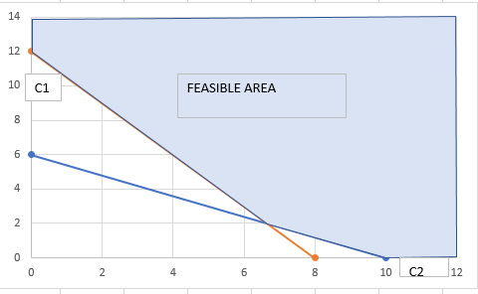
C1
C2
b)
Testing minimization equations
Z = .4x1+.4x2
Guess 1 (10,10)
Z = .4(10)+.4(10)
Z = 8
Guess 2 (12,12)
Z = .4(12)+.4(12) =< 8
Z = 4.8+4.8 = 9.6
By testing the objective function, the direction of the objective function is going inwards, meaning the left-hand side of the graph.
Testing the corner points
Determining point B (intersection point) by using the substitution method
3x1+5x2 >= 30 and 6x1+4x2 >= 48
Determining value of x1  3x1+5x2 = 30  X1= (30-5x2)/3  X1 = 10-(5x2/3) | Replacing the value of x1 in the second equations to determine the value of x2  6x1+4x2 = 48  6(10-(5x2/3))+4x2 = 48  60-(30x2/3)+4x2 = 48  -10x2+4x2 = -12  -6x2 = -12  X2 = 2 | Adding value of x2 to the first equations  3x1+5x2 = 30  3x1+5(2) = 30  3x1 = 20  X1 = 20/3  (20/3 , 2)

Point A (0,12)  Z = .4x1+.4x2  Z = .4(0)+.4(12)  Z = 4.8 | Point B (20/3, 2)  Z = .4x1+.4x2  Z = .4(20/3) + .4(2)  Z = 2.67+0.8  Z = 3.47 | Point C (10,0)  Z = .4x1+.4x2  Z = .4(10)+.4(0)  Z = 4

The optimal solution is point B, 20/3g of x1 and 2g of x2 which gives a total cost of 3.47$.
c)
Finding the slope for constraint 2  6x1+4x2 >= 48  6x1 = 48-4x2  X1 = 8-2/3x2  The slope for this equation is 2/3 | Adding 2/3 in value x1 in the objective function  Z = ?x1+0.4x2  Z = 2/3x1+.4x2  -2/3x1 =.4x2  -2x1 = 1.2x2  X1 = -0.6

The objective function and the carbohydrate constraints are now parallel, the new objective function is Z= -0.6x1 + 0.4x2.
Problem 3
a)
Constraint 1
x1+x2 <= 6
Points for constraint:
x1+x2 <= 6  (0)+x2 = 6  x2 = 6  (0,6) | x1+x2 <= 6  x1+(0) = 6  x1 = 6  (6,0)

Constraint 2
x1-x2 >= 0
Points for constraint:
x1-x2 >= 0  (0)-x2 = 0  x2 = 0  (0,0) | Since both x1 and x2 give point (0,0) I have decided to use the point (6,6) since this point satisfies the constraint.  (6,6)

Constraint 3
x1+x2 >= 3
Points for constraints:
x1+x2 >=3  (0)+x2 = 3  x2 = 3  (0,3) | x1+x2 >=3  x1+(0) = 3  x1 = 3  (3,0)

Testing the direction for feasible area
Constraint 1 (C1) | Constraint 2 (C2) | Constraint 3 (C3) | Constraint 4
x1+x2 <= 6  Testing Point (3,2)  3+2 = 5  Testing point (4,4)  4+4=8, which does not satisfy the constraint, therefore the direction of the constraint is | x1-x2 >= 0  Testing Point (3,2)  3-2 = 1  Testing Point (4,5)  4-5=-1, which does not satisfy the constraint, therefore the direction of the constraint is | x1+x2 >= 3  Testing point (3,3)  3+3 = 6  Testing Point (1,1)  1+1=2, which does not satisfy the constraint, therefore the direction of the constraint is | x1, x2 >=0

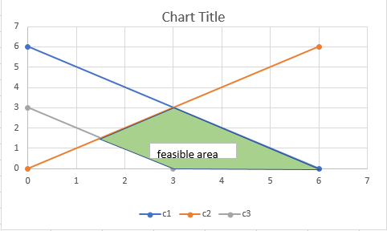
- Testing the direction of the objective function
Z = x1+2x2
Guess 1: Point (5,5)
Z = 5+2(5) = 15
Guess 2: Point (6,6)
Z = 6+2(6) = 18
Base on the objective function, the direction is going towards the right-hand side of the graph. To determine the optimal solution, I will be using the corner method.
Determining Point B – intersection of C2 and C3
C2 = x1-x2 >= 0, C3= x1+x2>= 3  x1-x2>=0  x1=x2  Substitution method  x1+x2>=3  x2+x2=3  2x2=3  x2=1.5 | x2 = 1.5  Plugging x2 value in C2 equations to determine value of x1  x1=x2  x1=1.5  Point B (1.5,1.5)

Determining point C – intersection of C1 and C2
C1 = x1+x2 <= 6, C2 = x1-x2 >= 0  x1-x2>= 0  x1=x2  Substitution method  x1+x2<= 6  x2+x2=6  2x2=6  x2 = 3 | x2 = 3  x1=x2  x1=3  Point C is (3,3)

Point A (3, 0) | Point B (1.5, 1.5) | Point C (3,3) | Point D (6,0)
Z = x1+2x2  Z = 3+2(0)  Z=3 | Z = x1+2x2  Z = 1.5+2(1.5)  Z = 4.5 | Z = x1+2x2  Z = 3+2(3)  Z = 9 | Z = x1+2x2  Z = 6+2(0)  Z = 6

The optimal solution is point C (3,3) which gives a value of 9.

- Optimal solution (3,3)
C1: x1+x2<=6  3+3=6  Binding | C2: x1-x2>=0  3-3=0  Binding | C3: x1+x2>=3  3+3=6  Non-binding | C4: x1,x2>=0  x1=3 , x2= 3  Non-binding

Problem 4
a)
x1 = tables
x2 = chairs
Maximize Z = 400x1+100x2
Constraints:
Pounds of Oak: 50x1+25x2 <=2500
Hours of Labour: 6x1+6x2<=480
Constraints on chairs: x1-2x2=0
b)
Sheet 1
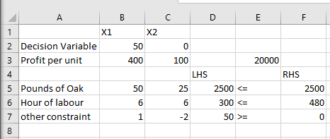
Answer Report
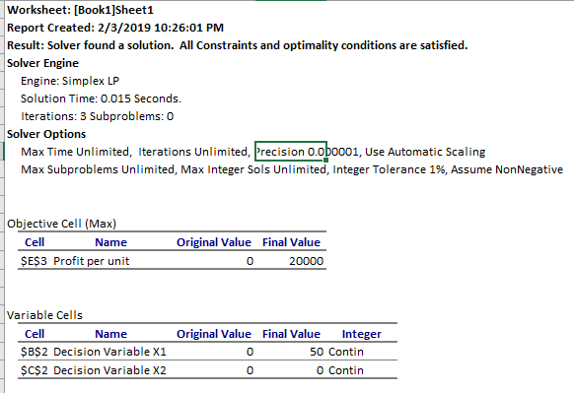
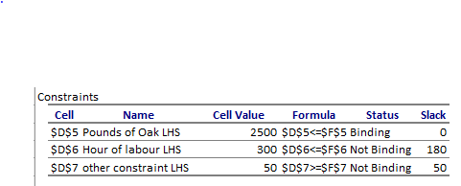

Sensitivity Report


