Lymphatic Vessels and Nodes
Lymphatic vessels are closely associated with the circulatory system. They carry lymph, collected from lymphatic capillaries, back to the venous circulatory system
Lymphatic nodes are found within lymphatic vessels throughout the body. They contain immune cells and filter lymph fluid as it travels through the lymph node.
Identify the composition of lymphatic vessels and nodes
Lymphatic Vessels: inner layer of endothelial cells, middle layer of smooth muscle and outer layer of connective tissue. Similar to veins, lymphatic vessels also contain one-way valves to ensure lymph flows in the same direction towards the heart.
Lymphatic Node: discrete bean-shaped bodies surrounded by connective tissue. It has an outer cortex containing germinal centers that produce immune cells and an inner medulla that house immune cells.
Describe lymph fluid
Lymph fluid has a similar composition to plasma. It is made up of absorbed interstitial fluid, proteins, ions and triglycerides (fats) and will be white in colour. It also contains white blood cells produced in lymph nodes and secondary lymphatic tissues.
Discuss the origin of lymph fluid
Lymph fluid originates from the absorption of excess interstitial fluid. Lymphatic capillaries have a single layer of endothelial cells with porous junction, allowing the passage of interstitial fluid, proteins and fats.
Discuss how the lymphatic vessels contribute to homeostasis
Lymphatic vessels help maintain blood and tissue volume by absorbing excess interstitial fluid. It is also an important part of the immune system as it carries immune cells to various parts of the body to ward off infection. Lastly, it carries fat absorbed from the intestinal tract back to the circulatory system.
Describe the route of lymph fluid from the tissues back to systemic circulation
Lymphatic capillaries absorb interstitial fluid from surrounding tissues. Once inside lymphatic vessels, the absorbed fluid is called lymph fluid. The larger lymphatic vessels and lymph ducts transport lymph fluid to either the thoracic duct or right lymphatic duct where lymph is returned to the venous circulatory system via the left and right subclavian veins, respectively.
Identify factors that promote lymph fluid movement through lymphatic vessels
- One-way valves: prevents backflow of lymph
- Contraction of Smooth Muscle Layer (lymphatic vessel): squeezes lymph forward
- Skeletal Muscle: contraction of surrounding skeletal muscle compresses lymph vessels and propels lymph forward
- Respiratory System: pressure within the abdomen during inspiration pumps lymph against gravity as it travels upward towards the heart
Define afferent and efferent lymph vessels and discuss why their arrangement is important to immunity
Afferent Lymph Vessels: carries lymph toward lymph nodes
Efferent Lymph Vessels: carries lymph away from lymph nodes
Having more afferent lymph vessels draining into the lymph nodes and fewer efferent vessels leaving the lymph node allows for slower filtration of lymph as it passes through the lymph node.
Define afferent and efferent lymph vessels and discuss why their arrangement is important to immunity
Afferent Lymph Vessels: carries lymph toward lymph nodes
Efferent Lymph Vessels: carries lymph away from lymph nodeHaving more afferent lymph vessels draining into the lymph nodes and fewer efferent vessels leaving the lymph node allows for slower filtration of lymph as it passes through the lymph node.
Discuss the lymph nodes role in homeostasis
Lymph nodes are an integral component of the immune system. It is a site of lymphocyte production and storage as well as lymph fluid filtration.
Discuss the physiological functions of the thymus, spleen and Peyer’s patches
Thymus: formation of T-cells
Spleen: contains lymphocytes and filters blood; stores additional red blood cells that can be released in situations where additional red blood cells and oxygen carrying capacity is required such as external hemorrhaging, exercise and altitude sickness.
Peyer’s patches: contains lymphocytes and other immune cells that protects and maintains the mucosal integrity of the digestive tract, preventing entry of pathogens into the body.
Describe the anatomy of the thymus, spleen and Peyer’s patches
Thymus is a lymphoid organ located in the thoracic cavity, within the mediastinum, and is most prominent in young mammals. During aging, the thymus atrophies and is replaced by adipose tissue.
Spleen is located near the stomach, in the left upper portion of the abdomen. It consists of two sections; white pulp which houses lymphocytes and the red pulp that stores red blood cells
Peyer’s patches are lymphoid tissue closely associated with the small intestine, specifically the ileum; they are elongated thickening of intestinal epithelium.
Identify the constituents of blood
-Organic molecules (glucose, protein, lipids)
- Respiratory Gases (oxygen, carbon dioxide)
- Hormones
- Growth Factors
- Immune Cells
- Electrolytes
- Metabolic waste products (urea, ions, excess water)
- Heat
Describe the morphology of red blood cells and state the importance to physiology
Normal red blood cells are flattened, bioconcave discs. This shape allows for hemoglobin to be closer to the cell surface and increases the surface area for gases to diffuse, maximizing binding of oxygen to hemoglobin. It also allows red blood cells to squeeze between tight spaces.
Discuss erythropoiesis
Erythropoeisis is the formation and differentiation of erythrocytes (red blood cells). This takes place in myeloid tissue (red bone marrow) of the long bones, ribs, sternum, pelvis, veterbrae and portion of skulls. Erythopoesis is stimulated by the hormone erythroprotein secreted by the kidney.
Describe the role of hemoglobin
In the lungs, hemoglobin binds oxygen, transports the oxygen through the circulatory system and releases oxygen to tissues. Each hemoglobin consists of four heme molecules with an iron group
Describe the ABO system of red blood cell antigens
Red blood cells contain antigens on their cell surface that are recognized by the body’s immune system. The ABO system is the group of antigens most commonly found on red blood cells and and used to reference a person’s blood type. Type A blood refers to a person that only contains ‘A’ antigens on their RBC surface, type B only have “B” antigens, type AB can have both A or B antigens, whereas type O do not have “A” or “B” antigens. ABO antigens are coded from genes that are inherited from 2 genes, one from each parent.
Discuss blood type matching and agglutination reactions
The ABO system of blood type classification is important for blood transfusion to ensure that both the donor and the recipient have the same blood type and thus same antigens on their cell surface. If blood types do not match, the recipient’s immune system will react to the unknown antigens found on the cell surface in a process called agglutination. During the agglutination reaction, recipient antibodies attach to the donor’s red blood cells causing them to clump together.
Discuss erythropoietin function in erythropoiesis
Erythropoetin is a hormone produced and secreted by the kidney. It stimulates the production and differentiation of red blood cells.
Identify factors that lead to erythropoietin release
Erythropoetin is released when there is a low level of oxygen in the blood such as during blood loss, lung disease and at higher altitude
Define anucleate and discuss how that impacts cellular metabolism and lifespan of red blood cells
Anucleate: a cell that does not have a nucleus. Red blood cells are anucleate which results in a short lifespan of only 120 days. RBC’s also rely on anaerobic metabolism (glycolysis) for energy production.
Discuss the production of platelets
Platelets originate from the bone marrow as fragments of larger cells called megakaryocytes. Platelets are part of the formed elements in the blood, and like red blood cells, do not have a nucleus.
Identify the role of platelets in hemostasis
Platelets are the major component of platelet plugs that are used to block and stop bleeding (hemostasis).
Activated platelets will trigger a cascade of events to assist blood clot formation and reduce damage to the blood vessel. This includes the activation of clotting factors to reinforce the platelet plug as well as the release of serotonin to decrease blood flow to the injured area by constriction local blood vessels.
Describe the morphology of platelets
During normal blood circulation, platelets are repelled from the endothelium lining and from each other. However, platelets will become activated upon exposure to damaged endothelial layer of a blood vessel. Once activated, platelets will change their shape to be more star-like. This allows them to be sticky and clump together to form the platelet plug.
Identify 5 common white blood cells and indicate their function
Lymphocytes: provide specific immunity (adaptive immunity, B-cells, T-cells)
Monocytes: differentiate into macrophage when in tissue cells; involved in phagocytosis of bacteria, dead cells and other cellular and tissue debris
Eosinophils: detoxify foreign substances and involved in allergic reaction and fight against parasites
Basophils: releases heparin and histamine
Neutrophils: phagocytize bacteria, fungi and viruses.

Briefly describe the production of white blood cells
Leukopoiesis, the production of white blood cells, takes place in both myeloid and lymphoid tissue. During differentiation, specific membrane receptors develop to react to different cytokines (autocrine regulators). This will cause the production of different subtypes of white blood cells.
Identify common innate immune defense mechanisms and discuss how they provide immune protection
External defense mechanisms are the first line of defense by preventing entry of pathogens into the body. Skin is a physical barrier that prevents penetration of pathogens, whereas acidity in the digestive tract and genitourinary will kill pathogens before they can enter the body. In the respiratory tract, the mucociliary escalator will trap and clear foreign particles before reaching the alveoli/capillary blood membrane.

If pathogens enter the body, internal defense mechanisms will be used to destroy them. These include phagocytic cells such as macrophages and neutrophils that will ingest and destroy bacteria and toxins, natural killer cells that destroy cells infected with virus as well as mast cells that release histamine and inflammatory mediators
Briefly describe inflammation, mechanical barriers, complement system, chemical barriers, phagocytosis and fever
Inflammation – swelling, redness and heat at site of infection due to invasion of immune cells and increased blood flow.
Mechanical Barriers – first line of defense by preventing entry of pathogens into the body by physically separating the external environment from the body’s internal environment. Examples include skin, the largest mechanical barrier, and epithelial membranes that line the respiratory and digestive tracts.
Complement System – part of the innate immune system that will help the adaptive immune system clear pathogens from the body. Upon binding of antibodies to antigens, complement proteins are activated, promoting the killing and phagocytosis of the targeted pathogen.
Chemical Barriers – chemicals that will kill pathogens prior to entry in the body. These include enzymes that are released by lysosomes on the skin and acidity in the stomach and urinary tract.
Phagocytosis – engulfment of pathogens/particles into cells followed by enzymatic digestion by the cell’s lysosomes.
Fever – cytokines, released from leukocytes, will cause an increase in body temperature which triggers increased level of neutrophils and interferons which can help fight infection
Define specific immunity, antigens, haptens, epitope
Specific Immunity: immunity that specifically targets molecules/disease through the development of antibodies.
Antigens: foreign molecule that will stimulate and bind to antibodies
Haptens: small organic molecule that cannot stimulate an immune response on its own. It needs to bind to a carrier protein to become immunogenic.
Epitope: part of the antigen that is recognized and bound by antibodies (antigenic determinant)
Differentiate between class I and class II major histocompatibility complexes
Class I major histocompatibility complexes (MHC) are found in all cells (except red blood cells); Class II MHC are only produced by leukocytes (antigen presenting cells; B lymphocytes.)
Cytotoxic (killer) T-cells are only activated by antigens presented with Class I MHC molecules, whereas helper T-cells are activated by antigen presenting cells with Class II MHC molecules.
Describe antigen recognition and processing by antigen presenting cells
Antigen presenting cells engulf and partially digest an antigen into shorter polypeptides. These shorter polypeptides migrate and associate with histocompatibility complexes on their cell surface. Antigen presenting cells will then travel to secondary lymphatic organs, where they secrete chemokines to attract T-cells. The T-cells activate upon exposure to the antigen + MHC on the cell surface of the antigen presenting cells.
Identify common antigen presenting cells
Macrophages, dendritic cells
Discuss cell mediated immunity
Cell mediated immunity requires physical contact between the immune cell and the target cell as opposed to circulating antibodies (humoral immunity) that can kill from a distance. Cell mediated immunity is facilitated by presenting foreign antigens in combination with MHC to T lymphocytes through antigen presenting cells. This results in the proliferation of cytotoxic cells, helper T-cells and release of cytokines that ultimately destroy target cells.
Differentiate between cytotoxic and helper T-cells
Helper T-cells enhances both cell-meditated and humoral immune system by triggering the proliferation of immune cells (cell-mediated: cytotoxic T-cells; humoral: differentiation of B cells into plasma cells to produce large amounts of antibodies)
Cytotoxic T-cells are part of the cell-mediated immunity and directly destroy infected cells.
Describe cell mediated destruction by cytotoxic T-cells
Upon presentation of a cell with viral antigen and Class I MHC, a cytotoxic T-cell will release perforins to perforate the target cell’s membrane, followed by granzymes that will enter the cytoplasm to destroy the viral DNA.
Discuss how helper T-cells contribute to cell mediated immunity
Helper T-cells bind to antigen presenting cells that present a viral antigen in combination with Class II MHC. This activation causes the secretion of lymphokines (cytokines) which helps in the proliferation of cytotoxic T-cells.
Indicate how human immunodeficiency virus (HIV) leads to acquired immunodeficiency syndrome
HIV leads to immune suppression by specifically targeting and destroying helper T-cells, preventing activation of cytotoxic T-cells and B-cells. Due to the immune suppression, people infected with HIV are more susceptible to infections such as pneumonia since they are not able to mount an immune response.
Describe perforin mediated apoptosis
Perforin are molecules secreted by the killer cells (cytotoxic T-cells); they enter the victim cell through the plasma membrane to form a large pore creating osmotic pressure which ultimately destroys the cell. The large pore allows the entry of granzymes release by cytotoxic T-cells, destroying the viral DNA.
Describe humoral immunity
Humoral, or antibody-mediated, immune response refers to immunity that takes place within the fluid compartments of the body (i.e. blood and lymph).
Discuss how B-cells contribute to humoral immunity
B-cells have antibodies on their cell surface that bind to specific antigens. They circulate through the lymphatic and circulatory system awaiting exposure to an antigen. Binding of the antigen to the antibody triggers an immune response including B-cell proliferation and antibody production against the antigen.
Describe how antibodies mediate humoral immunity
Antibodies recognize and serve as a binding site for antigens; this conjugation triggers the proliferation of antibody clones that will become plasma and memory cells. Plasma cells will produce large amounts of antibodies identical to the B-cell parent to combat the specific antigen by activating the complement immune system (non-specific immune processes)
Differentiate between primary and secondary immune responses
Primary immune response: immune response from exposure to a new pathogen/antigen. The infected person will not be completely protected from the pathogen as the immune system needs to create antibodies specific to the pathogen that can take up to 5-10 days.
Secondary immune response: immune response that is mounted upon secondary exposure to a pathogen. Antibody production is much faster due to memory lymphocytes and will reach maximal levels within 2 hours of infection. This is likely sufficient to prevent development of disease.
Identify constituents of blood plasma
Water, ions, organic molecules (metabolites), hormones, antibodies, proteins, cellular waste, dissolved gases
Describe the process of hemostasis
1) Upon damage to the blood vessel, vasoconstriction of local smooth muscle will be triggered, decreasing blood flow to the injured area. Vasoconstriction will continue due to the release of serotonin from the platelet plug.

2) Platelet plug: When there is damage to the endothelial layer of a blood vessel, the exposed collagen will trigger the aggregation of platelets to the site of injury forming a sticky plug to prevent blood loss. Glycoproteins found in platelet’s membrane will bind to the exposed collagen fibres along with von Willebrand factor (protein) to form the plug. Upon binding, platelets are activated causing the degranulation of secretory granules and the release of ADP and thromboxane A2 to promote the formation of the platelet plug, and serotonin to stimulate vasoconstriction.

3) Fibrin Web: activated platelets will also activate a variety of plasma clotting factors that will lead to the conversion of fibrinogen (insoluble) to fibrin (soluble). Fibrin will bind to the platelets’ plasma membrane, strengthening the platelet plug.
Identify components of a platelet plug
Platelet cells, von Willebrand’s factor (protein), fibrin
Discuss the intrinsic, extrinsic and common coagulation pathways
Conversion of fibrinogen to fibrin can occur through either the intrinsic or extrinsic pathways. Both pathways are a series of cascade events that will lead to the same common pathway that will ultimately lead to the formation of fibrin.
Intrinsic pathway: initiated within the blood by exposure to negatively charged surfaces such as exposure to collagen/glass; longer and slower pathway
Extrinsic pathway: initiated by tissue factors that are released from damaged tissues (outside of blood); shorter and more rapid pathway
Common pathway: convergence of the intrinsic and extrinsic pathway to a common pathway – activation of Factor X, leading to the conversion of fibrinogen to fibrin
Identify common factors that induce coagulation
Fibrinogen (Factor I), Prothrombin (Factor II), Proaccelerin (Factor V); Stuart –Prower (Factor X),
Discuss how coagulation is limited to the site of injury
In undamaged blood vessels, the endothelial lining physically separates collagen and platelet activators from blood so that platelets do not stick together and trigger coagulation. The endothelium also secretes nitric oxide and prostacyclin to inhibit platelet aggregation. Therefore, it is only at the site of injury with damaged endothelial lining that causes the activation of platelets and coagulation is triggered.
n addition, fibrin (part of the clot) will bind to thrombin to slow down the positive feedback loop to ensure the clotting reaction does not spread. During tissue repair, basophils and mast cells will secrete heparin to prevent the formation of thrombin, thus stopping the conversion of fibrinogen to fibrin.
Describe the tissue repair process at the site of a blood clot
At the site of blood clot, activated platelets will release various factors to assist in the repair process including platelet derived growth factor (PDGF), vascular endothelial growth factor (VEGF) and transforming growth factor beta (TGF-β). Tissue repair includes shrinking of the clot, infiltration by fibroblast to synthesize new collagen and extracellular matrix and formation of new blood vessels through angiogenesis.
Describe the process of fibrinolysis
Fibrinolysis is the enzymatic degradation of a blood clot following tissue repair. Factor XII activates the plasma molecule kallikrein, which in turn, converts plasminogen to plasmin. Plasmin will digest fibrin, causing the dissolution of the clot
Pulmunary and systemic circuits of cardio system
pulmonary: deoxygenated blood pumped from heart to lungs and oxygenated pumped back to the heart
systemic: oxygenated pumped from heart to body and deoixy returned back to heart
Major Vessels of Heart
aorta: The aorta is the largest artery in the body. The aortabegins at the top of the left ventricle, the heart's muscular pumping chamber
pulmonary trunk: The pulmonary trunk is a major vessel of the human heart that originates from the right ventricle. It branches into the right and left pulmonary arteries, which lead to the lungs.
pulmonary artery: the artery carrying blood from the right ventricle of the heart to the lungs for oxygenation.
pulmonary veins: The pulmonary veins are the veins that transfer oxygenated blood from the lungs to the heart. The largest pulmonary veins are the four mainpulmonary veins, two from each lung that drain into the left atrium of the hear
The superior vena cava (SVC) is the superior of the two venae cavae, the great venous trunks that return deoxygenated blood from the systemic circulation to the right atrium of the heart. It is a large-diameter (24 mm), yet short, vein that receives venous return from the upper half of the body, above the diaphragm.
The inferior vena cava (or IVC) (Latin: vena, "vein", cavus, "hollow") is a large vein that carries deoxygenated blood from the lower and middle body into the right atrium of the heart. Its walls are rigid and has valves so the blood does not flow down via gravity
Chambers and Areas of the Heart
Atria: The atria are the two upper chambers. ... The left atrium receives the oxygenated blood from the left and right pulmonary veins, which it pumps to the left ventricle (through the mitral valve) for pumping out through the aorta for systemic circulation.
A ventricle is one of two large chambers in the heart that collect and expel blood received from an atrium towards the peripheral beds within the body and lungs. The atrium (an adjacent/upper heart chamber that is smaller than aventricle) primes the pump.
One auricle is attached to each of the anterior surfaces of the outer-walls of the atria (that is, the left atrium and the right atrium). Visually, they look like wrinkled pouch-like structures. Their purpose is to increase the capacity of the atrium, and so also increase the volume of blood that it is able to contain
The anterior interventricular sulcus (or anteriorlongitudinal sulcus) is one of two grooves that separates the ventricles of the heart, the other being the posteriorinterventricular sulcus. The anterior interventricular sulcus is situated on the sternocostal surface of the heart, close to its left margin
The interventricular septum (IVS, or ventricular septum, or during development septum inferius), is the stout wall separating the lower chambers (the ventricles) of the heart from one another.
The interatrial septum is the wall of tissue that separates the right and left atria of the heart
Major Valves
The mitral valve is a valve that lets blood flow from one chamber of the heart, the left atrium, to another called the left ventricle. In mitral valve prolapse, part of the mitral valve slips backward loosely into the chamber called the left atrium
The mitral valve, also known as the bicuspid valve orleft atrioventricular valve, is a valve with two flaps in the heart, that lies between the left atrium and theleft ventricle.
The tricuspid valve, or right atrioventricular valve, is on theright dorsal side of the mammalian heart, between the rightatrium and the right ventricle. The function of the valve is to prevent back flow of blood into the right atrium
The aortic valve is a valve in the human heart between the left ventricle and the aorta. It is one of the two semilunar valves of the heart,
The pulmonary valve (sometimes referred to as thepulmonic valve) is the semilunar valve of the heart that lies between the right ventricle and the pulmonary artery and has three cusps
The chordae tendineae (tendinous chords), colloquially known as the heart strings, are cord-like tendons that connect the papillary muscles to the tricuspid valve and the mitral valve in the hear
The papillary muscles are muscles located in the ventricles of the heart. They attach to the cusps of the atrioventricular valves (also known as the mitral and tricuspid valves) via the chordae tendineae and contract to prevent inversion or prolapse of these valves on systole (or ventricular contraction)
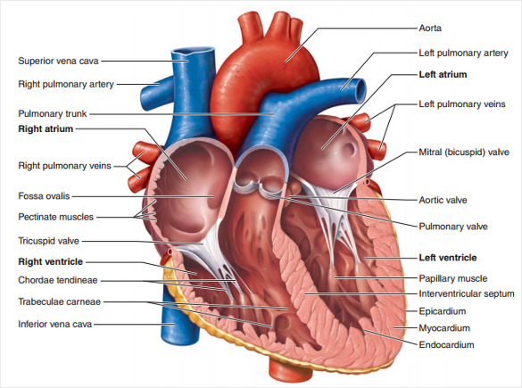
Blood Supply to the Heart
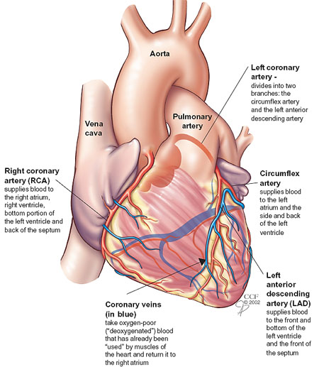

coronary sinus : The coronary sinus is a collection of veins joined together to form a large vessel that collects blood from the heart muscle (myocardium). It delivers less-oxygenated blood to the right atrium, as do the superior and inferior vena cavae. It is present in all mammals, including humans
Blood flow from right to left
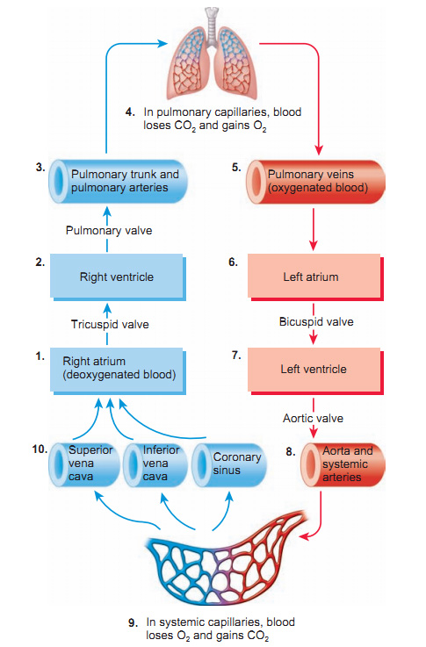

Define
Venous return is the rate of blood flow back to the heart. It normally limits cardiac output. Superposition of the cardiac function curve and venous returncurve is used in one hemodynamic model.
diastole: the phase of the heartbeat when the heart muscle relaxes and allows the chambers to fill with blood
Systole, period of contraction of the ventricles of the heart that occurs between the first and second heart sounds of the cardiac cycle (the sequence of events in a single heart beat). Systole causes the ejection of blood into the aorta and pulmonary trunk.
In cardiovascular physiology, end-diastolic volume (EDV) is the volume of blood in the right and/or left ventricle at end load or filling in (diastole) or the amount of blood in the ventricles just before systole.
End-systolic volume (ESV) is the volume of blood in a ventricle at the end of contraction, or systole, and the beginning of filling, or diastole. ESV is the lowestvolume of blood in the ventricle at any point in the cardiac cyc
Major Driving Forces of Blood
DP, SP, MAP
MAP most important
Functional Syncytium
Cardiac muscle as a “Functional Syncytium.” The angulated dark areas crossing the cardiac muscle fibers are called intercalated discs; however, they are actually cell membranes that separate individual cardiac muscle cells from each other.
Gap Junctions in Myocardial Cells
Gap junctions are particularly important in cardiac muscle: the signal to contract is passed efficiently through gap junctions, allowing the heart muscle cells to contract in unison. ... Several human genetic disorders are associated with mutations in gap junction genes.
Full Cardiac Cycle
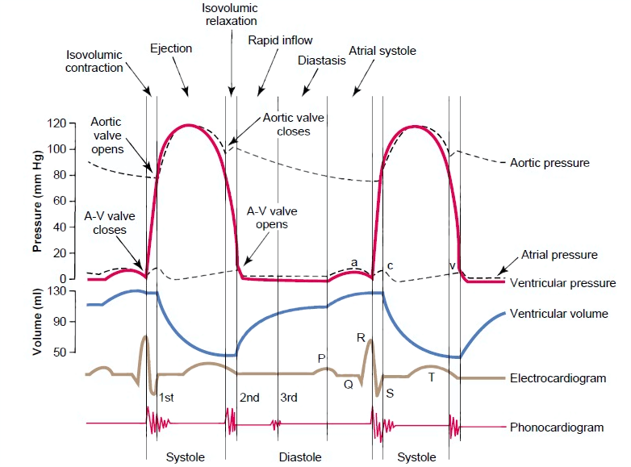
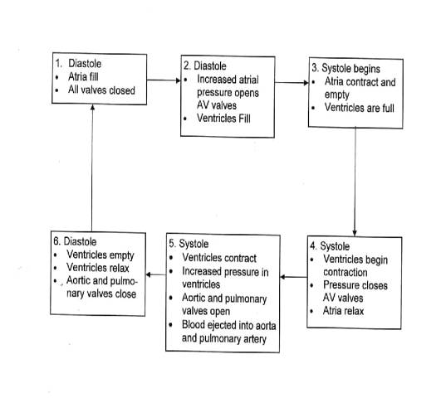

Define
In cardiovascular physiology, end-diastolic volume (EDV) is the volume of blood in the right and/or left ventricle at end load or filling in (diastole) or the amount of blood in the ventricles just before systole.
In cardiovascular physiology, stroke volume (SV) is the volume of blood pumped from the left ventricle per beat. ... The stroke volumes for each ventricle are generally equal, both being approximately 70 mL in a healthy 70-kg man.
End-systolic volume (ESV) is the volume of blood in a ventricle at the end of contraction, or systole, and the beginning of filling, or diastole. ESV is the lowestvolume of blood in the ventricle at any point in the cardiac cycle.

www.heart.org

Ejection fraction is a measurement of the percentage of blood leaving your heart each time it contracts. During each heartbeat pumping cycle, the heart contracts and relaxes. When your heart contracts, it ejects blood from the two pumping chambers (ventricles). When your heart relaxes, the ventricles refill with blood.
In cardiac physiology, isovolumetric contraction is an event occurring in early systole during which the ventricles contract with no corresponding volume change (isovolumetrically). This short-lasting portion of the cardiac cycle takes place whilst all heart valves are closed
Isovolumic relaxation time (IVRT) is an interval in the cardiac cycle, from the aortic component of the second heart sound, that is, closure of the aortic valve, to onset of filling by opening of the mitral valve. It can be used as an indicator of diastolic dysfunction

