Bio1140 Midterm 2- Cellular respiration and communication
Anabolic- require energy, combine
Catabolic- release energy, break down
Bioenergetics- study of energy flow through a living system

Forms of cellwork
Chemical- building molecules
Transport- pumping across a membrane
Mechanical- motor proteins, beating cilia

Laws of thermodynamics:
- Total amount of energy in the universe is constant, Energy can’t be created or destroyed
- Transfer of energy is not efficient, therefore energy transformations increase entropy

How ATP is used for energy: ATP is hydrolyzed. This is a catabolic reaction and therefore exergonic. This energy can be used to drive an endergonic reaction. Energy coupling

How enzymes lower activation energy:
- Positions the substrates so the align
- Provide optimal environment (acidic or polar)
- Contort the substrate so it is less stable
- Chemically change the substrate making is less stable

Metabolism regulated by:
- Turning on/off genes encoding enzymes(
- Regulating enzyme activity

Enzymes require cofactor or coenzyme to function. Most come from diet
Cofactor- inorganic ions (Fe, Mg, Zn)
Coenzymes- organic molecules (ATP, NADH, vitamins)

Enzyme inhibition
- Competitive inhibitors- similar shape as substrate. Competes for binding site(blocks substrate)
- Noncompetitive inhibitors- bind to enzyme at different location, change enzyme shape
- Allosteric inhibitors- change active site so substrate can’t bind
- Allosteric activator- change active site so substrate affinity increases
- Feedback inhibition- when product of pathway inhibits upstream step. most common control mechanism(low ATP +respiration, high ATP -respiration)

Cellular Respiration
C₆H₁₂O₆ + 6 O₂ à 6 CO₂ + 6 H₂O + energy
ΔG= −2870 kJ/mol
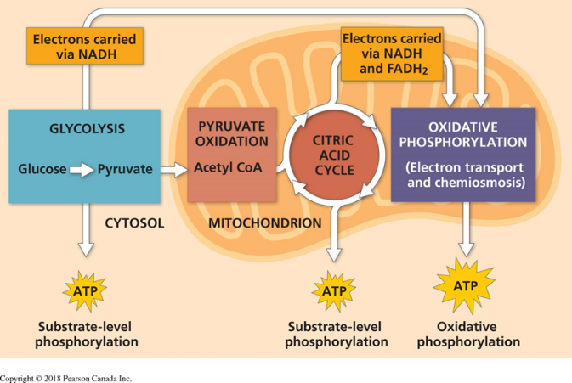
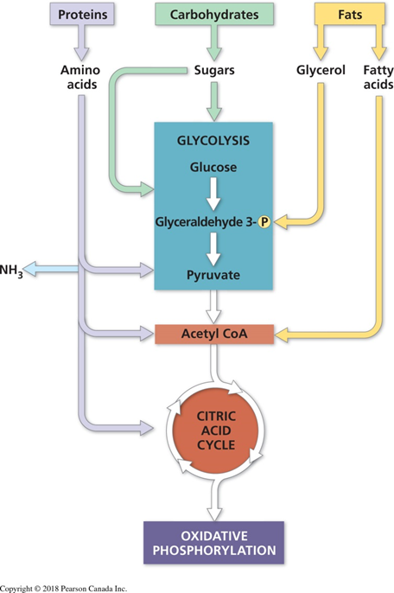
-Energy from transfer of electrons(NADH FADH)
Glycolysis:
Involves 10 steps
Investment: Uses 2 ATP, glucose phosphorylated twice then split into 2 G3P(3C)
Payoff: Each G3P produces 2 NADH 4ATP 2water
Occurs in cystol, no O₂ needed
Almost all organisms perform glycolysis
Net +2 ATP +2 NADH +2 water

Pyruvate Oxidation:
Each pyruvate turned into acetyl-CoA by coenzyme A
Occurs in mitochondria
Each acetyl-CoA has 2 carbon. -1 bc CO₂
+2NADH +2CO₂
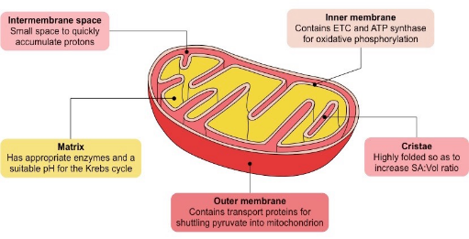
Citric Acid Cycle/Krebs Cycle:
8 Steps and occurs is mitochondrial matrix
Acetyl-Coa (ads2C) combined with oxaloacetate(4C) to form citrate(6C)
Citrate decomposed back to oxaloacetate to reset cycle
For each cycle 3NADH 1FADH₂ 2CO₂ 1ATP

Oxidative Phosphorylation:
ETC and chemiosmosis
e⁻ from NADH and FADH₂ pass through increasingly electronegative complexes.
O₂ final acceptor(most electronegative)
H⁺ pumped from mitochondrial matrix to intermembrane space
ATP synthase(hydro dam) uses H⁺ gradient to phosphorylate ADP to ATP
30-36 ATP per glucose

Fermentation
Much less efficient, only 2 ATP per glucose
Lactic acid fermentation- Occurs in muscle cells, yogurt bacteria
Alcohol fermentation- anaerobic yeast
Cellular communication
3 stages:
Reception: signalling molecule binds to receptor
Transduction: signal travels down transduction pathway
Response: Transduced signal triggers response
(bacteria use quorum sensing to sense Population density, autoinducers released and detected by each bacteria)
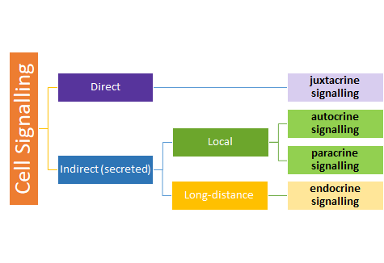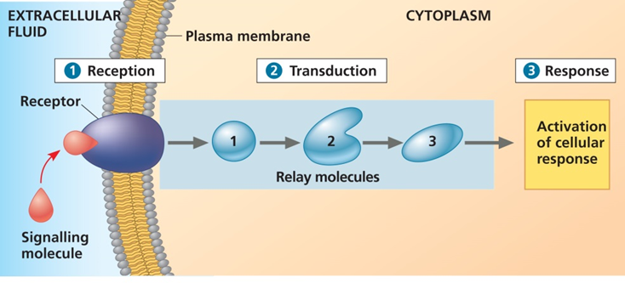
Types of signalling:
Direct/juxtacrine signalling
-Channels connecting 2 adjacent cells(gap junctions)
-Cell-cell recognition by physical contact
Important during development and immune responses

Indirect Cell signalling: signalling molecules(ligand) are secreted into environment.
Local:
Autocrine- secretes signalling molecule that acts on itself
Paracrine- signalling molecule acts on nearby cells
Synaptic signalling- specific form of paracrine
Long distance:
Endocrine- uses hormones travel through circulatory system

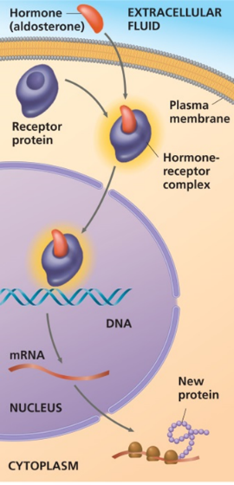
Types of receptors:
Intracellular receptors- Small hydrophobic signalling molecules can cross membrane.
-Receptor either in cytosol or nucleus
-Inside, the signalling molecule binds to receptor protein forming hormone-receptor complex, which can act as transcription factor in nucleus
Ex. Aldosterone- secreted by kidneys cells, when attached to receptor protein it turns on specific genes that control water and Na flow

Cell-surface receptors(3types)- Large hydrophilic signalling molecules, unstable so difficult to crystallize for analysis using x-ray crystallography

G protein linked- Consists of G protein coupled receptor(GPCR) and G protein
1. ligand binds to GPCR, causing change to cytosolic region
2. Cytosolic region causes conformation change of alpha subunit.
3.GDP removed and is replaced by GTP which is abundant in cytosol
4. GTP binding causes alpha subunit to split from beta-gamma complex. Both parts can relay information
5. GTP of alpha subunit is hydrolyzed back to GDP making in inactive

-G protein- heterotrimeric(3different parts)
-Acts as on/off switch. Inactive when bound to GDP, active with GTP
-Alpha and gamma subunits have covalent tail that anchor it to membrane
-Many bacteria secrete toxins that interrupt GPCR(cholera)

Enzyme linked(RTK)- kinases are enzymes that catalyze transfer of phosphate
Receptor tyrosine kinases(RTK)- consists of 2 RTK proteins with 3 tyrosines on each. Abnormal function associated with cancers
1. Ligand binds to both RTKs causing dimerization and activating kinase activity
2. RTKs phosphorylate each other(cross-phosphorylation)
3. Various proteins dock at phosphorylated sites(3 per RTK)
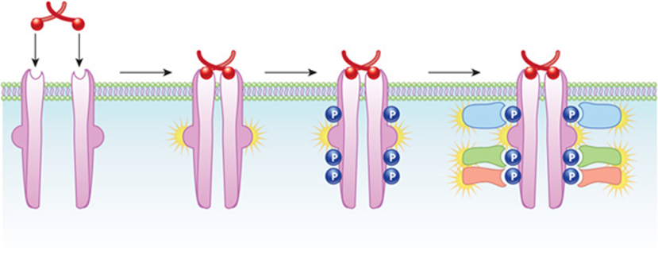
4. Signal terminates when phosphatase removes phosphates from RTKs

Ion-channel linked- Ligand binds to gate opening it

Signal transduction:
Multiple steps allow the signal to be amplified and more opportunities for regulation
2 ways to propagate a signal:
- protein phosphorylation and dephosphorylation(MAPK)
Protein kinases transfer phosphates from ATP to target protein
Protein phosphatases later remove phosphates from protein
Ex. MAPK cascasde- most common, G protein called RAS activates 3 serine-threonine kinases. Ends in MAPK phosphorylating many proteins
Growth factors use the MAPK pathway

- Second messengers(IP₃)
Small, nonprotein, water soluble molecules or ions
Ex. cAMP, Ca²⁺,IP₃, DAG
cAMP- most popular second messenger:
1.Released by adenylyl cyclase by converting ATP > cAMP
2.cAMP usually activates protein kinase A(PKA)
3.Stopped when phosphodiesterase converts cAMP back to ATP
Ca²⁺- cytosolic conc. lower to outside of cell and internal ER
Ca released through activation of inositol phospholipid pathway
1. Phospholipase C(activated by GPCR) cleaves PIP₂> IP₃ and diacylglycerol(DAG)
2. IP₃ is second messenger and binds to ion gate, releasing Ca

Cellular Responses:
Nuclear:
Regulate protein synthesis by turning on/off genes. Final molecule is transcription factor that binds to specific DNA sequences> mRNA> protein
Cytoplasmic:
Regulates activity of protein rather than their synthesis
Ex. epinephrine alters glucose metabolism by stimulating glycogen breakdown
More than on/off:
Amplification- enzyme cascades amplify the cell response
Specificity- cells produce different proteins that allow detection of different signals
Efficiency- Proteins involved in the same pathway are grouped together by scaffolding proteins
Termination

Cellular Death:
Necrosis- Rupture of plasma membrane and release of intracellular contents
Results in inflammation to clean up the contents
Autophagy- characterized by formation of autophagosome. Fuse with lysosome to degrade damaged contents
Apoptosis- tightly regulated programed death. Loss of contact with other cells and shrink(removing webbing between fingers)
Dismantled by enzymes called caspases 2 types:
Initiator- activates the executioner
Executioner- dismantle the cell



