University of Ottawa
Faculty of Engineering



Digital Systems I - ITI1100A
Aziz Abdesselam
Lab 1: Logic Gates

Date: February 7, 2017

Objectives

The main focus in this laboratory session was to learn about the logic gates using a software and a device. This has been achieved by the following steps:

- Constructing simple combinations of logic circuits.
- Experimenting and determining the results of several circuit configurations.
.
Equipment and components used

- Quartus II 13.0 Service-Pack 1
- Altera DE2-115 card

Circuit diagram
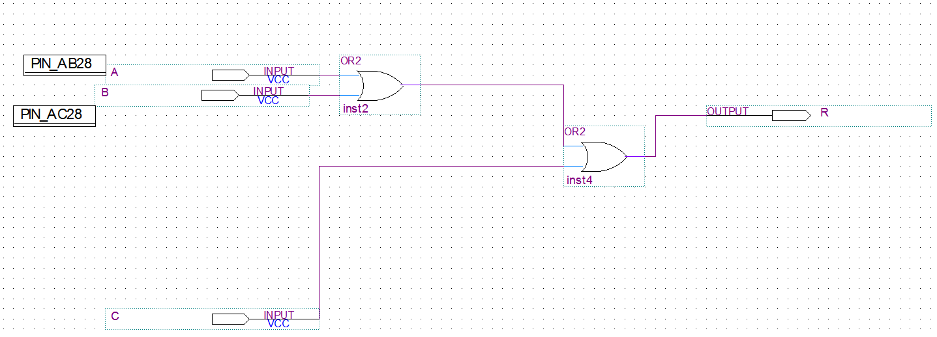
Figure 5.1.1
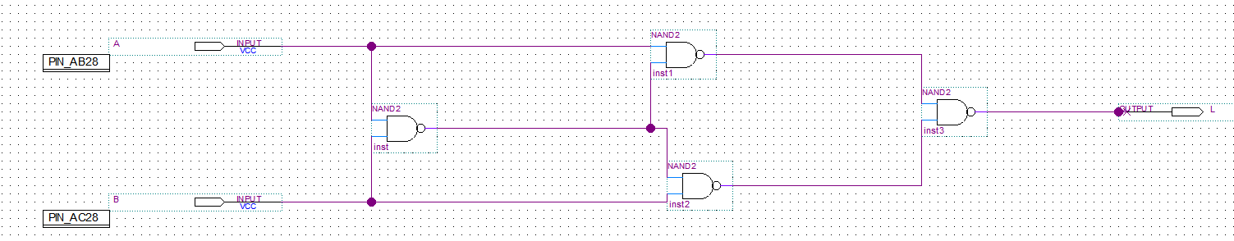
Figure 5.1.5
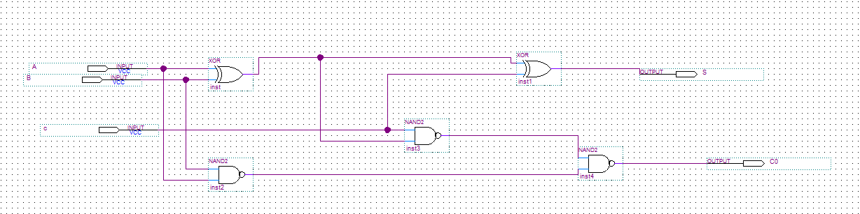
Figure 5.1.8

Experimental data and data processing
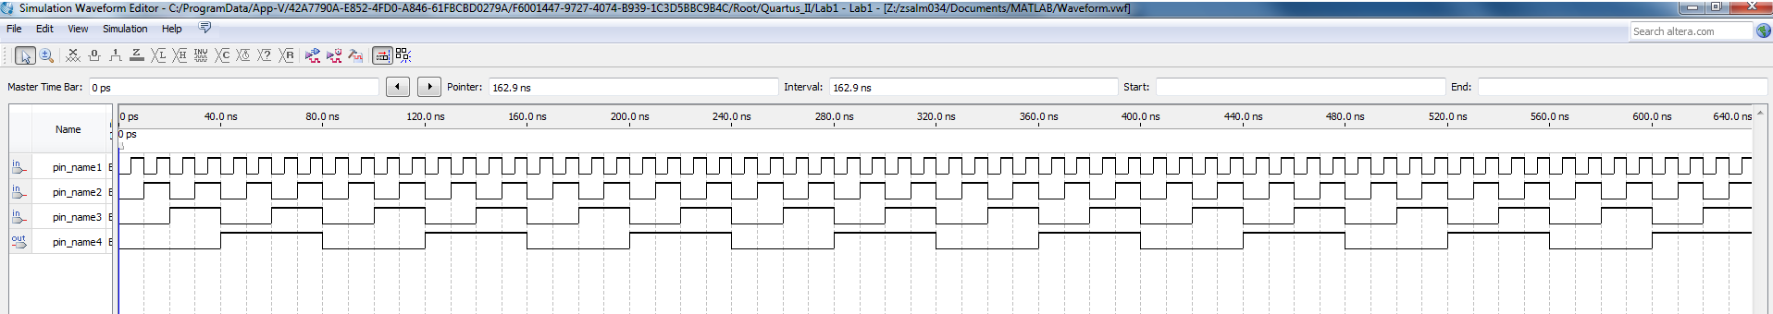
Figure 5.1.1

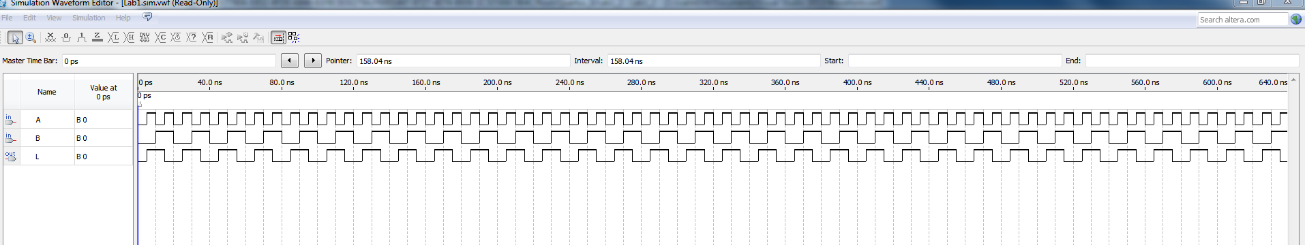
Figure 5.1.5
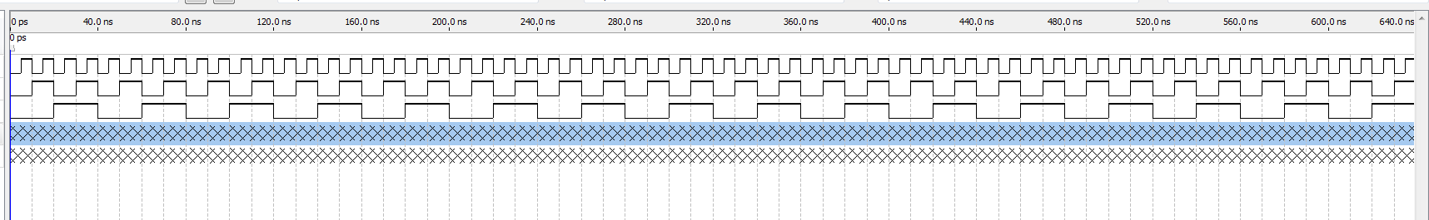
Figure 5.1.8

Comparison of expected data and experimental data

TABLE 1.0 for Figure 5.1.1
A | B | C | R
0 | 0 | 0 | 0
0 | 0 | 1 | 1
0 | 1 | 0 | 1
0 | 1 | 1 | 1
1 | 0 | 0 | 1
1 | 0 | 1 | 1
1 | 1 | 0 | 1
1 | 1 | 1 | 1

R = (A + B) + C

TABLE 2.0 for Figure 5.1.5
A | B | L
0 | 0 | 0
0 | 0 | 1
1 | 1 | 0
1 | 1 | 0

L = A(A’+B’) + B(A’+B’)

TABLE 3.0 for Figure 5.1.8
A | B | C | S | C out
0 | 0 | 0 | 0 | 1
0 | 0 | 1 | 1 | 0
0 | 1 | 0 | 1 | 1
0 | 1 | 1 | 0 | 1
1 | 0 | 0 | 1 | 1
1 | 0 | 1 | 0 | 1
1 | 1 | 0 | 0 | 1
1 | 1 | 1 | 1 | 1

S = (A⊕B)⊕C
C out = (AB) + [(A⊕B) + C’)]

Discussion and conclusion

There were three separate experiments performed in this lab. In the first experiment performed (Figure 5.1.1), there were three inputs taken (A,B,& C) with one output (R) . The experiment makes use of 2 OR gates, where R = (A + B) + C, with the results of the experiment being as we hypothesized from the truth table. In the second experiment we performed (FIgure 5.1.5), there were two inputs taken (A & B) with one output (L). In this experiment 4 NAND gates were used, where L = A(A’+B’) + B(A’+B’), with the results once again resembling the truth table used to hypothesize the results of the experiment. In the final part of this lab, the experiment (Figure 5.1.8), there were 3 inputs taken (A,B,& C) with 2 outputs (S & C out). This experiment makes use of two XOR gates and 3 NANd Gates, giving two outputs S = (A⊕B)⊕C and C out = (AB) + [(A⊕B) + C’)], and once again the yielding the same results as the truth table.

In conclusion with all 3 experiments performed in this lab, the results matched the truth tables we used to hypothesize the data that would yield from these experiments.



