Chapter 12: Sexuality Across the Life Span

Childhood Sexuality

• We know far less about the development of sexuality in childhood than we do about sexuality in adolescence and adulthood
– There is a cultural belief that children are innocent.
– There is reluctance to ask children about their sexual behaviour or their understanding
of sexuality.
– We rely on (sometimes unreliable) reports of parents or caregivers.
– More attention is paid to child abuse than to the course of typical child sexual dev.

• Infancy (Birth to 2 years)
– Infants engage in a variety of “sexual” behaviours:
• Boys have erections in the first few weeks of life.
• Evidence of lubrication and genital swelling has been reported in infant girls.
– Masturbation is typical, and may start at five months of age

• However, children’s reflexes should not be interpreted according to adult
concepts of sexuality.
– Reflexes of lubrication and erection don’t signify an interest in sex

• Children should learn proper names for body parts.

• Early Childhood (2 to 5 years)
– Children may show curiosity about anatomy (e.g., play doctor).
– Hugging, kissing, climbing on others is not a cause for concern.
– Rough-and-tumble play, including touching the genitals, is common.
– Children should be taught the basic rules of privacy that they have basic autonomy over their own bodies, and distinctions between good and bad touch.

• Middle Childhood (5 to 8 years)
– Crushes (our first romantic attachments) and relationships that resemble dating may
occur.
– Curiosity about the genitals increases; playing doctor is common between ages 6-10
- Exploratory same gender play is more common than play with the other gender, may include handling and oral or anal contact.
– Same-sex play does not foreshadow adult sexual orientation
– Experiences aren’t overtly sexual in terms of desire or sexual gratification – more to
satisfy their curiosity
– May ask, “Where do babies come from?”
– May have some awareness that not all people are heterosexual.
– Discuss these issues with factual information.

• Preadolescence (9 to 12 years)
– gender segregated groups and friendships common.
– Increasing preoccupied and self-conscious with their bodies.
– Feel pressure to conform with peers.
– Critical for children of this age to be educated about physical and emotional changes
they’ll experience in puberty –if they are better informed, it means they’ll be better
able to accept changes in a positive way.
– Masturbation is primary means of achieving orgasm.
• 45% of males and 15% of females masturbated by age 13 (Kinsey and
colleagues, 1948, 1953).

– Sex play with others is quite common and do not appear to effect sexual adjustment
• Most activities are single episodes or short-lived experiences.

– Interest in the other sex develops in heterosexuals.

• Adolescent Sexuality
– Though teens are biologically ready for sex, parents often see them as too cognitively,
emotionally, and socially immature to be sexually active.
– These issues are complicated by a sex-saturated media.
– Four main developmental tasks of adolescent sexuality:
- Adapt to the physical and emotional changes in puberty
- Accept yourself as a sexual being
- Explore romantic and sexual relationships
- Learn to protect your sexual health
– Parents, educators and society at large have focused on 1 and 4, but 2 and 3 are
equally important.

Adolescent Sexuality

• Puberty
– The stage of development when reproduction first becomes possible.
– Begins with the appearance of secondary sex characteristics, and ends when the long
bones make no further gains in length.

– Secondary Sex Characteristics
• Definition: physical characteristics that differentiate males and females. Not directly involved in reproduction. Ex Bodily distributions of hair and fat, dev of muscle mass and deepening of the voice

– Primary Sex Characteristics
• Definition: physical characteristics that differentiate males and females that directly involved in reproduction.
• These are the sex organs.

• Puberty: Female changes
– Increased estrogen stimulates growth of breast tissue and onset of menarche.
– Menarche
• The onset of menstruation; first menstruation.
• Commonly occurs between ages of 11 and 14, can occur as early as 9 or as late as 16.
• Puberty has been starting earlier over the past century.
• Early menstrual cycles are typically anovulatory (without ovulation).

A World of Diversity

• The Many Meanings of Menarche
– In some cultures, menarche is greeted with elaborate ceremony
– In certain historical contexts, viewed as polluting women viewed as irrational
– Girls’ attitudes towards menarche related to level of education and certain physical realities
– In Canada, most girls receive information about menstruation.

Adolescent Sexuality

• Puberty: Male changes
– Increased testosterone prompts growth of the testes, scrotum and penis; fosters differentiation of the secondary male characteristics
– Testicle growth accelerates testosterone production and pubertal changes.
– The scrotal sac becomes larger and hangs loosely from the body; the penis widens and
lengthens, pubic hair appears.
– By age 13 or 14 erections become frequent.
– First ejaculations occur by age 13 or 14 most often through masturbation
– After about a year, boys may begin to experience nocturnal emissions (wet dreams).
– underarm hair begins to appear at 15, facial hair at 17 or 18.
– Voice deepens at age 14 or 15
– Boys grow taller and increase in muscle mass.
– Estrogen causes nearly 1 in 2 boys to experience temporary enlargement of the breasts during puberty

• Puberty: Sexual Self-Acceptance
– Getting to know themselves as sexual beings; likes and dislikes; people they are
attracted to.
– body image can be a huge concern.
– Stereotypes can make it difficult for youth to accept who they are (if they don’t fit the
mold).
– Developing self-acceptance can be particularly challenging for LGBTQ youth growing
up in a heterosexist society.
– Exploring sexual identities can lead to sexual well-being.

• Puberty: Romantic and Sexual Relationships
– During the teen years, most adolescents have their first romantic and sexual
relationships.
– Many fall in love for the first time.
– Learning how to develop satisfying, mutually beneficial relationships are a process of
trial and error
- Open communication about sex is related to greater relationship satisfaction.
– First sex occurs around age 17, usually in the context of a romantic relationship

– More females than males report that they were in love with their partners at the time
– Males find first sexual relationship more physically than emotionally satisfying; the
reverse is true for females.
– Far more males than females report having orgasms their first time
– Females view their first intercourse experience as a gift to give partners; males are more likely to perceive virginity as a stigma.

– Although adolescents report a high degree of sexual desire, pleasure, and satisfaction: • 81.4% of males and 75% of female’s report experiencing anxiousness
• 60.5% of males and 66.9% of females reported that they hadn’t found sex
pleasurable on at least one occasion.

– Teens overestimate how much sex their peers are having
–inaccurate assumptions about the sex lives of others can negatively impact our
assessments of our own lives.
– Contrary to media portrayals and boasting of peers about their sexual exploits,
developing into a sexual being involves trials and errors.
– Learning from these experiences sets the stage for a satisfying sex life in adulthood.

• Adolescent Sexual Behaviour
– masturbation
• A major sexual outlet in adolescence.
• Boys are more likely to masturbate than girls
–Stronger sex drive or societal constraints?

• Cultural and religious norms impact frequency.
• There is considerable variation in both sexes –some masturbate frequently and
some not at all.
• Researchers find no links between adolescent masturbation and sexual adjustment in adulthood.

– Sexual Touching (Petting)
• Most adolescents experiment with sexual touching.
• mutual masturbation is a primary activity for those who don’t feel ready for
oral sex or intercourse, or who want to avoid pregnancy or STI infection.

– Oral Sex
• Oral sex has captured the public’s attention recently.
• Media reports have led to a false assumption that oral sex among teens
happens commonly
• Oral sex is about as common as intercourse and occurs at about the same age • Less then one-third of adolescents under age 18 regularly engage in oral sex.

– Intercourse
• Approx. one-third of youth experience intercourse before 17
• The proportion of younger adolescents who have had intercourse has
remained stable in recent years.
• The proportion of older adolescents who have had intercourse declined from 70%-65% over the years.
– Two-thirds have intercourse before age 20.

• Most sexually active youth aged 15 to 17 have only one intercourse partner at
a time.

– Early Age at First Intercourse
• Various factors predict intercourse at a young age: (List 5)
- Poor school attachment
- Poor relationships with parents
- Having peers having sex
- Sexually permissive peers

– Casual Sex
• Sexual double-standard continues to exist: Girls are judged more harshly than
boys for engaging in casual sex.
• Rates increase when non-intercourse behaviours are included.
• New names for pre-existing sexual practices (hooking up, booty call, friends
with benefits).
• Challenges include one partner may want a committed relationship and conflict

A World of Diversity

• Do Sexy TV Shows Encourage Teen Sex and Pregnancy?
– One study found an association between watching sexual content and intercourse
initiation.
– Teenage pregnancy was correlated to sexual content exposure.
• Did not show cause and effect.
• May be due to a selection factor.

Adolescent Sexuality

• Obstacles Faced by Sexual-Minority Youth
– LGBTQ youth continue to face discrimination, prejudice, and violence
– Self-acceptance is difficult because society doesn’t really accept them.
– We know comparatively little about the timing and context of sexual behaviour among
sexual minority youth.
• LGB youth report more emotional distress and lower self-esteem than
heterosexual youth.

– School can be an unwelcoming place; many experience harassment.
– School-based sexual health education in Canada is predominantly heterosexual in
focus.

• Protecting Sexual Health in Adolescence
– Unintended pregnancy and STI infection are threats to health and well-being.
• Teen pregnancy rates have fallen over the past several decades.

– Adolescents use a number of strategies to protect their sexual health: (list 3)
- Abstaining
- Engage in activities with lower risk (petting, oral)
- Condoms

– Condom use has increased in recent years
• More common among younger than older teens.
• Older teens may have switched to other forms of birth control believing that they are at low risk for STIs.

– Adolescent sexual health is improving in many respects; but challenges remain:
• STI rates remain high.
• Sexual-health education needs are less well-addressed for LGBTQ youth.

A World of Diversity

• A Gay Prom Date
– Marc Hall, 17-year-old Oshawa student won a court victory for Catholic students in
2002.
• Hall wanted to bring his boyfriend to the prom. He was unable to, due to a ban
within Catholic school board.
• The ban on same-sex dates at the prom was a violation of constitutional rights.
• The school board chair was very disappointed with the court’s ruling.

Adult Sexuality

• Developmental Tasks
– Adults tend to seek more long-term, complete, relationships.
– Marriage has traditionally been, and is currently (though less so), the primary
relationship for adult Canadians.

– Passion
• Romantic relationships usually begin with physical and emotional attraction
• Once the novelty subsides, partners learn if they are compatible in other
dimensions.

– Friendship
• Is one of the most important dimensions of a strong, mutually satisfying
relationship.
• Over time, a couple’s sexual satisfaction becomes a function of their sense of
shared intimacy.

– Communication
• More direct communication may be an important contributor to a mutually satisfying relationship.
• Better communication about sexual likes and dislikes is associated with sexual
satisfaction.

– Sexual Health
• Protecting sexual health is no less important in adulthood.
• Commitment to condoms decreases with age, even though the health risks
remain high.

• Being Single
– Singlehood is now the most common lifestyle among people in their 20s (it used to be
marriage).
• Many are postponing marriage to pursue education and career goals.
• Many decide to live together but not marry.

– Some singles choose to remain single, some do not.
– Many view it as an alternative open-ended way of life, rather than a stage preceding
marriage.
– Many single people are lonely.
– Many achieve intimacy through friendships.
– Most are sexually active, some practice serial monogamy (being involved in one
exclusive relationship at a time).
– Online dating and social networking sites provide new avenues for connecting with
others.
– Celibacy
• definition:
• For religious reasons, or to focus on other aspects of life.

• Cohabitation
– The state whereby two people live together as a couple but are not legally married
– Socially acceptable.

• Common-law Relationship
– A relationship in which two people live together as a couple, but are not legally
Married.
• May be same-sex or other-sex relationships.
• Cultures differ in their acceptance of this practice.

• Cohabitation before Marriage
– Many believe cohabitation will help them work out the kinks before marriage.
– However, Canadian couples who live together before marriage are twice as likely to
get divorced.
• Cohabitators tend to be more committed to personal independence, are less
traditional, and less religious.
• They tend to be less committed to the values and interests traditionally
associated with the institution of marriage.

• Marriage
– Found in all human societies.
– The most common lifestyle in Canada; 75% of Canadians in their 30s will marry at
some point.
– Most see marriage as something they hope will be permanent

• Marriage: Same-Sex Marriage
– In July, 2002, the Ontario Superior Court of Justice ordered governments to redefine
the term “marriage” to include same-sex couples.
– In 2005, Canadian Parliament passed legislation allowing same-sex couples to marry.
– Number of same-sex marriages jumped from 7500 in 2006 to 21,000 in 2011:
• 54.5% were male couples.
• 45.5% were female couples.

– Benefits of marriage for same-sex couples: (list 5)
- Greater acceptance of their relationship by friends and family
- Equality in terms of making decisions for ill partners, caring for children, inheritances, and insurance benefits
- Greater relationship satisfaction
- Decreased feelings of internalized homophobia
- More openness to the idea of having children
– Not everyone in the gay community supports same-sex marriage: marriage has been
criticized as a patriarchal and heterosexual institution.

• Why do People Marry? (List 6 reasons)
meets personal and cultural needs, provides legal sanction for deeply committed relationships, permits maintenance of home life, provides institution in which children can supported and socialized, man can be assured kids born are his, transmission of wealth through families
– lovw is the most common reason for marriage: however, marrying for love is a
relatively recent notion.

• Types of Marriage
– Monogamy
• Marriage to one person.

– Polygamy
• A person has more than one spouse and is permitted sexual access to all of
them.
• Polygyny – definition: a man is married to more than one women at the same time
• Polyandry – definition: a woman is married to more than one man at the same time

• Arranged Marriage
– Parents in Western cultures rarely arrange marriages.
– Among recent immigrants to Canada from the Middle East and Asia, arranged
marriage is fairly common.

• Who We Marry
– Not relatives.
– People who attract us.
– People who seem to meet our marital, sexual, and psychological needs.
– People who are similar to us in attractiveness and attitudes (homogamy).
• Ethnic background, educational level, religion, age.

– Mixed-race couples are increasing in number in Canada.

• Marital Sexuality
– Varies across cultures, but there are common threads:
• Privacy for sexual relations is valued.
• Most cultures place restrictions on sex during menstruation, during some
stages of pregnancy, and for a time after birth.

– The sexual revolution led to a rising recognition of importance of sexual pleasure for
women.
– Among married sexually active Canadians, aged 18–49:
• 2% had sex every day.
• 34% had sex a few times a week.
• 46% had sex a few times a month.
• 16% had sex once a month or less often.

– Among unmarried relationships:
• 20% had sex every day.
• 43% had sex a few times a week.

• Marital Satisfaction
– Commitment.
– Adequate income.
– Sharing in housework.
– Generosity toward one’s spouse.
– Support of one’s family and friends.
– Agreement on attitudes toward having/raising children.
– Sexual satisfaction (closely linked).
– For many couples, a belief in the religious or spiritual value of marriage.

– Martial and sexual satisfaction are linked.
– The perception of rewards and costs is related to feelings of sexual satisfaction.
– Communication is also related to satisfaction.
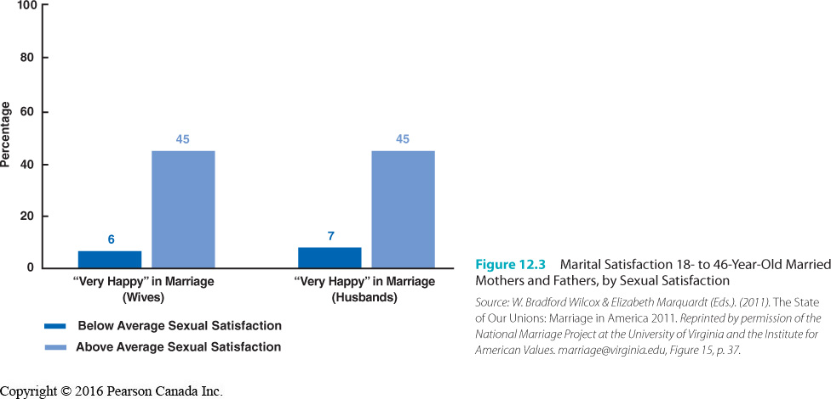

Adult Sexuality

• Sexual Conflict
– In a study of couples in New Brunswick:
• ¼ men agreed “I like to do things my partner does not”.
• 1/3 of women agreed “My partner chooses inconvenient times for sex”.

– More than 1/3 of Canadians have conflicts about sex more than once a month.
• Those in common-law relationships have more conflict than do married
couples.

• Sexual Orientation and Relationship Satisfaction
– Many studies have been done in terms of the factors that predict relationship satisfaction in heterosexual and homosexual couples.
• One difference is that gay and lesbian couples tend to household chores evenly

– For heterosexual and homosexual women, sexual satisfaction is tied to relationship satisfaction
– All couples (regardless of sexual orientation) are more satisfied when they are: (list four)
- Receive social support from partners
- Share power
- Fight fairly
- Perceive that their partner is committed

– Male-female couples are more likely to have the support from family and are less
likely to be stigmatized in society –these differences favour relationship stability.

• Extramarital Sex
– Sexual relations between a married person and someone other than his or her spouse. – Some definitions:
• Conventional adultery
–definition: extramarital sex that’s kept hidden from spouse

• Consensual adultery (consensual non-monogamy)
–definition: extramarital sex that’s engaged in openly with the knowledge and consent of one’s spouse

• Swinging
–definition: a form of consensual adultery in which both spouses share extramarital sexual experiences
–Also referred to as mate-swapping.

• Comarital sex
–definition: swinging or mate-swapping

– Motivations for extramarital sex:
- break the routine of confining marriages
- express hostity or retaliate
- cuiriostity and desire for personal growth
- boost self-esteem or prove that they are still attractive

– Women are usually seeking “soulmates” while men are seeking “playmates”.
– Men are more likely to separate love and sex; are more approving of extramarital
affairs.

– Patterns of Extramarital Sex
• 2005 Canadian Compas poll:
–10% of married people had extramarital affairs.
• Research suggests reported rates of infidelity may be increasing.
• Surveys may result in under-reporting of affairs because of social desirability.

– Attitudes Towards Extramarital Sex
• Most married couples believe monogamy is __________.
• Many Canadians believe an affair would definitely (41%) or probably (27%) end
of their relationship.

– Effects of Extramarital Sex
• anger, jealousy, shame, feelings of inadequacy and doubts about one’s attractiveness
• Perceived breach of trust and intimacy.
• May speed relationship dissolution or lead to renewed efforts and
commitment.

– Swinging
• Most swingers seek to avoid emotional entanglements with their swinging
partners.
• Emotional intimacy can be more threatening to the swingers’ primary
relationship than sexual intimacy.
• In 2005, the Supreme Court of Canada ruled that swinging is not illegal, using
the criteria of harm to society rather than community standards of morality.

• Polyamory
– A form of open relationship that allows for consensual sexual and/or emotional
interactions with more than one partner.
– Based on the view that people’s needs for intimacy are unlikely to be gratified through
one relationship.
– Proponents argue that relationships can be strengthened if the partners have
opportunities to develop emotionally intimate relationships with others.

• Divorce
– According to Statistics Canada projections, 37.9% of marriages that took place in 2004
will end in divorce.
• The average age for divorce will be 44 for men, and 41.2 for women.

– The divorce rate peaked in 1987 in response to changes to the Divorce Act in 1985,
which made it easier to obtain a divorce.
– The number of second divorces is also increasing
– Divorces are most likely to occur after 3-4 years of marriage.
– Divorced people often choose to cohabitate rather than re-marry.
– Why are divorces increasing?
- No fault divorce laws
- Women’s increase in economic independence
- More consider it an alterable condition
- Higher expectations for marriage
– The Costs of Divorce
• Financial and emotional problems.
• Stresses of solo childrearing (largely for women).
• Prompts feelings of failure as a spouse and a parent.
• Brings about feelings of loneliness, uncertainty about the future, and
depression.
• Contributes to high rates of physical and mental illness and suicide.

– Divorce can also be a catalyst for personal growth and renewal.

Senior Sexuality

• Seniors are the fastest-growing segment of the population.

• Beliefs about sexuality in older persons: (list 4)
1. Only see sex appropriate for the young
2. older people are sexless
3. older people with sexual urges is adnormal
3. and older males with sexual urges are “dirty old men”

• Research doesn’t support that individuals inevitably lose their sexuality as they age.
– Physical ability to function sexually diminishes somewhat.
– Psychological and social factors are as important as physical ones in determining
sexual behaviour and satisfaction among older people.
– Having a partner affects sexual frequency.

• Sexuality-related Developmental Tasks of Later Life (list 6)
- Maintaining self-perception as a sexual being while living in a culture that tends to equate sexuality to youth
- Adapting to reduced frequency to sexual desire
- Adapting to reduced intensity of genital sexual response
- Adapting to the death of a partner
- Adapting entry into long term care facility
- Using protection against STI and HIV
• Physical Changes
– Having accurate expectations can help older people to lead some of the most sexually
fulfilling years of their lives.

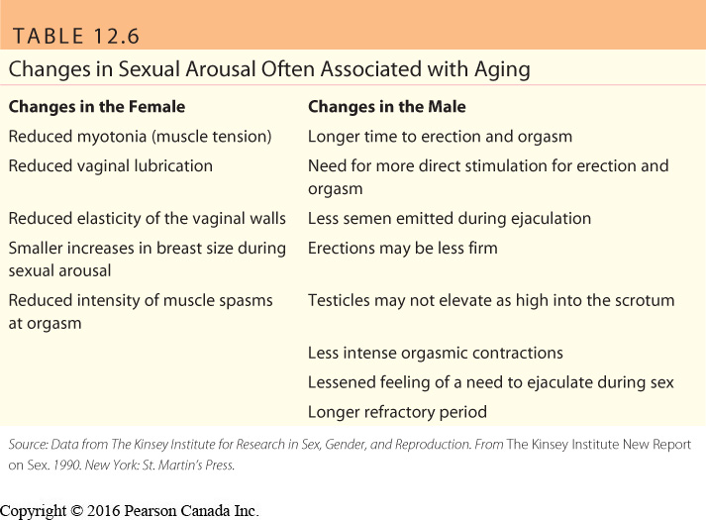

– Can be combatted with longer foreplay (for women) and adding
additional lubricant
– People’s attitudes, sexual histories and partners are important factors in sexual
behaviour and enjoyment.
– For some, years of sexual experience may more than compensate for decreased
physical responsiveness.

• Patterns of Sexual Activity
– Sexuality is variable.
– Many older people engage in sexual activities at least as often as they did when they
were younger.
– Research with 35-to 55-year-old women indicates that body image is an important
influence on sexual functioning and satisfaction, more so than menopause.

– Study of 3000 Americans, aged 57–85:
• Sexual relations declined with age.
• Many reported having sex partners during the previous year.
• Average sexual frequency was 2–3 times/month.
• Women were less likely to have sexual relations.
• People in good health are more likely to be sexually active.
• Half of those sexually active experienced sexual problems.
• 14% of men used Viagra or other supplements.
• Few felt that sex was “not that all important”.

– Peggy Kleinplatz (University of Ottawa researcher) studies optimal sexuality.
• For many, “great sex” didn’t occur until midlife.
• Great sex was possible well into later years.
• Erotic intimacy, interpersonal exploration, authenticity, freedom to be
themselves, and communication were ingredients for great sex.

– Couples may respond to physical changes of aging by broadening their sexual
repertoires.

• Losing a Partner
– The surviving partner faces a loss of companionship and physical intimacy.
– Reduced sexual activity among older people is due more to the loss of partner than
to reduced physical capacity
– Since women live longer than men, partner loss affects women disproportionately.

• Aging and Gay and Lesbian Sexuality
– Limited research has been carried out on the effects of aging on gay men.
• Gay men were interviewed in Toronto (Murray & Adam, 2001).
– Because the gay community values youth and attractiveness, many
older men felt at a disadvantage in finding sexual partners and saw
themselves as “invisible” to younger men.
– Feelings of loneliness and isolation were common.
– Some men felt in greater control of their sexuality.

– Older gay and lesbian persons may feel doubly discriminated against because of their
age and sexual orientation.
• Many agencies don’t know how to respond to the unique needs of older
lesbians and gay men (e.g., in nursing homes, where workers may be
homophobic).

• Protecting Sexual Health in Later Life
– A number of factors have led to increased risks for STIs among older Canadians:
- Changes in attitudes toward sexuality later in life made it more acceptable for older people to peruse sex lives
- Medical advances had made it that older people are healthy enough for sexual activities
- Increase divorce rates make it so more old people are part of the single scene
- Older people are not getting the message about safe sex.

