Chapter 9: Sexual Orientation

Getting Oriented Toward Sexual Orientation

• Sexual Orientation
– Definition: the directionality of one’s erotic attraction, that is to member of the same gander, the other gender or both

• Heterosexual Orientation
– Definition: erotic attraction to and preference for romantic relationship with members of the other gender

• Homosexual Orientation
– Definition: erotic attraction to and preference for romantic relationship with members of your own gender

• Bisexual Orientation
– Definition: erotic attraction to and preference for romantic relationship with both men and women

• Coming to Terms with Terms
– The term “homosexuality” is somewhat controversial:
• Draws attention to sexual behaviour.
• Has historical association with deviance and mental illness.
• Often used only in reference to men, rendering lesbians invisible.
– Sexual orientation refers to the direction of romantic interest and erotic attraction,
not by sexual activity
– This distinction is useful, because many heterosexual people have same-sex
experiences and many gay and lesbian people have opposite-sex experiences.

• Sexual Orientation and Gender Identity
– Like most heterosexuals, most gay men and lesbians have gender identities consistent
with their anatomic sex.
– A small percentage of gays and lesbians are transgender.
– When heterosexuals think about gays and lesbians, they often focus on sexual aspects of relationships; the relationships of gays and lesbians (like heterosexuals) involve more than sex
• Only a small amount of time in heterosexual and homosexual relationships is
spent on sex.
• More basic to gay or lesbian sexual orientation is the formation of romantic attachment with members of one’s own sex.

– Sexual orientation can be conceptualized/measured based on several factors
(Alderson, 2007): sexual attraction, sexual fantasies, sexual preference, sexual partners, tendency to fall in love romantically and experience of falling in love romantically

• Classifying Sexual Orientation
– Not clear cut –a significant percentage of people are neither exclusively heterosexual
nor exclusively gay or lesbian.
• It’s not unusual for heterosexual people to have same-sex sexual experiences. • Gay males and lesbians may also engage in male-female activity while maintaining a gay sexual orientation.

– Sexual orientation isn’t necessarily expressed in sexual behaviour.
• Many people see themselves as gay or heterosexual long before they have sex with members of their own gender

– People’s erotic interests may shift over time.
• Women’s sexual orientations are apparently somewhat more flexable than men’s.

– Chivers & Bailey (2005)
• Exposed men and women to visual male and female sexual stimuli and
measured genital responses and self-reports of sexual arousal.
• Male heterosexuals responded genitally to female stimuli; gay males to male
• Women, both heterosexual and lesbian, were more likely to be aroused by
both female and male

– People may have various degrees of sexual interest in, and sexual experience with,
people of either sex.
– Attraction to people of the same and other sex may not be mutually exclusive.

Kinsey Continuum
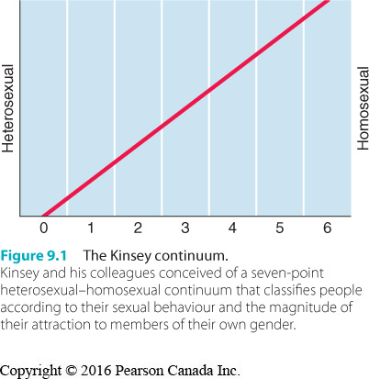

Getting Oriented Toward Sexual Orientation

• The Kinsey Continuum
– Kinsey and his colleagues (1948, 1953) found evidence of a continuum of sexual
orientation.
– Bisexuality represented a midpoint (3) between exclusively heterosexual (0) and
exclusively homosexual (6) orientation.
– Kinsey data suggested that approximately 10% of Americans were either gay or
predominantly gay.
– Half the people who reported male–male sexual activity in the Kinsey data limited it to
the ages of 12 to 14, another one-third had experiences before age 18 and not again.
– The Kinsey research showed that sexual behaviour patterns can change.

• Challenges to the Kinsey Continuum
– Heterosexual and homosexual orientations may be separate dimensions, rather than
polar opposites.
– Storm (1980) found evidence that there are separate dimensions of responsiveness to
male-female sexual stimulation (heteroeroticism) and same sex stimulation
(homoeroticism).
– Bisexuals are high in both dimensions.
– Asexuals are low in both dimensions.

Heterosexuality and Homosexuality as Separate Dimensions
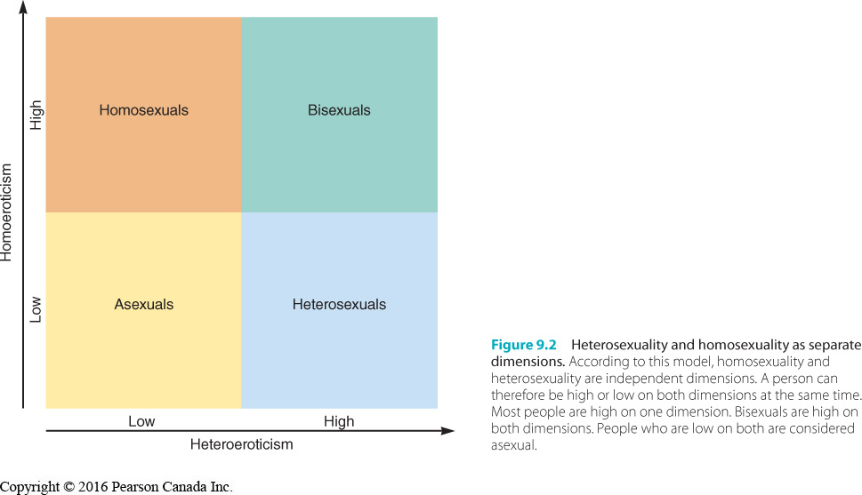

Getting Oriented Toward Sexual Orientation

• Estimates of Sexual Orientation
– The controversy about how many people aren’t heterosexual continues:
• About 7% of women and men in the U.S. define themselves as “other than
heterosexual”.
• However, 14% say they have had oral sex with person of same gender.
• Statistics Canada included a question for the first time in 2003:
– Of 135 000 respondents aged 18 to 59, 1% reported they were gay or
lesbian, 0.7% identified as bisexual.

– More recent 2012 Forum research poll found that younger people were more likely to
identify as non-heterosexual.
• 10% of 18-34 year olds identified as gay, lesbian, bisexual.

– Clear trend for more recent surveys to find higher percentages of people reporting a
non-heterosexual orientation than in the past.

• Bisexuality
– Sexual attraction to both males and females.
– Many have a somewhat stronger attraction to one sex over the other.
– Some believe claims to bisexuality are a “cop out” used by people to deny they are
gay or lesbian.
– Others view it as a form of experimentation.
– Many bisexuals and researchers assert that bisexuality is an authentic sexual
orientation.
• Bisexuals can maintain erotic interests in and romantic relationships with
members of both sexes.
• Bisexuality has it’s own developmental patterns.

– Biphobia
• Negative attitudes and feelings toward bisexual people, including intolerance,
hatred, and fear.

– Some bisexual people live in ways that satisfy their dual inclinations.
– Others are pressured by heterosexual and gay people alike to commit themselves one
way or another.
– Some gay and lesbian people mask their sexual orientations by adopting bisexual
lifestyles (e.g., getting married but having sexual relationships with members of the
same sex).

• Asexuality
– Anthony Bogaert (2006) argues that asexuality should be considered a sexual
orientation.
• lack of sexual attraction to both sexes.
• low interest in any kind of sexual stimulation, including masturbation.
• May be romantically attracted to others.

– In one study, 1% of respondents indicated they had never felt sexually attracted to
anyone at all.
• One-third of these were currently in relationships.

– More research is needed in this area.
– However, research that has been conducted suggests that asexuality isn’t pathological,
shouldn’t be seen as a sexual dysfunction, and that asexual people can live happy
lives.

• Queer, Questioning, Transgendered, and Two-Spirited
– Queer
• Definition: find the traditional terms too limiting, don’t see themselves as fitting into standard classification of sexual orientation

– Questioning
• Definition: unsure which available labels best describe their sexual orientations. Still discovering their identity or coming to term that they are not hetro

– Pansexual
• Definition: sexual or emotional attraction to people regardless of gender identity or sexual orientation
• Challenges the heterosexual/homosexual dichotomy and the male-female
gender dichotomy.

– Transgender
• Some argue that transgender people should be included in discussions of
sexual orientation, because they are the most visible minority of people
engaged in same-sex practices.

– Two-Spirited
• Among Aboriginal communities, refers to gender or social identity and in many
cases includes same-sex behaviour.

A World of Diversity

• Youth Challenging Traditional Concepts of Sexual Orientation and Gender
– Book The New Gay Teenager by American researcher Rich Savin-Williams, argues that
today’s urban teenagers no longer accept traditional gender and sexual orientations.
– Savin-Williams is critical of researchers who force participants to put themselves into
traditional categories, and of those who oversample troubled teens, giving an
inaccurate picture of gay teens today.
– Canadian Kris Wells (2008) of the University of Alberta concurs; says Canadian youth
are
• Challenging traditional sexuality and gender stereotypes.
• Reluctant to have their identities forced into narrow categories.

Perspectives on Gay and Lesbian Sexual Orientations

• Historical and Religious Perspectives
– Jews and Christians have referred to male-male sexual activity as the sin of Sodom.
– Despite this, some churches marry gay couples.
– Some churches allow gay and lesbian clergy to be ordained, if they remain celibate.
– Struggles over gay rights occur internationally (i.e., at the United Nations).

• Cross-Cultural Perspectives
– Male-male sexual behaviours have been engaged in across cultures and history.
• Viewed as normal in 49 of 76 preliterate societies studied by Ford and Beach
(1951), and occurred despite sanctions in the others.
• Has been considered a rite that marks initiation into manhood.

– Little is known about female-female sexual activity in non-Western cultures.
• Ford and Beach found evidence of this in 17 of 76 societies.

• Cross-Species Perspectives
– Biologists have observed male-male and female-female sexual behaviour in at least
450 animal species, in every part of the world.
– Displays of dominance and submissiveness seem sexual, but it is difficult to infer
sexual motivation.
– Bisexual orientation has been observed among female Japanese macaques.

• Biological Perspectives
– Evolutionary Perspective
• Strong male-male and female-female alliances have advantages for group
survival – describe these: bind group members together emotionally increase altruism. Women related to gay males apparently bear more children

– Genetics and Sexual Orientation
• There is considerable evidence that gay and lesbian sexual orientations run in
families (e.g., twin studies).
• Evidence suggests the marker is x chromosome -linked.

– Hormonal Influences and Sexual Orientation
• Research has not connected sexual orientation with differences in male or
female sex hormone levels in adulthood– may have a activating effect (sex drive but not preference).

– Brain Structure and Sexual Orientation
• Similarities have been found in the brains of lesbians and heterosexual men,
and in gay men and heterosexual women.
• Preliminary research also suggests that a segment of the hypothalamus may be smaller in gay men.

– Biology and Sexual Orientation
• To some degree, sexual orientation is influenced by biological factors, and the
relationship appears stronger in men than in women
• These factors likely play a role prior to birth.

Innovative Canadian Research

• Birth Order and Sexual Orientation
– Ray Blanchard and colleagues at the Centre for Addiction and Mental Health in
Toronto have conducted several studies on birth order and sexual orientation.
– They concluded that a gay male with three or more older brothers can attribute most of the origin of his sexual orientation to this effect.
– Older brothers only increase the odds of being homosexual for right-handed males.

Perspectives on Gay and Lesbian Sexual Orientations

• Psychological Perspectives
– Psychoanalytical Views
• Gay or lesbian sexual orientation results from failure to successfully resolve the Oedipus complex
• Castration Anxiety
– Man’s fear that his genitals will be removed.

• Penis Envy
– A girl’s wish to have a penis.

– Learning Theory
• Early sexual behaviour patterns are reinforced.
• Pleasurable sexual activity with same-sex friends may be reinforcing and lead
to future behaviours (but not for most people who engage in same-sex sexual
exploration…).
• Learning theorists have not identified specific experiences that would lead to
differing orientations.
• The majority of gays and lesbians are aware of sexual interest in their on gender before they experience sexual encounters.

– Gender Nonconformity
• Definition: not behaving in a way that is consistent with the gender role stereotype associated with ones anatomic sex
• Gay men and lesbians are more likely to report childhood behaviours more
typical of the other gender.

– Gender Nonconformity
• Butch
–A lesbian who assumes a traditional masculine gender role.

• Femme
–A lesbian who assumes a traditional feminine gender role.

• Current Attitudes
– There is far greater acceptance of equal rights for gay people in Canada today than at
other times in history.
• Can be attributed in part to exposure to gay individuals.
• However, Canadian population remains segmented in attitudes towards moral
acceptability of homosexuality (Langstaff, 2011).
– Shift is result of people who were more or less neutral toward greater
acceptance.
– People who oppose homosexuality have become more
firm in their beliefs.

– Most Canadians accept same-sex marriage.

• Homophobia
- Takes many forms, including:
  - Using derogatory names
  - Telling disparaging “queer jokes”
  - Barring gay people from housing, employment, and social opportunities
  - Taunting (e.g. verbal abuse)
  - Gay bashing (e.g. physical abuse)

- May stem from: stereotypical gender role attitudes and feel more threatened. Some have denial of homoerotic attitudes and take it out on gays
– More common among conservative, traditional men, people who hold fundamentalist
religious views, those who identify with Nazi beliefs.
– Some homophobic men may have homoerotic impulses they are unaware of: denial of
impulses connected to fear and disapproval of gay men.

• Harassment of LGBTQ Youth in Canada
– Despite many strides, Canada still remains a hostile and damaging environment for
many LGBTQ youth.
– EGALE Canada’s national survey found 64% of LGBTQ students felt unsafe at school,
21% had been physically harassed.
– LGBTQ youth are more likely than heterosexual youth to be physically and sexually
abused by people inside and outside the family.

• Heterosexism
– Definition: (heterosexual bias) the tendency for society to view the world in heterosexual terms like that hetro relations are “normal”
– This perspective devalues other kinds of relationships.
– Lesbians and gay men are often as concerned about heterosexism as homophobia,
because it is so pervasive in society.

• Sexual Orientation and Canadian Law
– Decriminalization of same-sex behaviour between consenting adults occurred in 1969. • Since then, other pieces of legislation have benefited gay men and lesbians.
• EGALE has lobbied for changes to the Charter of Rights and Freedoms and the
Canadian Human Rights Act.

• Gay Activism
– By challenging heterosexuality as the social norm and affirming their right to self-
determination, gay men and lesbians are helping other groups to achieve sexual freedom.

• Stereotypes and Sexual Behaviour
– Some people assume that in gay and lesbian couples, that one partner assumes the
masculine role and that the other assumes the feminine role in sexual relations.
– This assumption is often mistaken.

The Coming Out Process

• Due to the social condemnation and discrimination
– Gay men and lesbians often struggle coming to terms with their sexual orientations.
– Referred to as “coming out”.
– Two-part process:
1. coming out to themselves
2. and coming out to others

– Can create a sense of pride and ability to form satisfying relationships.

• Self-Acceptance and Coming Out
– Given the stigma historically associated with homosexuality, it is not surprising that
some gay, lesbian and bisexual people have a hard time recognizing and accepting
their sexual orientation.
• Sexual minority youth growing up in hostile environments have extra
challenges.

– There is often a 10-year gap between initial attraction to members of one’s own sex and disclosure of one’s orientation to others.

• Self-Acceptance and Coming Out
– Four Steps in Development of Sexual Identity in Gay Men and Lesbian Women (Savin-
Williams & Diamond, 2000):
1. attraction to members of the same gender
2. self-labeling as gay or lesbian
3. sexual contact with members of the same gender
4. disclosure of their sexual orientation to other people

– Other models have been proposed (e.g., Alderson’s Ecological Model of gay male
identity).
– Accepting one’s identity can be sudden or gradual.
– Males are more likely to become involved with same-sex sexual activity before they label themselves as gay.
– Females are more likely to label themselves as lesbian before pursuing relationships with other females
– Younger cohorts tend to come out earlier than older ones.

• Coming Out to Others
– Many people are reluctant to come out.
• Attractive men and those who believe in a just world are likely to come out at a
younger age.
• Those with feminine behavioural traits in childhood tend to delay coming out.

– Disclosure is fraught with risks.
– Negative reactions are often anticipated from family members, but family reactions
vary.
– Many parents report initial reactions are highly emotional, involving shock, denial, guilt, and shame.

Applied Knowledge

• Counselling Gays and Lesbians
– Blais and colleagues (2004) outlined key issues related to sexual orientation for
therapists:
• homophobia, HIV, the lack of conjugal role models, and the coming out process

• Gays and lesbian couples face many of same issues as heterosexual couples.

Gay and Lesbian Adjustment

• Results of a meta-analysis comparing the mental health of heterosexuals and non-
heterosexuals indicated that lesbian, gay, and bisexual individuals were more than twice as
likely as heterosexuals to attempt suicide.
– More likely to be diagnosed with depression, anxiety, and dependence on alcohol and
other substances.
– Likely due, in part, to sexual abuse and emotional distress

• Gay, Lesbian and Bisexual Youth
– Compared to heterosexual youth, GLB youth are more likely to:
- experience physical and sexual abuse, harassment in school, and discrimination in the community
- more likely to run away from home at least once during the previous year
- more likely to be sexually experienced
- where more likely to have been pregnant or gotten someone pregnant
- more likely to have reported emotional stress, suicidal thoughts, and suicide attempts
- less likely to participate in sports and physical activities
- more likely to spend time on the computer
- left less cared about by parents and less connected to their families

– LGB youth that felt highly connected to their families and schools were far less likely to attempt suicide.
– Most gay males and lesbians are well-adjusted, particularly if they accept their
orientation and are open about it.
– Gay people who lived with partners in stable, intimate relationships were about as
well-adjusted as married heterosexual couples.
– Most who are in close relationships are satisfied with the quality of those
relationships.

Gay and Lesbian Lifestyles

• All gay and lesbian people are not the same.
• VanderLaan & Vasey (2008) found variations in mate retention strategies of gay, lesbian, and
heterosexual couples.
• Gays and lesbians in larger urban centres usually have support from gay communal
structures/services (e.g., gay rights organizations, newspapers, bookstores etc.).
• Not all gay men and lesbians feel a part of the gay community or participate in gay rights
organizations.

Innovative Canadian Research

• Innovations in Gay Male Relationships
– Barry Adam (2006) interviewed gay men in couple relationships in Toronto about
sexual inclusivity.
• Monogamy was most common among younger men and men in new
Relationships.
• Most couples were involved in sexually open relationships.
• They wanted emotional security of a committed relationship with the experience of Sexual pleasure with other men
• The primary partner was deemed most important and rules for conduct were
negotiated.

Gay and Lesbian Lifestyles

• Gay and Lesbian Parenting
– Foster’s (2005) analysis of research on lesbian families has found:
• Most lesbian families have formed as a result of birth mothers’ having children
in heterosexual relationships.
• Children in raised in lesbian families:
- dev. Typical gender identities and gender roles
- dev. Typical peer relationships
- exhibit normal emotional and behavioural dev.
- Have fewer issues regarding their sexual identity than children raised in heterosexual families
- Are no more likely to grow up gay or lesbian

– Foster’s (2005) analysis of research on lesbian families has found:
• Key factor in the children’s development appears to be the equalitarian,
nurturing and empathic nature of the families.
• Children raised in lesbian families are at least as well adjusted as those raised
in heterosexual families.

– Similar findings have been reported for children raised by gay male parents.
– The APA has concluded that there is no scientific evidence that parenting effectiveness
is related to parental sexual orientation.

