Chapter 6: Attraction and Love

Attraction

• The Attraction-Similarity Hypothesis
– The concept that people tend to develop romantic relationships with those whose
level of attractiveness and other traits are similar to their own.
– Our partners tend to resemble us in terms of race and ethnicity, age, level of education and religion.

• Do Opposites Attract, or Do Birds of a Feather Flock Together?
– Opposites do not attract!
– Why do we have partners from our own backgrounds?
• propinquity –we live near people who are similar to ourselves.
• We’re drawn to people whose attitudes are similar to our own.

– Women place greater weight on similar attitudes, men on physical attraction
– We tend to assume people we find attractive share our attitudes.
– Similarity may be important in determining initial attraction; compatibility appears to
be a stronger predictor of maintaining an intimate relationship.

• Reciprocity: If You Like Me, You Must Have Excellent Judgement
– When we feel admired and complimented, we tend to return those feelings and
behaviours.
– Reciprocity
• Mutual exchange.
• May enable many couples to become happy with one another.
• Can stoke neutral or mild feelings into robust, affirmative feelings of attraction.

• Physical Attractiveness: How Important is it to Look Good?
– Physical attractiveness is a major determinant of interpersonal and sexual
attractiveness.
– Some contend it is the key factor in consideration of partners for dates, sex, and long-
term relationships.
– What is considered attractive varies by culture
– In general, women consider taller men to be more attractive.
– Thinness is valued in North American culture.
– The hourglass figure is popular in Canada and in most other cultures (this varies by
sexual orientation, however).
– What is considered attractive to women varies across the menstrual cycle.
– How attractive women are perceived to be is also influenced by where they are in the
menstrual cycle.
– People who are attractive know it.

• Physical Attractiveness: Non-physical traits and attractiveness
– How beautiful we find a partner is likely to be enhanced by traits such as familiarity,
liking, respect, and shared values and goals.
– Gender role orientation and expectations affect perceptions of attractiveness.

Innovative Canadian Research

• What do Women Want?
– Researchers at Queens University and the University of Victoria tested the hypothesis
that women who were more open to short-term sexual relationships would be more
likely to prefer highly masculine male faces and bodies.
• Concluded that women associated higher levels of masculinity with healthier
genes.

– Study at McMaster University found that women have a slight preference for men
with lower-pitched voices for both short and long-term relationships.
• Women also equated lower voices with infidelity.

Attraction

• Physical Attractiveness: What do you look for in a relationship?
– In selecting a long-term partner:
• Men and Women: Rate responsibility as the most important skill, followed by
physical attractiveness, sexual skill, and status/popularity.
• Women: Place relatively greater emphasis on responsibility.
• Men: Place relatively greater consideration on physical attractiveness.

– In selecting a short-term partner:
• Women rate physical attractiveness as more important than men.

• Physical Attractiveness: An evolutionary perspective on mate preference
– Some evolutionary psychologists believe evolutionary forces favour the continuation
of gender differences in mate preference because these traits offer reproductive
advantages.
– A woman’s reproductive value would be tied to youth and health.
– A man’s reproductive value might depend on his ability to provide for his family.
– Critics suggest that gender differences in mate preferences are maintained by male-
dominated social structures.
– As cultures develop higher levels of gender equality, male and female standards of
attractiveness will gradually change.
– Some of these changes are occurring already.

A World of Diversity

• Sex Differences in Mate Preference Across 37 Cultures
– Buss (1994) reviewed survey evidence for preferred age differences between
individuals and their mates.
– In every culture:
• Men wanted mates to be younger and women preferred mates who were
older
• Men placed greater value on good looks
• Both genders placed greater emphasis on other qualities such as being “kind”,
“understanding” and “intelligent”—these all rated higher than characteristics
emphasizing power or physical attractiveness.

• Ready, Set, Speed Date
– Studies examining speed-dating and partner preferences have found:
• Women in more competitive environments are less selective in their partner
preferences.
• A person’s beliefs about their preferences may not predict who they actually
become attracted to or pursue a relationship with.

Love

• Our culture idealizes the concept of romantic love

• People who feel loved have better health than those who do not.

• The concept of love must be understood within a cultural context.

• A Greek Heritage
– The concept of love can be traced back to the classical age of Greece.
– The Greeks distinguished four concepts of love:
• Storge
– Definition: loving attachment and nonsexual affection. This is the type of emotion that binds parents to children

• Agape
– Definition: selfless love. This is the kind of love that is similar to generosity or charity

• Philia
– Definition: love between friends. This kind of love is based on liking and respect rather than physical desire

• Eros
– Definition: the kind of love that’s closest to our modern-day concept of passion

• Romantic Love
– Romantic love, as represented by fairy tales, has been idealized in Western culture.
– In adolescence, strong sexual arousal and idealized images of the objects of our desire
lead us to label our feelings “love”.
– Being “in love” ennobles sexual attraction and sexual arousal.
– Most people in Canada believe romantic love is a prerequisite for marriage.
– About one-half of Canadians believe in love at first sight.
– When fulfilled, romantic love is usually a source of deep fulfillment and ecstasy.
– When unrequited, it can lead to emptiness, anxiety, and despair.

• Romantic Love: Infatuation versus “true love”
– Infatuation
• Definition: a state of intense absorption in or focus on another person
• Usually accompanied by sexual desire, elation, general physiological arousal or
excitement, passion.
–Difficult to distinguish between the two for the first month or two.
–As partners begin to view each other more realistically, they are better
able to determine if a relationship should continue.

– Infatuation is based on intense feelings of passion, not on deeper attachment and caring
– Infatuation can lead to a more lasting love relationship, but it isn’t a necessary
precursor.
– Sometimes, one partner experiences infatuation and the other does not.

• Contemporary Models of Love: Biological Mechanisms
– Some researchers focus on the bodily changes that occur when we experience feelings
of romantic love.
• e.g., neural pathways, brain chemistry, hormones.

• Contemporary Models of Love: Love as Appraisal of Arousal
– Hatfield and Rapson define romantic love as intense psychological arousal
and the cognitive appraisal of the arousal as love
• e.g., sweaty palms, racing heart attributed as love.

– The perception of falling in love requires: state of arousal in connection with love
object, cultural setting which idealizes romantic love, attribution of arousal to feelings
of love.

• Contemporary Models of Love: Styles of Love
– Hendrick and Hendrick (2003) developed Love Attitudes Scale which depicts 6 styles
of love:
- Romantic love (eros) – we are attracted to each other
- Game-playing love (Ludus) – keep lover up all night worrying about what I’m doing
- Friendship (storge, philia) – best love grows out of friendship
- Logical love (pragma) – think if lover will be a good parent
- Possessive, excited love (mania) – if he ignores me I get sick all over
- Selfless love (agape) – I will do anything for them

• Contemporary Models of Love: Sternberg’s Triangular Theory of Love
– Organizes the relationships between different kinds of love discussed by many
theorists.
– Three components of love:
• intimacy, passion, commitment

– Intimacy
• The experience of warmth toward another person that arises from feelings of
closeness, bondedness, and connectedness.
• Includes the desire to give and receive emotional support and to share one’s
innermost thoughts.

– Passion
• An intense romantic or sexual desire for another person accompanied by
physiological arousal.

– Commitment
• Dedication to maintaining the relationship through good times and bad.

– Love can be conceptualized in terms of a triangle, with each vertex representing one
of these basic elements of love.
• The way the components are balanced can be represented by the shape of the
triangle.
• Couples are well-matched if their triangles are congruent.

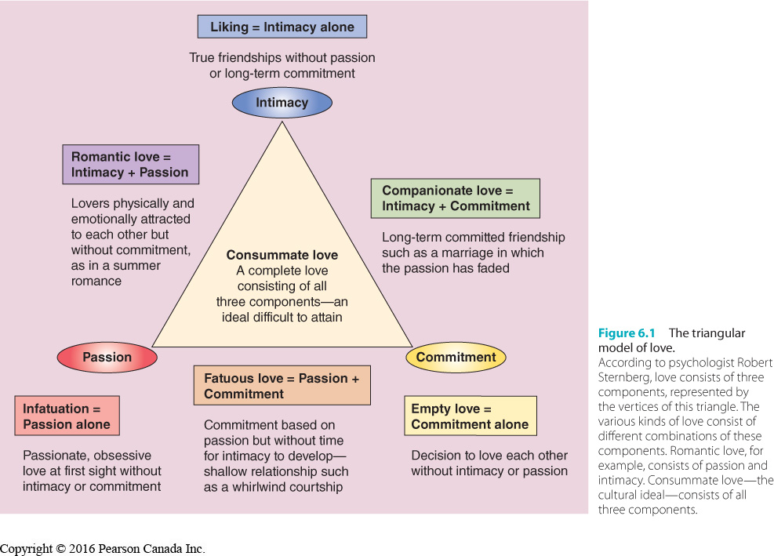

– Various combinations of the three components of love characterize six different types
of love relationships:
• Liking = basis for friendship, closeness and warmth, without passion and commitment. Reserved for people we can share feeling with.
• Empty love = nothing but commitment. Tolerate partner and remain with them because of a sense of duty. Remain for personal or social prescription
• Infatuation = strong sexual desire, not intimacy and commitment, feel a passionate love unrequited
• Romantic Love = passion and intimacy but lacks commitment. Can die down or continue to burn bright
• Companionate Love = has intimacy and commitment but no passion, long term ‘platonic’ relationships. Or in marriages where passion has ebbed but there is still a deep friendship
• Fatuous Love = has passion and commitment but no intimacy. Often burn out when realize that they are not a match
• Consummate Love = desire, deeper intimacy and commitment. What westerners strive for.

