Chapter 5: Gender Identity and Gender Roles

Gender Identity and Gender Roles

• Gender
– definition: the psychological state of being female or male, as influenced by cultural concepts of gender-appropriate behaviour, gender is distinct from anatomic sex

• Gender Typing
– definition: the process by which children acquire behaviours deemed appropriate for their sex

Prenatal Sexual Differentiation

• Sexual Differentiation
– Males and females develop distinct reproductive anatomy.
– x or y chromosomes from male parent combine with x chromosomes from female
parent.
– 23rd pair is the sex chromosomes.
– The ovum carries an X sex chromosome.
– Sperm can carry an X or Y sex chromosome.

• Zygote
– Definition: a fertilized ovum (egg cell)

• Embryo
– Begins with implantation of a fertilized ovum and concludes with development of the
major organ systems.

• After fertilization, the zygote divides repeatedly.
– During the first six weeks, embryonic structures of both sexes develop along similar
lines.
– At the seventh week, the genetic code (XX or XY) begins to assert itself.
– If a Y chromosome is absent, ovaries begin to differentiate.

• Sex Hormones and Sexual Differentiation
– Androgens
• Male sex hormones.
• Without androgens, we would all develop female external reproductive organs

– Testosterone
• The male sex hormone that fosters the development of the male duct system and is connected with the sex drive.

• Descent of the Testes and Ovaries
– By 10 weeks after conception, testes and ovaries have descended.
– Four months after conception, testes descend into the scrotal sac.
– Cryptorchidism
• Definition: a condition in which at least one of the testes fails to descend

• Sex-Chromosomal Abnormalities
– Klinefelter Syndrome
• Extra X chromosome.
• Affects 1 in 500 males.
• Men fail to develop appropriate secondary sex characteristics.
• Fail to produce sperm.

– Turner Syndrome
• A disorder in which a female has just one X sex chromosome (X rather than
XX).
• Affects 1 in 2500 females.
• May not naturally undergo puberty.
• Often treated with hormones to spur development of secondary sex characteristics.

– Brain undergoes prenatal sexual differentiation.
• Testosterone causes hypothalamus of male fetus to become insensitive to
estrogen.
• In the absence of testosterone, the hypothalamus of a female fetus becomes
sensitive to estrogen.
• Estrogen is important to regulation of the menstrual cycle.

Gender Identity

• Gender Identity
– Definition: ones internal and individual sense of being female, male, or other shade of gender

• Assigned Sex
– Definition: the classification of autonomic sex assigned to an individual after birth

• Intersex
– Definition: a person who possesses the gonads of one gender and external genitalia that are ambiguous or typical of the other gender

• Cisgender
– Definition: the gender identity that matches the assigned sex

Gender Identity—Nature and Nurture

• What determines gender identity?
– Our brains and hormones?
– Learning and the environment?
– Biological and environmental influences?

• Gender identity is usually consistent with chromosomal gender.
– This does not prove that gender is biologically determined.

• Gender Binary
– A social system that defines gender as either strictly male or female.
– Does not accurately reflect the diverse range of gender identities that actually exist.

• Hermaphrodites
– Possess both ovarian and testicular tissue.
– Usually assume gender identity and gender role assigned at birth.

• Intersexual
– Gonads match their chromosomal sex.
– External genitalia, and sometimes internal reproductive anatomy, are ambiguous or
resemble those of other sex.
– Occurs in 1 in 5000 infants.

• Congenital Adrenal Hyperplasia (CAH)
– Most common form of female intersexualism.
– Genetic female has internal female structures but masculinized external genitals.
– Girls with CAH showed more interest in masculine toys, were more likely to
have boys as friends, and to want masculine-typed careers.

• Androgen-Insensitivity Syndrome
– Affects genetic males who, as a result of a mutated gene, have experienced lower-
than-normal prenatal sensitivity to androgens.
– External genitals are feminized

• Dominican Republic Syndrome
– First documented in a group of 18 affected boys in two rural villages.
– A genetic enzyme disorder that prevents testosterone from masculinizing the external
genitals.
– Boys resembled girls at birth and were reared as females.
– At puberty, secondary sex characteristics developed.
– 17 shifted to a masculine gender identity.

Gender Identity

• Gender Dysphoria
– Until recently, the DSM listed Gender Identity Disorder as a psychiatric diagnosis.
– The 2013 edition of DSM adopted a less pathologizing diagnosis of Gender Identity.
Disorder:
• Definition of GID: a sense of incongruity between assigned sex and gender identity that causes significant distress
• The APA stresses that gender nonconformity is not a mental disorder, but the
diagnosis is dependent upon distress.

• Gender Non-conforming Children
– Children who indicate that they prefer to be a gender different from their assigned
sex.
– In the past, they were clinically diagnosed as having Gender Identity Disorder and
given therapy aimed at conforming to societal standards.
– Some clinicians continue to offer similar interventions; however, this practice is
increasingly opposed.
– Treatments designed to change gender identity/expression are no longer considered
ethical.
– Supportive/affirming approaches are now more common.

Gender Identity-Transgender

• Transgender (“Trans”)
– Definition: a person whose gender identity is different from their assigned sex at birth
– Language related to transgender identities has changed over time.
– Language needs to reflect and be respectful of the transgender community.

• Transitioning
– The activities that some trans people may pursue to begin living as the gender with
which they identify, rather than the gender they were assigned at birth.
– May include: List three: changing their names and the way the dress, and possibly having medical treatments

• Transitioning—Motivations
– Incongruity between genital anatomy and gender identity.
– Some men fall into other categories: men who are extremely feminine, men who are
sexually aroused by the idea of becoming women.

• Autogynephilic
– Definition: men who are sexually stimulated by fantasies that their bodies are female

• Transitioning—Motivations
– Trans activists have contested the idea that some transgender people are motivated
to seek gender reassignment by erotic interests.
– Often, transgender people show cross-gender preferences in play and dress in early
childhood.

Innovative Canadian Research

• What can the Samoan Fa’Afafine teach us about western concepts of gender identity? (Vasey
& Bartlett, 2007)
– Conducted a study in Samoa high tolerance for men with feminine characteristics,
cross-gender behaviour in children was seen as unproblematic.
– Interviewed males referred to as fa’afafine feminine males who are attracted to
masculine men.
• Found no evidence that female-typical behaviours in childhood provoked
distress.
• Often recalled that they loved engaging in those activities.

Gender Identity—Transgender

• Gender Reassignment
– Surgery is one element of gender reassignment.
– Health professionals conduct careful evaluations to determine that people seeking
reassignments are competent to make such decisions and have thought through the
consequences.
– Usually requires that people live openly as members of the other sex for extended trial
periods before surgery.
– Involves a lifetime of hormone treatments.
– Surgery is largely cosmetic –cannot construct internal genitals or gonads.

• Phalloplasty
– Surgical creation of an artificial penis.
– Surgery is costly.
– The penises often don’t work very well.

• Surgical Outcomes
• Most reports of trans peoples’ postoperative adjustments are positive.
• Most are no longer gender-dysphoric.
• Most function well sexually, psychologically, and socially.
• Adjustment is most favourable for female-to-male transsexuals.

• Surgical Outcomes
– Research on attitudes towards transsexuals suggests that students are divided in
terms of liking and disliking trans people.
• More negative attitudes reported towards trans people than toward gay and
lesbian persons.

– Research suggests that hearing directly from a trans person is the best way to learn
about transgender issues, generating understanding and empathy.

A World of Diversity

• Third Gender/Third Sex
– Refers to people who are considered neither women nor men.
– May represent
• An intermediate state between man and woman.
• State of being both man and woman.
• State of being neither man or woman.

– Examples:
• The ladyboys of Thailand.
• The Two-Spirits of North America.
• The Hijras of South-Central Asia.

Innovative Canadian Research

• The Trans Pulse Project
– Community-based research project that examines the impact of social exclusion and
discrimination on the health of the trans community.
– Results in Ontario indicate:
• Split evenly between female to male (54%) and male to female (47%).
• Participants identified with a range of sexual orientations.
• Broad range of cultural and ethno-racial groups.
– 48% were living full-time in their felt gender, 30% part-time, 22% not living in felt
gender at all.
– 59% became aware their gender did not match their bodies before age of 10 –
Approximately 25% completed medical transition.
– Almost all had experiences of transphobia and discrimination.

Gender Roles and Stereotypes

• Stereotype
– Definition: a fixed, conventional idea about a group of people

• Gender Roles
– Definition: complex clusters of ways males and females are expected to behave

Sexism

• Sexism
– Definition: the prejudgment that a person will process certain traits because of gender
– May lead us to interpret the same behaviour in different ways.
– Children develop stereotypes about “men’s work” and “women’s work”.
– Psychologically damaging.
– Some progress has been made with respect to gender equality in Canadian society;
the feminist movement in Canada has played a major role in this.

• Gender Roles and Aggression
– In most studies, males have been found to behave more aggressively than females.
– Aggression seems to have increased among girls in recent years.
– Bullying in both genders in elementary school is highly predictive of aggression in later
dating relationships.

Gender Typing

• Gender Typing
– Definition: the process by which a child acquires behaviours deemed appropriate for his or her gender

• Biological Perspectives
– Tend to focus on the roles of genetic and prenatal influences.
• The evolutionary perspective
–Men’s role as hunters and warriors and women’s roles as caregivers and
gatherers are carried forward in our genes.
–Has been criticized for its stereotypical gender roles

– Prenatal brain organization
• Prenatal sex hormones may masculinize or feminize the brain by creating
predispositions that are consistent with gender role stereotypes.
• One study found that sex differences in toy interest emerge earlier than self-
awareness of one’s sex.

• Psychological Perspectives
– Psychoanalytic Theory (Freud)
• Gender typing is explained in terms of identification.
• Appropriate gender typing requires boys to come to identify with their fathers
and girls with their mothers.
• Oedipus complex
–Definition: in psychoanalytic theory, a conflict of the phallic stage in which the boy wishes to possess his mother sexually and perceives his father as a rival for her love

– Social-Cognitive Theory
• Explains gender-typed behaviour in terms of processes such as observational
learning, identification, and socialization.
• Socialization
–Definition: the process by which an individual is guided into socially acceptable behaviour patterns though information, rewards and punishments
–Parents are key agents of socialization: parental roles in gender typing
are changing.

– Cognitive-Developmental Theory
• Children play an active role in gender typing through the formation of schemas
about gender.
• Schema
–Definition: a concept or a way of interpreting experience or processing information

• Gender stability
–Definition: the concept that people retain their genders for a lifetime by age 4-5

• Gender constancy
–Definition: the concept that peoples genders do no change even if they alter their dress or behaviour
–Achieved by age 7 or 8

• Children are motivated to behave in gender appropriate ways once they’ve
established the concepts of gender stability and gender constancy.

– Gender-Schema Theory
• Children develop gender schemas as a means of organizing their perceptions of
the world.
• Gender schema
–Definition: a cluster of mental representations about male and female physical qualities, behaviours and personality traits

• Gender gains prominence as an organizing construct because of society’s
emphasis on it.

• Gender roles affect sexual behaviour
– Traditional Sexual Script
• A sexual script based on stereotypical standards for sexual behaviour that
dictates that males take an assertive and active role in heterosexual interaction
while women take a receptive and passive role.
– Children learn at an early age that men usually approach women and initiate sexual
encounters, whereas women serve as the gatekeepers in romantic relationships.
– Embedded in the larger stereotype that men are sexually aggressive and women are
sexually passive.
– Men expected to have a higher number of sexual partners.

• Gendered sexual stereotypes
- Men sexually aggressive where women are passive
- Men expected to have more sex partners then women
- Men are expected to initiate sexual encounters and dictate all the moves after. Women are supposed to let men determine choice timing and sequence of sex positions and techniques
- Men are expected to take the lead in bringing their partners to orgasm, expected to be natural experts
- Believed the men to be easily aroused and that women don’t share a natural interest in sex
– Gender roles in Western culture have evolved in recent decades.

• Attitude and Behaviour Differences
– An assumption is that gender differences in sexual attitudes and behaviours are quite
large.
– A meta-analysis (Petersen & Hyde, 2011) found differences in general sexual
permissiveness were relatively small and decreasing over time.
• Larger differences are related to masturbation and the use of sexually explicit
Materials.
– There is greater variation within gender than between genders.

A World of Diversity

• Are there universal differences in sexual strategies?
– Sexual Strategies Theory
• Men and women differ in long-term and short-term mating strategies.
• Qualities that men and women seek are believed to help solve adaptive
problems humans have faced throughout evolutionary history.
• Men more interested in in short-term, sexual variety place more value on
signals of fertility.
• Women more interested in long-term, commitment place more value on
signals of resources, commitment.
• Men are more interested in one-night stands.
• Women have little to gain from casual encounters.
• Evolutionary theory seeks human universal behaviours.
• Schmitt (2003) conducted a large cross-cultural study to examine sex
differences in desire for sexual variety.
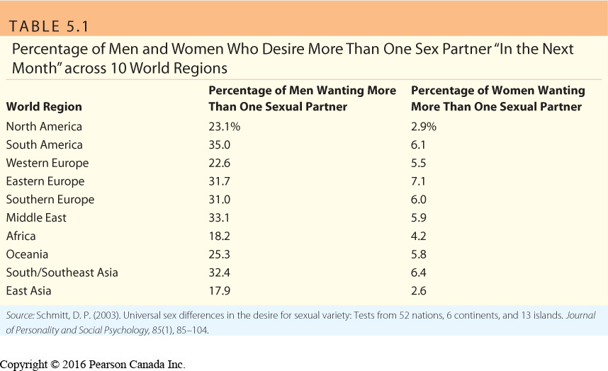

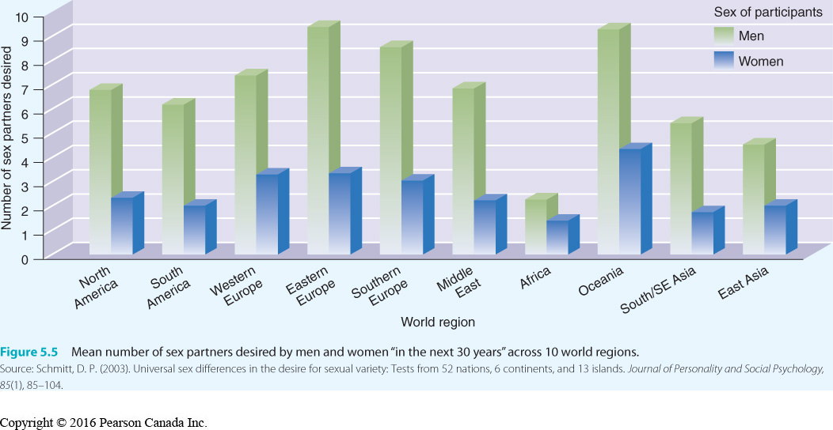

A World of Diversity

• Alternative Explanations?
– Common global communication affecting the ways in which parents and cultural
institutions influence children around the world.

Gender Roles and Sexual Behaviour

• The Sexual Double Standard
– Men and women are evaluated differently for the same behaviours.
– Many men and women perceive a sexual double standard.
– Women are judged more harshly than men for having many sexual partners.
– Women may be harsher judges of women’s behaviour than men.
– Despite the perception of a double standard, most endorse a single standard.
– Some endorse a reverse double standard.
– Research indicates that the nature of the double standard is more complex than
originally thought.
– A range of measures are needed to accurately capture sexual attitudes.

• Gender and Sex-Advice Literature
– Gender stereotypes heavily influence the type of relational and sexual advice provided
to couples.
– In the 1900s, the husband was presented as the wife’s sexual tutor and the initiator of
sex.
– In the period between the First and Second World wars, it was emphasized that
husbands should provide their wives with sexual pleasure.
– During sexual revolution of 1960s, sex was no longer tied to marriage.
– Marriage manuals were renamed as sex manuals.
• Focused on the need for a couple to master new sexual techniques and
maximize pleasure.

• Highly Sexual Women
– Some women consider themselves “highly sexual”.
• Think about sex a lot.
• Enjoy fantasizing about sex.
• Willing to try almost anything.
• Confident about their sexual abilities.
• Enjoy masturbating.

– Many women are attempting to change the perception in society that women are not
interested in sex.
– Sex therapist Joy Davidson encourages women to:
• Let go of sexual inhibitions.
• Electrify their libidos.
• Liberate their fantasies.
• Feel good about their “kinkier” sexual desires; explore them safely.

Innovative Canadian Research

• Do young men really prefer sex over romance?
– Research and theory concludes that men are more sexually motivated than women,
women are more romantically motivated than men.
– Explanations differ (e.g., Evolutionary Theory vs. Social Psychology theories).
– Most research relies on self report.
– Researchers used an Implicit Association Test (IAT) to compensate for social
desirability (Thompson & O’Sullivan, 2012).
– Assessed differences in students’ pleasant and unpleasant associations to romantic
and sexual stimuli.
– Both men and women had a stronger automatic preference for romantic stimuli.
– Explanations?
• Previous research has overstated actual gender differences.
• Findings reflect changes in ways that men are socialized in Western culture.

Psychological Androgyny

• Psychological Androgyny
– Definition: a state characterized by possession of both stereotypical masculine and feminine traits
– May lead to an individual being able to meet the demands of various situations and to
better express their desires and talents.
– May be perceived as a desirable goal for people who oppose constraints of traditional
gender roles.
– Critics suggest that some benefits of psychological androgyny are confounded with
masculinity.

