Chapter 4: Sexual Arousal and Response

The Senses and Sexual Arousal

• Sight: The Better to See You With
– Visual cues can be sexual turn-ons.
– Men appear to be more responsive to visual stimuli than women; however, women
also respond to visual stimuli.
– Common visual stimulation:
• Having sex in a mirror
• sexually explicit media
–Men appear to be more interested in visual erotica.

• Smell: Does the Nose Know Best?
– Smell plays a lesser role in governing sexual arousal in humans than in lower
mammals.
– Our body’s natural odours can play a role in sexual attraction and arousal.
– Aphrodisiacs
• Definition: any drug or other agent that’s sexually arousing or that increases sexual desire

– Pheromones
• Definition: chemical substances that are secreted externally by certain animals and that convey information or to produce specific responses in other members of the same species
• Garnering attention in recent years, and are considered to have an impact on
sexual attraction.

– Menstrual synchrony
• Exposure to other women’s sweat can modify a woman’s menstrual cycle.

– Body odours and sexual orientation
• Odours may play a role in the selection of sex partners.
• Gay males and lesbians may produce axillary odours that can be distinguished
from those of heterosexuals.
• Gay males are most likely to be attracted to the body odours of other gay
males; heterosexual males are least likely to be attracted to body odours of
gay males.

• Touch: Sex as a Touching Experience
– Erogenous zones
• Definition: parts of the body that are especially sensitive to tactile sexual stimulation.
• Primary erogenous zones
–Areas richly endowed with nerve endings.
• Secondary erogenous zones
–Parts of the body which become erotically sensitized through
experience.

• Taste: On Savoury Sex
– Some people are sexually aroused by the taste of genital secretions.
– Biologically arousing or learned? Could associate it with pleasure

• Hearing: The Better to Hear You With
– Sounds can be turn-ons or turn-offs.
• Talking dirty
• Music

A World of Diversity

• YSEX: The Reasons People Give For Wanting To Have Sex (Meston& Buss, 2007)
– Questionnaire examining most/least common reasons for sex.
– Sample of 1549 undergraduate students.
– Most common reasons
- feelings of attraction
- desire for physical pleasure
- expression of feelings of love
- feeling desired by the other person
- desire to deepen the relationship
- novel experience
- celebration of special occasion
- opportunity
- seeming to just happen

– Least frequent reasons
- to hurt partners (cheating)
- job or promotion
- get rid of headache or cramps
- pressure or sense of duty
- feel closer to god

– Gender differences
• Men reported more reasons related to: physical reasons, sheer opportunity, bragging rights, peruse a conquest and bragging rights
• Women reported more reasons related to love

• YSEX: The Reasons People Give For Wanting To Have Sex (Wood, Milhausen & Maitland, 2013)
– Sexual Minority Women (lesbian, bisexual, queer & questioning).
• Most common reasons for sex included:
– pleasure
- physical desirability
–express love to partner

Aphrodisiacs, Anaphrodisiacs, and Psychoactive Drugs

• Aphrodisiac
– A substance that arouses or increases one’s capacity for sexual pleasure or response.
– Some are subject to the placebo effect.
– Examples:
• Food
• Drugs “poppers” (amyl nitrate), Viagra, L-dopa
• Hormones Testosterone

• Placebo Effect
– The perception that consumption of a substance (e.g., medication) results in an effect
(e.g., relief), even though the substance does not contain properties (e.g., active
ingredients) that cause the effect to occur.

• Anaphrodisiac
– A substance that is an antagonist to sexual arousal and desire.
– Anti-androgens may have anaphrodisiac effects; have been used in the treatment of
deviant sexual behaviour patterns.
– Other examples:
• antihypertensive drugs
• antidepressants
• nicotine

• Psychoactive Drugs
– Alcohol
• Small amounts can induce feelings of well-being but large amounts can
curb sexual desire
• Can lower sexual inhibitions and induce feelings of euphoria.
• Expectations regarding alcohol may influence sexual responsiveness.
• Appears to impair ability to weigh information.
• Leads us to ascribe our behaviour to the effects of alcohol rather than to
ourselves.

– Marijuana
• Facilitates desire and heightens sexual pleasure among some women.
• Can facilitate sexual desire and pleasure among men, but may hinder erectile
functioning.
• Effects on both men and women are dose-dependent.

– Stimulants (e.g., amphetamines, cocaine, crystal methamphetamine)
• Reputed to heighten arousal and sensations of orgasm.
• May increase levels of arousal in men and women by increasing levels of dopamine.
• New users report enhanced sexual experiences continued use often
results in diminished sexual functioning (McKay, 2005).

Sexual Response and the Brain

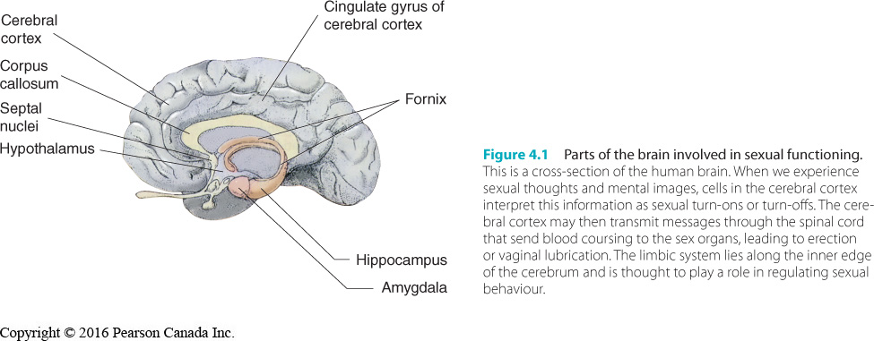

Sexual Response and the Brain

• The brain plays a central role in sexual functioning—the cerebral cortex and limbic system
play key roles.

• Cerebral Cortex
– The wrinkled surface area (grey matter) of the cerebrum (main part of the brain).
– Cells fire when we experience sexual thoughts, images, wishes and fantasies.

• Limbic System
– Active in memory, motivation, and emotion.

Sex Hormones and Sexual Behaviour

• Hormones
– Chemical substances secreted by an endocrine gland.
– Regulate various body functions.
– Secondary sex characteristics
• Definition: a substance secreted by an endocrine glad that regulates various bodily functions

• Organizing and Activating Influences
– Organizing effects
• Influence the type of behaviour that is expressed.
–e.g., mating behaviours in lower animals.

– Activating influences
• Influence the frequency or intensity of the drive that motivates the behaviour and ability to perform the behaviour.
–e.g., sexual response and sexual desire, testosterone.

• Male Sexual Behaviour
– Male sex hormones influence sex drive and sexual response c
– Surgically/chemically castrated men exhibit a decrease in testosterone which decreases sexuality fantasies and desires, lose capacity to maintain erection or ejaculate.
• However, there is great variation in sexual interest and functioning
learning and motivation play a large role.

– Evidence of the role of hormones is found among men whose testosterone levels have
declined.
– Hypogonadism
• Definition: a condition marked by abnormally low levels of testosterone
• Leads to loss of sexual desire and decline in sexual activity

– At puberty, hormonal variation plays a more direct role in stimulating sexual interest
and activity in males.

• Female Sexual Behaviour
– Female sex hormones do not appear to play a direct role in determining sexual
motivation or response in human females.
– Unlike most mammals, human females are sexually responsive during all phases of
menstrual cycle.
– Women who have had ovariectomies (surgical removal of ovaries):
• Continue to have sex drive/interest.
• May experience vaginal dryness.

– Sexual responsiveness may be influenced by the presence of circulating androgens.
– Smaller amounts of androgens does not equal a weaker sex drive compared to men.
• Adrenal gland removal associated with decreased sexual desire
• Androgen levels predict sexual interest among teenage women.

• Factors Influencing Sexual Arousal
– Milhausen (2004) found arousal among men and women could be enhanced by
partner’s positive characteristics, varied sex, and anticipation of sexual encounters.
– Arousal was inhibited by a partner’s self-consciousness, a lack of balance in giving and
receiving in sex, and worries about various issues.
– Women were more aroused than men by partner’s positive characteristics, feeling
emotionally connected, trusting their partners, feeling partners were sensitive to their
needs, and hormones.
– Men were more aroused by specific sexual stimuli.
– Women were more inhibited than men by possible sexual violence and exploitation,
and concern about sexual performance.

Innovative Canadian Research

• Gender, Sexual Orientation and Arousal
– Chivers and colleagues have conducted ground-breaking research demonstrating that
sexual arousal patterns vary by gender and sexual orientation.
- Arousal was strongest when watching the sexual intercourse video
- And weakest the with the nude exercise one.
• Gender, Sexual Orientation and Arousal (Lawrence, Latty, Chivers, & Bailey, 2005)
– Examined arousal patterns in male-to-female transgender participants before and
after gender reassignment surgery. Gender of the actor was more important for men than for women
– Participants who identified as gay before reassignment more aroused by men
– Participants who identified as heterosexual before reassignment more aroused
by women for men and women aroused by both
– Responses after surgery similar to those before surgery.

Theories of Sexual Response

• Masters and Johnson (1966) found that the physiological responses of men and women to
sexual stimulation were quite alike.

• The sequence of changes that take place in the body is referred to as the sexual response
cycle.

• Masters and Johnson divided the cycle into four phases.

• Masters and Johnson’s Four-Phase Sexual Response Cycle
– Both men and women experience vasocongestion and myotonia.
• vasocongestion
–Swelling of the genital tissue with blood.

• myotonia
–Muscle tension.

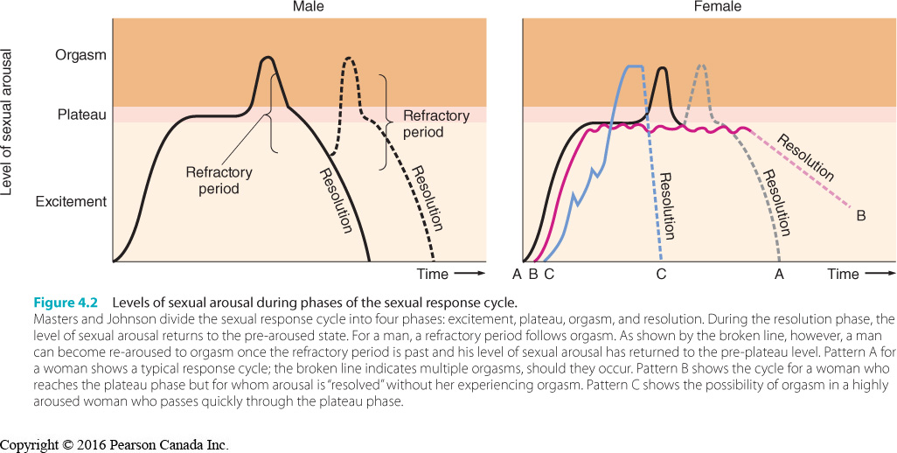

Theories of Sexual Response

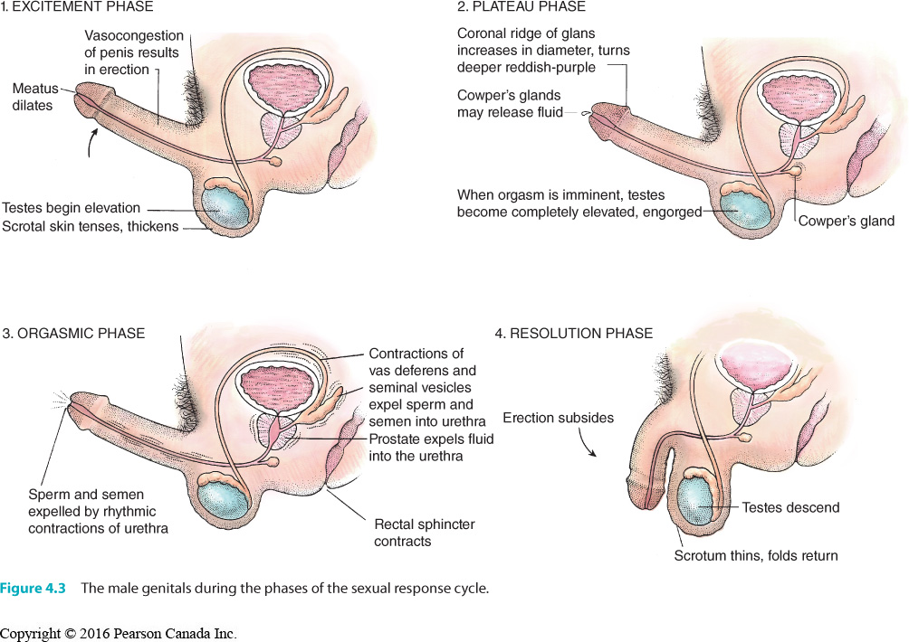

Theories of Sexual Response

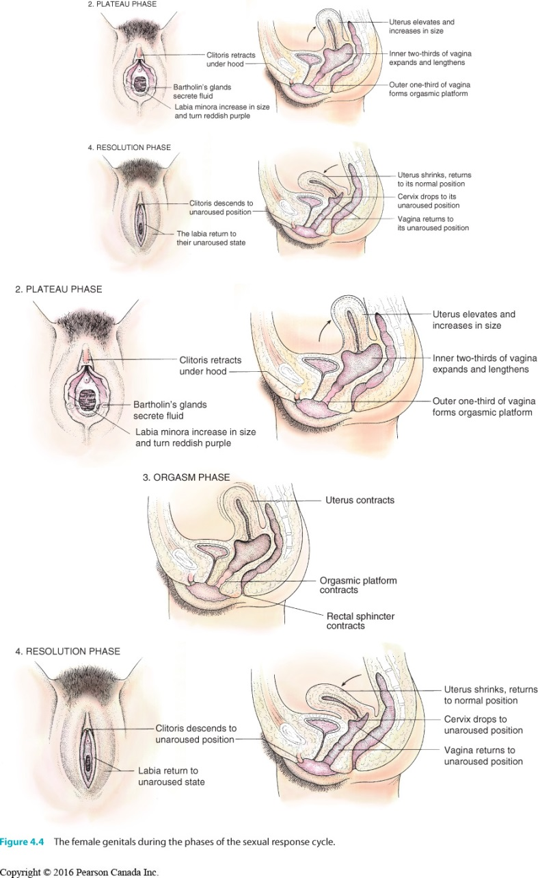

Theories of Sexual Response

• Masters and Johnson’s Four-Phase Sexual Response Cycle
– excitement phase
• Erection in the male, scrotal skin thickens, testes increase in size, testes and
scrotum become elevated.
• Vaginal lubrication in the female, vasocongestion, uterus engorges, breasts
enlarge.
• Skin may take on rosy “sex flush”, more pronounced in women than men.
• Increased myotonia, heart rate, and blood pressure.

– plateau phase
• Increases in vasocongestion, muscle tension, rapid breathing, heart rate, and
blood pressure.
• Myotonia may cause facial grimaces.
• In men, coronal ridge increases in size, glans turns purplish hue, testes further
elevate, Cowper’s glands excrete a few drops of fluid found at the tip of the
penis.
• In women, vasocongestion swells the tissues of the outer one-third of the
vagina, contracting the vaginal opening.
• Orgasmic platform
–Definition: thickening of the walls of the outer one third of the vagina because of vasocongetion during plateau phase

• Uterus becomes fully elevated.
• Clitoris shortens and withdraws beneath the clitoral hood.
• Labia minora turns red, known as the “sex skin”.
• Sex skin
–The reddening of the labia minora.

– orgasmic phase
• In the male, consists of two stages of muscular contraction.
• Sensations of pleasure tend to be related to strength of contractions and
amount of seminal fluid.
• First 3 to 4 are most intense and occur at 0.8-second intervals; 2 to 4 more
occur at a slower pace.
• In the female, orgasm is comprised of 3 to 15 contractions of the pelvic
muscles that surround the vaginal barrel, first contractions occur at 0.8-second
intervals.
• Followed by another 3–6 weaker, slower contractions.
• Spacing of contractions more variable in women.
• In both genders, muscles throughout the body spasm, blood pressure and
heart rate peak, and respiration increases to 40 breaths per minute.

– resolution phase
• Body gradually returns to its pre-aroused state.
• Muscle tension dissipates within 5 minutes of orgasm.
• Blood pressure, heart rate, and respiration return to pre-arousal levels within
a few minutes.
• Both men and women may feel relaxed and satiated.
• myotonia and vasocongestion may take an hour to dissipate among those who
did not have orgasm.
• Men lose erection in two stages.
• Men enter refractory period where they are physiologically incapable of
experiencing another orgasm or ejaculation.
• In women, orgasm triggers release of blood from engorged areas.
• Clitoris, vaginal barrel, uterus, and labia gradually shrink to their pre-aroused
states, sex flush lightens gradually.
• Persistent pelvic vasocongestion in a man may cause “blue balls” (slang term
for a throbbing ache).
–Can be relieved through masturbation or partnered sex.

• Women may also experience this sensation if they become highly aroused and
don’t find release.
• Not an excuse to pressure or coerce someone into sex.

Innovative Canadian Research

• Genital Versus Subjective Sexual Arousal
– Sexual concordance refers to the degree to which actual genital response and self-
reported sexual arousal correspond with each other.
– Male genital arousal is measured by the degree of penile erection
– Female genital arousal measured by genital vasocongestion or vaginal blood
– Subjective arousal is measured by questioners and interviews
– Men tend to have a higher degree of sexual concordance than women.
– Suggested explanations:
- May not be aware of the physical arousal
- May only be vaguely aware of physical arousal
- May be aware of physical sensations but not define them as sexual
- May interpret as sexual but no experience the sensation as enjoyable

Theories of Sexual Response

• Kaplan’s Three Stages of Sexual Response
– Helen Singer Kaplan was a prominent sex therapist and author.
– Based on her clinical work, she developed a three-stage model noteworthy for
designating desire as a separate phase of sexual response (1974, 1987):
• desire
• excitement
• orgasm

• Basson’s Intimacy Model of Female Sexual Response
– Rosemary Basson (2008) developed an intimacy-based model of female sexual
response, especially relevant for women in long-term relationships.
• Process may not always begin with desire
• Women may feel aroused for intimacy reasons.
• arousal may precede desire.
• Arousal may not lead to orgasm

• Comparing Models of Female Sexual Response
– Sand and Fisher (2007) conducted a study to see how closely women felt their own
experiences fit the Masters and Johnson, Kaplan, and Basson models.
– Almost equal proportions of women selected each model.

Innovative Canadian Research

• The Subjective Experience of Orgasm
– Studies suggest that the orgasms of both genders may feel quite similar.
– Mah and Binik (2002) asked men and women to rate adjectives describing orgasms
they had experienced during masturbation and sex with a partner.
– Two dimensions were found: sensory (e.g., flooding, throbbing) and emotional (e.g., relaxation, emotional intimacy).
– A subsequent analysis of the data found that women experienced differences in
orgasms types, depending on partnered vs. solitary masturbation.
– Partnered Orgasms
• More flushing sensations, general spasms, pleasurable satisfaction, emotional
intimacy, ecstasy.

– Solitary Orgasms
• Greater feelings of relaxation.

– Salisbury and Fisher (2013) explored the importance of female orgasm for men and
women in a sexual relationship.
• Men believe women need regular orgasms to be satisfied; women felt
pleasure was more important to their satisfaction.
• Women not having an orgasm was tied to feelings of inadequacy among men. • Women reported faking orgasms in order to please their partner.

The Enigmatic Orgasm

• Multiple Orgasms
– One or more additional orgasms following the first.
– Occurs before the body returns to a pre-plateau level of arousal.
- Kinsey and colleagues thought: 14% were capable of multiple orgasms
- Masters and Johnson thought: most is not all were capable of multiple orgasms, however men are not capable
– Women can maintain a high level of arousal and experience orgasms in rapid
succession because they do not have a refractory period.
– In a study of 720 nurses, 435 reported experiencing multiple orgasms, often occurring
with vibrator use applied to the clitoris.
– Women reported the orgasms experienced with vibrators to be more intense than
other kinds.
– Some men report experiencing multiple orgasms without ejaculation (“dry orgasms”);
do not follow a refractory period after initial dry orgasm.

• How many kinds of orgasms do women have?
– Freud
• Suggested two types of orgasms: clitoral and vaginal, should give up clitoral when mature
• Critiqued as heterosexist. Lesbians don’t rely on penile thrusting
• Most women report needing clitoral stimulation.

– Masters and Johnson
• Found only one kind of orgasm, regardless of whether stimulation was clitoral
or vaginal. Spasmodic contraction

Sexuality and Disability

• Millions of Canadians live with physical or intellectual disabilities and are often seen as sexless
and childlike.

• These views are based on misconceptions.

• Some disabilities may call for adjustments to sexual activity.

• Most people with disabilities have the same sexual needs, feelings, and desires as those
without.

• Research indicates that there is a stigma attached to the sexuality of people with disabilities
(Esmail, Darby, Walter, & Knupp, 2010).

• Internalized stigma may impact the confidence and desire of people with disabilities.

• Sex education in schools typically does not include or acknowledge the information needs of
people with disabilities.

• Community resources are improving.
• Their abilities to express their needs and feelings depend on the physical limitations imposed
by their disabilities, how they adjust to their disabilities, and the availability of partners.

• Perhaps the biggest challenge to the sexuality of disabled people is that they must live in a
society where myths, misconceptions, and negative stereotypes about sexuality and disability
abound.

• Physical Disabilities
– Sexual wellness for people with disabilities involves five factors:
- A positive sexual self-concept
- Knowledge about sexuality
- Positive productive relationships
- An ability to cope with social, envirmental, physical, and emotional barriers to sexuality
- Maintenance of good general and sexual health, within personal limitations

– Cerebral palsy
– Spinal cord injuries
– Sensory disabilities (blindness, deafness)
– Other physical disabilities and impairments
• Arthritis

• Expanding Sexual Horizons
– One of the greatest impediments to sexual fulfillment among people with disabilities is
finding a loving and supportive partner.
– This barrier may decrease as stereotypes of disabled people as undesirable erode.
– Living with disabilities can prompt couples to explore creative avenues for sexual
expression.

