Chapter 3: Female and Male Anatomy and Physiology

Female Anatomy and Physiology

• External Female Sex Organs
– Vulva
• Definition: the external sexual structures of the female

External Sex Organs

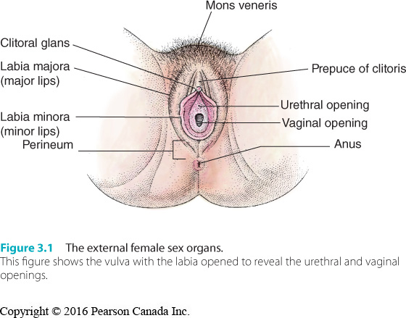

External Sex Organs

• Mons Veneris
– Fatty tissue covering the pubic bone
– Also known as the mons pubis or mons.
– At puberty becomes covered with pubic hair.
– Cushions a woman’s body during sexual intercourse.

• Labia Majora
– Large folds of skin that run downward from the mons along the sides of the vulva.
– Shields the labia minora and the urethral and vaginal openings.
– Outer surfaces covered with pubic hair.

• Labia Minora
– Hairless, light-coloured membranes located between labia majora.
– Surround the urethral and vaginal openings.
– Outer surfaces of the labia minora merge with the major lips.
– At the top they join at the prepuce (hood) of the clitoris.

• Clitoris
– Female sex organ most sensitive to sexual stimulation.
– Consists of a ________ and ___________.
– Body, termed the clitoral shaft, is about 2.5 cm long and 0.5 cm wide – Consists of
erectile tissue which stiffens when aroused.
– Corpora cavernosa
• Definition: masses of spongy tissue in the clitoral shaft that become engorged with blood and stiffen in repose to sexual stimulation

– Prepuce
• Definition: the fold of skin covering the glands of the clitoris (or penis is male)

– Clitoral glans is a smooth, round knob or lump of tissue.
– Situated about the urethral opening.
– Highly sensitive to touch.
– Homologous to the penis.
• Similar in structure.
• Developing from the same embryonic tissues.

– Not analogous to the penis.
• Not similar in function.

A World of Diversity

• Pubic hair removal
– Historical evidence of women in ancient cultures who practised pubic hair removal.

• Study of 2400 women under age 50 found that the majority practised some form of pubic
hair removal (2010).

• Study of men found that 82% of gay and 66% of heterosexual men removed some pubic hair
(2008).

• Female Genital Mutilation
– Clitoridectomy
• Surgical removal of the clitoris.
– Rite of initiation into womanhood in many predominantly Islamic cultures.
– Often performed as a puberty ritual in late childhood or early adolescence.
– The typical young woman does not see herself as a victim.

External Sex Organs

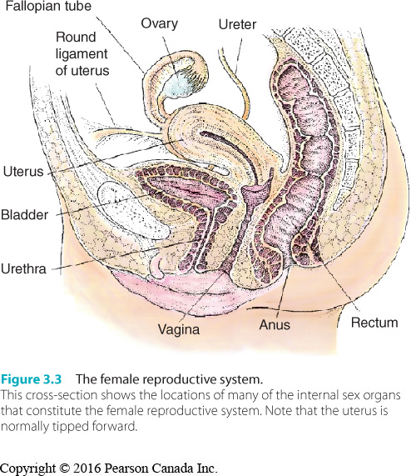

External Sex Organs Continued

• Vestibule
– Area within the labia minora.
– Contains openings to vagina and the urethra.

• Urethral Opening
– The opening through which urine passes from the female body.
– May become infected from bacteria (cystitis).

• Vaginal Opening
– Also known as the introitus
– Hymen
• Fold of tissue across vaginal opening.
• Usually present at birth.
• Various types of hymens.

• Vaginal Opening
– Perineum
• Skin and tissue that lies between vaginal opening and the anus.
• Rich in nerve endings.

– Episiotomy
• Surgical incision in the perineum that may be made during childbirth.
• Protects the vagina from tearing.

• Structures that Underlie External Sex Organs
– Sphincters
• Ring-shaped muscles that constrict body openings.

– Crura
• Attach clitoris to the pubic bone.

– Vestibular bulbs
• Cavernous structures that extend downward along the sides of the introitus
and swell during sexual arousal.

– Bartholin’s glands
• Glands that lie just inside the minor lips and secrete fluid just before orgasm.

– Pubococcygeal muscle
• The muscle that encircles the entrance to the vagina.
• Repeatedly contracting and relaxing this muscle (called kegels) is
sometimes recommended.

Internal Sex Organs
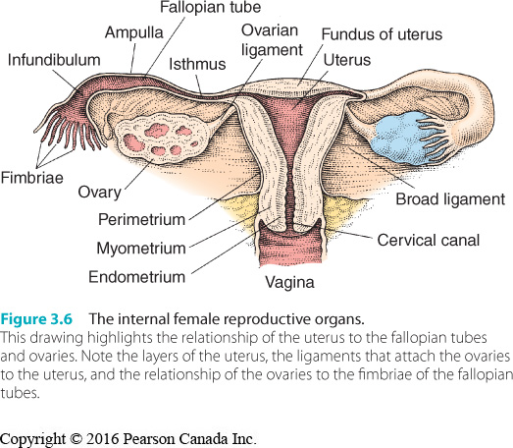

Internal Sex Organs

• Vagina
– The tubular female sex organ that contains the penis during sexual intercourse and
through which a baby is born.
– Extends back and upward from vaginal opening.
– Vaginal walls have three layers – Inner two-thirds of vagina insensitive to touch.
– Vaginal walls secrete substances that help maintain the vagina’s normal acidity.
– Vaginitis refers to any vaginal inflammation.
• Infection, birth control pills, antibiotics, allergic reaction, chemical irritation,
lowered resistance due to fatigue or poor diet.
• Changes in body chemistry or lowered resistance may permit normal micro-
organisms to multiply to dangerous levels.

• The G Spot and Female Ejaculation
– The Grafenberg spot is theorized to be a part of the vagina—a bean-shaped area in the
anterior (front) wall.
– It is believed to lie about 2.5–5 cm from the vaginal entrance and to consist of a soft
mass of tissue that swells from the size of a dime to a loonie when stimulated.
– Stimulation may lead to female ejaculation.
– Some researchers challenge its existence.
– It is commonly agreed that:
• The anterior wall of the vagina has many nerve endings and may be sensitive
to stimulation.
• Many women may exude fluid through the urethra at the time of orgasm.

The G-Spot

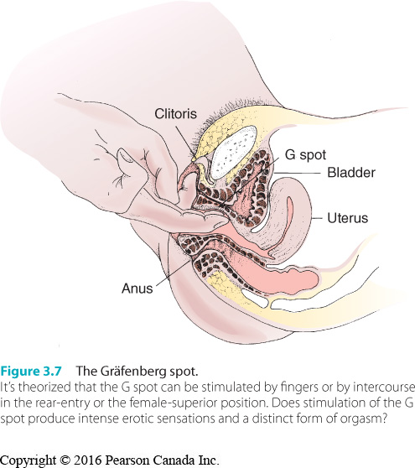

Internal Sex Organs

• Cervix
– Lower end of the uterus.
– Contributes to the chemical balance of the vagina.
– the os is the opening in the middle of the cervix.
– Cervical cancer
• Incidence has declined since 1970s because women get regular Pap tests.
• Greatest risk factor is HPV infection.
– Vaccine against HPV has been approved by Canadian government.
– If detected early, most cases can be treated.
• If sexually active, women should get Pap test every one to three years.

• Uterus
– Hollow, muscular, pear-shaped organ in which a fertilized ovum implants and
develops until birth.
– Ovum
• Egg cell.

– Endometrium
• The innermost layer of the uterus.

– Endometriosis
• A condition in which endometrial tissues may also grow in the abdominal
cavity or elsewhere in the reproductive system.
• Most common symptom is menstrual pain.
• Left untreated, it can lead to infertility.

– Uterine/Endometrial Cancer
• 4600 new cases of uterine cancer were diagnosed in Canada in 2013.
• One of the most common forms is cancer of the endometrial lining.
• Risk factors are high exposure to estrogen, late menopause, estrogen
replacement therapy, obesity, a high-fat diet, and diabetes.
• Symptomized by abnormal uterine staining or bleeding.

– Hysterectomy
• Surgical removal of the uterus.
• May be performed when women develop cancer of the uterus, ovaries or
cervix.
• Complete hysterectomy involves removal of ovaries, fallopian tubes, cervix and
uterus.
• Partial hysterectomy removes uterus, but not ovaries and fallopian tubes.
• Some women report sexual difficulties post surgery.

• Fallopian Tubes
– Uterine tubes 10 cm in length.
– Extend from upper uterus toward ovaries.
– Passageway for the ova to the uterus, providing nourishment along the way.
– Ectopic pregnancy
• Fertilized ovum implants outside the uterus, usually in the fallopian tube.

• Ovaries
– Two almond shaped organs, 4 cm long.
– Lie on ether side of the uterus, attached by ligaments.
– Produce ova, estrogen, and progesterone.
– Estrogen
• Generic term for female sex hormones.
• Promotes female sex characteristics.
• Regulates menstrual cycle.
– Progesterone
• Secreted by the corpus luteum.
• Steroid hormone that stimulates proliferation of the endometrium.
• Regulates menstrual cycle.

– Follicle
• Capsule within an ovary that contains an ovum.

– Ovarian cancer
• 2600 cases of ovarian cancer in 2013; 1700 deaths.
• Strikes women between the ages of 40 and 70.
• 4th leading cancer killer of women.
• Early detection is key, but often there are no signs or symptoms.
• Surgery, radiation therapy and drug therapy are treatment options.

• The Pelvic Examination
– Woman examined externally for irritations, swellings, abnormal discharges, and
clitoral adhesions.
– Speculum inserted to view cervix and vaginal walls.
– Sample of cells taken from cervix with a wooden spatula (Pap test).
– Bimanual vaginal exam to examine internal sex organs Internal Sex Organs.

Pelvic Examination

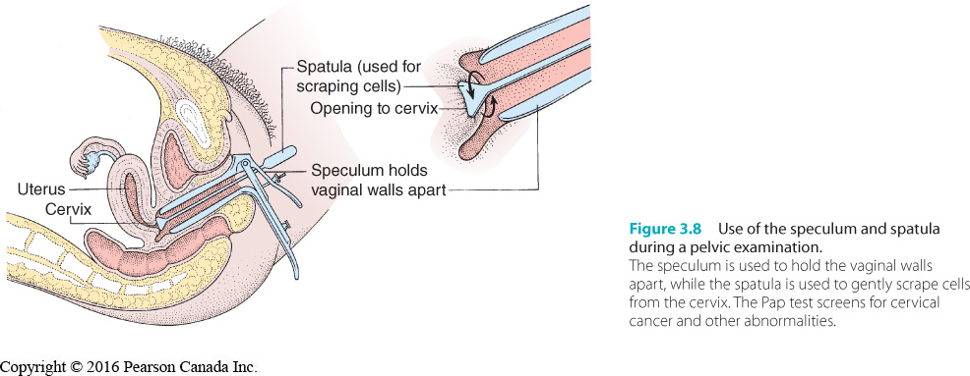

The Female Breasts
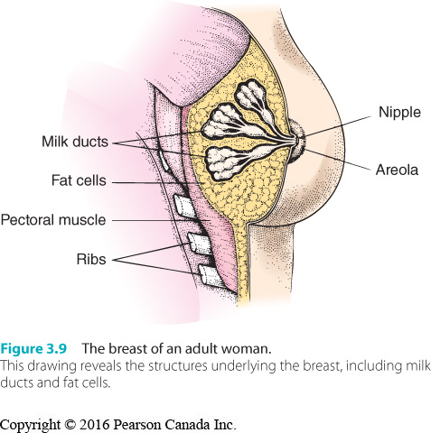

The Female Breasts

• Secondary Sex Characteristics
– Traits that distinguish women from men
– Not directly involved in with reproduction

• Mammary Glands
– Each breast contains 15 to 20 milk-producing glands.
– Little variation between women in terms of glandular tissue.
–breast size does not determine the amount of milk produced.

• Areola
– Dark ring that encircles the nipple.
– Darkens during pregnancy and remains darker after delivery.

• Breast Cancer
– Most commonly diagnosed cancer in women and second-leading cause of cancer-
related death.
– 23,800 new cases in Canada in 2013; 5000 deaths.
– High survival rate if cancer has not spread.
– Risk factors
• Family history.
• Genetics (inherited BRCA1 and BRCA2 mutations).
• Higher breast density.
• Increased lifetime exposure to estrogen: First menstrual period before the age
of 12, menopause after age 55, delayed childbearing, and never having
children.
• Long-term use of hormone therapy.

– Detection and treatment
• Cysts: Sac-like structures filled with fluid or diseased material.
• Benign tumours: Doing little or no harm.
• Malignant: Cancerous breast lumps.
• Mammography allows the detection and treatment of tiny, highly curable
cancers before they can be felt by touch.

– Can be detected by self-examination, physical examination, mammography, MRI.
– Practice of breast self-exam is controversial.
– may not benefit women.

– Lumpectomy
• Surgical removal of a lump from the breast.

– Mastectomy
• Surgical removal of all or part of a breast.

The Menstrual Cycle

• Menstruation
– Cyclical bleeding that stems from the shedding of endometrium.
– Human menstrual cycle averages 28 days in length.

• Ovulation
– second phase of the cycle.
– Release of an ovum from an ovary.

• Secretory or Luteal Phase is the third phase of the menstrual cycle, right after ovulation.

• Corpus luteum
– Follicle that releases the ovum.
– Functions as an endocrine gland.
– Endocrine gland
• Ductless gland that secretes directly into the blood stream.

• Menarche
– Definition: the first menstrual period

• Variations in menstrual cycle are common.

• Psychological factors can influence secretion or hormones, impacting menstrual cycle.

• Regulation of the Menstrual Cycle
– hypothalamus
• Regulates body temperature, motivation, and emotion.

– pituitary gland
• Secretes growth hormone, prolactin, oxytocin.

– hormone
• A substance secreted by an endocrine gland to regulate body functions.

• Phases of the Menstrual Cycle
– proliferative phase
• Begins with the end of menstruation and lasts for 9 to 10 days.
• Endometrium proliferates.

– ovulation phase
• A follicle ruptures and releases a mature ovum.

– secretory phase
• Corpus luteum secretes large amounts of progesterone and estrogen following
Ovulation.

– menstrual phase
• Endometrium is sloughed off.
• Tampon
–Cylindrical plug of cotton inserted into the vagina to absorb menstrual
fluid.

• Toxic Shock Syndrome (TSS)
–Caused when bacteria overbreed when highly absorbent tampons are
left in place for many hours.

• Sex During Menstruation
– There is no evidence that coitus during menstruation is harmful.
– Orgasm may help to relieve cramping.
– Desire for sex has been found to peak around the time of ovulation.
– Human coital patterns seem to reflect personal decisions, not hormone fluctuations.

• Menopause
– Cessation of menstruation.
– Perimenopause is the beginning of menopause, 3 to 11 months of amenorrhea.
– Climacteric
• Gradual decline in the reproductive capacity of the ovaries.

– Deficit of estrogen may lead to a number of unpleasant symptoms.
– Hormone Replacement Therapy (HRT)
• Synthetic equivalents of estrogen and/or progesterone.
• In 2002, controversy over HRT erupted in Canada because of increase in
incidence of breast cancer in women taking HRT.
• Now HRT is recommended only for short-term use in women with severe
symptoms.
• Alternatives are available.

Menstrual Difficulties

• Dysmenorrhea
– Definition: pain or discomfort during menstruation
• Primary dysmenorrhea: menstrual pain or discomfort that occurs in the nascence of known organic problems. or secondary dysmenorrhea.
• Prostaglandin
–Hormones that cause the muscle fibres in the uterine walls to contract –
result in menstrual cramps.

• Mastalgia –Swelling of breasts causing premenstrual discomfort.

• Amenorrhea
– Definition: absence of menstruation
• Primary amenorrhea: absence in menstruation in women that have never menstruated
• Secondary amenorrhea

– Caused by abnormalities in structures of the reproductive system, hormonal
abnormalities, growths, psychological problems (stress), and anorexia.

• Premenstrual Syndrome (PMS)
– Combination of physical and psychological symptoms that may affect a woman during
a four- to six-day interval that precedes menses.
– Most often involves mild to moderate discomfort.
– Options to reduce effects include exercise, dietary control, hormone treatments, and
other medications.

A World of Diversity

• Historical and cross-cultural perspectives on menstruation: beliefs vary between cultures.

• Limited understanding by ancient (and some contemporary) societies of bodily processes.

• Myth of being unclean causes anxiety, depression, and lowered self-esteem.

Applied Knowledge

• How to Handle Menstrual Discomfort
– Not due to a “hysterical” nature.
– Keep a menstrual calendar.
– Develop strategies for dealing with distress.
– Ask yourself whether you harbour any self-defeating attitudes toward menstruation.
– See a doctor about your concerns.
– Develop nutritious eating habits.
– Eat several small meals throughout the day.
– Some women find vigorous exercise helpful.
– Check with your doctor about vitamin and mineral supplements.
– Ibuprofen and other medicines may be helpful for cramping.
– Prescription medications and oral contraceptions may help.

Male Anatomy and Physiology

• Phallic symbols
– Images of the penis that are usually suggestive of generative power.

• Testes (testicles)
– Definition: the male sex glands, suspended in the scrotum.
– Produce sperm cells and male hormone.
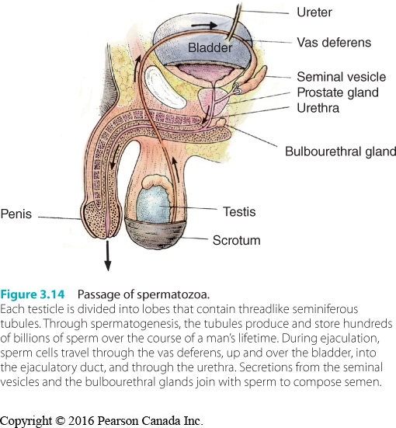

External Sex Organs

• Penis
– Male organ of sexual intercourse.
– Conduit for urine.
– Contains no bones or muscles
– Corpora cavernosa
• Definition: two cylinders of spongy tissue in the penis that become congested with blood and stiffen during sexual arousal

- Corpus spongiosum
- Definition: the spongy body that runs along the bottom of the penis
• Contains the urethra.
• Enlarges at the tip of the penis to form the glans.

– Corona
• Definition: the ridge that separates the glans from the body of the penis

– Frenulum
• Definition: the sensitive strip of tissue that connects the underside of penile glands to the penis

– Root
• Definition: the base of the penis that extends into the pelvis

– Shaft
• Definition: the body of the penis
• Expands as a result of vasocongestion.

– Foreskin (prepuce)
• Definition: the loose skin that covers the penile glands in a uncircumcised male.

– Circumcision
• Surgical removal of the foreskin of the penis.
• About 17% of Canadian male babies are circumcised.
• 1996 report of the Canadian Paediatric Society concluded that the procedure is
is not medically necessary and is not recommended
• Lessens the risk of HPV, HIV, prostate cancer, genital herpes.
• Montreal-based lobby group seeks to ban circumcision.

– Phimosis
• An abnormal condition in which the foreskin is so tight that it cannot be
withdrawn from the glans.

– Penis size
• Most women report preference for average or slightly larger than average size. • Average flaccid penis 9 to 10 cm; erect 14 to 16 cm.

• Scrotum
– Definition: the pouch of loose skin that contains the testes.
– Spermatic cord
• Cord that suspends the testicle within the scrotum and contains the vas
deferens, blood vessels, nerves, and cremaster muscle.

– Vas deferens
• Definition: a tube that conducts sperm from the testicle to the ejaculatory duct of the penis.

– Cremaster muscle
• Definition: the muscle that raises and lowers the testicle in response to tempature change and sexual stimulation

Internal Sex Organs

• The Testes
– Male sex glands, suspended in the scrotum.
– Secrete sex hormones (androgens) and produce mature germ cells.
• A cell from which a new organism develops.
• Germ cells produced by the testes are called sperm.

– Testosterone
• Most important androgen.
• Stimulates prenatal differentiation of male sex organs.

– Testes usually range between 2.5 and 4.5 cm in length.
- The left testicle usually hangs lower.

– Sperm
• Seminiferous tubules
– Definition: a tiny winding sperm-producing tube located within the lobe of the testis,

• Spermatogenesis
– Definition: the process by which sperm cells are produced and developed

• Takes 72 days for testes to manufacture a mature sperm cell.
• Each sperm cell is 0.0005 cm long.
• Epididymis
–Where seminiferous tubules converge.
–Tube that lies against the back wall of each testicle.
–Storage facility for sperm.

• Vas Deferentia
– Each epididymis empties into a vas deferens.
– This cylindrical tube is about 40 cm long.
– Severed in a vasectomy
• Sterilization procedure

• Seminal Vesicles
– Small glands 5 cm long.
– Lie behind bladder and open into ejaculatory ducts.
– Secrete fluids that combine with sperm.
– Ejaculatory duct
• Duct formed by the convergence of a vas deferens with a seminal vesicle.

• Is there a male menopause? Not certain.
– Also known as andropause.
– Men experience gradual declines in testosterone as they age (after age 30).
– Drop may be connected to a variety of age-related symptoms.
– Some experts believe that testosterone replacement can help avert problems.

• Prostate Gland
– Lies beneath bladder, approximately the size and shape of a chestnut.
– Contains muscle fibres and glandular issue that secretes prostatic fluid.
– Gives semen its characteristic odour and texture.
– Stimulation can heighten arousal and pleasure.
– Alkalinity neutralizes some of the acidity of the vaginal tract.

• Cowper’s Glands
– Lie below the prostate.
– Empty their secretions into the urethra during sexual arousal.
– Function of the fluid is not entirely understood.

• Semen
– Whitish fluid that constitutes the ejaculate.
– Consists of sperm and secretions from the seminal vesicles, prostate gland, and
Cowper’s glands.
– Contains water, mucus, sugar, acids and bases.
– Typical ejaculate contains 200 to 400 million sperm cells and ranges from 3 to 5 mL in
volume.

Diseases of the Urogenital System

• Urologist
– A physician who specializes in the diagnosis and treatment of diseases of the
urogenital system.

• Urethritis
– Inflammation of the bladder or urethra
• Frequent urination, a strong need to urinate, burning during urination, and a
penile discharge.

• Testicular Cancer
– 960 diagnosed cases in 2013; 29 deaths (Canada).
– Cryptorchidism
• A condition in which at least one of the testicles fail to descend from the
abdomen into the scrotum.
• Individuals with this condition in childhood have 40 times greater chance of
contracting testicular cancer.

Applied Knowledge

• Self-Examination of the Testes
– Best performed after a warm shower or bath.
– Roll each testicle between thumb and fingers.
– Watch for these signs:
• A slight enlargement of one of the testicles.
• A change in the consistency of a testicle.
• A dull ache in the lower abdomen or groin.
• Sensation of dragging and heaviness in a testicle.
• A lump on the testicle.

Diseases of the Urogenital System

• Prostate Disorders
– Benign prostatic hyperplasia
• Enlargement of the prostate gland due to hormonal changes associated with
aging.

– Cancer of the prostate
• 1 in 7 Canadian men will this develop in their lifetimes.
• 24 600 men were diagnosed with prostate cancer in 2010.
• Risk factors include age, family history, mutations in BRCA1 and BRCA2, and
ethnicity.
• Test involves a finger in the rectum followed by blood tests.
• PSA blood test used for screening.
• Most common treatment is surgical removal of the prostate gland.
• This surgery may lead to problems with urinary and sexual functioning.
• Other treatments include radiation, hormone treatment, anticancer drugs.
• Some doctors recommend “watchful waiting”– many men die from other causes rather than prostate cancer.

– Prostatitis
• Inflammation of the prostate gland.
• Usually treated with antibiotics.

Male Sexual Functions

• Erection
– Enlargement and stiffening of the penis as a consequence of its engorgement with
blood.
– In 10 to 15 seconds, the penis can double in length, become firm, and shift from a
funnel for passing urine to one that expels semen.
– Loss of erection occurs when sexual stimulation ceases or when the body returns to a
(sexual) resting state after orgasm.
– Loss of erection can also occur in response to anxiety or perceived threats.
– Performance Anxiety
• Dread and foreboding experienced in connection with sexual activity (or any
other activity which might be judged by another person).

– Men have nocturnal erections every 90 min or so as they sleep.

• Spinal Reflex and Sexual Response
– Regardless of the source of stimulation, men’s sexual responses occur by reflex.
– Reflexes governing erection and ejaculation are controlled by the spinal cord.
– Sacrum
• Thick, triangular bone near the bottom of the spinal column.

• Role of the Brain
– Sexual sensations are related to the brain from the spinal cord.
– The sight of one’s partner, erotic fantasies, memories, can result in maintaining or
strengthening the erection.
– The brain can also stifle sexual response.
– Erectile reflex is easily tripped in adolescents.

• Role of the Autonomic Nervous System
– The division of the nervous system which regulates automatic body processes.
– Sympathetic
• Controls most active during emotional responses that draw in the bodies reserves of energy such as fear and anxiety. Also largely controls ejaculation

– Parasympathetic
• Controls restores the bodies reserves of energy such as digestion. Largely controls erections

– Rapid (premature) ejaculation
• A sexual dysfunction in which the male ejaculates too early to afford the
couple adequate sexual gratification.

• Erectile Abnormalities
– Peyronie’s disease
• An abnormal condition characterized by excessive ___________ of the penis.
– Priapism
• Persistent and painful erection of the penis.

• Ejaculation
– Orgasm
• The climax of sexual excitement.
• Sudden muscle contractions which result in abrupt release of sexual tension.
• Accompanied by subjective sensations which are generally pleasurable.

– Usually occurs with orgasm, but not synonymous.
– Occurs in two stages
• emission stage
– Contractions of the prostate gland, seminal vesicles, upper part of vas
deferens (ampulla).
– Force propels seminal fluid into the prostatic part of the urethral tract.
– At this point, male experiences “ejaculatory inevitability”.

• expulsion stage
– Propulsion of the seminal fluid through the urethra and out of the
urethral opening (30 cm+).
– Muscles contract rhythmically (0.8 second intervals).
– Accompanied by highly pleasurable sensations of orgasm.

• Retrograde Ejaculation
– Ejaculate empties into the bladder
– Usually harmless, but can result in infertility.
– May be some changes in sensation associated with orgasm.

