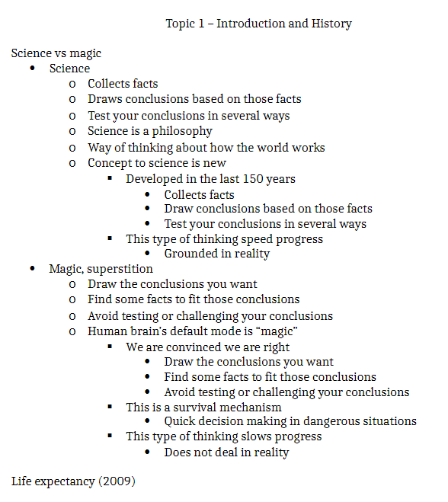

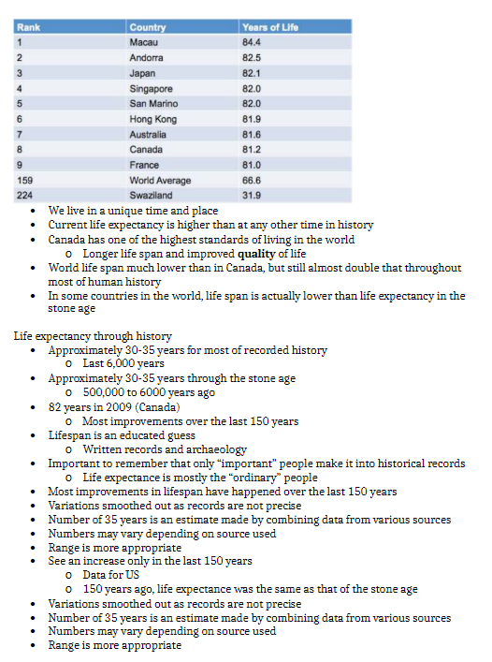

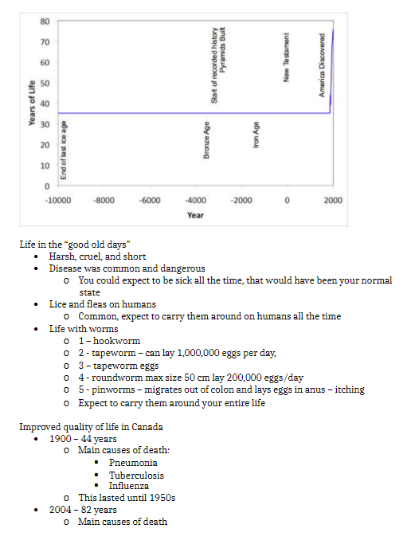

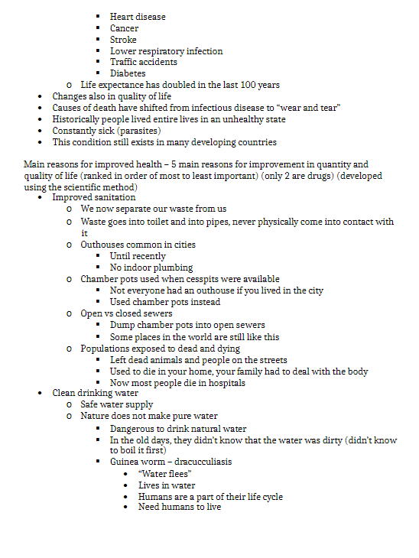

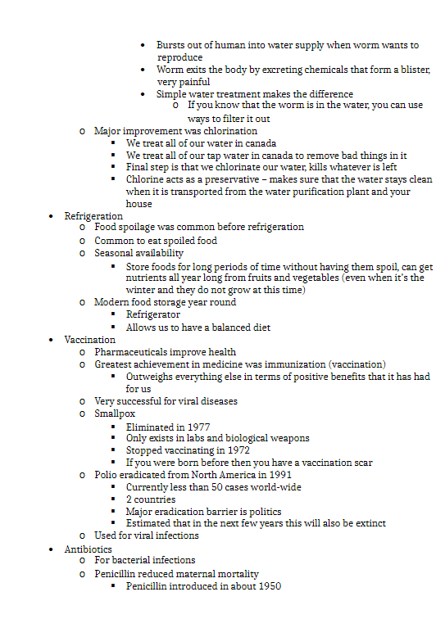

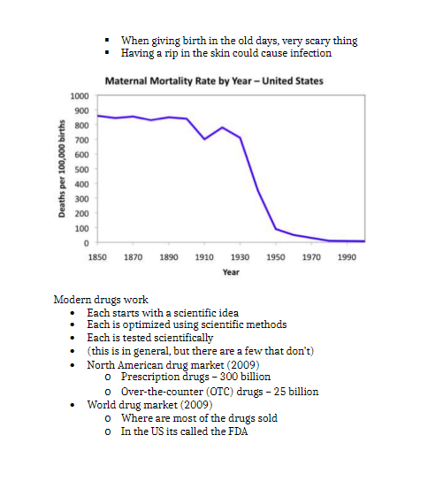

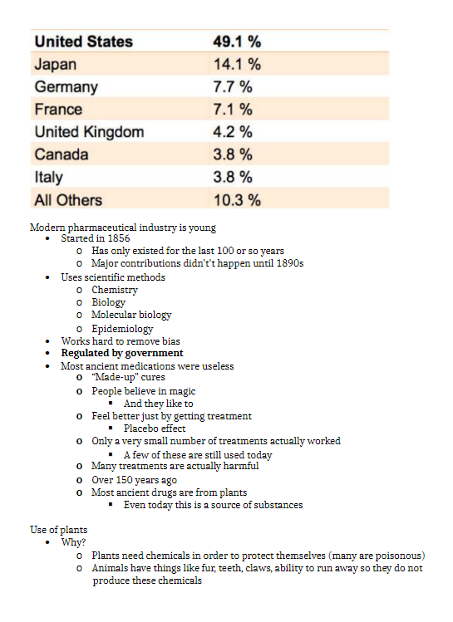

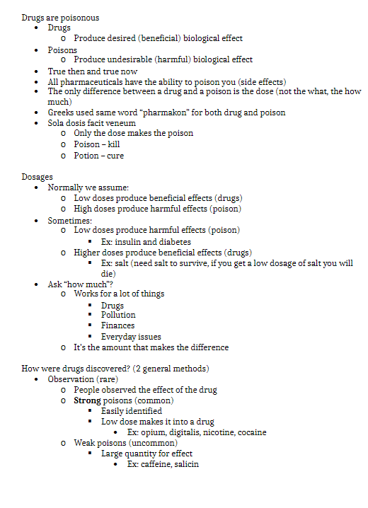

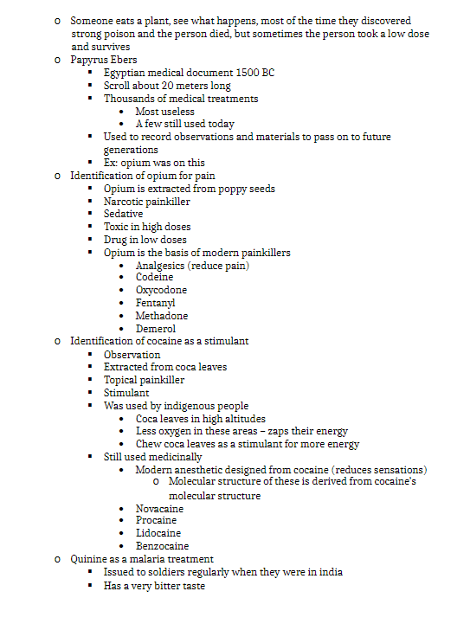

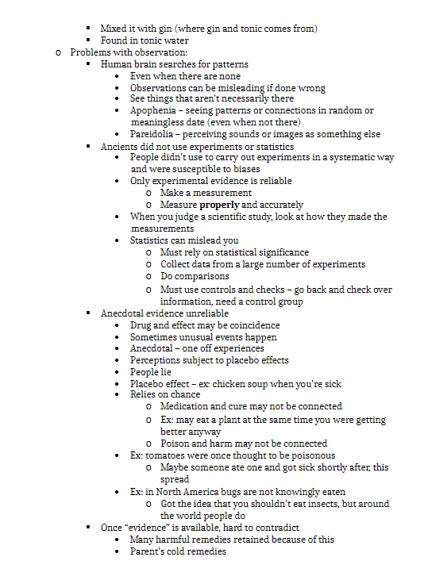

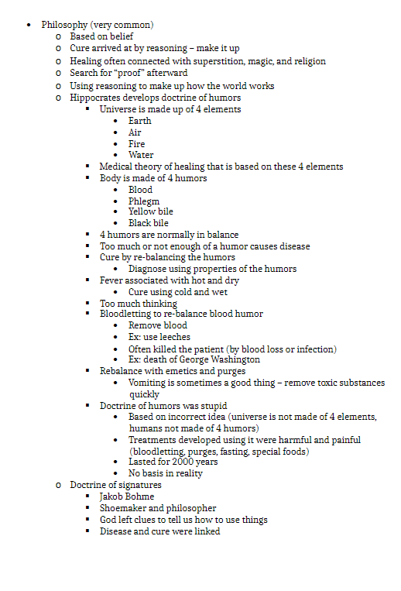

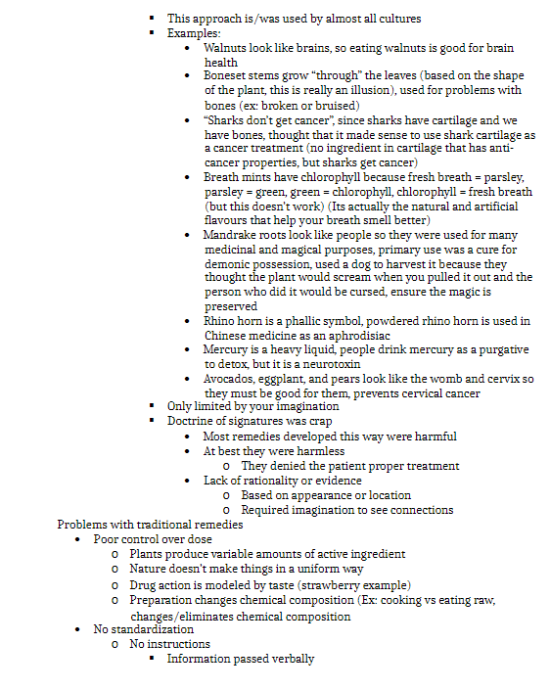

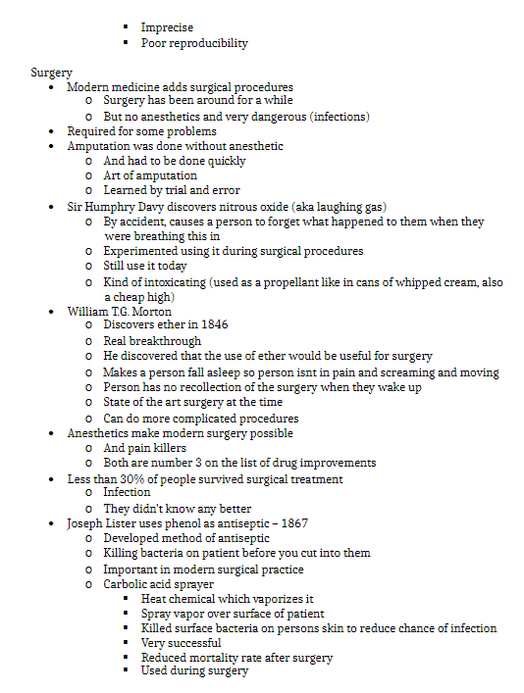

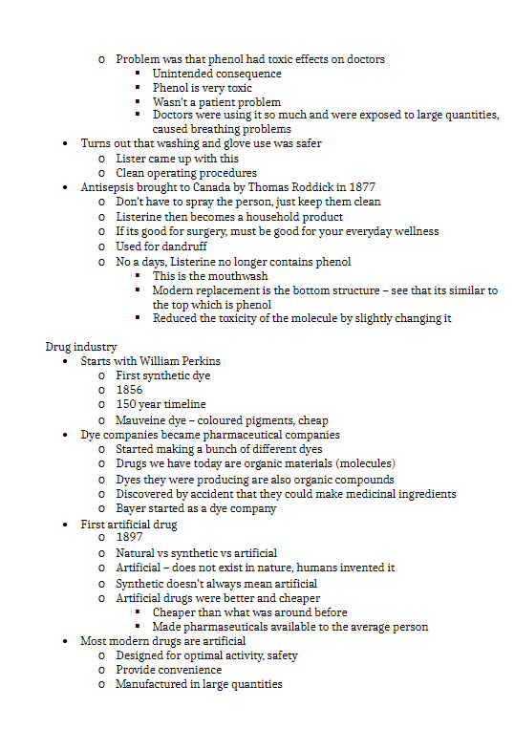

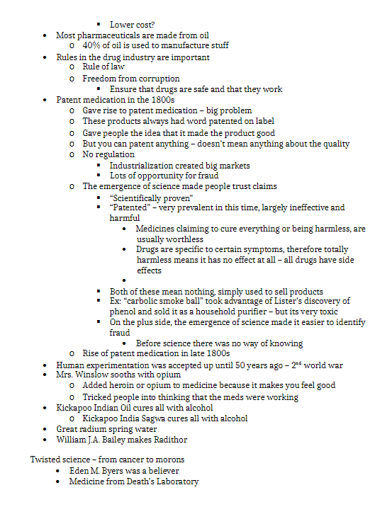

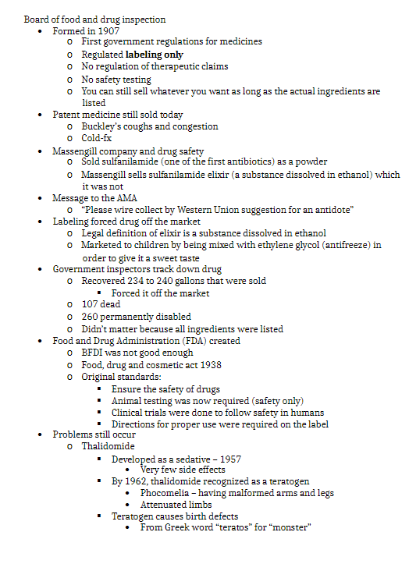

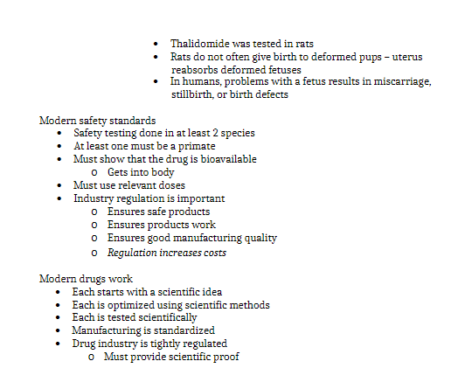

- Problems with observation
  - Humans don’t perceive world correctly all the time
  - If incomplete info, brains fills up info
  - Searches for patterns
  - If get little better after treatment, become convinced that it is ac working
  - Apohenia
    - Even scientists vulnerable
  - Pareidolia
    - Face on mars?
- Anecdotal evidence = misleading
  - One event DNE ac evidence
  - Relies on chance
  - Only experimental evidence is reliable
  - Must rely on statistical sig
    - Collect data from many experiments
      - Experimenting with drugs
      - Emphasis on stats = dangerous
- Traditional remedies
  - There is variability in natural products
    - Ripeness, health, where was made
- Preparation changes
  - How prepare drug has diff impact
  - Change molecular struc of food when you cook it
    - Can destroy active ingredient of plant if prepare wrong
- No standardization
  - Ppl didn’t read
  - All info passed verbally
- Difficult to correct info
  - Hard to correct info that has already speread
  - Tomatoes thought to be poisonous
  - Have mistaken impression that bugs are not to be eaten
- Philosophy to identify cures
- Hippocrates humors
  - Base on idea that earth based on 4 elements
  - If universe made of 4 things, pl ,made of 4 things
  - Humors supposed to be in balance
  - Out of balance if sick, if can find which humor is unbalanced, treat and get cured
  - Fever counteract with cold and wet
  - WRONG
- Bloodletting
  - Remove blood to restore balance
    - Location you remove also impacts?
    - Shape of cut?
  - Cut to get the blood als made susceptible to infection
  - Washington died bc took too much blood, got infection
- Rebalance with emetic
  - Can be good
    - If ate posion
- Humors is stupid
  - Not made of 4 things
- Doc of signatures
  - God left clues on earth to tell how to reat diseases
  - Walnut look like brain, good for it
  - Sharks don’t get cancer
  - Mints
    - Farmers chewed parsley to get rid of bad breath
      - Parsley = green=chlorophyll=good for breath
    - See dumb logic about chlor
  - Mercusry is heavy liquid
    - Float through system, take out all toxins
- Doc of sig is dumb
- Some probs require surgery
  - Need to physically make change to body (drugs don’t work)
- Nitrous oxide
  - Laughing gas
  - In aerosol (used as cheap high)
  - Ether
    - Left you unconscious
- Less than 30% survived surgery
  - Shock, infection
- Phenol as antiseptic
  - Joseph relaized bacteria caused disease
  - Carbolic acid sprayer filled with posion, sprays phenol over patient
  - Killed all bacteria on surface of skin and inside wound
  - TOXIC
  - Doctors exposed to a lot (compared to patients)
    - Made washing stations
    - Used gloves
    - Hospital gowns
- Perkin dye
  - Use coal to make dye
  - Colouring clothes was very expensive
  - Those fruits and veggies used were scarce
  - Dye companies becae pharma
  - Drugs were all made from coal
- First artificial drug
  - Aspirin
  - Artificial materials work better than natural
  - Nature makes things for itself
  - Poisonous plants make posion to defend sleves
  - Can make in large qty
    - Bc most made from oil
- Genetically engine drigs
  - Good for making proteins (insulin?)
- Rules are important
  - Before 1907
  - Anybpdy could make sell drugs
  - 1800s
  - Patent meds
    - Ppl think patent = quality
    - Just legal docu that prevents someone from remaking your prod
    - Word put on lots of fake meds
  - Kickapoo
    - No side effects = no medicinal effect
    - had coke, alcohol, hard drugs
      - gave you a buzz, so ppl thought was working
  - radthitor
    - radiation kill cancer, ppl though radiation good fro you
- board of food and drug inspection
  - 1907
  - Rules were slack
  - Only cared that you labeled ingredients
  - No need fro safety
- Massengill
  - Sulfanilamide
  - Taste nasty. Make elixir
  - Ethylene glycol used to disso.ve it (bc water did not)
  - Company kept selling product even though they knew was dangerous
    - No law to prevent, they wre in no wrong
    - Got off market bc called elixir
      - Elixir is dissolved in ethanol
        - Got off mkt bc technicality. Not bc pl dying
- FDA created
- Thalidomide
  - Sedative fro pregnant woman
  - Kids had deformities
  - Phocomelia
    - Latin word fro seal
  - Teratogen = substance that cause defect
    - Greek word teratos fro monster
    - Tested on rats
    - Uterus of rat detect deform, digests it
      - Chose wrong animal
  - Safety testing now done on 2 species
    - One must be a primate
    - If bioavailable
      - Make sure drug in blood
      - Use proper doses
  - Industry reg is impotant
    - Regulation increases cost
  - Modern drugs work

