Chandler:

His claim applies more for technologically advanced, capital intensive industries (For big companies)
Successful companies:
- Has economy of scale (The cost of producing one good reduces because of the large quantity that produce from that good),
- economy of scope (using the same raw material to produces related or similar goods),
Materials flow must be constant to assure the economies of scale and scope. Also, proper Marketing and distribution channels must be implemented in order to expand geographically (characteristic of economy of scale)
Size alone is not enough to exploit of the advantage of economies of scale and scope.
- create managerial structure,
Lower managers and head managers.
- grow from related diversification (The company buys or create others companies that commercialize similar or related goods).
Managerial hierarchy is necessary for 3). Also, for related diversification since experience in different fields is required. Managers (middle and lower) coordinate the production and high managers monitor the operation and future actions.
- And invest in Research and development (R and D),
First Movers: Have comparative advantage and dominate the market because they make in investment in R and D, in hiring managers, in growing.
The opportunity to make the first move is limited. If you lose the opportunity it is hard to regain competitive advantage after.

Poor growth strategies:
Growing throw Unrelated Diversification
This is a poor strategy because it doesn’t follow the logic of managerial enterprise. The managers don’t have experience in the field of an unrelated business

Companies still do it because:

Stock Market Pressure: The company has pressure from the investors. When the company buy new asset the shares of that company grows and investors are happy
Short Term thinking: Company things only in short run results and ignores the long run consequences. This happens also to make investors happy.

Greiner:

Organization Growth is characterized of phases of evolution and revolution. This depends on the age and sizes of the organization.
- Organization age:
Organization politics are not the same through the lifetime of the organization.
Behavior of employees become predictable and hard to change.
- Organization Size:
Problems change when there are more employees and more sales.
If the company doesn’t get larger, they keep the same management problems over the time.
Growth of rate: The industry growth tells us how fast the company will go through the phases.
Fast growing industries will have shorter evolution periods and slow growing ones will have larger ones.
Evolution= Prolonged growth periods
Revolution= Crisis Periods .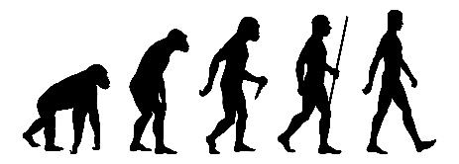
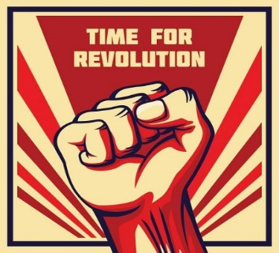
The managerial practices that make the company growth until this period, No longer work.
Managers need to think in the new set of practices that will take the company to the new evolutionary period and take them out of the revolution. Also, this solution will be updated when the new revolutionary period arrives.
A company can decide to stay small since Growth is no inevitable.
Managers that are not functional anymore should remove themselves (EJ: Elon Musk in Tesla.)

Phases of growth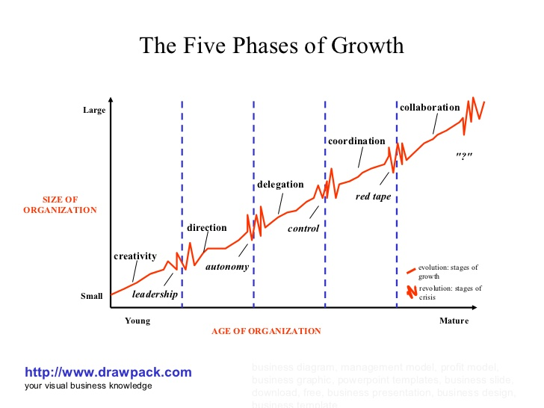1) CREATIVITY (Evolution): Entrepreneur work long ours with lower salaries expecting to earn more in the future. They have an informal communication. The company is in a stage of creation. (product and market). Decision based on costumer reactions.
LEADERSHIP (Revolution): More production requires more knowledge. More employees require Formal communication. Owners have way too many responsibilities.
SOLUTION: Higher a New Manager. Create new products. New Business techniques.

2)DIRECTION (Evolution): Company takes a structure with small departments. There are specialized task or jobs. Lower managers or supervisors don’t affect any more in the decision taking. Formal Communication. They use accounting systems and work standards.
AUTONOMY (Revolution): Employees feel limited. They start knowing more about the business than managers. Managers lose control over employees and/or employees start leaving the company
SOLUTION: Start to delegate.
3)DELEGATION (Evolution): More managers with more responsibilities. Bonuses and incentives are applied. Top managers don’t manage often and they direct the company through reports. The company is focus in acquisitions.
CONTROL (Revolution): Lose of coordination because of the diversify operations. The lower managers don’t pay much attention to top managers. Top Managers want the control back.
SOLUTION: Coordination techniques.
4)COORDINATION(Evolution): Formal planning procedures are put in action. New staff members to control the procedures. Data operation is centralized. Managers need to justify their actions to the board.
REDTAPE(Revolution): Company is too large to be controlled through rigid structures. Problems with the managers, employees and the board of executives. (The board doesn’t have trust in others). TOO bureaucratic.

5)COLLABORATION(Evolution): Formal system simplified. Problem solving through TEAM WORK. Educational programs to educate the teams.

POSSIBLE PHASE 6) EXTRA-ORGANIZATIONAL:
The company can’t grow any more by looking into internal solutions. They must look for external possibilities like partnering with a company, selling itself to a larger company, outsourcing etc.
Organization Can’t skip a phase.

Barney:
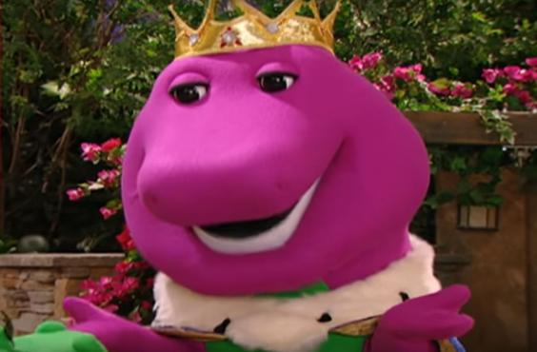

How companies gain sustainable competitive advantage?
Depends on the unique resources and capabilities that the company has.
PLUS the environmental factors.
Resources categories:
Financial: Retain earnings, debt, equity
Physical: Machines, buildings.
Human: The working culture of the people’s company. They behavior too.
Organizational: Managerial mechanism or procedures.

VRIO Analysis:
Question Of Value: The resources has value in the short run if they help take advantage of opportunities and eliminate external threats.
If an old resource turns out not valuable in the future it could be valuable for something else.
Question Of Rareness: Is this resource unique? Or it is a common resource in the market?
Question Of Imitability: Can this resource be copied easily?
Duplication: The competitor creates the same resource.
Substitution: The competitor creates a similar resource or substitute it for something else.
If it is not easy to copy is because:
-History: The company went through different situations in the past that enable it to be the big it is right now or to develop special skills. New companies didn’t have that opportunity so it is impossible for young companies to have the same opportunity.
-Numerous small decisions: Small decisions have a big impact in companies. However, Small decisions aren’t normally analyzed so it is hard to know exactly what are them. As a result, other companies can’t copy because they don’t know them or don’t pay attention to them. Big decisions are easier to imitate.
-Socially complex: The culture and marked behaviors of people working in the company. It is hard for a company to make its employees behave in a certain way.
Question of Organization: The company needs a good organizational basis in order to exploit the resource’s full advantage.
Then… If the company has a resource that it is:
- NOT VALUABLE.
COMPETITIVE DISAVANTAGE.
- ONLY VALUABLE
COMPETITIVE EQUALITY.
- VALUABLE, RARE
COMPETITIVE ADVANTAGE
- VALUABLE, RARE,
TEMPORARY COMPETITIVE ADVANTAGE
- VALUABLE, RARE, COSTLY TO IMITATE:
SUSTAINED COMPETITIVE ADVANTAGE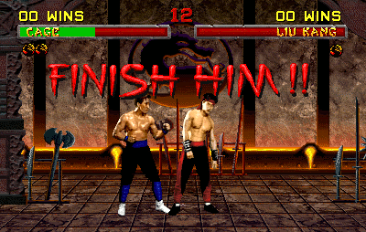

Collins and Porras

Companies that have clear and permanent Core Values and Core purpose are successful.
VISION: gives guidance. What stimulate the future progress and what are the cores values.
Vision is composed by:

1)Core Ideology: Why the firms exist for? DOESN’T CHANGE
Is the lighthouse of the company. The glue that holds the company together. Must inspire and guide employees. Employees must identify themselves with this.
The core ideology is obtained by looking inside the company! 

- CORE VALUES (ONLY 3 OR 5 OF THEM):The principles. They must be values that the company actually has (NOT ASPIRATIONS). And they must show the way that the members work or do business. These values do not change over the time.
- CORE PURPOSE: The reason for existing. It is never achieved, It is use for motivating the company. Or inspirational purposes. Ask the 5’s W in order to know them.
2)Envisioned Future: Where we go and what we wanna be?
For this we need progress.
- BHAG (big hairy audacious goal) 10-20 years big goal. It is an achievable BIG goal. (It is not like core purpose)
- Vivid description: Picture how it will be if we success or achieve the BHAG

