2nd Psychology Midterm Notes
Chapter 6 (pp.256-274); Chapter 3, Chapter 7

Chapter 3

Dual-Processing and 2-track Mind

Brain processes information at two levels
- Conscious level: serial processing
- Unconscious level: parallel processing

Blindsight: A condition in which a person can respond to a visual stimulus without consciously experiencing it
Selective attention: the focusing of conscious awareness on a particular stimulus
Inattentional blindness: fail to detect stimuli in environment because one is not paying attention to it
  - Change blindness: failure to notice change in environment (i.e. the woman asking directions example)
  - Choice blindness: being blind to own choices and preferences (i.e. researcher shows subject two photos, A and B, and asks subject which one he likes best – Subject likes photo A - Researcher changes photos and gives photo B back to subject and asks why he prefers this one- Subject goes on and on about why he likes photo B

Sleep and dreams

Circadian rhythm: biological clock; our body’s way of synchronizing with the 24h clock
Age and experience can alter this clock – i.e. 20-year olds are often night owls

Sleep stages
About every 90 minutes, we cycle through four distinct sleep stages
REM sleep (rapid eye movement sleep) – reoccurring sleep stage in which vivid dreams occur, also known as paradoxical sleep for its minor twitches

NREM-1 sleep – slow breathing and irregular brain waves
NREM-2 (about 20 minutes) – periodic sleep spindles (bursts of rapid rhythmic brain-wave activity
NREM-3 (30 minutes) – deep sleep, brain emits large, slow delta waves and you are hard to awaken
After this, you go back to NREM-2 before going into the final phase:
REM Sleep (10 minutes) – brain waves are rapid, saw-toothed – more like NREM-1 – but, unlike NREM-1, heart rate rises, breathing is rapid, and every 30 seconds, your eyes dart in bursts
- Your genitals become aroused
- Brains motor cortex is active, but brainstem blocks its messages

What affects our sleep patterns?
Genes play a part in regulating sleep

Bright morning light tweaks the circadian clock by activating light-sensitive retinal proteins – these proteins control circadian clock by triggering signals to brain’s suprachiasmatic nucleus (SCN) in hypothalamus

5 Reasons Why We Sleep
- Sleep protects
- Sleep helps us recuperate
- Sleep helps restore and rebuild our fading memories of the day’s experience
It reactivates recent experiences stored in the hippocampus and shifts them for permanent storage elsewhere
- Sleep feeds creative thinking
- Sleep supports growth

Sleep can also improve athletic ability

Sleep Deprivation and Sleep Disorders

Effects of sleep loss

- Predictor for depression
- Weight gain
- Increases ghrelin – hunger-arousing hormone and decreases hunger-supressing hormone leptin
- Decreases metabolic rate
- Increases cortisol – stress hormone
- Enhances limbic brain responses to the mere sight of food and decreases cortical inhibition

Major sleep disorders
- Insomnia – persistent problems falling asleep or staying asleep
- Narcolepsy – sudden attacks of overwhelming sleepiness, usually less than 5min
- Sleep apnea – people who intermittently stop breathing during sleep
- Night terrors – Targets children, may sit up, talk, experience irregular heart and breathing rates, are terrified – typically occur in NREM-3

Dreams

What We Dream
REM dreams are vivid, emotional and often bizarre
Commonly, a dream’s story line incorporates traces of previous’ days non-sexual experiences and preoccupations
The two-track mind continues to monitor environment during sleep – sensory info may be incorporated into a dream

Why we dream

To satisfy our wishes
“The Interpretation of Dreams” by Sigmund Freud– dreams provide a psychic safety valve that discharges otherwise unacceptable feelings
  - Manifest content – remembered storyline of a dream
  - Latent content – underlying meaning of a dream

To file away memories
The “Information-Processing Perspective” – dreams help sift, sort, and fix the day’s memories
There is a link between REM sleep and memory

To develop and preserve neural pathways
Dreams, or the brain activity associated with REM sleep serve a physiological function – providing the sleeping brain with periodic stimulation

To make sense of neural static
Dreams erupt from neural activation spreading upward from the brainstem
“Activation-Synthesis Theory” – dreams are the brain’s attempt to synthesize random neural activity

To reflect cognitive development
Dreams are a part of brain maturation and cognitive development

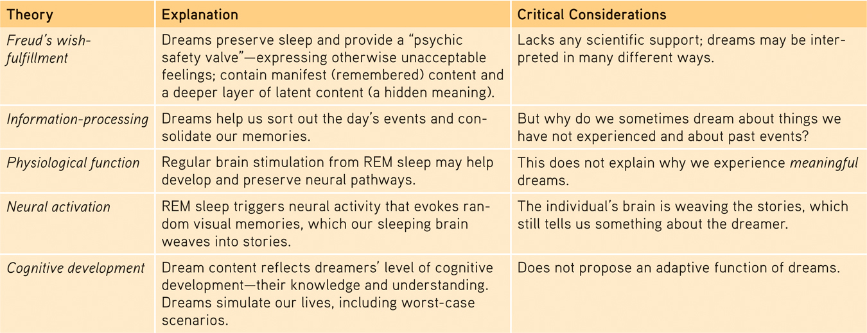

REM rebound: tendency for REM sleep to increase following REM deprivation (created by repeated awakenings during REM sleep)

Drugs and Consciousness

Psychoactive drug: chemical substance that alters perceptions and moods
Addiction: disease (acquired) where person feels driven to consume a drug, whatever the consequences
Tolerance: Diminishing effect with regular use of a drug, requiring the user to taker larger doses
Why? Neuroadaptation
- Example of neuroplasticity – drugs will change brain function and structure (i.e. brain may stop producing neurotransmitters or shut down receptors)
Withdrawal: Discomfort and distress associated with stopping the consumption of a drug

Types of Drugs

- Depressants
Type of psychoactive drug that reduces, activity of nervous system

A.1 Alcohol
Low/high dose = depressant

  - Slowed neural processing
  - Memory disruption
  - Reduced self-awareness and self-control
  - Expectancy effects

FAS (Fetal Alcohol Syndrome) – if woman drinks while pregnant, she runs risk of having baby with FAS

Affects sexuality, causes organ damage (damages liver, heart, stomach, etc.), affects neurotransmitters (agonizes GABA, antagonizes glutamate, agonizes dopamine)

A.2 Barbiturates and tranquilizers
Induce sleep/ reduce anxiety
Low does promote calming, relaxing; high doses are dangerous (coma, death)
Agonize GABA

A.3 Opiates
Man-made / nature made
Pupils constrict, breathing slows
i.e. opium, heroin, oxycontin, morphine
Agonize endorphins, agonize dopamine, antagonize GABA
If abused of, brain will stop making its own endorphins

- Stimulants
Drugs that increase, speed-up activity of nervous system

B.1 Nicotine
1 cigarette = 12 min of life lost
Agonizes acetylcholine, norepinephrine, dopamine
Highly addictive
Dual effect:
Very anxious smoke calm down
Sluggish smoke perk up

B.2. Cocaine
Highly addictive (high last 15/30 min, then crash)
Heaven euphoria, alertness, confidence
Agonizes norepinephrine, serotonin, dopamine
Hell short term depression, chronic permanent depression, formication, psychotic episodes, paranoid

B.3 Methamphetamines
Agonizes dopamine
Aftereffects include: irritability, insomnia, hypertension, seizures, social isolation, depression, violent outbursts
Overtime, may reduce dopamine levels – constant depression

B.4. Ecstasy (MDMA)
Stimulant + hallucinogen
Agonizes dopamine, norepinephrine + releases serotonin (AND blocks its reuptake)
Serotonin depletion depression lasts longer than high
Continued use damage to serotonin producing neurons (20-60% serotonin neurons damaged)

- Hallucinogens
Most profound effect on consciousness – known as mind-manifesting and mind-expanding

C.1. LSD
Unpredictable (some have good trip/some bad)
Physical effects: chills, tremors, increase in body temp
Emotional effects: multiple at once or switch from one to another very rapidly
Distorted perceptions, sensations, thoughts
Areas in brain that normally talk to each other, don’t; and those that don’t, do

C.2 Marijuana
Chemical THC
Mild hallucinogen amplifying colors, sounds, tastes, smells
Marijuana also relaxes, disinhibits and produces euphoric high
THC lasts in body for over a week
Disrupts memory formation

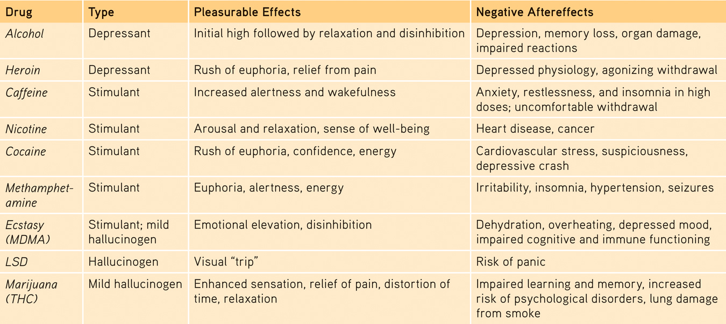

Influences on drug use

- Genetic component to addiction
CREB (gene) produced a protein called CREB - those with no CREB tend to drink 50% more alcohol

- Type of drug used
Some drugs are more addictive than others

- Method of administration
Smoking, injecting, inhaling increase addiction

- Age
The younger, the higher the risk for addiction

Psychosocial factors

- People in major transitions in life (mourning loss, breakup, etc.)
- Culture + community
- Mental illness
- Loneliness
- Peers
- Family

Chapter 6 (pp.546-274)

Hearing (Audition)

The stimulus – sound waves
Amplitude: height of the wave in Db – determines loudness
Frequency: length of the wave in Hz – determines pitch
Human can detect 20 to 20 000 Hz soundwaves

A complex soundwave will have a variety of amplitudes and frequencies – complexity translates in psychological experience of timbre (what makes a sound unique)

The Ear

Outer Ear
- Soundwaves are funneled through the pinna
- They travel through auditory canal
- They reach the eardrum – will cause it to vibrate
- Vibration of ear drum will cause the vibration in a piston made up of the hammer, anvil and stirrup
- These vibrations will cause vibrations in the oval window
- The vibration will cause the fluid in the cochlea to create waves
- The waves will create vibrations in the basilar membrane
- This will cause hair cells (cilia) to sway and bend
Then, the info is transduced and transmitted to brain’s auditory cortex via the auditory nerve

Detecting loudness
The louder the sound, the higher the # of hair cells fire

Perceiving Pitch

Helmholtz’s Place Theory – we hear different pitches because different sound waves trigger activity at different places along the cochlea’s basilar membrane, hence the brain identifies a specific pitch depending on where it is located on the membrane

Frequency Theory suggests an alternative – The brain reads pitch by monitoring the frequency of neural impulses traveling up the auditory nerve, hence frequency of soundwave will influence frequency of firing hair cells
1:1 ratio between the two
Problem Hair cells can fire a maximum of 1000 action potentials/sec, yet we can perceive up to 20 000 Hz – Why?
Different groups of hair cells will work together, combine efforts to inform brain
i.e. SW of 3000 Hz 3 groups of hair cells will work together in a rapid-fire way

Bottom line – Need both theories
Place theory explains how we perceive high-frequency soundwaves
Frequency theory best explains how we perceive low-frequency soundwaves

Locating Sound

Brain is constantly monitoring activity of both ears and looks for 2 clues:
- Timing of arrival of soundwaves
- Loudness of soundwaves

The ear closer to the source of sound will receive first + soundwave will be louder in it

Hearing Loss and Deaf Culture

2 kinds

Sensorineural hearing loss (nerve deafness)
Damage to any structure that detects, transduces, transmits information
Solution – cochlear implant

Conduction hearing loss
Damage of any structure that carries, transports, delivers soundwave for detection
Solution – digital hearing aid
Some hearing aids compress sounds (amplify soft sounds and leave alone loud sounds)

Other Senses
(Touch and Smell)

- Touch – cutaneous sense
We can sense pressure, warmth, cold, pain

A.1 Pain
Sensory receptors called nociceptors
Experience of pain is complex – does not only depend on damage; culture, emotions, etc. are factors as well

Gate-Control Theory
The spinal cord contains a “neurological gate”. When tissue is injured, the small fibers open and the “gate” is activated, you will feel pain. Large fiber activity closes the gate, blocking pain signals and preventing them from reaching the brain.

Small fibers activated open gate feel pain
Large fibers activated close gate experience of pain is reduced
Other factors that influence pain
- Stimulating certain areas of the brain can cause the opening/closing of this “gate” – very invasive
- Beliefs can also influence experience of pain (i.e. hook-swinging)
- Stress can also influence pain (i.e. in state of fight-or-flight – feel less pain)
- Mood and culture

- Smell (Olfaction)
Chemical sense stimulation comes from chemical odor molecules
Olfactory receptors are embedded in olfactory epithelium (membrane filled with mucus) and can regenerate
They alert the brain through their axon fibers – bypass sensory control center (thalamus)
  - Olfactory nerve goes to olfactory bulb and then goes to limbic system in brain
Least acute of senses
Aging and gender affect receptors
- Women and young adults have best sense of smell
- By 80 years old 75% of population has damage to receptors
Anosmia: loss of sense of smell
Specific anosmia: loss of sense of smell for certain things

- Taste (Gustation)
Chemical sense: stimulation comes from chemical molecules that dissolve in saliva and come in touch with gustatory cells
These cells are found in taste buds in papillae (tongue, cheeks, roof of mouth, back of throat)
4 basic sensory receptors
- Sweet, sour, salty, bitter
- 10 years ago, new umami (meat, fish, mushrooms, soy, cheese)

Gustatory cells regenerate
Taste and smell have a strong connection (sensory interaction)

McGurk effect
When two senses disagree and create a third variable (perceptual phenomenon that shows an interaction between vision and hearing in speech perception
i.e. Seeing the mouth move for a sound “ga” while we hear the sound “ba” being emitted will result in perceiving the sound “da”

Embodied cognition
After holding a warm drink rather than a cold one, people were more likely to rate someone more warmly – physical warmth promotes social warmth (brain blends tactile and social judgements)
Or
After being given the cold shoulder by others in an experiment, people judge the room as being colder than those that were treated warmly

Body Position and Movement

- Kinesthesis
Allows us to know where our body parts are and what they are doing
Sensory receptors all over body (muscles, joints, ligaments, tendons)

- Vestibular sense
Responsible for sense of balance/equilibrium
Monitors position of head/body
Sensory receptors (hair cells) found in semi-circular canals + in vestibular sacs (inner-ear)

Is there extrasensory perception?

Definitions
Telepathy: mind to mind communication
Clairvoyance: being able to perceive what is happening in a different location than the one you are in
Precognition: able to perceive the future
Psychokinesis: use of the mind to move objects

Parapsychology: Study of ESP
To date, there is no scientific evidence that ESP exists. In order to declare ESP as a scientific variable, its effects must be reproducible again and again. We must be able to replicate enough to exclude chance.

Chapter 7

Learning: process that leads to a relatively permanent change in how we think, feel behave as a result of experience

3 major ways we learn
- Classical conditioning
- Operant conditioning
- Observation and modeling

- Classical conditioning
Conditioning: process by which we learn to make associations
Classical conditioning: learning to form association between 2 events or 2 stimuli (one event announces arrival of other event)

Pavlov’s experiments

Steak dog salivates
Unconditioned stimulus unconditioned response

Sound of bell: neutral stimulus
Sound a bell each time before giving dog steak

After conditioning:
Sound of bell dog salivates
Conditioned stimulus conditioned response

Higher Order Conditioning
We trained a dog to salivate at the sound of a bell
Now we use bell to teach dog to salivate at sight of red triangle

Triangle + bell + meat = salivation
Repeated multiple times triangle will cause salivation

Acquisition
Process by which dog learns to salivate at sound of a bell
Factors that could influence:
- Frequency of presentation (more x you ring bell, higher probability of learning)
- Timing (must give dog food immediately or shortly after bell)
- Order of presentation (bell then meat)

Extinction
Diminishing of a conditioned response
Dog has been trained to salivate to bell, but we do not want that anymore
Hence, at sound of bell, no meat is given

Spontaneous Recovery
Reappearance, after a pause, of an extinguished conditioned response
Dog has stopped salivating at sound of bell, but one day, the bell sounds and he salivates

Generalization
The tendency, once a response has been conditioned, for similar stimuli to elicit similar responses
Train dog to salivate at sound of one bell he will salivate at all bells
Dog bites you afraid of all dogs
Can be adaptive and maladaptive

Discrimination
Train dog to salivate at specific bell he only salivates at sound of that bell
Discriminates between stimuli

Updating Pavlov’s Legacy

Cognitive Processes
Pavlov acknowledged presence of cognitive processes, but he felt that they did not need to be studied – modern researchers disagree
- Rescorla argued that animals are active learners and that they think like scientists – they learn info that is the most reliable and has the highest power to predict

Biological Constraints
Pavlov believed that as long as you follow the strict rules of classical conditioning, you can teach anything- modern researchers disagree
- Garcia & Koeling argued that nature puts limits as to what you can tteacch
Rats exposed to radiation nausea occurred
Sound + radiation nausea
In spite of this, rats never felt nausea with sound

Light + radiation = nausea
In spite of this, rats never felt nausea with light

Sugar + radiation = nausea
Sugar = nausea learned behavior

Pavlov’s Legacy

- Discovered classical conditioning
- Showed that psychological processes like learning can be studied scientifically
- Influenced John Watson
Before him, goal of psychology study consciousness by use of introspection
Watson felt it was too subjective and not scientific and believed that only observable behaviors were scientific, but he did not have the methodology before Pavlov

Watson is the founder of the school of behaviorism (dominated for over 50 years – 1920s-1960s)

- Operant Conditioning
Actions are associated with consequences, either a reinforcer or a punishment

Skinner is linked and associated with operant conditioning
Law of effect behavior is shaped by its consequences
If a behavior produces a desirable effect, it is more likely to be repeated

Principles of Reinforcement

Reinforcer a desirable consequence that si going to make behavior more likely to repeat in future
Positive reinforcer behavior = something pleasant is given
Negative reinforcer behavior = something unpleasant is removed

Primary vs Conditioned Reinforcer
Primary reinforcer naturally rewarding, reinforcing
i.e. glass of water when thirsty
Conditioned reinforcer not naturally rewarding/learned through experience
i.e. give a 50$ bill to a baby and it will not care

Immediate vs Delayed Reinforcer
Immediate reinforcer: do behavior reinforced immediately or shortly after
Delayed reinforcer: do behavior takes some time before being reinforced

Reinforcement Schedules

Continuous: every time it occurs, behavior is reinforced
Good for new behavior, not good if you want to maintain a behavior for a long time
Intermittent: Sometimes the behavior is reinforced and sometimes it isn’t

Ratio and Interval
Ratio: response based # of behaviors will determine when it is reinforced

Variable-ratio: # of times behavior must occur before reinforcement takes place is unpredictable
Produces a high, steady state of responsiveness
(i.e. slot machine players)

Fixed-ratio: a very specific # of times behavior must occur before reinforced
Produces a pause after being reinforced and then high responsiveness until next reinforcement
(i.e. for each 5 sweaters knit, you are given 200$)

Interval: reinforcement is time-based, passage of time determines reinforcement

Variable-interval: amount of time that must go by before being reinforced is variable
Produces a slow-steady state of responsiveness
(i.e. a longed-for message and checking Facebook for it – even if you check every 30 seconds, it still may not be there)

Fixed-interval: a specific amount of time must go by before reinforcement occurs
Produces a high response rate around specific time
(i.e. People check more frequently for mail around the delivery time)

Punishment
A behavior produces a consequence that is unpleasant and is thus less likely to be repeated
Positive punishment: behavior something bad is added
Negative punishment something good is taken away

Side effects
According to psychologists, it is better in reinforce desired behaviors that punish undesirable ones

Can lead to
- Suppression (of behavior, instead of getting rid of it)
- Aggression (teaches that it is okay)
- Fear/avoidance (teaches to fear and avoid you)
- Helplessness
- Does not guide one to a more desirable behavior

Shaping behavior: reinforcing successively closer approximation of behavior until the correct behavior is displayed

Updating Skinner

Cognition and Operant Conditioning
Skinner believed that you did not need to study cognitive processes in order to understand operant conditioning and disregarded them – modern researchers disagree
  - Expectations, beliefs, assumptions and very important in learning and must be taken into consideration
Skinner believed that learning occurred via trial/error, rewards and punishments
  - This is true, but not completely
Latent learning challenges this sometimes we learn things that we don’t even know we have learned until an there is an opportunity to use the knowledge
Cognitive map also challenged this Skinner believed that rats learned their way through a map with trial/error – however, the rat was actually creating a cognitive (mental) map

Motivations
- Intrinsic motivation: doing something for pleasure, passion
No external rewards – challenges Skinner’s ideas
- Extrinsic motivation: doing something in order to get something else

Insight learning: Figuring something out on your own – “Aha!” moment

Biological predispositions
Skinner believed that if the strict principles of operant conditioning were used, you could teach anything he was wrong
Nature puts limits
Examples:
- Using food as a reinforcer, you can teach a hamster to dig or rear-up, a hamster’s natural food searching abilities – however, you could not use food as a reinforcer to shape face washing
- You can shape a pigeon to peck to obtain food and/or flap their wings to avoid a shock because these are biological innate predispositions – you could not teach a pigeon to peck to avoid a shock

- Learning by Observation
Bandura important name
Observe social world (what is punished and reinforced) and we adjust behaviors accordingly

Imitation and Modeling
We are biologically predisposed to learn through observation
We have mirror neurons in brain that are highly specialized, and they activate when we do an activity and when we watch someone else to an activity – they are found all over brain, including the motor cortex

