Purifying Chemicals by Distillation

Procedure
The procedure followed for this experiment has been provided by the Laboratory Manual for Introductory Organic Chemistry 2019 provided by the Department of Chemistry of the University of Ottawa. To begin the experiment, a simple distillation apparatus was assembled in a fume hood using a 100 mL distillation flask and a 50 mL graduated cylinder as a receiving flask. 25 mL of a 50:50 solution was poured into the distillation flask. The 50:50 solution was slowly heated at 70°C and stirred using a magnetic stirrer as the distillation progressed until completion and the distillation was collected in the graduated cylinder. Following this distillation, the apparatus was partially disassembled to allow the pouring of the mixture back into the original flask, and the addition of the fractionating column to prepare for the fractional distillation. The mixture was distilled slowly at a heat of 75°C a with slow stirring as the distillate was collected in the graduated cylinder.

Observations & Results
The 50:50 solution and the distillate were both clear colourless liquids, and remained such throughout the entire procedure. Throughout the simple distillation, the temperature steadily increased, whereas the temperature increased then began to decrease slightly throughout the fractional distillation.

Table 1. Volume and temperature values for both distillation procedures
Volume (mL) | Simple distillation (°C) | Fractional distillation (°C)
0 (starting temperature) | 23.7 | 24.5
1 | 24.9 | 26.5
2 | 25.6 | 27.0
3 | 27.1 | 27.0
4 | 28.8 | 27.0
5 | 28.8 | 27.5
6 | 28.8 | 27.5
7 | 29.2 | 27.5
8 | 29.3 | 30.0
9 | 29.3 | 31.5
10 | 29.5 | 33.2
11 | 29.5 | 35.0
12 | 29.5 | 35.2
13 | 30.0 | 32.0
14 | 31.5 | 32.0
15 | 34.0 | 34.0
16 | 34.7 | 34.5
17 | 35.0 | /
18 | 35.0 | /
19 | 35.0 | /
20 | 35.5 | /
21 | 33.5 | /
Figure 1. Temperature changes during simple distillation
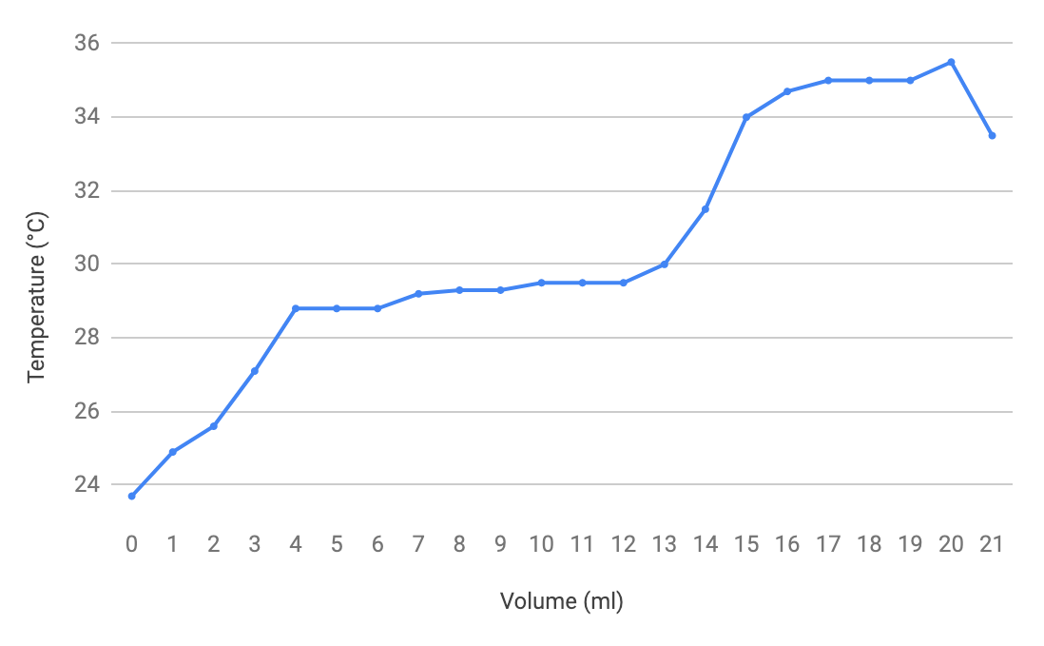
Figure 2. Temperature changes during fractional distillation
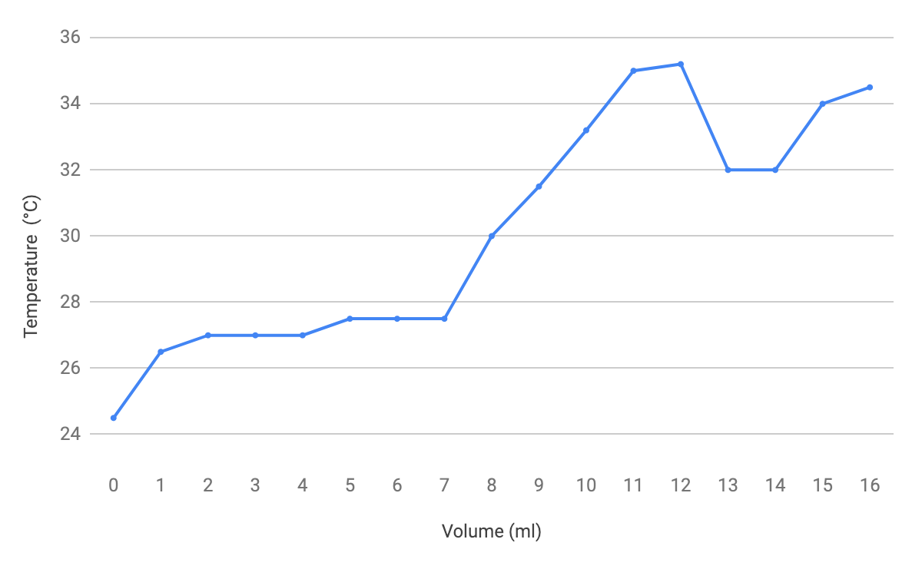

Discussion
Distillation in general is the process of separating two or more compounds based on their boiling points in which both liquids are heated together and vaporized, and the vapors are condensed and collected into a receiving apparatus. The two distillations performed in this experiment are essentially the same, except fractional distillation uses a fractionating column in order to improve the separation between the two liquids in the 50:50 solution being distilled and is therefore more effective than simple distillation. This can be seen by examining figure 1 depicting the simple distillation, with the absence of a sudden temperature spike in favour of a steadily increasing slope, and figure 2 depicting the fractional distillation, showing the sudden temperature spike occurring at approximately 26mL that signifies that the separation took place. By using a fractionating column for the second distillation, the packing material provided more surface area and allowed for multiple condensation and evaporation sequences to take place and enrich the vapor within the component that has a lower boiling point.
The distillation flask was not heated evenly, which could have possibly caused some disruptions and lowered the distillation rate, subsequently impacting the data and thus can be considered a source of error. Another possible source of error is having residue in the glassware that could interfere with the vaporization and condensation by altering the boiling point. Also, between experiments some of the distillate was boiled off accidentally after transferring it back into the warm distillation flask which could have had negative effects besides shortening the length of the distillation.

Conclusion
To conclude, while the simple distillation was faster to heat up and complete, it was not as effective as the fractional distillation trial in terms of separating the compounds in the mixture. The simple distillation was unsuccessful in separating the compounds, however the fractional distillation was successful in the separation.

Questions:
1) Is it possible to separate a mixture of ethanol and toluene via distillation? Explain.
Yes, it is possible. This is because the boiling point for ethanol is 78°C, and the boiling point for toluene is much higher than ethanol, which is 110°C. Keep the temperature of distilling flask higher than 78°C but lower than 110°C. When the temperature is above ethanol’s boiling point it will convert to vapour, and then convert the ethanol vapour back to liquid, the mixture of ethanol and toluene will be successfully separated.

2) Fractionating columns normally work better if they are insulated in order to maintain a smooth temperature gradient in the column. Why is it important to maintain a uniform temperature gradient in a fractionating column?
It is important to maintain a uniform temperature because the uniform temperature is able to make the convert rate constant. If the temperature is not constant the experiment will not be precise. For example, if the temperature is higher, the vapour may not be able to fully convert back to liquid .

3) The boiling point of dichloromethane is 39.6 °C. What is the vapour pressure of dichloromethane at this temperature?
The vapour pressure of the dichloromethane at 39.6 is 1001.3kp, because the boiling point vapour is equal to atmospheric pressure.

4) What effect does an increase in atmospheric pressure have on the boiling point of a liquid?
The boiling point will increase while atmospheric pressure increase.

5) Why is it important to have cooling water enter the bottom of the condenser and not the top?
If the cooling water enter from top, it will cause some difficulties to fully fill the condenser, because the water may directly go out from the bottom end. It will affect the efficiency of distillation.

6) Compound A has a vapour pressure of 350 mm Hg at 95 °C whereas compound B has a vapour pressure of 140 mm Hg at the same temperature. If A and B are miscible, what is the vapour pressure of a 4:1 mixture of A and B at 95 °C?
Given - Compound A: 350 mmHg temperature: 95°C
Compound B: 140 mmHg temperature: 95°C
Vapour pressure: 4:1
P_{Total} = (P_{A}) x (N_{A}) + ( P_{A}) x (N_{A})
= (350mm x 0.8) + (140 x 0.2)
= 308 mm Hg

Raw Data


