MARKETING FINAL CHAPTERS
CHAPTERS 9,10,11,13,14,16,3.

CHAPTER 9: Brand Strategy and Management.

What is a brand?
A name, symbol, icon, design, or a combination of these, that identifies the maker or marketer of a product.
Branding could add value to a product. They:
Have status and value, personality, involve emotions, signify quality, and provide legal protection.
Trademark names have monetary value which is why they should be trademarked (ex: Louis Vuitton, Coca-Cola bottle, Pillsbury doughboy, etc.)
Brand Equity:
A financial value attributed to the brand based largely on intangible qualities.
Brand Personality:
Human attributes and emotions they inspire toward customers.
Brand Elements include: name, logo &/or icon.
Logos support the brands positioning and adds personality.
Brand Strength can be measure through:
-Differentiation
-Relevance
-knowledge and esteem
-Customer equity.
A Brand Name Should:
-Suggest something about the product
-Be distinctive
-Be pronounceable in many languages and be easy to pronounce and remember
-Should be extendable
-Be legally clear: capable of registration and trademark protection
Brand Strategy

Positioning
There are 3 levels:
Top | Beliefs and Values | Strongest
Middle | Desirable Benefits | Strong
Bottom | Product Attributes | Least strong

Brand Positioning should also establish a mission and vision of what the brand must be and do.

Sponsorship
National/ Manufacturer Brands:
Created and owner by producer of product. (Ex: Samsung Galaxy, Kellogs Frosted Flakes)
Private/Store Brands:
Owned by the reseller of a product (Ex: Shopper’s life brand, Joe Fresh, Presidents choice, Great value -walmart, etc.)
Licensing:
The buying and selling of the rights to use a brand name, logo, character, icon, or image.
-Most manufacturers take years and spend millions to create their own brand names
-However, some companies license names or symbols previously created by other manufacturers, names of well-known celebrities or characters from popular movies/books (costs money)
Co-Branding:
Occurs when two established brand names of different companies are used on the same product.

Brand Development
STRATEGY | Line Extensions | Brand Extensions | Multibrands | New Brands
Description | Extending an existing brand name to new forms, colours, sizes ingredients, or flavours of an existing product category. | Extending an existing brand name to new product categories. | Brand development strategy in which the same manufacturer/producer produces many different brands in the same product category. | New brand names assigned to new products in new categories.
Advantages | Low cost, Low risk way to introduce new products. Meet desires for variety, demand more shelf space. | Instant recognition for new products. Saves advertising costs to build a new brand. | Appeals to dif. Customer segments. Locks up more retailer shelf space. Captures larger market share. | Useful when none of a company’s current brand names are appropriate.
Risks | Over-exposure (overextended) of brand namely lose its meaning. Sales of an extension may affect other items. | May confuse main brand image or meaning. If an extension fails it could harm customer attitudes. Brand name may not be suitable for the product. | Each brand may only have a small market share, and none may be profitable. | Too many new brands can spread a company’s resources too thin. Creating too many brands with too few differences.

Brand Stories:
Brands could be thought of as a form of storytelling, when brand managers tell stories about brands, the details of character, place, and action embellish the basic “information maps” or “schemas”.
Branded Content:
Any form of information or story written & produced by a brand marketer, with the brand clearly featured.
Branded Entertainment:
A form of entertainment, usually video, that is created with the cooperation or financial support of a marketer.

-Brand managers must create social groups, fan pages, and host dialogue with consumers.

Brand Advocates are people who:
-Voluntarily promote brands
-Trust brands and companies behind them
-Love the brands they advocate

CHAPTER 10: Pricing: Understanding and Capturing Customer Value.
What is price?
It is the amount of money charged for a product/service where the total value that customers exchange for the benefits of having or using the product or service.
**Price is the only element in the marketing mix that produces revenue; all others represent cost.
-It has a direct impact on a firms bottom line.
-Its plays a key role in creating customer value and building customer relations. (Its a part of a company’s value proposition).
Customer Value-Based Pricing
-Price is considered along with other marketing mix variables before the marketing program is set.
-Customer needs and value perceptions are assessed.
-Target price is based on value perception.
DESCRIPTION | CONSIDERATIONS | STRATEGIES | MEANING (strategies)
Pricing based on a buyers perception | 1- Customer needs | Good-Value Pricing | Offering the right combination of quality and good service at a fair price.
 | 2- Customer perceptions | Value-Added Pricing | Attaching value-added features and services to differentiate a company’s offers and charging higher prices
 | 3- Price based on perception of value

Cost-Base Pricing
-Costs set the floor for the price that the company can charge.
-Product-driven rather than value driven.

-Types of cost:
Fixed Cost: Do not vary with production or sales level
Variable Costs: Varies directly with the level of production.
This type of pricing ignores consumer demand. Still, mark-up pricing remains popular for many reasons. First, sellers are more certain about costs than about demand. By tying the price to cost, sellers simplify pricing. Second, when all firms in the industry use this pricing method, prices tend to be similar, minimizing price competition.
DESCRIPTION | CONSIDERATIONS | STRATEGIES | MEANING (strategies)
Pricing based on sellers cost (producing, distributing & selling) | 1- Total costs (fixed and variable) set minimum price charged. | Cost-plus (mark-up) pricing | Adding a standard mark-up to the cost of the product
 | 2- Product driven | Break even pricing | Setting price to break even on costs of making and marketing a product, or setting a price to make a target return.
 |  | Target return pricing | Same as above + uses a break-even chart

Example of a Break-Even Chart

Competition-Based Pricing
-Assumes consumers value of a product by competitors prices for similar products.
-Assessing competitors’ pricing strategies:
-How does the firm’s offering compare in term of customer value?
-How strong are competitors; what are their pricing strategies?
-What principle should guide pricing decisions relative to competition?
DESCRIPTION | CONSIDERATIONS | STRATEGIES
Pricing based on competitors strategies, prices, costs, & market offerings | Customers frame of reference | Competitive pricing
 | Competitors:  -Offerings  -Market position  -Strengths & Weaknesses | Above, at, or below pricing
Additional Factors/Considerations of Pricing:
Internal Factors:
(corporate strategy & objectives. other marketing mix elements. desired position. brand)
Overall marketing strategy, objectives, and marketing mix:
-Company must decide its overall product marketing strategy before setting price.
-Pricing helps to accomplish company objectives.
-Coordinate pricing decisions with packaging, promotion, & distribution decisions.
-Positioning may be based on price.
**Target costing supports price-based positioning strategies:
-Pricing starts with an ideal selling price, then targets costs that will ensure that the price is met.
-Other firms choose not to position or price, or select high price strategies to enhance product prestige.
Organizational considerations:
-Must decide who, within the organization, should set prices.
-This varies depending on size and type of company.
-Some firms maintain pricing departments
External Factors:
(market & demand. price elasticity. econ conditions. regulations. social awareness & concern)
The market and demand:
-A firms flexibility in setting price varies depending non the nature of the market.
-Four types of markets exist:
Pure Competition: many buyers and sellers trading a uniform commodity (ex: wheat, copper)
Monopolistic Competition: many buyers and sellers who trade over a range of prices rather than a single market price.
Oligopolistic Competition: Few sellers who are highly sensitive to each others pricing and marketing strategies.
Pure Monopoly: One seller; Government (Canada Post), Private (power company), private non regulated monopoly.
-Analyzing the price-demand relationship:
Different prices result in different levels of demand, shown by demand curve.
-Price Elasticity of Demand:
-Refers to how responsive changes in demand will be to change in price.
-Small change in demand = Inelastic demand
-Large change in demand = Elastic demand
The economy:
-Economic factors have a strong impact on pricing strategies.
-The recent recession led to many consumers becoming more value-conscious.
-While some firms cut price, others feature more affordable items in the marketing mix.
-Some firms have held price, but repositioned brands to enhance their value.
Other external factors:
-Resellers reaction to price
-Government reaction on pricing controls
-Social concerns

Price Demand Relationship
Each price the company might charge will lead to a different level of demand.
-Most companies try to measure their demand curves by estimating demand at different prices. The type of market makes a difference.
-Demand Curve
-Inverse relationship between price and quantity.
-Price elasticity:
A measure of the sensitivity of demand to changes in price .
*How responsive demand will be to a change of price.

The Economy
Affects consumer spending and consumer perceptions of the products price
Economic conditions impact pricing:
-Recessions
-Inflation
-Interest Rates

Market Skimming:
-Setting a high price for new products to “skim” revenue layer-by-layer from segments willing to pay the high price. … Fewer, but more profitable sales are made.
This strategy only makes sense under three conditions:
1- Products quality and image support a high price, and enough buyers are willing to purchase the product at that price.
2- Costs of low volume do not cancel the benefit of higher price.
3- Competitors should not be able to enter the market easily nor to undercut the high price.

Market Penetration:
-Setting a low initial price in order to “penetrate” the market quickly and deeply.
-This can attract a large number of buyers quickly and win a large market share.
We use this strategy when:
-A market is price-sensitive; low price produces market growth.
-Costs fall as sales volume increases.
-Competition can be kept out of the market with low pricing.

Product Mix Pricing
STRATEGY | DESCRIPTION | EXAMPLE
Product Line Pricing | Setting prices along an entire product line | Samsonite offers 20 different collections of bags @ dif $ from 20$-1000$
Optional Product Pricing | Pricing optional/accessory products sold with main product | GPS systems or android auto with a car
Captive-Product Pricing | Pricing products that must be used with the main product | Blades for razors
By-Product Pricing | Pricing by-products to make a main product’s price more attractive. | Wood by-products
Product Bundle Pricing | Pricing a bundle of individual products at a price lower than if purchased separately. | Fast food combos. Bell bundles tv, phone and internet.

Price Adjustment Strategies
STRATEGY | DESCRIPTION | FROM SLIDES
Discount and Allowance Pricing | Reducing prices to reward customer responses such as paying early or promoting the product | Discounts: Cash, quantity, functional, seasonal.  Allowances: Trade-in, promotion
Segmented Pricing | Adjusting prices to allow for differences in customers, products, or locations. | Types: customer segment, product form, location/time-based pricing
Psychological Pricing | Adjusting prices for psychological effects | Price is used to say something about the product, like perceptions of quality
Promotional Pricing | Temporarily reducing prices to increase short-run sales. | discounts, special events, cash rebates, low-interest financing, longer warranties free maintenance.
Geographical Pricing | Adjusting prices to account for the geographic location of customers. | free on board-origin pricing, zone pricing.
International Pricing | adjusting prices for international markets, subject to many considerations | economic/competitive conditions, laws/regulations, wholesale/retail, perceptions and preference, marketing objectives, costs.
Dynamic Pricing | Adjusting prices continually to meet the characteristics and needs of individual customers and situations | affect of internet on pricing? benefits to marketers: Mine databases  Benefits to consumers: Price comparison sites.

Marketers should avoid price gouging
Price Changes
-Price cuts may be initiated due to
Excess capacity, Falling demand, Drive to dominate market
-Price increases may be initiated to
Cost inflation and Over-demand
Reactions?
Buyers: Not always as expected
Competitors:
-Reduce price to match competition
-Raise the perceived value of its offer
-Improve quality and increase price
-Launch a low-price “fighting brand”
Chapter 11: Marketing Channels
Products come through a supply chain:
-Upstream producers supply raw materials and components necessary to create products
-Downstream marketing channel partners link producers to the customer.
Value Delivery Network:
Producers, suppliers, distributors, and customers who improve the performance of the entire system in delivering customer value.
Marketing Channel:
Interdependent firms that make a product available for businesses or consumers
-Channel decisions affect other marketing decisions.
-Channel decisions can lead to competitive advantage.
**Adding a distributor reduces the number of channel transactions
How Channel Members Add Value
-Financing -Promotion -Information
-After sales support -Physical distribution -Matching & Arranging
-Negotiation -Contacts -Risk Taking
*In general they add value by bridging the time, place, and possession gaps that separate goods and serviced from this who use them.

-Information Gathering and Distribution:
Channel partners, like retailers, that are closer to the final customer, have access to information the manufacturer might not have. Channel partners can collect market intelligence and communicate it back to the original producer.
-Promotion at Point of Purchase:
National brand advertising is typically handled by the manufacturer, but promotions at point of purchase (like locally advertised sales) are handled by distributers and retailers.
-Contact:
Channel members (sales agents in the field & local markets) can find new customers.
-Matching and Arranging:
Channel partners often play a role in adapting the product to fit the buyer’s needs, such as customizing the installation of kitchen cabinets. Channel members such a specialty retailers also display and arrange products to offer customers a choice.
-Negotiation:
Channel partners such as brokers and agents negotiate price and terms of delivery so that the product can move from one channel member to another.
-Physical Distribution:
Trucking and other transportation companies act as channel members by transporting and storing products as they move through the channel.
-Financing:
Companies such as Canadian Tire that offer store credit cards, and companies that sell large products such as cars, may have finance organizations as channel partners.
-Risk Taking:
Depending on them partner arrangement, channel members may assume the risk of handling, transporting and storing the product as it moves through the channel.
-After-Sales Support:
Some products, like electronics and automobiles, require after-sales support and servicing. These functions are typically performed by channel partners.

Types of intermediaries:
-Wholesalers: Sell products to those buying for resale or business use.
-Agents: Perform only a few functions and do not take title to goods.
-Retailers: Sell products directly to consumers.
-Drop Shipper and Ram Jobbers: Intermediaries that do not take possession of merchandise, but perform specific functions in the distribution channels
-Broker: Usually specialize by product line or customer type, they don't take tittle to goods and they only perform a few functions.
Channel 1: Direct marketing channel, no intermediaries.
Channel 2 & 3: Use one or more intermediaries.
**This figure depicts the difference between business-to-consumer (B-to-C) and business-to-business (B-to-B).

Vertical Marketing Systems
-A channel structure in which producers, wholesalers, and retailers act as a unified system.
-One channel member owns the others, has contracts with them, or has so much power that they all co-operate
VMS System | Description | Example
Corporate | Combines successive stages of production and distribution under single ownership. | Zara: they design, manufacture, produce, distribute and sell their clothes on their own. they own everything they need to be able to do so.
Contractual | Independent firms at different levels of production/distribution work together under contract to obtain more economies of ace than if they were alone. | Franchise organizations
Administered | Coordinates successive stages of production and distribution, not through common ownership or contractual ties, but through the size and power of one of the parties. | P&G and Kraft can command their retailers regarding display, shelf-space , promotions and price policies for their products
Franchise | A retailer or service provider that operates under licence using another firms business model.  It links several stages in the production and distribution process, and controls operations from a central head office. | McDonald’s

**3 types of Franchise VMS Systems:
Manufacturer-sponsored retailer franchise
Manufacturer-sponsored wholesaler franchise
Service-firm sponsored retailer franchise

Horizontal Marketing Systems
An arrangement in which 2 or more companies that operate at the same channel level join together to follow a new marketing opportunity. (EX: Tims in Esso stations)
HMS System | Description | Example
Multichannel Marketing Systems  (Hybrid Marketing Channel System) | A single firm sets up 2 or more marketing channels to reach one or more customer groups. | John Deere lawn mowers = construction, home work. sells in home depot and on their own.
Distintermediation | Product and service producers cut out traditional intermediaries or displace resellers with new types of intermediaries | Online travel sites (ex: travelocity) cut out travel agents by allowing customers to book their own vacations.

Channel Conflict
Disagreement among marketing channel members over goals, roles, and rewards.
-Horizontal Conflict:
Occurs among firms that perform the same function at the same level of the channel. (EX: Holiday Inn franchise owner feels that another Holiday Inn is giving poor service, hurting the brand image.

-Vertical Conflict:
Occurs between different levels of the same channel, which is more common. (EX: KFC and franchisees came into conflict over the company's decision to emphasize grilled over fried chicken)

Changing Channel Organizations
Has to do with Disintermediation. Many companies have changed their channel organizations like Travelocity, Netflix, Uber, Amazon, etc. This phenomenon presents both opportunities and problems.

Channel Strategy and Design
Analyzing customer needs, setting channel objectives, determining which type of channel members are required and what their responsibilities should be.
-Distribution (Channel) Strategy:
3 strategies:
-Intensive Distribution:
A marketing strategy in which the product is stocked in as many outlets as possible. (Ex: products found in convenience stores, like toothpaste).
-Selective Distribution:
A distribution strategy in which the marketer selects a set of retailers that specialize in their product category. (Ex: Le Creuset sells its cookware to William-Sonoma). (EX: Bose would not be found in discount retailers) (Ex: Burberry = Holt but you would never find it at Giant Tiger)
-Exclusive Distribution:
A distribution strategy in which the marketer gives the rights to distribute its products to only 1 retailer, or to 1 retailer in a specific geographic area. (Ex: Rolex or Tiffany’s).

Channel Design Decisions
-Making decisions about international distribution channels:
-In some markets, the distribution system is complex and hard to penetrate.
-Distribution systems in developing countries may be scattered, inefficient or lacking.
-Marketing Channel Design:
Designing effective marketing channels by analyzing customer needs, setting channel objectives, determining the types and responsibilities of channel members and making decisions about international distribution channels.

Supply Chain Management and Logistics
The task of coordinating and controlling the physical flow of all those suppliers and products (logistics), from point of origin to points of consumption to meet customer requirements at profit.
-Getting the right product to the right customer in the right place at the right time.
4 Types:
-Outbound distribution: moving products from the factory to resellers and to customers.
-Inbound distribution: moving products and materials from suppliers to the factor.
-Reverse distribution: moving broken, unwanted, or excess products returned by consumers or resellers.
-Just-in-Time Logistics Systems: type of inventory management system in which only small inventories of parts/merch. are held, and new stock arrives “just in time” when needed.
*Takes into consideration
-Warehousing and distribution centres
-Logistics technology and third party logistics (3PL)
-Environmental impact
*Goal: Deliver a targeted level of customer service at the least cost.
**Look at modes of transportation in book**

Chapter 13: Communicating Customer Value: Advertising and Public Relations
The Promotion Mix
Tools used to persuasively communicate customer value and build customer relationships.
There are 5 Tools that are used:
-Advertising -Sales Promotion -Public relations
-Personal Selling -Direct Marketing
Communications with/to customers is changing:
-Consumers see ‘single’ messages from companies
-Communication technology is richer and faster
-Marketing strategies must be integrated
*These factors are shifting the market communications model towards more narrowcasting and less broadcasting.

The Need for Integrated Marketing Communications
Sometimes, mass-media ads say one thing, different from in-store promotion and company website, emails, fb, or videos on youtube.
-Advertising messages are planned and implemented by a department.
-Other departments are responsible for PR (sales promo, online, social media..)
Therefore companies today are adopting the concept of:
Integrated Marketing Communications (IMC):
Carefully integrating and coordinating the company communication channels to deliver a clear, consistent and compelling message about the organization and its products.
Shaping the Overall Promotion Mix
-Advertising:
PROS:
-Reaches masses at low cost per exposure
-Repeats messages multiple times
-Creates cust. Trust (views advert. products as more legitimate)
CONS:
-Promotes impersonally (one way)
-Costs are high for some media types
-Personal Selling:
PROS:
-Communicates personally (two ways)
-Builds preferences, convictions and actions
-Allows relationship building
CONS:
-Requires long-term commitment to sales force
-Most expensive promotion tool
-Sales Promotion:
PROS:
-Includes a wide assortment of tools
-Attracts consumer attention
-Offers strong incentives to purchase
-Dramatizes product offer
-Invites quick consumer response
CONS:
-Effects are short-lived

-Public Relations:
PROS:
-Legitimizes credibility, very believable
-Reaches people who resist advertising
-Dramatizes a company or product
-Saves money when used proactively
CONS:
-Tends to be used as an afterthought
-Direct/Digital Marketing:
PROS:
-Communicates more directly with targeted customers
-Reaches customers with tailored message
-Creates interactivity
-Builds one-to-one relationships
CONS:
-Often perceived as junk-mail/spam

Promotion Mix Strategies

Marketers can choose between 2 basic promotion mix strategies:
-Push Strategy:
Uses the sales force and trade promotion to push the product through channels. Producer promotes the prod. to channel members and they promote it to the final consumer.
-Pull Strategy:
Calls for spending a lot on advertising and consumer promotion to induce final consumers to buy the product, creating a demand vacuum that ‘pulls’ the product through the channel.

Advertising
-Marketing management must make 4 important decisions when developing an advertising program (Shown in figure).
Advertising
Informative  (New product category) | -Communicating customer value -Suggesting new uses for a product  -Building brand and company image -Informing the market of a price change  -Telling the market about a new product -Describing available services and support  -Explaining how a product works -Correcting false impressions
Persuasive  (comparative advertising) | -Building brand preference -Persuading customers to purchase now  -Encouraging switching to a brand -Creating customer engagement  -Changing cust. perceptions of prod. val. -Building brand community
Reminder  (mature products) | -Maintaining customer relationships -Reminding consumers where to buy the prod  -Reminding consumers that the product. -Keeping the brand in a customers mind  may be needed in the near future during off season

Advertising Budget Methods:
-Affordable Method:
Setting the budget at a level management thinks the company can afford.
-Percentage-of-sales method
Setting the budget at a certain % of current forecasted sales, %of unit sales price
-Competitive-Parity Method
Setting promotion budget to match competitors outlays.
-Objective-and-Task Method
Developing the budget by:
1-Defining specific objectives
2-Determining tasks that must be performed to achieve these objectives
3-Estimating the cost of performing these tasks
Developing Advertising Strategy
-Creating the Advertising Message:
-Must break through the clutter.
-Branded entertainment
-Madison&Vine “Advertainement”: merging ads with entertainment.
-Selecting Advertising Media:
-Set reach, frequency, and impact goals
-Choose among major media types
-Select specific media vehicles
-Decide on media timing
*Message strategy:
-Identify benefits to be used as appeals
-Develop a compelling creative concept (Big idea that will bring the message to life in a distinct, memorable way)
-Choose an advertising appeal that is: meaningful, believable, and distinctive

*Message Execution:
-Slice of life: typical ppl using the product (Silk soy milk)
-Lifestyle: Lululemon and yoga
-Fantasy: IKEA, fancy room designs with IKEA furniture
-Mood/Image: Nestle hot cocoa in winter
-Musical: M&M Love Ballad
-Personality Symbol: Mr.clean, Flo, Wendy, Ronald McDonald
-Technical Expertise: Kashi (carefully selecting ingredients)
-Scientific Evidence: Crest
-Testimonial Evidence/Endorsements: Dos Equis, Trivago hot man

Media Types:
Medium | Advantages | Limitations
TV | Good mass marketing coverage; Low per cost exposure; Appeals to sense (sight, sound, motion) | High absolute cost; High clutter; Fleeting exposure; Less audience selectivity
Online, Mobile, Social Media | Focus on individuals/cust. communities; immediacy; personalization, interaction & engagement; Social sharing power; Low costs | Potential narrow impact; Difficult to control; Audience often controls content & exposure
Newspapers | Flexibility; Timelines; Good local coverage; broad acceptability; high believability | Short life; Poor reproduction quality; Small pass along audience
Direct Mail | High audience selectivity; Flexibility; no ad competition; personalization | High cost per exposure; ‘Junk mail’ Image
Magazines | High Geo/Demo select.; Credibility/Prestige  ;Long life, good pass-along readership | Long ad purchase lead time; High costs; No guarantee of position
Radio | Good local acceptance; High geo/demo selectivity; Low costs | Audio only; fleeting exposure; Low attention; Fragmented audiences
Outdoor | Flexibility; High repeat exposure; low costs; low message comp.; Good positional selectivity | Little audience selectivity; Creative limitations.

Evaluating advertising involves measuring:
-Communication effects of an ad or campaign
-Sales and Profit effects of the ad campaign
Return on advertising investment:
-The net return on ad investment divided by the cost of advertising the investment
Advertising agency:
A marketing services firm that assist companies in planning, preparing, implementing, and evaluating all or portions of their advertising programs.
-Small Companies- advertising done by someone in sales
-Large Companies- have advertising departments, Most use outside advertising agencies.

Public Relations
About building strong relations with the company’s various stakeholders by:
-Obtaining favourable publicity
-Communicating a trustworthy corporate image
-Managing unexpected occurrences, both positive and negative.
-It can have a strong impact on public awareness at a much lower cost than advertising
Public Relation Functions
Function | Description
Press Relations/ Press Agency | Creating and placing newsworthy information in the news media to attract attention to a person, product or service
Product Publicity | Publicizing specific products
Public Affairs | Building and maintaining national or local community relations
Lobbying | Building and maintaining relationships with legislators and government officials to influence legislation and regulations
Investor Relations | Maintaining relationships with shareholders and other in the financial community
Development | Working with donors or members of nonprofit organizations to gain financial or volunteer support.

Major Public Relations Tools
-News -Speeches -Special events -Written Material -Audio/Visual Materials
-Corporate Identity -Public Service Activities -Buzz Marketing -Company Website

Chapter 14: Personal Selling and Sales Promotions
The Nature of Personal Selling
Personal Selling:
Personal customer interactions by the firm’s sales force for the purpose of making sales and building customer relationships.
-face to face, telephone, email, videos/web conferences
-Can be more effective than advertising
The term covers a range of positions:
-Order taker: Department store clerk
-Oder getter: Demands creative selling and relationship building
-Most salespeople are well-educated, well trained professionals who build and maintain long-term customer relationships

The role of the Sales Force
Sales and other marketing functions should work together to create value
-Critical link between company and customers
-Coordinating marketing and sales
Sales Force Management:
Analyzing, planning, implementing and controlling sales force activities
Steps in Sales Force Management:

-Recruiting and selecting salespeople: Hire people with specific skills:
-Intrinsically motivated -Disciplined work style
-Relationship building -Ability to close a sale
-Training Salespeople:
-Seminars, Sales meeting, and e-training from the basis of sales training programs;
Customer knowledge, The selling process.
-Goal is to achieve understanding of a company, product, customer, and market knowledge
-Compensating Salespeople:
-Fixed amount (salary)
-Variable amount (Commission or bonuses)
-Expenses and fringe benefits

Territorial Sales Force Structure
A sales force organization that assigns each salesperson to an exclusive geographic territory in which that salesperson sells the company’s full line.
Product Sales Force Structure
A sales force organization in which salespeople specialize in selling only a portion of the company’s products or lines.
Customer (or market) Sales Force Structure
A sales force organization in which salespeople specialize in selling only to certain customers or industries
Outside Sales Force (or Field Sales Force)
Salespeople who travel to call on customers in the field
Inside Sales Forces
Salespeople who conduct business from their offices via phone, online and social media interactions, or visits from prospective buyers.
Team Selling
Using teams of people from sales, marketing, engineering, finance, technical support, and upper management to service large, complex accounts.
How salespeople spend their time
Selling Digitally: Online, Mobile, and Social Media Tools
Digital tools to supplement sales force management:
-Social Networking -Time and costs saving -Technology is a supplement
-Combination of proprietary systems and public portals (youtube, linkedIn)

“In response to this new digital buying environment, sellers are reorienting their selling processes around the new customer buying process. They are “going where customers are”—social media, Web forums, online communities, blogs—in order to engage customers earlier. They are engaging customers not just where and when they are buying, but also where and when they are learning about and evaluating what they will buy. Salespeople now routinely use digital tools to monitor customer social media exchanges to spot trends, identify prospects, and learn what customers would like to buy, how they feel about a vendor, and what it would take to make a sale”

The Personal Selling Process

Selling Process:

The steps that salespeople follow when selling:

-Prospecting and Qualifying: I identify qualified potential customers

-Preapproach: Learn as much as possible about a prospective customer before a sales

call.

-Approach: Meet the customer for the first time

-Presentation: Tell the “value story” to the buyer

-Handling Objections: Seek out, clarify, and overcome customer objections to buying

-Closing: Ask the customer for an order

-Follow-up: Follow up after the sale to ensure customer satisfaction and repeat business

The Personal Selling Process

-Selling process reviewed is transaction oriented

-Building profitable relations, not just sales, is key for most companies. This requires listening to customers, understanding their needs and coordinating the company efforts to create value.

Sales Promotion

Short-term incentives to encourage purchase or sale of a product/service

Targeted towards:

-Final buyers (consumer promotions)

-Retailers and wholesalers (trade promotions)

-Business customers (business promotions)

-The sales force (sales force promotions)

Several factors have contributed to the rapid growth of sales promotion:

-Product managers are facing more pressure to increase their current sales

-Companies face more competition from less differentiated brands

-Advertising efficiency has declined

-Consumers have become more deal oriented

Sales Promotion Objectives

-Consumer Promotions: to urge short-term customer buying or boost customer

brand involvement.

-Trade Promotions: getting retailers to carry new items and more inventory, buy

ahead, or promote the company’s products and give them more shelf space.

-Business Promotions: used to generate business leads, stimulate purchases,

reward customers, and motivate sales people.

Sales Promotion Tools

-Samples, Coupons, Rebates (price reduction after purchase), Price packs (“buy one

get one”), Premiums (extra goods offered free with purchase), Promo products (t-shirts

hats with company name), Point-of-purchase (celebrity cardboard cutouts), Contests/

Games (“roll up the rim”), Sweepstakes (enter a draw), Event marketing (concerts).

Developing sales promotion Program

1-Size of Incentive

2-Conditions of Participation

3-Promotion and Distribution of Program

4-Length of Program

5-Evaluate Program

Chapter 4: Digital Marketing and Social Media: Living in the Connected World

E-business:

Conducting online transactions with customers by collecting and analyzing business

information, carrying out exchanges and maintaining online relationships with

Customers.

Categories of E-business

-E-tailing, or virtual store fronts on websites

-Business-to-business transactions: Electronic data interchanges (EDI)

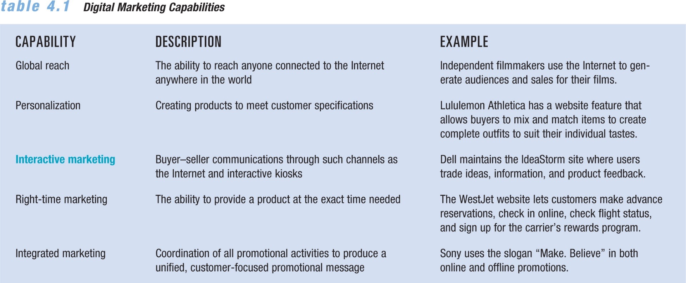
-Email, IM, blogs, podcasts, vlogs, & other wed communication tools.

-Web contacts that allow the gathering and use of demographic, product & other info

Digital Marketing

Strategic process of creating, distributing, promoting and pricing goods/services to a

target market over the internet of through digital tools

Benefits?:

Global reach, Personalization, Interactive marketing, Right-time marketing,

Integrated marketing

B2C Digital Marketing (Bussiness-to-Customer)

Selling directly to consumers over the internet

-Interactive Marketing: buyer-seller, the customer controls the amount and type of

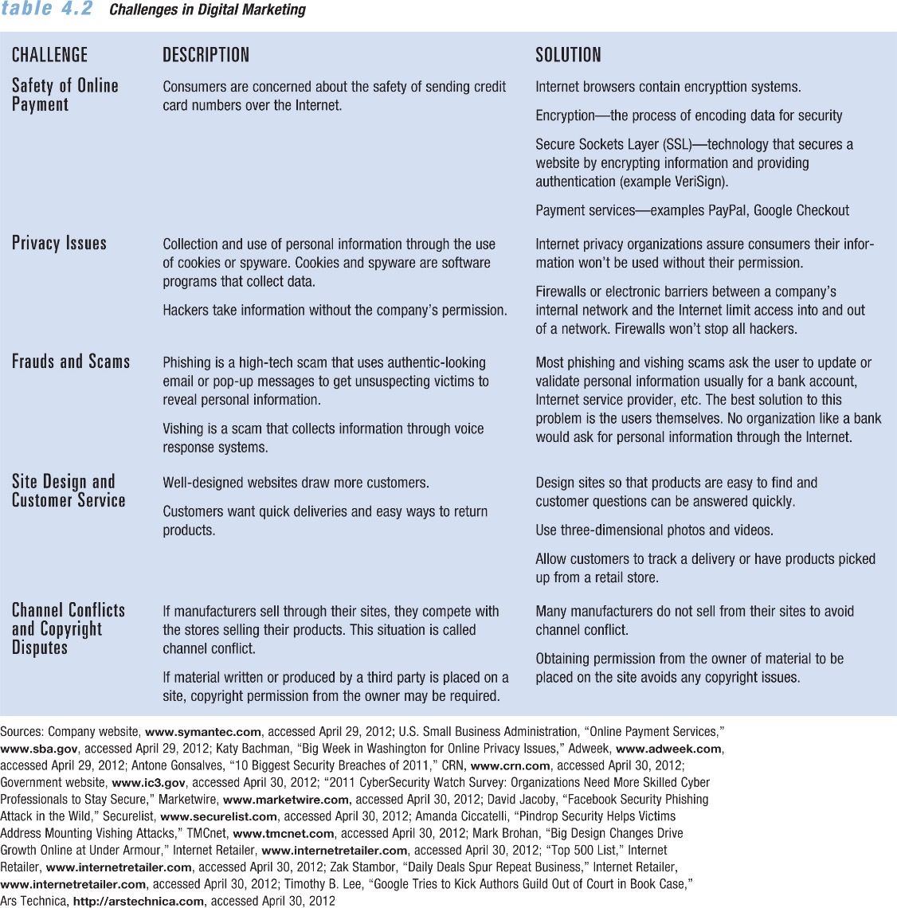
info received through the internet and virtual reality kioks

-Electronic Storefronts: company websites that offer items for sale

-Electronic Shopping Cart: where items are placed

Benefits: Competitive Pricing, Access & Convenience, Personalized Service.

Internet 4 Main functions: Digital business, Entertainment, Information, Communications

Blog: Online Journal

Wiki: Web page you can edit

Podcasts: Online audio or video file

Promotions on web: banner ads, pop-ups, pre-roll video ads, widgets, search marketing

An E-business website can:

-Broaden customer bases

-Provide immediate access to current catalogues

-Accept and process orders

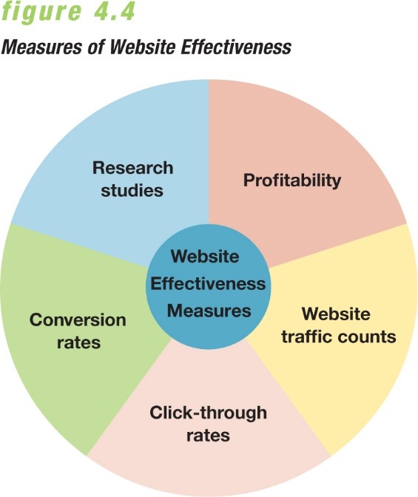
-Offer personalized customer service

Successful Site Development: Establish goals, Implementation & interest, Pricing & maintenance, Assessing site effectiveness.

Content should be relevant to users, easy to access and understand, updated regularly, written or displayed in a compelling way.

The costs of creating a site include: development, placing the site on a web server, maintaining and updating the site, promoting the site.
Profitability: generating revenues directly from online orders, advertising, subscription sales
Web-to-Store Shoppers: ppl who use the internet as a tool to help their in store purchases
Click-through Rates: % of ppl presented with a banner ad who click it
Conversation Rates: measure of % of visitors to a website who make a purchase: 3-5% is average
Engagement: measures how much time users spend on sites rather than how many pages of a site they view

Social Media

Different forms of electronic communication through which users can create online communities to exchange: Information, Ideas, Messages, Other content like videos.

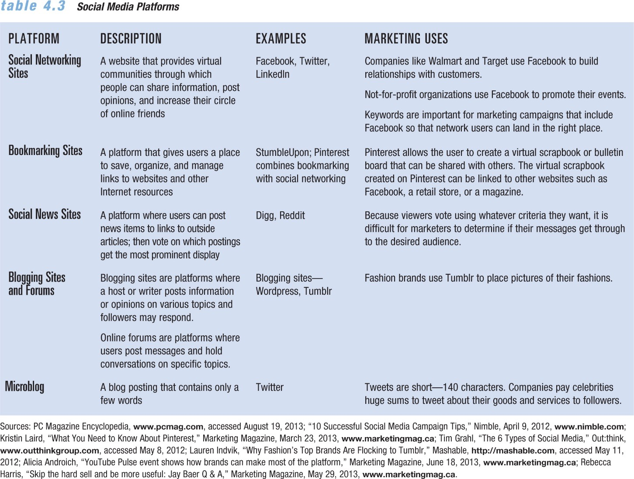
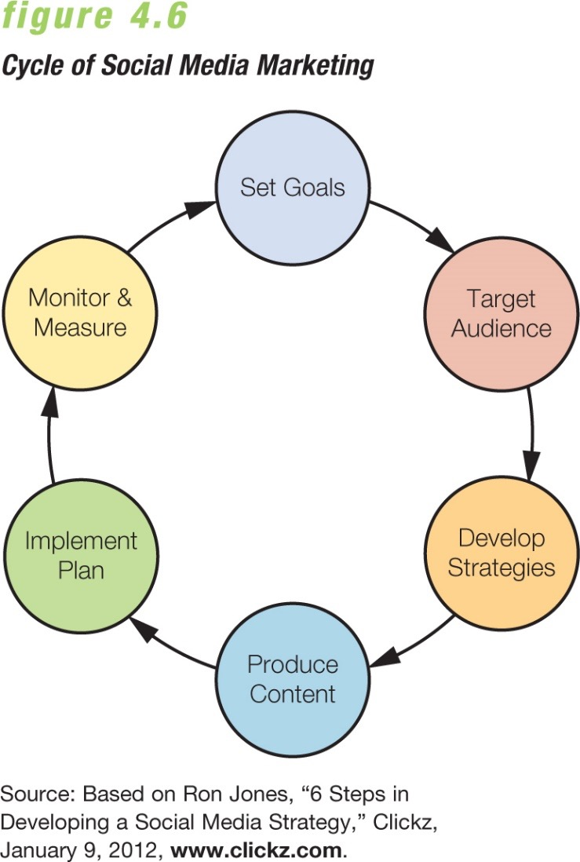
Social Media Tools: Sharing services, Blogs, Microblogs, Apps, QR codes
- A formal document that includes:
  - Goals and strategies
  - Target market
  - Budget
  - Implementation methods
  - Tactics for monitoring, measuring, and managing the SMM effort

Social media is a tool for marketers to: Build relationships with customers, Strengthen brands, Launch new products, Enter new markets, Boost sales.

Social Media Marketing Plan

Monitoring, Measuring and Managing the SMM Campaign

-Social media monitoring: tracking, measuring and evaluating a firms social media marketing initiatives.

-Social media analytics: tools that help marketer track, measure and interpret data related to SMM initiatives.

-Firms calculate their Return on Investment (ROI) of their social media marketing initiatives using:

-Reach: % of ppl in target market who are exposed to the marketing effort

-Frequency: # of times an individual is exposed to the marketing materials

Measuring the success of a social media marketing plan includes factors as:

Share of voice, Awareness of company/brand, Level of engagement by target

audience, Influence created, Popularity among target audience members

Chapter 16: The Global Market Place

Direct Marketing Benefits

What is a Global firm?

A firm that in operating more than one country gains R&D, production, marketing,

and financial advantages in its costs and reputation that are not available to purely

domestic competitors.
Major International Marketing Decisions

International Trade System: tariffs & duties, quotas, exchange controls, nontarrif trade barriers.

World Trade Organizations:

Replaced GATT, Promotes world trade, Reassess trade barriers, Imposes trade

sanctions, mediates trade disputes.

Free-Trade Zones: European Union, NAFTA, Trans-Pacific Partnership
Industrial Structure | Definition
Subsistence Economies | Vast majority of ppl engage in simple agriculture, They consumer most of their output and barter the rest for simple goods and services
Raw Material Exporting Economies | They are rich in one or more natural resources but poor in other ways, Most of their revenue comes from exporting these resources
Emerging/Industrializing Economies | Fast growth in manufacturing results in rapid overall economic growth. This usually creates a new rich class and a growing middle class
Industrial Economies | Major exporters of manufactured goods, services and investment funds. They trade goods among themselves and also export them to other types of econo. for raw materials and semi-finished goods

Income Distribution

-Industrialized nations may have wide range of incomes.

-Subsistence economies- mostly households with very low income families.

-Emerging economies may be attractive markets for all kinds of goods.

Political/Legal Environment

Factors to consider:

-The country’s attitudes towards international buying

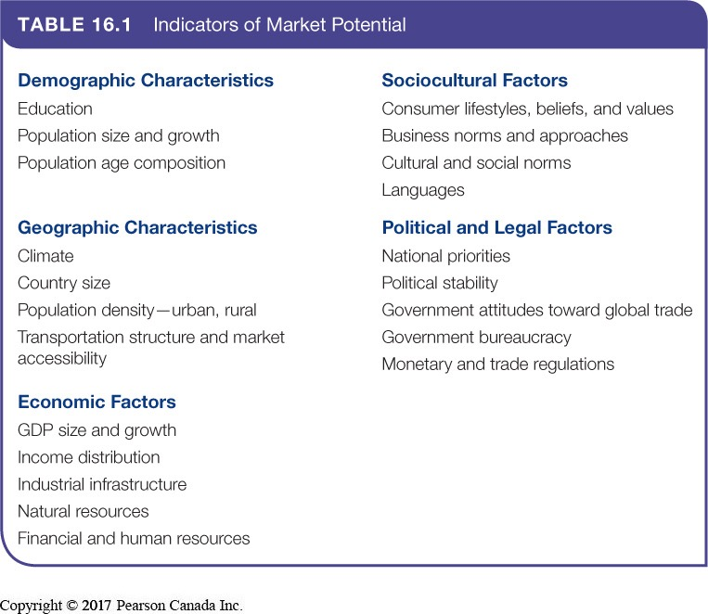
-Government Bureaucracy

-Political Stability

-Monetary Regulations

Cultural Environment

-Each country has its own folkways, norms, and taboos

-Must understand how culture affects consumer reactions

-Must understand how their strategies affect local cultures

-Business norms and behaviours also vary country to country

Deciding which markets to enter:

Deciding How to Enter the Market:

Exporting: Simplest way to enter a foreign market.

-Indirect: Working through independent international marketing intermediaries

-Direct: Handling their own exports

Joint-Venturing: Entering markets by joining with foreign companies to produce or market a product or service. (4 types listed above)

Direct Investment: Entering a foreign market by developing foreign-based assembly or manufacturing facilities.

Deciding on the Global Marketing Program

-Standardized Global Marketing:

Using the same marketing strategy approaches and marketing mix worldwide

-Adapted Global Marketing

Adjusting the marketing strategy and mix elements to each target market. This

involves higher costs with the goal of producing a larger market share and return

Product

Straight product extension: Marketing a product in a foreign market without making any

changes.

Product adaptation: Changing the product to meet local requirements/conditions/wants.

Product invention: Making something new to meet needs of consumers in a country.

There are 2 Communication Strategies:

-Either adopt the same communication strategy used in the home market (promotion)

-Change it for each local market (communication adoption)

Price

-Uniform Price Globally (too high in poor countries and too low in rich ones?)

-Charge a rate at which fits what consumers would bear (ignores differences in cost)

-Use a standard markup of its costs everywhere (might price comp out of market)

Distribution Channels

Whole Channel View: designing international channels that take into account the entire global supply chain and marketing channel, forging an effective global value delivery network.

Chapter 3: Sustainable Marketing Social Responsibility and Ethics

Sustainable Marketing:

Calls for socially and environmentally responsible actions that meet the present needs of consumers and businesses while preserving the ability of future generations.

Social Criticisms of Marketing

-Deceptive Practices

-Pricing: falsely advertising ‘wholesale/factory’ prices

-Promotion: misrepresenting a products feature/performance

-Packaging: exaggerating package contents through design, labelling or size.

-Planned Obsolence

-Using inferior materials and components

-Continuous changing of acceptable styles

-Delaying features until follow-up versions

-Consequences of deceptive practices

Legislative penalty from eh competition bureau, Ontario’s consumer protection act, Canada consumer product safety act (CCPSA)

Environmental Sustainability Portfolio

Sustainable Marketing Principles:

-Consumer-Oriented Marketing: Marketing activities are viewed and organized from

the consumer’s point of view.

-Customer-Value Marketing: Company resources go toward customer-value-building

marketing investments.

Innovative marketing: requires that the company continually seek real products and marketing improvements.

Sense of mission marketing: The company should define its mission in broad social terms rather than narrow product terms.

Societal Classification of Products

-Deficient Products: has neither immediate appeal nor long-run benefits.

(Bad tasting ineffective medicine)

-Pleasing Products: high immediate satisfaction but may hurt consumers in the long run.

(Cigarettes and junk food)

-Salutary Products: low appeal but may benefit consumers in the long run.

(Bicycle helmets)

-Desirable Products: high immediate satisfaction and high long run benefits

(Tasty, nutritious breakfast)

Corporate Marketing Ethics Policies cover:

Distribution relations, Advertising standards, Customer service, Pricing, Product

development, General ethical standards

