Lecture 2: Introduction to Cell Biology
- Biology- study of life
- All living things have:
  - Growth
  - Reproduce
  - Heredity
  - Homeostasis
  - Metabolism
  - Cellular (response and composition)
  - Respond to the environment
- Cell is the smallest collection of matter that can be alive, fundamental unit of life
- Most animal and plant cells can grow to be 10-100 nanometers
- Nucleus, most bacteria and mitochondria cane be 1-10 nanometers
- Why are cells small?
  - Small cells have a greater surface are to volume ratio, this is very important for metabolic processes. Plasma membrane acts as a selective barrier and only allows nutrients and waste to pass through it. Cells have to be big enough to fit all organelles but small enough to carry out metabolism.
- What does the cell theory state?
  - All living things are composed of one or more cells
  - Cells are the basic structural unit of life
  - All life comes from pre-existing cells
- Dissecting microscope *x
- Compound microscope 1000x
- Light microscope
  - Light passes through the specimen and then through glass lenses
  - Can see things up to 2 nanometers
  - Can only see basic structure
  - Stains or dyes are used to enhance the phase contrast, can allow us to see more details, but most dies kill cells
- Fluorescence microscopy
  - Subtype of light microcopy
  - Specific molecules are visualized with fluorescently-labelled dyes or antibodies
  - Can determine sub-cellular locations to be determined
- Confocal microscopy
  - Laser produces sharper images, 3-D reconstructions can be made
- Super resolution
  - Techniques increase resolution to 40 nanometers
- Scanning Electron Microscopes (SEMs)
  - Beam of electrons focused onto a surface of a specimen and provide a 3-D image
  - Look on the outside
- Transmission Electron Microscopes (TEMs)
  - Focus a beam of electrons through a specimen
  - Look on the inside
  - Res limit 50 nanometers
- SEMs and TEMs only look at dead things
- SEE CELL COMPARISION
- Mitochondrion and chloroplast are examples of membrane bound organelles
- Endosymbiotic Theory
  - Early ancestor of eukaryotes engulfed an aerobic non-photosynthetic prokaryote
  - Engulfed cell remained in the host cell, became an endosymbiont evolving into the mitochondrion
  - Second endosymbiotic event involved a photosynthetic prokaryote being engulfed by a eukaryote containing a mitochondria, this evolved into a chloroplast
    - Evidence Mitochondria and Chloroplasts resemble
      - Size of a prokaryote
      - Bound by two outer membranes]grow and reproduce independently in cells using prokaryotic-like mechanisms
      - Contain their own circular DNA molecules
      - Contain free ribosomes to synthesize protein
- Viruses
  - Protein capsules that contain nucleic acid structures. Seem to have many structures of life but:
    - Do not have a cellular structure, no cellular membrane
    - Do not maintain homeostasis
    - Don’t carry out their own metabolism
    - Cant reproduce with a host
Lecture 3: The Cell and its Organelles
- Cell catalogue
Lecture 4: The Chemistry of Life
- Matter is made of elements
  - Mainly: Oxygen, Carbon, Hydrogen and Nitrogen and other stuff
- Trace element less than 0.01%
  - Iron- necessary for oxygen transport as part of hemoglobin
  - Iodine- necessary for hormone production in the thyroid
  - Copper- necessary for many metabolic enzymes
- Atom- smallest unit of matter and make up elements
- Electrons in shells posses different potential energies, closer to nucleus have less energy, help to determine chemical properties
- Electronegativity- an atoms attraction for the electrons in a covalent bond
- Covalent bond
  - Sharing of a pair of valence electrons
  - not polar
    - nonpolar covalent bonds
      - atoms share electrons equally
    - Polar covalent bonds
      - One atom is more electronegative and the atoms do not share electrons equally
  - Strong bonds- allow atoms to for molecules
  - Require lots of energy to break
  - Attractions between molecules or a part of a large molecule are governed by covalent bonds
- Ionic Bonds-valence electrons are given up or gained
  - Do not have as much energy as covalent bonds
  - This is used to make drugs and allows them to easily dissolve in our bodies
- Hydrogen bonds- a hydrogen atom covalently bound to an electronegative atom is also attracted to another electronegative atom, this is because hydrogen has a partially positive charge
  - Common partners are oxygen or nitrogen
- Van Der Waals interactions- attractions form because molecules are physically close to each other that arise due to momentary dipoles (asymmetrically distributed electrons in molecules or atoms can result in momentary “hotspots” or dipoles, slight charge
  - Geckos have tiny hair like projections on their feet, interactions between the foot molecules and the wall molecules are very weak but numerous, together they can support the geckos body weight
- Bonds
  - Reinforce molecule shape
  - Help molecules adhere together
  - Reversibility can be advantageous
- Water
  - Bonds between oxygen and hydrogen are polar covalent, all atoms in a water molecule can form hydrogen bonds:
    - Allow function like, different states
    - Heat capacity/ vaporization
    - Cohesive properties
    - Solvent properties
      - Ions, polar molecules can dissolve in water (spheres of hydration form around ions separation them), non-polar molecules (proteins) can dissolve in water if they have polar or ionic regions
  - Hydrophobic- polar, water loving
  - Hydrophilic- non-polar, water fearing
- pH of biological fluids 6-8
- Buffers- minimize the change of concentration of a hydrogen ions and hydroxide ions in a solution, contain weak acid and corresponding bas
- Functional groups- components of organic molecules involved in chemical reactions
  - Have 1 or more electronegative atoms
  - Number and arrangement of functional groups give organic molecules unique properties
- 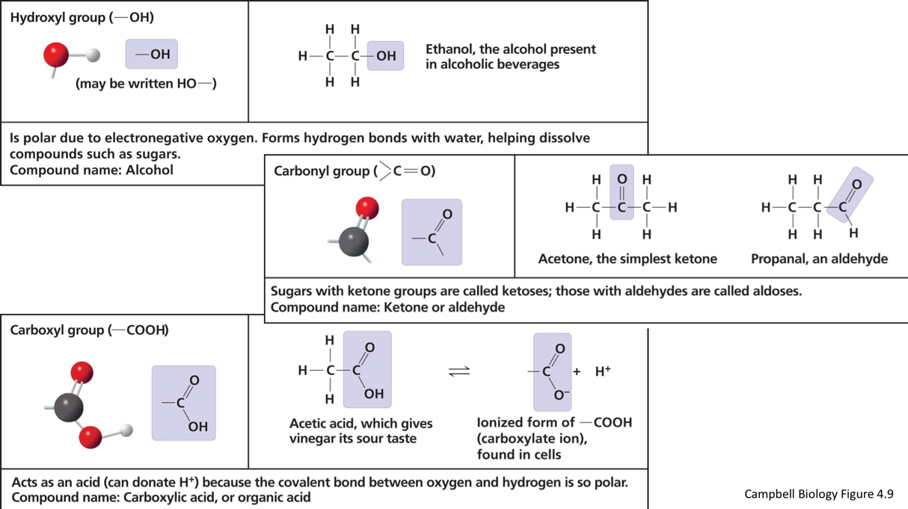

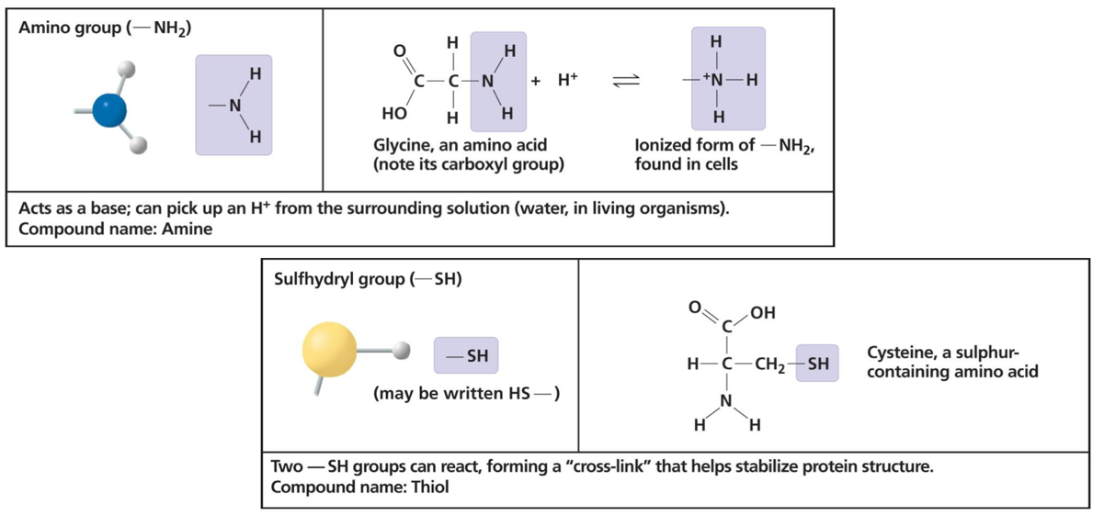
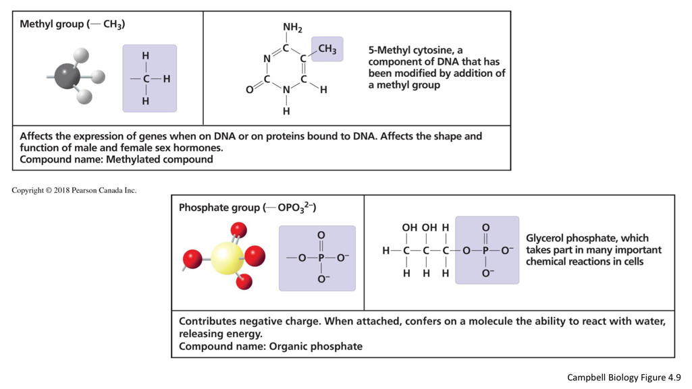
-protein
-sulfur is important in protein and form a disulfide bridge

- Macromolecules- carbon based molecules that carry out functions of life, cells can have thousands of different macromolecules, they are built from a carbon skeleton and different functional groups
  - Polymer- long molecule with many of the same building blocks (monomers), ex. carbohydrates (disaccharides), proteins, nucleic acid
  - Monomers are joined through dehydration or polymerization reaction (water is a biproduct of the reaction)
  - Polymers broken apart by a hydrolysis reaction, water put in
    - Carbohydrates
      - Structure and function determined by
        - Sugar monomer
        - Position and types of bond holding them together
      - Provide cell with chemical energy, have storage and structural roles
      - Monosaccharides
      - Polysaccharides
        - Glycogen- energy store in animal cells
        - Cellulose- cell walls of plants
    - Nucleic Acids
      - Polymers called polynucleotides, that are mad of nucleotides
      - Deoxyribonucleic acid (DNA) and Ribonucleic acid (RNA)
    - Proteins
      - Functional molecule made up of one or more polypeptides (chain of amino acids)
- 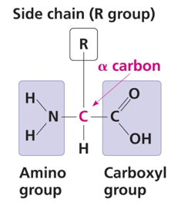
- Non-polar: mainly just CH groups
- Polar: hydroxyl or amino group with a double bonded oxygen or a sulfur present
- Electrically charged: charged atom present

- 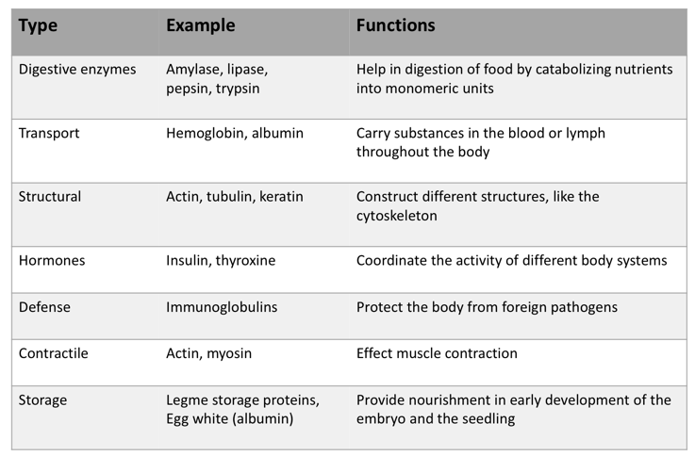

- Structure

  - Primary- sequence of amino acids held together by a peptide bonds, determined by genetic information
  - Secondary- hydrogen bonds between constituents of the back bond, coil to form alpha helix or hold to form beta pleated sheets
  - Tertiary- interactions of the R groups, include: hydrogen bonds, ionic bonds, hydrophilic interactions and Van der Waals interactions and strong covalent bond (disulfide bridges) reinforce proteins structure
  - Quaternary- two or more polypeptide chains joined together to form a macromolecule
  - Sickle-cell- amino acid substitution in hemoglobin, go from flat to c shaped, impede blood flow in blood vessels
  - Changes in pH, salt concentration, temperature can denature a protein, making them not biologically active ex. Alzheimer’s, mad cow

4. Lipids
- Do not form polymers, they are not attracted to water because they are hydrocarbons that contain mostly water
- Function- long-term energy store, insulation, building blocks for some hormones, important component of cellular membranes
  - Fats
    - Triacylglycerol or triglyceride- made of glycerol (3 carbon alcohol hydroxyl group attached to each carbon) and 3 fatty acid tails (hydroxyl group linked to a long hydrocarbon chain)
    - Ester linkage attached glycerol and fatty acid tails
    - Saturated- no double bonds, pack tightly, soiled at room temperature
    - Unsaturated- double bonds, loosely packed, liquid at room temperature
  - Waxes
    - Long fatty acid chains esterified to long alcohol chains
    - Hydrophobic
    - Feathers of some birds and surface of some plants
  - Steroids
    - Lipids with a carbon skeleton and have 4 fused rings
    - Cholesterol- in animal cell membranes precursor for many types of hormones
  - Phospholipids
    - 2 fatty acid tails attached to a glycerol
    - Fatty acid tails are hydrophobic phosphate head it hydrophilic
    - Make up a major part of the plasma membrane
    - When added to water form a bi-layer: hydrophilic head groups face to aqueous solution, hydrophobic tails make up the inner part of the membrane
    - Held together by weak hydrophobic interactions, stable boundary between two aqueous environments
Lecture 5: Cell Membranes

- Plasma membrane- boundary that separates a living cell form it surrounding, 5-10 nm, selective permeability, this allows internal and external cellular environments to differ from on another.
- Made of proteins (50%), lipids (40%) phospholipids and cholesterol, carbs (10%)
- Compositions vary from cell to cell myelin mostly fats, mitochondrial inner membrane (76 protein and 24 lipid), red blood (30 lipid)
- Amphipathic molecules- have both hydrophobic and hydrophilic regions, results in a bilayer structure in a aqueous environment
- Fluid mosaic model
  - outside: glycolipid, carbohydrate, glycoprotein, fibers of extra cellular matrix
  - middle: cholesterol, integral
  - inside: peripheral protein, microfilaments of the cytoskeleton
    - membranes are not static- phospholipids and proteins in the plasma membrane can move with in the bilayer, mostly drift, sometimes phospholipid flip-flop transversely. FOR MEMBRANES TO WORK PROPERLY THEY MUST BE FLUID, temperature greatly effects fluidity
  - the way that temperature effects a membrane depends on lipid composition, rich in fatty acids it is fluid, rich in saturated fatty viscous (solid)
  - cholesterol effects fluidity: warm temperatures restrains movement of phospholipids preventing the membrane from becoming to fluid, at cool temperature it maintains fluidity by preventing tight packing
- Membrane proteins- membrane has a lot of different proteins, often grouped together, embedded in the fluid matrix of the lipid bilayer, these determine most of the membranes specific function
- Two types of membrane proteins:
  - Peripheral- on the surface of the membrane, attached to either integral proteins or phospholipids
  - Integral- penetrate hydrophobic of the phospholipid bilayer core and are embedded in the membrane. Hydrophobic regions of an integral protein consist of one or more stretches of nonpolar amino acids often coiled into alpha helices. Location and number of hydrophobic regions determine how they arrange within the bilayer. Do not have to cross both layers of the membrane,(non-polar region usually on the inside, polar region on the outside)
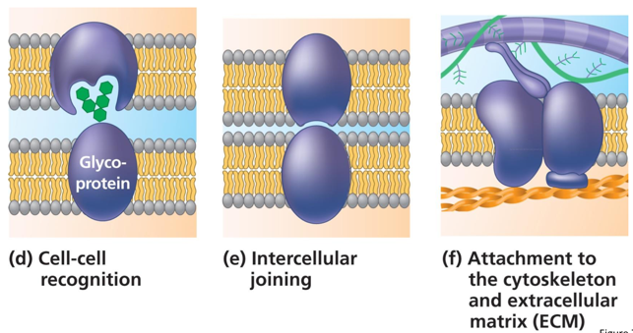
- Transmembrane- span the membrane, can be organized to make a hydrophilic channel through the membrane ex. Aquaporin
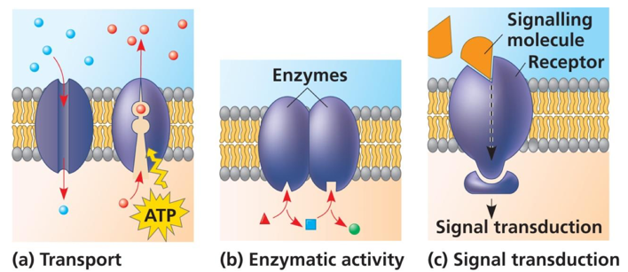

- Carbohydrates
  - Only on the exterior surface of the plasma membrane, covalently bonded to either
    - Proteins=glycoproteins
    - Lipids= glycolipids
    - Together= glycocalyx
  - Function- cell-cell recognition and attachment, increases hydrophilicity of the cell (increase interactions with the extracellular environment) ex. Blood types vary in the carbohydrate component of the glycoprotein on the surface of the red blood cells
- Membrane sidedness- membranes are asymmetric the inner surface differs from the outer surface
- Membrane synthesis- asymmetric distribution is determined then the membrane is built by the ER and the Golgi apparatus
  - Lipids, proteins are synthesized in the (ER), proteins may acquire carbohydrates here
  - Vesicles travel from the ER to the cis-face of the Golgi apparatus were they fuse
  - Vesicles with membrane proteins, secretory proteins, glycolipids bud off the trans-face of the Golgi
  - Vesicles travel the plasma membrane, fuse and release constants into the extracellular space
  - Internal layer of the vesicle’s lipid bilayer is now on the outer surface of the cell membrane, vesicle outer lipid layer is in internal leaflet of the plasma membrane

Lecture: Transport Across Cell Membranes
Gradient movemeny
Down

down

Down

Up

Up

Up

Up

up
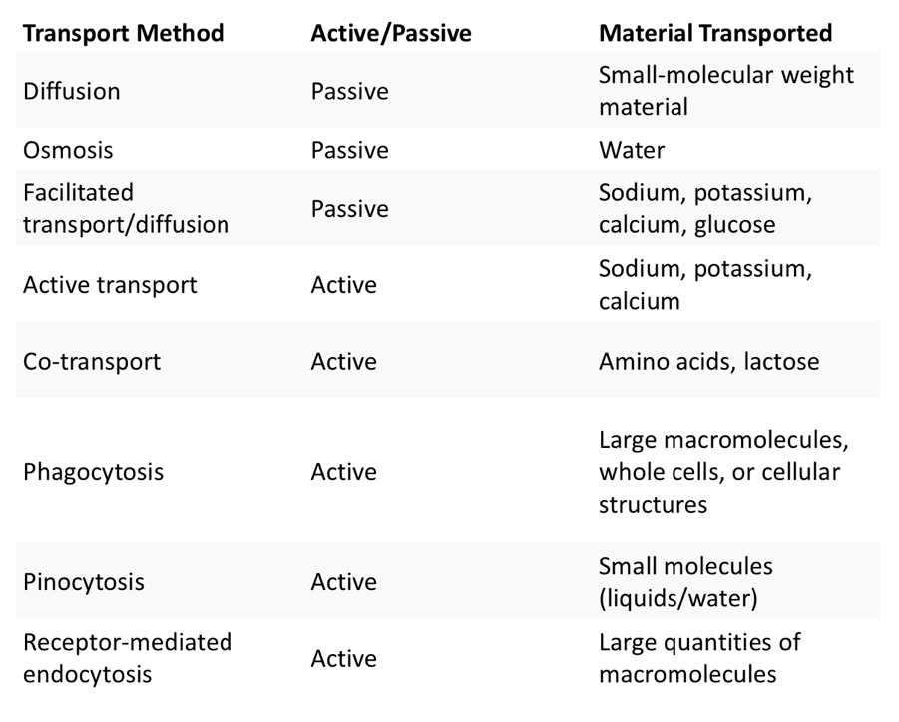
- Diffusion
  - Tendency for molecules to spared out in space, spontaneous process driven by energy of molecules involved
  - Each molecules moves randomly
  - Diffuse down to concentration gradient (high to low)
  - Also known as passive transport, no energy required by the cell
  - Factors effecting diffusion rates: concentration gradients, mass of molecules, temperature, solvent density, solubility, surface area, distance travelled, pressure
- Facilitated Diffusion
  - Moves down concentration gradient, through integral membrane proteins
  - Ions and small polar molecules diffuse across this way
  - Two type: Channel proteins and Carrier proteins
    - Channel proteins- provides corridors that allow a specific molecule or ion to cross the plasma membrane. Some are open all the time, others only open when a signal is received. Ex. Aquaporins specific to water, muscle cells have gated ion channels allowing muscles to contract when opened
    - Carrier proteins- specific to a particular substance, bind to the substance change conformation and translocate the substance to the other side. Allows movement to either side of the gradient. Ex glucose transport proteins (GLUTS)
- Osmosis
  - Diffusion of water across a membrane
  - Differences in water concentration occur when a solute cannot pass through the selectively permeable. Free water diffuses across the membrane from the region of lower solute concentration to a region of higher solute concentration, until the solute concentration is equal on both side
    - Water balance in cells animal:
      - Tonicity-ability of a surrounding solution to cause cells to gain or loose water
      - Isotonic- solute concentrations are the same on the inside and the outside of the cell, no net water movement, this is when animal cells function the best
      - Hypertonic- solute concentration is grater on the outside then the inside, cell loose water
      - Hypotonic- solute concentration is greater on the inside of the cell, water moves in the cell
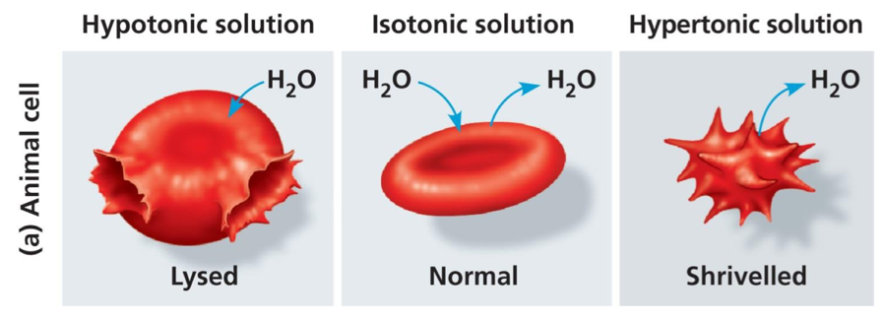
    - Water balance in plant cells:
      - Turgid-plant cell hypotonic solution swells until wall opposes uptake (firm)
      - Flaccid- plant cell in isotonic environment, no net movement of water (limp)
      - Plasmolysis- in a hypertonic environment, plant cells loose water, plasma membrane pulls away from the cell membrane causing the plant to wilt lethal
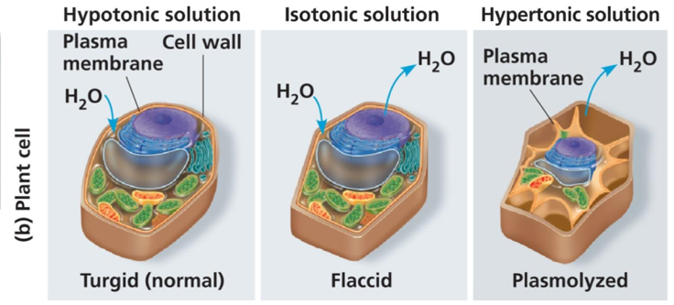
  - Osmoregulation-control of solute concentrations and water balance, this is necessary adaptation for life is such environments, ex. Fresh water protists, use contractile vacuoles to pump water out of their cells so they do not burst in their hypertonic environment
- Chemical gradient- difference in concentration
- Electrical gradient- difference in charge ex. Sodium potassium pump
- Active transport
  - Allows cells to maintain gradients that differ from their surroundings, ex. Cytoplasm containing more negatively charged molecules than ECF is critical for proper cell function
  - Uses energy in the form of ATP to move substances against the concentration gradient, occurs through transmembrane, integral carrier protein pumps
  - Carrier proteins
    - Uniporter- carries one molecule or ion
    - Symporter- carries 2 different molecules or ions, same direction
    - Antiporter- carries 2 different molecules or ions, different directions, Ex. Sodium potassium pump- addition of phosphorus changes conformation (phosphate attached open to the outside of the cell, no phosphate attached open to the inside of the cell), move 3 sodium in and 2 potassium out
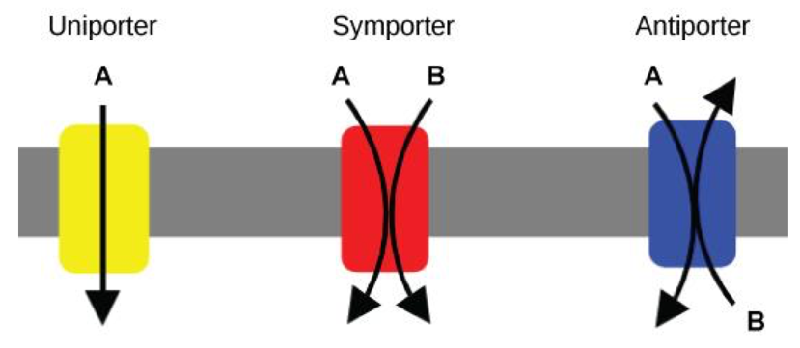
- Cotransport- when active transport of a solute indirectly drives transport of other solutes, plant use a hydrogen ion gradient to drive active transport of nutrients into a cell
- Bulk transport- importing or exporting molecules/particles that are too large to pass through a transport protein
  - Exocytosis- transport vesicles migrate to the membrane, fuse with it and release their contents to the outside of the cell
  - Endocytosis- substance moving into the cell, opposite od exocytosis
    - Phagocytosis- cell engulfs a particle to form a membrane bound vacuole, vacuole fuses with lysosomes to digest the particle, ex. White blood cell phagocytosing a bacteria to protect the body from it. PLANTS CANNOT DO THIS DUE TO THE CELL WALL
    - Pinocytosis- EFC is gulped into tiny membrane bound vesicles, internal vesicles fuse with lysosomes to digest contents ex. Ingulfing a bacteria toxin to see if it is harmful to the cell
    - Receptor-Mediated Endocytosis- binding of ligands (specific molecule) to receptors embedded in the membrane triggers vesicle formation and internalization ,ex. Take in cholesterol for membrane synthesis and the production of steroid hormones
Lecture 7:The Cytoskeleton and Extracellular Matrix
- Cytoskeleton- network of 3 types of protein fibers extending throughout the cytoplasm. Work together to organize cell’s structure, anchor organelles, facilitate cellular activities
- Microtubules
  - Hollow rods about 25nm in diameter
  - Made of tubulin- protein made up of 2 polypeptide chains (alternate alpha, beta)
  - Function- shaping cell (resist compression), guiding movement of organelles and vesicles, separating chromosomes during cell division
  - Grow/shrink through the addition/ removal of tubulin dimers at either end of the polymer
  - Asymmetrical- allowing for addition/ removal of tubulin at a significantly faster rate (plus end) than the other (minus end)
  - Minus end is generally anchored into the microtubule organizing centers (MTOCs)
    - Primary MTOC in an animal cell is called a centrosome, usually located adjacent to the nucleus
    - In animal cells centrosome has a pair of centrioles each with 9 triplets of microtubules arranged in a ring
  - Cell motility- refers to changes in cell location and movement of cell parts
    - Involves interaction between the cytoskeleton and motor-proteins which convert chemical energy to mechanical energy ex. Vesicle walking on the cytoskeleton to its destination
- Intermediate filaments
  - 8-12 nm in diameter
  - Composed of keratin which organizes into cables
  - More permanent even after death of the cell these networks still exist
  - Support cell shape and fix organelles in place ex. Nucleus sits within a cage of intermediate filaments
- Microfilaments
  - 7nm in diameter
  - Twisted double chain of actin subunits
  - Bear tension resisting pulling factors in a cell
  - Forms a 3-D network called the cortex that can be organized in a varity of ways to support different cell shapes
  - Microfilaments that function in cellular motility contain the protein myosin in addition to actin, allows various types of movement
- Connection between cells- cells in animals and plants are organized into tissues, organs and organ systems
  - Plant cell walls- function: maintain the shape of the cell, prevent excessive water uptake, act as a barrier to infection. Made of cellulose embedded in other polysaccharides and protein
  - Have multiple layers
    - Primary cell wall- first to be made thin and flexible
    - Middle lamella- thin layer of pectin (sticky polysaccharide) glue adjacent cell walls together
    - Secondary cell wall (in some cells)-several laminated layers strong durable, for protection and support
- Extracellular Structures in Animal cells
  - Lack cells walls but have ECMs-functions: support, adhesion, movement, regulation
  - ECM made of: fibrous glycoproteins such as collagen and fibronectin, carbohydrate rich glycoproteins called proteoglycans
    - ECM compositions vary between cell and tissue types
    - Cells attach to ECM through integrin proteins
      - Integrins- can transmit information between ECM and cytoskeleton, integrating what is happening both inside and outside of the cell
- Intercellular Junctions- provide direct channels of communication between cells, Plants-plasmodesmata- channels between cell walls of adjacent plant cells which connect their cytoplasm and allow materials to move from cell to cell
  - Tight junctions-watertight seals between animal cells that prevent materials from leaking between the cells. PMs are pressed tightly against each other and bound together by proteins, often found between epithelial cells that line internal organs and cavities ex. These make blood vessels water tight
  - Desmosomes- anchoring junctions that form when cadherins (type of transmembrane protein) in adjacent cells interact, these are spots or rivets. Tied into the cytoskeleton by their interactions with intermediate filaments. Join adjacent cells in tissues that stretch
  - Gap junctions-6 connexins proteins assemble to form a channel through the plasma membrane called a connexon or hemichannel, when connexons of adjacent cells are aligned, they can dock this creates a channel between the cells called a gap junction, hemichannels and gap junctions allow ions and other small signaling molecules to travel through them



