CIVI 321: ENGINEERING MATERIALS

Chapter 1: Materials Engineering Concepts

  - Economic Factors

The economics of the material selection process are affected by much more than just the cost of the material. Factors that should be considered in the selection of the material include:
- availability and cost of raw materials
- manufacturing costs
- transportation
- placing
- maintenance

1.2 Mechanical Properties

The mechanical behavior of materials is the response of the material to external loads. All materials deform in response to loads; however, the specific response of a material depends on its properties, the magnitude and type of load, and the geometry of the element. Whether the material “fails” under the load conditions depends on the failure criterion. Catastrophic failure of a structural member, resulting in the collapse of the structure, is an obvious material failure. However, in some cases the failure is more subtle, but with equally severe consequences.

1.2.1 Loading Conditions

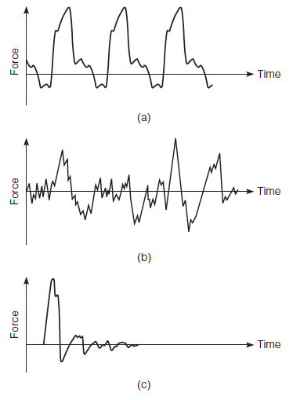
Static Loads

- Sustained loading of the structure over a period of time.
- The static load may remain in place or be removed slowly.
- Loads that remain in place for an extended period of time are called sustained (dead) loads.

Dynamic Loads

- Loads that generate a shock or vibration in the structure.
- Periodic (a), random (b), or transient (c).
- Called live loads.

1.2.2 Stress-Strain Relations

- The amount of deformation is proportional to the properties of the material and its dimensions.
- The force per unit area is defined as the stress in the specimen ($σ$).
- Dividing the deformation by the original length is defined as strain of the specimen ($ε$).

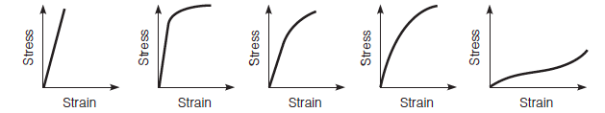
glass/chalk steel aluminum alloy concrete soft rubber

1.2.3 Elastic Behavior

If a material exhibits true elastic behavior, it must have an instantaneous response (deformation) to load, and the material must return to its original shape when the load is removed.

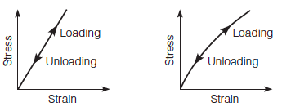

Linear Non-linear

1.2.4 Elastoplastic Behavior

For some materials, as the stress applied on the specimen is increased, the strain will proportionally increase up to a point; after this point the strain will increase with little additional stress. In this case, the material exhibits linear elastic behavior followed by plastic response.
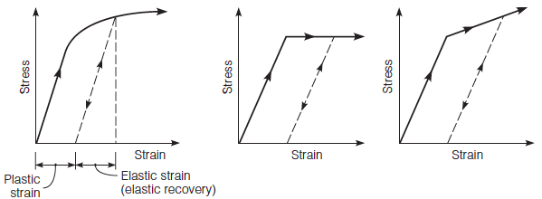

Example of:
- Loading and unloading
- Elastic-perfectly plastic
- Elasto-plastic with strain
hardening.

1.2.5 Viscoelastic Behavior

In some cases, materials exhibit both viscous and elastic responses, which are known as viscoelastic.
Typical viscoelastic materials used in construction applications are asphalt and plastics.
The amount of time delayed of the deformation depends on the material characteristics and the temperature.

1.2.6 Temperature and Time Effects

Ferrous metals, including steel, demonstrate a change from ductile to brittle behavior as the temperature drops below the transition temperature. This change from ductile to brittle behavior greatly reduces the toughness of the material. While this could be determined by evaluating the stress–strain diagram at different temperatures, it is more common to evaluate the toughness of a material with an impact test that measures the energy required to fracture a specimen.

In addition to temperature, some materials, such as viscoelastic materials, are affected by the load duration. The longer the load is applied, the larger is the amount of deformation or creep. In fact, increasing the load duration and increasing the temperature cause similar material responses. Therefore, temperature and time can be interchanged for testing purposes.

1.2.7 Work and Energy

By manipulating the units of the stress–strain diagram, we can see that the area under the stress–strain diagram equals the work per unit volume of material required to deform or fracture the material. This is a useful concept, for it tells us the energy that is required to deform or fracture the material.

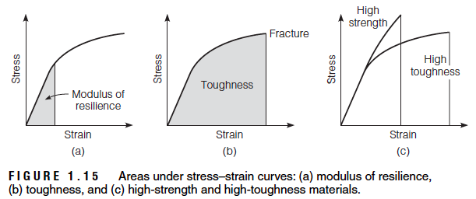

1.2.8 Failure and Safety

Failure occurs when a member or structure ceases to perform the function for which it was designed. Failure of a structure can take several modes, including fracture fatigue, general yielding, buckling, and excessive deformation. Fracture is a common failure mode. A brittle material typically fractures suddenly when the static stress reaches the strength of the material, where the strength is defined as the maximum stress the material can carry. On the other hand, a ductile material may fracture due to excessive plastic deformation.

To minimize the chance of failure, structures are designed to carry a load greater than the maximum anticipated load. The factor of safety (FS) is defined as the ratio of the stress at failure to the allowable stress for design. It varies depending on:

- Cost of unpredictable failure in lives, dollars, and time
- Variability in material properties
- Degree of accuracy in considering all possible loads applied to the structure, such as earthquakes
- Possible misuse of the structure, such as improperly hanging an object from a truss roof
- Degree of accuracy of considering the proper response of materials during design, such as assuming elastic response although the material might not be perfectly elastic

1.3 Non-mechanical Properties

Non-mechanical properties refer to characteristics of the material, other than load response, that affect selection, use, and performance. There are several types of properties that are of interest to engineers, but those of the greatest concern to civil engineers are density, thermal properties, and surface characteristics.

1.3.1 Density and Unit Weight

In many structures, the dead weight of the materials in the structure significantly contributes to the total design stress. If the weight of the materials can be reduced, the size of the structural members can be also reduced.

Density is the mass per unit volume of material.

Unit weight is the weight per unit volume of material.

Specific gravity is the ratio of the mass of a substance relative to the mass of an equal volume of water at a specified temperature.

1.3.2 Thermal Expansion

Practically all materials expand as temperature increases and contract as temperature falls. The amount of expansion per unit length due to one unit of temperature increase is a material constant and is expressed as the coefficient of thermal expansion.

Linear coefficient of thermal expansion: $α_{L}=\frac{{δL}/{δT}}{L}$

Volumetric coefficient of thermal expansion: $α_{V}=\frac{{δV}/{δT}}{V}$

1.4 Production and Construction

Production considerations include the availability of the material and the ability to fabricate the material into the desired shapes and required specifications. Construction considerations address all the factors that relate to the ability to fabricate and erect the structure on site.

1.5 Aesthetic Characteristics

The mix of artistic and technical design skills makes the project acceptable to the community. In fact, political views are often more difficult to deal with than technical design problems. Thus, engineers should understand that there are many factors beyond the technical needs that must be considered when selecting materials and designing public projects.

1.6 Sustainable Design

While sustainable design is a philosophy, implementation of the concept requires direct and measureable actions. To this end the Green Building Council developed the Leadership in Environment and Energy Design, LEED, building rating system.

For new construction and major renovations the rating areas of LEED include:

- Sustainable sites
- Water efficiency
- Energy and atmosphere
- Materials and resources
- Indoor environmental quality
- Innovation in design
- Regional priority

The items considered in the Materials and Resource area include:

- Storage and collection of recyclables
- Building reuse–maintain existing walls, floors and roof, interior walls and nonstructural elements
- Construction waste management
- Material reuse
- Recycled content
- Regional materials
- Rapidly renewable materials
- Certified wood

1.7 Material Variability

It is essential to understand that engineering materials are inherently variable.

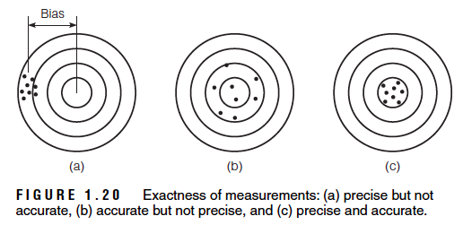

1.7.1 Sampling

Typically, samples are taken from a lot or population, since it is not practical or possible to test the entire lot. By testing sufficient samples, it is possible to estimate the properties of the entire lot. In order for the samples to be valid they must be randomly selected.

1.7.2 Normal Distribution

The normal distribution describes many populations that occur in nature, research, and industry, including material properties. The area under the curve between any two values represents the probability of occurrence of an event of interest. Expressing the results in terms of mean and standard deviation, it is possible to determine the probabilities of an occurrence of an event.

1.7.3 Control Charts

Control charts have many benefits:

- detect trouble early
- decrease variability
- establish process capability
- reduce price adjustment cost
- decrease inspection frequency
- provide a basis for altering specification limits
- provide a permanent record of quality
- provide basis for acceptance
- instill quality awareness

Chapter 5: Aggregates

Generally, in civil engineering the term aggregate means a mass of crushed stone, gravel, sand, etc., predominantly composed of individual particles, but in some cases including clays and silts. The largest particle size in aggregates may have a diameter as large as 150 mm (6 in.), and the smallest particle can be as fine as 5 to 10 microns.

Traditional definitions:

- Maximum aggregate size: The smallest sieve through which 100 percent of the aggregates pass.
- Nominal maximum aggregate size: The largest sieve that retains any of the aggregate, but generally not more than 10 percent.

Superpave definitions:

- Maximum aggregate size: One sieve size larger than the nominal maximum aggregate size.
- Nominal maximum aggregate size: One sieve larger than the first sieve to retain more than 10 percent of the aggregates.

5.1 Aggregate Sources

Natural sources for aggregates include gravel pits, river run deposits, and rock quarries. Generally, gravel comes from pits and river deposits, whereas crushed stones are the result of processing rocks from quarries. Usually, gravel deposits must also be crushed to obtain the needed size distribution, shape, and texture.

Manufactured aggregates can use slag waste from iron and steel mills and expanded shale and clays to produce lightweight aggregates. Heavyweight concrete, used for radiation shields, can use steel slag and bearings for the aggregate. Styrofoam beads can be used as an aggregate in lightweight concrete used for insulation. Natural lightweight aggregates include pumice, scoria, volcanic cinders, tuff, and diatomite.

5.3 Evaluation of Aggregate Sources

The physical and chemical properties of the rocks determine the acceptability of an aggregate source for a construction project.
These characteristics vary within a quarry or gravel pit, making it necessary to sample and test the materials continually as the aggregates are being produced.

Potential aggregate sources are usually evaluated for quality of the larger pieces, the nature and amount of fine material, and the gradation of the aggregate. The extent and quality of rock in the quarry is usually investigated by drilling cores and performing trial blasts (or shots) to evaluate how the rock breaks and by crushing some materials in the laboratory to evaluate grading, particle shape, soundness, durability, and amount of fine material.
Potential sand and gravel pits are evaluated by collecting samples and performing sieve analysis tests. The amount of large gravel and cobble sizes determines the need for crushing, while the amount of fine material determines the need for washing.

Price and availability are universal criteria that apply to all uses of aggregates. However, the required aggregate characteristics depend on how they will be used in the structure.

5.4 Aggregate Uses

Aggregates are used primarily as an underlying material for foundations and pavements, and as ingredients in portland cement and asphalt concretes. Aggregate underlying materials, or base courses, can add stability to a structure, provide a drainage layer, and protect the structure from frost damage.

In portland cement concrete, 60% to 75% of the volume and 79% to 85% of the weight are made up of aggregates. The aggregates act as a filler to reduce the amount of cement paste needed in the mix. In addition, aggregates have greater volume stability than the cement paste. Therefore, maximizing the amount of aggregate, to a certain extent, improves the quality and economy of the mix.

In asphalt concrete, aggregates constitute 75% to 85% of the volume and 92% to 96% of the mass. The asphalt cement acts as a binder to hold the aggregates together, but does not have enough strength to lock the aggregate particles into position. As a result, the strength and stability of asphalt concrete depends mostly on interparticle friction between the aggregates and, to a limited extent, on the binder.

5.5 Aggregate Properties

Aggregates’ properties are defined by the characteristics of both the individual particles and the characteristics of the combined material. These properties can be further described by their physical, chemical, and mechanical characteristics. Several individual particle characteristics are important in determining if an aggregate source is suitable for a particular application.

5.5.1 Particle Shape and Surface Texture

The shape and surface texture of the individual aggregate particles determine how the material will pack into a dense configuration and also determines the mobility of the stones within a mix. There are two considerations in the shape of the material: angularity and flakiness. Crushing rocks produces angular particles with sharp corners and rough texture. Due to weathering, the corners of the aggregates break down, creating subangular particles and smooth texture. When the aggregates tumble while being transported in water, the corners can become completely rounded. Generally, angular and rough-textured aggregates produce bulk materials with higher stability than rounded, smooth-textured aggregates. However, the angular aggregates will be more difficult to work into place than rounded aggregates, since their shapes make it difficult for them to slide across each other.

Coarse Aggregates:

- Aggregates with a rough texture are more difficult to compact into a dense configuration.
- Rough texture generally improves bonding and increases interparticle friction.
- Natural gravel and sand have a smooth texture, whereas crushed aggregates have a rough texture.
- Portland cement rounded and smooth aggregate particles to improve the workability of fresh concrete during mixing.
- Asphalt concrete angular and rough particles are desirable for asphalt concrete and base courses in order to increase the stability of the materials in the field and to reduce rutting.

Fine Aggregates:

- The angularity and texture of fine aggregates have a very strong influence on the stability of asphalt concrete mixes.
- The higher the amount of void content, the more angular and the rougher will be the surface texture of the fine aggregate.

5.5.2 Soundness and Durability

The ability of aggregate to withstand weathering is defined as soundness or durability. Water freezing in the voids of aggregates generates stresses that can fracture the stones.

5.5.3 Toughness, Hardness and Abrasion Resistance

The ability of aggregates to resist the damaging effect of loads is related to the hardness of the aggregate particles and is described as the toughness or abrasion resistance. The aggregate must resist crushing, degradation, and disintegration when stockpiled, mixed as either portland cement or asphalt concrete, placed and compacted, and exposed to loads. (Test: Los Angeles abrasion test)

5.5.4 Absorption

- Absorption is important for Portland cement concrete design.
- Absorbed water is not available for cement reactions.
- In asphalt concrete, aggregate will absorb binder.
- High absorption high bonding & more binder $

Moisture States:

- Oven-dry: contains no water (water evaporates at 100$°$C)
- Air-dry: contains some water in voids
- Saturated surface dry (SSD): voids are completely filled with water but the surface is dry (from damp cloth)
- Moist state: excess surface water on top of filling all voids

$$Absorption=\frac{SSD-DRY}{DRY}= \frac{mass of water}{mass of dry aggregate}$$

Typically, < 1-2%
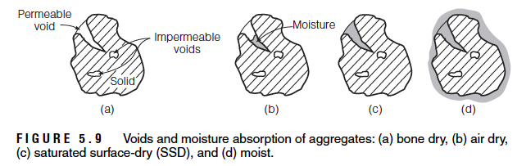

5.5.5 Specific Gravity

$$specific gravity= \frac{mass of material}{mass of equal volume of water}$$

$$bulk dry specific gravity= \frac{DRY}{SSD-SUSP}$$

where SUSP is the suspended mass.

$$bulk SSD specific gravity=\frac{SSD}{SSD-SUSP}$$

specific gravity: 2.5-2.8

5.5.6 Bulk Unit Weight and Voids in Aggregate

It is a measure of packing efficiency.

$$unit weight=\frac{weight (mg)}{volume}$$

Usually between 1500-1700 KN/m³.

$$voids=\frac{({SG}_{dry} × W-ρ_{g})}{{SG}_{dry} × W}$$

5.5.7 Strength and Modulus

- Aggregate is limiting for strength of concrete.
- High strength concrete needs strong and small aggregate.
- Strength depends on size.

5.5.8 Gradation

- Gradation: particle size distribution.
- Maximum size: largest size used.
- Maximum nominal size: up to 10% may be larger.
- Minimizes binder.
- Same size aggregates for drainage.
- Gap-Graded (missing one or mire sizes): To conform to limits 1. Crush large particles to make “missing” sizes or 2. Blend with another source.

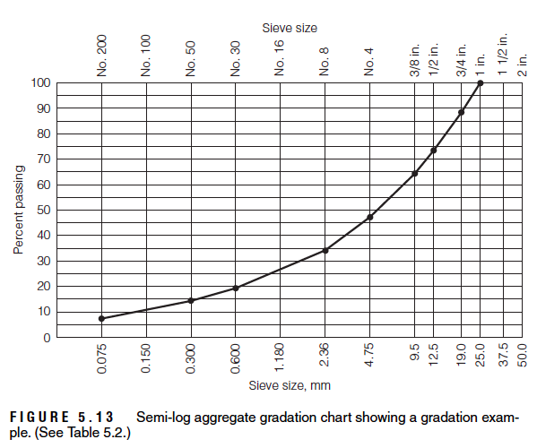
Sieve Analysis

- Set of sieves with progressively smaller openings.
- Metric or US sizes.
- Each sieve opening is about half the size of the one above it.
- Metric: 4.75mm, 2.36mm, 1.18mm, 0.60mm, 0.30mm, 0.15mm.

Fineness Modulus

$$FM= \frac{Σ cumulative \% retained}{100}$$

expected value: 2.8-3.1

- Fine aggregate must be within limits for mixing in concrete ASTM C33.

5.5.9 Cleanness and Deleterious Substances

- Organic matter (problem: delays concrete set).
- Small particles <0.075 mm (weakens bond between aggregate and binder, increase water requirement).
- Coal or low-density materials like clay lumps and soft particles (reduces strength, reduces durability)

5.5.10 Alkali-Aggregate Reactivity

- Most common is alkali-silica reaction, very common in Montreal.
- Visual sign is map cracking.
- Aggregate can contain reactive silica.
- Cement contains alkali Na₂O or K₂O.
- Alkalis lead to high pH.
- Alkali and silica react (in presence of water) to form alkali-silica gel, which is expansive.

5.5.11 Affinity for Asphalt

Stripping, or moisture-induced damage, is a separation of the asphalt film from the aggregate through the action of water, reducing the durability of the asphalt concrete and resulting in pavement failure.
One important factor is the relative affinity of the aggregate for either water or asphalt. Hydrophilic (water-loving) aggregates, such as silicates, have a greater affinity for water than for asphalt. They are usually acidic in nature and have a negative surface charge. Conversely, hydrophobic (waterrepelling) aggregates have a greater affinity for asphalt than for water. These aggregates, such as limestone, are basic in nature and have a positive surface charge. Hydrophilic aggregates are more susceptible to stripping than hydrophobic aggregates.
Other stripping factors include porosity, absorption, and the existence of coatings and other deleterious substances.

5.6 Handling Aggregates

- Handled, stored in a way to minimize segregation, deterioration and contamination.

5.6.1 Sampling Aggregates

- Sampling must be representative
- Take from top, middle and bottom
- Use plywood

Methods to divide a large sample:
- Quartering: spread out aggregate
- Sample splitter

Chapter 6: Portland Cement, Mixing Water and Admixtures

6.1 Portland Cement Production

Production of portland cement starts with two basic raw ingredients: a calcareous material and an argillaceous material. The calcareous material is a calcium oxide, such as limestone, chalk, or oyster shells. The argillaceous material is a combination of silica and alumina that can be obtained from clay, shale, and blast furnace slag.

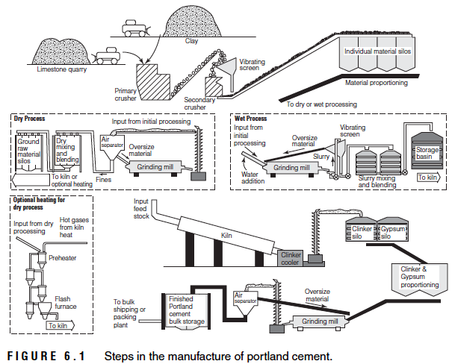

6.2 Chemical Composition of Portland Cement

The raw materials used to manufacture portland cement are lime, silica, alumina, and iron oxide. These raw materials interact in the kiln, forming complex chemical compounds. Calcination in the kiln restructures the molecular composition, producing four main compounds:

- Tricalcium Silicate (C₃S)
- Dicalcium Silicate (C₂S)
- Tricalcium Aluminate (C₃A)
- Tetracalcium Aluminoferrite (C₄AF)
6.3 Fineness of Portland Cement

Fineness of cement particles is an important property that must be carefully controlled. Since hydration starts at the surface of cement particles, the finer the cement particles, the larger the surface area and the faster the hydration.

6.4 Specific Gravity of Portland Cement

The specific gravity of cement is needed for mixture-proportioning calculations.
The specific gravity of portland cement (without voids between particles) is about 3.15.
The density of the bulk cement (including voids between particles) varies considerably, depending on how it is handled and stored.

6.5 Hydration of Portland Cement

Hydration is the chemical reaction between the cement particles and water. The features of this reaction are the change in matter, the change in energy level, and the rate of reaction.

6.5.1 Structure Development in Cement Paste
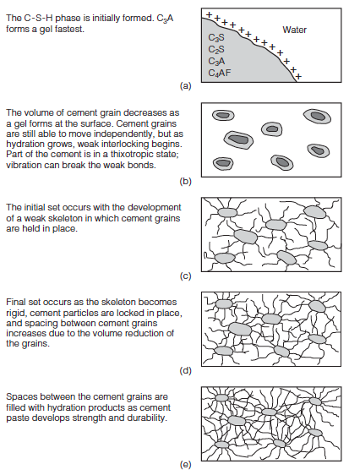

Initial C-S-H phase

Forming of gels

Initial Set (development of weak skeleton)

Final Set (development of rigid skeleton)

Hardening

6.5.2 Evaluation of Hydration Progress

Methods to evaluate the progress of cement hydration include measuring:

- the heat of hydration
- the amount of calcium hydroxide in the paste developed due to hydration
- the specific gravity of the paste
- the amount of chemically combined water
- the amount of unhydrated cement paste using X-ray quantitative analysis
- the strength of the hydrated paste, an indirect measurement

6.6 Voids in Hydrated Cement

Due to the random growth of the crystals and the different types of crystals, voids are left in the paste structure as the cement hydrates. Concrete strength, durability, and volume stability are greatly influenced by voids. Two types of voids are formed during hydration: the interlayer hydration space and capillary voids.

Interlayer hydration space occurs between the layers in the C-S-H.

Capillary voids are the result of the hydrated cement paste having a lower bulk specific gravity than the cement particles. The amount and size of capillary voids depends on the initial separation of the cement particles, which is largely controlled by the ratio of water to cement paste.

In addition to the interlayer space and capillary voids, air can be trapped in the cement paste during mixing. The trapped air reduces strength and increases permeability. However, well-distributed, minute air bubbles can greatly increase the durability of the cement paste.

6.7 Properties of Hydrated Cement

6.7.1 Setting

Setting refers to the stiffening of the cement paste or the change from a plastic state to a solid state. Although with setting comes some strength, it should be distinguished from hardening, which refers to the strength gain in a set cement paste. Setting is usually described by two levels: initial set and final set.

6.7.2 Soundness

Soundness of the cement paste refers to its ability to retain its volume after setting. Expansion after setting, caused by delayed or slow hydration or other reactions, could result if the cement is unsound.

6.7.3 Compressive Strength of Mortar

Compressive strength of mortar is measured by preparing 50-mm (2 in.) cubes and subjecting them to compression. The mortar is prepared with cement, water, and standard sand. Minimum compressive strength values are specified by ASTM C150 for different cement types at different ages. The compressive strength of mortar cubes is proportional to the compressive strength of concrete cylinders.

6.8 Water-Cement Ratio

For fully compacted concrete made with sound and clean aggregates, strength and other desirable properties are improved by reducing the weight of water used per unit weight of cement. This concept is frequently identified as Abrams’ law.

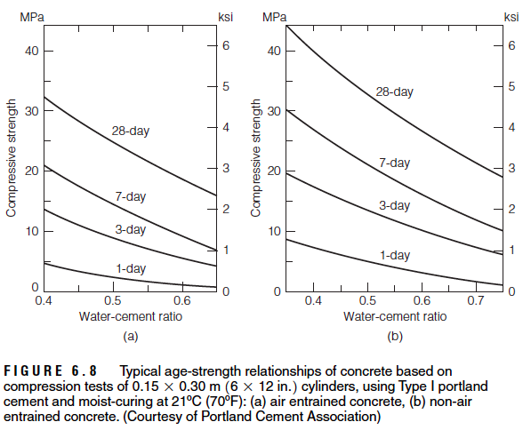
6.9 Types of Portland Cement

6.9.1 Standard Portland Cement Types

In addition to these five types, air entrainers can be added to Type I, II, and III cements during manufacturing, producing Types IA, IIA, and IIIA, which provide better resistance to freeze and thaw than do non–air-entrained cements.
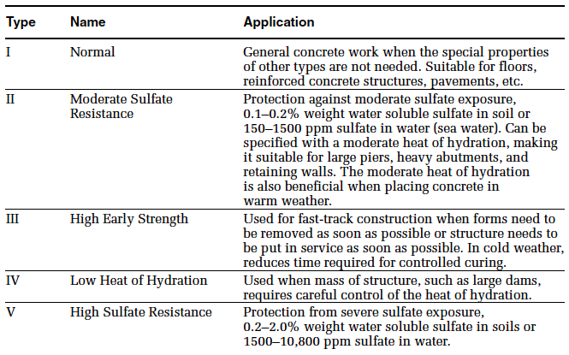

6.9.2 Other Cement Types

In general, these cements have limited applications. Civil and construction engineers should be aware of their existence, but should study them further before using them.
Examples: White portland cement, Blended hydraulic cements

6.10 Mixing Water

Any potable water is suitable for making concrete. However, some non-potable water may also be suitable. Frequently, material suppliers will use unprocessed surface or well water if it can be obtained at a lower cost than processed water. However, impurities in the mixing water can affect concrete set time, strength, and long-term durability.

6.10.1 Acceptable Criteria

The acceptance criteria for questionable water are specified in ASTM C94. After seven days, the average compressive strength of mortar cubes made with the questionable water should not be less than 90% of the average strength of cubes made with potable or distilled water (ASTM C109).

6.10.2 Disposal and Reuse of Concrete Wash Water

Disposal of wastewater from ready-mixed concrete operations is a great concern of the ready-mixed concrete producers. This waste water is usually generated from truck wash systems, washing of central mixing plant, storm water runoff from the ready-mix plant yard, waste water generated from water sprayed dust control, and conveyor washdown. According to the Water Quality Act, wastewater from ready-mixed concrete operations is a hazardous substance (it contains caustic soda and potash. In addition, the high pH makes concrete wash water hazardous under the EPA definition of corrosivity.

6.11 Admixtures for Concrete

Admixtures are ingredients other than portland cement, water, and aggregates that may be added to concrete to impart a specific quality to either the plastic (fresh) mix or the hardened concrete.

6.11.1 Air Entrainers

Air entrainers produce tiny air bubbles in the hardened concrete to provide space for water to expand upon freezing.

6.11.2 Water Reducers

Workability of fresh or plastic concrete requires more water than is needed for hydration. The excess water, beyond the hydration requirements, is detrimental to all desirable properties of hardened concrete. Therefore, water-reducing admixtures have been developed to gain workability and, at the same time, maintain quality. Water reducers increase the mobility of the cement particles in the plastic mix, allowing workability to be achieved at lower water contents.

6.11.3 Retarders

Some construction conditions require that the time between mixing and placing or finishing the concrete be increased. In such cases, retarders can be used to delay the initial set of concrete.

6.11.4 Hydration-Control Admixtures

These admixtures have the ability to stop and reactivate the hydration process of concrete. They consist of two parts: a stabilizer and an activator. Adding the stabilizer completely stops the hydration of the cementing materials for up to 72 hours, while adding the activator to the stabilized concrete reestablishes normal hydration and setting. These admixtures are very useful in extending the use of ready-mixed concrete when the work at the jobsite is stopped for various reasons. They are also useful when concrete is being hauled for a long time.
6.11.5 Accelerators

Accelerators are used to develop early strength of concrete at a faster rate than that developed in normal concrete. The ultimate strength, however, of high early strength concrete is about the same as that of normal concrete.

6.11.6 Specialty Admixtures

In addition to the admixtures previously mentioned, several admixtures are available to improve concrete quality in particular ways.

Examples:
- workability agents
- corrosion inhibitors
- damp-proofing agents
- permeability-reducing agents
- fungicidal, germicidal, and insecticidal admixtures
- pumping aids
- bonding agents
- grouting agents
- gas-forming agents
- coloring agents
- shrinkage reducing

6.12 Supplementary Cementitious Materials

Fly ash is the most commonly used pozzolan in civil engineering structures. Fly ash is a by-product of the coal industry, it increases the workability of the fresh concrete. In addition, fly ash extends the hydration process, allowing a greater strength development and reduced porosity.

Slag cement is made from iron blast furnace slag. It is a non-metallic hydraulic cement consisting basically of silicates and aluminosilicates of calcium.

Silica fume is a byproduct of the production of silicon metal or ferrosilicon alloys. One of the most beneficial uses for silica fume is as a mineral admixture in concrete. Because of its chemical and physical properties, it is a very reactive pozzolan. Concrete containing silica fume can have very high strength and can be very durable.

Natural pozzolans, such as fine volcanic ash, combined with burned lime, are siliceous and aluminous materials which, in themselves, possess little or no cementitious value but will, in finely divided form and in the presence of moisture, react chemically with calcium hydroxide at ordinary temperatures to form compounds possessing cementitious properties.

Chapter 7: Portland Cement Concrete

The quality of the concrete is governed by the chemical composition of the Portland cement, hydration and development of the microstructure, admixtures, and aggregate characteristics. The quality is strongly affected by placement, consolidation, and curing, as well.

7.1 Proportioning of Concrete Mixes

Properties of the hardened concrete important to the materials engineer are the strength, modulus of elasticity, durability, and porosity. Strength is generally the controlling design factor. Unless otherwise specified, concrete strength f’_{c} refers to the average compressive strength of three tests. Each test is the average result of two 6 in. x 12 in. cylinders tested in compression after curing for 28 days.

Three qualities required of properly proportioned concrete mixtures:

- Acceptable workability of freshly mixed concrete
- Durability, strength, and uniform appearance of hardened concrete
- Economy

7.1.1 Basic Steps for Weight and Absolute Volume Methods

- Evaluate strength requirements.

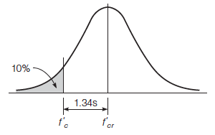

- Determine the water-cement (water–cementitious materials) ratio required.
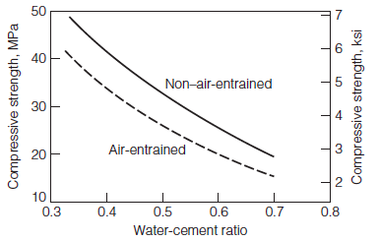

- Evaluate coarse aggregate requirements.
  - maximum aggregate size of the coarse aggregate
  - quantity of the coarse aggregate
- Determine air entrainment requirements.
- Evaluate workability requirements of the plastic concrete.
- Estimate the water content requirements of the mix.
- Determine cementing materials content and type needed.
- Evaluate the need and application rate of admixtures.
- Evaluate fine aggregate requirements.
- Determine moisture corrections.
- Make and test trial mixes.

7.1.2 Mixing Concrete for Small Jobs

Tables are used for proportioning concrete mixes by weight and volume, respectively. The tables provide ratios of components, with a sum of one unit. Therefore, the required total weight or volume of the concrete mix can be multiplied by the given ratios to obtain the weight or volume of each component.

7.2 Mixing, Placing and Handling Fresh Concrete

Batching is measuring and introducing the concrete ingredients into the mixer. Batching by weight is more accurate than batching by volume, since weight batching avoids the problem created by bulking of damp sand. Water and liquid admixtures, however, can be measured accurately either by weight or volume.
On the other hand, batching by volume is commonly used with continuous mixers and when hand mixing. Continuous mixers are specifically designed to overcome the bulking problem.
Mixers are usually charged with 10% of the water, followed by uniform additions of solids and 80% of the water. Finally, the remainder of the water is added to the mixer.

7.2.1 Ready-Mixed Concrete

Ready-mixed concrete is mixed in a central plant, and delivered to the job site in mixing trucks ready for placing. Three mixing methods can be used for ready-mixed concrete:

- Central-mixed concrete is mixed completely in a stationary mixer and delivered in an agitator truck (2 rpm to 6 rpm).
- Shrink-mixed concrete is partially mixed in a stationary mixer and completed in a mixer truck (4 rpm to 16 rpm).
- Truck-mixed concrete is mixed completely in a mixer truck (4 rpm to 16 rpm).

Truck manufacturers usually specify the speed of rotation for their equipment. Also, specifications limit the number of revolutions in a truck mixer in order to avoid segregation. Furthermore, the concrete should be discharged at the job site within 90 minutes from the start of mixing, even if retarders are used

7.2.2 Mobile Batcher Mixed Concrete

Concrete can be mixed in a mobile batcher mixer at the job site. Aggregate, cement, water, and admixtures are fed continuously by volume, and the concrete is usually pumped into the forms.

7.2.3 Depositing Concrete

Several methods are available to deposit concrete at the jobsite. Concrete should be deposited continuously as close as possible to its final position. Advance planning and good workmanship are essential to reduce delay, early stiffening and drying out, and segregation.

7.2.4 Pumped Concrete

Pumped concrete is frequently used for large construction projects. Special pumps deliver the concrete directly into the forms. Careful attention must be exercised to ensure well-mixed concrete with proper workability. The slump should be between 40 mm to 100 mm (1-1/2 in. to 4 in.) before pumping. During pumping, the slump decreases by about 12 mm to 25 mm (1/2 in. to 1 in.), due to partial compaction.
Blockage could happen during pumping, due to either the escape of water through the voids in the mix or due to friction if fines content is too high

7.2.5 Vibration of Concrete

Quality concrete requires thorough consolidation to reduce the entrapped air in the mix. On small jobs, consolidation can be accomplished manually by ramming and tamping the concrete. For large jobs, vibrators are used to consolidate the concrete.
Several types of vibrators are available, depending on the application. Internal vibrators are the most common type used on construction projects. These consist of an eccentric weight housed in a spud. The weight is rotated at high speed to produce vibration. The spud is slowly lowered into and through the entire layer of concrete, penetrating into the underlying layer if it is still plastic. The spud is left in place for 5 seconds to 2 minutes, depending on the type of vibrator and the consistency of the concrete. The operator judges the total vibration time required.
Over-vibration causes segregation as the mortar migrates to the surface.
Several specialty types of vibrators are used in the production of precast concrete. These include external vibrators, vibrating tables, surface vibrators, electric hammers, and vibratory rollers

