- Alimentary canal aka (GI tract)

- Continuous muscular tube that digests and absorbs
- Mouth to anus
- Mouth → pharynx → esophagus →stomach →
small intestine → large intestine (then anus)
- Cadaver has longer canal vs living people have short
  - This is due to MUSCLE TONE

- 4 basic layers for all organs
  - Mucosa or mucous membrane
    - Innermost layer
    - Moist epithelial
    - Function
      - Secrete mucus , enzymes, hormones
      - Absorb nutrient into blood
      - Protect from infections and acid
    - 3 layers of the mucosa
      - Epithelium
        - Simple columnar epithelium
        - Lots of mucus secreting cells (goblet cells)
        - Very abundant in the stomach

- Lamina propria
  - Loose areolar CT
  - Capillaries nourish and absorb
  - Contains isolated follicles from MALT
    - Defend against pathogens
    - Prevent them from entering our digestive tract

- Muscularis mucosae
  - Smaller layer of smooth muscle cells
  - Responsible for local movements of mucosa

- Submucosa

- Muscularis externa
- Serosa

This system is enclosed by a membrane called peritoneum.

Visceral peritoneum
- Covers external surface of digestive organs
- Continuous with the internal covering
Parietal Peritoneum
- Lays above the organs
- More internal than the visceral layer

Peritoneal cavity
- Space between the two layers
- Wall of this pace has serous membrane
  - Serous fluid is excreted from this (slippery fluids)

Mesentery
- Double layer of peritoneum
- Serous membrane back to back
- Provides supply of blood, nerves and lymph
- Anchors the organs in place
- Good fat storage
- Most are dorsal = attached to the posterior body wall
- Some are ventral = attached to the anterior body wall
- Helps prevent the intestines from knotting and anchors them in place
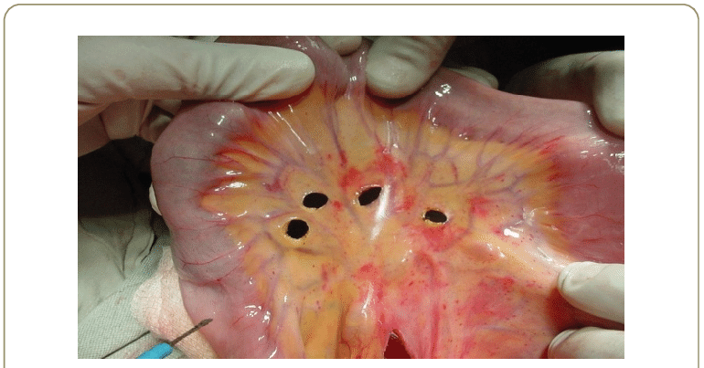
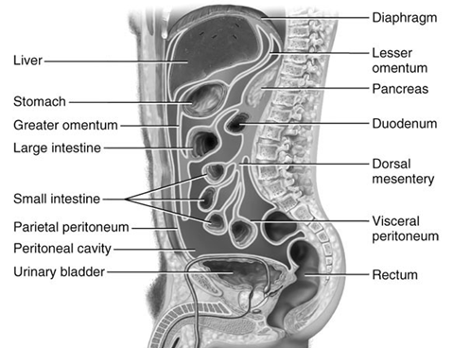

- Organs that lost their mesentery = retroperitoneal
  - Pancreases
  - Part of the small intestine
- Organs that kept their mesentery = intraperitoneal or peritoneal organ

- Peritonitis = inflammation of the peritoneum
  - Common Cause = busted appendix

- Accessory organs

- Aid in digestion ..but not part of the canal
- Teeth, tongue, gallbladder, salivary glands, liver, pancreas



